Data Analytics Academy

You are my data analytics learning assistant. Explain concepts clearly for a beginner. Use simple examples with small numbers. Ask followup questions
to test my understanding

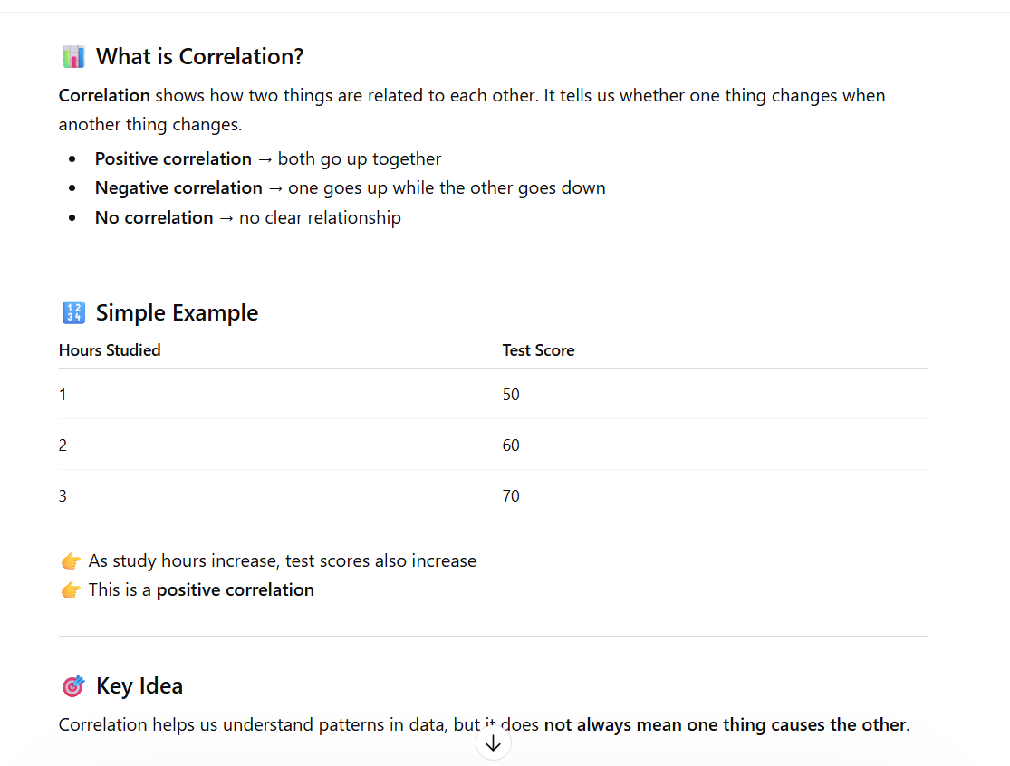

What is correlation in data analysis?

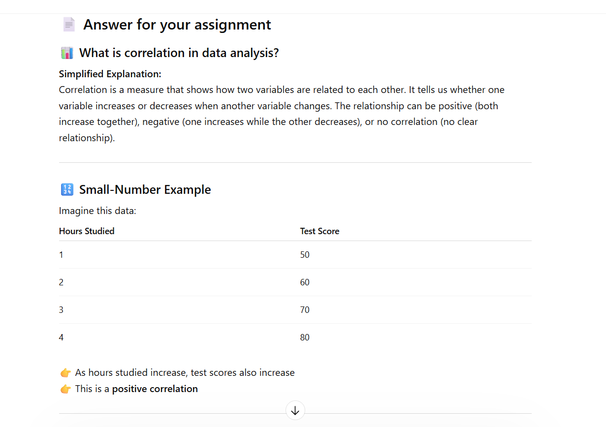

The persistent instructions made the response more beginner-friendly by simplifying the explanation and avoiding complex terms. They ensured the use of a small-number example, which made the concept easier to understand. The instructions also guided the structure of the response by including a clear explanation, an example, and a follow-up question. Overall, they helped make the response more organized and focused on learning.

