Getting Chrome to work with DOD Certs:
This guide assumes that the DA-Anywhere script has been run and that the pcsc libraries and OpenSC were installed via the script.
Step 1: Download these 5 DoD certificate files to your computer
AllCerts.p7b,
RootCert2.p7b,
RootCert3.p7b,
RootCert4.p7b
RootCert5.p7b

Step 2: Install the certificates in Chrome, select the 3 dots (top right of web browser), select Settings
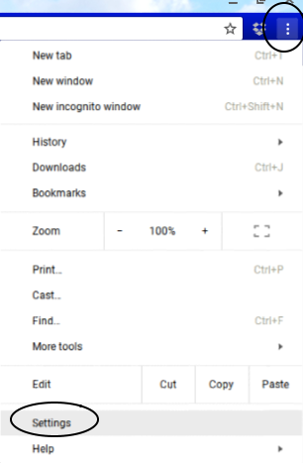

.
Step 3: Scroll down to Privacy and security, then select Security
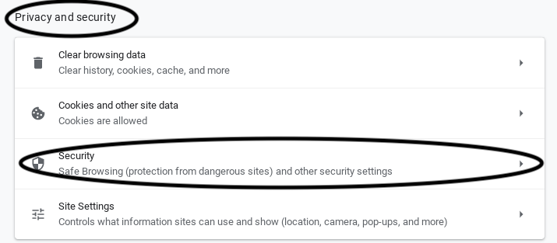

Step 4: Scroll down and click on Manage certificates under Advanced
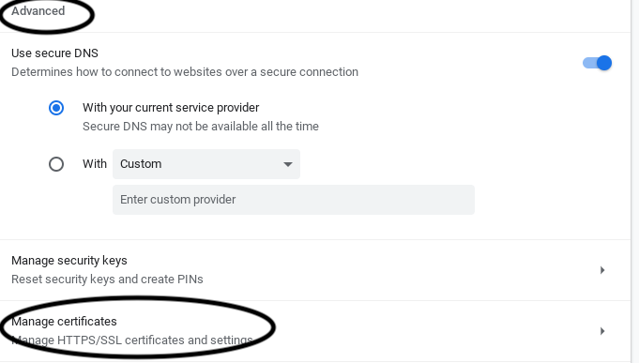

.
Step 5: Click the AUTHORITIES (tab)
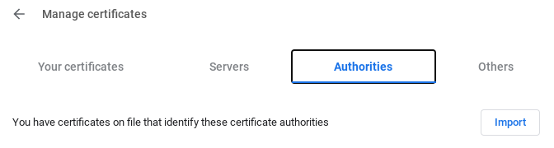

.

Step 6: Click IMPORT


Step 7: Navigate to the folder you downloaded the above files to, then change the drop down to: All files (found in lower left corner of page)
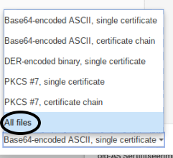

Step 8: Select RootCert5.p7b, then click OPEN
NOTE: Install the files in this order:
RootCert5.p7b,
RootCert4.p7b,
RootCert3.p7b,
RootCert2.p7b,
and finally AllCerts.p7b
by selecting each and clicking OPEN
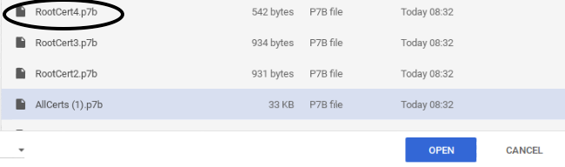

Step 9: Check all three boxes under Trust settings, click OK
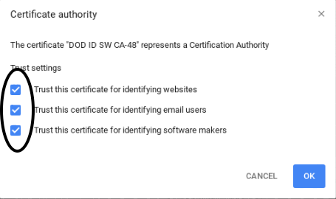

Step 10: Install the other files you downloaded by going back to IMPORT

Step 11: Repeat steps 7, 8, & 9 for each of the downloads
Reminder to OPEN in this order:
RootCert4.p7b,
RootCert3.p7b,
RootCert2.p7b,
and finally AllCerts.p7b by selecting each and clicking OPEN
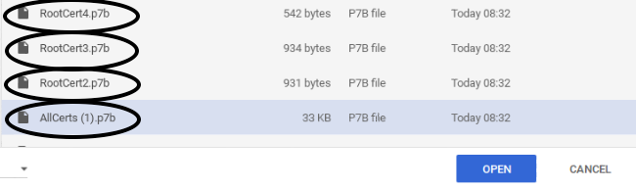

Step 12: To verify all certificates installed… Stay in the AUTHORITIES (tab), scroll down to org-U.S. Government, the certificates listed below should be there:,
DOD EMAIL CA-33 through DOD EMAIL CA-34,
DOD EMAIL CA-39 through DOD EMAIL CA-44,
DOD EMAIL CA-49 through DOD EMAIL CA-52,
DOD EMAIL CA-59,
DOD EMAIL CA-62 through DOD EMAIL CA-65,
DOD ID CA-33 through DOD ID CA-34,
DOD ID CA-39 through DOD ID CA-44,
DOD ID CA-49 through DOD ID CA-52,
DOD ID CA-59,
DOD ID CA-62 through DOD ID CA-65
DOD ID SW CA-35 through DOD ID SW CA-38,
DOD ID SW CA-45 through DOD ID SW CA-48,
DoD Root CA 2 through DoD Root CA 5,
DOD SW CA-53 through DOD SW CA-58,
DOD SW CA-60 through DOD SW CA-61

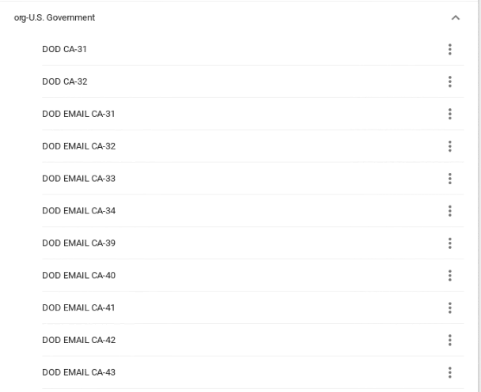

Step 13: All of the DOD certificates are now installed, the next step is to get the Opensc middle-ware working:

First, change to your home directory:
$ cd ~
Next, type:
$ modutil -dbdir sql:.pki/nssdb/ -list
You should get something similar to the result below:
modutil -dbdir sql:.pki/nssdb/ -list
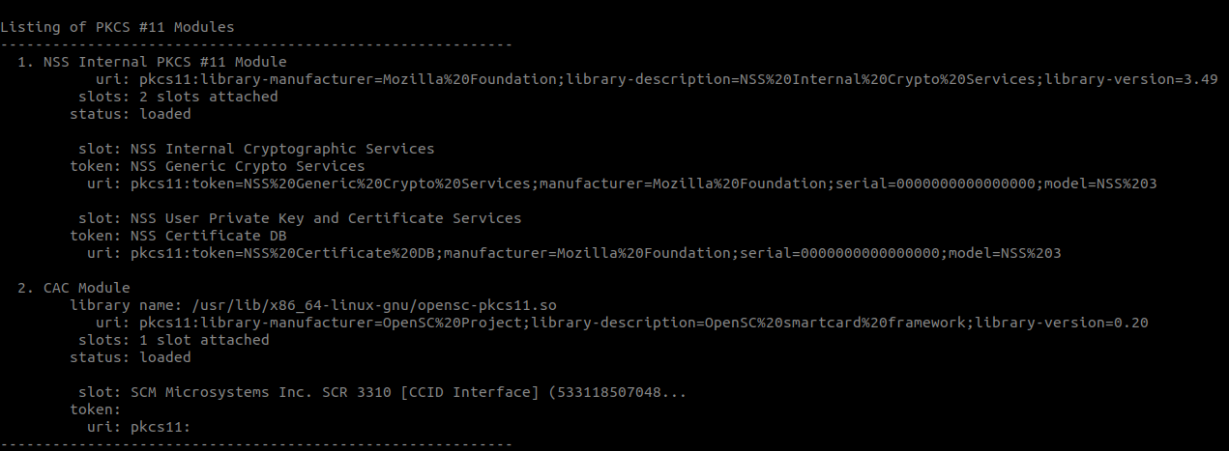
Now type:
$ modutil -dbdir sql:.pki/nssdb/ -add "CAC Module" -libfile /usr/lib/x86_64-linux-gnu/pkcs11/opensc-pkcs11.so

modutil -dbdir sql:.pki/nssdb/ -add "CAC Module" -libfile /usr/lib/x86_64-linux-gnu/pkcs11/opensc-pkcs11.so

This should add the CAC reader module, and now typing
$ modutil -dbdir sql:.pki/nssdb/ -list
modutil -dbdir sql:.pki/nssdb/ -list

should return the results:
If your card is inserted, the PKCS #11 Module 2 should also display information about your CAC Card.

