You should be able to access most CAC enabled websites.

Step 1: Download these 5 DoD certificate files to your computer
AllCerts.p7b,
RootCert2.p7b,
RootCert3.p7b,
RootCert4.p7b
RootCert5.p7b

Step 2: Install the certificates in Chrome, select the 3 dots (top right of web browser), select Settings
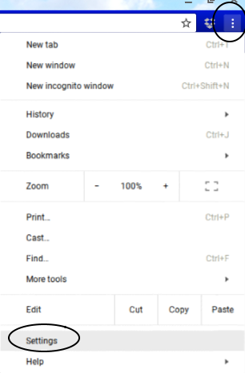

.
Step 3: Scroll down to Privacy and security, then select Security
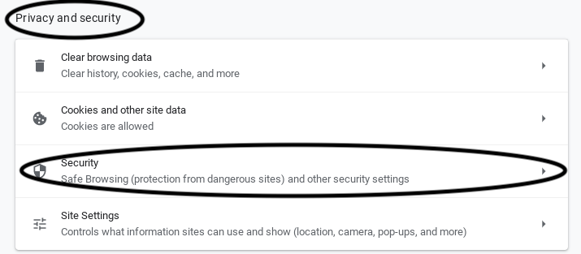

Step 4: Scroll down and click on Manage certificates under Advanced
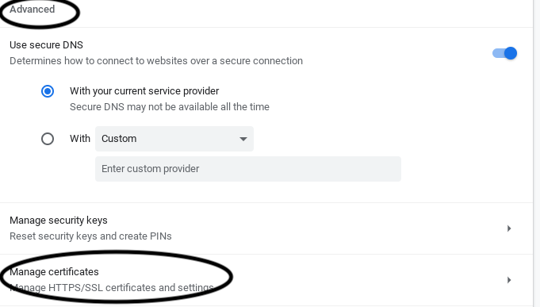

.
Step 5: Click the AUTHORITIES (tab)
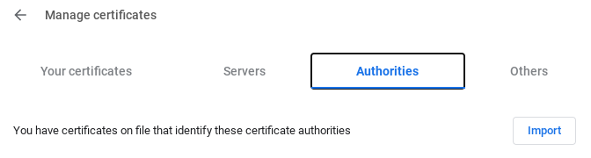

.

Step 6: Click IMPORT


Step 7: Navigate to the folder you downloaded the above files to, then change the drop down to: All files (found in lower left corner of page)
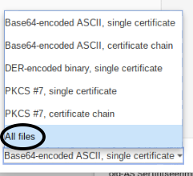

Step 8: Select RootCert5.p7b, then click OPEN
NOTE: Install the files in this order:
RootCert5.p7b,
RootCert4.p7b,
RootCert3.p7b,
RootCert2.p7b,
and finally AllCerts.p7b
by selecting each and clicking OPEN
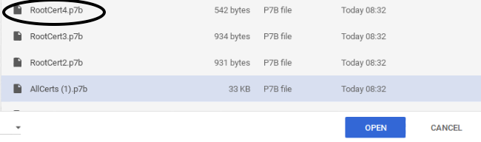

Step 9: Check all three boxes under Trust settings, click OK
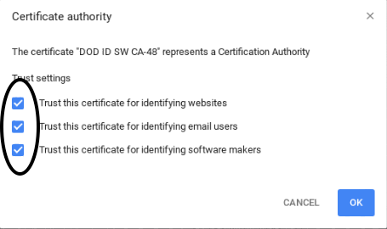

Step 10: Install the other files you downloaded by going back to IMPORT

Step 11: Repeat steps 7, 8, & 9 for each of the downloads
Reminder to OPEN in this order:
RootCert4.p7b,
RootCert3.p7b,
RootCert2.p7b,
and finally AllCerts.p7b by selecting each and clicking OPEN
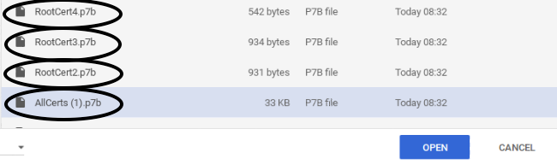

Step 12: To verify all certificates installed… Stay in the AUTHORITIES (tab), scroll down to org-U.S. Government, the certificates listed below should be there:,
DOD EMAIL CA-33 through DOD EMAIL CA-34,
DOD EMAIL CA-39 through DOD EMAIL CA-44,
DOD EMAIL CA-49 through DOD EMAIL CA-52,
DOD EMAIL CA-59,
DOD EMAIL CA-62 through DOD EMAIL CA-65,
DOD ID CA-33 through DOD ID CA-34,
DOD ID CA-39 through DOD ID CA-44,
DOD ID CA-49 through DOD ID CA-52,
DOD ID CA-59,
DOD ID CA-62 through DOD ID CA-65
DOD ID SW CA-35 through DOD ID SW CA-38,
DOD ID SW CA-45 through DOD ID SW CA-48,
DoD Root CA 2 through DoD Root CA 5,
DOD SW CA-53 through DOD SW CA-58,
DOD SW CA-60 through DOD SW CA-61

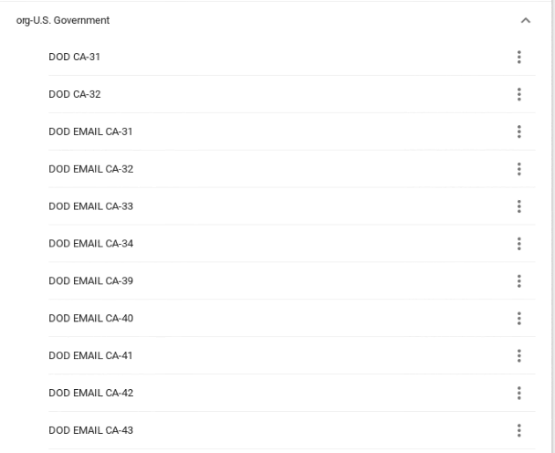

Step 13: All of the DoD certificates are now installed, the next step is to install CACKey Smart Card Middleware.
?? Using OpenSC? Don’t need CACKey? ??

cd ~
modutil -dbdir sql:.pki/nssdb/ -add "CAC Module" -libfile /usr/lib/x86_64-linux-gnu/pkcs11/opensc-pkcs11.so

