WASABI AI
Visual Identity & Design System
00 HOW TO USE THIS DOCUMENT
Read this before anything else.
This is the Wasabi AI Visual Identity & Design System. It covers every visual decision — color, typography, illustration, imagery, layout, and surface-specific rules. It does not cover brand voice or messaging — that is a separate Brand Voice Guide document.
This document is for designers, developers, social media managers, agency partners, and anyone creating anything visual under the Wasabi name. If you are making something that will be seen by the outside world, this document governs how it looks.

The golden rule
- Every design decision should feel: premium but accessible, ambitious but grounded, modern but deeply human.
- When in doubt, use less. More white space. Fewer colors. Simpler layouts.
- The brand is not built by using every element at once. It is built by using the right element with restraint.
01 COLOR SYSTEM
Five colors. Each with a specific role. Use them with intention, not decoration.
The Primary Palette
Deep Forest Dark  #11241F  RGB 17, 36, 31  Dark backgrounds, headings on light | Wasabi Green  #2D6A4F  RGB 45, 106, 79  Primary brand color. Dominant. | Soft Terracotta  #E5784A  RGB 229, 120, 74  Accent only. Use sparingly. | Warm Cream  #FFF4E3  RGB 255, 244, 227  Background base. Most surfaces. | White  #FFFFFF  RGB 255, 255, 255  Text on dark. Clean space.

Color Roles — What Each Color Does
- Deep Forest Dark #11241F
- Wasabi Green #2D6A4F
- Soft Terracotta #E5784A
- Warm Cream #FFF4E3
- White #FFFFFF

Approved Color Combinations
These are the only combinations approved for use. Do not invent new combinations.

Preview | Combination | Use For | Status
Aa  Sample text | Cream + Dark text | All body copy, website pages, brochure body | ✓ APPROVED
Aa  Sample text | Cream + Green text | Headings, key statements, section labels | ✓ APPROVED
Aa  Sample text | Green + White text | Primary buttons, section headers, callout blocks | ✓ APPROVED
Aa  Sample text | Forest Dark + White | Dark sections, impact stats, quotes, covers | ✓ APPROVED
Aa  Sample text | Forest Dark + Cream text | Elevated dark sections with warmth | ✓ APPROVED
Aa  Sample text | Terracotta + White | Single accent CTA or highlight only | ✓ APPROVED
Aa  Sample text | White + Dark text | Digital body copy, slides body text | ✓ APPROVED
Aa  Sample text | Cream + Terracotta text | Accent quotes, highlighted numbers only | ✓ APPROVED
Aa  Sample text | Green + Terracotta | Never use together as text/bg combination | ✗ AVOID
Aa  Sample text | Terracotta + Green | Never — too much visual conflict | ✗ AVOID
Aa  Sample text | Forest Dark + Green text | Avoid — insufficient contrast for body text | ✗ AVOID

Terracotta Rules — Read Carefully
Terracotta is an accent, not a theme
- Maximum one terracotta element per page or screen.
- Never use terracotta as a background for large areas.
- Never place terracotta next to Wasabi green as equal elements — one must be dominant.
- Terracotta works best on cream backgrounds or dark backgrounds. Never on white alone.
- When terracotta appears, everything else should be quiet. It is a spotlight, not ambient lighting.

Color Usage by Surface
SURFACE | COLOR GUIDANCE
Website | Cream background throughout. Green for nav, CTAs, section accents. Forest dark for footer. Terracotta for one key CTA per page only.
Social Media | Alternate between cream and forest dark as card backgrounds. Green for type highlights. Terracotta for one accent element per post. Never use all five colors in one post.
Presentations / Decks | Forest dark for title slides and section dividers. Cream for content slides. Green for headlines and key data. Terracotta for the single most important number or statement on any given slide.
Brochures / Print | Cream as base — never pure white in print. Green for all headings. Forest dark for pull sections. Terracotta used maximum twice across a full brochure.
Email Newsletters | White or cream background. Green for header band. Dark text for body. Single green CTA button. No terracotta in email — it renders unpredictably across clients.
Event Materials / Banners | Forest dark or green as dominant background. White or cream text. Terracotta for one accent element. High contrast always — these are read from distance.
02 TYPOGRAPHY SYSTEM
Two fonts. Every size defined. No improvisation.
The Two Fonts
DISPLAY / HEADLINES  Cormorant Garamond  Serif · Variable · Google Fonts (Free)  Character. Confidence. Gravitas. Carries the weight of what Wasabi believes. Every major headline is set in Cormorant. |  | BODY / INTERFACE  DM Sans  Sans-serif · Variable · Google Fonts (Free)  Clean. Readable. Gets out of the way. Carries all body copy, UI text, captions, and supporting information.

Typography Scale — Complete Reference
All sizes shown in points (pt) for print and pixels (px) for digital. Line height shown as multiplier.

Level | Font & Style | Size | Color | Line Height | Use For
Display | Cormorant Garamond Bold | 60–72pt / 64–80px | Forest Dark or Green | 1.1× | Cover headlines, hero statements, campaign taglines
H1 | Cormorant Garamond SemiBold | 40–48pt / 48–56px | Forest Dark or Green | 1.15× | Page titles, section openers, brochure chapter heads
H2 | Cormorant Garamond Regular | 28–32pt / 36–40px | Forest Dark or Green | 1.2× | Sub-section titles, slide headers, card headings
H3 | DM Sans Bold | 18–20pt / 22–24px | Forest Dark or Black | 1.3× | Sub-headings within sections, feature titles, sidebar labels
H4 | DM Sans SemiBold | 14–16pt / 18–20px | Black or Green | 1.35× | Card labels, table headers, caption titles, tag labels
Body L | DM Sans Regular | 12–13pt / 16–18px | Black (#1A1A1A) | 1.6× | Long-form reading: brochures, website paragraphs, reports
Body M | DM Sans Regular | 10–11pt / 14–16px | Black or Gray | 1.55× | Standard body copy: presentations, email, social captions
Body S | DM Sans Regular | 9–10pt / 12–14px | Gray (#6B6B6B) | 1.5× | Captions, footnotes, metadata, legal text
Label | DM Sans Bold, ALL CAPS | 8–9pt / 10–12px | Green or Gray | 1.4× | Section tags, category labels, eyebrow text above headlines
Quote | Cormorant Garamond Italic | 22–28pt / 28–36px | Green or Forest Dark | 1.3× | Pull quotes, testimonials, key philosophical statements
Stat / Number | Cormorant Garamond Bold | 48–72pt / 56–80px | Green or Terracotta | 1.0× | Impact numbers, impact metrics, data highlights

Typography Rules

✓ DO  - Use Cormorant Garamond for all major headlines — always.  - Use DM Sans for all body copy, UI text, and anything below H3.  - Set headline letter-spacing slightly tight (–0.02em to –0.04em) for large display text.  - Set body copy letter-spacing at 0 or very slightly positive (+0.01em).  - Keep body text left-aligned. Headlines can be centered only on cover/hero layouts.  - Use sentence case for most headlines. ALL CAPS only for labels and eyebrow text.  - Keep maximum line length to 70–75 characters for comfortable reading.  - When a headline runs more than two lines, reduce the size — never let it become a paragraph. |  | ✗ DON'T  - Never use any font other than Cormorant Garamond and DM Sans.  - Never center-align body paragraphs.  - Never use bold DM Sans as a headline replacement for Cormorant.  - Never set body copy below 10pt / 12px — unreadable for many audiences.  - Never stack two Cormorant elements without DM Sans between them.  - Never use light-weight DM Sans (100/200) — insufficient contrast on cream.  - Never use decorative, script, or display fonts from other families.  - Never stretch or condense letterforms — let the font breathe naturally.

Typography on Different Backgrounds
Cream background | Headings in Forest Dark or Green. Body in Black (#1A1A1A). Labels in Green. Pull quotes in Green. Never use gray body text on cream — insufficient contrast.
Forest Dark background | All text in White or Cream. Accent text in Terracotta for one element only. Never use Green text on Forest Dark — contrast too low for body copy.
Green background | Text in White. Subtext in Cream. This is a high-impact background — use sparingly for key callout blocks only.
White background (digital) | Headings in Forest Dark. Body in Black. Labels in Green. Same rules as cream — white is functionally equivalent in digital context.
03 ILLUSTRATION & IMAGE SYSTEM
Four distinct visual styles. Each has a specific job. Use the right one for the right moment.
Wasabi's visual language is built around one consistent thread: the hand-drawn single line. Whether it connects real photographs, outlines a person, sketches a scene, or forms a concept — the line is always present, always human, always continuous. This line is our visual signature. It represents the connection between people, between ideas, and between where someone is now and what they can become.

STYLE 01 REAL PHOTO + FLOWING LINE CONNECTION
Real photographs of Bharat people, cut into organic blob shapes, connected by a single continuous flowing hand-drawn line.
USE WHEN:
- Hero moments and primary visual statements
- Brochure covers and opening spreads
- Website hero sections and landing pages
- Impact pages showing real reach across geographies
- Annual reports and partnership decks — the opening visual
NOT FOR:
- Social media posts — too complex at small sizes
- Email headers — does not scale down well
- Diagrams or process explanations
SURFACES:
Brochure covers · Website hero · Large-format print · Partnership presentation openers
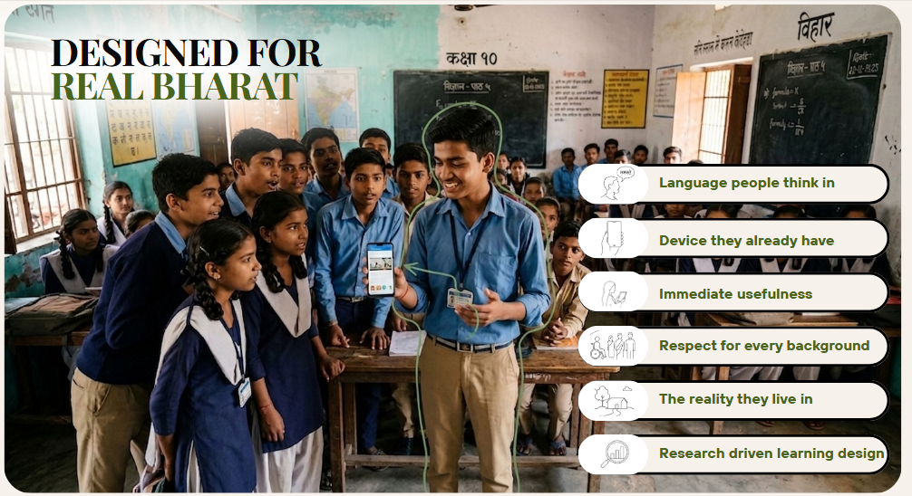
STYLE 02 REAL PHOTO + LINE OUTLINE / AURA
A real photograph with a loose hand-drawn line traced around the subject — like someone circled them with purpose.
USE WHEN:
- Spotlight moments — featuring a specific person or story
- Testimonials and the Wasabi Moment narrative
- Case studies where one individual is the focus
- Social media posts featuring a featured builder or student
- Pull-quote designs where the person behind the quote matters
NOT FOR:
- Group scenes — the outline works for single subjects
- Abstract concepts that have no human anchor
- Headers or backgrounds — too busy at scale
SURFACES:
Social media spotlight cards · Testimonial pages · Individual story features

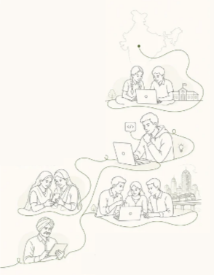


STYLE 03 PURE LINE ILLUSTRATION
No photographs. Clean single-line sketched characters in context — maps, skylines, people at devices, community scenes.
USE WHEN:
- Diagrams and process flows — the Wasabi capability loop, program structure
- Ecosystem maps — showing how programs connect
- Infographics where data needs a human visual anchor
- Slide decks where photography is unavailable or inappropriate
- App UI illustrations and empty-state graphics
- Report sections explaining methodology or structure
NOT FOR:
- Hero visuals — does not carry enough emotional weight alone
- Any context where real human presence is needed
- Dense layouts — these illustrations need room to breathe
SURFACES:
Presentation decks · Program brochure internals · Website diagrams · App UI · Reports

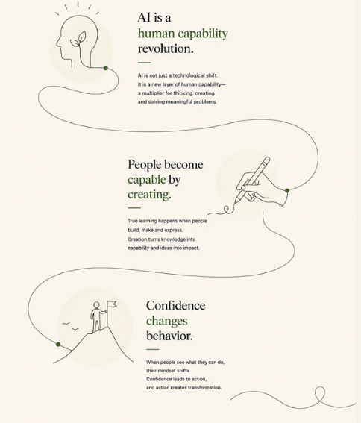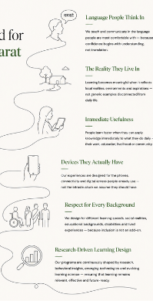
STYLE 04 SINGLE CONCEPT ILLUSTRATION
One continuous line that becomes a meaningful image — a head with a leaf, a hand writing, a person on a summit. Philosophical and meditative.
USE WHEN:
- Belief and philosophy pages — What We Believe, Why This Matters
- Section openers for a single big idea
- Pull-quote visual companions
- Moments in the brochure where the brand needs to slow down and breathe
- Social media posts that carry a philosophical message
NOT FOR:
- Data-heavy pages — too quiet for information density
- Program feature pages — needs action, not contemplation
- Any context requiring group or diversity representation
SURFACES:
Brochure philosophy pages · Social media belief posts · Brand film stills · Deck section dividers

Photography Direction — Real Images
When using real photographs across any Wasabi surface, these rules apply without exception.

✓ DO  - Real students, real classrooms, real workshops — actual Wasabi environments wherever possible.  - People mid-action: building, presenting, looking at a screen with genuine expression.  - Diversity that reflects real Bharat geography — not just urban, not just metropolitan.  - Equal representation of boys and girls across all materials.  - Images that capture genuine emotion — curiosity, concentration, excitement, pride.  - Desaturate images slightly (10–15%) when compositing with the color palette.  - Use organic blob masking (Style 1 and 2) rather than rectangular crops wherever possible.  - Show devices people actually have — phones, low-cost laptops, shared screens. |  | ✗ DON'T  - Never use generic stock photography of people who look nothing like Bharat.  - Never use sci-fi AI imagery — robotic hands, holograms, circuit-board aesthetics.  - Never use images that feel staged or performative — authenticity is non-negotiable.  - Never use images of only urban, English-speaking, clearly elite environments.  - Never use images where the technology is the hero — the human must always be.  - Never use rectangular crops when organic masking is possible.  - Never use images without clearing rights for all intended platforms.
04 LOGO USAGE

The Wasabi Logo
The Wasabi AI logo consists of two elements: the Wasabi mark (the interlocking circular symbol) and the wordmark (Wasabi AI in text). These two elements must always appear together unless specific alternate usage has been approved. The logo design itself is fixed — it does not change across applications. What changes is the color version used.

Approved Logo Versions
Primary — Green on Cream | The default version. Use on all cream and white backgrounds. This is the logo in its most natural state.
Reversed — White on Green | Use when the logo sits on a Wasabi green background. Button headers, green sections.
Reversed — White on Forest Dark | Use when the logo sits on Forest Dark backgrounds. Footer, dark hero sections, event backdrops.
Reversed — Cream on Forest Dark | An elevated alternative to pure white on dark. Slightly warmer.
Single Color — All Green | For single-color print applications, embroidery, stamps, or when full color is unavailable.
Single Color — All White | For light-on-dark single-color applications only.

Clear Space
The logo must always have clear space around it equal to the height of the Wasabi mark symbol. Nothing — no text, no image, no graphic element — may enter this zone. This applies on every surface.

Minimum Size
Digital: Never smaller than 120px wide. Print: Never smaller than 30mm wide. Below this, the mark becomes illegible.

✓ DO  - Use the correct color version for the background it sits on.  - Maintain clear space on all four sides equal to the symbol height.  - Use the logo file provided — never recreate it manually.  - Use the logo at full opacity always.  - Place the logo in a position of hierarchy — top left or top center on most layouts. |  | ✗ DON'T  - Never change the logo colors outside the approved versions.  - Never stretch, squish, rotate, or distort the logo in any direction.  - Never add drop shadows, glows, outlines, or effects to the logo.  - Never place the logo on a busy photographic background without a solid color pad.  - Never use the wordmark alone without the symbol mark.  - Never use the terracotta color for the logo — ever.  - Never place the logo on a terracotta background.  - Never recreate the logo in a different font.
05 LAYOUT, SPACING & GRID
The invisible system that makes everything feel intentional.
The Core Layout Principle
Wasabi designs breathe. White space — or cream space — is not emptiness. It is confidence. Crowded layouts signal insecurity. Restrained layouts signal authority. When in doubt, remove something rather than add something.

Grid System
- Print / Brochure
- Website / Digital
- Presentations
- Social Media

Spacing Scale
Use these spacing values consistently. Do not invent intermediate values.

Name | Value (Digital / Print) | Use For
XS | 8px / 2mm | Between a label and its value, between icon and text
S | 16px / 4mm | Between list items, between small related elements
M | 24px / 6mm | Between paragraph and subheading, between card elements
L | 40px / 10mm | Between sections within a page, between major content blocks
XL | 80px / 20mm | Between major page sections, generous breathing space
XXL | 120px / 30mm | Between chapter-level sections, hero section padding
06 SURFACE-SPECIFIC DESIGN RULES
The same system, applied differently across each context.
Website
Website design rules
- Navigation: Forest dark or white background. Logo top left. Links in DM Sans Medium. One green CTA button maximum in the nav.
- Hero section: Full-width. Style 1 illustration (photo + flowing line) or a powerful Cormorant headline on cream. Single CTA button in green.
- Section backgrounds: Alternate between cream and forest dark as you scroll. Never two consecutive forest dark sections.
- Buttons: Primary = Green fill, white text. Secondary = Green outline, green text. Never terracotta for a secondary action.
- Cards: Cream background, thin green-mid border, generous internal padding (L spacing minimum). One card should breathe.
- Footer: Forest dark background. White and cream text. Logo reversed to white. Green for link hover states.

Social Media
Social media design rules
- Every post must be legible in 2 seconds. One idea per post. One visual hierarchy.
- Use a consistent card template — same margins, same font sizes, same logo placement for your brand series.
- Alternate backgrounds across your feed: cream, forest dark, green. Never same background in consecutive posts.
- The Wasabi logo appears on every post. Bottom right, small, consistent position.
- Terracotta used maximum once per post — for a number, a word, or a border element. Never as background.
- Captions in DM Sans. Stories can use larger Cormorant headlines for impact moments.
- Reels and video: First frame must be as designed as a still post. The thumbnail is the brand.

Presentations & Decks
Presentation design rules
- Title slide: Forest dark background. Cormorant headline in white or cream. Logo in white. One sentence. No more.
- Section divider slides: Green background. White Cormorant headline. Nothing else.
- Content slides: Cream background. H2 in Forest dark or Green. Body in DM Sans. Maximum 5 lines of body copy per slide.
- Data slides: Big numbers in Cormorant Bold, green or terracotta. Label in DM Sans Label style. One chart maximum per slide.
- Do not use PowerPoint default themes, templates, or clipart at any point.
- Slide transitions: None or a simple fade. Never kinetic or decorative transitions.
- Consistent left margin of approximately 10% on all content slides.

Brochures & Print
Brochure design rules
- Always design at 300dpi minimum for print.
- Use CMYK color values. Conversion: Green #2D6A4F = C:75 M:30 Y:62 K:17. Forest Dark #11241F = C:80 M:50 Y:68 K:70. Terracotta #E5784A = C:0 M:58 Y:72 K:0. Cream #FFF4E3 = C:0 M:3 Y:11 K:0.
- Paper: Uncoated or silk-coated stock preferred. Cream or natural white — not bright white.
- Each page: one dominant visual, one headline, supporting body. Never more than two visual elements competing.
- Bleed: 3mm bleed on all sides. Safe zone: 5mm from trim edge for all critical content.
- Style 1 illustration (photo + flowing line) for opening spreads. Style 3 or 4 for internal philosophy pages.
07 GLOBAL DESIGN DON'TS
These apply everywhere, always, without exception.

Things that will never appear in Wasabi design
- Gradient fills on backgrounds — flat colors only.
- Drop shadows on text.
- Decorative borders or ornamental dividers.
- Clip art, emoji used as design elements, or cartoon-style graphics.
- Comic Sans, Papyrus, or any font outside the approved two.
- Text over a busy photograph without a solid color overlay.
- Busy, complex backgrounds behind body text.
- More than three fonts, sizes, or colors on a single layout.
- Terracotta used as a primary or dominant color on any surface.
- Neon colors, electric hues, or anything that reads as gaming or hype culture.
- Stock imagery of generic global people that do not represent Bharat.
- Robotic, futuristic, or sci-fi AI imagery of any kind.
- Justified text alignment (creates uneven spacing in body copy).
- Underlined text used for anything other than hyperlinks.
- Text in all-caps for anything longer than a four-word label.
- Overcrowded layouts — if it feels full, remove something.
08 QUICK REFERENCE CARD
The essentials on one page. Print this and pin it up.

COLORS  Forest Dark #11241F — Dark backgrounds  Wasabi Green #2D6A4F — Primary brand  Terracotta #E5784A — Accent only, 1× per page  Warm Cream #FFF4E3 — Base background  White #FFFFFF — Text on dark, utility  TYPOGRAPHY  Headlines → Cormorant Garamond  Body / UI → DM Sans  Display: 60–72pt H1: 40–48pt H2: 28–32pt  H3: 18–20pt (DM Sans Bold)  Body L: 12–13pt Body M: 10–11pt |  | ILLUSTRATION STYLES  Style 1 — Photo + Flowing Line → Hero moments  Style 2 — Photo + Outline Aura → Spotlight stories  Style 3 — Pure Line Illustration → Diagrams, decks  Style 4 — Single Concept Illustration → Philosophy pages  GLOBAL RULES  One idea per layout  One terracotta element per page max  Real people, real Bharat, always  White space is confidence  When in doubt — remove, don't add  Cormorant for gravitas, DM Sans for clarity

WASABI AI · Visual Identity & Design System · Version 1.0
Questions about this document? Contact the Wasabi team before making any design decisions not covered here.

