PolyMarker Analytics
Complete Project Guide

A scalable big-data architecture for multi-biomarker clustering, symptom correlation and functional-range discovery in unstructured health records.

Prepared for: Riya Pataskar
Repository: github.com/SonicVortex408/careflow (branch main)
Live deployment: Vercel (frontend) · Modal (backend, AI service, jobs) · Supabase (database, file storage)
Date: 30 September 2026

Important: All population-level data in this project is synthetic. Every cluster, functional range, percentile and risk score is derived from synthetic data, for research/demo purposes, and is not clinical guidance. PolyMarker does not diagnose.
Contents

If the contents list appears empty, right-click it in Word and choose Update Field (LibreOffice: Tools → Update → Update All).

1. What PolyMarker is
PolyMarker Analytics (formerly careFlow / LabLens) is a web application that turns thyroid and micronutrient lab reports into plain-language insight that a clinician has reviewed. A patient uploads a lab report (PDF, scan, photo or text file), records how they have been feeling, and, once a clinician has checked and signed off the automated interpretation, sees their results explained: where each value sits against the lab's range and a data-derived "functional" band, how their pattern compares with a (synthetic) population, which symptoms their pattern is associated with, and what to ask at their next appointment.
It is also a big-data engineering project. Behind the web app sits an offline analytics engine that generates and processes a 50,000-patient synthetic data lake with Spark or DuckDB. It clusters patients, discovers functional ranges, trains calibrated symptom-risk models with explanations, and publishes versioned model files that the live service uses.

1.1 Scope
Area | What is covered
Biomarkers (9) | TSH, Free T3, Free T4, Anti-TPO (thyroid antibodies), Vitamin D (25-OH), Vitamin B12, Ferritin (iron stores), Magnesium, Zinc
Symptoms / PROMs (3) | Tiredness (fatigue severity 1–10), brain-fog frequency (never … always), hair loss (none … severe)
Users (3 roles) | Patient, Clinician, Admin
Formats read | Text PDFs, scanned/image PDFs, PNG/JPG photos, plain text; 5 lab label styles; conventional and SI units

1.2 What it is not
- It is not a diagnostic device. It never names a diagnosis, never gives a dose and never tells anyone to start or stop a medicine. These rules are enforced in code, not only in prompts.
- It has not been validated on real patients. All population statistics come from synthetic data (see Section 18, Limitations).
- No automated interpretation reaches a patient until a clinician approves it.

1.3 The four design principles
- Clinician in the loop. Every interpretation is stored as "pending clinician review"; the patient sees nothing until a clinician approves, edits or rejects it.
- The AI is never the last step. Anything an AI model writes passes deterministic safety checks (guardrails). Failing drafts are regenerated, then replaced with a safe template.
- Evidence is traceable. Every link in the knowledge graph carries its source and evidence level; unverified links are shown as unverified.
- Honest labelling. Anything derived from synthetic data says so in code, API responses and the user interface.

2. How it works: the journey of one lab report
This is what happens, step by step, when a patient uploads a report on the live site.
- Symptom check-in (optional but recommended). The patient rates tiredness 1–10 and picks brain-fog and hair-loss levels. The latest check-in is attached to every upload.
- Upload. The browser sends the file to the backend (POST /api/reports). The backend checks the file type (PDF, TXT, PNG, JPG; max 10 MB), stores the original in a private Supabase Storage bucket, and creates a report row in Postgres with status processing and an audit entry "uploaded".
- Job queued. The backend forwards the file to the AI service with a shared secret key. The AI service answers immediately with a job id (the patient is not kept waiting) and starts a background job on Modal.
- Reading the document (OCR). If the PDF has a text layer it is read directly. If it is a scan or photo, Tesseract OCR reads it and a column detector rebuilds the table rows. Each value gets a confidence score.
- Parsing and normalizing. A layout-tolerant parser finds each test name, value, unit and flag. Names are matched to the 9 markers (LOINC codes) even with typos or different lab wording; units are converted to SI (e.g. vitamin D ng/mL → nmol/L). Patient names are never extracted.
- Data-quality checks. Plausibility limits, decimal-point misreads, z-score and IQR outliers, duplicates and missing units are flagged for the clinician.
- Analytics. Using the published model files: where each value sits against the lab range and the functional band, population percentile, cluster profile, and calibrated symptom-risk scores with SHAP "drivers".
- Evidence. The knowledge graph (Neo4j, or its identical in-memory copy) supplies evidence chains such as "low ferritin → associated with → fatigue", each with source and evidence level.
- Summary and guardrails. A plain-language summary is written (by an LLM if a key is configured, otherwise by a deterministic template) and then checked: no diagnosis, no prescribing or dosing, reading grade ≤ 8, disclaimer present, no leaked ids or injected instructions. Escalation rules set the priority (routine, priority, urgent).
- Waiting for review. The backend polls the job; when it completes the report becomes pending_clinician_review. The patient sees only a status message.
- Clinician review. The clinician sees the extracted values with confidence, quality warnings, escalation reasons, the summary and the audit trail, then approves, edits and approves, or rejects (a reason is required).
- Patient view. After approval the patient's dashboard shows gauges, a radar chart, a cohort map, symptom likelihood with drivers, evidence and appointment questions. The AI assistant can now use the approved results as context.
Note: Report statuses: processing → pending_clinician_review → approved | rejected. A report whose job fails or is lost becomes failed. Each transition is written to the report's audit trail, and each is applied at most once even if several requests arrive at the same moment.

3. Architecture
PolyMarker is a monorepo of six projects plus deployment and documentation. In production they run on three free-tier platforms.
Browser ──HTTPS──► Frontend (React, on Vercel)
│ VITE_API_BASE_URL
▼
Backend API gateway (Express, on Modal) ──► Supabase Postgres (users, reports, …)
│ X-Internal-Key ──► Supabase Storage (uploaded files)
▼
AI service (FastAPI + LangGraph, on Modal) ──spawn──► run_job (OCR + interpretation)
│ └─ job state in a modal.Dict
├── graph_service (knowledge graph: Neo4j or in-memory)
└── models/ (versioned artifacts) ◄── bda_engine (offline Spark / DuckDB)
common/ shared library: biomarker catalog, parser, OCR, normalizer, quality checks

3.1 Components
Component | Technology | Responsibility
frontend/ | React 18, Vite, Tailwind, Recharts | All screens for the three roles; talks only to the backend
backend/ | Node.js 22, Express 5, node-postgres | Sign-in and roles (JWT), reports, review workflow, symptoms, conversations, file storage; proxy to the AI service
ai-service/ | Python 3.11, FastAPI, LangGraph, Celery/Modal | OCR jobs, interpretation, inference, GraphRAG assistant, guardrails
common/ | Python library (no heavy deps) | Biomarker catalog, parser, OCR, normalizer, quality checks, feature building, shared by all Python projects
graph_service/ | Python, Neo4j driver | Knowledge-graph schema, seed data, loader, connector with in-memory fallback
bda_engine/ | Python, PySpark or DuckDB, scikit-learn, XGBoost, SHAP | Offline: synthetic data lake, ETL, features, clustering, functional bands, risk models, artifact export
models/ | JSON + XGBoost .ubj files | Versioned artifacts (1.0.0, seed 42) with a manifest, loaded by the AI service
evaluation/ | Python scripts, figures | Metrics for OCR, ETL, clustering, risk, bands, guardrails, assistant, retrieval
deploy/modal_app.py | Modal | Production deployment of backend, AI service and jobs

3.2 Key design decisions
Decision | Why
Postgres (Supabase) is the operational database; Parquet is the analytics lake | Free hosted Postgres + storage; clean separation of live data from the big-data lake
Ids are 24-hex strings | The AI service validates ids in this format before using them in any file path (prevents path traversal), and the guardrails redact them from text
Separate Python projects (uv) for bda_engine and graph_service | Keeps heavy Spark/XGBoost-training dependencies out of the live AI service image
Spark and DuckDB run the same SQL | Spark shows the horizontal-scaling path; DuckDB is faster at this size and used for development and CI
Tesseract by default; PaddleOCR and LayoutLMv3 behind flags | Tesseract installs cleanly; the others pull very large packages
Versioned model files + manifest, no MLflow | One fewer service to run; the loading path would not change if MLflow were added
Guardrails are deterministic and run last | Safety must not depend on the LLM behaving
Retrieval filters enforced in code | Internal and draft knowledge-base pages can never be returned, whatever the prompt says
LLM provider chosen by environment variable and created lazily | The service starts and works without any AI key
Single frontend API client reading VITE_API_BASE_URL | No hard-coded server addresses; CI fails if one is reintroduced

4. The three user roles
Role | How the account is created | What they can do | What they cannot do
Patient | Self-registration on the site | Symptom check-in; upload reports; see status; see approved results (My results, My reports); AI assistant; edit profile (sex, birth year, name); delete own reports | See anything before a clinician approves; see other patients' data; open review, analytics or admin pages
Clinician | Created by an admin, or by the seed command | Review queue (sorted urgent → priority → routine); Escalations; open a report with values, confidence, quality warnings, escalation reasons, audit trail; approve, edit & approve, or reject (with reason); cohort analytics; AI assistant | Upload reports; manage clinicians
Admin | Seed command only (no public sign-up) | Create and list clinicians; review queue; cohort analytics | Admins are a separate account type: a clinician password does not work on the Admin tab
The login page has three tabs (Patient, Clinician, Admin). The database, not the sign-in token, decides a user's role on every request.
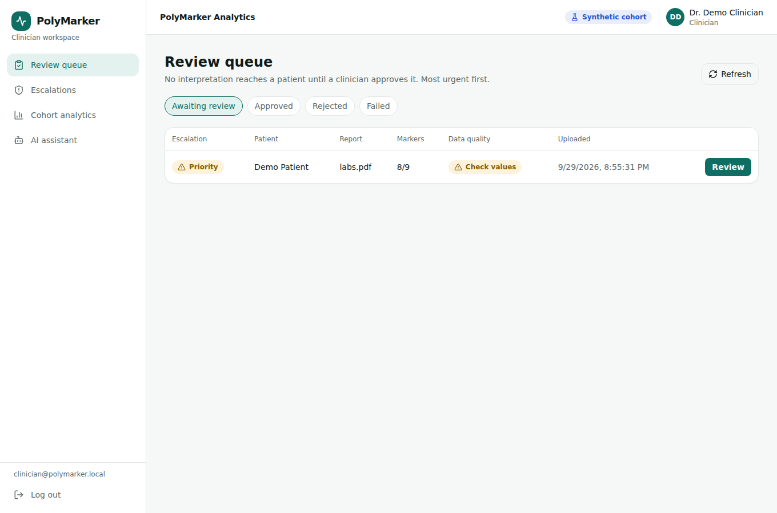
Clinician review queue, sorted by escalation level

5. Repository tour: every folder explained
This section walks through everything you get when you download the repository (Code → Download ZIP on GitHub, or git clone).

5.1 Top level
Path | What it is
README.md | Project overview, quick start, 4-V big-data framing, 14-week plan status, test counts, safety model
docker-compose.yml | Runs the whole stack locally: Postgres, Redis Stack, Neo4j, AI service, Celery worker, backend, frontend, plus optional bda (ml profile) and graph-seed / seed one-offs
.env.example | Template for local secrets (JWT secret, internal key, demo passwords, optional Groq key)
.github/workflows/ci.yml | Continuous integration: 8 jobs run on every push and pull request (Section 15)
deploy/modal_app.py | Production deployment on Modal (Section 13)
.dockerignore, .gitignore | Keep virtual environments, caches, data and secrets out of images and git
docs/ | Architecture, deployment guide, research mapping, presentation outline, audits, screenshots, this guide
testing/ | Manual test plan for the three roles and 9 sample lab reports (Section 15.3)

5.2 common/: the shared library (polymarker_common)
Used by the AI service, the analytics engine and the graph service so that a report is read identically everywhere.
File | Purpose
data/biomarkers.json | The catalog: for each of the 9 markers its LOINC code, display names, aliases (lab wordings and typos), units and conversion factors, lab reference range, plausible limits and escalation thresholds
catalog.py | Loads the catalog; escalation rule objects
normalizer.py | Maps a raw label to a marker (exact, alias, fuzzy) with a confidence; converts units to SI; cleans unit spellings
parser.py | Layout-tolerant parser for 4+ table layouts; handles flags between value and unit, decimal commas, detection limits; extracts age/sex/date/lab but never names
ocr.py | Text-layer extraction (pypdf), rasterising (pypdfium2) and Tesseract OCR with column detection; PaddleOCR and LayoutLMv3 hooks behind flags
quality.py | Data-quality checks: plausibility, decimal misread, z-score / IQR outliers, duplicates, completeness
features.py | Feature building shared by training and live inference (ratios, interactions, missingness flags)
proms.py | Symptom (PROM) schema and normalisation
pipeline.py | One call from file → structured extraction (used by the Spark batch OCR and the live service)
tests/ | 45 tests: parser, normalizer, OCR pipeline, quality

5.3 bda_engine/: the offline big-data engine
File / folder | Purpose
scripts/generate_synthetic_data.py | Generates 50,000 synthetic patients, 67,266 reports and 500,908 result rows across 5 labs with different labels, units and formats; injects typos, missing units, decimal misreads and duplicates; renders 500 PDFs in 4 layouts (35% as noisy scans); hides the true generator thresholds in a hold-out file that training never reads
schemas/ | Lake schema (raw → bronze → silver → gold) and the canonical report JSON schema
etl/engine.py, etl/lake.py | The same SQL on PySpark or DuckDB (ETL_ENGINE=spark|duckdb): bronze (typed raw), silver (normalised, de-duplicated, quality-flagged), gold (one feature row per patient)
etl/ocr_batch.py | Distributed OCR of the PDF set with Spark mapPartitions
features/build.py | Joint feature vectors: FT3/FT4 ratio, ferritin-to-TSH, TSH×FT4, deficit count, missingness flags, imputation
models/clustering.py | K-Means (k chosen by silhouette), Gaussian mixture (BIC), DBSCAN (density outliers)
models/functional_ranges.py | Spline-logistic functional-band discovery with bootstrap confidence intervals
models/risk.py | XGBoost per symptom + isotonic calibration + TreeSHAP explanations
models/export.py, pipeline.py | Writes versioned artifacts and manifest to models/; uv run bda all runs everything
tests/ | 13 tests including Spark-vs-DuckDB identical output

5.4 models/: the published model files
File | Contents
manifest.json | Version 1.0.0, seed 42, list of artifacts with hashes
population_stats_*.json | Percentiles per marker (for "where you sit in the cohort")
functional_bands_*.json | Discovered functional bands per marker, with confidence intervals
cluster_model_*.json, cohort_projection_*.json | Cluster centres and profiles; 2-D projection for the cohort map
risk_fatigue / risk_brain_fog / risk_hair_loss_*.ubj | Trained XGBoost models
risk_meta_*.json, feature_spec_*.json | Calibration maps, feature order, model metadata
correlations_*.json | Marker ↔ symptom and marker ↔ marker correlations (loaded into the graph as synthetic-derived)
training_report_*.json | Metrics recorded at training time

5.5 graph_service/: the knowledge graph
Neo4j schema (schema.cypher), generated seed (seed.cypher, seed_data.py) and a loader that also imports the synthetic-derived bands and correlations. Nodes include Biomarker, LOINC, FunctionalRange, Condition and Symptom; every relationship has source and evidence_level. The connector falls back to an in-memory copy of the same graph when Neo4j is not configured, so evidence chains are identical either way (a test asserts this). 10 tests.

5.6 ai-service/: the AI and processing service
Path | Purpose
app/main.py | FastAPI application factory
app/api/ocr.py | POST /api/ocr (upload → job id), GET /api/ocr/jobs/{id} (status/result), POST /api/interpret
app/api/inference.py | Cohort, bands, catalog, model info, and on-demand inference
app/api/chat.py | Assistant endpoint used by the backend
app/api/documents.py | Indexing of patient documents for the assistant
app/api/health.py | /health and /ready (reports job backend and graph backend status)
app/services/interpretation.py | The end-to-end pipeline for one report (Section 2, steps 4–9)
app/services/inference.py, model_registry.py | Loads models/ and computes bands, percentiles, cluster, risk and SHAP drivers
app/services/guardrails.py | Deterministic safety checks and escalation rules (Section 9)
app/services/summary.py | Template and LLM summaries with regeneration
app/services/evidence.py | Knowledge-graph evidence chains
app/services/jobs.py | Job backends: celery (Redis), modal (production), local (development/tests)
app/agent/ | LangGraph GraphRAG assistant: nodes, tools, prompts, state, checkpointer
app/retrieval/ | Knowledge-base retrieval (lexical, optional vector), per-patient index
app/core/ | Settings, lazy LLM construction, security (id validation, safe paths, internal key)
app/worker/ | Celery app and task implementations
knowledge_base/ | 13 reviewed patient-education pages (one per marker, symptoms, functional ranges, when to seek care) plus 2 internal/draft pages that retrieval must never return
tests/ | 43 tests (+3 live integration tests against real Redis, Celery and Neo4j)

5.7 backend/: the API gateway
Path | Purpose
src/app.js, server.js | Express app (helmet, CORS, JSON limits, rate limiting) and start-up (connect, migrate, check storage bucket, listen)
src/config/env.js, db.js | Environment settings; Postgres pool with TLS modes, transactions, migrations under an advisory lock, id generator
src/db/schema.sql | The 7 tables with constraints and indexes; row level security enabled
src/models/ | Small SQL repositories: User, Admin, Report, SymptomEntry, Conversation, Message, Document
src/controllers/ | Auth, admin, user, report, review, symptom, conversation, AI chat, document, insight
src/routes/ | URL routing per area (Section 12)
src/middleware/ | Auth (JWT → account + role), role checks, upload limits/types, error handling
src/services/ | AI-service client, report workflow (sync + serialisation), storage (Supabase Storage or local disk)
src/scripts/migrate.js, seed.js | Apply schema + create bucket; create admin/clinician/patient accounts from SEED_* settings
test/ | 18 tests against a real Postgres (fake AI service and fake Supabase Storage)

5.8 frontend/: the web interface
Path | Purpose
src/services/apiClient.js | The only place that talks to the server; reads VITE_API_BASE_URL
src/pages/Login.jsx, Register.jsx | Three-tab sign-in; patient registration
src/pages/patient/ | PatientDashboard (My results), LabUpload, SymptomIntake, MyReports, Profile
src/pages/clinician/ | ReviewQueue (also Escalations), ReviewDetail, CohortAnalytics
src/pages/admin/Clinicians.jsx | Create and list clinicians
src/pages/AIAssistant.jsx + components/assistant/ | Chat with conversation list and New chat
src/components/biomarkers/ | BiomarkerGauge, BiomarkerRadar, CohortScatter, RiskPanel, EvidenceList, InterpretationView
src/components/layout, shared/ | Header, role-based sidebar, badges, cards, dialogs, brand
src/__tests__/ | 14 tests (API client, biomarker helpers, components)

5.9 evaluation/
run_bda_eval.py (OCR, ETL, clustering, risk, bands) and run_ai_eval.py (guardrails, summaries, assistant, retrieval) regenerate results/*.json and figures/*.png. REPORT.md explains every number; cases/ holds the red-team, assistant and retrieval test cases.

5.10 docs/
File | Contents
ARCHITECTURE.md | Target architecture, diagrams, design decisions, environment variables, risks
DEPLOYMENT.md | Supabase → Modal → Vercel deployment steps
RESEARCH_MAPPING.md | How each of the 15 papers in the plan maps to code (Appendix A)
PRESENTATION.md | Slide-by-slide outline for the final presentation
CURRENT_STATE.md, DOMAIN_MISMATCH.md | The Step 0 audit of the original careFlow code and the "approve and adapt" dispositions (historical)
images/ | Screenshots from a live end-to-end run
PolyMarker_Project_Guide.docx | This document

6. The synthetic data lake
Real health records cannot be shared, so the project generates a realistic synthetic population with known hidden rules. This makes it possible to measure whether the pipeline recovers structure that is really there.
Item | Amount
Patients | 50,000 (40,049 with ≥ 7 markers and complete symptoms used for modelling)
Lab reports / result rows | 67,266 reports · 500,908 rows from 5 labs (4 CSV, 1 JSONL)
PDFs | 500 in 4 layouts; 168 rendered as scanned images with blur and skew
Injected noise | 4,862 label typos · 4,977 missing units · 1,430 decimal-point misreads · 2,371 duplicate rows
Hidden phenotypes | Replete, subclinical autoimmune thyroid, vitamin deficient, multi-micronutrient, mineral low, iron deficient, overt thyroid

6.1 The four Vs
V | Where it shows up
Volume | 50k patients, 0.5 M rows, 500 PDFs; partitioned Parquet lake; Spark ETL with an identical DuckDB path
Variety | 5 labs with different labels, units (conventional vs SI) and formats; decimal commas; detection limits; unstructured PDFs in 4 layouts; free-text symptom answers; a property graph
Velocity | Asynchronous job queue with status polling; about 0.4 s OCR per document; about 13 ms interpretation per report; Spark batch OCR
Value | Functional bands narrower than lab ranges, cluster profiles, calibrated symptom risk with SHAP drivers, evidence chains, clinician-reviewed summaries

6.2 ETL performance
Engine | bronze | silver | gold | total
DuckDB (1 node) | 1.9 s | 5.2 s | 0.9 s | 7.9 s
PySpark local[4] | 15.0 s | 43.0 s | 9.8 s | 67.8 s
At half a million rows Spark is about 8× slower because JVM start-up and shuffles dominate; it is kept because the same job runs unchanged on a cluster. Both engines produce identical tables (tested row for row).
Injected problem | Injected | Detected / handled
Duplicate rows | 2,371 | 2,371 removed
Missing units | 4,977 | 4,997 inferred (+20 unknown-unit rows)
Decimal misreads (×10) | 1,430 | 1,451 flagged
Label typos | 4,862 | 4,666 mapped by fuzzy matching (96.0%)

7. Reading reports: OCR, parsing and normalization
Subset | Docs | Character error | Word error | Field recall | Value accuracy
All | 500 | 0.18% | 0.79% | 99.0% | 97.7%
Text-layer PDFs | 332 | 0.00% | 0.00% | 100% | 100%
Scanned (Tesseract) | 168 | 0.55% | 2.35% | 97.1% | 93.1%
- By layout, value accuracy is 99.7% (colon-inline), 99.2% (pipe table), 96.2% (columns) and 95.6% (boxed grid).
- Metadata accuracy is 99.8% for sex, 100% for age and lab, and 99.4% for date. Patient names never appear in the output (0/500).
- 78% of wrongly read scanned values carry a low-confidence flag and are highlighted for the clinician. The other 22% are wrong with high confidence, which is why clinician sign-off, not OCR confidence, is the safety control.

7.1 Units and codes
Marker | Stored unit (SI) | Example conversion | Lab range used | Escalation thresholds
TSH | mIU/L | uIU/mL = mIU/L | 0.4–4.0 | <0.1 or >10 priority; >50 urgent
Free T4 | pmol/L | ng/dL × 12.87 | 10–23 | <5 or >50 urgent
Free T3 | pmol/L | pg/mL × 1.536 | 3.1–6.8 | >20 urgent
Anti-TPO | IU/mL | — | 0–35 | >500 priority
Vitamin D | nmol/L | ng/mL × 2.496 | 50–125 | <30 priority; >375 urgent
Vitamin B12 | pmol/L | pg/mL × 0.738 | 148–664 | <111 priority
Ferritin | ug/L | ng/mL = ug/L | 15–300 | <10 priority; >1000 urgent
Magnesium | mmol/L | mg/dL × 0.411 | 0.7–1.0 | <0.5 or >1.5 urgent
Zinc | umol/L | ug/dL × 0.153 | 9.2–18.4 | <7.6 priority

8. Machine learning and analytics

8.1 Clustering
Model | Groups | Silhouette | Davies–Bouldin | Agreement with hidden phenotype (ARI)
K-Means (k by silhouette) | 9 | 0.135 | 1.56 | 0.258
Gaussian mixture (BIC) | 8 | −0.018 | 11.9 | 0.117
DBSCAN | 1 + noise | — | — | —
Lab values overlap, so clusters are best read as profiles ("Low ferritin", "High anti-TPO", "Low free T4, high TSH" …) rather than disease groups. DBSCAN's 3.7% density outliers are clinically distinct: 56% report strong tiredness (vs 17%), making outlier detection a useful triage signal.
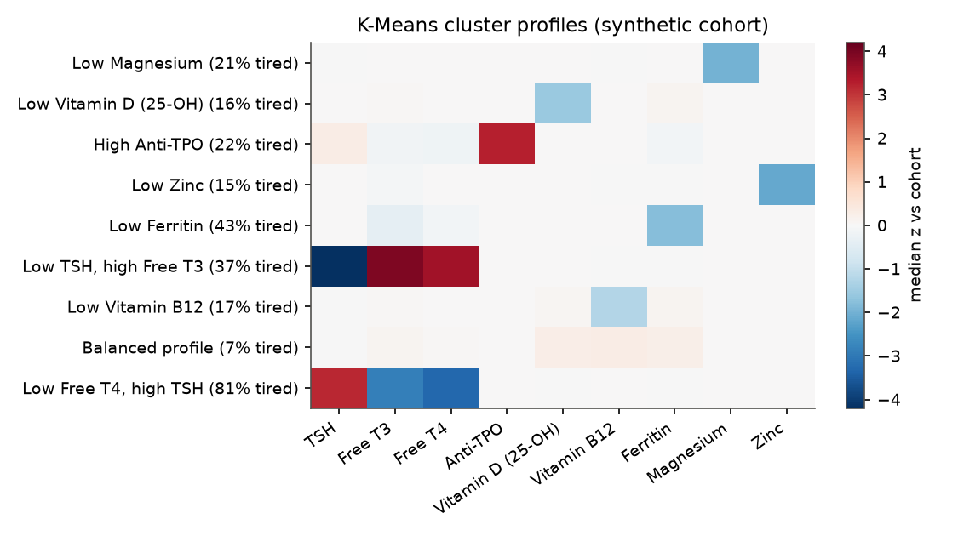
Cluster profiles (derived from synthetic data)

8.2 Symptom-risk models with explanations
Target | Prevalence | AUROC | AUPRC | Calibration error (ECE) | Linear baseline AUROC
Strong tiredness (≥ 7/10) | 18.5% | 0.81 | 0.59 | 0.012 | 0.78
Frequent brain fog | 24.1% | 0.69 | 0.48 | 0.012 | 0.67
Noticeable hair loss | 22.1% | 0.74 | 0.52 | 0.016 | 0.72
XGBoost per symptom, calibrated with isotonic regression and tested on a separate 15% split (6,008 patients). SHAP shows each patient's drivers (e.g. tiredness → ferritin, TSH, B12), and the live service computes the same values.
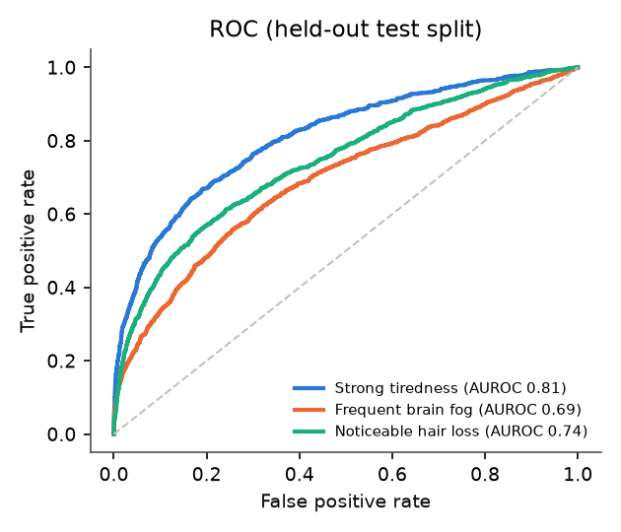
ROC curves for the three symptom models
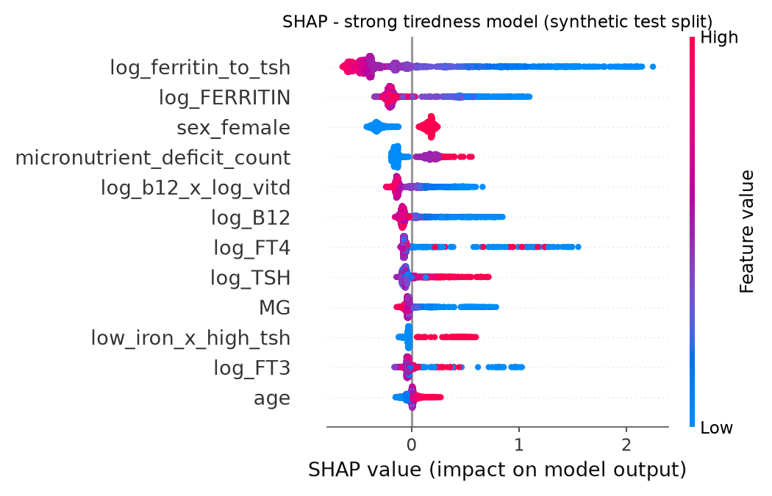
SHAP drivers of the tiredness model

8.3 Functional-range discovery
A functional band is the range where modelled symptom risk stays near its minimum, typically narrower than the lab range. The discovered edges are compared with the hidden generator thresholds that training never sees.
Marker | Edge | Hidden truth | Discovered | Lab range edge
TSH | upper | 2.5 | 2.39 | 4.0
Free T4 | lower | 12.0 | 13.5 | 10.0
Ferritin | lower | 45 | 55.4 | 15
Vitamin D | lower | 60 | 44.2 | 50
Vitamin B12 | lower | 260 | 226 | 148
Magnesium | lower | 0.78 | 0.72 | 0.70
Median relative error is 12.6%, and 5 of 6 bands are narrower than the lab range. The bootstrap interval contains the true value for only 1 of 6 markers, because the method's error is systematic rather than random.
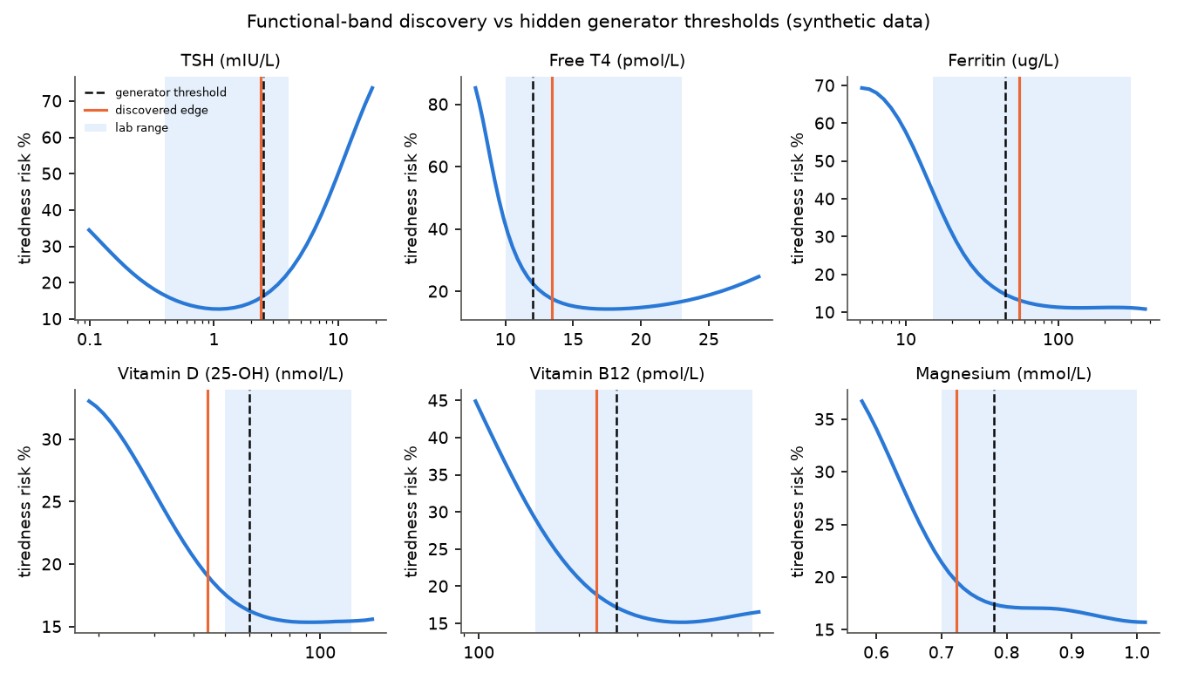
Discovered functional bands vs hidden truth vs lab ranges
Caution: Circularity (validity threat R2): symptoms were generated from marker values, so recovering the thresholds proves the method finds structure that exists. It is not evidence that such thresholds exist in real people.

9. The AI assistant and safety guardrails

9.1 How the assistant answers
The assistant is a LangGraph GraphRAG agent. For each question it gathers:
- the patient's clinician-approved results (never unapproved ones)
- knowledge-graph evidence chains
- cohort insights
- passages from the reviewed knowledge base, with filters enforced in code
With an LLM key (Groq or Google) it drafts an answer from these; without one it composes the answer from the reviewed pages. Either way the guardrails run last.

9.2 Guardrails (deterministic, always last)
Check | What it prevents
Diagnostic language | "You have Hashimoto's", "this means you are hypothyroid"
Prescriptive / dosage language | "Take 50,000 IU", "stop your levothyroxine", "increase your dose"
Cure / guarantee claims | "This will cure your fatigue"
Readability | Text above Flesch–Kincaid grade 8 is regenerated or simplified
Disclaimer | Every patient-facing text ends with the information-only disclaimer
Privacy | Internal ids, filenames and system-prompt mentions are removed
Prompt injection | Instructions hidden in reports or questions are treated as data
Regeneration | A failing LLM draft is regenerated (max 2 times), then replaced by the safe template

9.3 Escalation levels
Level | Triggered by | Effect
routine | Nothing concerning | Normal place in the review queue
priority | Marker thresholds (e.g. TSH > 10, ferritin < 10); tiredness ≥ 9; constant brain fog with severe hair loss; an untrustworthy value | Higher in the queue; listed under Escalations
urgent | Critical values (e.g. TSH > 50, free T4 < 5, magnesium < 0.5) | Top of the queue; the patient is advised to contact their clinician today
emergency | Red-flag words in the chat (chest pain, trouble breathing, fainting, self-harm, severe bleeding, palpitations, stroke signs) | Answer starts by telling the patient to call their local emergency number now

9.4 Measured safety
- On the red-team set, 30 of 30 unsafe sentences were caught, with 0 of 25 false alarms.
- Across 500 template summaries, all were at or below reading grade 8 (mean 4.95), and none contained a number that was not in the input.
- The assistant passed 10 of 10 test cases, and knowledge-base retrieval was correct first time for 13 of 13 queries, with 0 leaks of internal pages.
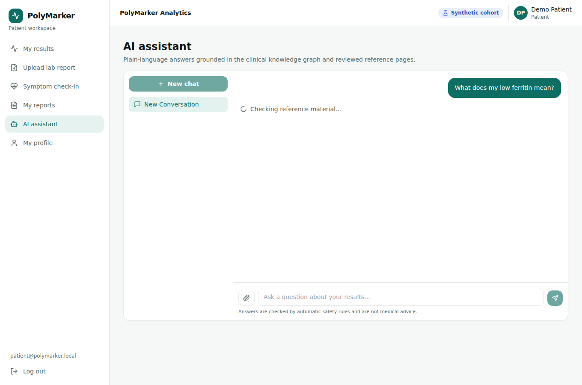
AI assistant with grounded answer and disclaimer

10. Clinician review workflow
The review portal shows, for each report:
- patient details and the attached symptom check-in
- OCR method and confidence
- a table of extracted values: raw value, normalised SI value, LOINC code and confidence
- quality warnings and escalation reasons with thresholds
- the generated summary and its source (template or LLM)
- the full audit trail
Decision | Result
Approve | Status approved; the patient sees the generated summary and the optional note
Edit & approve | Status approved; the patient sees the clinician's edited text (marked as edited by the clinician)
Reject (reason required) | Status rejected; the patient sees the reason and no summary
Only one decision is recorded if two clinicians act at the same moment; the second is told the report was already reviewed. Audit trail actions: uploaded, enqueued, interpretation_ready, viewed_by_reviewer, review_approve/edit/reject, plus job_failed, job_lost or enqueue_failed when something goes wrong.
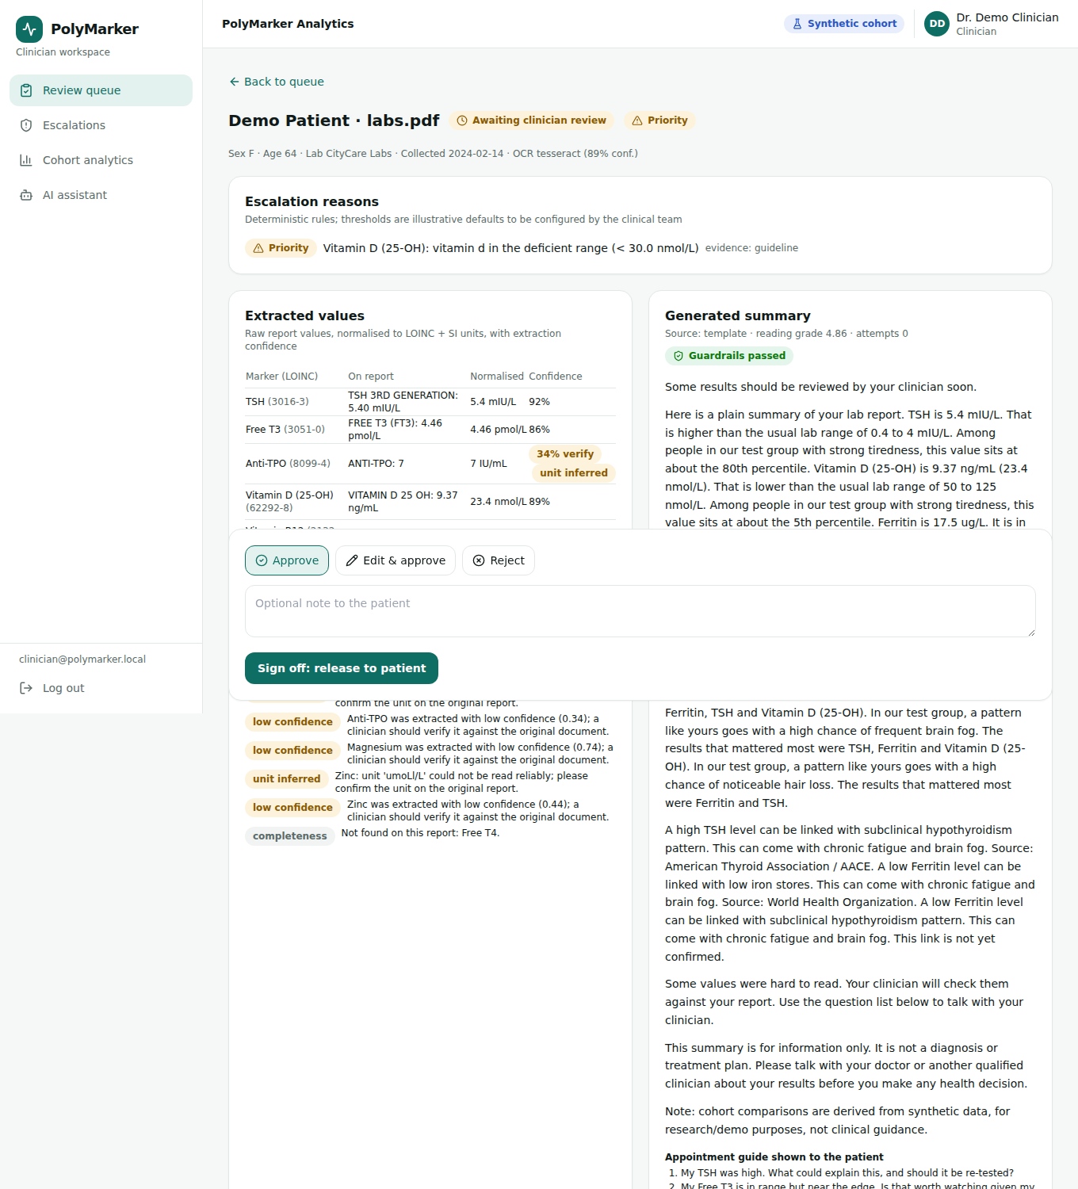
Clinician review detail (top of page)

10.1 What the patient sees after approval
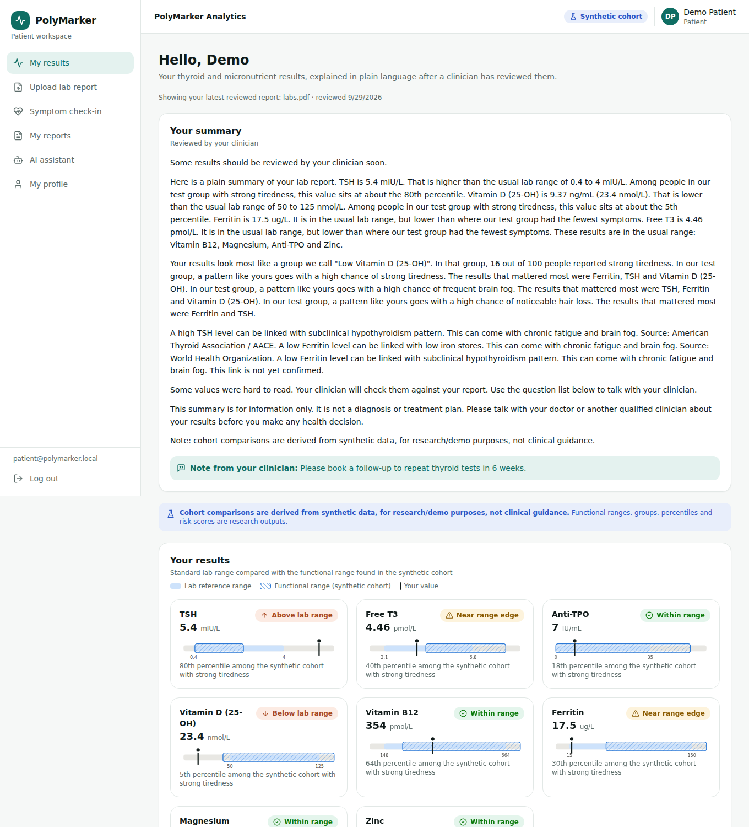
Patient dashboard (top of page)

11. Database and file storage (Supabase)
Table | Holds | Notes
users | Patients and clinicians: name, email, bcrypt password hash, role, sex, birth year | Email unique and lower-case
admins | Platform administrators | Separate from users by design
symptom_entries | Symptom check-ins | Checks enforce 1–10 and allowed levels
reports | One row per uploaded report: file location, status, job id, symptom snapshot, interpretation (JSON), escalation level, review (JSON), audit trail (JSON) | Interpretation hidden from the patient until approved
documents | Extra documents indexed for the assistant
conversations | Assistant conversations per user
messages | Chat messages with escalation info
- Row level security is on for every table with no policies, so Supabase's public Data API (anon or publishable key) can read nothing. Only the backend, which connects as the table owner, can read the data.
- The schema is applied automatically and safely on start, and by migrate and seed, so there is no manual SQL.
- Storage: originals are kept in the private bucket lab-reports, under reports/<patient-id>/. Deleting a report deletes its file.
- Deleting a user deletes their reports, symptoms, conversations and messages automatically (cascading deletes).

12. API reference

12.1 Backend (what the frontend calls, prefix /api)
Method and path | Who | Purpose
POST /auth/register | public | Create a patient account
POST /auth/login · POST /auth/admin/login | public | Sign in (patient/clinician; admin)
GET · PATCH /users/profile | signed in | Read / update own profile
POST /symptoms · GET /symptoms | patient | Record / list symptom check-ins
POST /reports | patient | Upload a report (field file) → 202 with report and job ids
GET /reports · GET /reports/:id · GET /reports/:id/status · DELETE /reports/:id | patient (own) | List, view (interpretation only once approved), poll, withdraw
GET /reviews?status= · GET /reviews/:id · POST /reviews/:id | clinician, admin | Queue, detail, decision {approve|edit|reject, comment, editedSummary}
GET /admin/clinicians · POST /admin/clinicians | admin | List / create clinicians
GET /insights/:name | signed in | cohort, bands, catalog, model (cached 5 min)
POST /conversations · GET /conversations · GET /conversations/:id/messages | signed in | Assistant conversations
POST /ai/chat | signed in | Send a message to the assistant
POST /ai/documents · GET /ai/documents/:id/status | patient | Extra documents for the assistant
GET /health | public | Liveness check

12.2 AI service (only the backend may call it; X-Internal-Key required)
Method and path | Purpose
POST /api/ocr · GET /api/ocr/jobs/{id} | Queue a report; job status and result
POST /api/interpret | Interpret already-structured values
POST /api/inference · GET /api/inference/{cohort|bands|catalog|model} | Analytics
POST /api/chat/ | Assistant
POST /api/documents/process | Index a patient document
GET /health · GET /ready | Health; readiness of jobs and graph backends

13. Your live deployment
Piece | Service (free tier) | Your address / name
Frontend | Vercel Hobby | Your Vercel project URL (e.g. careflow-….vercel.app)
Backend API | Modal (Starter credits) | https://riyapataskar--polymarker-api.modal.run (health: /api/health)
AI service | Modal | https://riyapataskar--polymarker-ai.modal.run (backend only)
Jobs | Modal function run_job | App polymarker in the Modal dashboard
Database + storage | Supabase Free | Project lwtmwbjiabuvqqoajwey (region ap-south-1), bucket lab-reports
Knowledge graph | In-memory (Neo4j Aura optional) | Add NEO4J_URI to use Aura
LLM | None (template mode); Groq optional | Add GROQ_API_KEY + LLM_PROVIDER=groq

13.1 Modal secrets
Secret | Keys | Used by
polymarker-shared | INTERNAL_API_KEY | Backend and AI service (shared key)
polymarker-ai | LLM_PROVIDER (none), optional GROQ_API_KEY, NEO4J_URI, NEO4J_PASSWORD | AI service and jobs
polymarker-backend | DATABASE_URL (Supabase transaction pooler), JWT_SECRET, FRONTEND_URL, SUPABASE_URL, SUPABASE_SERVICE_KEY, SEED_ADMIN_*, SEED_CLINICIAN_* | Backend, migrate, seed
Vercel has one variable: VITE_API_BASE_URL = https://riyapataskar--polymarker-api.modal.run/api, type Config (not Secret).

13.2 Everyday commands (run from the project folder)
modal deploy deploy/modal_app.py # redeploy after code or secret changes
modal run deploy/modal_app.py::seed # create accounts from SEED_* (safe to repeat)
modal run deploy/modal_app.py::migrate # apply schema + bucket (also runs on start)
modal run deploy/modal_app.py::load_graph # only with Neo4j Aura

13.3 Free-tier behaviour
- Cold starts. After 5 idle minutes services sleep; the first request takes a few seconds (API) or 10–20 s (AI service).
- Supabase pauses free projects after about a week without activity; restore from the dashboard (data is kept).
- Assistant memory of earlier turns lasts while the AI container is running; saved messages remain visible.
- Changing a secret needs a modal deploy; changing a Vercel variable needs a Redeploy.
Security: The Supabase database password and secret key, and the demo account passwords, were shared in a chat. Rotate them: Supabase → Database → Reset password; API Keys → new secret key; then update the polymarker-backend secret and run modal deploy.

14. Configuration reference
Variable | Service | Meaning
VITE_API_BASE_URL | frontend | Backend address including /api (build time)
DATABASE_URL, DATABASE_SSL, DATABASE_CA_CERT | backend | Postgres connection; TLS disable/require/verify
DB_AUTO_MIGRATE | backend | Apply schema on start (default true)
JWT_SECRET | backend | Signs sign-in tokens (required in production)
FRONTEND_URL | backend | Allowed browser origins (comma-separated)
SUPABASE_URL, SUPABASE_SERVICE_KEY, STORAGE_BUCKET | backend | File storage (local disk if unset)
AI_SERVICE_URL, AI_INTERNAL_KEY / INTERNAL_API_KEY, AI_TIMEOUT_MS | backend | How to reach the AI service
SEED_ADMIN_*, SEED_CLINICIAN_*, SEED_PATIENT_* | backend | Accounts created by seed
INTERNAL_API_KEY | ai-service | Required X-Internal-Key
JOB_BACKEND | ai-service | celery | modal | local
LLM_PROVIDER, LLM_MODEL, GROQ_API_KEY, GOOGLE_API_KEY, MAX_REGENERATIONS | ai-service | Optional LLM
CHECKPOINTER, REDIS_URL | ai-service | Conversation memory (memory or Redis Stack)
NEO4J_URI, NEO4J_USER, NEO4J_PASSWORD | ai-service | Knowledge graph (in-memory if unset)
OCR_ENGINE, ENABLE_LAYOUTLMV3, MODEL_ARTIFACT_DIR | ai-service | OCR engine and model location
ETL_ENGINE | bda_engine | spark | duckdb

15. Testing and quality

15.1 Automated tests
Project | Tests | Highlights
common | 45 | Parser layouts, unit conversion, OCR pipeline, quality checks
graph_service | 10 | Schema/seed, live Neo4j equals in-memory graph
bda_engine | 13 | Generator, Spark = DuckDB, models, batch OCR
ai-service | 43 (+3 live) | API, guardrails, summaries, retrieval, Modal jobs; live Celery/Redis/Neo4j
backend | 18 | Roles, approval gate, privacy, storage, review race, RLS, TLS
frontend | 14 | API client, biomarker helpers, components

15.2 Continuous integration (8 jobs, all green on main)
The CI jobs are common, graph-service (with Neo4j), bda-engine (Java + Tesseract), ai-service (lint, tests, live integration, safety evaluation), backend (with Postgres), frontend (tests, build, no-hard-coded-URL guard), compose (Docker image builds) and modal (validates the deployment definition).

15.3 Manual test pack (testing/)
testing/TEST_PLAN.md has 14 patient tests, 7 assistant tests, 14 clinician tests, 8 admin tests and 5 cross-checks. testing/sample-reports/ has 9 synthetic reports:
File | Tests | Expected
01-normal-all-in-range.pdf | Baseline | 9 markers, routine
02-thyroid-autoimmune-low-iron-vitd.pdf | Typical pattern | 9 markers, routine, high tiredness risk
03-priority-escalation.pdf | 5 thresholds | priority
04-urgent-escalation.pdf | Critical values | urgent (top of queue)
05-si-units-other-lab.pdf | SI units, other lab | 8 markers, routine
06-scanned-image-report.pdf | OCR | 6 markers, lower confidence
07-partial-panel-three-markers.pdf | Partial panel | 3 markers
08-prompt-injection.txt | Injected instructions | Ignored; not in summary
09-no-lab-values-letter.pdf | No results | 0 markers; clinician rejects

16. Security and privacy
- Passwords are hashed with bcrypt. Sign-in tokens last 7 days and roles are checked against the database on every request.
- There is no public admin or clinician sign-up. Sign-in attempts are rate-limited, and error messages never reveal whether the email or the password was wrong.
- Patients can only reach their own records: every query filters on the signed-in patient.
- Uploads are limited to PDF, TXT, PNG and JPG, 10 MB maximum. The client's filename is never used as a storage path.
- Ids are validated before any file path is built, which prevents path traversal.
- The AI service requires the internal key on every data endpoint.
- Supabase row level security blocks the public Data API, and files sit in a private bucket accessed only with the secret key.
- Standard web protections are on: helmet security headers, a CORS allow-list and JSON size limits.
- Patient names are never extracted from reports, and guardrails redact ids from patient-facing text.

17. Running it on your own computer
cp .env.example .env # set JWT_SECRET, AI_INTERNAL_KEY; optional GROQ_API_KEY
docker compose up --build # Postgres, Redis, Neo4j, AI service, worker, backend, frontend
# open http://localhost:5173
docker compose --profile ml run --rm bda all # optional: regenerate data + retrain (~8 GB RAM)
Minimum resources: 4 CPUs and 6 GB RAM for the core stack. Each project can also be run on its own with uv sync && uv run pytest (Python) or npm ci && npm test (Node). The backend tests need a Postgres, set with DATABASE_URL_TEST.

18. Limitations and known issues
Item | Detail | Suggested next step
Synthetic data only | All bands, clusters and risks are method demonstrations (circularity threat R2) | De-identified real data, pre-registered thresholds, external validation
LLM summaries unmeasured | No AI key during evaluation; all measured summaries came from the template | Add a Groq key and rerun run_ai_eval.py
Assistant readability in template mode | Some quoted knowledge-base passages read at grade 8.6–8.8 (target ≤ 8); flagged, not a safety issue | Simplify the knowledge-base wording or enable an LLM
Medicine questions in template mode | Answered with general marker information plus the disclaimer, not a targeted reply | Add a specific medicine-question response
No password reset | Seed does not change existing passwords | Add a reset command or a change-password screen
Conversation memory on Modal | Resets when the AI container sleeps | Point at a Redis Stack instance (CHECKPOINTER=redis)
OCR on real faxes and phone photos | Synthetic scans are cleaner than real ones | Evaluate LayoutLMv3 / PaddleOCR on real samples
Small safety test sets | Written by the developers | Independent clinical red team

19. Troubleshooting
Symptom | Likely cause and fix
"Cannot reach the server" | VITE_API_BASE_URL missing (set as Config, then Redeploy on Vercel); or FRONTEND_URL does not match the site address (update the secret, run modal deploy); or the backend is not starting (check the api logs in Modal)
"Invalid credentials" | Wrong tab (Admin vs Clinician) or wrong password; passwords are case-sensitive
Upload stays "processing" | Check run_job logs in Modal; the first upload after idle is slower
"Postgres connection failed" in logs | DATABASE_URL must be the Supabase transaction pooler URL (port 6543); the project may be paused
Deploy says a secret is missing keys | Recreate the secret with all required keys (DATABASE_URL, JWT_SECRET, FRONTEND_URL)
Vercel will not switch a variable to Config | Saved Secrets cannot change type: delete it and create a new Config variable

20. Glossary
Term | Meaning
PROM | Patient-reported outcome measure: here tiredness, brain fog and hair loss
LOINC | Standard codes for lab tests, so different lab names map to one marker
OCR | Optical character recognition: reading text from images
Functional band | A data-derived range where symptom risk stays near its minimum (synthetic-derived)
SHAP | A method that shows how much each value pushed a model's prediction up or down
AUROC / ECE | How well a model ranks risk (0.5 is chance, 1 is perfect) / how close predicted probabilities are to reality
GraphRAG | Answering questions with retrieval from a knowledge graph and documents
Guardrails | Deterministic checks applied to every patient-facing text
Bronze / silver / gold | Data-lake stages: raw typed, cleaned and normalised, analysis-ready
RLS | Row level security: database rules controlling who can read which rows
Cold start | Delay while a sleeping serverless service starts up

Appendix A. Research mapping (15 papers)
# | Idea from the plan's papers | Where it is implemented
1 | Cohort-level lab analytics (TriNetX) | Silver/gold lake, percentiles, cluster profiles
2 | Multi-source lake of labs, demographics, PROMs (MELD) | Raw → bronze → silver → gold over 5 labs + intake forms
3 | Population-health analytics framing | 4-V mapping; Spark/DuckDB engine
4 | Bias correction in lab data | Data-quality layer before modelling; limitations
5 | Lab data as early-warning signals | Escalation rules and queue triage
6 | Joint multi-marker correlation | Spearman matrices loaded into the graph
7 | Engineered multi-biomarker features | Ratios, interactions, deficit count, missingness
8 | Unsupervised sub-clinical patterns | K-Means, GMM, DBSCAN outliers
9 | Context improves prediction | Symptoms + demographics in risk models; SHAP
10 | Layout-aware document analysis | 4 PDF layouts, column detection, LayoutLMv3 hook
11 | Personalised interpretation | Per-patient bands, percentiles, cluster, risk
12 | Structured PROM extraction | Free-text intake normalised to the PROM schema
13 | Biomarker knowledge graph (BiomarkerKB) | graph_service with source + evidence level
14 | Clinical decision support with guardrails | GraphRAG + deterministic guardrails + audit
15 | PROMs as model targets | Tiredness / brain fog / hair-loss calibrated risk

Appendix B. The 14-week plan: delivered
Phase | Weeks | Delivered
1 · Ingestion & BDA engine | 1–4 | Lake schemas; 50k synthetic generator; OCR (text layer / Tesseract + tables; Paddle & LayoutLMv3 behind flags); job queue; LOINC + unit normalizer; quality checks with audit
2 · Graph & ML | 5–8 | Neo4j graph with evidence levels; feature vectors; K-Means / GMM / DBSCAN; functional bands; XGBoost + SHAP
3 · GraphRAG & safety | 9–11 | GraphRAG agent with cohort insights; deterministic guardrails; unified output JSON
4 · UI, review, evaluation, docs | 12–14 | Gauges, radar, cohort map; clinician review portal; full evaluation; rebrand; docs; CI; free-tier deployment (Vercel + Modal + Supabase)

