Homework 3

# Run Cycle 1

1. Learning Rate = 0.1,
2. Epochs = 30,
3. Batch Size = 64,
4. Hidden layers = 4,
5. 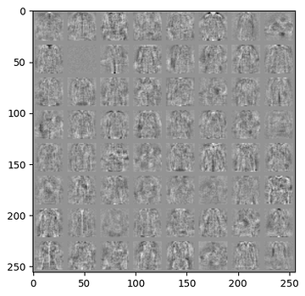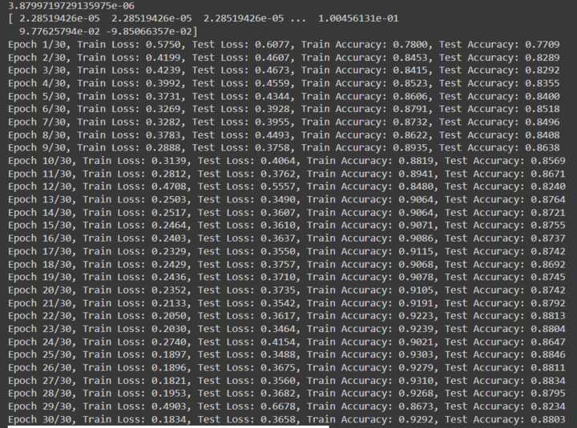Neurons = 72 (each hidden layer)

# Run Cycle 2

1. Learning Rate = 0.1,
2. Epochs = 20,
3. Batch Size = 128,
4. Hidden layers = 2,
5. 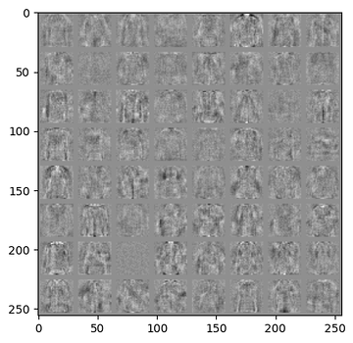Neurons = 64 (each hidden layer)

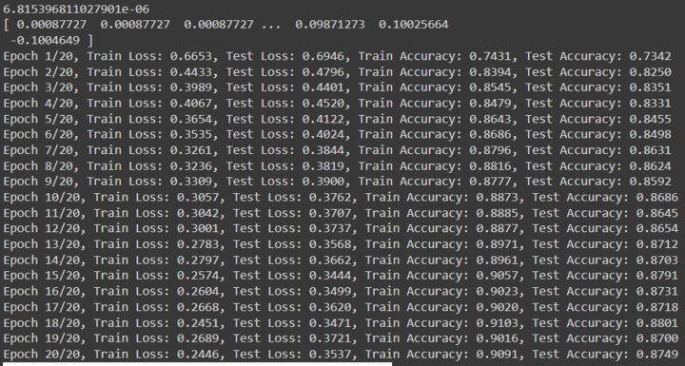

# Run Cycle 3

1. Learning Rate = 0.5,
2. Epochs = 20,
3. Batch Size = 128,
4. Hidden layers = 2,
5. Neurons = 72 (each hidden layer)

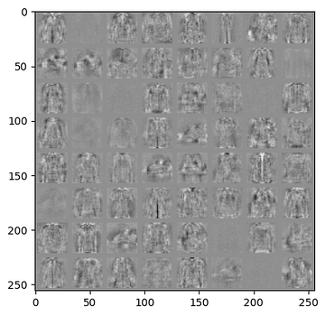

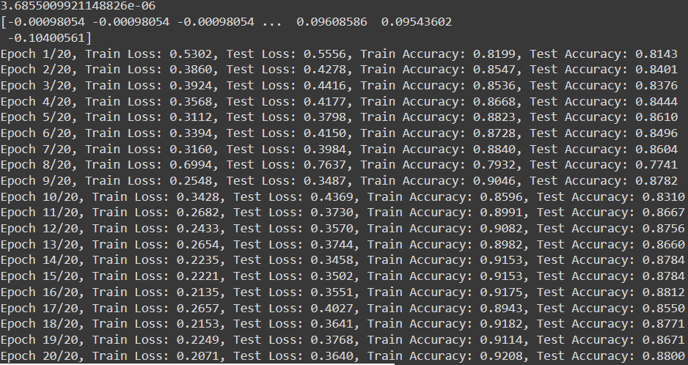

# Run cycle 4

1. Learning Rate = 0.01,
2. Epochs = 100,
3. Batch Size = 128,
4. Hidden layers = 1,
5. Neurons = 72 (each hidden layer)

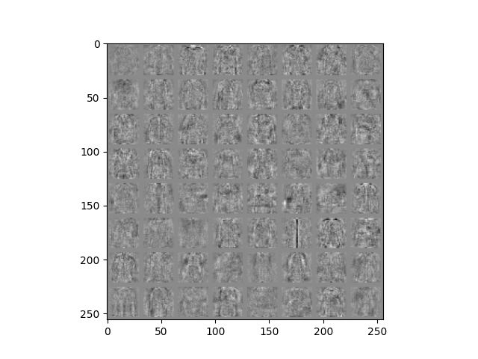

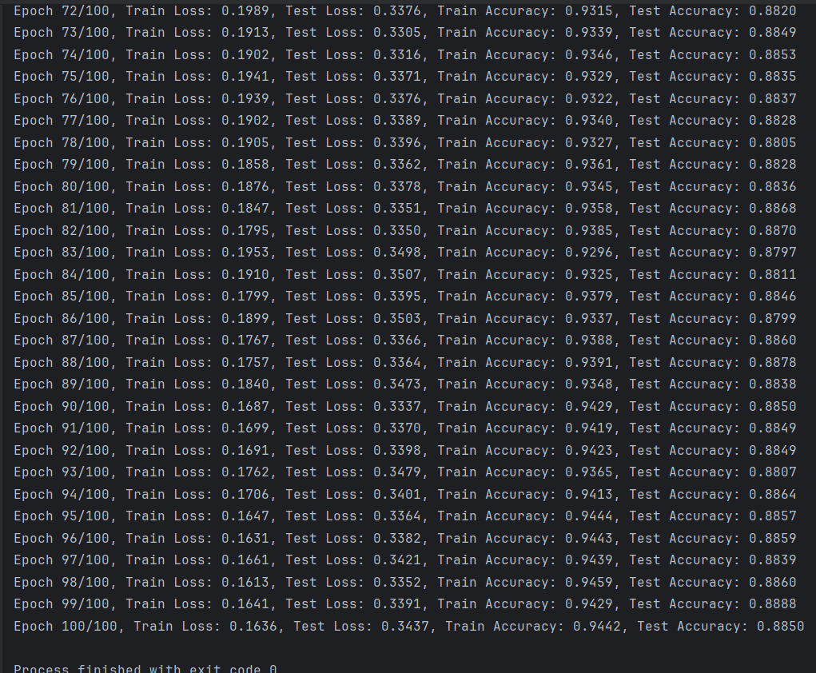

3.346745681059974e-06

[-0.00602718 -0.00602718 -0.00602718 ... 0.10093788 0.09539526

-0.0978953 ]

Epoch 1/100, Train Loss: 0.5661, Test Loss: 0.5871, Train Accuracy: 0.7971, Test Accuracy: 0.7830

Epoch 2/100, Train Loss: 0.4890, Test Loss: 0.5184, Train Accuracy: 0.8276, Test Accuracy: 0.8141

Epoch 3/100, Train Loss: 0.4514, Test Loss: 0.4829, Train Accuracy: 0.8396, Test Accuracy: 0.8240

Epoch 4/100, Train Loss: 0.4295, Test Loss: 0.4637, Train Accuracy: 0.8465, Test Accuracy: 0.8302

Epoch 5/100, Train Loss: 0.4089, Test Loss: 0.4468, Train Accuracy: 0.8570, Test Accuracy: 0.8405

Epoch 6/100, Train Loss: 0.4049, Test Loss: 0.4450, Train Accuracy: 0.8563, Test Accuracy: 0.8398

Epoch 7/100, Train Loss: 0.3826, Test Loss: 0.4218, Train Accuracy: 0.8648, Test Accuracy: 0.8489

Epoch 8/100, Train Loss: 0.3741, Test Loss: 0.4160, Train Accuracy: 0.8678, Test Accuracy: 0.8526

Epoch 9/100, Train Loss: 0.3654, Test Loss: 0.4084, Train Accuracy: 0.8704, Test Accuracy: 0.8531

Epoch 10/100, Train Loss: 0.3588, Test Loss: 0.4059, Train Accuracy: 0.8726, Test Accuracy: 0.8534

Epoch 11/100, Train Loss: 0.3543, Test Loss: 0.4016, Train Accuracy: 0.8753, Test Accuracy: 0.8585

Epoch 12/100, Train Loss: 0.3547, Test Loss: 0.4045, Train Accuracy: 0.8727, Test Accuracy: 0.8547

Epoch 13/100, Train Loss: 0.3444, Test Loss: 0.3950, Train Accuracy: 0.8770, Test Accuracy: 0.8599

Epoch 14/100, Train Loss: 0.3336, Test Loss: 0.3847, Train Accuracy: 0.8830, Test Accuracy: 0.8621

Epoch 15/100, Train Loss: 0.3305, Test Loss: 0.3824, Train Accuracy: 0.8821, Test Accuracy: 0.8639

Epoch 16/100, Train Loss: 0.3273, Test Loss: 0.3817, Train Accuracy: 0.8822, Test Accuracy: 0.8636

Epoch 17/100, Train Loss: 0.3251, Test Loss: 0.3810, Train Accuracy: 0.8837, Test Accuracy: 0.8615

Epoch 18/100, Train Loss: 0.3217, Test Loss: 0.3802, Train Accuracy: 0.8854, Test Accuracy: 0.8638

Epoch 19/100, Train Loss: 0.3157, Test Loss: 0.3760, Train Accuracy: 0.8864, Test Accuracy: 0.8634

Epoch 20/100, Train Loss: 0.3100, Test Loss: 0.3695, Train Accuracy: 0.8900, Test Accuracy: 0.8673

Epoch 21/100, Train Loss: 0.3033, Test Loss: 0.3673, Train Accuracy: 0.8925, Test Accuracy: 0.8702

Epoch 22/100, Train Loss: 0.2976, Test Loss: 0.3603, Train Accuracy: 0.8949, Test Accuracy: 0.8709

Epoch 23/100, Train Loss: 0.2968, Test Loss: 0.3629, Train Accuracy: 0.8944, Test Accuracy: 0.8734

Epoch 24/100, Train Loss: 0.3010, Test Loss: 0.3690, Train Accuracy: 0.8929, Test Accuracy: 0.8666

Epoch 25/100, Train Loss: 0.2962, Test Loss: 0.3627, Train Accuracy: 0.8952, Test Accuracy: 0.8706

Epoch 26/100, Train Loss: 0.2889, Test Loss: 0.3573, Train Accuracy: 0.8971, Test Accuracy: 0.8726

Epoch 27/100, Train Loss: 0.2861, Test Loss: 0.3590, Train Accuracy: 0.8988, Test Accuracy: 0.8712

Epoch 28/100, Train Loss: 0.2851, Test Loss: 0.3577, Train Accuracy: 0.8992, Test Accuracy: 0.8722

Epoch 29/100, Train Loss: 0.2820, Test Loss: 0.3589, Train Accuracy: 0.8993, Test Accuracy: 0.8733

Epoch 30/100, Train Loss: 0.2735, Test Loss: 0.3489, Train Accuracy: 0.9041, Test Accuracy: 0.8758

Epoch 31/100, Train Loss: 0.2754, Test Loss: 0.3518, Train Accuracy: 0.9012, Test Accuracy: 0.8751

Epoch 32/100, Train Loss: 0.2702, Test Loss: 0.3473, Train Accuracy: 0.9038, Test Accuracy: 0.8753

Epoch 33/100, Train Loss: 0.2867, Test Loss: 0.3679, Train Accuracy: 0.8954, Test Accuracy: 0.8649

Epoch 34/100, Train Loss: 0.2724, Test Loss: 0.3522, Train Accuracy: 0.9034, Test Accuracy: 0.8750

Epoch 35/100, Train Loss: 0.2598, Test Loss: 0.3422, Train Accuracy: 0.9082, Test Accuracy: 0.8781

Epoch 36/100, Train Loss: 0.2674, Test Loss: 0.3526, Train Accuracy: 0.9052, Test Accuracy: 0.8763

Epoch 37/100, Train Loss: 0.2634, Test Loss: 0.3491, Train Accuracy: 0.9045, Test Accuracy: 0.8751

Epoch 38/100, Train Loss: 0.2652, Test Loss: 0.3509, Train Accuracy: 0.9064, Test Accuracy: 0.8750

Epoch 39/100, Train Loss: 0.2529, Test Loss: 0.3401, Train Accuracy: 0.9104, Test Accuracy: 0.8783

Epoch 40/100, Train Loss: 0.2554, Test Loss: 0.3484, Train Accuracy: 0.9080, Test Accuracy: 0.8708

Epoch 41/100, Train Loss: 0.2457, Test Loss: 0.3371, Train Accuracy: 0.9125, Test Accuracy: 0.8801

Epoch 42/100, Train Loss: 0.2529, Test Loss: 0.3466, Train Accuracy: 0.9088, Test Accuracy: 0.8770

Epoch 43/100, Train Loss: 0.2418, Test Loss: 0.3358, Train Accuracy: 0.9140, Test Accuracy: 0.8808

Epoch 44/100, Train Loss: 0.2485, Test Loss: 0.3429, Train Accuracy: 0.9103, Test Accuracy: 0.8754

Epoch 45/100, Train Loss: 0.2410, Test Loss: 0.3388, Train Accuracy: 0.9144, Test Accuracy: 0.8794

Epoch 46/100, Train Loss: 0.2435, Test Loss: 0.3445, Train Accuracy: 0.9141, Test Accuracy: 0.8769

Epoch 47/100, Train Loss: 0.2495, Test Loss: 0.3519, Train Accuracy: 0.9103, Test Accuracy: 0.8732

Epoch 48/100, Train Loss: 0.2457, Test Loss: 0.3496, Train Accuracy: 0.9123, Test Accuracy: 0.8776

Epoch 49/100, Train Loss: 0.2321, Test Loss: 0.3371, Train Accuracy: 0.9184, Test Accuracy: 0.8801

Epoch 50/100, Train Loss: 0.2410, Test Loss: 0.3449, Train Accuracy: 0.9138, Test Accuracy: 0.8768

Epoch 51/100, Train Loss: 0.2289, Test Loss: 0.3345, Train Accuracy: 0.9194, Test Accuracy: 0.8818

Epoch 52/100, Train Loss: 0.2275, Test Loss: 0.3350, Train Accuracy: 0.9191, Test Accuracy: 0.8819

Epoch 53/100, Train Loss: 0.2338, Test Loss: 0.3452, Train Accuracy: 0.9163, Test Accuracy: 0.8774

Epoch 54/100, Train Loss: 0.2285, Test Loss: 0.3366, Train Accuracy: 0.9191, Test Accuracy: 0.8816

Epoch 55/100, Train Loss: 0.2195, Test Loss: 0.3351, Train Accuracy: 0.9234, Test Accuracy: 0.8798

Epoch 56/100, Train Loss: 0.2357, Test Loss: 0.3500, Train Accuracy: 0.9172, Test Accuracy: 0.8760

Epoch 57/100, Train Loss: 0.2347, Test Loss: 0.3493, Train Accuracy: 0.9145, Test Accuracy: 0.8752

Epoch 58/100, Train Loss: 0.2171, Test Loss: 0.3368, Train Accuracy: 0.9235, Test Accuracy: 0.8797

Epoch 59/100, Train Loss: 0.2105, Test Loss: 0.3298, Train Accuracy: 0.9273, Test Accuracy: 0.8826

Epoch 60/100, Train Loss: 0.2095, Test Loss: 0.3315, Train Accuracy: 0.9271, Test Accuracy: 0.8847

Epoch 61/100, Train Loss: 0.2114, Test Loss: 0.3329, Train Accuracy: 0.9251, Test Accuracy: 0.8839

Epoch 62/100, Train Loss: 0.2041, Test Loss: 0.3277, Train Accuracy: 0.9294, Test Accuracy: 0.8849

Epoch 63/100, Train Loss: 0.2074, Test Loss: 0.3311, Train Accuracy: 0.9283, Test Accuracy: 0.8859

Epoch 64/100, Train Loss: 0.2078, Test Loss: 0.3341, Train Accuracy: 0.9272, Test Accuracy: 0.8836

Epoch 65/100, Train Loss: 0.2086, Test Loss: 0.3355, Train Accuracy: 0.9269, Test Accuracy: 0.8852

Epoch 66/100, Train Loss: 0.2012, Test Loss: 0.3296, Train Accuracy: 0.9303, Test Accuracy: 0.8844

Epoch 67/100, Train Loss: 0.2035, Test Loss: 0.3339, Train Accuracy: 0.9275, Test Accuracy: 0.8866

Epoch 68/100, Train Loss: 0.2154, Test Loss: 0.3486, Train Accuracy: 0.9209, Test Accuracy: 0.8735

Epoch 69/100, Train Loss: 0.2005, Test Loss: 0.3353, Train Accuracy: 0.9304, Test Accuracy: 0.8810

Epoch 70/100, Train Loss: 0.1963, Test Loss: 0.3304, Train Accuracy: 0.9320, Test Accuracy: 0.8841

Epoch 71/100, Train Loss: 0.1934, Test Loss: 0.3294, Train Accuracy: 0.9332, Test Accuracy: 0.8867

Epoch 72/100, Train Loss: 0.1989, Test Loss: 0.3376, Train Accuracy: 0.9315, Test Accuracy: 0.8820

Epoch 73/100, Train Loss: 0.1913, Test Loss: 0.3305, Train Accuracy: 0.9339, Test Accuracy: 0.8849

Epoch 74/100, Train Loss: 0.1902, Test Loss: 0.3316, Train Accuracy: 0.9346, Test Accuracy: 0.8853

Epoch 75/100, Train Loss: 0.1941, Test Loss: 0.3371, Train Accuracy: 0.9329, Test Accuracy: 0.8835

Epoch 76/100, Train Loss: 0.1939, Test Loss: 0.3376, Train Accuracy: 0.9322, Test Accuracy: 0.8837

Epoch 77/100, Train Loss: 0.1902, Test Loss: 0.3389, Train Accuracy: 0.9340, Test Accuracy: 0.8828

Epoch 78/100, Train Loss: 0.1905, Test Loss: 0.3396, Train Accuracy: 0.9327, Test Accuracy: 0.8805

Epoch 79/100, Train Loss: 0.1858, Test Loss: 0.3362, Train Accuracy: 0.9361, Test Accuracy: 0.8828

Epoch 80/100, Train Loss: 0.1876, Test Loss: 0.3378, Train Accuracy: 0.9345, Test Accuracy: 0.8836

Epoch 81/100, Train Loss: 0.1847, Test Loss: 0.3351, Train Accuracy: 0.9358, Test Accuracy: 0.8868

Epoch 82/100, Train Loss: 0.1795, Test Loss: 0.3350, Train Accuracy: 0.9385, Test Accuracy: 0.8870

Epoch 83/100, Train Loss: 0.1953, Test Loss: 0.3498, Train Accuracy: 0.9296, Test Accuracy: 0.8797

Epoch 84/100, Train Loss: 0.1910, Test Loss: 0.3507, Train Accuracy: 0.9325, Test Accuracy: 0.8811

Epoch 85/100, Train Loss: 0.1799, Test Loss: 0.3395, Train Accuracy: 0.9379, Test Accuracy: 0.8846

Epoch 86/100, Train Loss: 0.1899, Test Loss: 0.3503, Train Accuracy: 0.9337, Test Accuracy: 0.8799

Epoch 87/100, Train Loss: 0.1767, Test Loss: 0.3366, Train Accuracy: 0.9388, Test Accuracy: 0.8860

Epoch 88/100, Train Loss: 0.1757, Test Loss: 0.3364, Train Accuracy: 0.9391, Test Accuracy: 0.8878

Epoch 89/100, Train Loss: 0.1840, Test Loss: 0.3473, Train Accuracy: 0.9348, Test Accuracy: 0.8838

Epoch 90/100, Train Loss: 0.1687, Test Loss: 0.3337, Train Accuracy: 0.9429, Test Accuracy: 0.8850

Epoch 91/100, Train Loss: 0.1699, Test Loss: 0.3370, Train Accuracy: 0.9419, Test Accuracy: 0.8849

Epoch 92/100, Train Loss: 0.1691, Test Loss: 0.3398, Train Accuracy: 0.9423, Test Accuracy: 0.8849

Epoch 93/100, Train Loss: 0.1762, Test Loss: 0.3479, Train Accuracy: 0.9365, Test Accuracy: 0.8807

Epoch 94/100, Train Loss: 0.1706, Test Loss: 0.3401, Train Accuracy: 0.9413, Test Accuracy: 0.8864

Epoch 95/100, Train Loss: 0.1647, Test Loss: 0.3364, Train Accuracy: 0.9444, Test Accuracy: 0.8857

Epoch 96/100, Train Loss: 0.1631, Test Loss: 0.3382, Train Accuracy: 0.9443, Test Accuracy: 0.8859

Epoch 97/100, Train Loss: 0.1661, Test Loss: 0.3421, Train Accuracy: 0.9439, Test Accuracy: 0.8839

Epoch 98/100, Train Loss: 0.1613, Test Loss: 0.3352, Train Accuracy: 0.9459, Test Accuracy: 0.8860

Epoch 99/100, Train Loss: 0.1641, Test Loss: 0.3391, Train Accuracy: 0.9429, Test Accuracy: 0.8888

Epoch 100/100, Train Loss: 0.1636, Test Loss: 0.3437, Train Accuracy: 0.9442, Test Accuracy: 0.8850

Process finished with exit code 0