Traditional Search Engines

vs.

Generative AI-based Search Engines

# Introduction

In today’s world, we have two powerful tools at our disposal when searching for information: traditional search engines like Google and the newer, AI-powered search engines like Perplexity.ai and You.com. While both help us find answers, they approach it in very different ways. This report takes a closer look at how these two types of search engines handle more complex queries, weighing their strengths and weaknesses. By the end, we’ll have a clearer sense of when each one is the better choice, depending on what you're looking for.

# Search Engines Overview

## Traditional Search Engines (Google):

Google is the dominant search engine that uses keyword-based search algorithms to return a list of web pages ranked by relevance. It excels at finding diverse content and delivering a variety of options, such as web pages, news, academic papers, and more.

## Generative AI-based Search Engines (Perplexity.ai, You.com):

These search engines use large language models (LLMs) to generate responses to user queries. Instead of returning a list of links, they provide synthesized answers directly. Perplexity.ai and You.com are examples of this new paradigm, where the search engines aim to create conversational and accurate responses to inquiries.

# Query Comparison

To really test the difference between Google and these AI-powered engines, I tried out three more complex questions to see how they each performed.

## Query 1 - “Best strategies for investing in 2024”

### Google:

Search results included links to finance blogs, investment advisors, news outlets, and platforms like “Bankrate” and “NerdWallet”. The results were a mix of professional opinions, expert analysis, and discussion forums.

* + **Pros**: Wide variety of viewpoints, access to expert insights.
  + **Cons**: Requires careful selection of reliable sources, time-consuming.



### Perplexity.ai/You.com Results:

The response from Perplexity.ai focused on general investment strategies like diversification, risk management, and trending sectors but didn’t reference specific current market conditions.

* + **Pros**: Fast, easy-to-understand advice on basic investment principles.
  + **Cons**: Lacks the depth and specificity that investors would need for 2024-specific strategies, no up-to-date financial data.

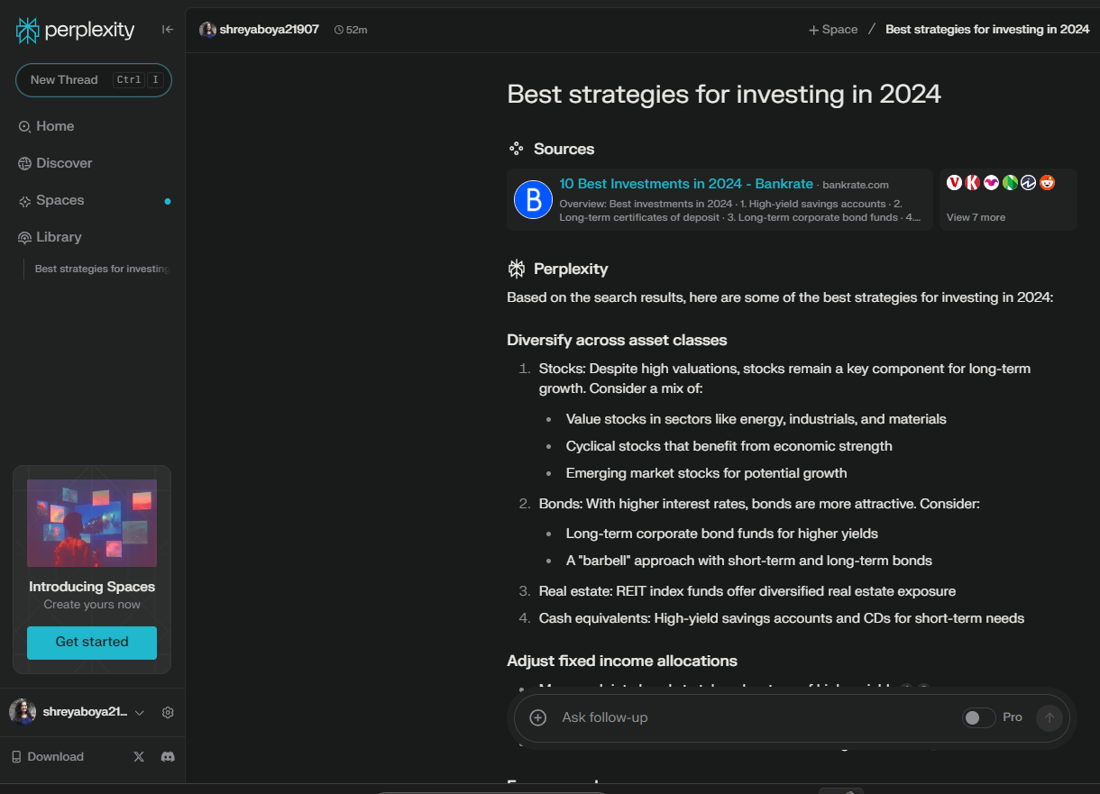

## Query 2 – “Explain the implications of blockchain technology on supply chain management”

### Google:

Google provided a series of links, including white papers, research articles, news articles, and corporate blog posts from platforms like IBM, Forbes, and academic journals.

* + **Pros**: Access to detailed and authoritative resources, including articles from reputable industry sources. Users can explore various perspectives, including business, technical, and academic discussions.
  + **Cons**: Requires time to review multiple articles and resources to synthesize the information. Clicking through several links to get a comprehensive understanding takes longer.

### Perplexity.ai:

Perplexity.ai generated a concise summary explaining how blockchain enhances transparency, traceability, and efficiency in supply chain management by allowing immutable records of transactions. The response also touched on the reduction of fraud and automation of contract execution.

* + **Pros**: Instant, well-rounded summary. It gives a clear, focused answer on the implications.
  + **Cons**: Lacks citations or direct links to specific articles, making it hard to verify or explore the topic further without a secondary search.

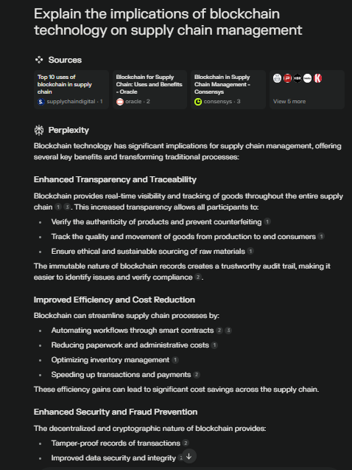

### You.com Results:

You.com offered a more technical explanation of blockchain’s role in supply chain management, mentioning decentralized databases, smart contracts, and real-time tracking benefits. It also displayed a mix of sources, providing direct answers and clickable links to external articles.

* + **Pros**: Balanced approach with both summarized information and links to further resources for in-depth reading.
  + **Cons**: The interface felt somewhat cluttered compared to the simplicity of Perplexity.ai.



## Query 3 – “Latest advancements in AI for healthcare”

### Google:

Traditional search engines provided a list of recent articles, research papers, and news about advancements in AI for healthcare, including links to sources such as journals, news websites, and industry reports.

* + **Pros**: Timely information from news outlets, access to scientific papers.
  + **Cons**: Requires time to sift through results to find high-quality sources.



### Perplexity.ai/You.com Results:

Generative AI-based search engines produced a summary of the latest AI advancements in healthcare, mentioning AI diagnostics, predictive modelling, and robotic surgery. It pulled data from recent sources but didn't provide clickable links for further reading.

* + **Pros**: Quick and comprehensive summary.
  + **Cons**: No direct references or citations to original research, limited follow-up resources.

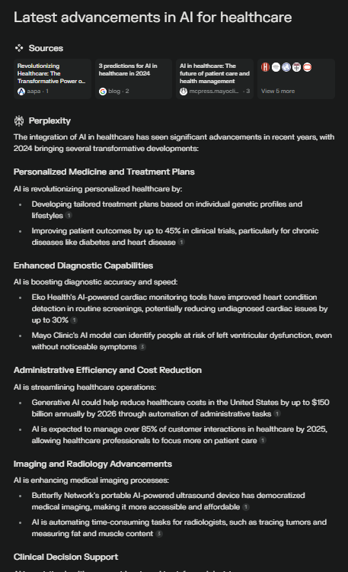

# Pros and Cons of Traditional vs. Generative AI-based Search Engines

|  |  |  |  |
| --- | --- | --- | --- |
| Aspect | Google (Traditional Search) | Perplexity.ai (Generative AI-based) | You.com (Generative AI-based) |
| **Search Result Format** | List of web links, often with snippets and featured results. | Direct, synthesized answers. | Direct answers with a mix of external links and summaries. |
| **Depth of Information** | High, with access to detailed articles and academic papers. | Moderate, focuses on summarization, lacks depth for complex queries. | Moderate to high, depending on the query. More detailed than Perplexity, with links to external resources. |
| **Source Variety** | Extensive variety, from news outlets to academic papers and blog posts. | Limited; the answers are generated without providing a list of sources. | Moderate variety, with a mix of generated answers and external links. |
| **Time Efficiency** | Can require more time to sift through results and find the right resources. | Very quick; generates an immediate answer without requiring the user to click links. | Quick but with more information and links to resources, allowing for deeper exploration. |
| **Reliability/Accuracy** | High, but depends on the user’s ability to filter credible sources. | Generally reliable, but hard to verify without links or citations. | Reliable, and users can verify by clicking on provided links. |
| **Use Cases** | Best for research, detailed inquiries, and access to diverse opinions. | Best for quick summaries and casual inquiries. | Suitable for both quick overviews and more detailed exploration, depending on the user's needs. |
| **Current Information** | Up-to-date, real-time results from a wide range of sources. | Usually accurate but not always guaranteed to have the most recent developments. | More flexible, with some current information depending on external sources, but may still lag behind real-time search engines. |

# Conclusion

## Traditional Search Engine (Google) is most appropriate when:

* Users need in-depth information from a variety of sources, especially for research or academic purposes.
* The query is complex, and the user needs to verify facts by reviewing multiple credible sources.
* Exploration of diverse perspectives is necessary, such as in topics that involve debates, ethics, or technical details.

## Generative AI-based Search Engines (Perplexity.ai, You.com) are ideal when:

* Users need fast, summarized answers and are not looking for in-depth exploration.
* The query is straightforward, and the user prefers concise responses over browsing through multiple links.
* Time is limited, and the task doesn’t require extensive verification of sources or very detailed data.

In conclusion, traditional search engines like Google are better suited for research-intensive tasks, while generative AI-based search engines like Perplexity.ai and You.com excel in providing quick, conversational answers. For complex queries where accuracy and exploration are key, Google’s breadth and depth are more beneficial. However, for fast insights or casual searches, generative AI-based engines offer convenience and speed.