Part 2

# Task1 : Building the Decision Tree

**Step 1: Convert the dataset into a structured format.**

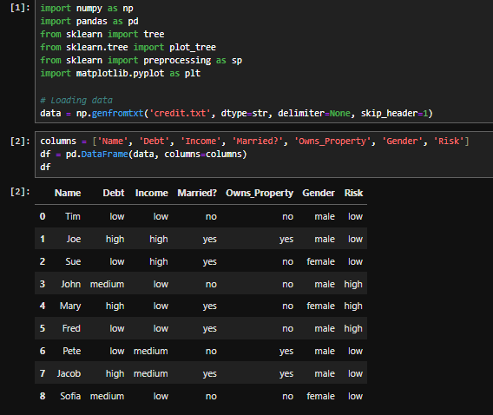

**Step 2: Build the Decision Tree**

Using an algorithm like ID3, we can calculate the entropy and information gain for each attribute, then split the data accordingly. The decision tree would likely prioritize attributes that provide the highest information gain.

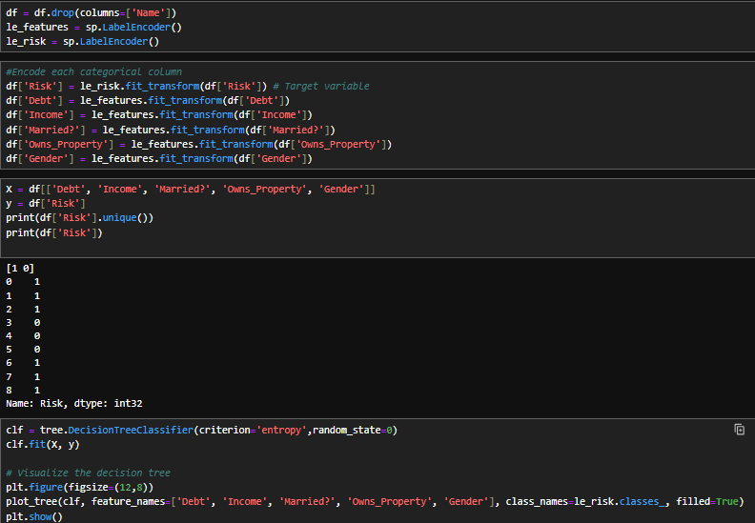

Here’s a simplified decision tree structure (code-based):

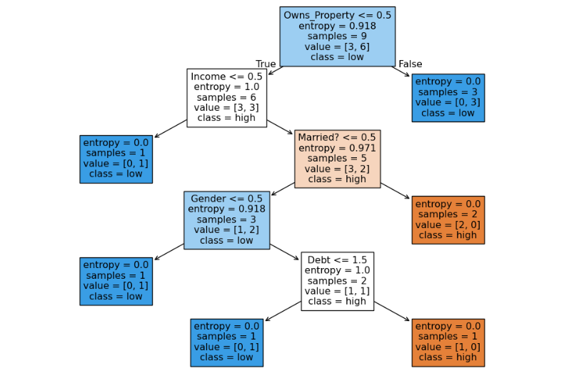

**Step 3: Predictions for Tom and Ana**

* **Tom** (low debt, low income, not married, owns property, male): Following the decision tree, for low debt and low income, the risk is predicted as **low**.
* **Ana** (low debt, medium income, married, owns property, female): For low debt and medium income, the risk is predicted as **low**.

# Task 2: Effect of Changing Sofia's Risk

If Sofia's risk is changed from **low** to **high**, the decision tree might adjust its structure. Specifically, the impact will likely be on the **Debt = medium** branch, as Sofia has medium debt. This could cause a reconsideration of whether **Debt = medium** always leads to high risk, depending on the balance of the remaining examples.

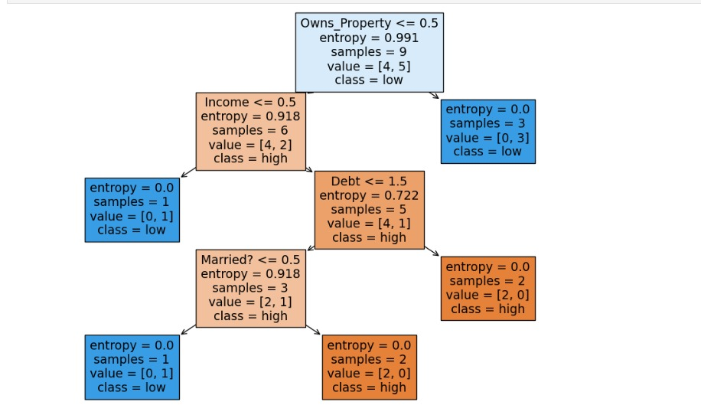

Also, features like **Gender & Name** do not play a significant role, as it does not appear to influence the outcome in the tree (since all predictions are based on debt, income, and marital status).