INVENTORY MANAGEMENT SCREEN

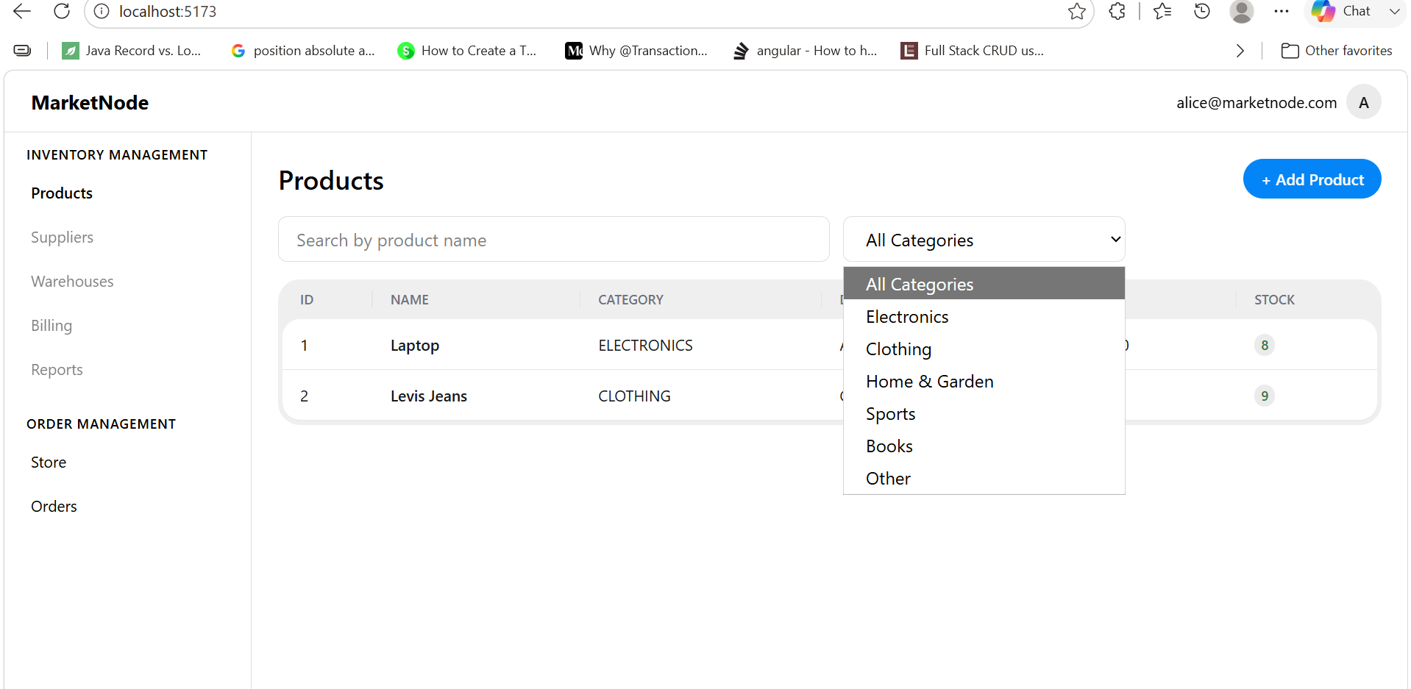

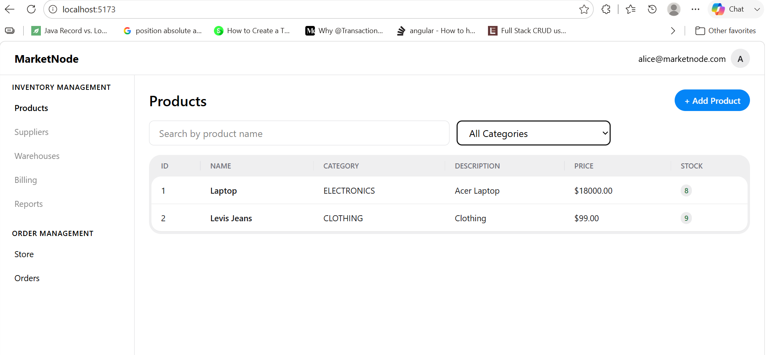
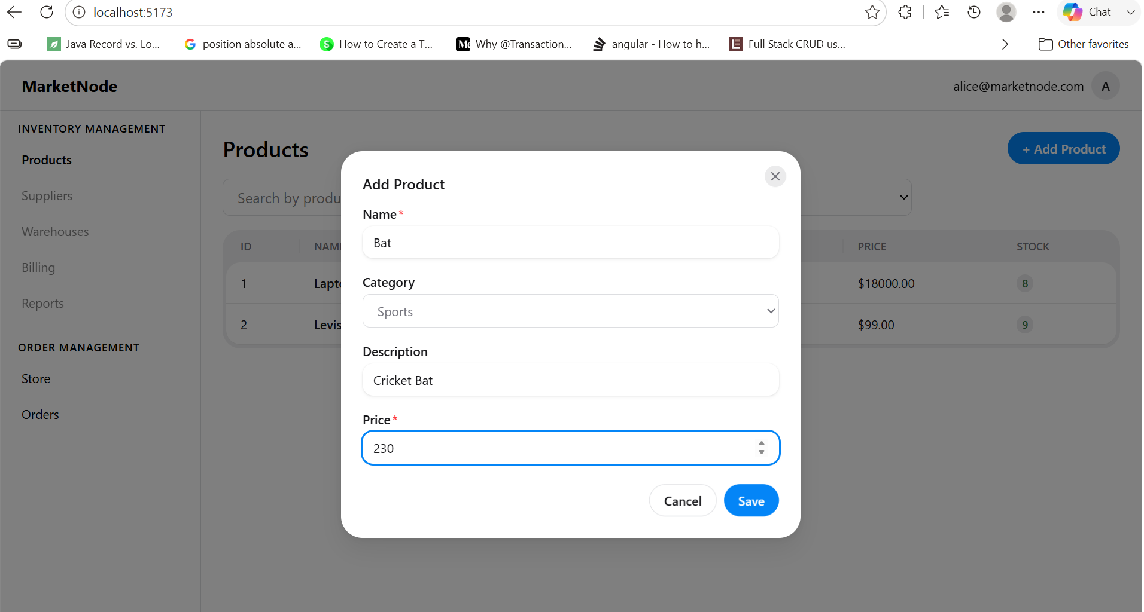

ORDER MANAGEMENT SCREEN

PLACE ORDER:-
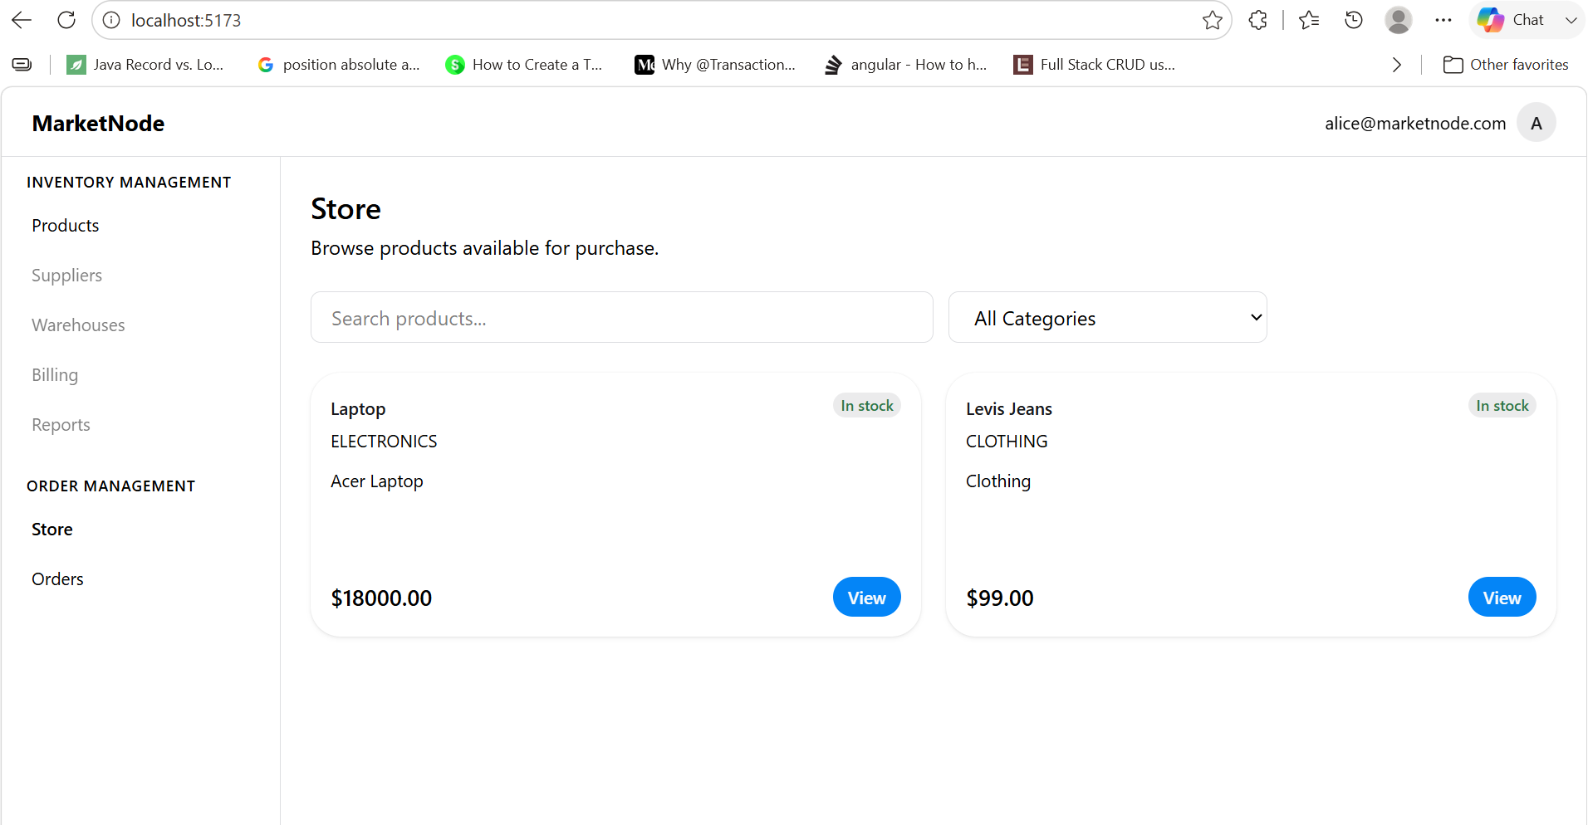
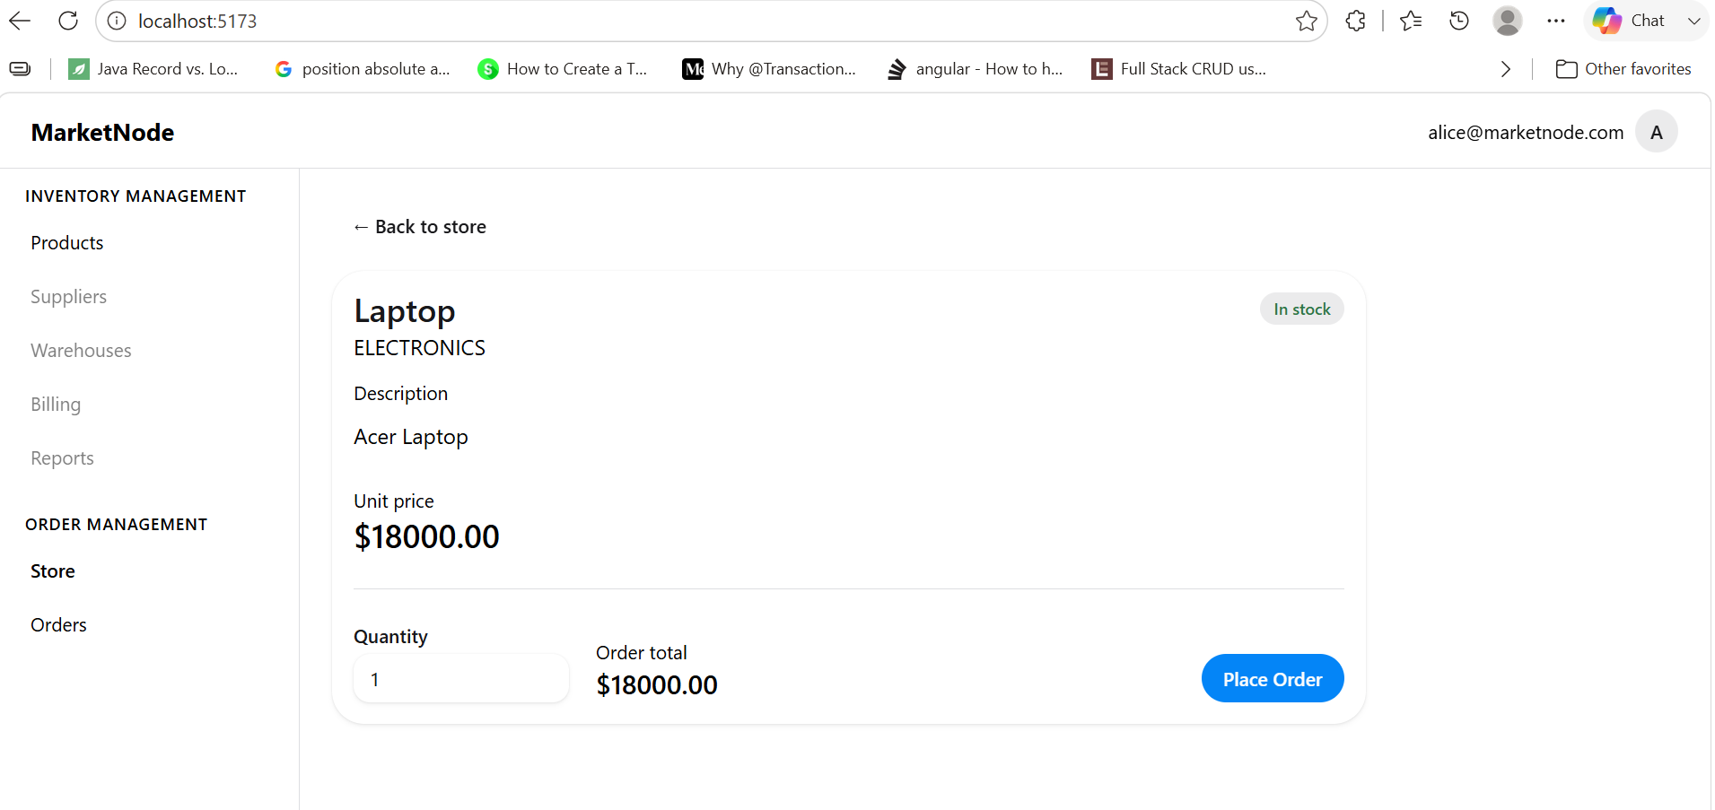
AFTER ORDER IS PLACED
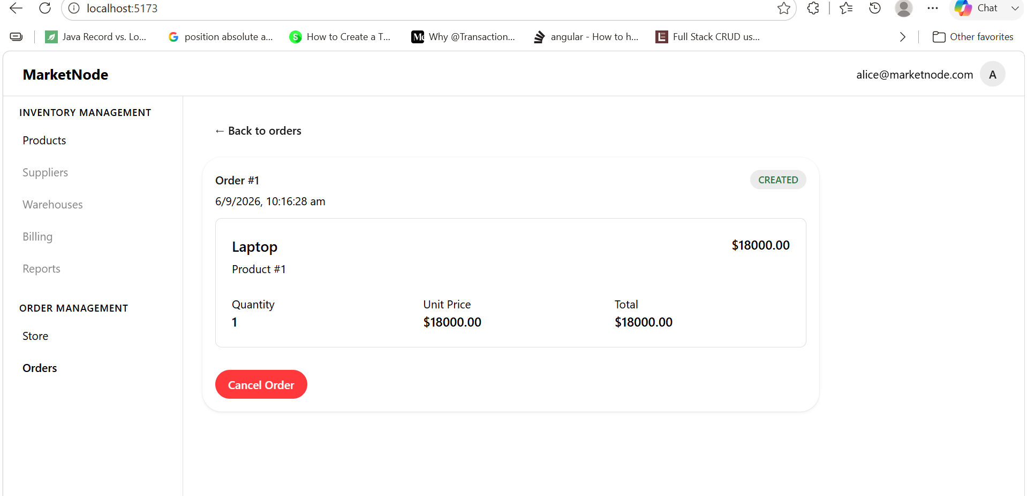

ORDER HISTORY
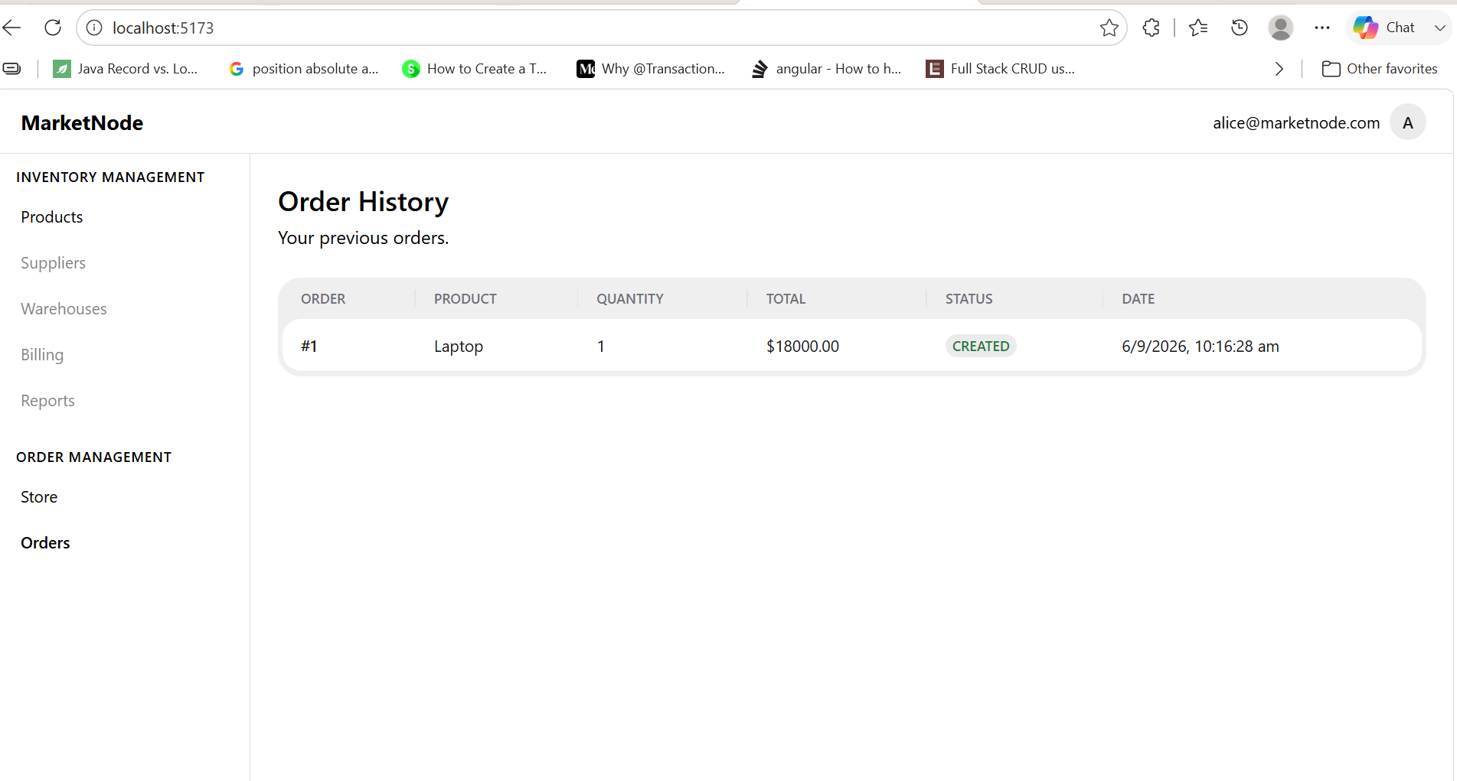
INVENTORY REDUCTION AFTER ORDER PLACED(LAPTOP COUNT REDUCED to 7 FROM 8)

