Advanced Computer Networks – PCS223
Assignment 1
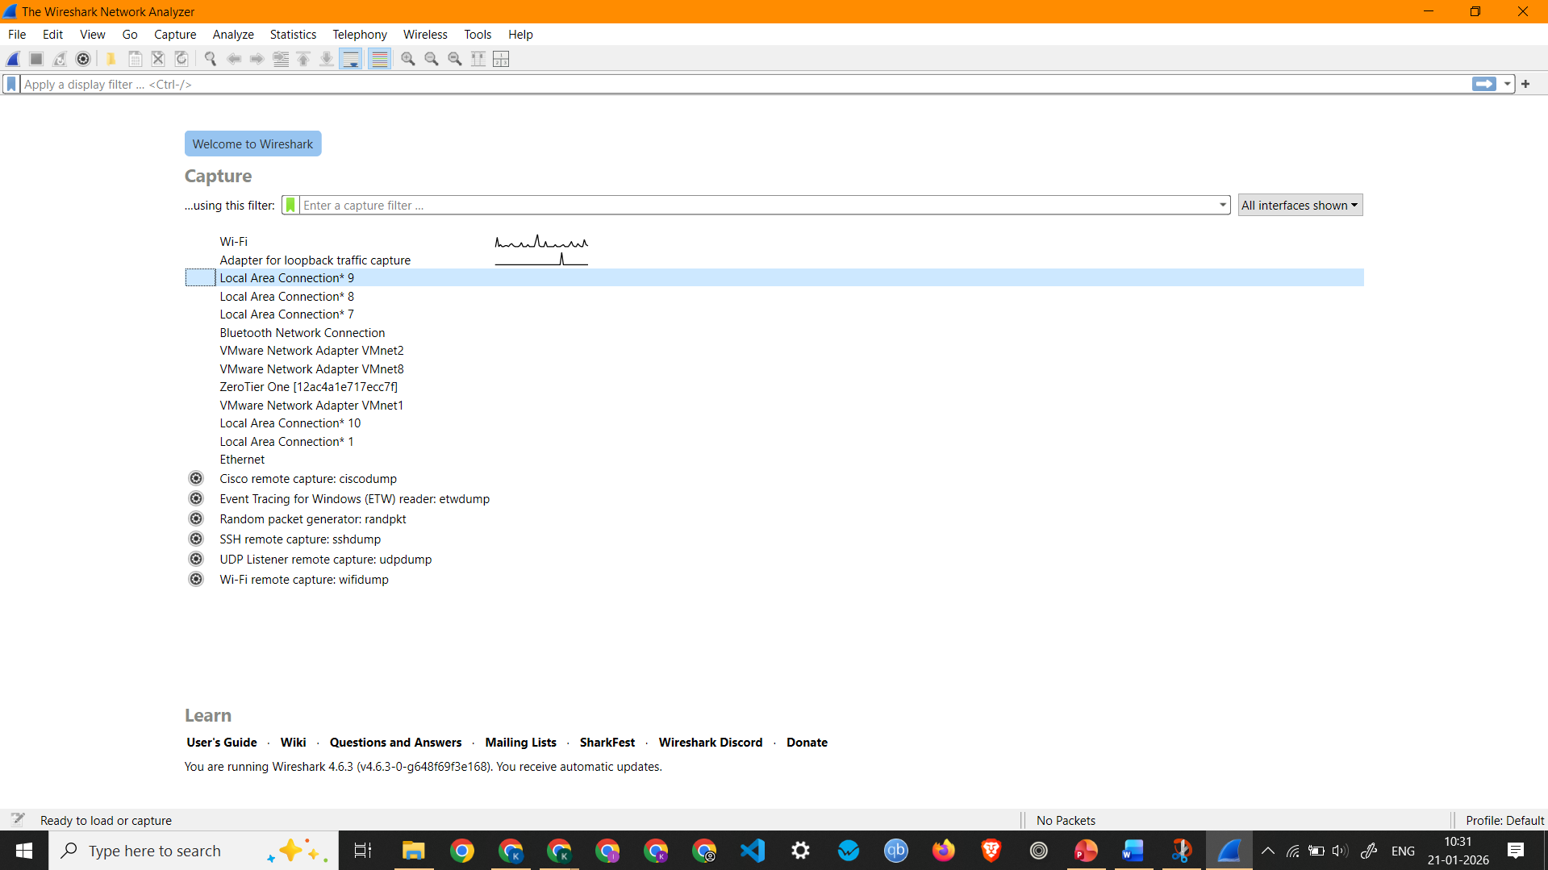

Wireshark Home screen showing all interfaces and the active interface (Wi-Fi)
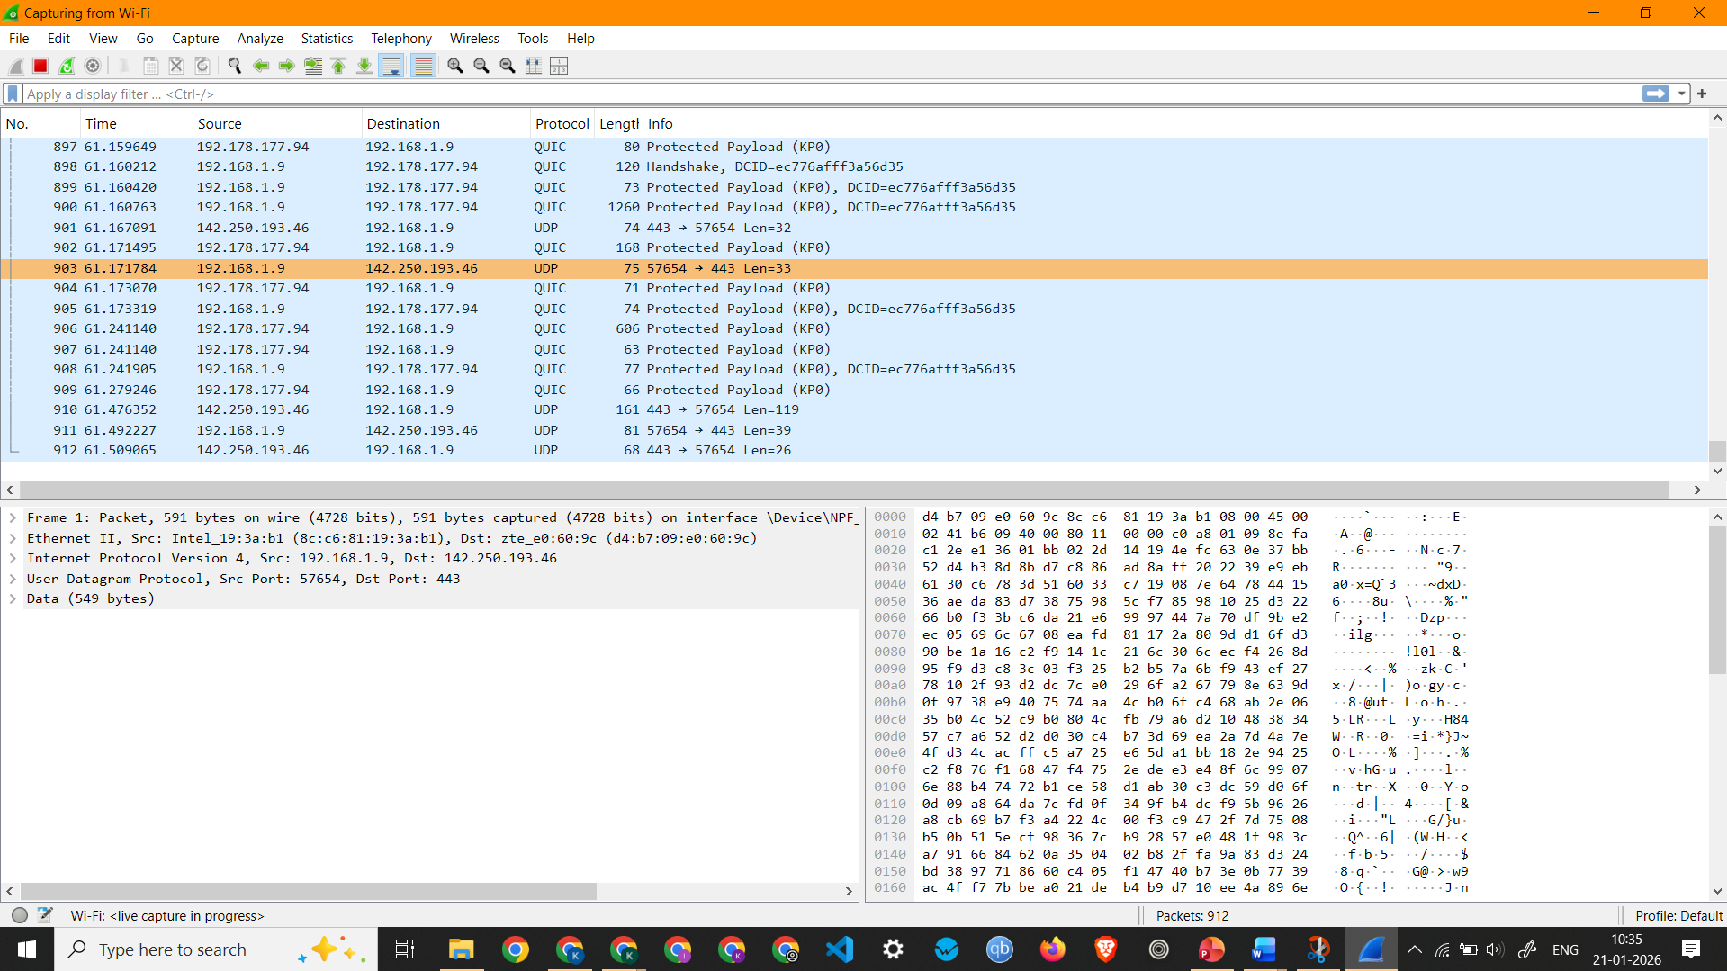
Showing Live Packet Capture on Wi-Fi
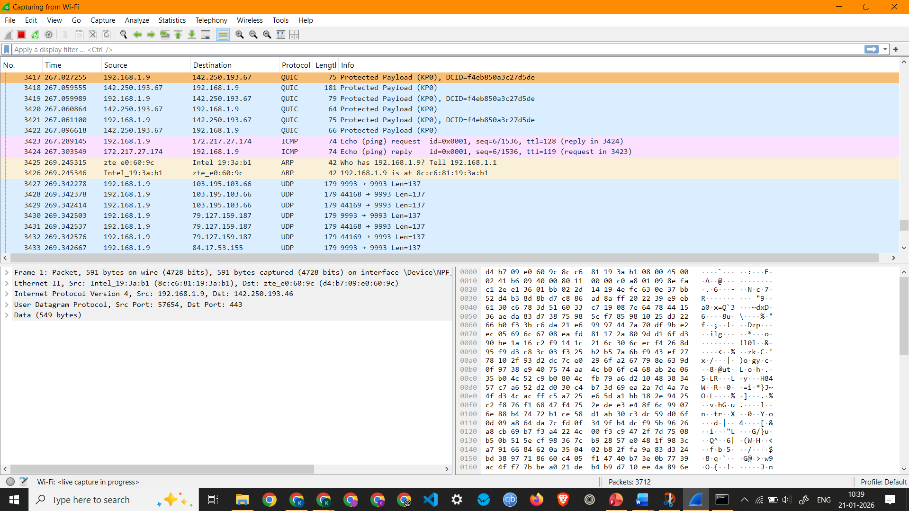
ICMP Packets Captured by pinging google.com

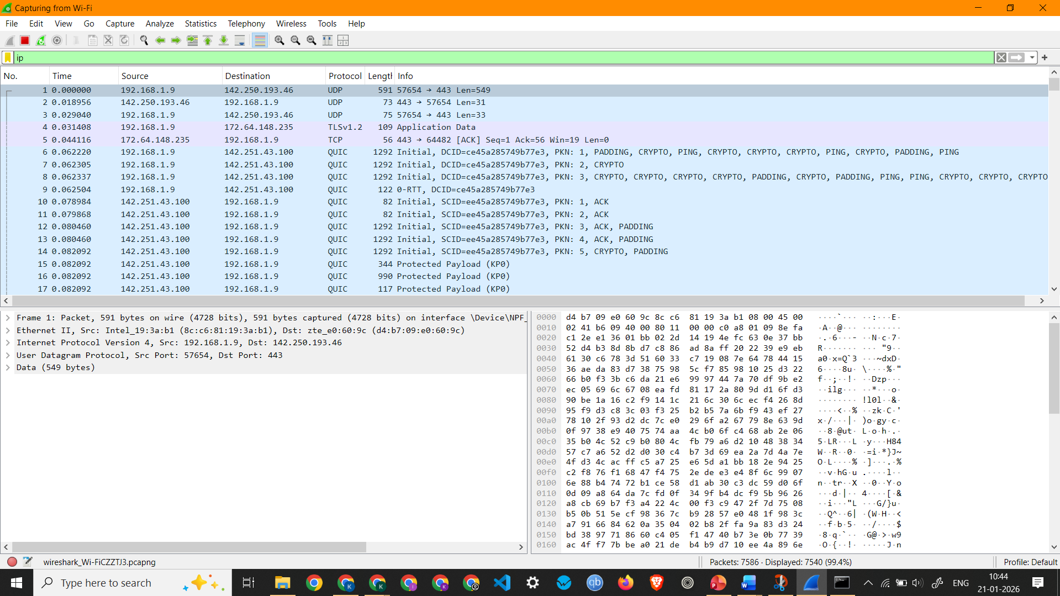
IP Packets
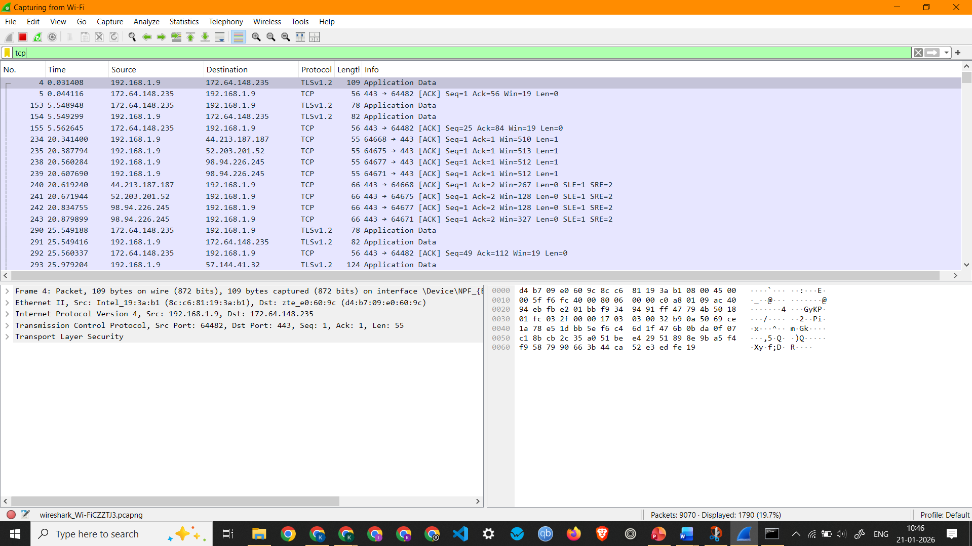
TCP Packets Capture

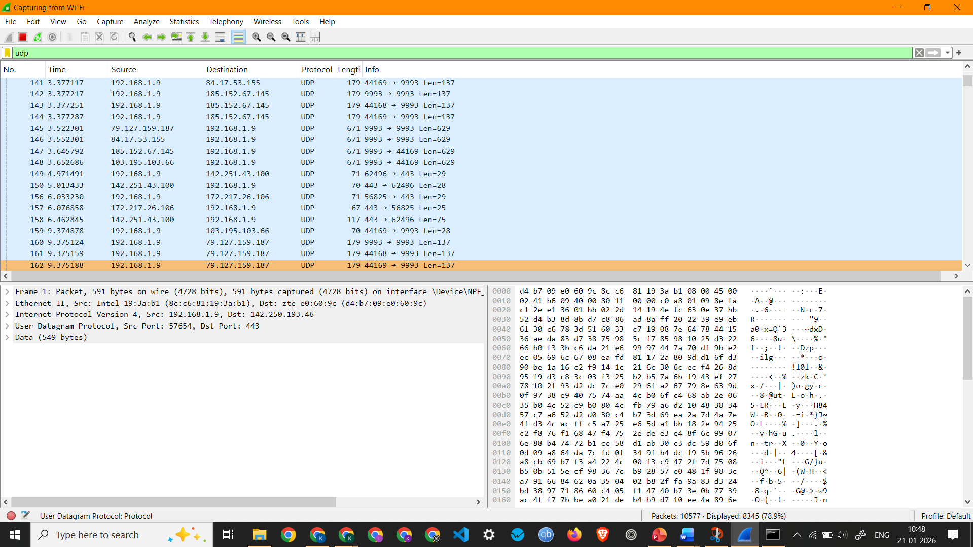
UDP Packets Capture
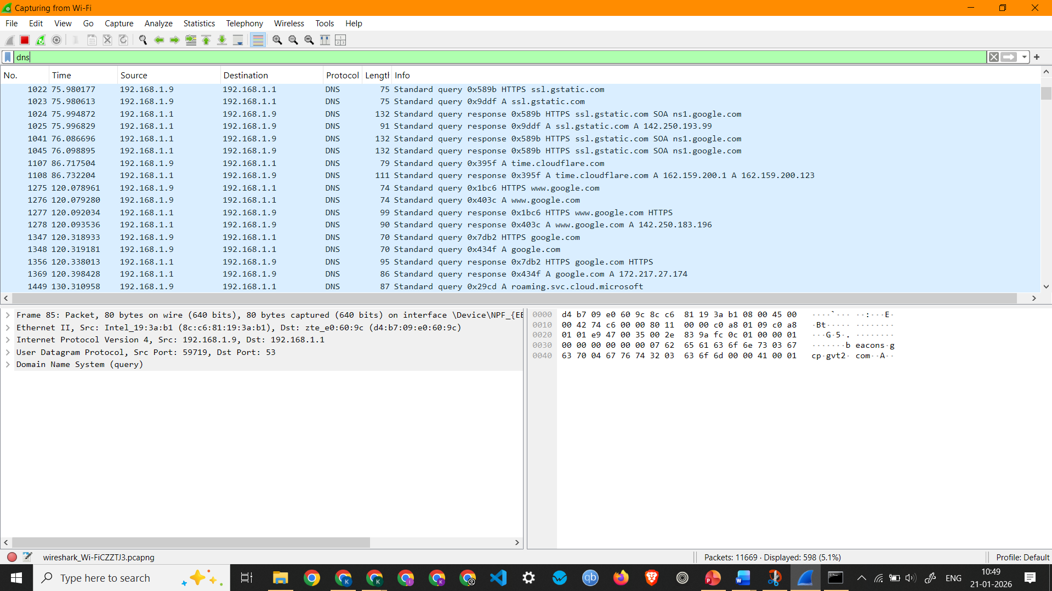
DNS Packets Capture

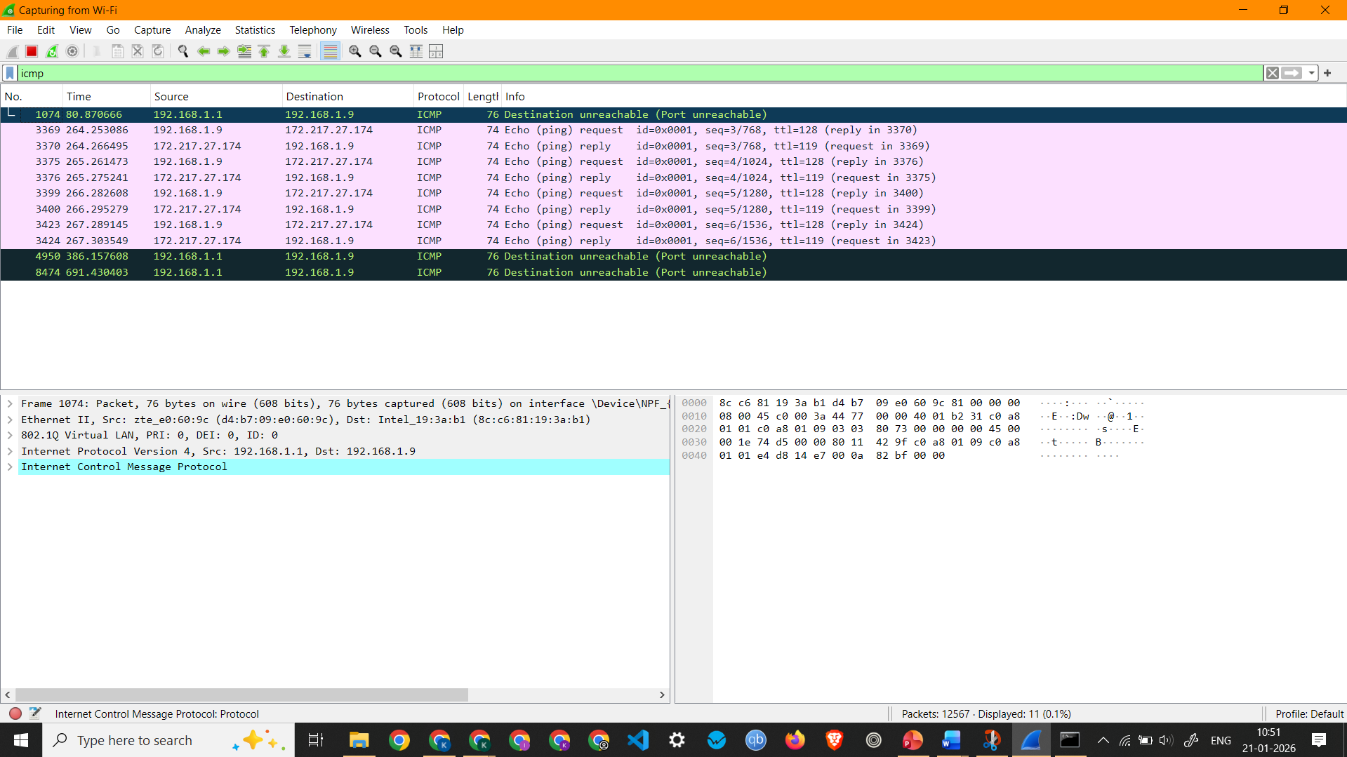
ICMP Packets Capture
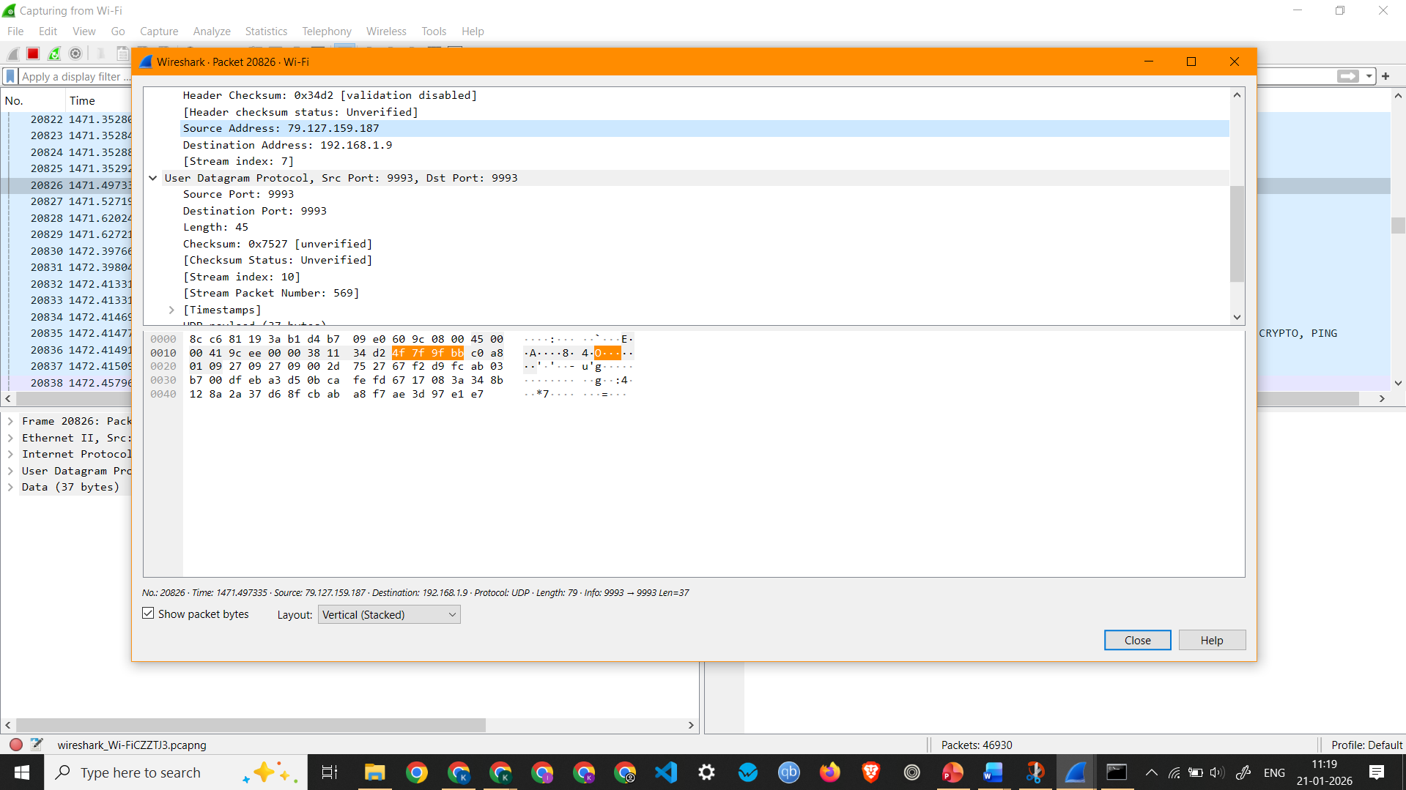
All Details of a UDP Packet

Observation: UDP Packet 20826 –
  - Interface Used: Wi-Fi
  - Protocols Observed: Ethernet II, Internet Protocol Version 4, and User Datagram Protocol
  - Source IP Address: 79.127.159.187
  - Destination IP Address: 192.168.1.9
  - Packet Length: 79 Bytes

