Advanced Computer Networks – PCS223
Assignment 6
Q.1 Objective
To configure and verify routing using RIP Version 2 protocol in a network.

Problem Statement
Design and implement the given network topology in Cisco Packet Tracer with three routers
(R1, R2, R3), two LANs, and PCs using the provided IP addressing scheme.

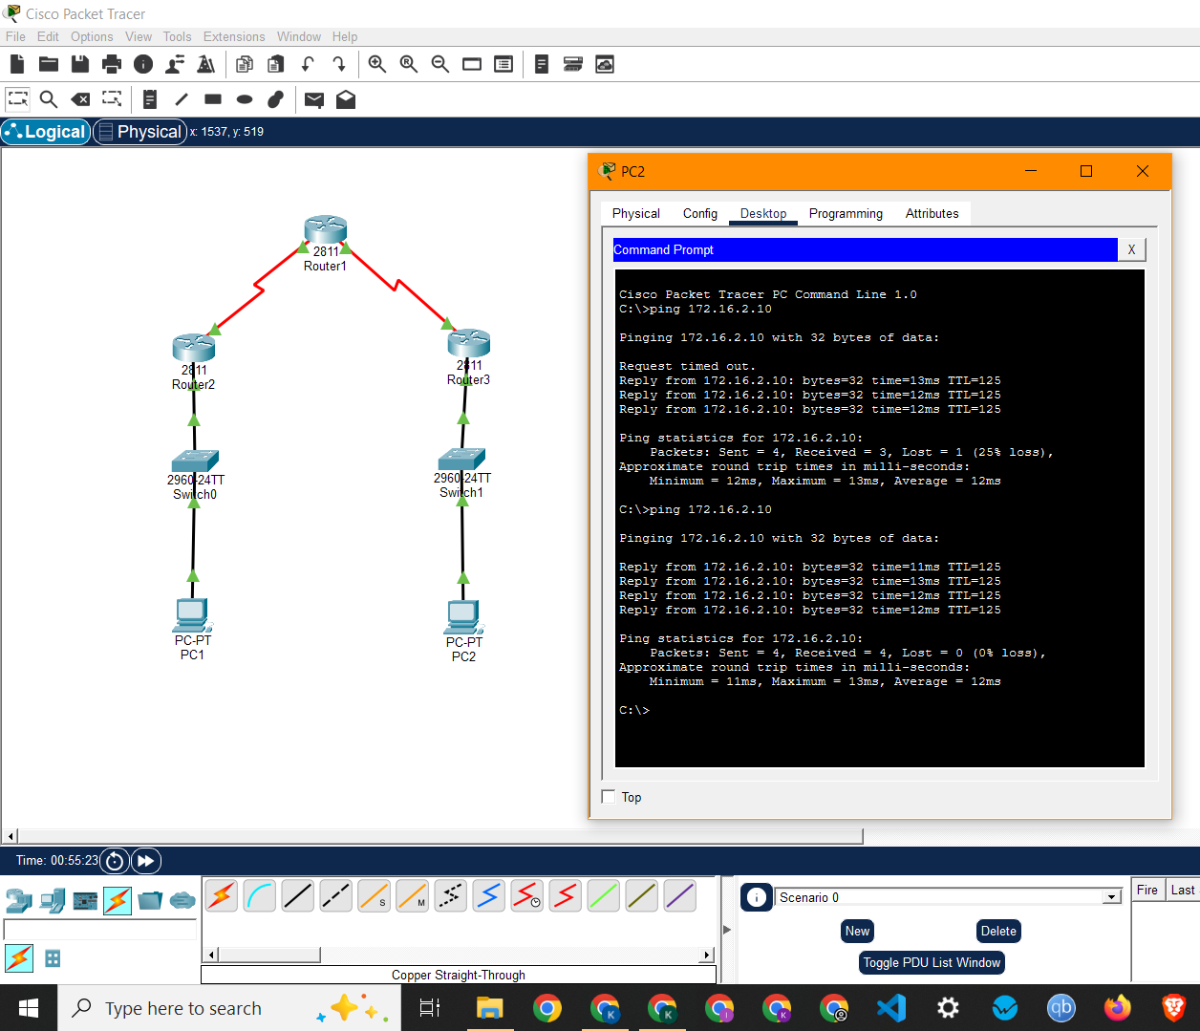

Network topology and successful ping from PC2 to PC1

