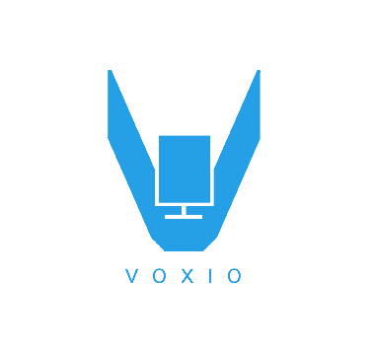**VOXIO**

**Voice to Sign Translator**



**Problem Statement !!!**

Imagine a world without sound and the frustration of trying to express what you feel or need to others !!! Is it possible…?Over 5% of world population, 360 million people worldwide have disabling hearing loss. From child hood, they faces many problems in communication .So they are “Being Left Out” of things.



DESCRIPTION

* VOXIO – Voice to text & sign language translator
* The interpretation based on American standard sign language(ASL).
* what we say or write in English is immediately translated into corresponding text and sign
* Voice to text translation is done through Google API then corresponding sign is retrieved from database and shown is screen.
* It is not meant as a replacement for human interpreters.
* It gives deaf a new voice. Deaf people can use this app as a personal assistant.

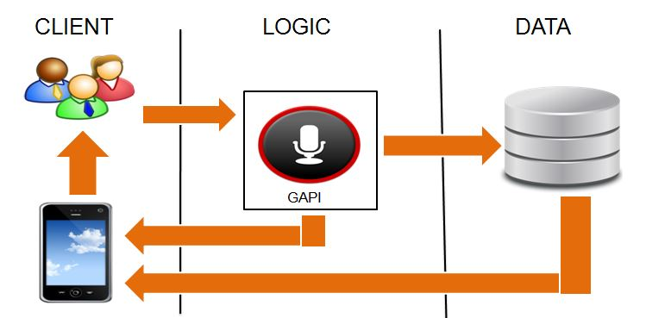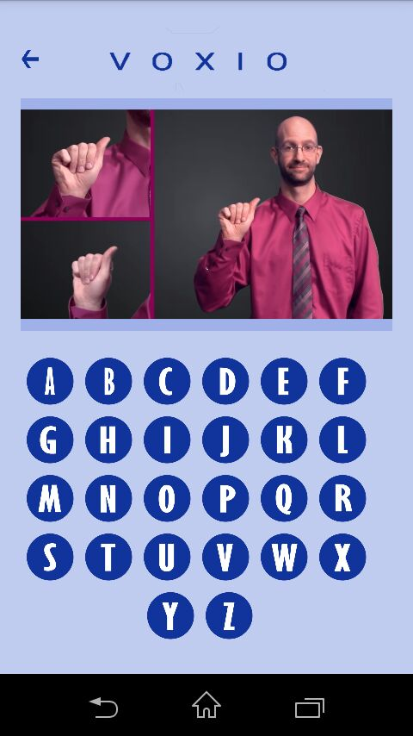 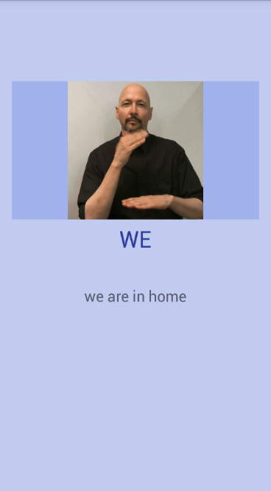

**ARCHITECTURE DIAGRAM**

FEATURES OF THE SYSTEM

* Real time translation
* User friendly
* Sign language learning tool
* Speech Recognition
* Play Quiz
* Efficient, effective communication
* Increase language and literacy skills
* Enhance independence and self-confidence.

**Team Members : Jismi Johnson**

**Sona S**

**Jithin Joy C**

**Project Guide : Ms. Ninu Francis**

**Asst.prof.CSE dpt**

**JECC**