

**ITMD – 510 Object Oriented App Development Phase II**



Sonita Bose

A20447922

**Contents**

Introduction ............................................................................4

Reason for developing this project............................................ 5

Benefits...................................................................................5

Expected outcomes ................................................................ 6

Application Features............................................................... 7

Technologies Used (Front-End and Back-End) and Domain ........8

Initial High-level architecture ....................................................9

ER Diagram............................................................................10

Gantt Chart timeline ……………………………………………………………..11

User Login ………………………………………………………………………….11

New User Registration …………………………………………………………12

Different User Profiles ………………………………………………………….13

Buyer Functionality……………………………………………………………….13

Vendor Functionality …………………………………………………………….14

Screenshots …………………………………………………………………………16

Validations of Login ………………………………………………………………26

Conclusion……………………………………………………………………………28

Future Developments ……………………………………………………………29

**Introduction**

The objective of the project is to create a platform for sales and purchase of “PERISHABLE” goods like fruits and vegetables. Currently the process is carried out by traders at district levels and cities with the last mile distribution done by retail vendors. The drawback with this system is that the sales price derived at any point factors in the risk of wastage since it might not be sold and goods being perishable. If the quantity to be sold is confirmed the entire trade system can be operated at lower risk coverage which benefits all stakeholders of the system.

**Reason for developing this project**

The objectives achieved by this project.

1. This application is designed for customer-end-marketing of perishable produce with zero premiums to cover wastage.
2. This application provides a process for optimum price discovery.

**Benefits**

* Implementing the above functionality removes the middleman and his associated margins and costs.
* Retail Banks get a good quality of debt to sell.
* It may be possible to offer Banks to bid for the credit so that we can introduce competition between banks to enable the farmers to avail the cheapest loan.

**Expected outcomes**

The expected outcomes of the application are the following.

1. Customers in a fixed price eCommerce portal would be limited to binary options. In a market style eCommerce platform, customers can opt for other vendors for the same product which can be sorted price point wise. This application is designed for produce that is essentially treated to be same, irrespective of the vendor, but the customer gets a clear option of the prices available. The customer also provides an expected price acceptable which guides the vendor’s procurement strategy.
2. Vendor in a conventional eCommerce portal generally have to ensure availability of stocks but have no clue about demand. Vendors in this platform get enough time to procure the exact amount of stocks that they need to supply. There is no risk of losses due to wastage of produce. This enables vendors to operate at thinner margins but better profits.

**Application Features**

* MVC Module Frameworks
* CRUD Application for multi-role users to perform different DML and DDL operations.
* Interfaces used to show offers for Vendors and Buyers.
* Admin role available to manage user deletion.
* Application to achieve and optimize the supply and demand chain where buyers place orders and vendors place offers depending on the supply demand trend.
* CSS styling used for the look and Feel of the project along with Scene builder.

**Technologies Used (Front-End and Back-End) and Domain**

Front End

JavaFX application code can reference API’s from any Java library. It is used to design the look and feel of desktop applications.

Back End

MySQL Workbench

Java

Domain Knowledge

Ecommerce and Retail

Tools Used

Eclipse IDE: 2018-12 (4.10.0)

MySQL Workbench 8.0

**Initial High-level architecture**

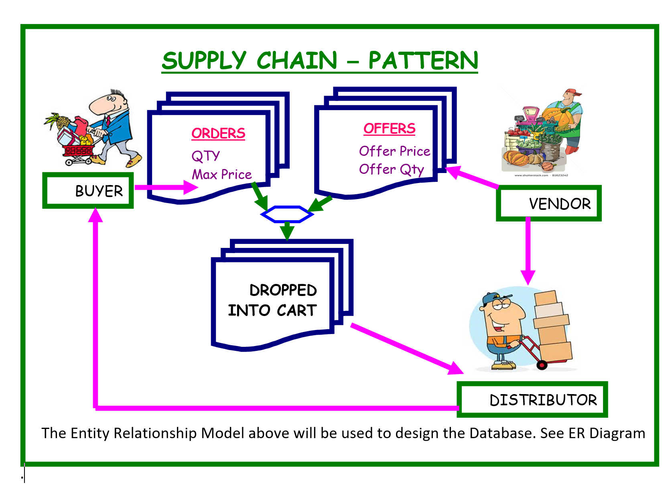

**ER Diagram**

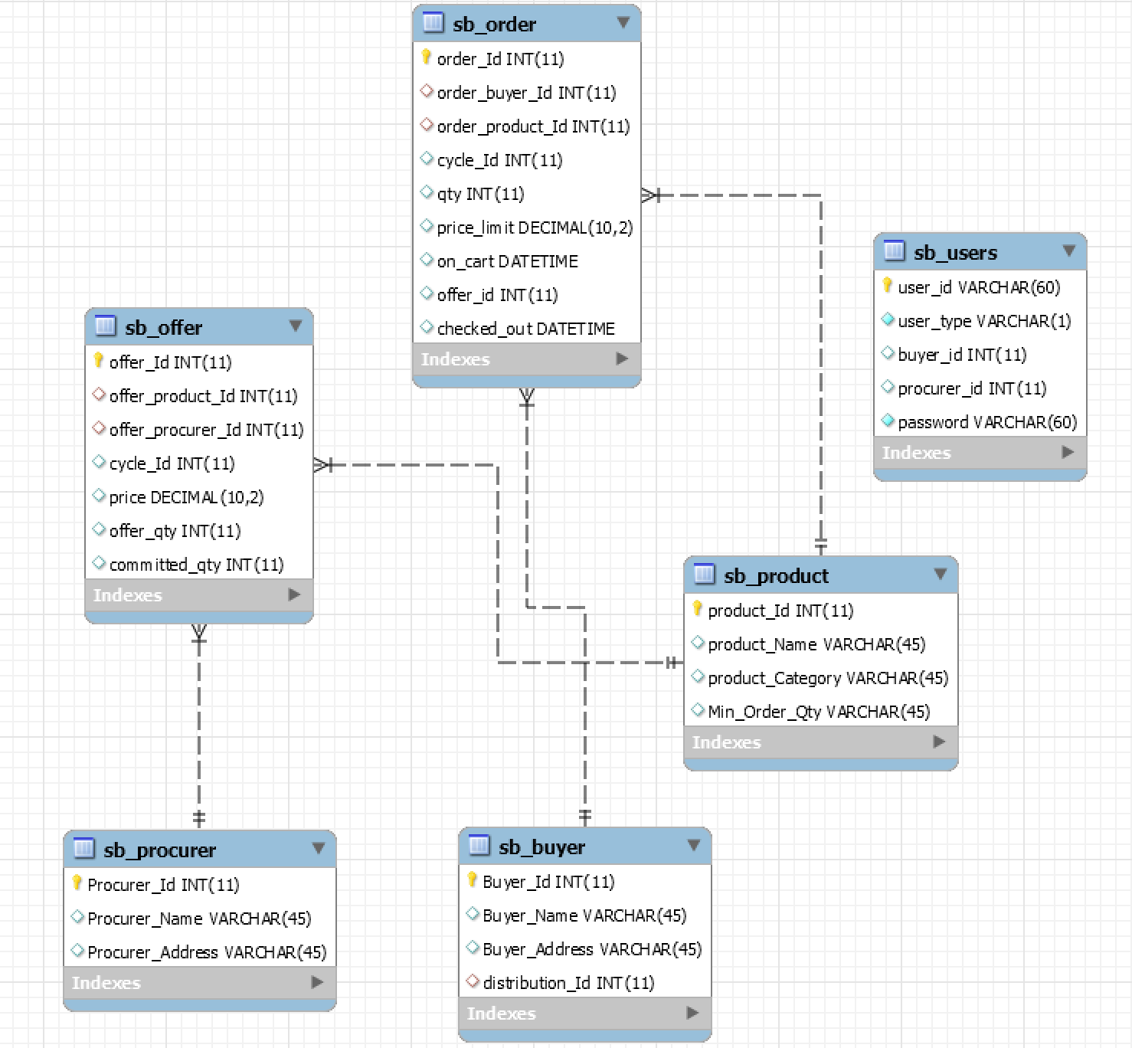

**Gantt Chart timeline**

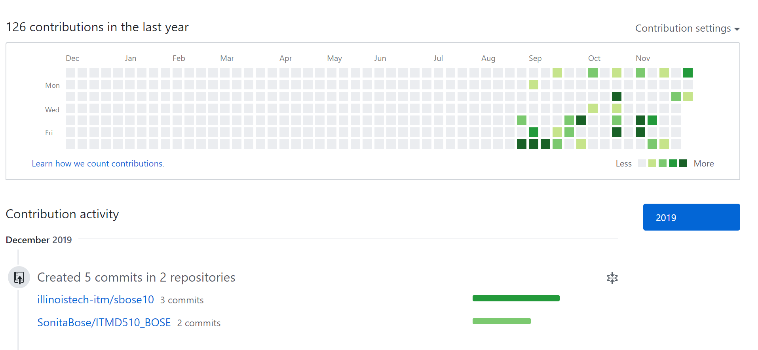

**User Login**

The project consists of five javafxml files

Login.fxml

Buyer.fxml

Admin.fxml

Register.fxml

Vendor.fxml

The code begins from the login page where the user needs to enter username and password if already an existing user.

**User Profiles**

There are three types of users:

* Admins
* Buyers
* Vendors

Existing Login Credentials Buyer:

Username: s@gmail.com

Password: password

Existing Login Credentials Vendor:

Username: Cermac@gmail.com

Password: password

Existing Login Credentials Admin:

Username: admin@gmail.com

Password: password

**New User Registration**

If not an existing user, they need to click on the register tab.

The user needs to select if intend to login as a buyer or vendor.

Created a separate register.fxml and register controller

Based on the type of user different panes are displayed.

User needs to enter ‘B’ for Buyer ‘V’ for Vendor and ‘A’ for Admin.

**Buyer Functionality**

My Orders

On clicking on my orders, the existing orders appears in a table.

Show Offers

On clicking on my offers, the existing offers appears in a table.

Add orders

You can select from a group of vegetables and min quantity.

The buyer can enter “Ask Price” which is the price at which he wants to buy and also the quantity.

After submitting the order he would be able to see it under the my orders tab which is updated in the database.

Logout

The logout tab logs out the user and redirects him to the Login Page.

**Vendor Functionality**

Raise Offers

Vendors can raise offers against any products depending on the material he has in his warehouse

Check All orders

Vendor will be able to see all the different orders placed by buyers and take a decision on the offer he will offer. This is to understand the demand of the market and supply accordingly.

Check All Offers

The Vendor is able to see all the offers provided by different vendors and he would have idea of the market of the selling price of the other vendors.

Check Offers

The Vendor is able to see the offer he has place for the particular product.

Logout

Logs out and redirects to the login page.

**Screenshots**

**Login** :



**Sign-Up**

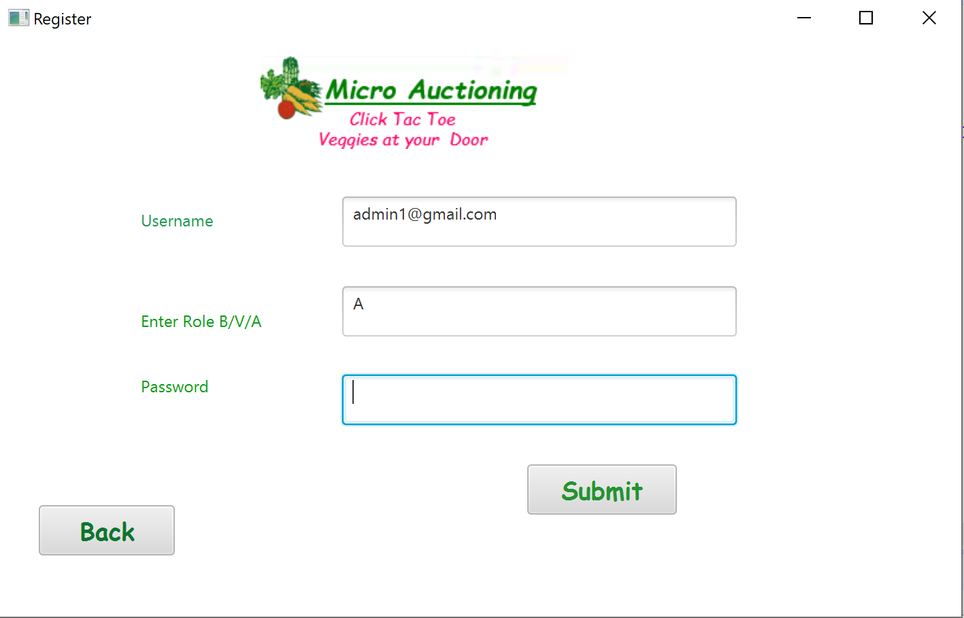

**Pop up : Registered**

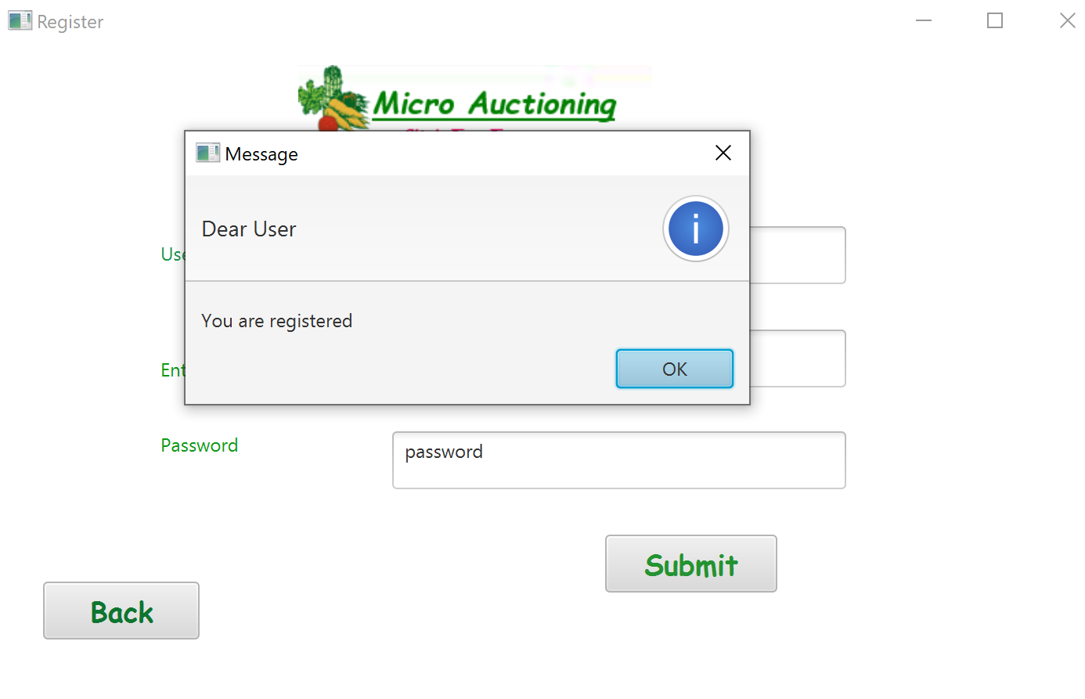

**Admin can delete users**



**Add order**

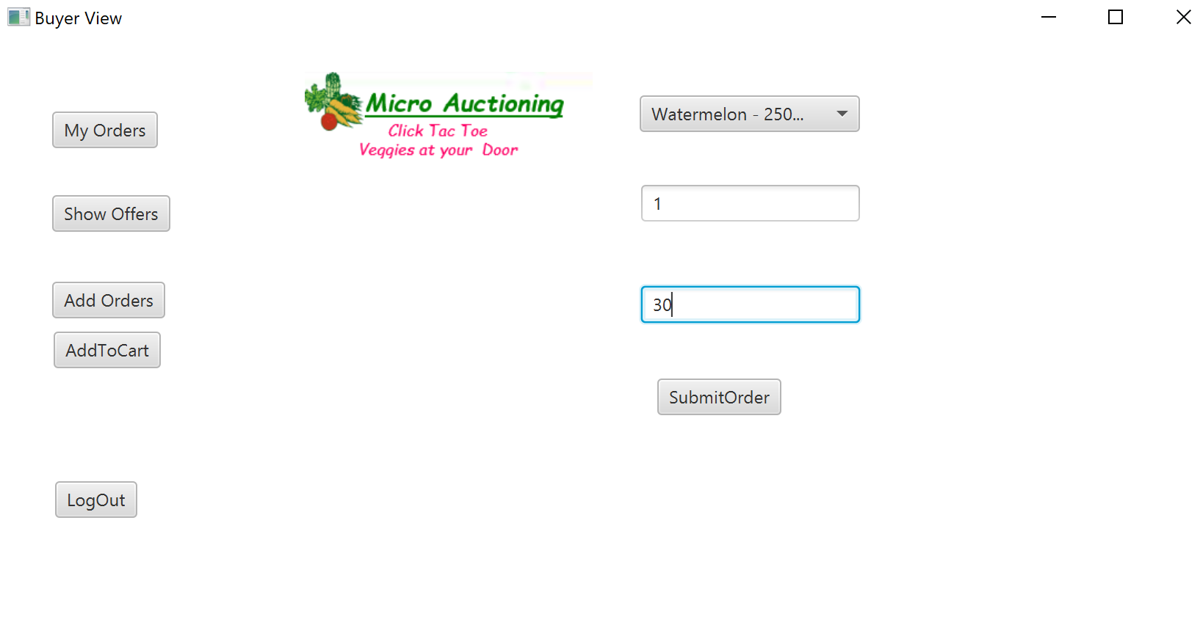

**Submitted order Pop Up**

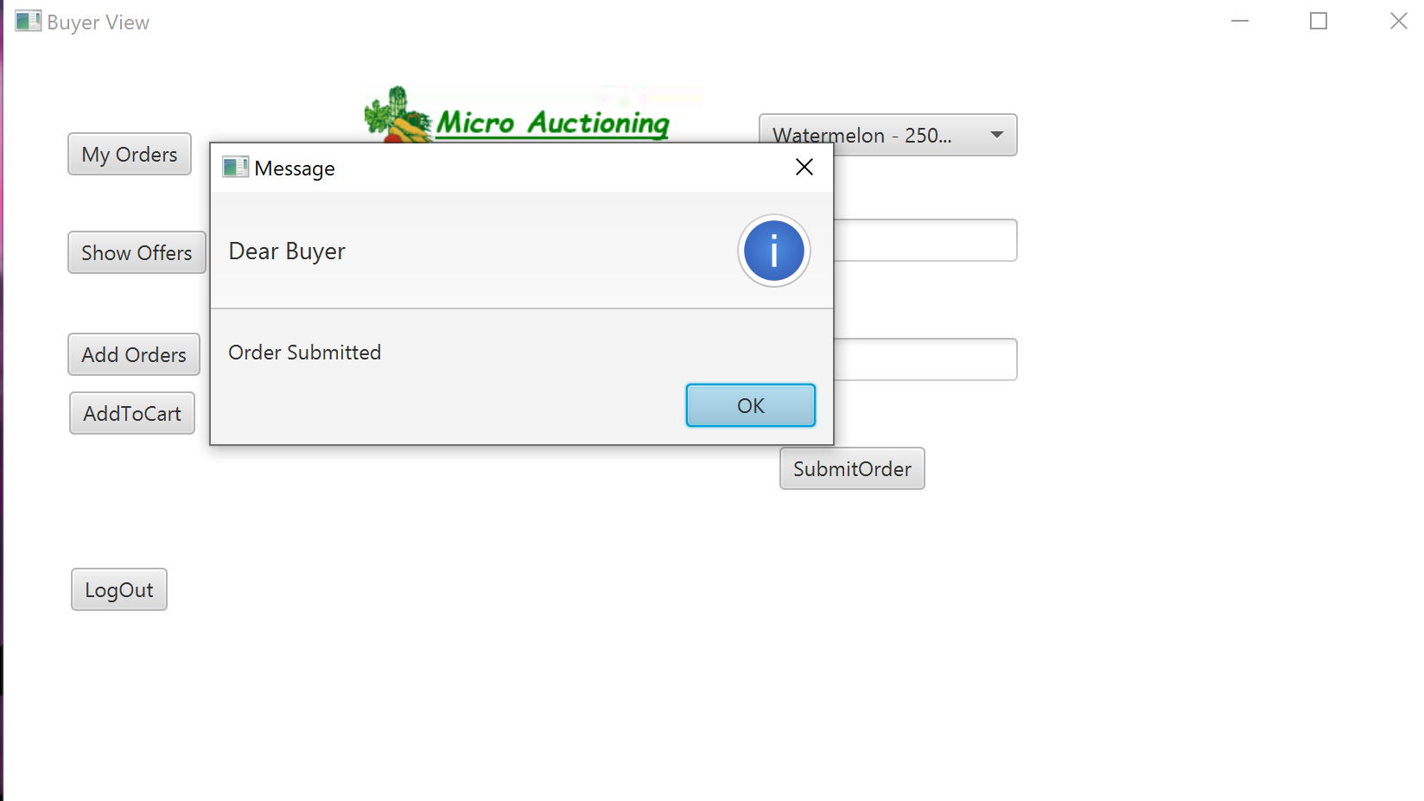

**My orders show Watermelon in table**

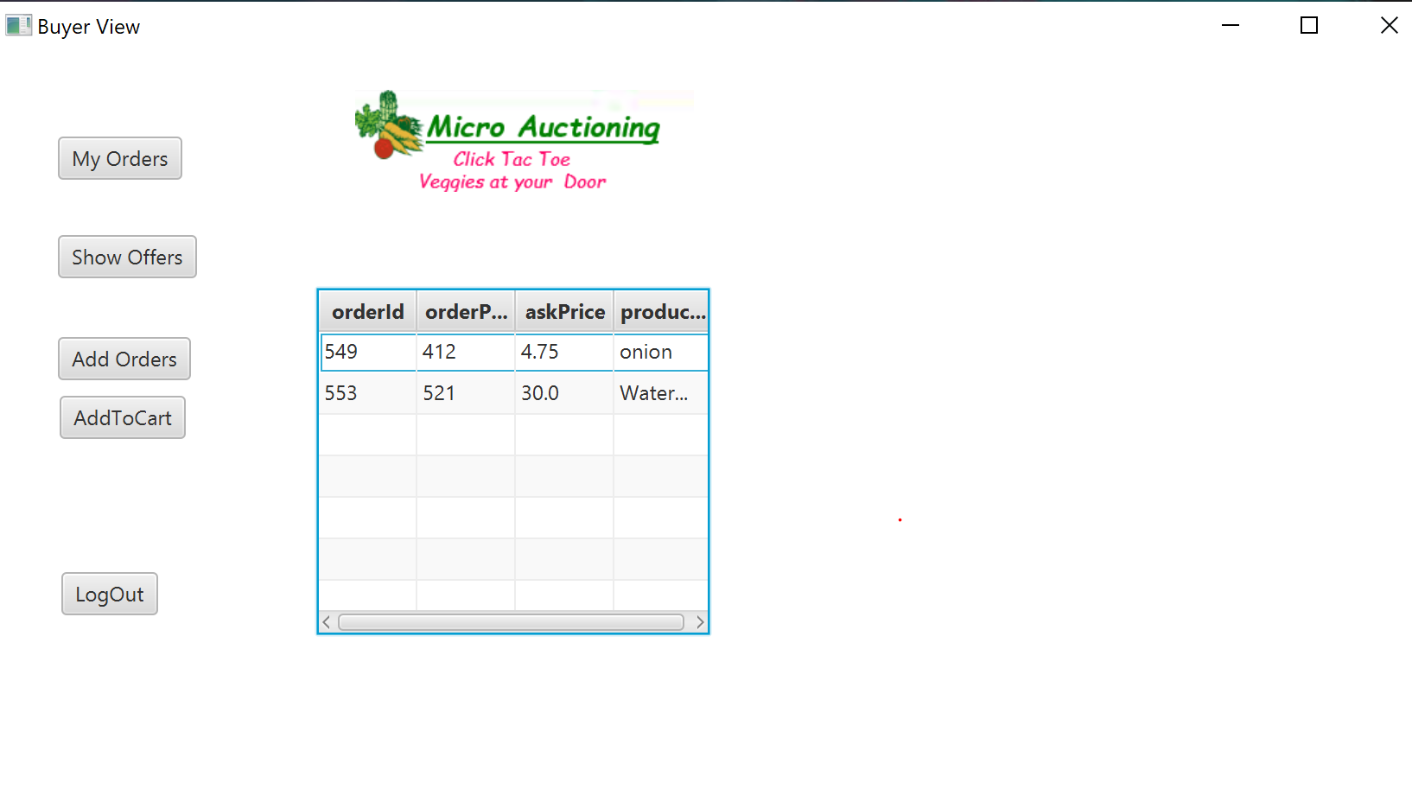

**Vendor Cermac Logged in**

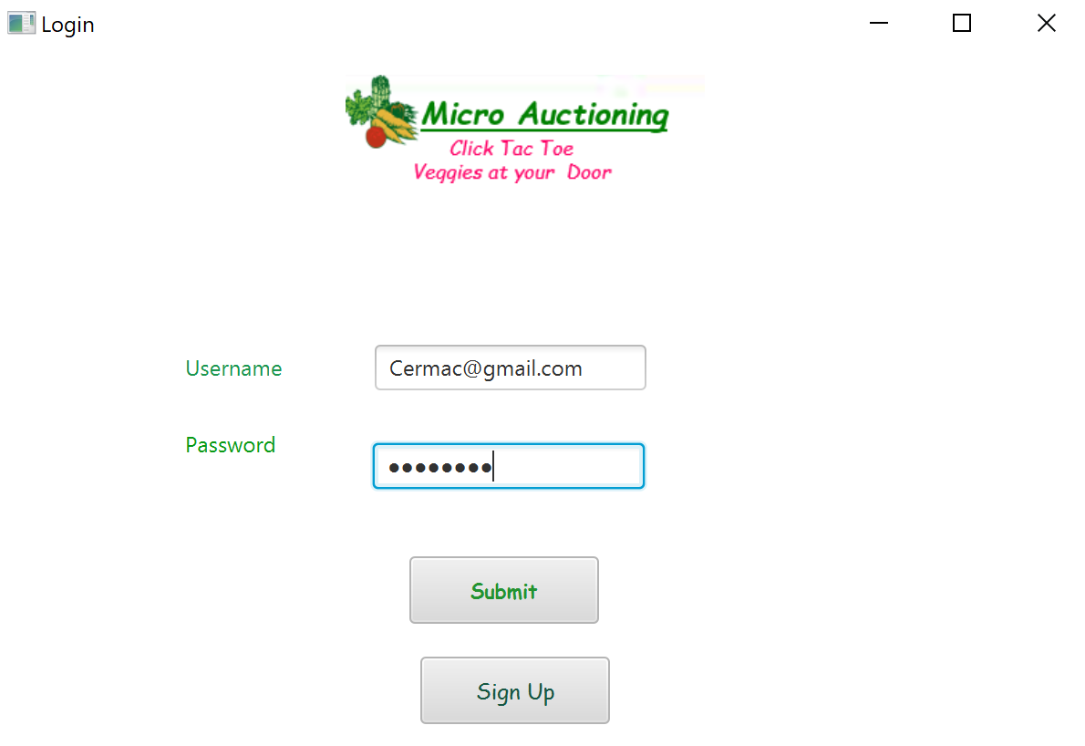

**Vendor Logged in and can see buyers offer of paying $30 for watermelon**

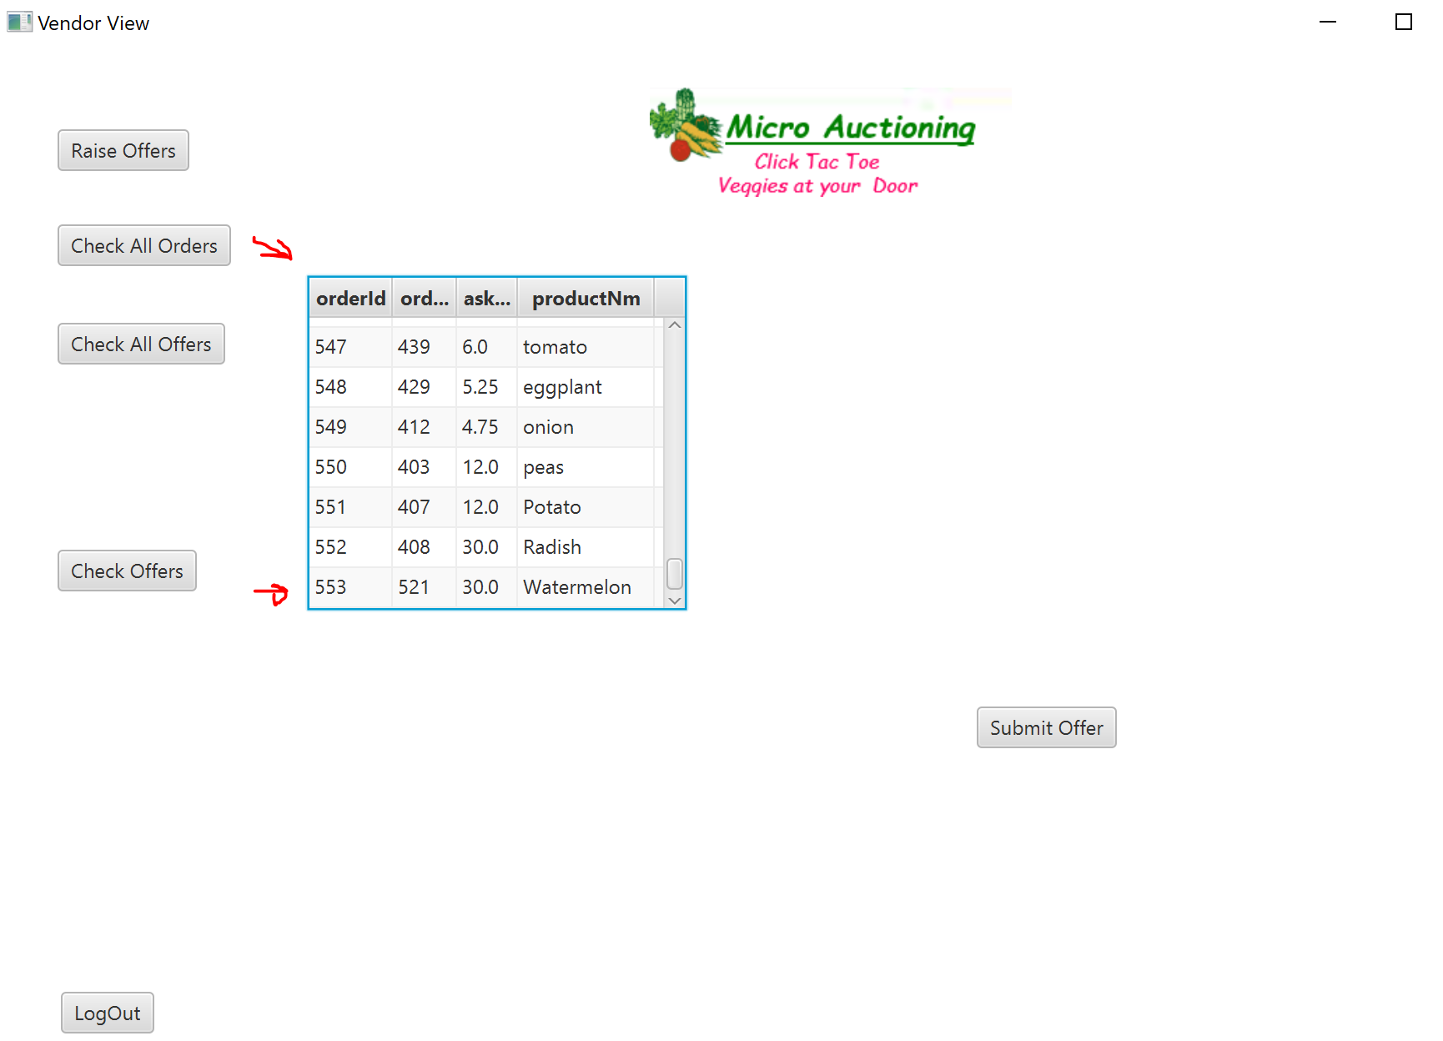

**Vendor can now check all the offers from different vendors and buyers and raise an offer against it depending on the supply in his warehouse**

**Raise offer tab**

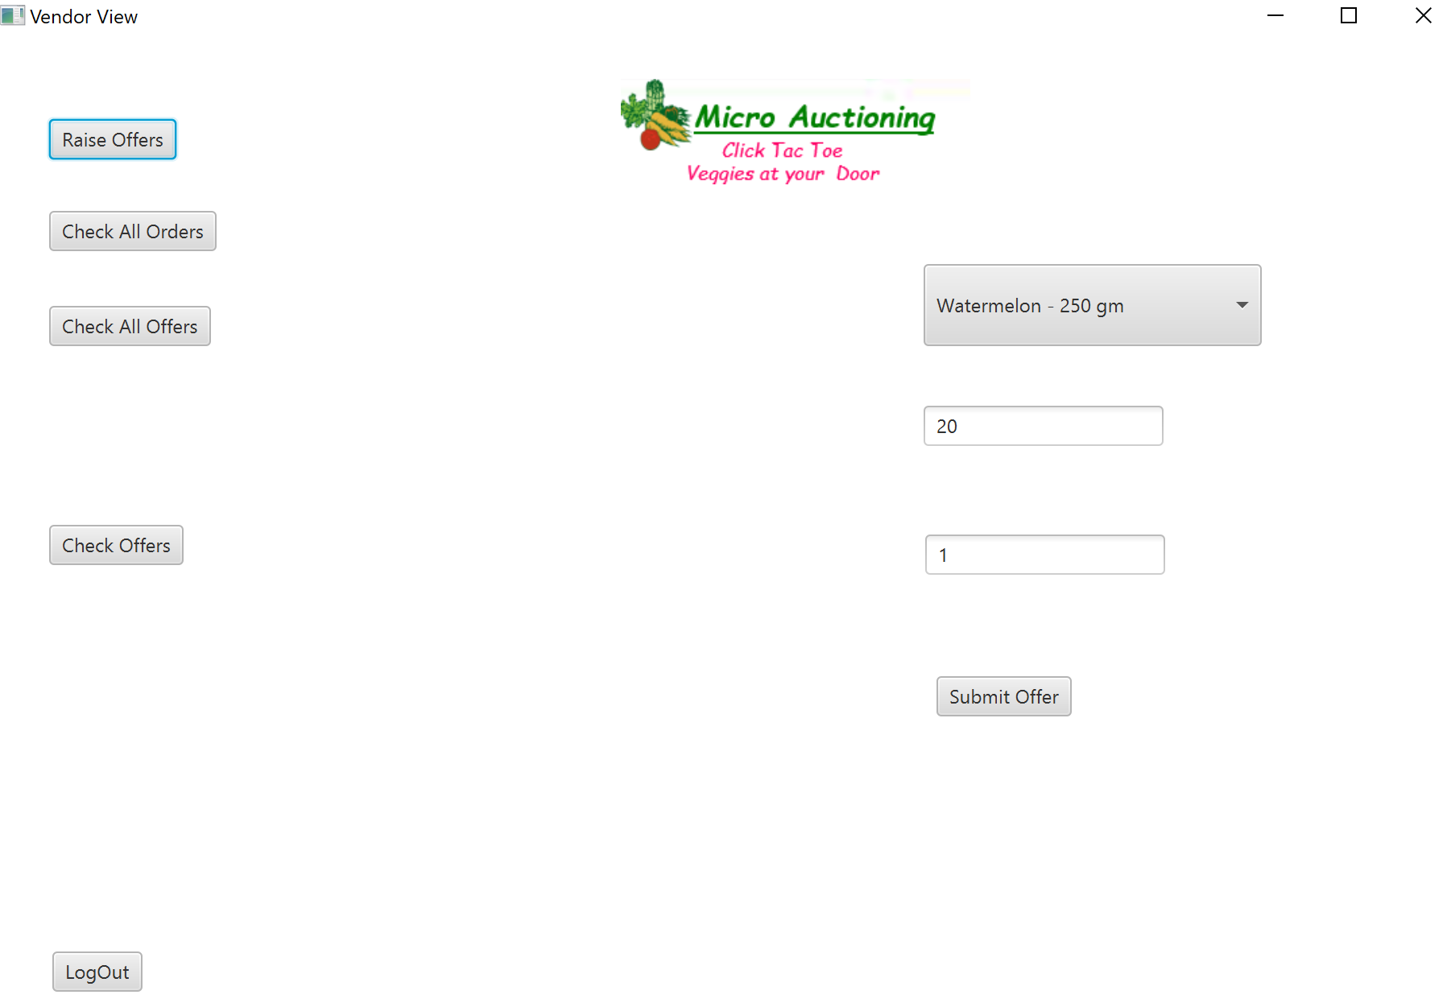

**Vendor raised an offer of $20 for watermelon**

**And he can see that with the Check offers tab**

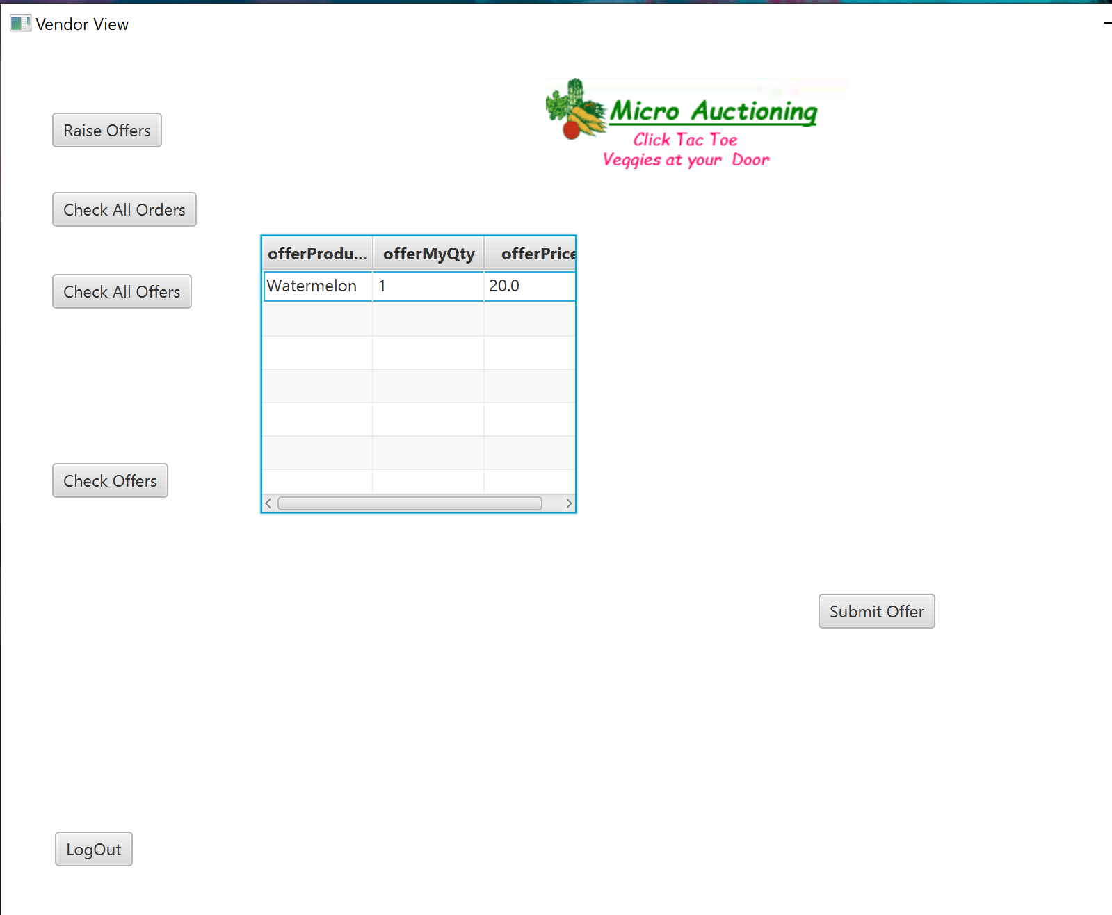

**Check All offers Tab**

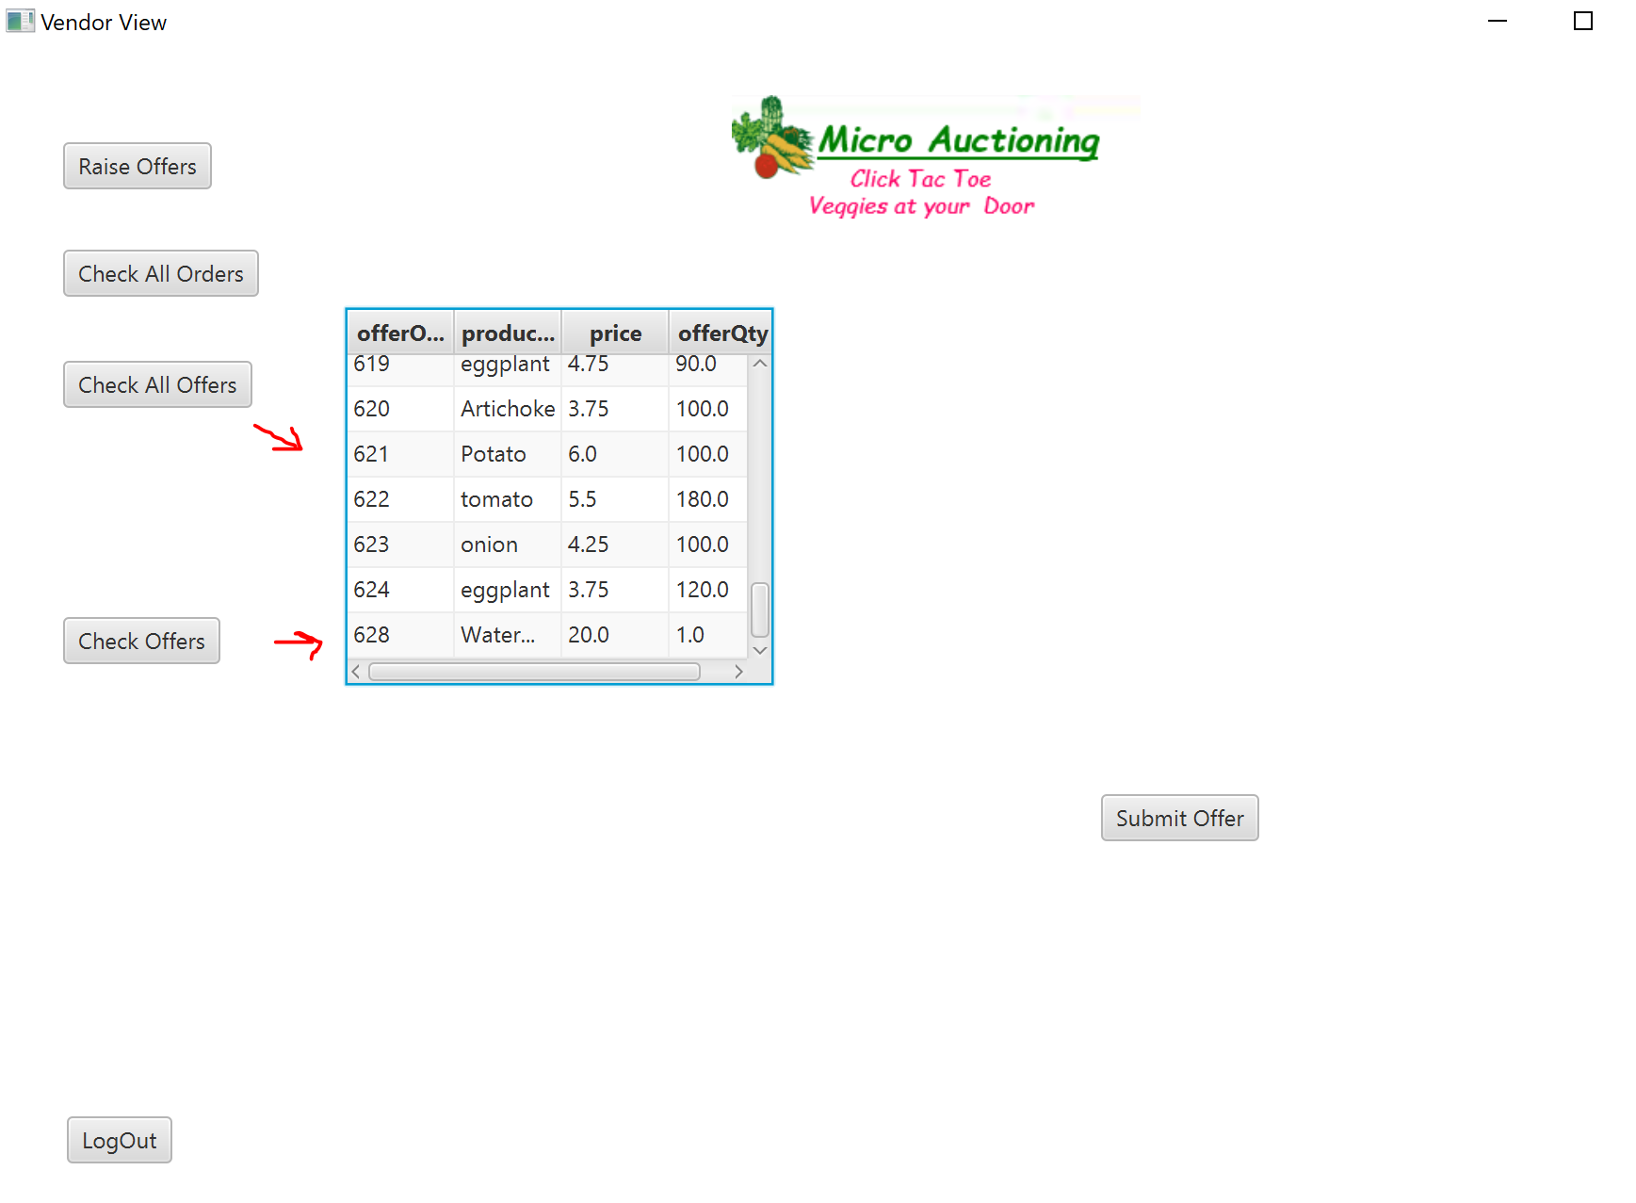

**So buyer has agreed to spend $30 for watermelons**

**And now should be able to see the bid price of watermelons from different vendors**

**Now buyer clicks on show offers and can see that there are two vendors selling watermelons, one at the price of $20 and and for $21.**



**Buyer now will add order from the options in offers received**

**Buyer selected watermelon sold at $20 from the drop down menu by clicking on Add to Cart.**

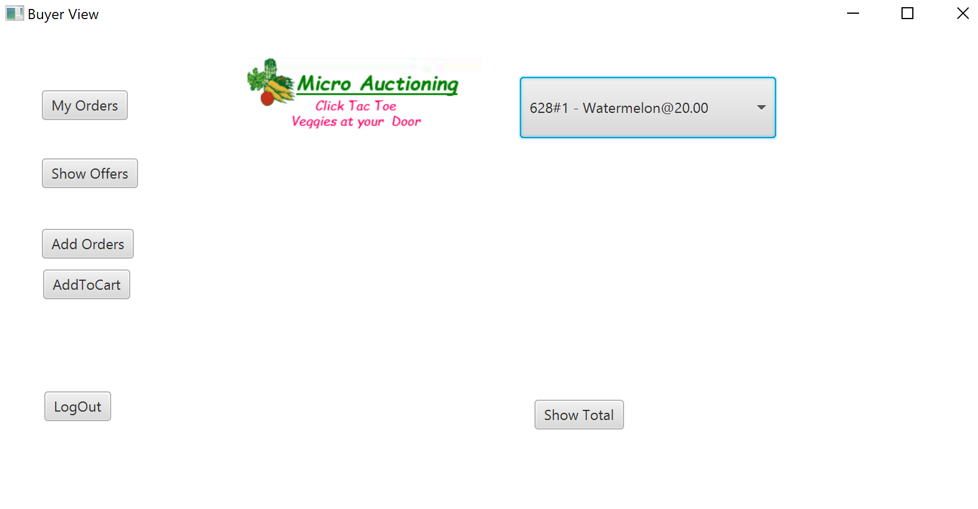

**Now can check Bill by clicking on Show total :**

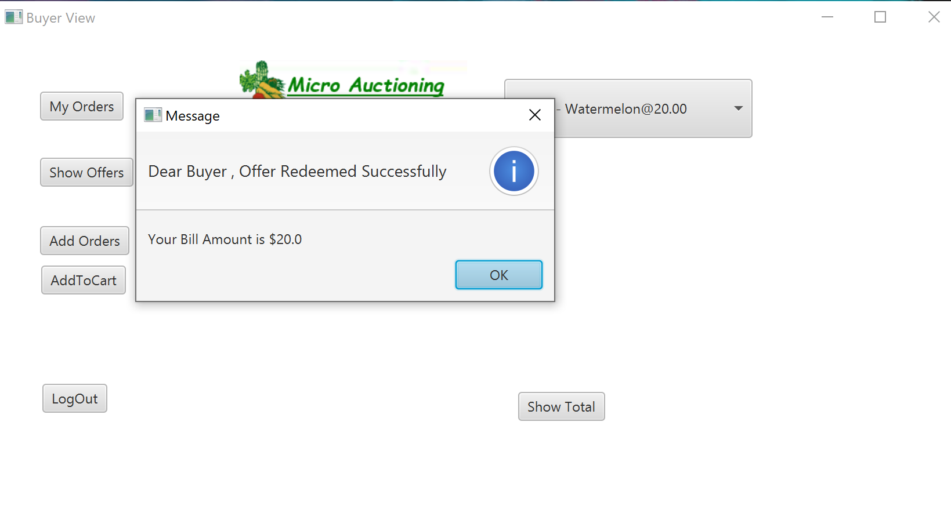

**Validations**

**Password kept empty**

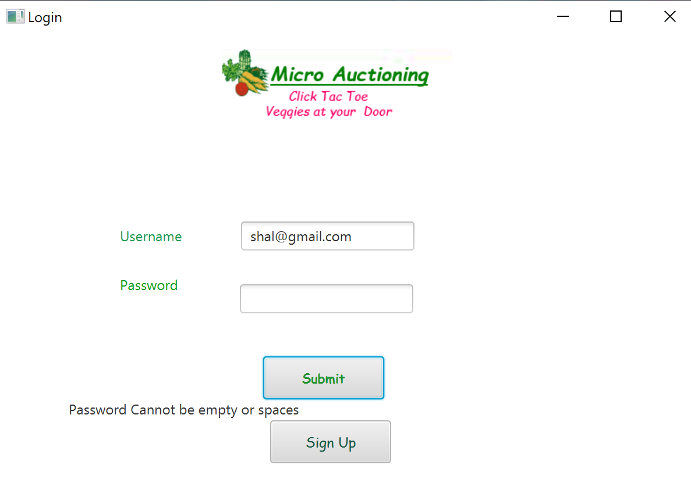

**Username cannot be kept empty**

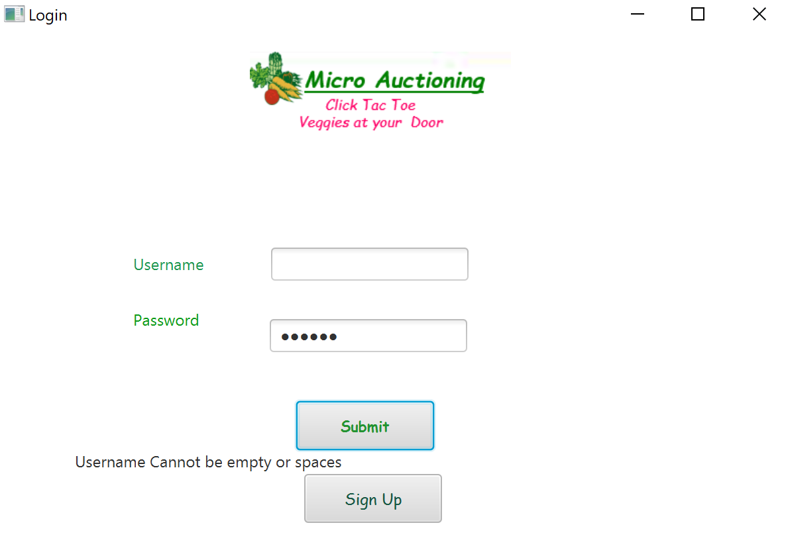

**Incorrect Credentials**



**Conclusion**

* This project is a platform where buyers can raise their orders which is the demand of the market.
* The Vendors are able to see the demand and optimize the cost accordingly.
* Once this application is used on a large scale, we can achieve a better idea of the demand which will help to understand the demand and reduce the wastage of the perishable items like vegetables.
* We need to have a middle man distributor from the farmer and this application can directly be used by Farmers in the future.
* We can achieve a variety of analytics with the increase of usage of the application based on pricing, demand and supply.

**Future Development**

The Future of this application will be to add a functionality where a buyer can place orders for future dates as far as six months or more. Vendors too can place offers for future sales.

This is how it will work

* If the buyer and vendor agree they can seal the deal for a sale on a future date. The buyer will pay upfront a percentage of the total bill.
* In such cases the vendor can be the actual producer of vegetables or the farmer. The platform can stand guarantee to a bank loan that the farmer can avail with the upfront payment as margin money.
* The buyer pays up at a date reasonably near the date of delivery and the farmer gets his margin after the bank recovers its loaned amount plus interest.