STQA Mini Project
Testing of “EduFlow” — Academic Management & Productivity Portal
using Selenium WebDriver, Selenium IDE and pytest

Software Testing and Quality Assurance
BE Computer Engineering

1. Title
Testing of EduFlow, an academic management and student productivity web portal, using Selenium WebDriver (Python, pytest) and Selenium IDE.

2. Problem Definition
EduFlow is a web application used by an institution's administrators, teachers and students. Admins manage users and classes, teachers publish assignments and grade submissions, and students submit work, manage personal tasks and track their progress. Because it handles accounts, grades and uploaded files, defects in login, access control, validation or the assignment workflow directly affect users.
The problem is to plan and carry out systematic testing of EduFlow: write a test plan, define a bug taxonomy, design test cases covering valid and invalid inputs, boundary values, navigation and session handling, automate them with Selenium WebDriver, record Selenium IDE flows, perform exploratory testing, and report the defects found and the overall quality against defined exit criteria.

3. Prepared By
Sr. No. | Name | Roll No. | Class
1 | Soniya Pawar | [Roll No] | BE COMP
2 | Sakshi Jagadale | [Roll No] | BE COMP
3 | Priti Merurkar | [Roll No] | BE COMP

4. Prerequisite
- Core Java: object-oriented concepts (classes, objects, inheritance, exceptions) and collections. Selenium's API (WebDriver, WebElement, By, WebDriverWait) is the same object model in Java and Python, so these concepts carry over directly.
- Python 3: functions, modules, exceptions, and the pytest testing framework (fixtures, assertions). The automation scripts in this project are written in Python.
- Basic HTML/CSS (element ids, classes, forms) and CSS/XPath locators.
- Software testing fundamentals: test plan, test case design, black-box techniques (equivalence partitioning, boundary value analysis), defect life cycle.

5. Software Requirements
Software | Version / details
Operating system | Windows 11 (64-bit)
Application under test | EduFlow (PHP 8.4.5, MySQL 8.0, Bootstrap 5.3, Chart.js 4.4)
Web server | PHP built-in development server (or Apache via XAMPP)
Browser | Google Chrome 154
Language | Python 3.13
Automation | Selenium WebDriver 4.27.1 (Selenium Manager for ChromeDriver)
Test framework / reporting | pytest 8.3.4, pytest-html 4.1.1
Record & playback | Selenium IDE browser extension
Documentation | Markdown, Microsoft Word (python-docx 1.1.2 to assemble)
Version control | Git, GitHub

6. Hardware Requirements
Component | Minimum
Processor | Intel Core i3 / AMD Ryzen 3 or better, 64-bit
RAM | 8 GB (Chrome, MySQL and PHP run together)
Storage | 2 GB free disk space
Display | 1366 × 768 or higher
Network | Internet access for first-time ChromeDriver download and CDN assets

7. Theory

7.1 Introduction to the mini project
This mini project applies the software testing life cycle to a complete, working web application. EduFlow has three roles (Admin, Teacher, Student) and features such as authentication, user and class management, assignment publishing and grading, file submission, personal task management, notifications, a calendar and analytics charts. We tested it as a black box through its web interface: planning, designing test cases, automating them, exploring the application manually, and reporting defects.
Software testing is the process of executing a program to find defects and to check that it meets its requirements. Quality assurance is the wider set of activities that make sure a process produces quality software. Testing types used here are integration testing (UI, server and database working together), system testing (complete user journeys), regression testing (re-running the automated suite after changes) and exploratory testing (simultaneous learning, test design and execution).

7.2 Selenium
Selenium is an open-source suite of tools for automating web browsers. It supports several languages (Java, Python, C#, JavaScript, Ruby) and all major browsers. It consists of four components:
- Selenium IDE (Integrated Development Environment): a browser extension for Chrome and Firefox that records user actions (clicks, typing) as commands and plays them back. Recordings are saved as .side project files. It needs no programming and is useful for quick smoke tests and for learning locators. In this project it records the login, quick-add task and logout flows.
- Selenium RC (Remote Control): the original Selenium 1 tool. A server injected JavaScript into the browser to drive it, and test programs talked to that server. It was slow and limited by browser security, and has been deprecated and replaced by WebDriver since Selenium 3.
- Selenium WebDriver: a programming interface that controls the browser directly through the browser's native automation support (ChromeDriver, GeckoDriver, etc.) using the W3C WebDriver protocol. Tests locate elements with By locators (ID, NAME, CSS_SELECTOR, XPATH, LINK_TEXT…), perform actions, and use explicit waits (WebDriverWait with expected_conditions) to synchronise with dynamic pages. This project's 36 automated tests use Selenium 4 WebDriver with Python.
- Selenium Grid: runs WebDriver tests in parallel on many machines, browsers and operating systems through a hub that distributes sessions to nodes. It reduces execution time and enables cross-browser testing. It was not needed for this single-machine project.

7.3 pytest and pytest-html
pytest discovers functions named test_*, runs them and reports assertions that fail. Fixtures provide set-up and tear-down (here: starting the app, resetting the database, opening and closing Chrome). The pytest-html plug-in produces a self-contained HTML report with each test's result, duration and failure screenshot.

8. Test Plan
Project | STQA Mini Project, BE Computer Engineering
Application under test | EduFlow (PHP 8.4, MySQL 8, Bootstrap 5, Chart.js)
URL under test | http://127.0.0.1:8000 (local)
Prepared by | Soniya Pawar, Sakshi Jagadale, Priti Merurkar
Version / date | 1.0 / 12 October 2026

Introduction
Purpose. This plan describes how the team will test EduFlow, a web portal that combines school/college administration, assignment distribution and grading, and a student productivity dashboard. It defines what will be tested, how, by whom, when, and how we decide that testing is complete.
Scope. Black-box functional testing of the web user interface for the three user roles (Admin, Teacher, Student), automated with Selenium WebDriver (Python + pytest) and supported by Selenium IDE recordings and exploratory testing. The application source code is not modified.
About the application. EduFlow has three roles:
- Admin manages users, classes, subjects, academic sessions, reports and settings.
- Teacher creates and publishes assignments, reviews submissions, grades and returns work.
- Student views and submits assignments, manages personal tasks, and sees a calendar,
notifications and progress charts.

1 Test Strategy

1.1 Scope
Features to be tested
Module | Roles | Description
Login & authentication | All | Valid/invalid login, empty fields, case-insensitive email, lockout after repeated failures, role-based redirect
Password recovery | All | Forgot-password request, email format validation, invalid reset link
Session & access control | All | Logout, back-navigation after logout, direct URL access without login, role restrictions (403)
User management | Admin | Create student, duplicate email, password boundary values, search, deactivate account
Class management | Admin | Create class
Assignment management | Teacher | Create and publish assignment, required-field validation, "due date required to publish" rule
Grading | Teacher | Grade a submission, marks above maximum rejected
Assignment submission | Student | Upload valid PDF, reject disallowed file type
Personal tasks | Student | Quick-add from a sentence, complete with checkbox, title length boundary
Dashboard & navigation | Student | Summary cards, card drill-down navigation
Notifications | Student | Unread badge, "Mark all as read"
Calendar | Student | Month view rendering, switch to agenda view
Progress analytics | Student | Charts render from data, period filter
Profile | All | Update name, change password with wrong current password

Features not to be tested
Feature | Reason
Email delivery of password-reset links | Mail is written to a log file in the test environment; no mail server
Scheduled reminder job (bin/reminders.php) | Command-line job, not part of the web UI; covered by the developers' unit tests
CSV report contents and CSV user import | File download/upload contents are outside the UI scope of this project
Performance and load testing | No load-testing tool in scope; a single local server is not representative
Cross-browser testing beyond Chrome | Only Google Chrome is available on the test machine
Attendance, parent access | Not implemented in the application

1.2 Test types
Type | What we will do
Integration testing | Verify that UI, server and database work together, e.g. a student submission appears in the teacher's review queue, publishing creates notifications
System testing | End-to-end tests of complete user journeys for every role on the running application
Regression testing | The automated Selenium suite is re-run after every fix or script change to confirm nothing else broke
Exploratory testing | Time-boxed sessions probing special characters, long strings, double submits, back/refresh, direct URLs, and small screen sizes

1.3 Risks and mitigation
Risk | Impact | Mitigation
Tests change data (new users, submissions), so a second run behaves differently | Flaky or failing re-runs | Reset the database to the demo seed before every full run (php bin/migrate.php --fresh + php bin/seed.php)
Login lockout (5 failed attempts in 15 min) blocks accounts used by other tests | Unrelated tests fail | Lockout test uses a dedicated account not used elsewhere; database reset clears counters
Timing issues with JavaScript-loaded content | False failures | Explicit waits (WebDriverWait) on visible elements; no fixed sleeps
ChromeDriver / Chrome version mismatch | Suite cannot start | Selenium Manager downloads the matching driver automatically
Team members unfamiliar with Selenium | Slow script writing | Shared helper module (login, waits, screenshots) and Selenium IDE recordings as examples
Limited time before submission | Incomplete testing | Prioritise login, access control and the assignment workflow first

1.4 Test logistics
Activity | Who | When
Requirement study, test plan, bug taxonomy | Soniya Pawar | Day 1
Test case design | Sakshi Jagadale, Priti Merurkar | Day 1–2
Selenium WebDriver scripts | Soniya Pawar, Sakshi Jagadale | Day 2–3
Selenium IDE recordings | Priti Merurkar | Day 3
Test execution and regression runs | All | Day 3–4
Exploratory testing and bug reporting | Priti Merurkar, Sakshi Jagadale | Day 4
Final test report and documentation | Soniya Pawar | Day 5

2 Test Objective
- Verify that every feature in scope works as intended for each role.
- Verify input validation: required fields, formats, and boundary values.
- Verify that access control prevents unauthenticated and unauthorised access.
- Find and document defects with clear reproduction steps, severity and priority.
- Provide an automated regression suite that can be re-run after changes.
- Decide, using the criteria below, whether the application is ready for release.

3 Test Criteria

Suspension criteria
Testing is suspended if 40 % or more of the executed test cases fail, or if a blocker (the application does not start, login is impossible for all roles) is found. Testing resumes after the development team fixes the blocking defects.

Exit criteria
Criterion | Target
Run rate (test cases executed ÷ total) | 100 %
Pass rate (test cases passed ÷ executed) | ≥ 80 %
Open Critical defects | 0

4 Resource Planning

System resources
Resource | Details
Server / test machine | Windows 11, Intel/AMD x64, 8 GB RAM or more
Application stack | PHP 8.4 built-in server, MySQL 8.0
Browser | Google Chrome 154 (headless and normal)
Automation | Python 3.13, Selenium 4.27, pytest 8.3, pytest-html 4.1
Recording tool | Selenium IDE browser extension
Documentation | Markdown, Microsoft Word
Version control | Git, GitHub

Human resources
Member | Role | Responsibilities
Soniya Pawar | Test lead | Plan, automation framework, final report
Sakshi Jagadale | Test engineer | Test cases, automation scripts, exploratory testing
Priti Merurkar | Test engineer | Test cases, Selenium IDE, bug reports

5 Schedule and Estimation
Task | Members | Man-hours
Understand the application and requirements | All | 6
Write test plan and bug taxonomy | Soniya Pawar | 4
Design test cases | Sakshi Jagadale, Priti Merurkar | 6
Build automation framework and scripts | Soniya Pawar, Sakshi Jagadale | 12
Record Selenium IDE flows | Priti Merurkar | 2
Execute tests and regression runs | All | 4
Exploratory testing and bug reports | Sakshi Jagadale, Priti Merurkar | 5
Final test report and Word document | Soniya Pawar | 4
Total |  | 43

6 Test Deliverables
Stage | Deliverables
Before testing | Test plan (test_plan.md), bug taxonomy (bug_taxonomy.md), test cases (test_cases.md)
During testing | Selenium WebDriver scripts (tests/), Selenium IDE file (selenium_ide/), screenshots (screenshots/), execution logs
After testing | Executed test cases with results, HTML test report (reports/), bug report (bug_report.md), exploratory testing notes (exploratory_testing.md), final report (reports/final_report.md), Word report (STQA_Mini_Project_Report.docx)

9. Bug Taxonomy
A bug taxonomy is a classification scheme for defects. Every bug in bug_report.md is assigned one category, one severity and one priority from this document.

Categories
Category | Definition | Examples in EduFlow
Functional | A feature does not do what it should, or gives wrong results | Publishing an assignment does not notify students; marks saved against the wrong submission; dashboard "Completed" count does not match the task list
UI (User Interface) | Layout, text, styling or visual feedback is wrong, but the function works | Overlapping chart labels; button text cut off; success message not shown after saving
Validation | Input is accepted when it should be rejected, rejected when valid, or the error message is wrong/missing | 7-character password accepted; .txt upload accepted where only PDF is allowed; empty title accepted
Navigation | Links, redirects, back/refresh or URL handling take the user to the wrong place | Logout leaves the dashboard reachable with the Back button; card click opens an unfiltered list; 404 for an existing page
Performance | Pages or actions are unacceptably slow, or resources leak | Dashboard takes more than 3 s to load with demo data; repeated chart redraws freeze the page
Security | Data or actions are available to someone who should not have them | Student opens /admin/users; another student's file downloadable by changing the id; form works without CSRF token
Compatibility | Works in one browser, screen size or device but not another | Horizontal scrolling on a 390 px phone screen; calendar unreadable on mobile; date picker missing in a browser

Severity scale (impact on the system)
Severity | Definition | EduFlow example
Critical | Blocks a core function or exposes data; no workaround | No user can log in; students can see other students' submissions
Major | A main feature fails or gives wrong results; a workaround may exist | Students cannot submit assignments; grades are not saved
Minor | Limited feature or validation problem; the main flow still works | Wrong error text; a filter ignores one option
Trivial | Cosmetic issue with no functional effect | Spelling mistake; misaligned icon

Priority scale (urgency of fixing)
Priority | Definition | Typical pairing
P1 — Immediate | Fix before any further testing or release | Critical bugs
P2 — High | Fix in the current release | Major bugs, visible Minor bugs on main flows
P3 — Medium | Fix when time allows in this or the next release | Minor bugs
P4 — Low | Fix if convenient; may be deferred | Trivial bugs

Severity describes how bad the defect is; priority describes how soon it must be fixed. They usually match, but not always: a spelling mistake in the login page title is Trivial but could be P2 because every user sees it.

Bug status lifecycle
New → Open → Fixed → Retested → Closed, with Reopened if the retest fails, and Deferred or Rejected (not a bug / works as designed) when applicable.

10. Test Cases
36 test cases were designed and automated. Results below are from the final run (35 passed, 1 failed).

TC ID | Description | Input / Steps | Expected Result | Actual Result | Status
TC01 | Valid login as Admin | Open /login; email admin@eduflow.test, password Demo@1234; click Log in | Redirected to /admin; page title "Overview" | Redirected to /admin; heading 'Overview' | Pass
TC02 | Valid login as Teacher | Email meera.teacher@eduflow.test, valid password | Redirected to /teacher; Dashboard shown | Redirected to /teacher; heading 'Dashboard' | Pass
TC03 | Valid login as Student | Email priya.student@eduflow.test, valid password | Redirected to /student; Dashboard with summary cards | Redirected to /student; 7 summary cards shown | Pass
TC04 | Login with wrong password | Valid email, password WrongPass1 | Stays on login page; "Incorrect email or password." shown | Stayed on /login; message: 'Incorrect email or password.' | Pass
TC05 | Login with unregistered email | Email nobody@eduflow.test, any password | Same generic error; no hint that the email does not exist | Stayed on /login; same generic message: 'Incorrect email or password.' | Pass
TC06 | Login with empty fields | Leave email and password empty; click Log in | Not logged in; error message shown | Not logged in; message: 'Incorrect email or password.' | Pass
TC07 | Email is case-insensitive | Email PRIYA.STUDENT@EDUFLOW.TEST, valid password | Logged in, redirected to /student | Upper-case email accepted; redirected to /student | Pass
TC08 | Account lockout after 5 failed attempts (boundary) | Enter wrong password 5 times for isha.student@eduflow.test, then the correct password | 6th attempt refused with "Too many login attempts" | 5 failures accepted as errors; 6th (correct password) refused: 'Too many login attempts. Please wait 15 minutes and try again.' | Pass
TC09 | Logout ends the session | Log in as student; open profile menu; Log out; then open /student | Redirected to /login after logout; /student redirects to /login | After logout at /login; reopening /student redirected to /login?next=%2Fstudent | Pass
TC10 | Direct URL access without login | Without logging in, open /admin/users | Redirected to /login?next=… | Redirected to /login?next=%2Fadmin%2Fusers | Pass
TC11 | Role restriction | Log in as student; open /admin/users | "403 · Access denied" page | Page shows '403 · Access denied' | Pass
TC12 | Forgot password with valid email | /forgot-password; email priya.student@eduflow.test; Send | Redirected to /login with "If an account exists…" notice | Redirected to /login with notice: 'If an account exists for that email, a reset link has been sent. It expires in 1 hour.' | Pass
TC13 | Forgot password with invalid email format | Email not-an-email; Send | "Enter a valid email address." shown | Message: 'Enter a valid email address.' | Pass
TC14 | Reset password with invalid link | Open /reset-password?token=abc123 | "This reset link is invalid or has expired." and link to request a new one | Message: 'This reset link is invalid or has expired.'; link offered: 'Request a new link' | Pass
TC15 | Admin creates a student (happy path) | Admin → Students → Add student; name Test Student, unique email, password Secure123, admission no STQA001; Save | Toast "Account created."; student appears in search results | Toast 'Account created.'; student found by admission number | Pass
TC16 | Duplicate email rejected | Add student with email priya.student@eduflow.test | Field error "An account with this email already exists." | Field error: 'An account with this email already exists.' | Pass
TC17 | Password below minimum length (boundary 7) | Add student with password Abcde12 (7 chars) | Field error "Password must be at least 8 characters." | Field error: 'Password must be at least 8 characters.' | Pass
TC18 | Password at minimum length (boundary 8) | Add student with password Abcdef12 (8 chars), unique email | Account created | 8-character password accepted; toast 'Account created.' | Pass
TC19 | Admin creates a class | Admin → Classes → Add class; name SY BSc CS, division C; Save | Toast "Class created."; class listed | Toast 'Class created.'; 'SY BSc CS C' listed | Pass
TC20 | Admin searches users | Admin → Users; type Kulkarni in search | Only "Meera Kulkarni" listed | Results: ['Meera Kulkarni'] | Pass
TC21 | Admin deactivates a user, who then cannot log in | Admin → Students; deactivate Dev Patil; confirm; then log in as dev.student@eduflow.test | Status shows "Deactivated"; login shows "This account has been deactivated" | Status 'Deactivated' shown; login message: 'This account has been deactivated. Contact your administrator.' | Pass
TC22 | Teacher creates and publishes an assignment | Teacher → Assignments → New; title, instructions, class & subject, due date; Save & publish | Assignment page opens with "Published" badge | Assignment page opened: 'Recursion practice set' with Published badge | Pass
TC23 | Assignment required fields | New assignment; leave everything empty; Save as draft | Errors under Title, Instructions and Class & subject; not saved | Title: 'This field is required.', Instructions: 'This field is required.', Class & subject: 'no message', top banner: 'This field is required. This field is required.' | Fail
TC24 | Publish without due date rejected | New assignment with title, instructions, class; no due date; Save & publish | Error "Set a due date before publishing…" | Field error: 'Set a due date before publishing an assignment that needs a submission.' | Pass
TC25 | Marks above maximum rejected (boundary) | Teacher opens Sara Khan's "ER diagram" submission (max 20); marks 21; Save grade | Error "Marks cannot exceed 20." | Field error: 'Marks cannot exceed 20.' | Pass
TC26 | Teacher grades a submission | Same submission; marks 18, feedback; Save grade | Status changes to "Graded"; toast "Grade saved." | Toast 'Grade saved.'; status badge 'Graded', marks 18 / 20 | Pass
TC27 | Student submits a valid PDF | Student Priya → My Assignments → "Normalization case study"; upload answer.pdf; Submit | Toast "Submitted…"; status "Submitted", file listed | Toast 'Submitted. Your teacher can see it now.'; card shows 'Your submission Submitted' and answer.pdf | Pass
TC28 | Disallowed file type rejected | Student Sara → same assignment; upload notes.txt; Submit | Error "…is not an allowed file type…"; nothing saved | Field error: '"notes.txt" is not an allowed file type. Allowed: pdf, docx.'; status still 'Not submitted' | Pass
TC29 | Quick-add a personal task | Student → Personal Tasks; type Revise OS notes tomorrow 6pm high priority; Add | Toast Added "Revise OS notes"; task listed with High priority | Preview 'Revise OS notes'; toast 'Added "Revise OS notes".'; listed with High priority | Pass
TC30 | Complete a personal task | Tick the checkbox next to a pending personal task | Toast "marked complete"; task status Completed | 'Revise OS notes' ticked; toast 'Nice — marked complete.'; now in Completed list | Pass
TC31 | Task title maximum length (boundary 200) | New personal task; type 250 characters in Title; Save | Field accepts only 200 characters; task saved | Typed 250 characters, field kept 200; toast 'Task added.' | Pass
TC32 | Dashboard card navigation | Student dashboard; click the "Overdue" card | Personal Tasks page opens with Status filter = Overdue | Overdue card (1) opened /student/tasks?status=overdue with filter 'Overdue' | Pass
TC33 | Mark all notifications as read | Student → Notifications → Mark all as read | Toast "Marked N as read."; unread badge disappears | Badge was 5; toast 'Marked 5 as read.'; badge hidden, no unread items | Pass
TC34 | Calendar views | Student → Calendar; switch to Agenda | Month grid shown first; agenda list shown after switching | Month grid with 42 days and 74 events; agenda view shows 24 days | Pass
TC35 | Progress charts and period filter | Student → My Progress; change Period to "This week" | Charts render without errors; date range text changes | 5 charts rendered, no errors; range 'Oct 1, 2026 – Oct 31, 2026' changed to 'Oct 12, 2026 – Oct 18, 2026' | Pass
TC36 | Profile update and wrong current password | Profile; change name, Save; then change password with wrong current password | Toast "Profile saved."; error "Current password is incorrect." | Toast 'Profile saved.'; name persisted after refresh; password error 'Current password is incorrect.' | Pass

11. Narration of Regression Scripts
The regression suite lives in stqa_project/tests/ and is run with a single command, pytest. Every run starts from the same data, so the same 36 checks can be repeated after any change to the application to confirm that nothing that worked before has broken.

How a run works
- Start-up (`conftest.py`). pytest loads the fixtures. The base_url fixture checks that
EduFlow answers on http://127.0.0.1:8000; if it does not, it starts PHP's built-in server. The fresh_database fixture runs php bin/migrate.php --fresh and php bin/seed.php, which rebuild the database with the fictional demo institution. This makes every regression run independent of earlier runs.
- A new browser per test. The driver fixture opens a fresh headless Chrome window
(1366 × 900) through Selenium Manager, which downloads a ChromeDriver that matches the installed Chrome. Each test therefore starts logged out with no cookies, and is closed at the end even if it fails.
- Page actions (`helpers.py`). The App class wraps the driver. login() types the email
and password into #email and #password and clicks the submit button. visible(), clickable() and toast() use WebDriverWait with expected_conditions, waiting up to 10 seconds for the element instead of sleeping. Modal forms are filled by field name (modal_type, modal_select), and validation messages are read from the [data-error-for=…] element under each field.
- Checks and evidence. Each test asserts the expected outcome (URL, heading, toast message,
field error, list contents) and calls actual(...) to record what it observed. Key passing steps save screenshots such as TC22_assignment_published.png. When an assertion fails, a hook saves screenshots/FAIL_TCxx.png and embeds it in the HTML report.
- Reporting. pytest-html writes reports/test_report.html. A custom summary prints totals and
each test case's status in the console, and reports/results.json stores the observed results, which fill_results.py copies into test_cases.md.

Scripts and what they cover
Script | Test cases | Narration
test_01_auth.py | TC01–TC14 | Logs in as each role and checks the landing page; tries a wrong password, an unknown email, empty fields and an upper-case email; fails five times on one account to trigger the lockout; logs out and checks that protected pages redirect to login; opens admin pages without logging in and as a student (403); requests a password reset with valid and invalid emails; opens a reset link with a bad token.
test_02_admin.py | TC15–TC21 | Logs in as admin, opens Add student, and creates a valid student, then tries a duplicate email and passwords of 7 and 8 characters (boundary values). Creates a class, searches users by name, and deactivates a student before checking that the student can no longer log in.
test_03_teacher.py | TC22–TC26 | Logs in as a teacher and creates an assignment with a due date, then uses Save & publish and checks the Published badge. Submits the empty form to check required-field messages, and publishes without a due date to check that rule. Opens a student's submission from the roster and enters marks above the maximum (boundary), then valid marks with feedback.
test_04_student.py | TC27–TC36 | Logs in as students, uploads a valid PDF and a disallowed .txt file, quick-adds a task from a sentence, ticks a task complete, types 250 characters into a 200-character title, clicks the Overdue dashboard card, marks all notifications as read, switches calendar views, checks that the five progress charts render and respond to the period filter, and updates the profile and tries a wrong current password.

Design choices
- Selenium 4 syntax only: driver.find_element(By.CSS_SELECTOR, …), never the removed
find_element_by_* methods.
- Stable locators: element ids (#email), form field names ([name='title']) and the
application's data-* attributes, rather than layout-dependent XPath.
- Explicit waits only: no time.sleep in any test. The one short pause in conftest.py waits
for the PHP server process to start, not for the user interface.
- Independent tests: each test logs in itself and uses its own data (for example a dedicated
account for the lockout test), so tests can run alone (pytest -k tc22) or in any order.

Fixing scripts vs reporting bugs
The first run had three failures. TC25 and TC26 failed because the roster's Open button was below the visible part of the page, so Chrome refused the click. That was a script problem; the script now scrolls the button into view (scroll_click). TC23 failed because the application does not show the Class & subject required-field message under the field. That is a real defect, so the script was left strict and the defect is reported as BUG-01.

12. Code and Output Screenshots
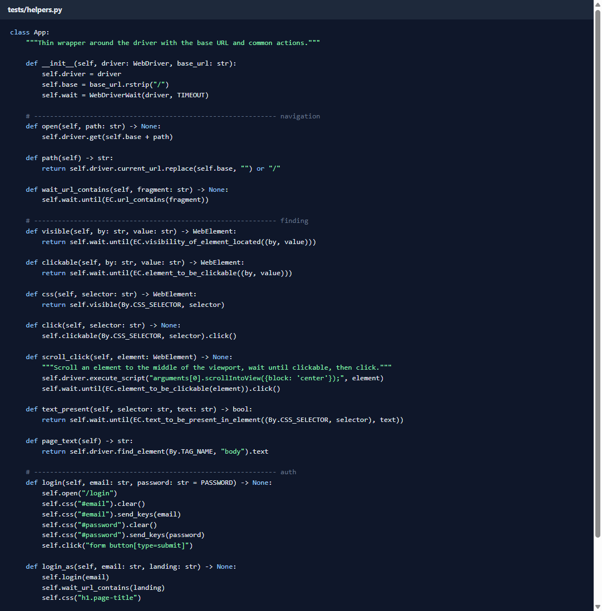
Figure 1: helpers.py — reusable App class with explicit waits, login/logout and screenshot helpers
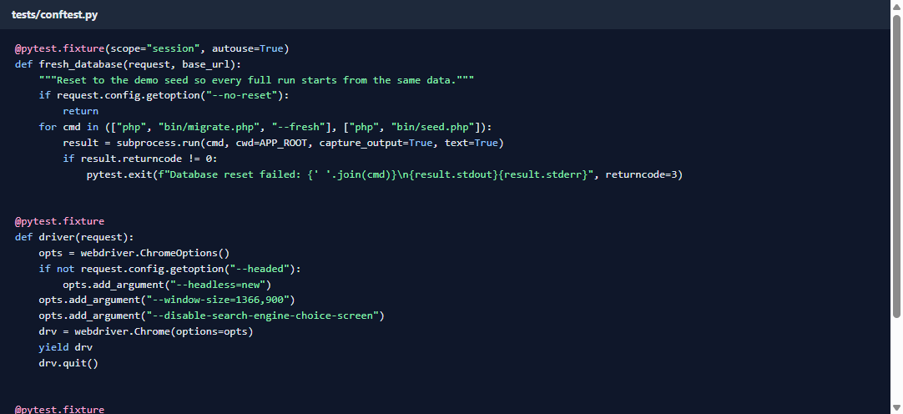
Figure 2: conftest.py — fixtures for server, database reset, Chrome driver and failure screenshots
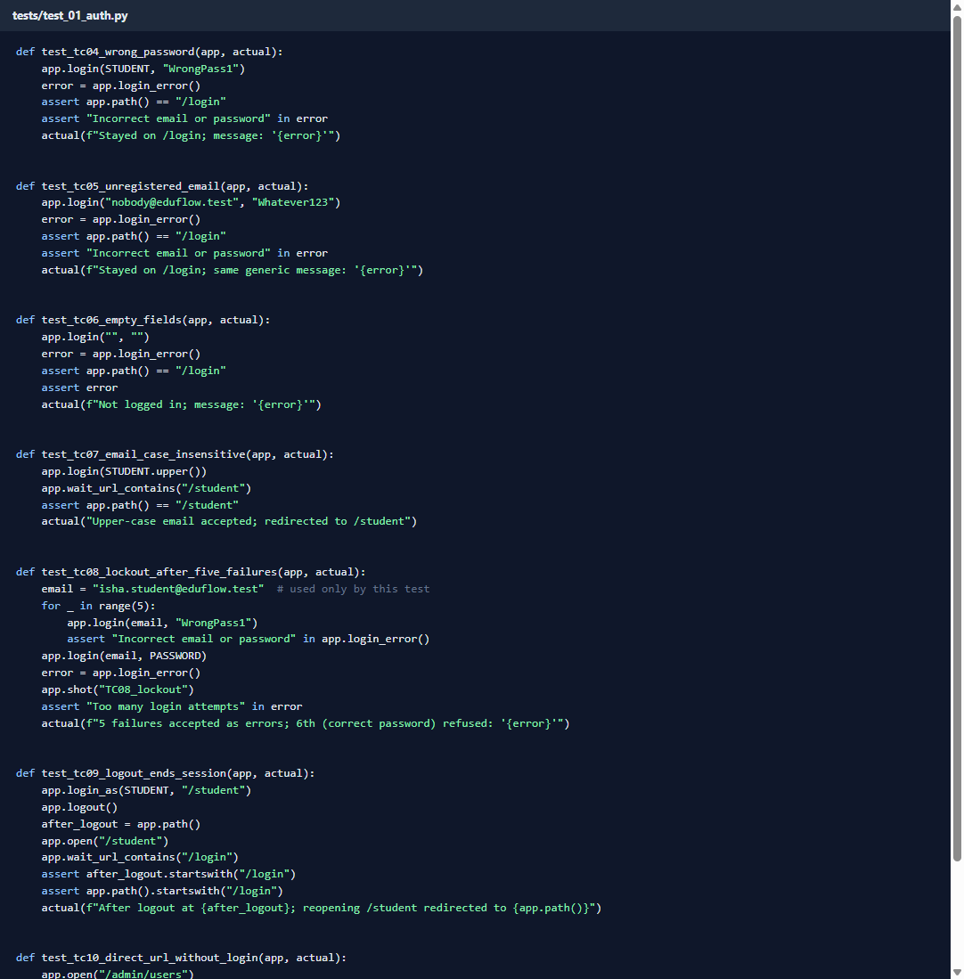
Figure 3: test_01_auth.py — login, lockout, logout and access-control tests
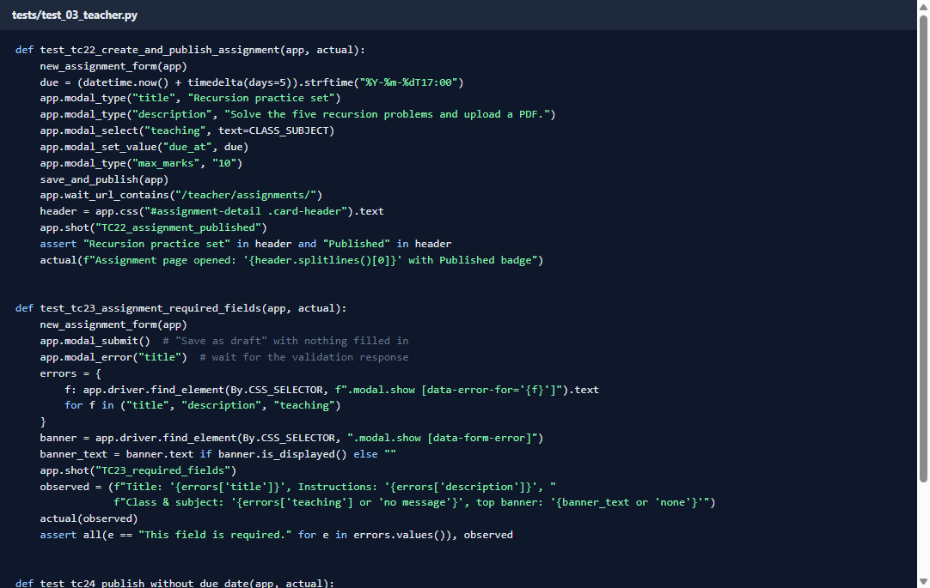
Figure 4: test_03_teacher.py — assignment publishing and grading tests
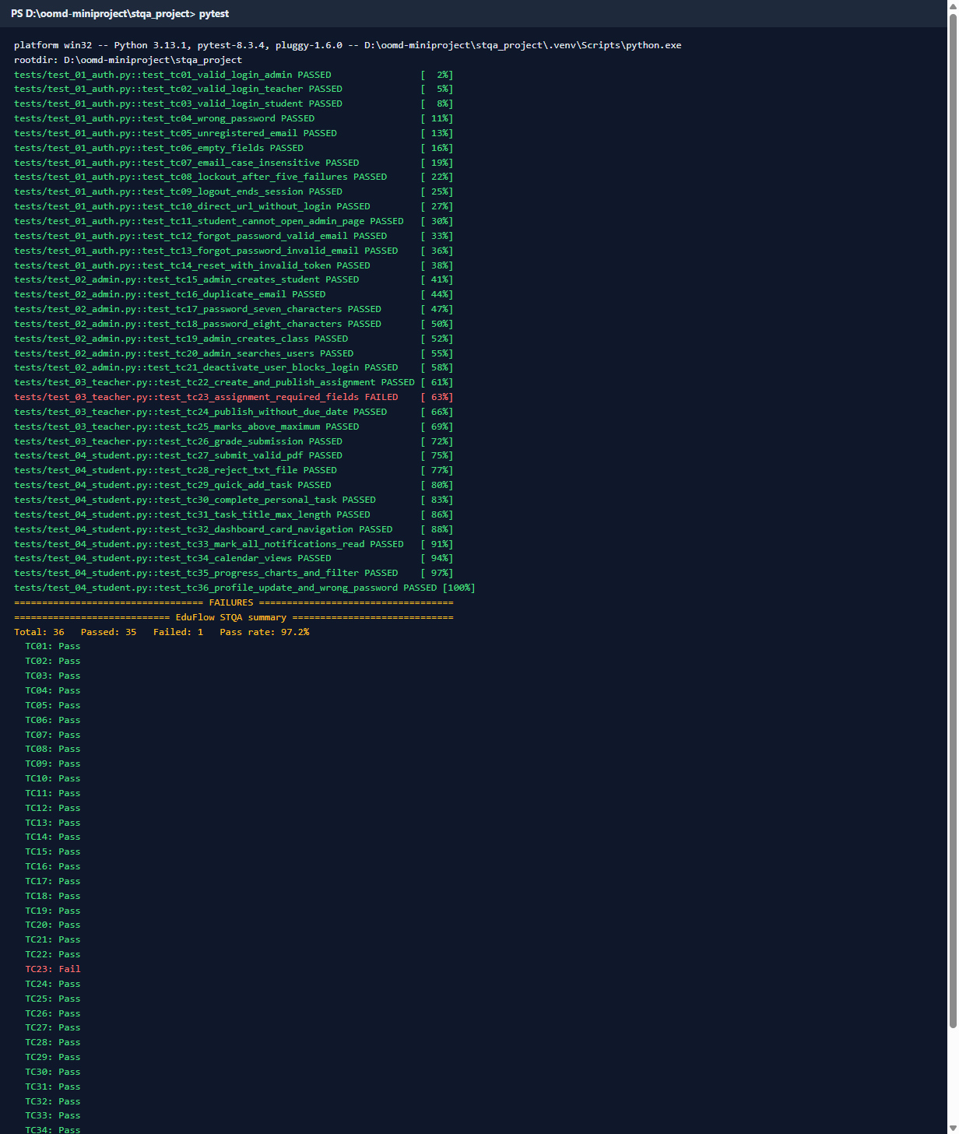
Figure 5: Console output of the full regression run with the pass/fail summary
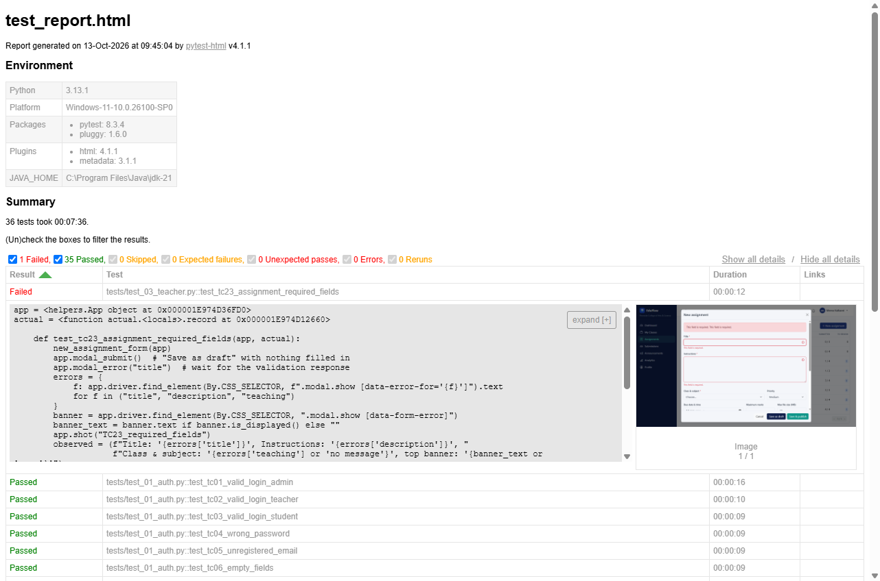
Figure 6: pytest-html report generated in reports/test_report.html
Figure 7: Selenium IDE flows replayed with WebDriver

13. GUI Screenshots (captured by Selenium)
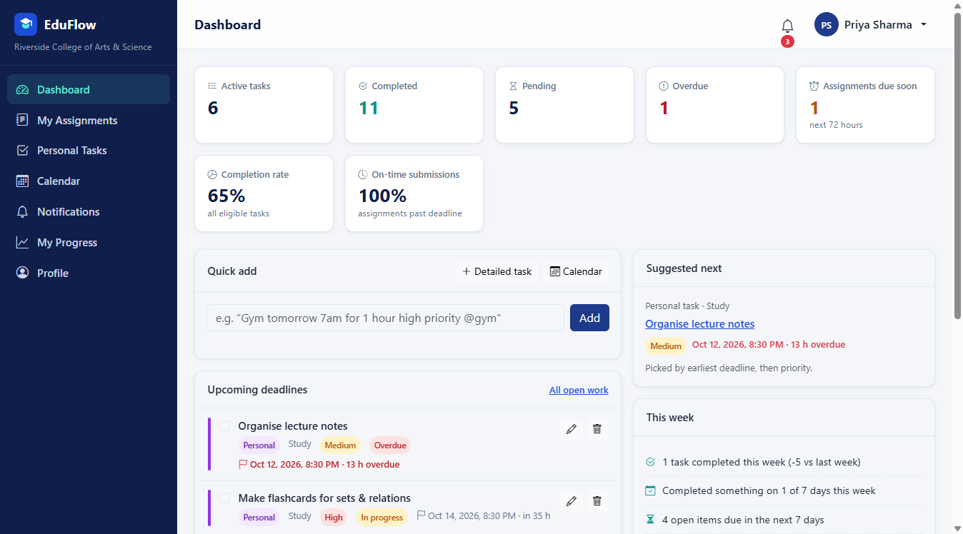
Figure 8: Student dashboard after a successful login (TC03)
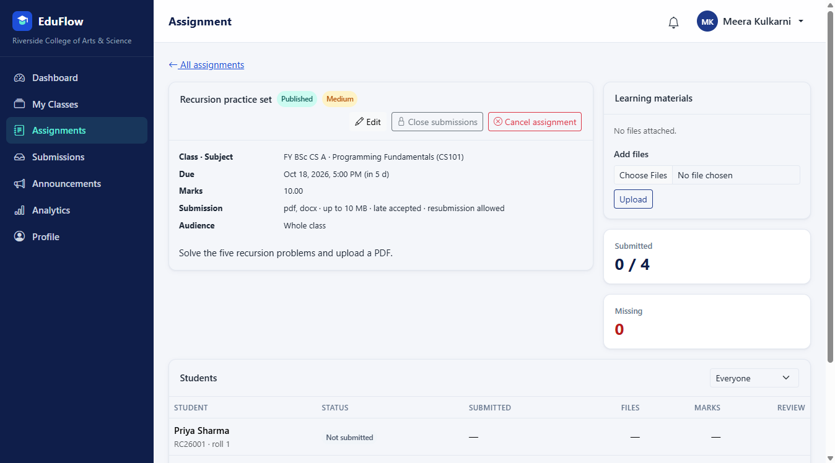
Figure 9: Teacher's assignment page after Save & publish (TC22)
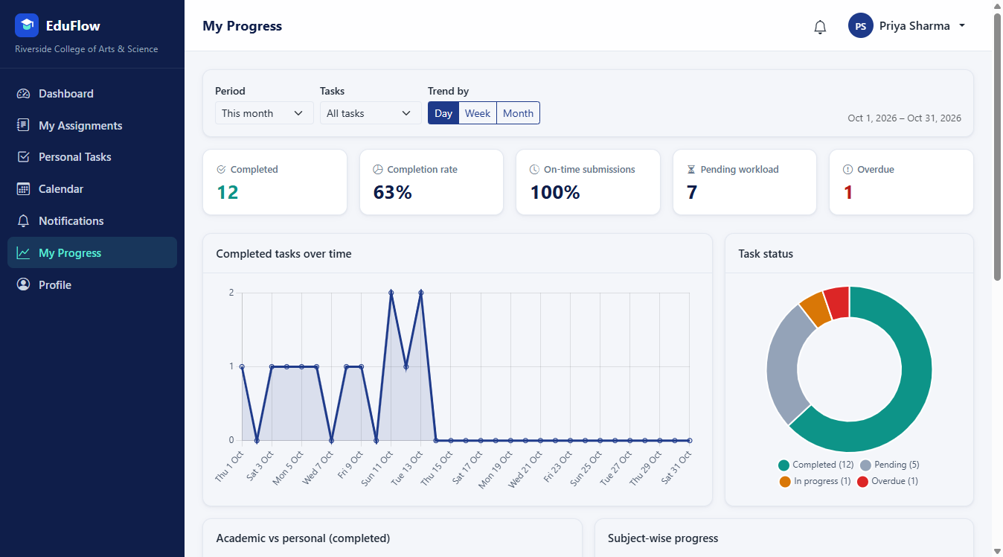
Figure 10: Student progress analytics with Chart.js charts (TC35)
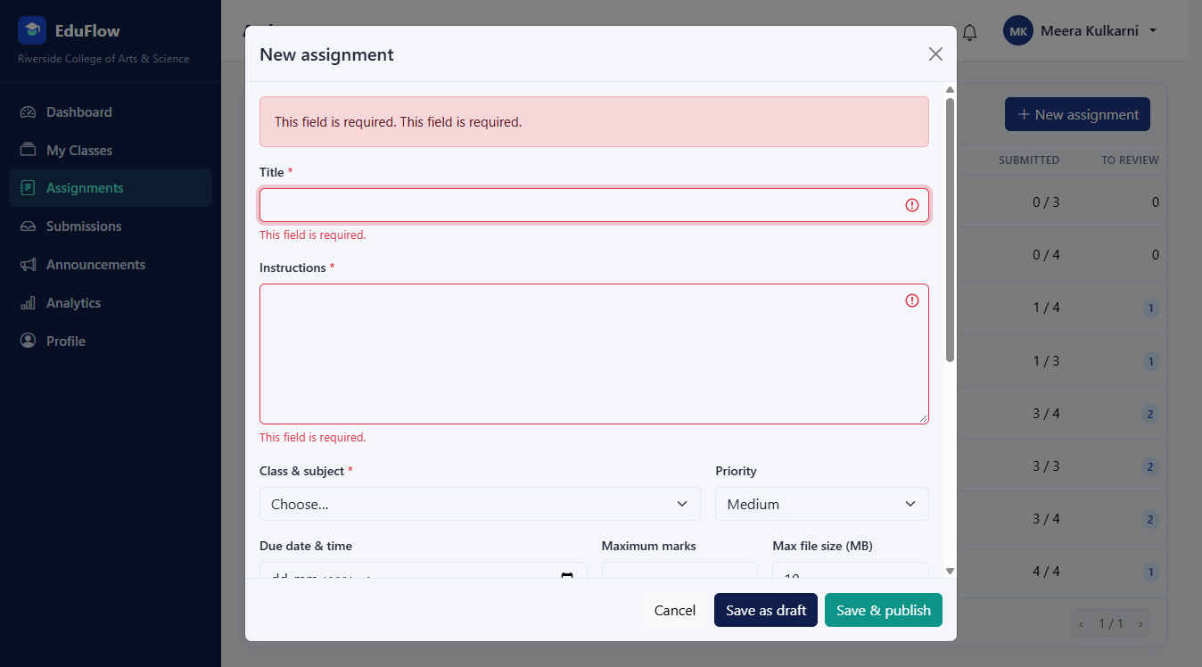
Figure 11: Required-field validation on a new assignment — evidence for BUG-01 (TC23)

14. Bug Report
Only defects that were reproduced on the running application (13 October 2026, Chrome 154, http://127.0.0.1:8000, demo seed data) are listed. Categories, severities and priorities follow bug_taxonomy.md.

Summary
Bug ID | Title | Category | Severity | Priority | Found by | Status
BUG-01 | "Class & subject" required error not shown under the field; vague duplicate banner instead | Validation / UI | Minor | P3 | TC23 (scripted) | Open
BUG-02 | Double-clicking "Add" in quick-add creates duplicate tasks | Functional | Minor | P3 | Exploratory | Open

BUG-01 — "Class & subject" required error is not shown under the field
Field | Details
Bug ID | BUG-01
Module | Teacher → Assignments → New assignment
Description | When the new-assignment form is saved empty, Title and Instructions show "This field is required." under each field, but Class & subject shows no message and is not highlighted. Instead a red banner at the top of the form says "This field is required. This field is required." without saying which field is meant.
Steps to reproduce | 1. Log in as meera.teacher@eduflow.test / Demo@1234.<br>2. Open Assignments and click New assignment.<br>3. Leave all fields empty and click Save as draft.
Expected result | "This field is required." appears under Title, Instructions and Class & subject, and the Class & subject drop-down is highlighted.
Actual result | Title: "This field is required."; Instructions: "This field is required."; Class & subject: no message, not highlighted; top banner: "This field is required. This field is required."
Evidence | screenshots/TC23_required_fields.png, screenshots/FAIL_TC23.png, pytest-html report entry for TC23
Probable cause | The server validates class_id and subject_id, but the form shows one combined field named teaching, so the two error messages cannot be matched to a field and fall back to the banner.
Severity | Minor — the assignment is correctly not saved; only the guidance to the user is unclear.
Priority | P3
Category | Validation (wrong/missing error message), UI
Status | Open

BUG-02 — Double-clicking "Add" in quick-add creates duplicate tasks
Field | Details
Bug ID | BUG-02
Module | Student → Personal Tasks / Dashboard → Quick add
Description | Quick-add sends one request per click and does not disable the Add button while the first request is in progress, so a double-click (or a fast double press of Enter + click) saves the same task twice.
Steps to reproduce | 1. Log in as priya.student@eduflow.test / Demo@1234.<br>2. Open Personal Tasks.<br>3. Type Double click probe in the quick-add box.<br>4. Double-click Add.<br>5. Search the task list for "Double click probe".
Expected result | One task is created (the button is disabled, or the second click is ignored, until the first save completes).
Actual result | Two identical tasks are created. Reproduced on 2 of 2 attempts.
Evidence | screenshots/EXP03_double_submit.png, exploratory/observations.json
Comparison | The teacher's "New assignment" form handles the same double-click correctly (1 assignment created), because its Save button is disabled while saving.
Severity | Minor — data is duplicated but can be deleted; no data loss or security impact.
Priority | P3
Category | Functional (double submission)
Status | Open

15. Test Report
Application | EduFlow — Academic Management & Productivity Portal
Environment | Windows 11, PHP 8.4.5 built-in server, MySQL 8.0, Chrome 154 (headless)
Tools | Selenium WebDriver 4.27.1 (Python 3.13), pytest 8.3.4, pytest-html 4.1.1, Selenium IDE
Test run | 13 October 2026, full regression suite, database reset to demo seed before the run
Prepared by | Soniya Pawar, Sakshi Jagadale, Priti Merurkar

Execution summary
Metric | Value
Test cases designed | 36
Test cases executed | 36
Passed | 35
Failed | 1 (TC23)
Blocked / not run | 0
Run rate | 100 % (36 / 36)
Pass rate | 97.2 % (35 / 36)
Execution time | 8 min 18 s (497.6 s)
Selenium IDE flows | 3 / 3 passed (login, quick-add task, logout)

Results by module
Module | Test cases | Passed | Failed
Login, session, access control, password recovery | TC01–TC14 | 14 | 0
Admin: users and classes | TC15–TC21 | 7 | 0
Teacher: assignments and grading | TC22–TC26 | 4 | 1 (TC23)
Student: submissions, tasks, dashboard, notifications, calendar, progress, profile | TC27–TC36 | 10 | 0
Total | 36 | 35 | 1

Exit criteria
Criterion | Target | Achieved | Met?
Run rate | 100 % | 100 % | Yes
Pass rate | ≥ 80 % | 97.2 % | Yes
Open Critical defects | 0 | 0 | Yes
Suspension threshold | < 40 % failing | 2.8 % failing | Not triggered

All exit criteria are met.

Bug summary
Bug ID | Title | Category | Severity | Priority | Status
BUG-01 | "Class & subject" required error not shown under the field; vague duplicate banner instead | Validation / UI | Minor | P3 | Open
BUG-02 | Double-clicking "Add" in quick-add creates duplicate tasks | Functional | Minor | P3 | Open

Severity | Count
Critical | 0
Major | 0
Minor | 2
Trivial | 0

Script failures vs application defects
The first execution of the suite had three failures. Each was investigated:
Test case | First-run failure | Cause | Action
TC25, TC26 | "element click intercepted" on the roster's Open button | Script: the button was below the visible area | Script fixed to scroll the button into view; both now pass
TC23 | No error message under Class & subject | Application defect | Kept as a failing test; reported as BUG-01

Exploratory testing findings
20 exploratory ideas were tried (special characters, very long strings, whitespace-only input, double submits, Back/Refresh, two tabs, direct URLs and API calls without login, id tampering, injection-like search text, Unicode, negative marks, upper-case file extensions, and phone/tablet layouts). 19 behaved correctly and 1 defect was found (BUG-02). Notable positives:
- Every protected page, API endpoint and file download refused access without login or outside
the user's own scope.
- HTML typed into inputs is displayed as text, never executed.
- Length limits and number ranges are enforced with clear messages.
- No horizontal scrolling at 390 px and 768 px widths.

Conclusion
EduFlow meets the exit criteria: 100 % of the 36 test cases were executed, 97.2 % passed, and no Critical or Major defects are open. The two open defects are Minor (an unclear validation message and duplicate tasks on a double-click) and do not block the main workflows. We recommend fixing both in the next release (priority P3) and re-running the regression suite, where TC23 is expected to pass once BUG-01 is fixed.

15.1 Exploratory testing
Date: 13 October 2026 · Build: EduFlow local, demo seed · Browser: Chrome 154 · Testers: Sakshi Jagadale, Priti Merurkar · Time box: about 60 minutes

Charter
Explore EduFlow beyond the scripted test cases to find defects in input handling, double submission, browser navigation (Back, Refresh, multiple tabs), access without logging in or with another user's ids, and layout on small screens.

Approach
Each idea was tried in the running application and the outcome recorded. To make the session repeatable, the probes were also written as a script (exploratory/explore.py) that saves screenshots (screenshots/EXP*.png) and the observations (exploratory/observations.json). Three probe scripts initially broke because of our own selectors (they did not wait for the redirect after saving, used a stale element, and clicked a hidden close button). These were fixed and re-run, and are not counted as application bugs.

Findings
# | Area | What we tried | What happened | Result
1 | Special characters | Task title <script>alert('x')</script> Café & "quotes" 😀 | Saved and displayed literally; no script ran | OK
2 | Very long input | 6,000 characters in task notes (limit 5,000) | Rejected: "Must be at most 5000 characters." | OK
3 | Long input (boundary) | 250 characters typed into the 200-character task title | Field keeps 200 characters (scripted TC31) | OK
4 | Whitespace only | Quick-add with only spaces | "Type what you need to do first." | OK
5 | Double submit | Double-click Add in quick-add | Two identical tasks created (2/2 attempts) | BUG-02
6 | Double submit | Double-click Save as draft on a new assignment | One assignment created (button disabled while saving) | OK
7 | Back button | Log out, then press browser Back | Returned to /login?next=%2Fstudent, not the dashboard | OK
8 | Refresh | Submit an assignment, then refresh the page | No resubmission prompt; one file listed | OK
9 | Multiple tabs | Log out in tab 2, then add a task in tab 1 | Tab 1 is sent to the login page | OK
10 | Direct URL, no login | /teacher/assignments/1, /student/tasks, /admin/settings, /profile | All redirect to /login?next=… | OK
11 | Direct API, no login | /api/admin/users, /api/files/submissions/1 | {"error":"Please log in to continue."} | OK
12 | Id tampering | Class B student opens a class A assignment and another student's file by id | "Assignment not found." / "Not found." | OK
13 | Injection-like input | ' OR 1=1 -- in admin user search | "No users match these filters." | OK
14 | Unicode | Devanagari profile name कबीर सिंह | Saved and shown in the header | OK
15 | Input normalisation | Login email with leading/trailing spaces | Logged in normally | OK
16 | Invalid number | Marks -5 when grading | "Must be at least 0." | OK
17 | File name case | Upload ANSWER_UPPER.PDF where pdf is allowed | Accepted | OK
18 | Logged-in user opens /login | Teacher visits /login | Redirected to the teacher dashboard | OK
19 | Responsive (390 px phone) | Dashboard, tasks, calendar, progress, assignments | No horizontal scrolling; sidebar collapses to a menu button that opens it | OK
20 | Responsive (768 px tablet) | Same pages | No horizontal scrolling; menu works | OK

Summary
20 ideas explored, 19 behaved correctly, 1 defect found (BUG-02, duplicate task on double-click). Access control held up well: every direct URL, API call and id change outside the user's scope was refused. Input handling escaped HTML, enforced length limits and accepted Unicode.

Screenshots
- EXP01_special_chars.png — HTML shown as text in the task list
- EXP02_long_description.png — 5,000-character limit message
- EXP03_double_submit.png — duplicate tasks after double-click (BUG-02)
- EXP04_back_after_logout.png — login page after Back
- EXP_phone_dashboard.png, EXP_phone_menu.png, EXP_tablet_dashboard.png, EXP_tablet_menu.png — responsive layouts

16. Conclusion
In this mini project we applied the software testing life cycle to EduFlow, a complete web application with three user roles. We prepared a test plan with scope, risks, entry/exit criteria and a schedule; defined a bug taxonomy with categories, severity and priority; designed 36 test cases covering valid and invalid logins, empty fields, boundary values, each module's main flow, navigation, logout and session handling; and automated all of them with Selenium WebDriver and pytest, using explicit waits, stable locators and automatic failure screenshots. We also recorded three flows in Selenium IDE and explored the application manually.
The final regression run executed all 36 test cases with 35 passing (97.2 %), which meets the exit criteria of a 100 % run rate and at least an 80 % pass rate. Two Minor defects were found and reported: a missing field-level validation message on the new-assignment form (BUG-01) and duplicate tasks created by a double-click in quick-add (BUG-02). Exploratory testing showed that access control, input escaping, length limits and responsive layouts work correctly.
The project showed us the value of automation for regression testing: the whole suite runs unattended in about eight minutes from a clean database, so it can be repeated after every change. It also showed that a failing test must be investigated before it is reported: two of our three first-run failures were caused by our own scripts, not by the application. Selenium WebDriver with pytest proved suitable for testing a modern JavaScript-driven web application, and the same suite can be extended with Selenium Grid for cross-browser testing in the future.

