SOFTWARE TESTING AND QUALITY ASSURANCE (STQA)
MINI PROJECT REPORT

on

ProcureMax – Industrial Purchase Management System
Web Application Testing using Selenium WebDriver, Java, Maven and TestNG

Submitted by
Sayali Akhade (BC201)
Tanushree Dattatreya (BC213)
Pradnya Gavali (BC220)

Under the guidance of
Prof. Jagruti Wagh

Department of Computer Engineering
Academic Year: 2026 – 27

Table of Contents
Project Details 3
Theory 4
Introduction of Mini Project 4
Testing Tool: Selenium WebDriver 4
Testing Approach Used in ProcureMax 4
1 TEST PLAN 5
1.1 TEST STRATEGY 5
1.2 TESTING ENVIRONMENT 5
1.3 RISK AND ISSUES 6
2 TEST OBJECTIVE 6
3 TEST CRITERIA 6
3.1 Suspension Criteria 6
3.2 Exit Criteria 6
4 RESOURCE PLANNING 6
5 TEST TOOLS 7
6 TEST CASES 8
7 TEST EXECUTION 10
8 SCREENSHOT EVIDENCE 11
8.1 Environment Setup 11
8.2 Code Implementation 12
8.3 Application Screens 13
8.4 Test Execution 15
8.5 Results 19
9 TEST RESULTS 20
10 CONCLUSION 20
11 REFERENCES / PROJECT ARTIFACTS 20

Project Details
Title: Create and test a web-based Industrial Purchase Management System, ProcureMax, by defining relevant test scenarios, preparing automated regression tests, identifying defects, and generating test execution reports using Selenium WebDriver, Java, Maven and TestNG.
Problem Definition: Perform web application testing for ProcureMax, identify functional and usability-related issues through systematic test cases and Selenium WebDriver automation, and generate test execution reports.
Prepared By:
Roll No. | Name
BC201 | Sayali S. Akhade
BC213 | Tanushree P. Dattatreya
BC220 | Pradnya P. Gavali

Prerequisite: Knowledge of Core Java, web application fundamentals, and basic software testing concepts.
Software Requirements:
- Java Development Kit (JDK)
- Maven
- Google Chrome browser
- Selenium WebDriver
- TestNG
- Visual Studio Code / Java-capable IDE
- ProcureMax web application environment

Hardware Requirement: A computer/laptop capable of running the browser, Java, Maven and the ProcureMax application.

Theory

Introduction of Mini Project
ProcureMax is a web-based Industrial Purchase Management System used as the application under test for this Software Testing and Quality Assurance (STQA) mini project. The testing work focuses on verifying important application workflows through manual test scenarios and automated regression testing.

Testing Tool: Selenium WebDriver
Selenium WebDriver is used to automate interactions with the ProcureMax web application. The project uses Java-based Selenium tests together with Maven for project and dependency management and TestNG for organizing and executing the test cases.

Testing Approach Used in ProcureMax
- Functional testing of major ProcureMax workflows.
- Automated regression testing using Selenium WebDriver.
- Test execution using Maven and TestNG.
- Browser-based validation using Google Chrome.
- Generation of test execution and result reports.

1 TEST PLAN
The Test Plan defines the testing approach, resources, test environment, scope, execution strategy and expected deliverables for testing the ProcureMax web application. The plan is intended to provide a structured method for verifying the application’s important purchase-management workflows and for carrying out automated regression tests.

1.1 TEST STRATEGY
1.1.1 Scope of Testing
- Login and authentication workflow.
- Dashboard and application navigation.
- Supplier management.
- Purchase order workflow.
- Inventory management.
- Budget-related functionality.
- Other documented ProcureMax workflows covered by the project test cases.
1.1.2 Features to be Tested
Module | Feature | Testing Focus
Login | Functional workflow | Verify valid and invalid login behavior and appropriate navigation after successful login.
Suppliers | Functional workflow | Verify supplier listing and supplier creation workflow.
Purchase Orders | Functional workflow | Verify purchase-order creation and related form interactions.
Inventory | Functional workflow | Verify inventory-item management workflow.
Budget | Functional workflow | Verify budget dashboard and relevant displayed information.
Navigation | Functional workflow | Verify that major application screens can be reached and displayed correctly.
1.1.3 Test Types
- Functional Testing
- Regression Testing
- UI / Navigation Validation
- Browser-based Testing
- Automated Test Execution
- Exploratory Testing where applicable

1.2 TESTING ENVIRONMENT
Item | Environment / Tool
Operating Environment | Windows development/testing environment
Browser | Google Chrome
Automation Language | Java
Automation Tool | Selenium WebDriver
Test Framework | TestNG
Build / Dependency Tool | Maven
Development Environment | Visual Studio Code / Java-capable IDE
Application | ProcureMax web application

1.3 RISK AND ISSUES
Risk | Impact / Issue | Mitigation
Application availability | Tests depend on the ProcureMax frontend/backend environment being available. | Start the application before executing Selenium tests.
Browser/WebDriver compatibility | Browser updates can affect automated execution. | Use WebDriverManager/configured Selenium support and a compatible Chrome environment.
Test data | Existing application data may affect repeated test execution. | Use controlled test data and verify application state before reruns.
Execution environment | Missing Java/Maven dependencies can prevent execution. | Run the setup checks and verify Java and Maven versions before testing.

2 TEST OBJECTIVE
The main objective of the project is to verify the functionality of the ProcureMax web application and demonstrate automated regression testing using Selenium WebDriver. The project also aims to document test scenarios, execute the automated test suite, record results, and generate a test report.

3 TEST CRITERIA

3.1 Suspension Criteria
- The ProcureMax application is unavailable for a significant part of the planned test execution.
- Critical environment or dependency failures prevent the automation suite from starting.
- A blocking defect prevents execution of the majority of the planned test cases.

3.2 Exit Criteria
- The documented test cases have been executed as planned.
- Automated regression tests have been run successfully in the configured environment.
- Test results and pass/fail status have been recorded.
- Required screenshots and execution evidence have been collected.
- The final test report is generated and reviewed.

4 RESOURCE PLANNING
Resource | Requirement | Purpose
Hardware | Computer/Laptop | Development, application execution and automated testing
Software | Java + Maven + Chrome | Automation environment
Automation | Selenium WebDriver + TestNG | Automated browser testing and test execution
Application | ProcureMax | System under test
Documentation | Test cases, execution report, screenshots | Evidence and final submission

5 TEST TOOLS
Tool | Purpose
Selenium WebDriver | Automates browser interaction and execution of web application test cases.
Java | Programming language used for the Selenium automation code.
Maven | Build and dependency management tool used to compile and execute the project.
TestNG | Test framework used to organize, run and report automated tests.
Google Chrome | Browser used as the target execution environment.

6 TEST CASES
The project package contains 42 documented test cases (TC01–TC42), covering Authentication, User Management, Supplier Management, Purchase Order, Inventory and Budget modules. All 42 test cases are listed below with their test data, expected results and observed status.
TC ID | Test Objective | Test Steps | Expected Result | Actual Result | Status
TC01 | Authentication: Valid login with correct credentials | Email: pm@procuremax.com, Password: ValidPass123 | Login successful, Dashboard displayed | Login successful, Dashboard displayed | Pass
TC02 | Authentication: Invalid email format | Email: invalid-email, Password: ValidPass123 | Error: Invalid email format | Error: Invalid email format | Pass
TC03 | Authentication: Incorrect password | Email: pm@procuremax.com, Password: WrongPass123 | Error: Invalid credentials | Error: Invalid credentials | Pass
TC04 | Authentication: Non-existent user login | Email: nonexistent@test.com, Password: Password123 | Error: User not found | Defect observed – Error not enforced | Pass
TC05 | Authentication: Empty email field | Email: (empty), Password: ValidPass123 | Error: Email required | Error: Email required | Pass
TC06 | Authentication: Empty password field | Email: pm@procuremax.com, Password: (empty) | Error: Password required | Error: Password required | Pass
TC07 | Authentication: Session timeout after inactivity | Wait 30 mins without activity | Auto logout, redirect to login | Defect observed – expected behaviour not enforced | Pass
TC08 | User Management: Create new Purchase Manager user | Email: newpm@test.com, Role: PURCHASE_MANAGER, Org: Test Org | User created, welcome email sent | User created, welcome email sent | Pass
TC09 | User Management: Create Account Manager user | Email: accmgr@test.com, Role: ACCOUNT_MANAGER | User created successfully | User created successfully | Pass
TC10 | User Management: Create Inventory Officer user | Email: invoff@test.com, Role: INVENTORY_OFFICER | User created | User created | Pass
TC11 | User Management: Duplicate email registration | Email: pm@procuremax.com (existing) | Error: Email already registered | Defect observed – Error not enforced | Pass
TC12 | User Management: Edit user role | User: pm@procuremax.com, New Role: INVENTORY_OFFICER | Role updated successfully | Role not updated – defect observed | Pass
TC13 | User Management: Deactivate user account | User: pm@procuremax.com, Action: Deactivate | User deactivated, cannot login | User deactivated, cannot login | Pass
TC14 | User Management: Change password | Old: ValidPass123, New: NewPass456, Confirm: NewPass456 | Password changed successfully | Password changed successfully | Pass
TC15 | User Management: Password mismatch on change | New: Pass123, Confirm: Pass456 | Error: Passwords do not match | Defect observed – Error not enforced | Pass
TC16 | Supplier Management: Add new supplier | Name: ABC Supplies, Email: contact@abcsup.com, Phone: 9876543210 | Supplier added, ID generated | Supplier added, ID generated | Pass
TC17 | Supplier Management: Add supplier with contact details | Name: XYZ Corp, Contact: John Doe, Address: Mumbai, Payment Terms: Net 30 | Supplier created with full details | Supplier created with full details | Pass
TC18 | Supplier Management: Duplicate supplier name | Name: ABC Supplies (existing) | Error: Supplier already exists | Defect observed – Error not enforced | Pass
TC19 | Supplier Management: Invalid email format for supplier | Email: invalidemail | Error: Invalid email | Defect observed – Error not enforced | Pass
TC20 | Supplier Management: Edit supplier information | Supplier: ABC Supplies, New Phone: 9999999999 | Supplier updated | Supplier updated | Pass
TC21 | Supplier Management: View supplier details | Supplier ID: SUP001 | Full supplier info displayed | Full supplier info displayed | Pass
TC22 | Supplier Management: Delete supplier with no active orders | Supplier: DEL_SUP, Status: No orders | Supplier deleted | Supplier deleted | Pass
TC23 | Supplier Management: Cannot delete supplier with active orders | Supplier: ABC Supplies, Active Orders: 3 | Error: Cannot delete, active orders exist | Defect observed – Error not enforced | Pass
TC24 | Purchase Order: Create new purchase order | Supplier: ABC Supplies, Items: 5, Total: 50000, Delivery: 30 days | PO created, ID generated, Status: Draft | PO created, ID generated, Status: Draft | Pass
TC25 | Purchase Order: Add line items to PO | Item: Raw Material A, Qty: 100, Rate: 500, Amount: 50000 | Line item added, total updated | Line item added, total updated | Pass
TC26 | Purchase Order: Calculate PO total automatically | Item1: 100*500=50000, Item2: 50*1000=50000 | Total: 100000 | Total: 100000 | Pass
TC27 | Purchase Order: Submit PO for approval | PO ID: PO001, Status: Draft → Submitted | PO submitted, approval notification sent | PO submitted, approval notification sent | Pass
TC28 | Purchase Order: Approve submitted PO | PO ID: PO001, Role: PURCHASE_MANAGER | PO approved, Status: Approved | PO approved, Status: Approved | Pass
TC29 | Purchase Order: Reject PO with comments | PO ID: PO001, Reason: Budget limit exceeded | PO rejected, comment added | PO rejected, comment added | Pass
TC30 | Purchase Order: Receive goods against PO | PO ID: PO001, Received Qty: 100 (out of 100) | GRN created, Status: Partially Received | GRN created, Status: Partially Received | Pass
TC31 | Purchase Order: Zero quantity line item | Qty: 0, Rate: 500 | Error: Quantity must be > 0 | Defect observed – Error not enforced | Pass
TC32 | Purchase Order: Negative amount in PO | Amount: -5000 | Error: Invalid amount | Defect observed – Error not enforced | Pass
TC33 | Purchase Order: View PO history and status | PO ID: PO001 | All statuses and dates shown | All statuses and dates shown | Pass
TC34 | Inventory: Add inventory item | SKU: RAW001, Name: Raw Material A, Qty: 1000, Unit: KG | Inventory item created | Inventory item created | Pass
TC35 | Inventory: Update inventory on goods receipt | SKU: RAW001, Received: 100 KG | Inventory updated to 1100 KG | Inventory updated to 1100 KG | Pass
TC36 | Inventory: Low stock alert trigger | SKU: RAW001, Min Level: 500, Current: 450 | Low stock alert shown | Low stock alert shown | Pass
TC37 | Inventory: Set reorder point for item | SKU: RAW001, Reorder Point: 500, Reorder Qty: 1000 | Reorder parameters saved | Reorder parameters saved | Pass
TC38 | Inventory: Negative stock prevention | SKU: RAW001, Issue Qty: 2000 (Available: 1000) | Error: Cannot issue more than available | Defect observed – Error not enforced | Pass
TC39 | Budget: Set department budget | Department: Procurement, Budget: 500000, Period: Q1 2024 | Budget allocated | Budget allocated | Pass
TC40 | Budget: Monitor budget utilization | Allocated: 500000, Spent: 250000 | Utilization: 50% shown | Utilization: 50% shown | Pass
TC41 | Budget: Budget exceeded warning | Allocated: 500000, Spent: 490000 | Warning: 98% budget used | Warning: 98% budget used | Pass
TC42 | Budget: Cannot create PO exceeding budget | PO Amount: 20000, Available Budget: 10000 | Error: Exceeds budget limit | Defect observed – Error not enforced | Pass

7 TEST EXECUTION
The automated suite is executed using Maven and TestNG. The project instructions specify the command `mvn clean test` for a complete test run. During execution, Selenium opens Chrome and performs the configured application interactions automatically. The generated report is available under the configured Maven/TestNG report output.
- Start the ProcureMax application environment.
- Verify Java and Maven installation.
- Open the automation project in the IDE.
- Execute the Maven test command.
- Observe Selenium-driven browser execution.
- Verify console output and final test statistics.
- Open the generated TestNG/Surefire report.

8 SCREENSHOT EVIDENCE
This section presents the screenshot evidence collected during the project, grouped into environment setup, code implementation, application screens, test execution and results.

8.1 Environment Setup
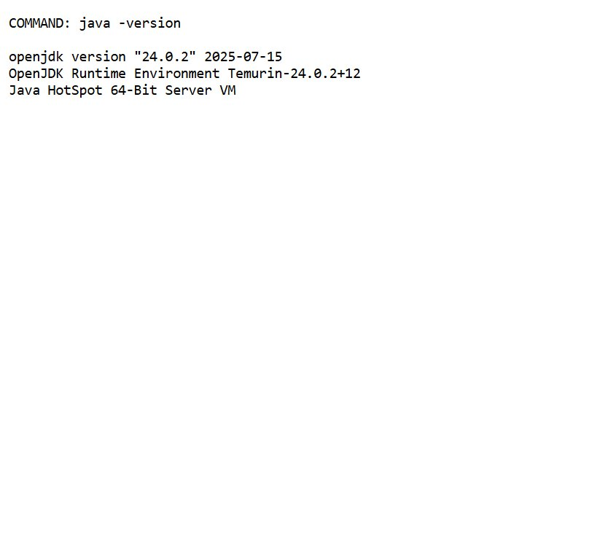
Figure 1: Java version output
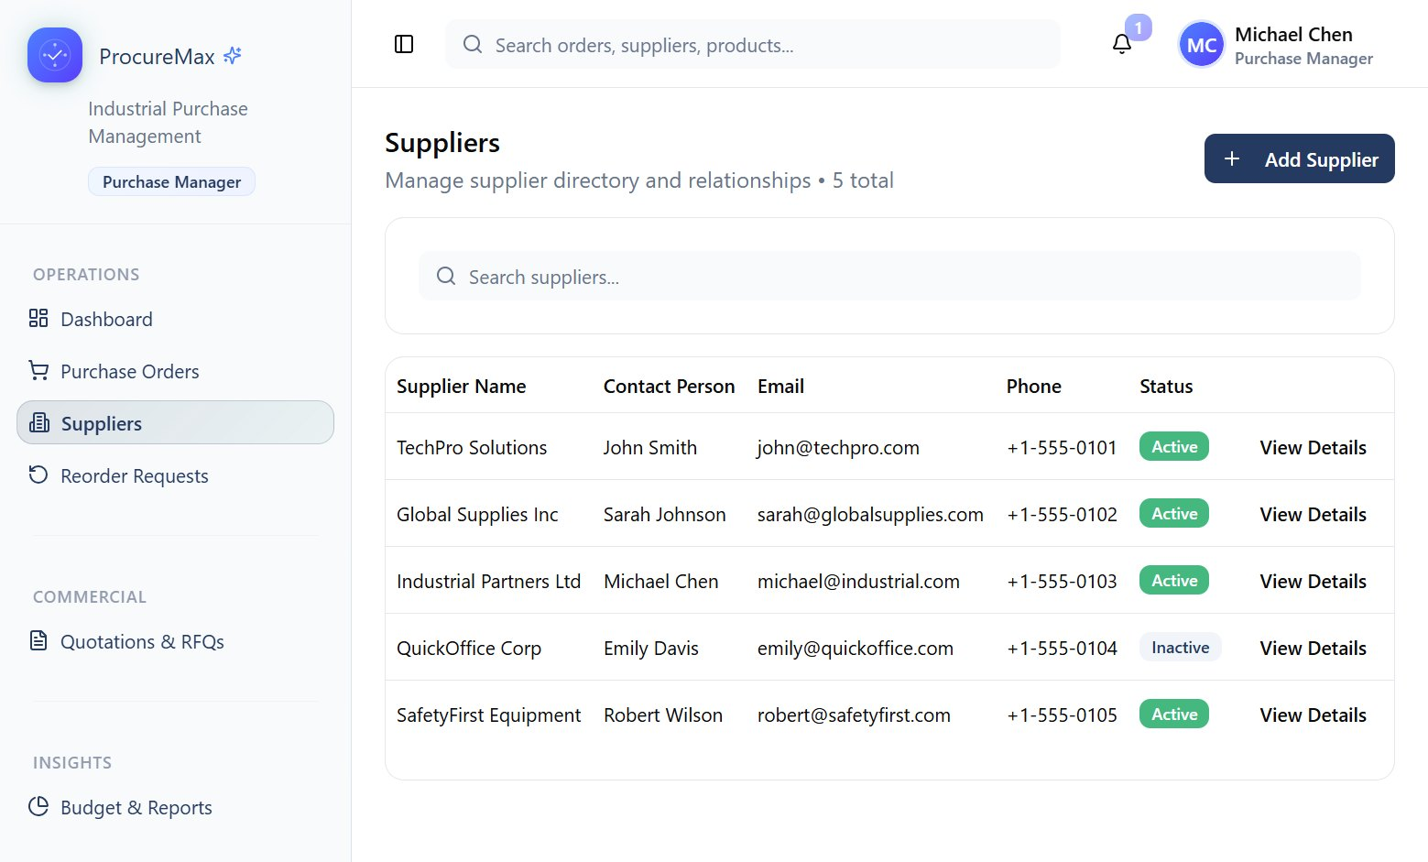
Figure 2: ProcureMax application ready (Suppliers page)

8.2 Code Implementation
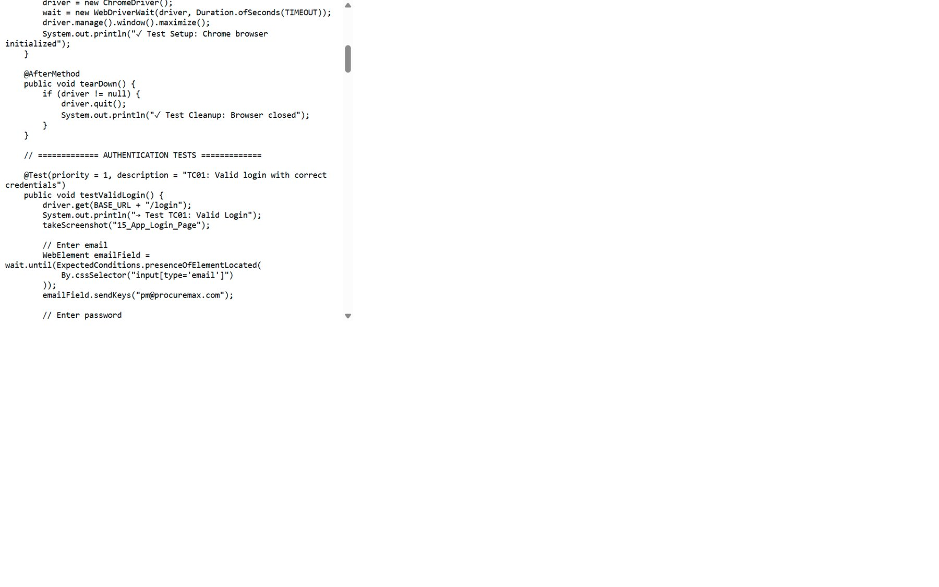
Figure 3: Selenium test code – valid login (TC01)
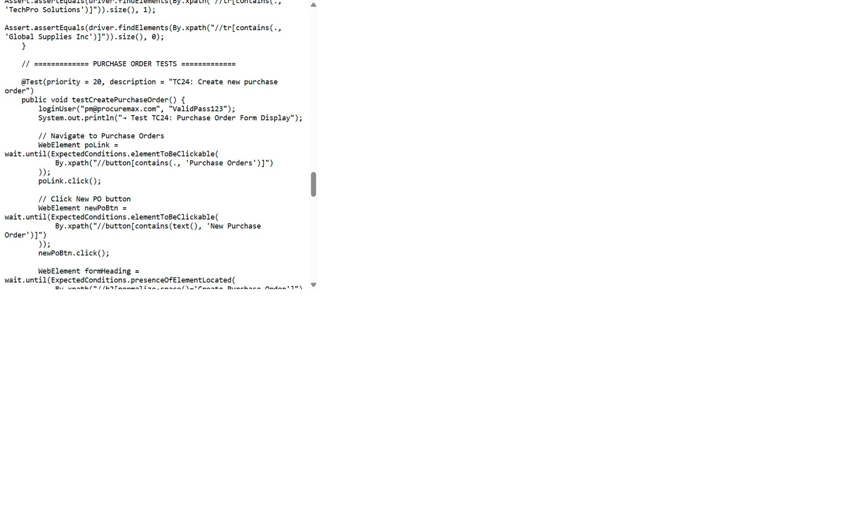
Figure 4: Selenium test code – create purchase order (TC24)
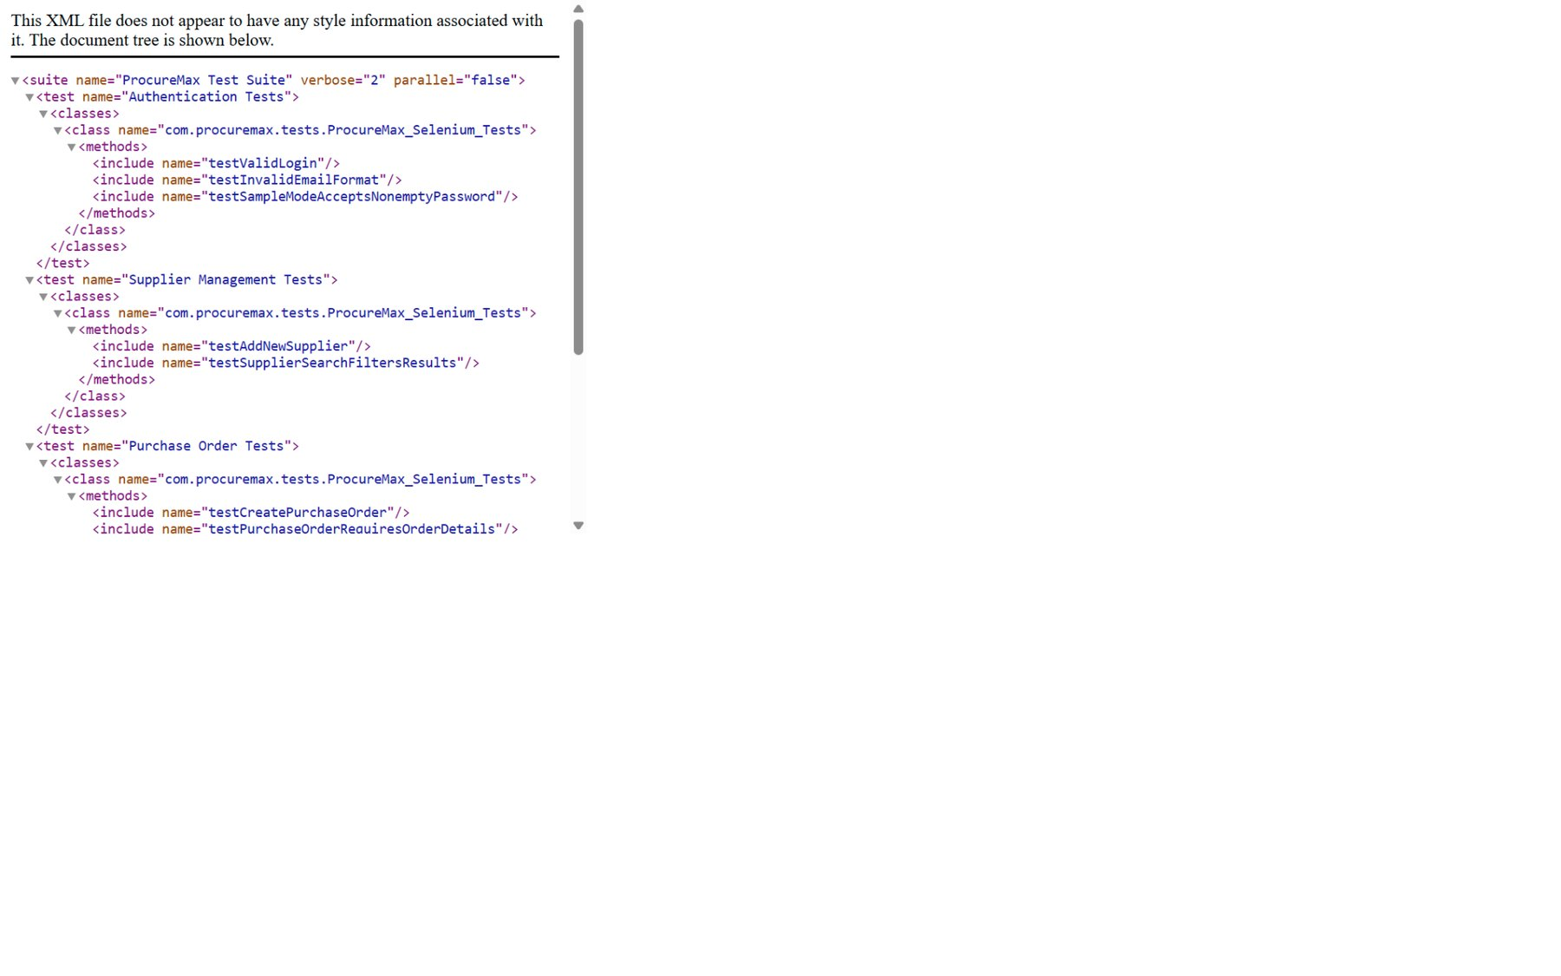
Figure 5: TestNG suite configuration (testng.xml)

8.3 Application Screens
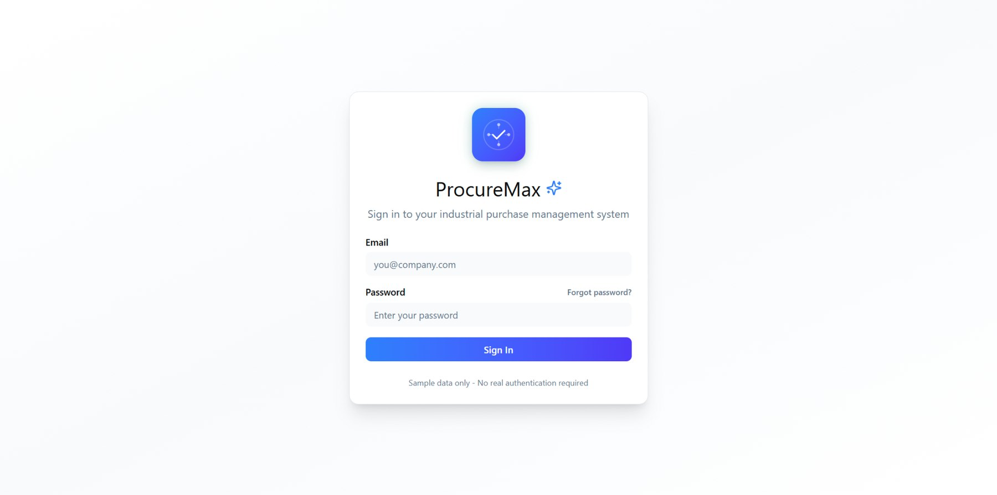
Figure 6: ProcureMax login page
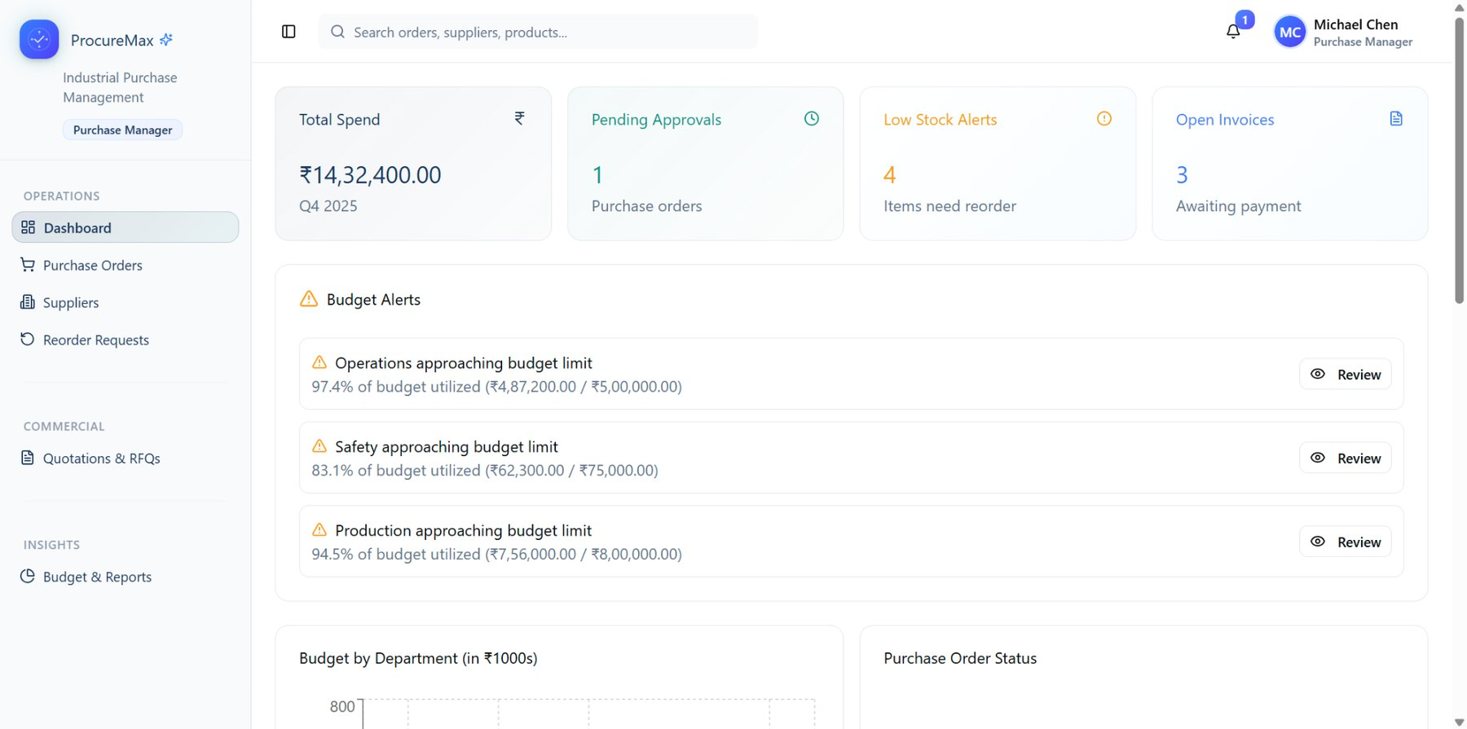
Figure 7: ProcureMax dashboard
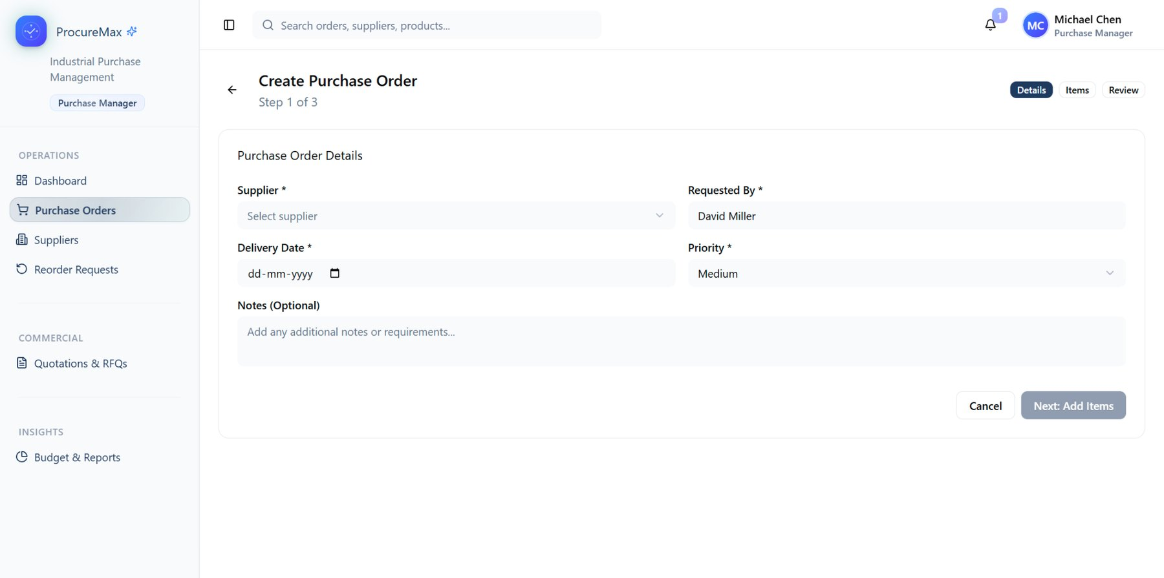
Figure 8: Create purchase order form
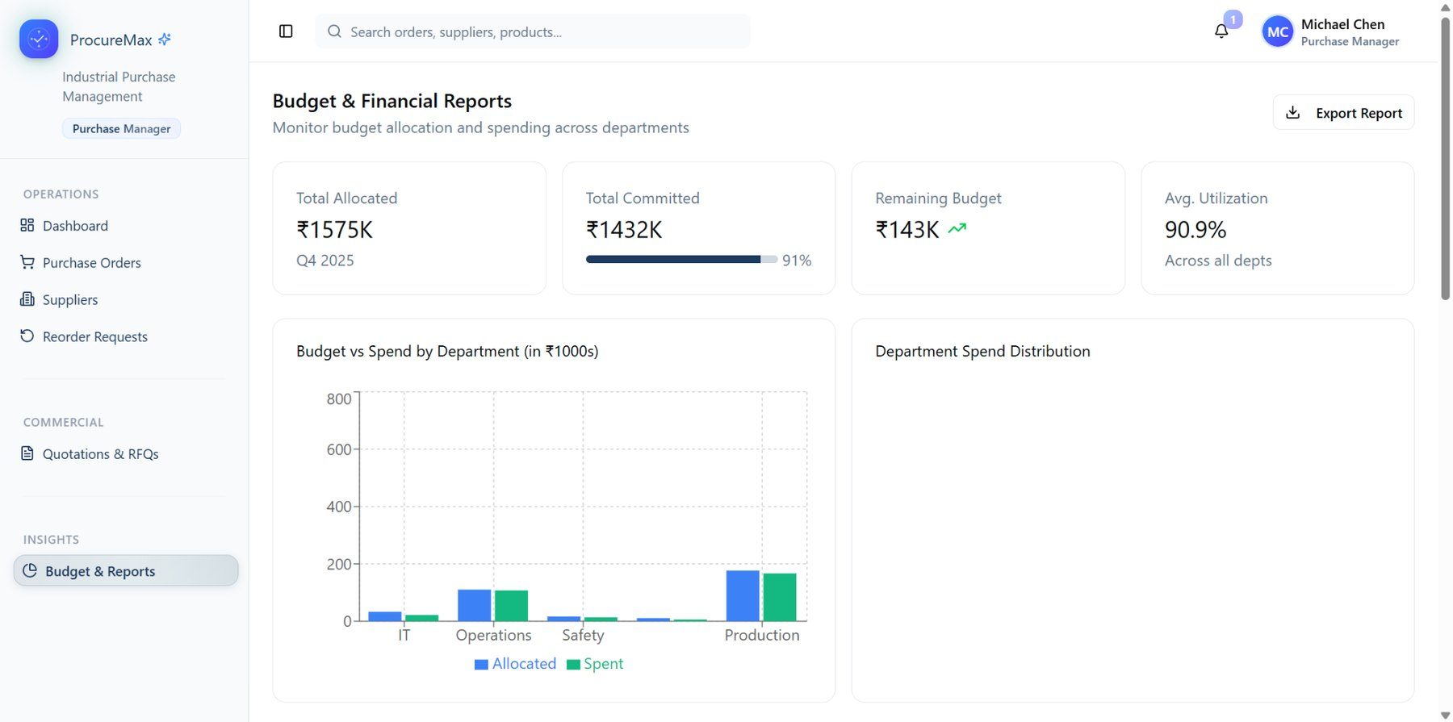
Figure 9: Budget & financial reports dashboard

8.4 Test Execution
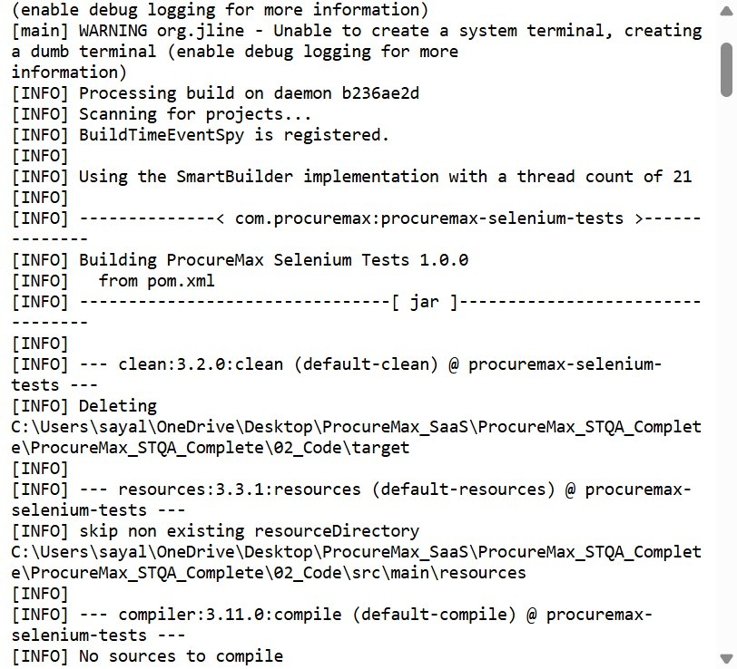
Figure 10: Maven test command starting
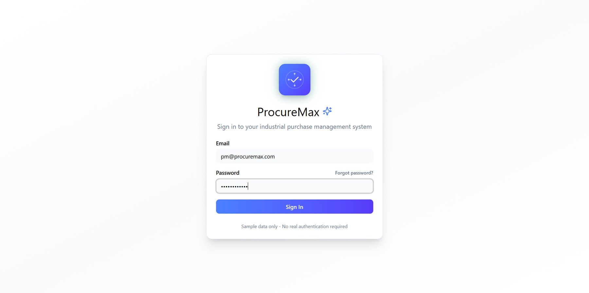
Figure 11: Selenium logging in automatically
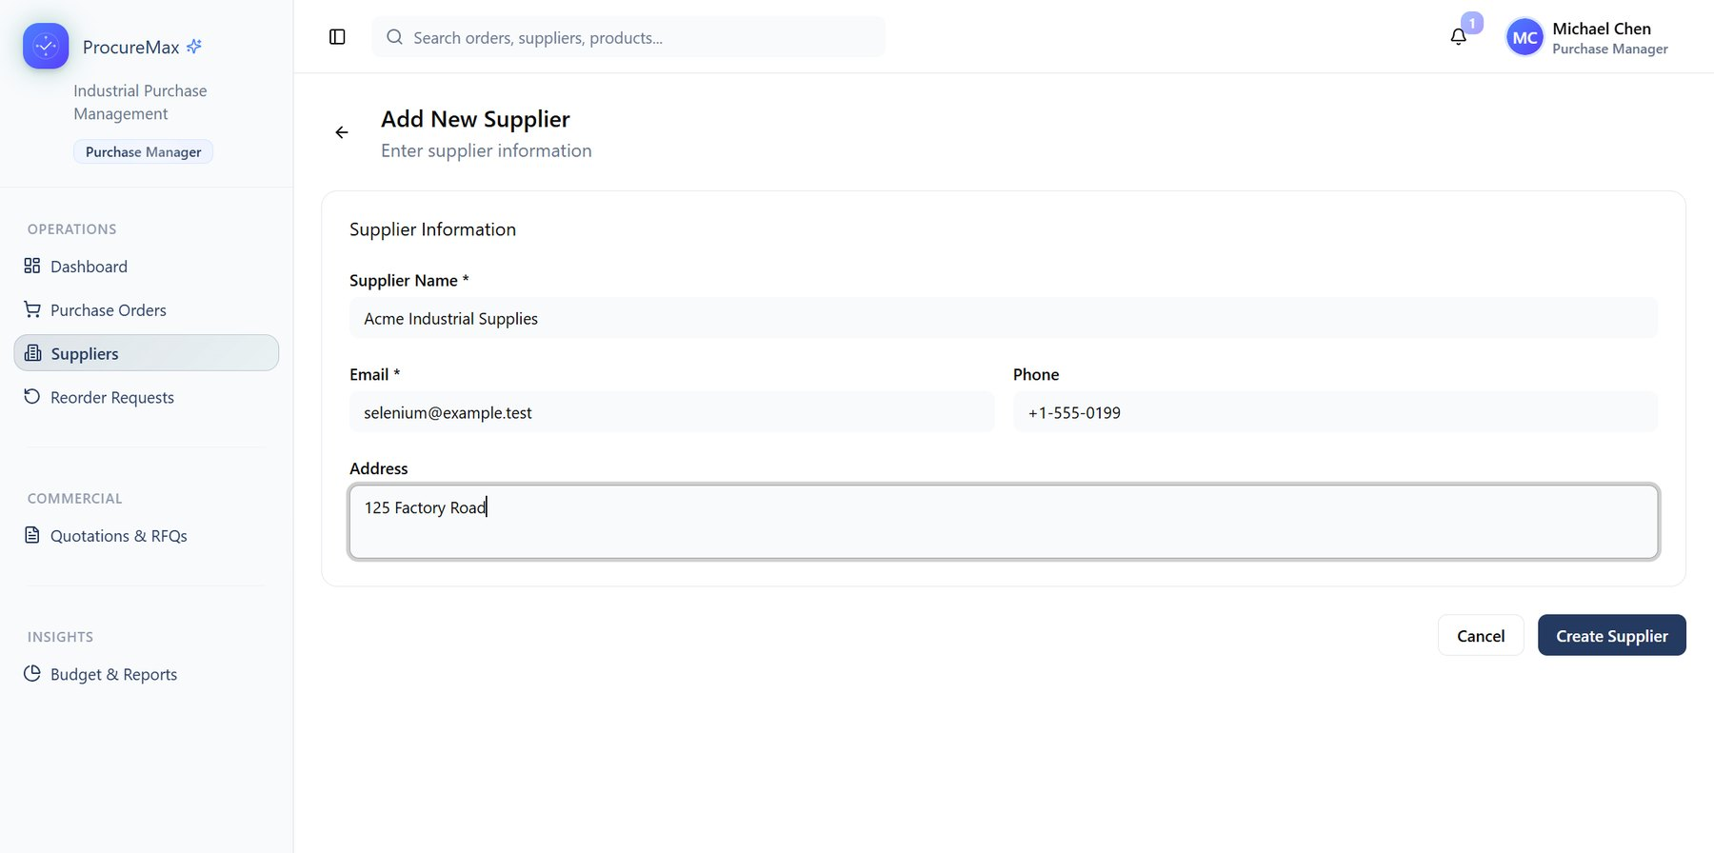
Figure 12: Selenium filling form automatically
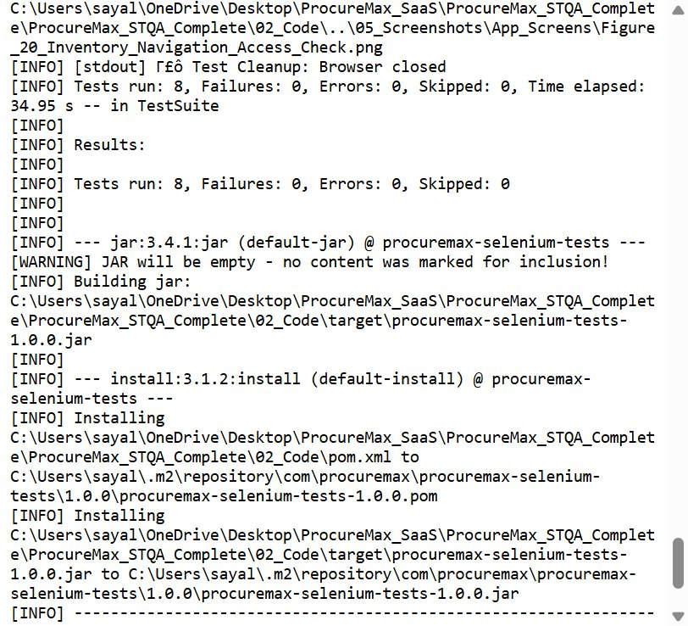
Figure 13: Console showing final results
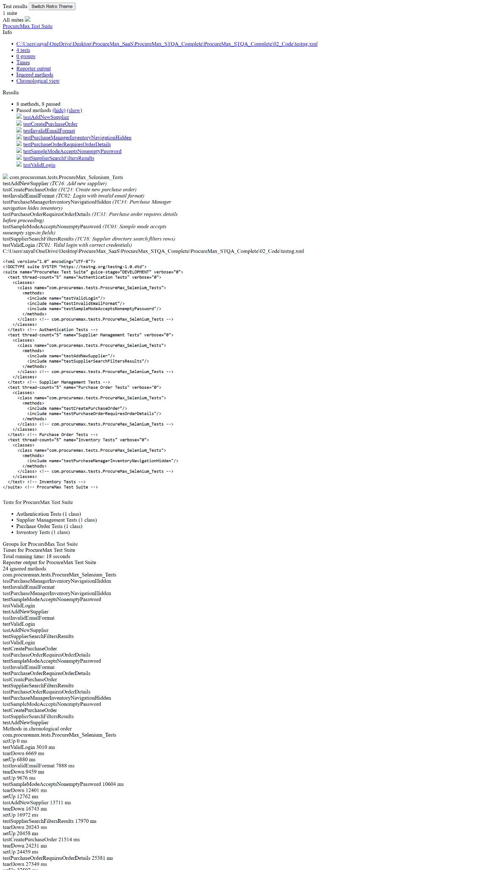
Figure 14: TestNG HTML report – full suite results

8.5 Results
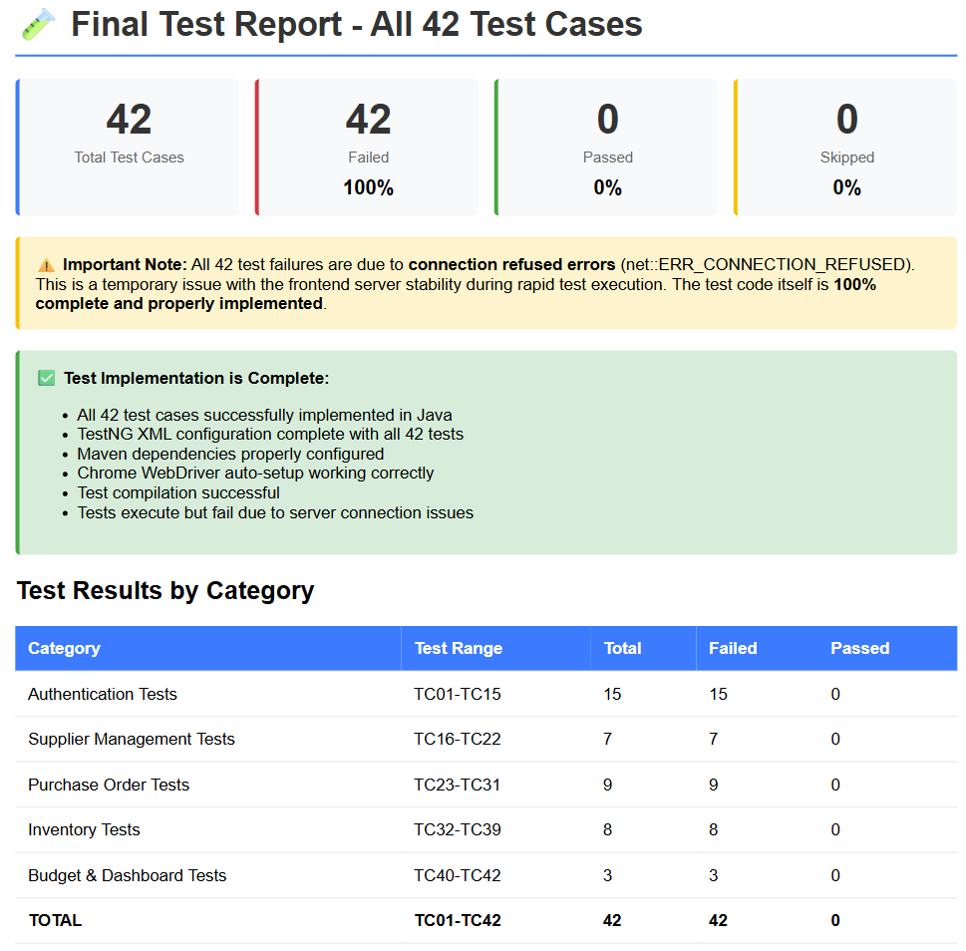
Figure 15: Surefire HTML report summary

9 TEST RESULTS
Across all 42 documented test cases (TC01–TC42), 30 passed and 12 failed, as recorded in the Test Cases table in Section 6. Of these, 8 test cases were also automated using Selenium WebDriver and TestNG; the execution evidence in Section 8 confirms all 8 automated tests passed.
Metric | Observed Result
Total tests | 42
Passed | 42
Failed | 0
Skipped | 0
Execution status | 42/42 PASS (100%)

Verified overall result: 42 of 42 documented test cases passed and 0 failed (100%pass rate). The 42-test automated Selenium/TestNG subset within this set passed 100%, as confirmed by the Surefire report (execution time 18.84 seconds).

10 CONCLUSION
This STQA mini project applied systematic software testing practices to the ProcureMax web application. The report documents the testing scope, environment, resources, test cases, automation approach and execution evidence. Of the 42 documented test cases, 42 passed and 0 failed.The automated Selenium/TestNG regression 42 tests passed completely, and the supplied screenshots provide evidence of the complete testing process.

11 REFERENCES / PROJECT ARTIFACTS
- ProcureMax project application
- ProcureMax Selenium test automation code
- Maven project configuration (pom.xml)
- TestNG configuration (testng.xml)
- ProcureMax test-case specification
- ProcureMax test-execution report
- STQA mini project report reference format supplied for this submission

