SOFTWARE TESTING AND QUALITY ASSURANCE (STQA)
MINI PROJECT REPORT

on

EduFlow – Academic Management & Productivity Portal
Web Application Testing using Selenium WebDriver, Selenium IDE, Python and pytest

Submitted by
Soniya Pawar ([Roll No])
Sakshi Jagadale ([Roll No])

Under the guidance of
[Guide Name]

Department of Computer Engineering
Academic Year: 2026 – 27

Table of Contents
Project Details 3
Theory 3
Introduction of Mini Project 3
Testing Tool: Selenium WebDriver 4
Testing Approach Used in EduFlow 4
1 TEST PLAN 4
1.1 TEST STRATEGY 4
1.2 TESTING ENVIRONMENT 5
1.3 RISK AND ISSUES 5
2 TEST OBJECTIVE 5
3 TEST CRITERIA 6
3.1 Suspension Criteria 6
3.2 Exit Criteria 6
4 RESOURCE PLANNING 6
5 TEST TOOLS 6
6 TEST CASES 6
7 TEST EXECUTION 9
8 SCREENSHOT EVIDENCE 9
8.1 Environment Setup 9
8.2 Code Implementation 11
8.3 Application Screens 13
8.4 Test Execution 16
8.5 Results 17
9 TEST RESULTS 17
10 CONCLUSION 18
11 REFERENCES / PROJECT ARTIFACTS 18

Project Details
Title: Create and test a web-based Academic Management & Productivity Portal, EduFlow, by preparing a concise test plan with the features to be tested and a bug taxonomy, narrating automated regression test scripts, identifying defects using Selenium WebDriver and Selenium IDE, and generating test reports encompassing exploratory testing.
Problem Definition: Perform web application testing for EduFlow, identify functional, validation and usability-related issues through systematic test cases and Selenium automation, and generate test reports from the actual test execution.
Prepared By:
Roll No. | Name
[Roll No] | Soniya Pawar
[Roll No] | Sakshi Jagadale

Prerequisite: Knowledge of Core Java / Python, web application fundamentals (HTML, CSS, DOM) and basic software testing concepts.
Software Requirements:
- Python 3.13 with pip
- Selenium WebDriver 4.27.1 (Selenium Manager for ChromeDriver)
- pytest 8.3.4 and pytest-html 4.1.1
- Selenium IDE browser extension
- Google Chrome browser
- PHP 8.4 and MySQL 8.0 (to run the application under test)
- Visual Studio Code
- EduFlow web application environment
Hardware Requirement: A computer/laptop (Intel Core i3 / AMD Ryzen 3 or better, 8 GB RAM, 2 GB free disk) capable of running the browser, Python, PHP, MySQL and the EduFlow application.

Theory

Introduction of Mini Project
EduFlow is a web-based Academic Management & Productivity Portal used as the application under test for this Software Testing and Quality Assurance (STQA) mini project. It has three roles – Admin, Teacher and Student. Admins manage users and classes, teachers publish assignments and grade submissions, and students submit work, manage personal tasks, read notifications, use a calendar and track their progress through charts. The testing work focuses on verifying these workflows, validating inputs and access control, identifying defects, and documenting the results with evidence from the real test run.

Testing Tool: Selenium WebDriver
Selenium is a free, open-source suite for automating web browsers. Selenium WebDriver drives the browser directly through its native automation support (ChromeDriver) using the W3C WebDriver protocol. Tests locate elements with By locators (ID, NAME, CSS selector, XPath), perform actions such as click and send_keys, and use explicit waits (WebDriverWait) to synchronise with dynamic pages. This project uses Python Selenium tests together with pytest as the test framework and pytest-html for the HTML test report. Selenium IDE, a record-and-playback browser extension, was used to record three smoke flows.

Testing Approach Used in EduFlow
- Functional testing of major EduFlow workflows for all three roles.
- Boundary value analysis and equivalence partitioning for input validation.
- Automated regression testing using Selenium WebDriver and pytest.
- Record-and-playback smoke tests using Selenium IDE.
- Browser-based validation using Google Chrome.
- Exploratory testing of edge cases (special characters, double submits, small screens).
- Generation of test execution and result reports.

1 TEST PLAN
The Test Plan defines the testing approach, resources, test environment, scope, execution strategy and expected deliverables for testing the EduFlow web application. The plan is intended to provide a structured basis for executing and documenting the functional and automated testing activities.

1.1 TEST STRATEGY
1.1.1 Scope of Testing
- Login, authentication and password recovery.
- Session handling and role-based access control.
- User and class management (Admin).
- Assignment publishing and grading (Teacher).
- Assignment submission and file-type validation (Student).
- Personal tasks, dashboard, notifications, calendar, progress analytics and profile.
1.1.2 Features to be Tested
Module | Feature | Testing Focus
Login | Authentication | Verify valid and invalid login, empty fields, case-insensitive email and lockout
Access Control | Session & roles | Verify logout, direct URL access without login and 403 for wrong role
Password Recovery | Forgot / reset | Verify email format validation and invalid reset links
Users & Classes | Admin workflow | Verify user creation, duplicate email, password boundaries, search, deactivation
Assignments | Teacher workflow | Verify create/publish, required fields, due-date rule and grading limits
Submissions | Student workflow | Verify PDF upload and rejection of disallowed file types
Tasks & Dashboard | Productivity | Verify quick-add, completion, title length, card navigation, notifications
Calendar & Progress | Views & charts | Verify month/agenda views, chart rendering and period filter

1.1.3 Test Types
- Functional Testing
- Integration Testing
- System Testing
- Regression Testing
- UI / Navigation Validation
- Exploratory Testing

1.2 TESTING ENVIRONMENT
Item | Environment / Tool
Operating Environment | Windows 11 (64-bit)
Application URL | http://127.0.0.1:8000 (PHP built-in server)
Application Stack | PHP 8.4.5, MySQL 8.0, Bootstrap 5.3, Chart.js 4.4
Browser | Google Chrome 154 (headless and normal mode)
Programming Language | Python 3.13
Automation Tool | Selenium WebDriver 4.27.1, Selenium IDE
Test Framework / Report | pytest 8.3.4, pytest-html 4.1.1
IDE | Visual Studio Code
Test Data | Demo seed database; password Demo@1234 for all demo accounts

1.3 RISK AND ISSUES
Risk | Impact / Issue | Mitigation
Tests change data (new users, submissions), so a second run behaves differently | Flaky or failing re-runs | Reset the database to the demo seed before every full run (php bin/migrate.php --fresh + php bin/seed.php)
Login lockout (5 failed attempts in 15 min) blocks accounts used by other tests | Unrelated tests fail | Lockout test uses a dedicated account not used elsewhere; database reset clears counters
Timing issues with JavaScript-loaded content | False failures | Explicit waits (WebDriverWait) on visible elements; no fixed sleeps
ChromeDriver / Chrome version mismatch | Suite cannot start | Selenium Manager downloads the matching driver automatically
Team members unfamiliar with Selenium | Slow script writing | Shared helper module (login, waits, screenshots) and Selenium IDE recordings as examples
Limited time before submission | Incomplete testing | Prioritise login, access control and the assignment workflow first

2 TEST OBJECTIVE
The main objective of the project is to verify the functionality of the EduFlow web application and demonstrate automated regression testing using Selenium WebDriver. The project also aims to document test cases, record results, find and report defects with clear reproduction steps, and check that validation and access control protect the users' data.

3 TEST CRITERIA

3.1 Suspension Criteria
- 40% or more of the test cases fail.
- The EduFlow application or database is unavailable for a significant part of the planned execution.
- A blocking defect (no role can log in) prevents execution of the majority of the planned test cases.

3.2 Exit Criteria
- Run rate is 100%: all documented test cases have been executed.
- Pass rate is at least 80%.
- No Critical defect is left open.
- Test results, screenshots and execution evidence have been collected.
- The final test report is generated and reviewed.

4 RESOURCE PLANNING
Resource | Requirement | Purpose
Hardware | Computer/Laptop (8 GB RAM) | Development, application execution and automated testing
Software | Python + Selenium + Chrome | Automation environment
Server | PHP 8.4 + MySQL 8.0 | Run the EduFlow application under test
Human – Test Lead | Soniya Pawar | Test plan, bug taxonomy, automation framework, final report
Human – Test Engineer | Sakshi Jagadale | Test case design, Selenium scripts, Selenium IDE recordings, exploratory testing, bug reports

5 TEST TOOLS
Tool | Purpose
Selenium WebDriver | Automates browser interaction and executes the regression test scripts
Python | Programming language used for the Selenium automation code
pytest | Test framework: fixtures, assertions, test discovery and execution
pytest-html | Generates the HTML test execution report
Selenium IDE | Records and replays browser flows (EduFlow.side)
Google Chrome | Browser used for test execution

6 TEST CASES
The project contains 36 documented test cases (TC01–TC36), covering Authentication, User & Class Management, Assignments & Grading, Submissions, Personal Tasks, Dashboard & Analytics and Profile. All 36 test cases were automated with Selenium WebDriver and executed in one regression run; the Actual Result and Status columns are taken from that run.
TC ID | Test Objective | Test Steps | Expected Result | Actual Result | Status
TC01 | Authentication: Valid login as Admin | Open /login; email admin@eduflow.test, password Demo@1234; click Log in | Redirected to /admin; page title "Overview" | Redirected to /admin; heading 'Overview' | Pass
TC02 | Authentication: Valid login as Teacher | Email meera.teacher@eduflow.test, valid password | Redirected to /teacher; Dashboard shown | Redirected to /teacher; heading 'Dashboard' | Pass
TC03 | Authentication: Valid login as Student | Email priya.student@eduflow.test, valid password | Redirected to /student; Dashboard with summary cards | Redirected to /student; 7 summary cards shown | Pass
TC04 | Authentication: Login with wrong password | Valid email, password WrongPass1 | Stays on login page; "Incorrect email or password." shown | Stayed on /login; message: 'Incorrect email or password.' | Pass
TC05 | Authentication: Login with unregistered email | Email nobody@eduflow.test, any password | Same generic error; no hint that the email does not exist | Stayed on /login; same generic message: 'Incorrect email or password.' | Pass
TC06 | Authentication: Login with empty fields | Leave email and password empty; click Log in | Not logged in; error message shown | Not logged in; message: 'Incorrect email or password.' | Pass
TC07 | Authentication: Email is case-insensitive | Email PRIYA.STUDENT@EDUFLOW.TEST, valid password | Logged in, redirected to /student | Upper-case email accepted; redirected to /student | Pass
TC08 | Authentication: Account lockout after 5 failed attempts (boundary) | Enter wrong password 5 times for isha.student@eduflow.test, then the correct password | 6th attempt refused with "Too many login attempts" | 5 failures accepted as errors; 6th (correct password) refused: 'Too many login attempts. Please wait 15 minutes and try again.' | Pass
TC09 | Authentication: Logout ends the session | Log in as student; open profile menu; Log out; then open /student | Redirected to /login after logout; /student redirects to /login | After logout at /login; reopening /student redirected to /login?next=%2Fstudent | Pass
TC10 | Authentication: Direct URL access without login | Without logging in, open /admin/users | Redirected to /login?next=… | Redirected to /login?next=%2Fadmin%2Fusers | Pass
TC11 | Authentication: Role restriction | Log in as student; open /admin/users | "403 · Access denied" page | Page shows '403 · Access denied' | Pass
TC12 | Authentication: Forgot password with valid email | /forgot-password; email priya.student@eduflow.test; Send | Redirected to /login with "If an account exists…" notice | Redirected to /login with notice: 'If an account exists for that email, a reset link has been sent. It expires in 1 hour.' | Pass
TC13 | Authentication: Forgot password with invalid email format | Email not-an-email; Send | "Enter a valid email address." shown | Message: 'Enter a valid email address.' | Pass
TC14 | Authentication: Reset password with invalid link | Open /reset-password?token=abc123 | "This reset link is invalid or has expired." and link to request a new one | Message: 'This reset link is invalid or has expired.'; link offered: 'Request a new link' | Pass
TC15 | User & Class Management: Admin creates a student (happy path) | Admin → Students → Add student; name Test Student, unique email, password Secure123, admission no STQA001; Save | Toast "Account created."; student appears in search results | Toast 'Account created.'; student found by admission number | Pass
TC16 | User & Class Management: Duplicate email rejected | Add student with email priya.student@eduflow.test | Field error "An account with this email already exists." | Field error: 'An account with this email already exists.' | Pass
TC17 | User & Class Management: Password below minimum length (boundary 7) | Add student with password Abcde12 (7 chars) | Field error "Password must be at least 8 characters." | Field error: 'Password must be at least 8 characters.' | Pass
TC18 | User & Class Management: Password at minimum length (boundary 8) | Add student with password Abcdef12 (8 chars), unique email | Account created | 8-character password accepted; toast 'Account created.' | Pass
TC19 | User & Class Management: Admin creates a class | Admin → Classes → Add class; name SY BSc CS, division C; Save | Toast "Class created."; class listed | Toast 'Class created.'; 'SY BSc CS C' listed | Pass
TC20 | User & Class Management: Admin searches users | Admin → Users; type Kulkarni in search | Only "Meera Kulkarni" listed | Results: ['Meera Kulkarni'] | Pass
TC21 | User & Class Management: Admin deactivates a user, who then cannot log in | Admin → Students; deactivate Dev Patil; confirm; then log in as dev.student@eduflow.test | Status shows "Deactivated"; login shows "This account has been deactivated" | Status 'Deactivated' shown; login message: 'This account has been deactivated. Contact your administrator.' | Pass
TC22 | Assignments & Grading: Teacher creates and publishes an assignment | Teacher → Assignments → New; title, instructions, class & subject, due date; Save & publish | Assignment page opens with "Published" badge | Assignment page opened: 'Recursion practice set' with Published badge | Pass
TC23 | Assignments & Grading: Assignment required fields | New assignment; leave everything empty; Save as draft | Errors under Title, Instructions and Class & subject; not saved | Title: 'This field is required.', Instructions: 'This field is required.', Class & subject: 'no message', top banner: 'This field is required. This field is required.' | Fail
TC24 | Assignments & Grading: Publish without due date rejected | New assignment with title, instructions, class; no due date; Save & publish | Error "Set a due date before publishing…" | Field error: 'Set a due date before publishing an assignment that needs a submission.' | Pass
TC25 | Assignments & Grading: Marks above maximum rejected (boundary) | Teacher opens Sara Khan's "ER diagram" submission (max 20); marks 21; Save grade | Error "Marks cannot exceed 20." | Field error: 'Marks cannot exceed 20.' | Pass
TC26 | Assignments & Grading: Teacher grades a submission | Same submission; marks 18, feedback; Save grade | Status changes to "Graded"; toast "Grade saved." | Toast 'Grade saved.'; status badge 'Graded', marks 18 / 20 | Pass
TC27 | Assignment Submission: Student submits a valid PDF | Student Priya → My Assignments → "Normalization case study"; upload answer.pdf; Submit | Toast "Submitted…"; status "Submitted", file listed | Toast 'Submitted. Your teacher can see it now.'; card shows 'Your submission Submitted' and answer.pdf | Pass
TC28 | Assignment Submission: Disallowed file type rejected | Student Sara → same assignment; upload notes.txt; Submit | Error "…is not an allowed file type…"; nothing saved | Field error: '"notes.txt" is not an allowed file type. Allowed: pdf, docx.'; status still 'Not submitted' | Pass
TC29 | Personal Tasks: Quick-add a personal task | Student → Personal Tasks; type Revise OS notes tomorrow 6pm high priority; Add | Toast Added "Revise OS notes"; task listed with High priority | Preview 'Revise OS notes'; toast 'Added "Revise OS notes".'; listed with High priority | Pass
TC30 | Personal Tasks: Complete a personal task | Tick the checkbox next to a pending personal task | Toast "marked complete"; task status Completed | 'Revise OS notes' ticked; toast 'Nice — marked complete.'; now in Completed list | Pass
TC31 | Personal Tasks: Task title maximum length (boundary 200) | New personal task; type 250 characters in Title; Save | Field accepts only 200 characters; task saved | Typed 250 characters, field kept 200; toast 'Task added.' | Pass
TC32 | Dashboard & Analytics: Dashboard card navigation | Student dashboard; click the "Overdue" card | Personal Tasks page opens with Status filter = Overdue | Overdue card (1) opened /student/tasks?status=overdue with filter 'Overdue' | Pass
TC33 | Dashboard & Analytics: Mark all notifications as read | Student → Notifications → Mark all as read | Toast "Marked N as read."; unread badge disappears | Badge was 5; toast 'Marked 5 as read.'; badge hidden, no unread items | Pass
TC34 | Dashboard & Analytics: Calendar views | Student → Calendar; switch to Agenda | Month grid shown first; agenda list shown after switching | Month grid with 42 days and 74 events; agenda view shows 24 days | Pass
TC35 | Dashboard & Analytics: Progress charts and period filter | Student → My Progress; change Period to "This week" | Charts render without errors; date range text changes | 5 charts rendered, no errors; range 'Oct 1, 2026 – Oct 31, 2026' changed to 'Oct 12, 2026 – Oct 18, 2026' | Pass
TC36 | Profile: Profile update and wrong current password | Profile; change name, Save; then change password with wrong current password | Toast "Profile saved."; error "Current password is incorrect." | Toast 'Profile saved.'; name persisted after refresh; password error 'Current password is incorrect.' | Pass

7 TEST EXECUTION
The automated suite is executed with pytest. The single command pytest starts the EduFlow server, resets the database to the demo seed, opens Chrome through Selenium WebDriver and performs every test case, saving a screenshot on failure and writing the HTML report to reports/test_report.html. The Selenium IDE flows are replayed with python selenium_ide/replay_side.py.
- Install the requirements: pip install -r requirements.txt.
- Verify the Python, PHP and MySQL installation.
- Open the automation project in Visual Studio Code.
- Execute the test command pytest.
- Observe Selenium-driven browser execution.
- Verify console output and final test statistics.
- Open the generated pytest-html report.

8 SCREENSHOT EVIDENCE
This section presents the screenshot evidence collected during the project, grouped into environment setup, code implementation, application screens, test execution and results.

8.1 Environment Setup
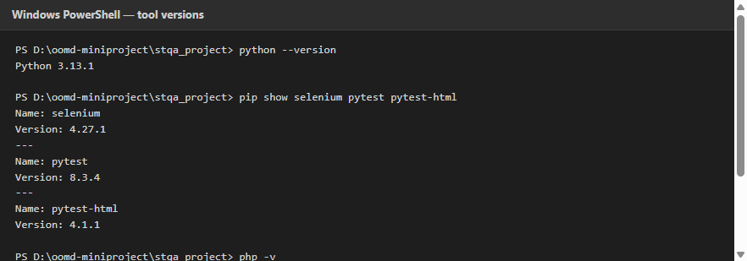
Figure 1: Python, Selenium, pytest, PHP and MySQL version output
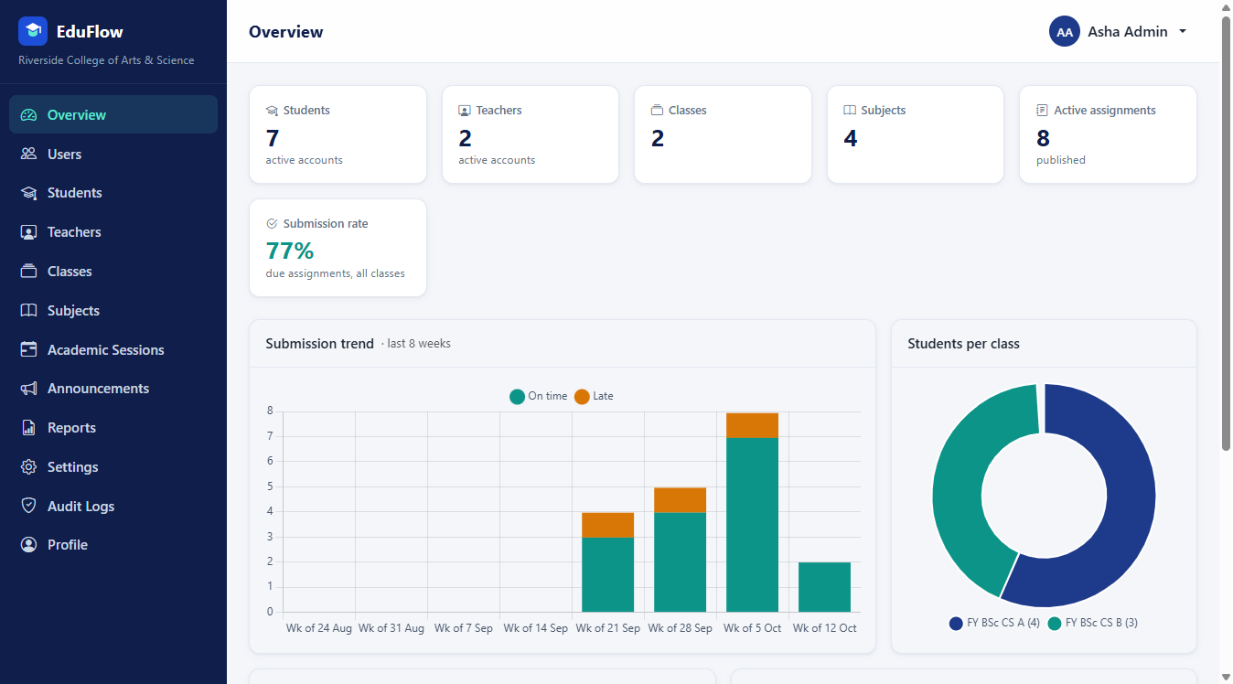
Figure 2: EduFlow application ready (Admin overview page)

8.2 Code Implementation
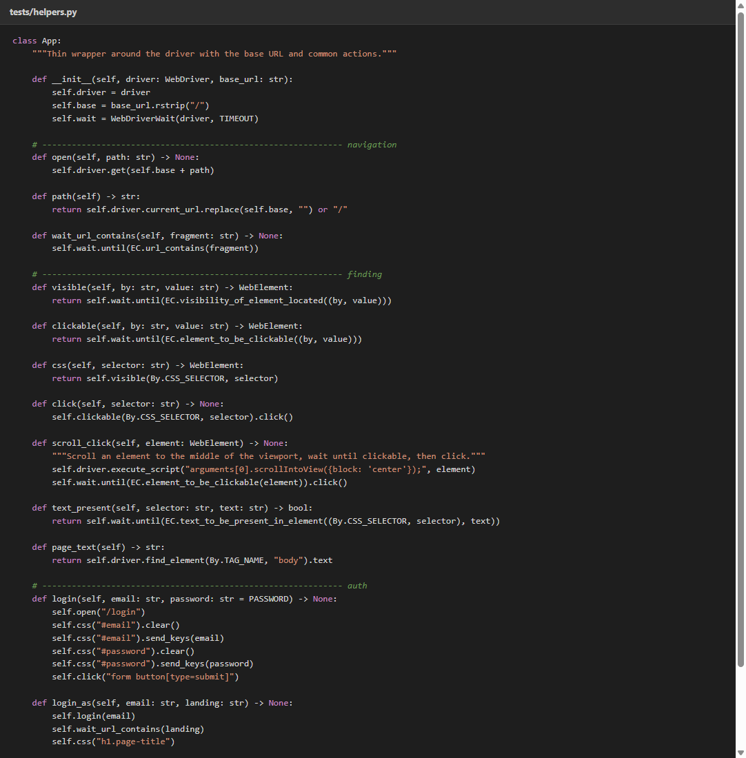
Figure 3: helpers.py – reusable App class with explicit waits, login and screenshot helpers
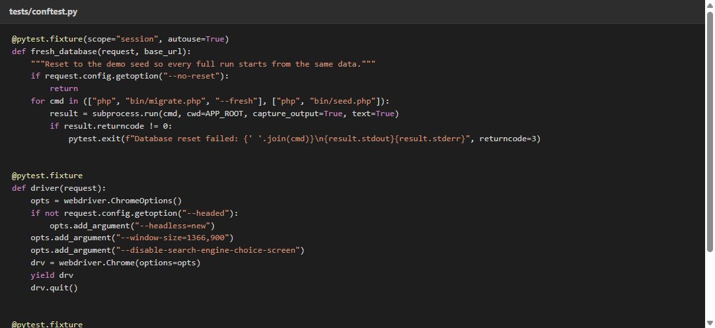
Figure 4: conftest.py – fixtures for server start-up, database reset and Chrome driver
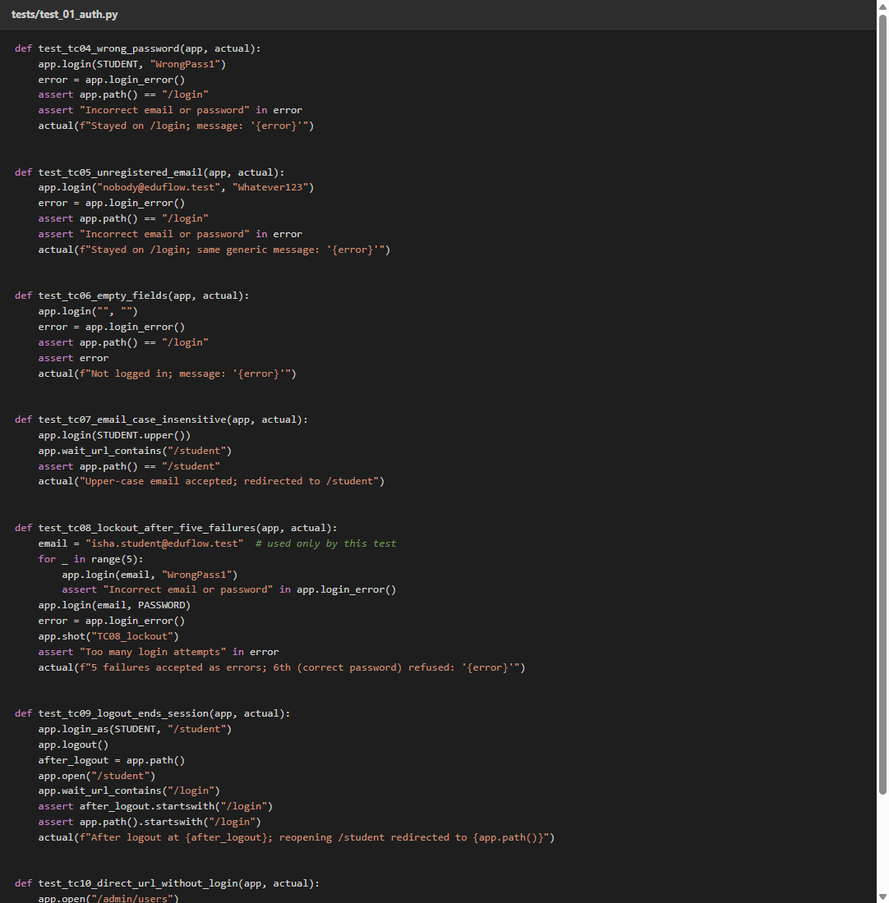
Figure 5: Selenium test code – login, lockout and access-control tests (TC04–TC11)
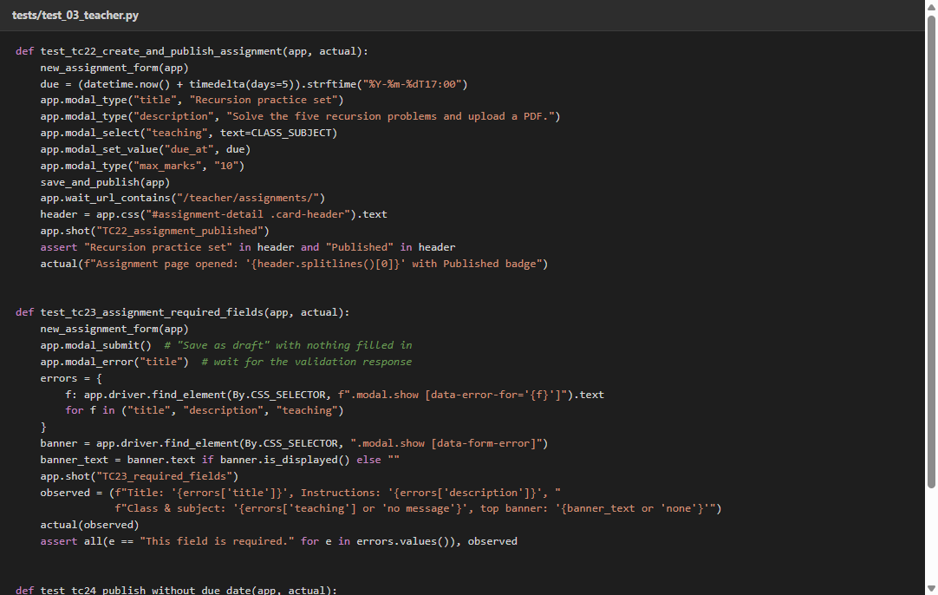
Figure 6: Selenium test code – create and publish assignment (TC22)

8.3 Application Screens
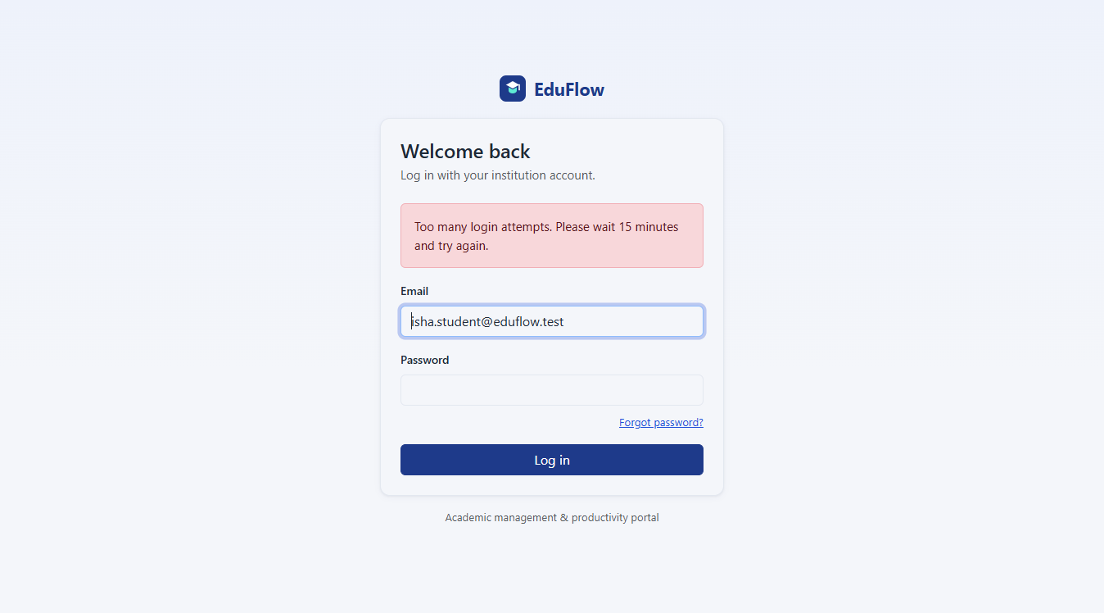
Figure 7: EduFlow login page – lockout after 5 failed attempts (TC08)
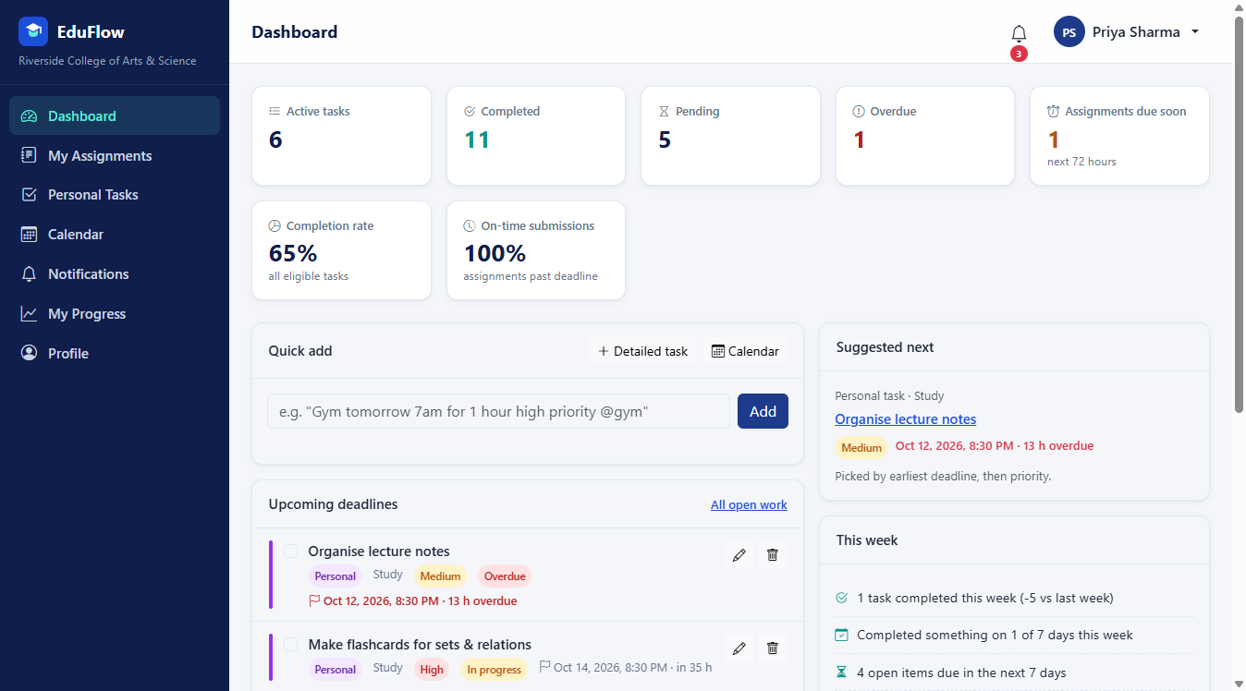
Figure 8: EduFlow student dashboard (TC03)
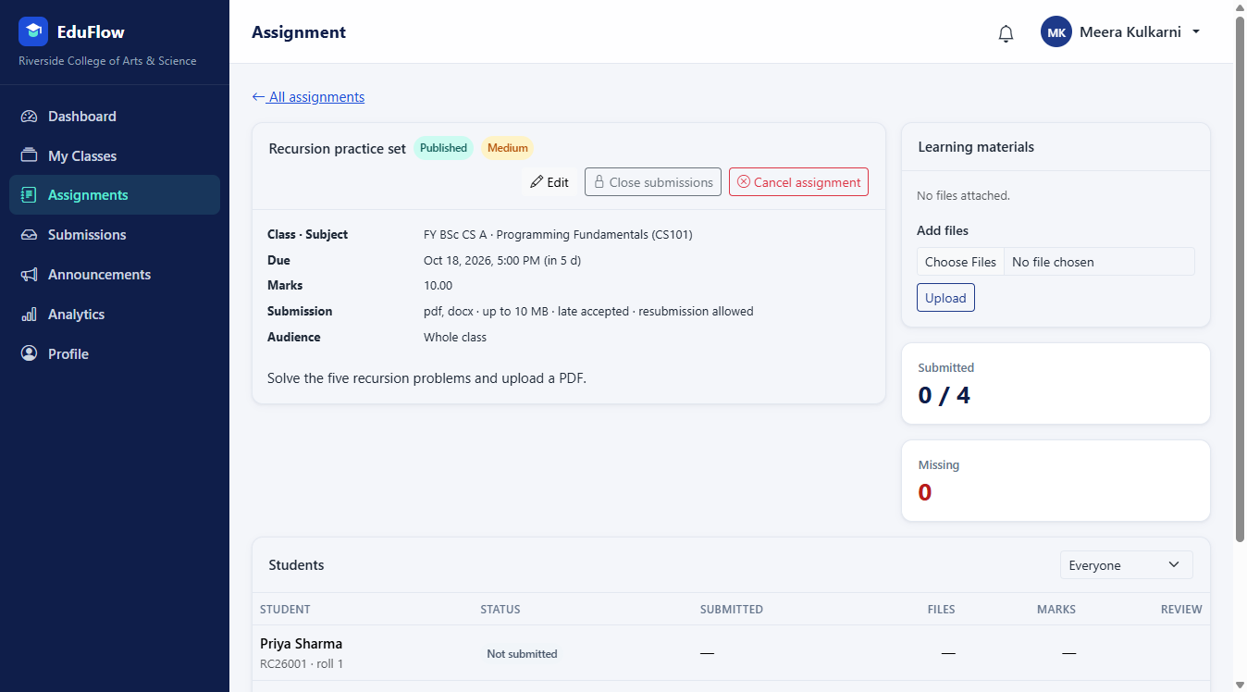
Figure 9: Teacher's assignment published (TC22)
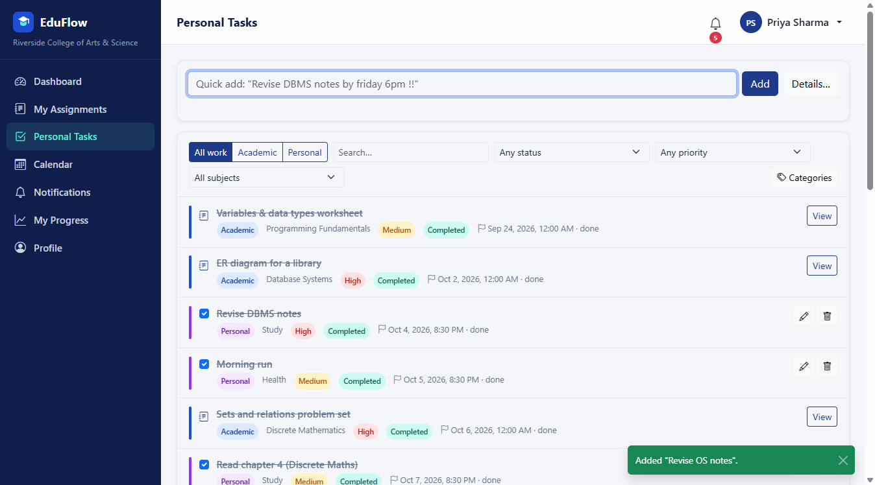
Figure 10: Quick-add personal task (TC29)
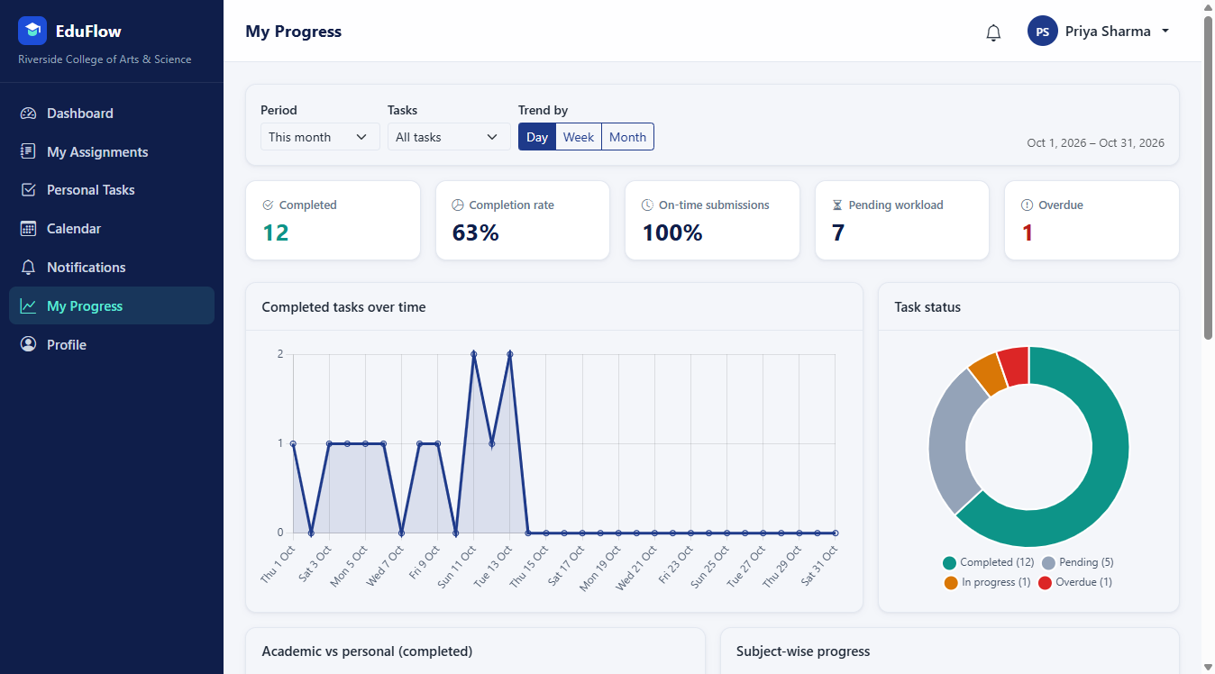
Figure 11: Student progress analytics dashboard (TC35)

8.4 Test Execution
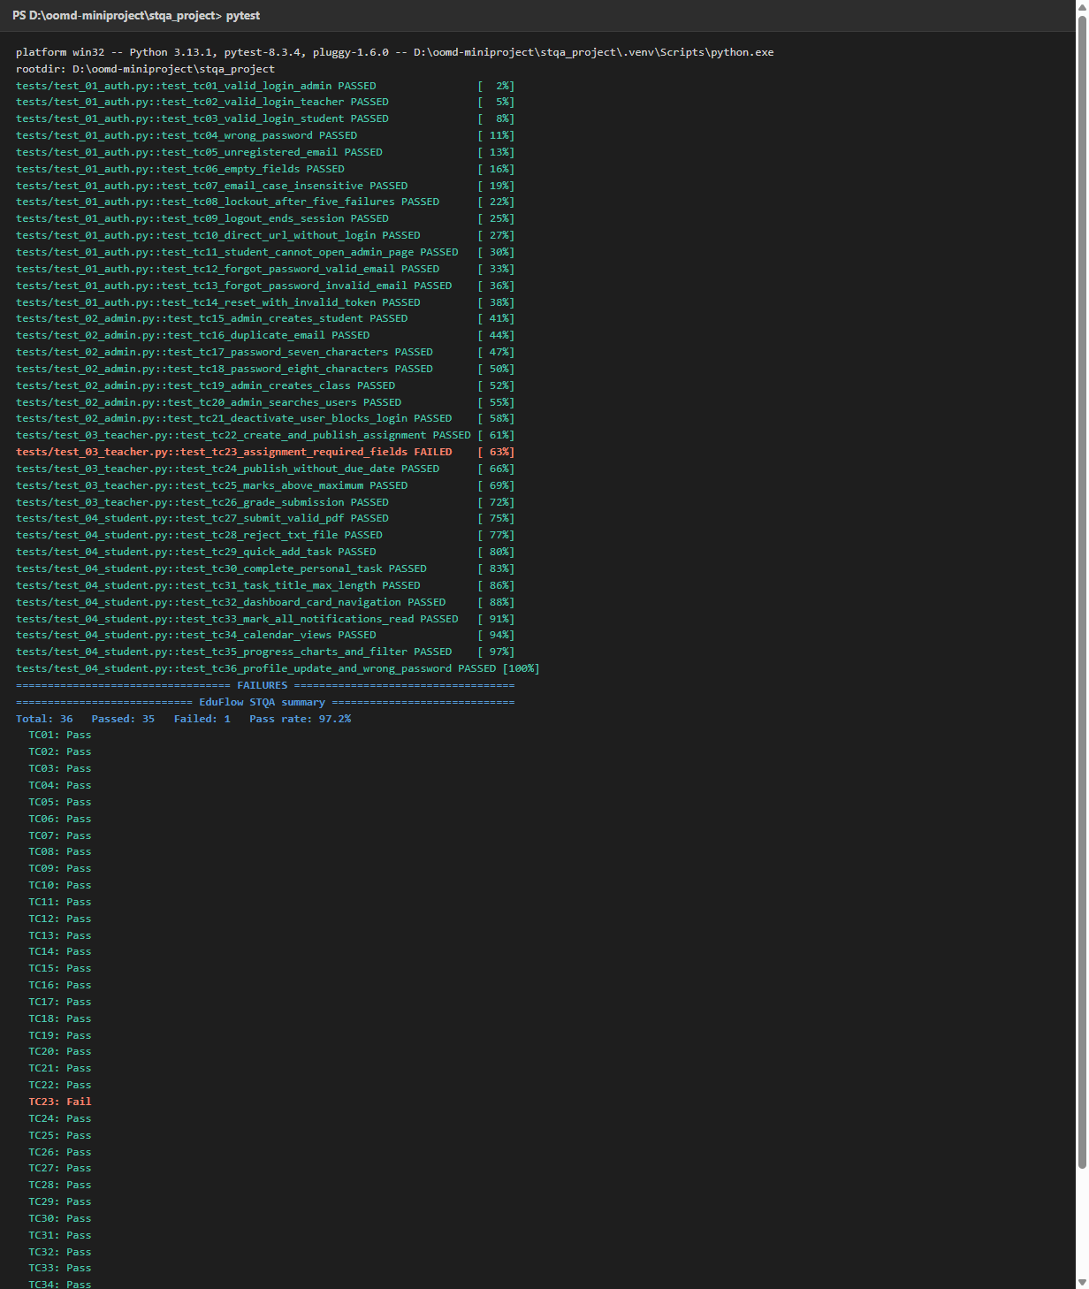
Figure 12: Console showing the full regression run and final results
Figure 13: Selenium IDE flows replayed – 3 of 3 passed
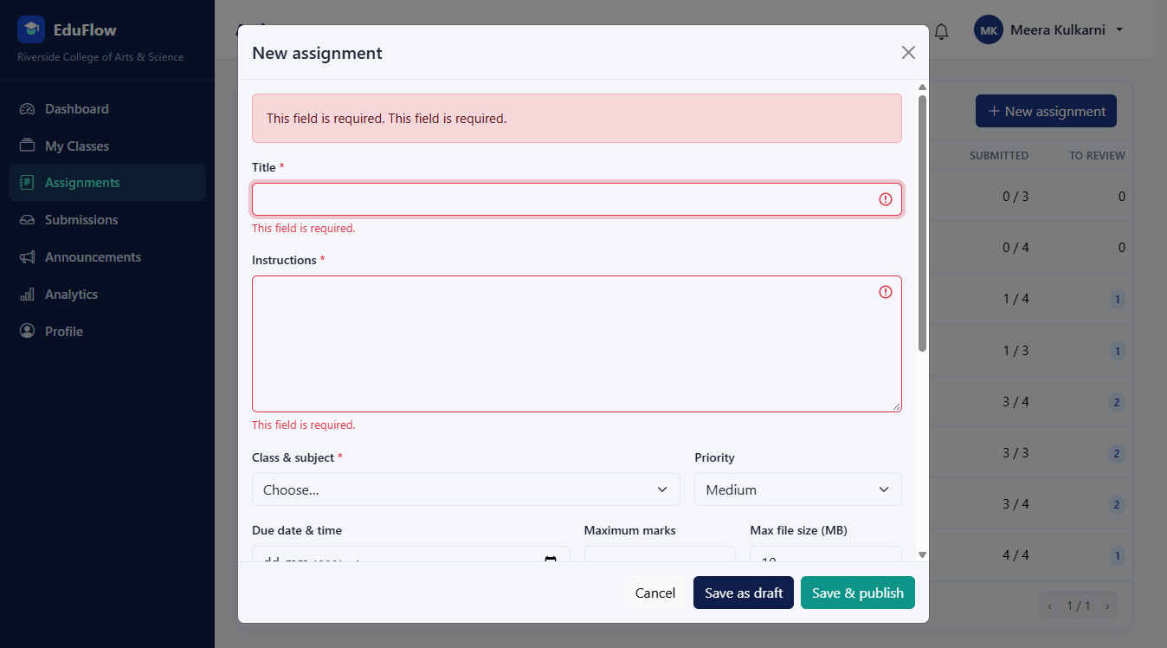
Figure 14: Failed test TC23 – no required-field message under Class & subject (BUG-01)

8.5 Results
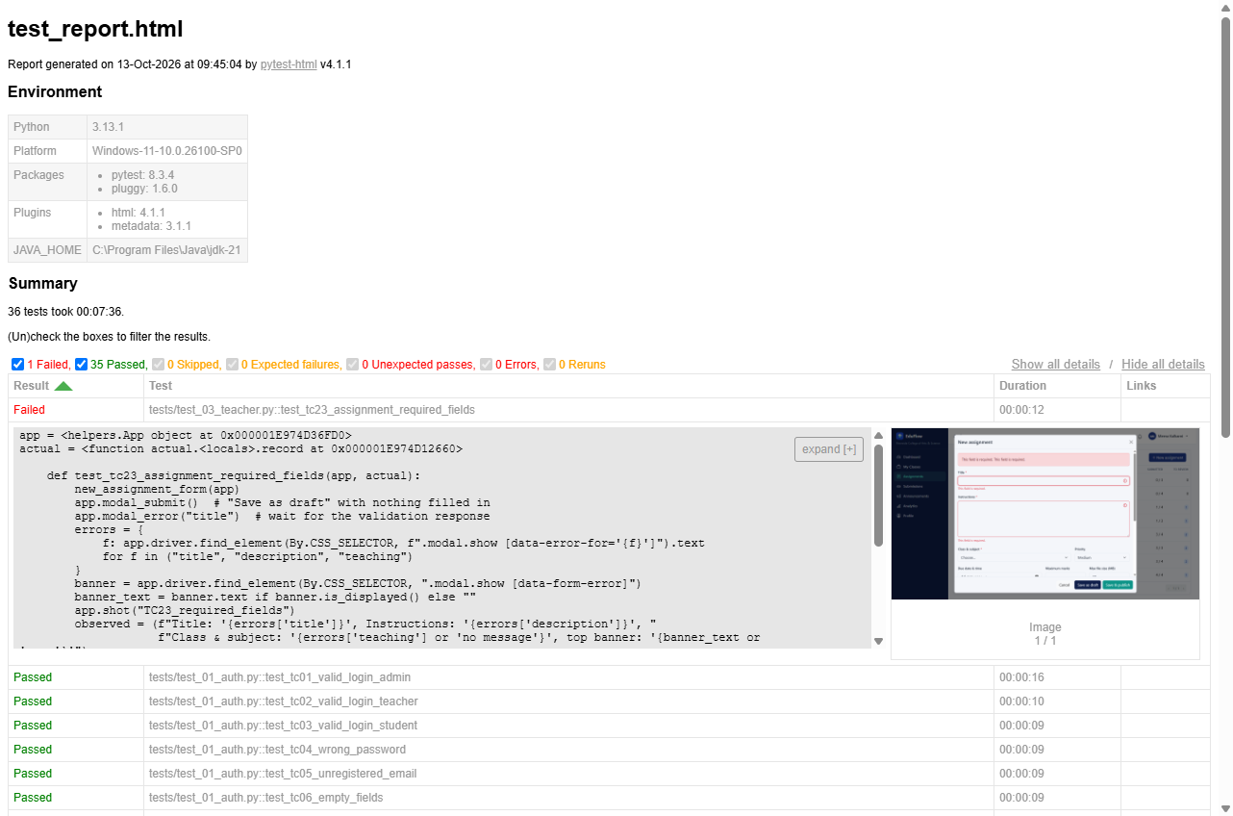
Figure 15: pytest-html report – full suite results

9 TEST RESULTS
Across all 36 documented test cases (TC01–TC36), 35 passed and 1 failed, as recorded in the Test Cases table in Section 6. All 36 were automated using Selenium WebDriver and pytest and executed in a single regression run from a freshly seeded database.
Metric | Observed Result
Total tests | 36
Passed | 35
Failed | 1 (TC23)
Run rate | 100%
Pass rate | 97.2%
Execution time | 3.2 minutes
Selenium IDE flows | 3 of 3 passed

Verified overall result: 35 of 36 test cases passed and 1 failed (97.2% pass rate), which meets the exit criteria (100% run rate, at least 80% pass rate, no open Critical defect). Two Minor defects were reported:
Bug ID | Title | Severity | Priority | Status
BUG-01 | "Class & subject" required error not shown under the field (found by TC23) | Minor | P3 | Open
BUG-02 | Double-clicking "Add" in quick-add creates duplicate tasks (exploratory) | Minor | P3 | Open

10 CONCLUSION
This STQA mini project applied systematic software testing practices to the EduFlow web application. The report documents the testing scope, environment, resources, test cases, automation approach and results. All 36 test cases were automated with Selenium WebDriver and pytest using explicit waits, stable locators and automatic failure screenshots; 35 passed and one exposed a real validation defect. Exploratory testing found a second defect and confirmed that access control, input escaping, length limits and responsive layouts work correctly.
The automated suite runs unattended in about eight minutes from a clean database, so it can be repeated after every change as a regression check. Selenium WebDriver with pytest proved suitable for testing a modern JavaScript-driven web application, and the suite can be extended with Selenium Grid for cross-browser testing in the future.

11 REFERENCES / PROJECT ARTIFACTS
- EduFlow project application
- EduFlow Selenium test automation code (tests/)
- pytest configuration (pytest.ini, requirements.txt)
- Selenium IDE project (selenium_ide/EduFlow.side)
- EduFlow test plan, test cases and bug taxonomy (test_plan.md, test_cases.md, bug_taxonomy.md)
- Bug report and exploratory testing notes (bug_report.md, exploratory_testing.md)
- EduFlow test-execution report (reports/test_report.html)
- STQA mini project report reference format supplied for this submission

