STQA MINI PROJECT REPORT
Web Testing of EduFlow – Academic Management & Productivity Portal using Selenium WebDriver and Selenium IDE

● Title : Create a small web-based application by selecting relevant system environments/platforms and programming languages. Narrate concise Test Plan consisting features to be tested and bug taxonomy. Narrate scripts in order to perform regression tests. Identify the bugs using Selenium WebDriver and IDE and generate test reports encompassing exploratory testing.

● Problem Definition : Perform Web testing and identify the bugs using Selenium WebDriver and IDE and generate test reports for EduFlow – Academic Management & Productivity Portal.
EduFlow is a web application used by an institution's administrators, teachers and students. Admins manage users and classes, teachers publish assignments and grade submissions, and students submit work, manage personal tasks and track their progress. Because it handles accounts, grades and uploaded files, defects in login, access control, validation or the assignment workflow directly affect its users. The application is tested as a black box through its web interface.

● Prepared By
Sr. No. | Name | Roll No. | Class
1 | Soniya Pawar | [Roll No] | BE COMP
2 | Sakshi Jagadale | [Roll No] | BE COMP
3 | Priti Merurkar | [Roll No] | BE COMP

● Prerequisite : Knowledge of Core Java
- Core Java: object-oriented concepts (classes, objects, inheritance, exceptions) and collections. Selenium's API (WebDriver, WebElement, By, WebDriverWait) is the same object model in Java and Python, so these concepts carry over directly.
- Python 3 and pytest: the regression scripts of this project are written in Python with the pytest framework (fixtures, assertions).
- Basic HTML, CSS and the DOM, and CSS / XPath locators.
- Software testing fundamentals: test plan, test case design, equivalence partitioning, boundary value analysis, defect life cycle.

● Software Requirements
Software | Version / details
Operating system | Windows 11 (64-bit)
Application under test | EduFlow (PHP 8.4.5, MySQL 8.0, Bootstrap 5.3, Chart.js 4.4)
Web server | PHP built-in development server (or Apache via XAMPP)
Database server | MySQL 8.0
Browser | Google Chrome 154
Programming language | Python 3.13
Automation tool | Selenium WebDriver 4.27.1 (Selenium Manager for ChromeDriver)
Record and playback tool | Selenium IDE browser extension
Test framework / reporting | pytest 8.3.4, pytest-html 4.1.1
Editor / IDE | Visual Studio Code
Documentation | Microsoft Word, Markdown
Version control | Git, GitHub

● Hardware Requirement
Component | Minimum requirement
Processor | Intel Core i3 / AMD Ryzen 3 or better, 64-bit
RAM | 8 GB (Chrome, MySQL and PHP run together)
Hard disk | 2 GB free disk space
Display | 1366 × 768 or higher resolution
Network | Internet access for first-time ChromeDriver download and CDN assets

● Theory

Introduction of mini project
This mini project applies the software testing life cycle to a complete, working web application. EduFlow has three roles (Admin, Teacher, Student) and features such as authentication, user and class management, assignment publishing and grading, file submission, personal task management, notifications, a calendar and analytics charts. The team planned the testing, designed 36 test cases, automated them with Selenium WebDriver, recorded smoke flows in Selenium IDE, explored the application manually, and reported the defects found against defined exit criteria.
Software testing is the process of executing a program to find defects and to check that it meets its requirements. Quality assurance is the wider set of activities that make sure a process produces quality software. The testing types used here are integration testing, system testing, regression testing (re-running the automated suite after changes) and exploratory testing (simultaneous learning, test design and execution).

Testing Tool: Selenium
Selenium is a free (open-source) automated testing suite for web applications across different browsers and platforms. It is similar to HP Quick Test Pro (QTP, now UFT), except that Selenium focuses only on automating web-based applications. Testing done using the Selenium tool is usually referred to as Selenium Testing. Selenium is not a single tool but a suite of software, each part catering to different testing needs of an organization. It has four components:
- Selenium Integrated Development Environment (IDE) – records user actions in the browser and plays them back.
- Selenium Remote Control (RC) – the original Selenium 1 server that injected JavaScript into the browser; now deprecated and replaced by WebDriver.
- WebDriver – a programming interface that drives the browser directly through its native automation support (ChromeDriver, GeckoDriver) using the W3C WebDriver protocol.
- Selenium Grid – runs WebDriver tests in parallel on many machines, browsers and operating systems through a hub that distributes sessions to nodes.

Selenium IDE
Selenium IDE (Integrated Development Environment) is the simplest tool in the Selenium Suite. It is a browser add-on (for Firefox and Chrome) that creates tests very quickly through its record-and-playback functionality. This feature is similar to that of QTP. It is effortless to install and easy to learn. Because of its simplicity, Selenium IDE should only be used as a prototyping tool, not as an overall solution for developing and maintaining complex test suites. Recordings are saved as .side project files.
Though Selenium IDE can be used without prior knowledge of programming, the tester should be familiar with HTML, JavaScript and the DOM (Document Object Model) to use it to its full potential. Knowledge of JavaScript is required for the Selenese command "run script".
Selenium IDE supports auto-complete mode when creating tests. This serves two purposes: it helps the tester enter commands more quickly, and it restricts the user from entering invalid commands. In this project Selenium IDE was used to record three smoke flows (student login, quick-add task, logout) in selenium_ide/EduFlow.side.

Selenium WebDriver
WebDriver controls the browser directly. Tests locate elements with By locators (ID, NAME, CSS_SELECTOR, XPATH, LINK_TEXT), perform actions such as click and send_keys, and use explicit waits (WebDriverWait with expected_conditions) to synchronise with dynamic pages. All 36 automated regression tests of this project use Selenium 4 WebDriver.

Setting up the Selenium project
In Java, a Selenium project is set up with Maven: the selenium-java dependency in the pom.xml file downloads the Java bindings and all their dependencies, and the project is then imported into IntelliJ IDEA or Eclipse. This project uses the equivalent Python bindings: pip install -r requirements.txt installs Selenium 4.27.1, pytest and pytest-html, and Selenium Manager downloads the ChromeDriver that matches the installed Chrome automatically. The suite is run with the single command pytest.

Advantages of Selenium
i) It is open-source software.
ii) It supports various operating environments (Windows, Linux, Mac etc.).
iii) It supports various browsers (Chrome, Firefox, Edge, Safari, Opera etc.).
iv) It supports various programming languages (Java, Python, C#, Ruby, JavaScript, PHP).
v) It supports parallel test execution (Selenium Grid).
vi) It uses fewer hardware resources than commercial tools.

Disadvantages of Selenium
i) It supports web-based applications only.
ii) No reliable vendor support; help comes from the community.
iii) No centralized maintenance of elements/objects (no built-in object repository).
iv) Setting up the environment takes effort.
v) Difficult to use without programming knowledge.
vi) Limited support for image-based testing.
vii) New browser features may not work properly until drivers are updated.
viii) No built-in test management or reporting facility (this project uses pytest-html for reports).

● Test Plan

INTRODUCTION
The Test Plan is designed to prescribe the scope, approach, resources, and schedule of all testing activities of the project EduFlow – Academic Management & Productivity Portal.
The plan identifies the items to be tested, the features to be tested, the types of testing to be performed, the personnel responsible for testing, the resources and schedule required to complete testing, and the risks associated with the plan. The application under test runs locally at http://127.0.0.1:8000 with fictional demo data.

1 TEST STRATEGY

1.1 Scope of Testing

1.1.1 Feature to be tested
All the features of EduFlow listed below, which are defined in its requirements for the three roles, need to be tested.
Module Name | Applicable Roles | Description
Login & authentication | All | Valid/invalid login, empty fields, case-insensitive email, lockout after repeated failures, role-based redirect
Password recovery | All | Forgot-password request, email format validation, invalid reset link
Session & access control | All | Logout, back-navigation after logout, direct URL access without login, role restrictions (403)
User management | Admin | Create student, duplicate email, password boundary values, search, deactivate account
Class management | Admin | Create class
Assignment management | Teacher | Create and publish assignment, required-field validation, "due date required to publish" rule
Grading | Teacher | Grade a submission, marks above maximum rejected
Assignment submission | Student | Upload valid PDF, reject disallowed file type
Personal tasks | Student | Quick-add from a sentence, complete with checkbox, title length boundary
Dashboard & navigation | Student | Summary cards, card drill-down navigation
Notifications | Student | Unread badge, "Mark all as read"
Calendar | Student | Month view rendering, switch to agenda view
Progress analytics | Student | Charts render from data, period filter
Profile | All | Update name, change password with wrong current password

1.1.2 Feature not to be tested
These features are not tested because they are outside the web user interface or not available in the test environment:
- Email delivery of password-reset links (mail is written to a log file; no mail server)
- Scheduled reminder job bin/reminders.php (command-line job, not part of the web UI)
- CSV report contents and CSV user import (file contents outside the UI scope)
- Website performance and load testing (no load-testing tool in scope)
- Cross-browser testing beyond Google Chrome (only Chrome on the test machine)
- Attendance and parent access (not implemented in the application)

1.2 Test Type
In the project EduFlow, four types of testing are conducted:
- Integration Testing: UI, server and database are combined and tested as a group, e.g. a student submission appears in the teacher's review queue, and publishing an assignment creates notifications.
- System Testing: conducted on the complete, integrated system to evaluate its compliance with the specified requirements, using end-to-end journeys for every role.
- Regression Testing: the automated Selenium WebDriver suite is re-run after every fix or script change to confirm that nothing else broke.
- Exploratory Testing: time-boxed sessions probing special characters, long strings, double submits, Back/Refresh, direct URLs and small screen sizes.

1.3 Risk and Issues
Risk | Mitigation
Tests change data (new users, submissions), so a second run behaves differently | Reset the database to the demo seed before every full run (migrate.php --fresh + seed.php)
Login lockout (5 failed attempts in 15 min) blocks accounts used by other tests | The lockout test uses a dedicated account; the database reset clears the counters
Timing issues with JavaScript-loaded content cause false failures | Explicit waits (WebDriverWait) on visible elements; no fixed sleeps
ChromeDriver / Chrome version mismatch stops the suite | Selenium Manager downloads the matching driver automatically
Team members lack experience with Selenium | Shared helper module (login, waits, screenshots) and Selenium IDE recordings as examples
The project schedule is tight | Set test priority: login, access control and the assignment workflow first

1.4 Test Logistics

1.4.1 Who will test?
The project team of three members performs all testing (no outsourced testers):
Activity | Who | When
Requirement study, test plan, bug taxonomy | Soniya Pawar | Day 1
Test case design | Sakshi Jagadale, Priti Merurkar | Day 1–2
Selenium WebDriver scripts | Soniya Pawar, Sakshi Jagadale | Day 2–3
Selenium IDE recordings | Priti Merurkar | Day 3
Test execution and regression runs | All | Day 3–4
Exploratory testing and bug reporting | Priti Merurkar, Sakshi Jagadale | Day 4
Final test report and documentation | Soniya Pawar | Day 5
Exploratory testing and bug reports | Sakshi Jagadale, Priti Merurkar | 5
Final test report and Word document | Soniya Pawar | 4

1.4.2 When will test occur?
The testers start test execution when all of the following inputs are ready:
- Software (EduFlow) is available for testing and running with the demo seed data
- Test specification (test plan and test cases) is created
- Test environment is built (PHP, MySQL, Chrome, Python, Selenium)
- Enough human resource is available for testing

2 TEST OBJECTIVE
The test objective is to verify the functionality of EduFlow. The project focuses on testing the academic operations such as login and access control, user and class management, assignment publishing, submission and grading, and the student productivity features, to guarantee that all these operations work normally in a real institution. In detail:
- Verify that every feature in scope works as intended for each role.
- Verify input validation: required fields, formats and boundary values.
- Verify that access control prevents unauthenticated and unauthorised access.
- Find and document defects with clear reproduction steps, severity and priority.
- Provide an automated regression suite that can be re-run after changes.

3 TEST CRITERIA

3.1 Suspension Criteria
If the team members report that 40% or more of the test cases have failed, or a blocker is found (the application does not start, or no role can log in), testing is suspended until the development team fixes the failed cases.

3.2 Exit Criteria
Specifies the criteria that denote a successful completion of a test phase:
- Run rate is mandatory to be 100% unless a clear reason is given.
- Pass rate is 80%; achieving the pass rate is mandatory.
- No Critical defect is left open.

4 RESOURCE PLANNING

4.1 System Resource
No. | Resources | Descriptions
1. | Server | PHP 8.4 built-in web server (or Apache) and a database server with MySQL 8.0
2. | Test tool | Selenium WebDriver 4.27 with Python 3.13 and pytest 8.3 for automated tests; pytest-html 4.1 to generate the test report; Selenium IDE for record and playback
3. | Browser | Google Chrome 154 (headless and normal mode)
4. | Network | Local host (127.0.0.1); Internet line for the first ChromeDriver download
5. | Computer | Windows 11, 64-bit, 8 GB RAM, Intel Core i3 / AMD Ryzen 3 or better
6. | Version control | Git and GitHub

4.2 Human Resource
No. | Member | Tasks
1. | Soniya Pawar  (Test Lead) | Manage the whole project; define the test plan and bug taxonomy; build the automation framework; prepare the final report
2. | Sakshi Jagadale  (Test Engineer) | Design test cases; write Selenium WebDriver scripts; execute tests; exploratory testing
3. | Priti Merurkar  (Test Engineer) | Design test cases; record Selenium IDE flows; exploratory testing; write bug reports

5 SCHEDULE & ESTIMATION

5.1 All project task and estimation
Task | Members | Estimate effort
Understand the application and requirements | All | 6 man-hour
Write test plan and bug taxonomy | Soniya Pawar | 4 man-hour
Design test cases | Sakshi Jagadale, Priti Merurkar | 6 man-hour
Build automation framework and scripts | Soniya Pawar, Sakshi Jagadale | 12 man-hour
Record Selenium IDE flows | Priti Merurkar | 2 man-hour
Execute tests and regression runs | All | 4 man-hour
Exploratory testing and bug reports | Sakshi Jagadale, Priti Merurkar | 5 man-hour
Final test report and Word document | Soniya Pawar | 4 man-hour
Total |  | 43 man-hour

Schedule to complete these tasks
Task Name | Start | End | Day 1 | Day 2 | Day 3 | Day 4 | Day 5
Understand the application and requirements | Day 1 | Day 1
Write test plan and bug taxonomy | Day 1 | Day 1
Design test cases | Day 1 | Day 2
Milestone: Test specification complete | Day 2 | Day 2 |  | ◆
Build automation framework and scripts | Day 2 | Day 3
Record Selenium IDE flows | Day 3 | Day 3
Execute tests and regression runs | Day 3 | Day 4
Exploratory testing and bug reports | Day 4 | Day 4
Milestone: Test execution complete | Day 4 | Day 4 |  |  |  | ◆
Final test report and documentation | Day 5 | Day 5
Milestone: Test delivery | Day 5 | Day 5 |  |  |  |  | ◆
Shaded cells show the days on which a task is carried out; ◆ marks a milestone.

6 BUG TAXONOMY
A bug taxonomy is a classification scheme for defects. Every bug in bug_report.md is assigned one category, one severity and one priority from this document.

Categories
Category | Definition | Examples in EduFlow
Functional | A feature does not do what it should, or gives wrong results | Publishing an assignment does not notify students; marks saved against the wrong submission; dashboard "Completed" count does not match the task list
UI (User Interface) | Layout, text, styling or visual feedback is wrong, but the function works | Overlapping chart labels; button text cut off; success message not shown after saving
Validation | Input is accepted when it should be rejected, rejected when valid, or the error message is wrong/missing | 7-character password accepted; .txt upload accepted where only PDF is allowed; empty title accepted
Navigation | Links, redirects, back/refresh or URL handling take the user to the wrong place | Logout leaves the dashboard reachable with the Back button; card click opens an unfiltered list; 404 for an existing page
Performance | Pages or actions are unacceptably slow, or resources leak | Dashboard takes more than 3 s to load with demo data; repeated chart redraws freeze the page
Security | Data or actions are available to someone who should not have them | Student opens /admin/users; another student's file downloadable by changing the id; form works without CSRF token
Compatibility | Works in one browser, screen size or device but not another | Horizontal scrolling on a 390 px phone screen; calendar unreadable on mobile; date picker missing in a browser

Severity scale (impact on the system)
Severity | Definition | EduFlow example
Critical | Blocks a core function or exposes data; no workaround | No user can log in; students can see other students' submissions
Major | A main feature fails or gives wrong results; a workaround may exist | Students cannot submit assignments; grades are not saved
Minor | Limited feature or validation problem; the main flow still works | Wrong error text; a filter ignores one option
Trivial | Cosmetic issue with no functional effect | Spelling mistake; misaligned icon

Priority scale (urgency of fixing)
Priority | Definition | Typical pairing
P1 — Immediate | Fix before any further testing or release | Critical bugs
P2 — High | Fix in the current release | Major bugs, visible Minor bugs on main flows
P3 — Medium | Fix when time allows in this or the next release | Minor bugs
P4 — Low | Fix if convenient; may be deferred | Trivial bugs

Severity describes how bad the defect is; priority describes how soon it must be fixed. They usually match, but not always: a spelling mistake in the login page title is Trivial but could be P2 because every user sees it.

Bug status lifecycle
New → Open → Fixed → Retested → Closed, with Reopened if the retest fails, and Deferred or Rejected (not a bug / works as designed) when applicable.

7 TEST DELIVERABLES
Test deliverables are provided as below:

7.1 Before testing phase
- Test plan document (test_plan.md)
- Test cases document (test_cases.md)
- Test design specification and bug taxonomy (bug_taxonomy.md)

7.2 During the testing
- Test tool: Selenium WebDriver scripts (tests/) and Selenium IDE project (selenium_ide/EduFlow.side)
- Test data: demo seed database and upload files (tests/files/)
- Test traceability: each test function is named after its test case (e.g. test_tc22_… ↔ TC22)
- Error logs and execution logs (reports/console_output.txt, failure screenshots)

7.3 After the testing cycles is over
- Test results / reports (reports/test_report.html, reports/final_report.md)
- Defect report (bug_report.md)
- Exploratory testing notes (exploratory_testing.md)
- Installation / test procedure guidelines (README.md)
- This project report

● Test Report for Test Cases inclusive of Test Procedures for identified Test Scenarios
Environment: http://127.0.0.1:8000, Google Chrome 154 (headless), database reset to the demo seed before the run, demo password for all accounts Demo@1234. 36 test cases were executed with Selenium WebDriver: 35 passed, 1 failed.
Sr. No. | Test Objective | Steps | Expected Result | Actual Result | Test Status
TC01 | Check valid login as Admin | Open /login; email admin@eduflow.test, password Demo@1234; click Log in | Redirected to /admin; page title "Overview" | Redirected to /admin; heading 'Overview' | Pass
TC02 | Check valid login as Teacher | Email meera.teacher@eduflow.test, valid password | Redirected to /teacher; Dashboard shown | Redirected to /teacher; heading 'Dashboard' | Pass
TC03 | Check valid login as Student | Email priya.student@eduflow.test, valid password | Redirected to /student; Dashboard with summary cards | Redirected to /student; 7 summary cards shown | Pass
TC04 | Check login with wrong password | Valid email, password WrongPass1 | Stays on login page; "Incorrect email or password." shown | Stayed on /login; message: 'Incorrect email or password.' | Pass
TC05 | Check login with unregistered email | Email nobody@eduflow.test, any password | Same generic error; no hint that the email does not exist | Stayed on /login; same generic message: 'Incorrect email or password.' | Pass
TC06 | Check login with empty fields | Leave email and password empty; click Log in | Not logged in; error message shown | Not logged in; message: 'Incorrect email or password.' | Pass
TC07 | Check email is case-insensitive | Email PRIYA.STUDENT@EDUFLOW.TEST, valid password | Logged in, redirected to /student | Upper-case email accepted; redirected to /student | Pass
TC08 | Check account lockout after 5 failed attempts (boundary) | Enter wrong password 5 times for isha.student@eduflow.test, then the correct password | 6th attempt refused with "Too many login attempts" | 5 failures accepted as errors; 6th (correct password) refused: 'Too many login attempts. Please wait 15 minutes and try again.' | Pass
TC09 | Check logout ends the session | Log in as student; open profile menu; Log out; then open /student | Redirected to /login after logout; /student redirects to /login | After logout at /login; reopening /student redirected to /login?next=%2Fstudent | Pass
TC10 | Check direct URL access without login | Without logging in, open /admin/users | Redirected to /login?next=… | Redirected to /login?next=%2Fadmin%2Fusers | Pass
TC11 | Check role restriction | Log in as student; open /admin/users | "403 · Access denied" page | Page shows '403 · Access denied' | Pass
TC12 | Check forgot password with valid email | /forgot-password; email priya.student@eduflow.test; Send | Redirected to /login with "If an account exists…" notice | Redirected to /login with notice: 'If an account exists for that email, a reset link has been sent. It expires in 1 hour.' | Pass
TC13 | Check forgot password with invalid email format | Email not-an-email; Send | "Enter a valid email address." shown | Message: 'Enter a valid email address.' | Pass
TC14 | Check reset password with invalid link | Open /reset-password?token=abc123 | "This reset link is invalid or has expired." and link to request a new one | Message: 'This reset link is invalid or has expired.'; link offered: 'Request a new link' | Pass
TC15 | Admin creates a student (happy path) | Admin → Students → Add student; name Test Student, unique email, password Secure123, admission no STQA001; Save | Toast "Account created."; student appears in search results | Toast 'Account created.'; student found by admission number | Pass
TC16 | Check duplicate email rejected | Add student with email priya.student@eduflow.test | Field error "An account with this email already exists." | Field error: 'An account with this email already exists.' | Pass
TC17 | Check password below minimum length (boundary 7) | Add student with password Abcde12 (7 chars) | Field error "Password must be at least 8 characters." | Field error: 'Password must be at least 8 characters.' | Pass
TC18 | Check password at minimum length (boundary 8) | Add student with password Abcdef12 (8 chars), unique email | Account created | 8-character password accepted; toast 'Account created.' | Pass
TC19 | Admin creates a class | Admin → Classes → Add class; name SY BSc CS, division C; Save | Toast "Class created."; class listed | Toast 'Class created.'; 'SY BSc CS C' listed | Pass
TC20 | Admin searches users | Admin → Users; type Kulkarni in search | Only "Meera Kulkarni" listed | Results: ['Meera Kulkarni'] | Pass
TC21 | Admin deactivates a user, who then cannot log in | Admin → Students; deactivate Dev Patil; confirm; then log in as dev.student@eduflow.test | Status shows "Deactivated"; login shows "This account has been deactivated" | Status 'Deactivated' shown; login message: 'This account has been deactivated. Contact your administrator.' | Pass
TC22 | Teacher creates and publishes an assignment | Teacher → Assignments → New; title, instructions, class & subject, due date; Save & publish | Assignment page opens with "Published" badge | Assignment page opened: 'Recursion practice set' with Published badge | Pass
TC23 | Check assignment required fields | New assignment; leave everything empty; Save as draft | Errors under Title, Instructions and Class & subject; not saved | Title: 'This field is required.', Instructions: 'This field is required.', Class & subject: 'no message', top banner: 'This field is required. This field is required.' | Fail
TC24 | Check publish without due date rejected | New assignment with title, instructions, class; no due date; Save & publish | Error "Set a due date before publishing…" | Field error: 'Set a due date before publishing an assignment that needs a submission.' | Pass
TC25 | Check marks above maximum rejected (boundary) | Teacher opens Sara Khan's "ER diagram" submission (max 20); marks 21; Save grade | Error "Marks cannot exceed 20." | Field error: 'Marks cannot exceed 20.' | Pass
TC26 | Teacher grades a submission | Same submission; marks 18, feedback; Save grade | Status changes to "Graded"; toast "Grade saved." | Toast 'Grade saved.'; status badge 'Graded', marks 18 / 20 | Pass
TC27 | Student submits a valid PDF | Student Priya → My Assignments → "Normalization case study"; upload answer.pdf; Submit | Toast "Submitted…"; status "Submitted", file listed | Toast 'Submitted. Your teacher can see it now.'; card shows 'Your submission Submitted' and answer.pdf | Pass
TC28 | Check disallowed file type rejected | Student Sara → same assignment; upload notes.txt; Submit | Error "…is not an allowed file type…"; nothing saved | Field error: '"notes.txt" is not an allowed file type. Allowed: pdf, docx.'; status still 'Not submitted' | Pass
TC29 | Check quick-add a personal task | Student → Personal Tasks; type Revise OS notes tomorrow 6pm high priority; Add | Toast Added "Revise OS notes"; task listed with High priority | Preview 'Revise OS notes'; toast 'Added "Revise OS notes".'; listed with High priority | Pass
TC30 | Check complete a personal task | Tick the checkbox next to a pending personal task | Toast "marked complete"; task status Completed | 'Revise OS notes' ticked; toast 'Nice — marked complete.'; now in Completed list | Pass
TC31 | Check task title maximum length (boundary 200) | New personal task; type 250 characters in Title; Save | Field accepts only 200 characters; task saved | Typed 250 characters, field kept 200; toast 'Task added.' | Pass
TC32 | Check dashboard card navigation | Student dashboard; click the "Overdue" card | Personal Tasks page opens with Status filter = Overdue | Overdue card (1) opened /student/tasks?status=overdue with filter 'Overdue' | Pass
TC33 | Check mark all notifications as read | Student → Notifications → Mark all as read | Toast "Marked N as read."; unread badge disappears | Badge was 5; toast 'Marked 5 as read.'; badge hidden, no unread items | Pass
TC34 | Check calendar views | Student → Calendar; switch to Agenda | Month grid shown first; agenda list shown after switching | Month grid with 42 days and 74 events; agenda view shows 24 days | Pass
TC35 | Check progress charts and period filter | Student → My Progress; change Period to "This week" | Charts render without errors; date range text changes | 5 charts rendered, no errors; range 'Oct 1, 2026 – Oct 31, 2026' changed to 'Oct 12, 2026 – Oct 18, 2026' | Pass
TC36 | Check profile update and wrong current password | Profile; change name, Save; then change password with wrong current password | Toast "Profile saved."; error "Current password is incorrect." | Toast 'Profile saved.'; name persisted after refresh; password error 'Current password is incorrect.' | Pass

● Narration of Regression Test Scripts
The regression suite lives in stqa_project/tests/ and is run with a single command, pytest. Every run starts from the same data, so the same 36 checks can be repeated after any change to the application to confirm that nothing that worked before has broken.

How a run works
- Start-up (`conftest.py`). pytest loads the fixtures. The base_url fixture checks that EduFlow answers on http://127.0.0.1:8000; if it does not, it starts PHP's built-in server. The fresh_database fixture runs php bin/migrate.php --fresh and php bin/seed.php, which rebuild the database with the fictional demo institution. This makes every regression run independent of earlier runs.
- A new browser per test. The driver fixture opens a fresh headless Chrome window (1366 × 900) through Selenium Manager, which downloads a ChromeDriver that matches the installed Chrome. Each test therefore starts logged out with no cookies, and is closed at the end even if it fails.
- Page actions (`helpers.py`). The App class wraps the driver. login() types the email and password into #email and #password and clicks the submit button. visible(), clickable() and toast() use WebDriverWait with expected_conditions, waiting up to 10 seconds for the element instead of sleeping. Modal forms are filled by field name (modal_type, modal_select), and validation messages are read from the [data-error-for=…] element under each field.
- Checks and evidence. Each test asserts the expected outcome (URL, heading, toast message, field error, list contents) and calls actual(...) to record what it observed. Key passing steps save screenshots such as TC22_assignment_published.png. When an assertion fails, a hook saves screenshots/FAIL_TCxx.png and embeds it in the HTML report.
- Reporting. pytest-html writes reports/test_report.html. A custom summary prints totals and each test case's status in the console, and reports/results.json stores the observed results, which fill_results.py copies into test_cases.md.

Scripts and what they cover
Script | Test cases | Narration
test_01_auth.py | TC01–TC14 | Logs in as each role and checks the landing page; tries a wrong password, an unknown email, empty fields and an upper-case email; fails five times on one account to trigger the lockout; logs out and checks that protected pages redirect to login; opens admin pages without logging in and as a student (403); requests a password reset with valid and invalid emails; opens a reset link with a bad token.
test_02_admin.py | TC15–TC21 | Logs in as admin, opens Add student, and creates a valid student, then tries a duplicate email and passwords of 7 and 8 characters (boundary values). Creates a class, searches users by name, and deactivates a student before checking that the student can no longer log in.
test_03_teacher.py | TC22–TC26 | Logs in as a teacher and creates an assignment with a due date, then uses Save & publish and checks the Published badge. Submits the empty form to check required-field messages, and publishes without a due date to check that rule. Opens a student's submission from the roster and enters marks above the maximum (boundary), then valid marks with feedback.
test_04_student.py | TC27–TC36 | Logs in as students, uploads a valid PDF and a disallowed .txt file, quick-adds a task from a sentence, ticks a task complete, types 250 characters into a 200-character title, clicks the Overdue dashboard card, marks all notifications as read, switches calendar views, checks that the five progress charts render and respond to the period filter, and updates the profile and tries a wrong current password.

Design choices
- Selenium 4 syntax only: driver.find_element(By.CSS_SELECTOR, …), never the removed
find_element_by_* methods.
- Stable locators: element ids (#email), form field names ([name='title']) and the
application's data-* attributes, rather than layout-dependent XPath.
- Explicit waits only: no time.sleep in any test. The one short pause in conftest.py waits
for the PHP server process to start, not for the user interface.
- Independent tests: each test logs in itself and uses its own data (for example a dedicated
account for the lockout test), so tests can run alone (pytest -k tc22) or in any order.

Fixing scripts vs reporting bugs
The first run had three failures. TC25 and TC26 failed because the roster's Open button was below the visible part of the page, so Chrome refused the click. That was a script problem; the script now scrolls the button into view (scroll_click). TC23 failed because the application does not show the Class & subject required-field message under the field. That is a real defect, so the script was left strict and the defect is reported as BUG-01.

Selenium IDE recorded test (Login as student)
No. | Command | Target | Value
1 | open | /login
2 | setWindowSize | 1366x900
3 | click | id=email
4 | type | id=email | priya.student@eduflow.test
5 | type | id=password | Demo@1234
6 | click | css=form button[type=submit]
7 | waitForElementVisible | css=h1.page-title | 10000
8 | assertText | css=h1.page-title | Dashboard
9 | waitForElementVisible | css=#student-stats .stat-card | 10000
10 | assertElementPresent | css=a[href='/student/tasks?status=overdue']

The project EduFlow.side contains three recorded flows in the suite "EduFlow smoke flows": Login as student, Quick-add a personal task, Logout. All three flows passed on replay (python selenium_ide/replay_side.py).

● Screenshot of Code and Output
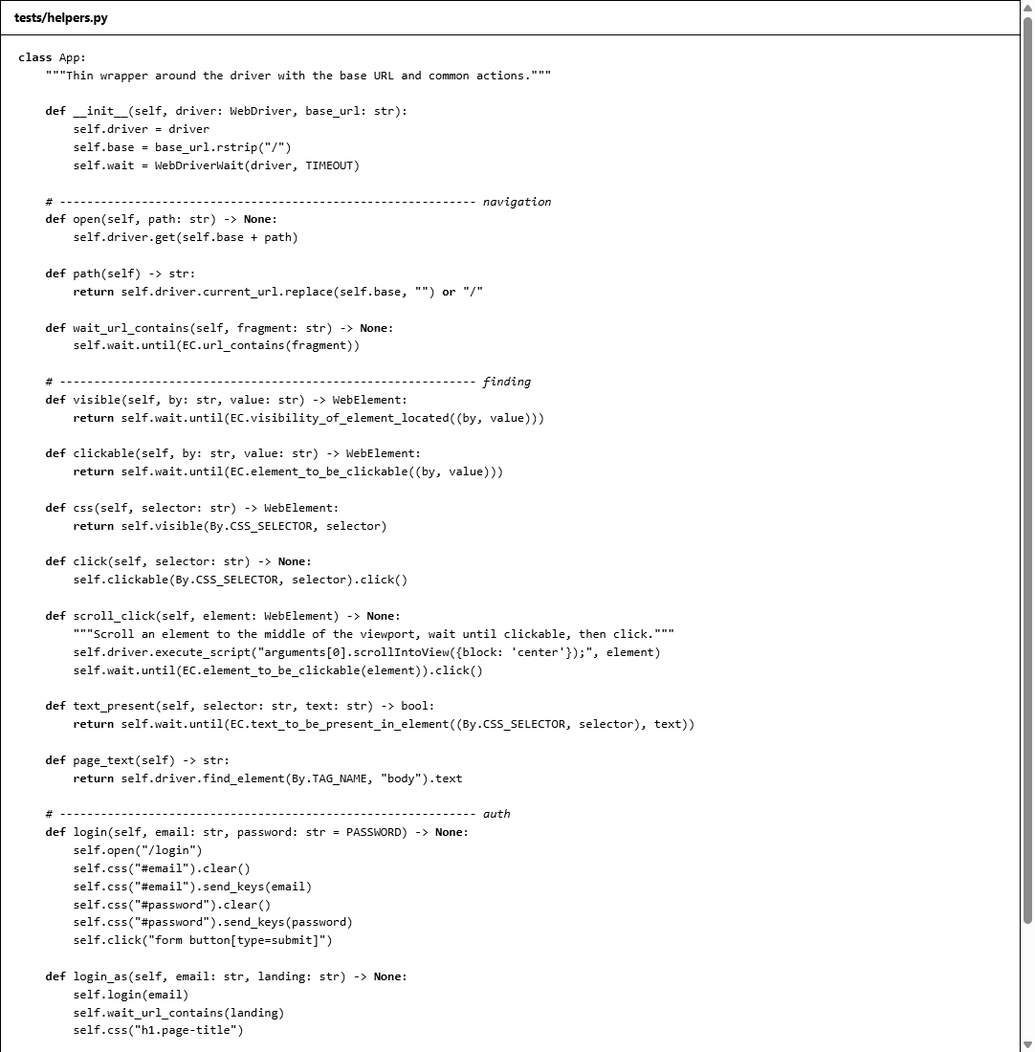
Figure 1: helpers.py – reusable App class with explicit waits, login/logout and screenshot helpers
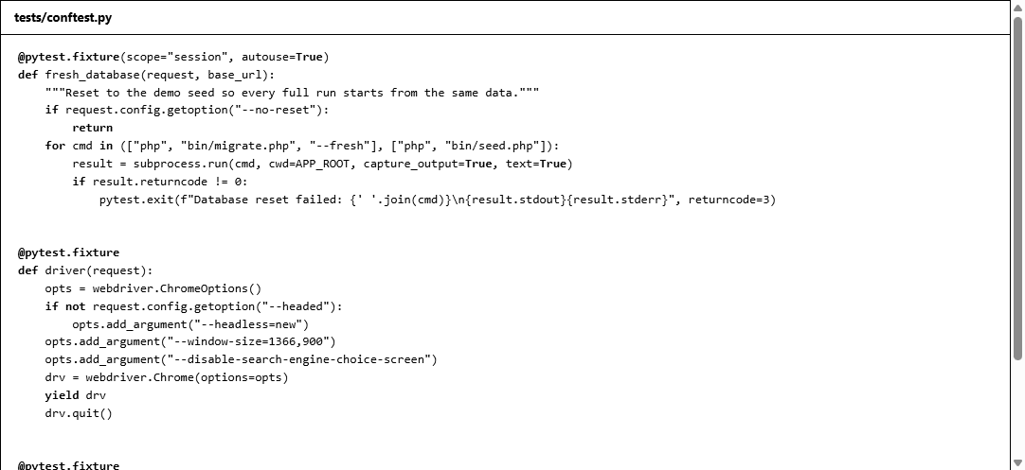
Figure 2: conftest.py – fixtures for server start-up, database reset and the Chrome driver
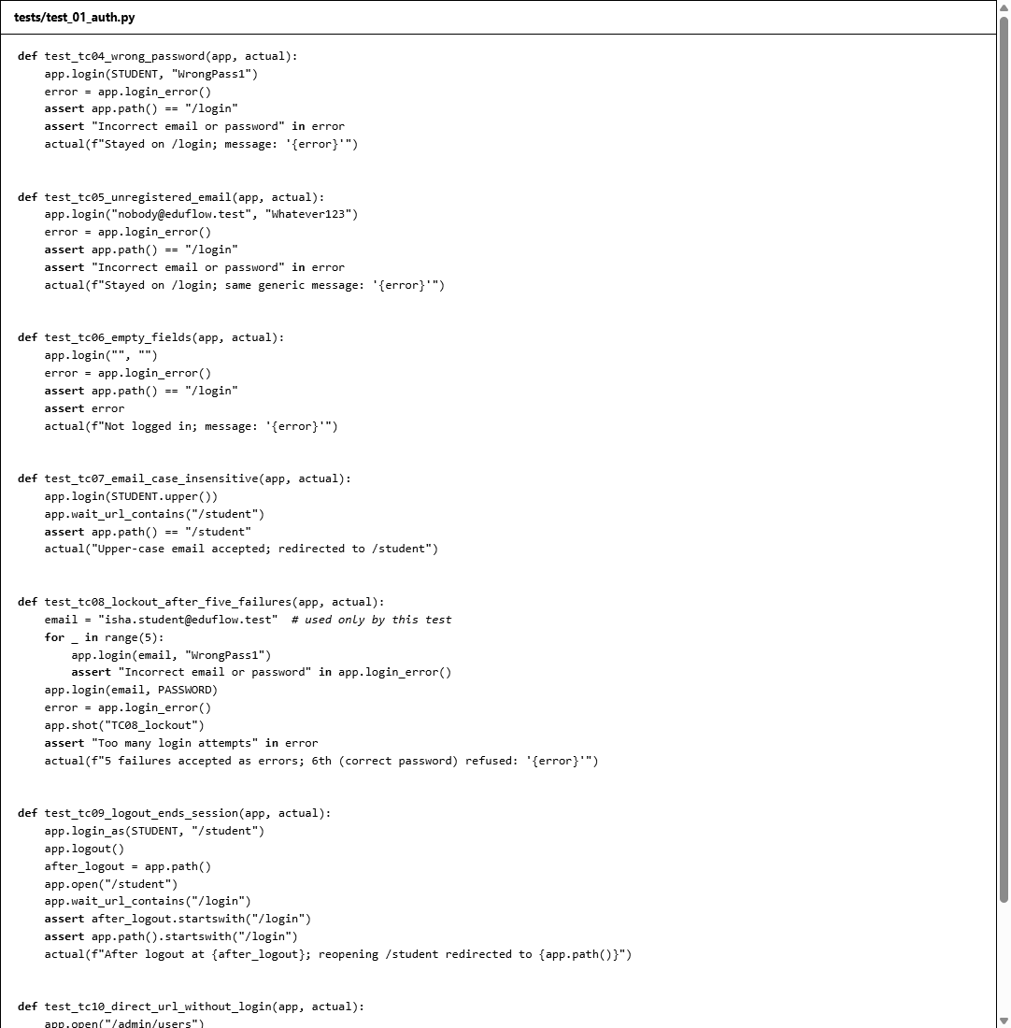
Figure 3: test_01_auth.py – login, lockout, logout and access-control tests
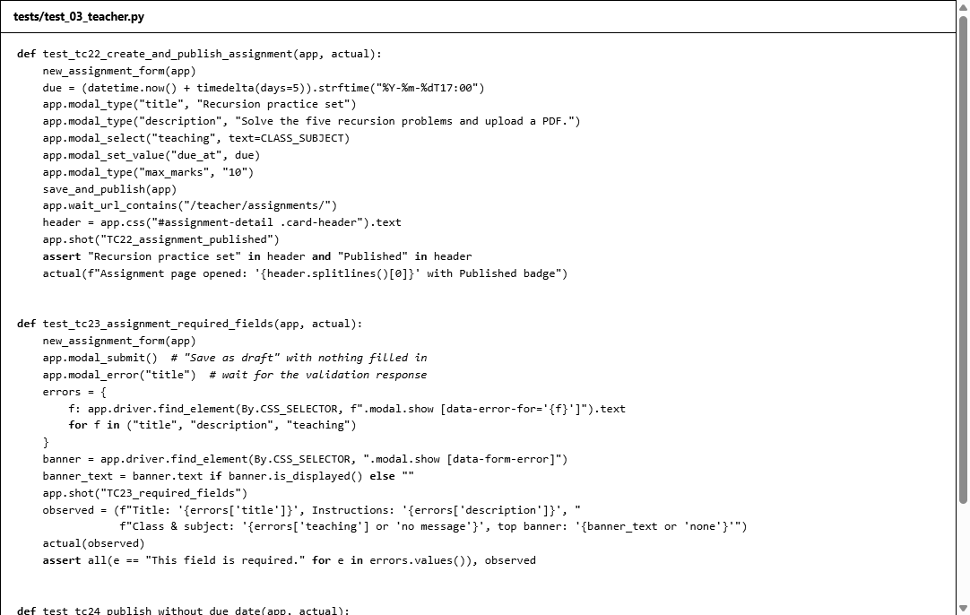
Figure 4: test_03_teacher.py – assignment publishing and grading tests
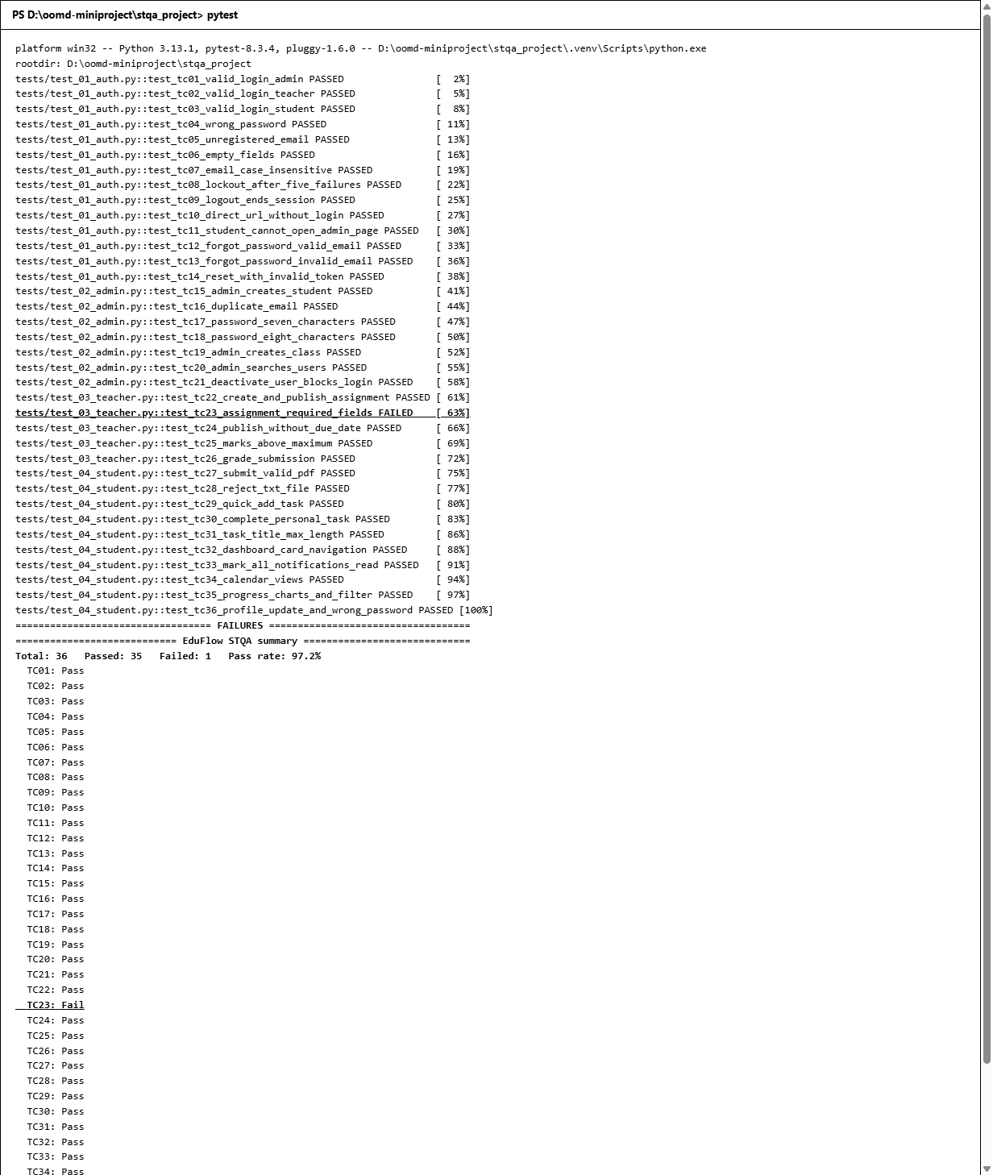
Figure 5: Output: console output of the full regression run with the pass/fail summary
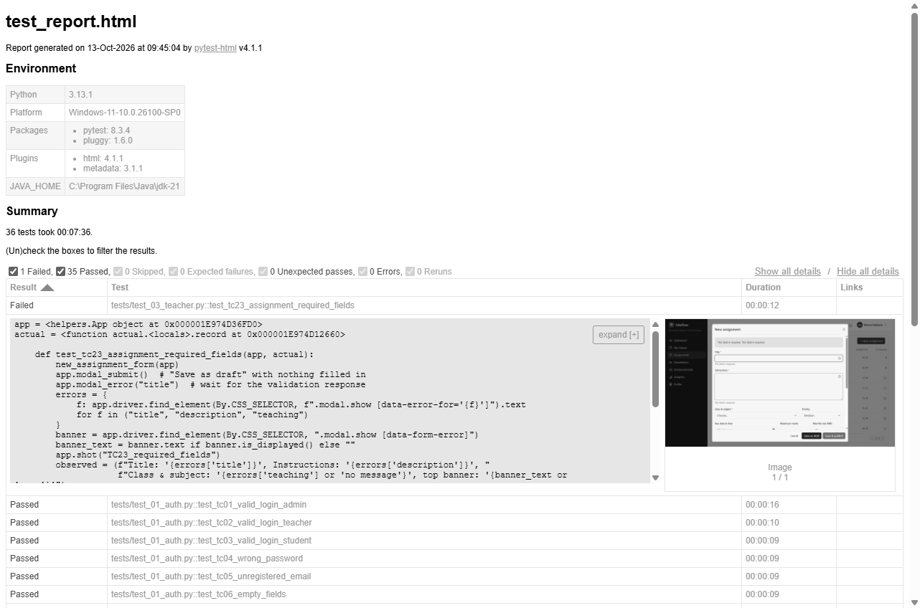
Figure 6: Output: pytest-html test report (reports/test_report.html)

● Screenshots of GUI
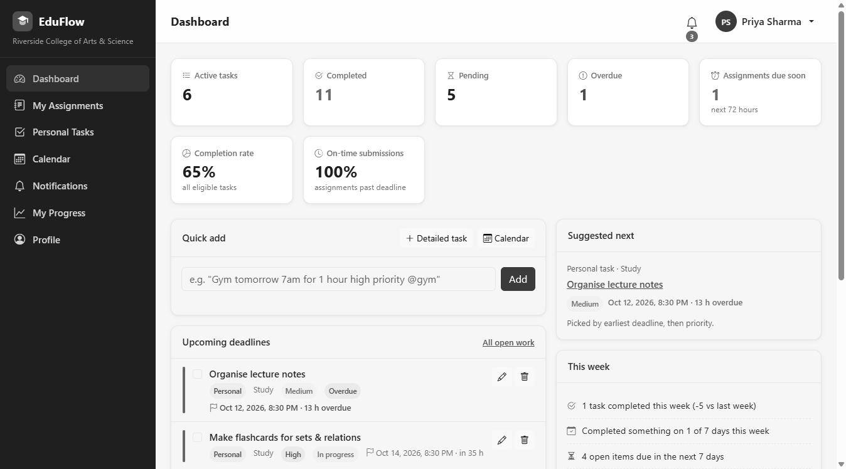
Figure 7: Student dashboard after a successful login (TC03)
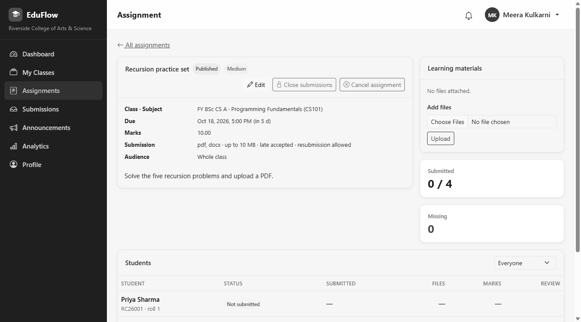
Figure 8: Teacher's assignment page after Save & publish (TC22)
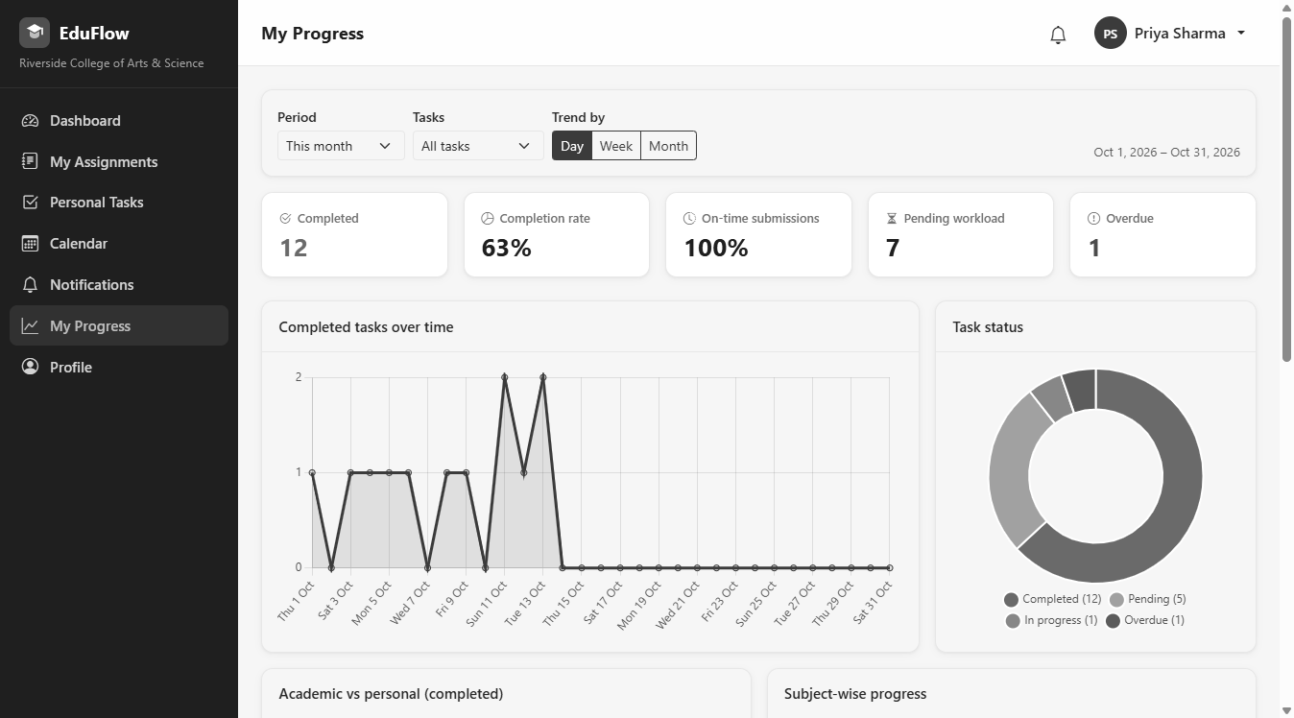
Figure 9: Student progress analytics with Chart.js charts (TC35)

● Bug Report
Only defects that were reproduced on the running application (13 October 2026, Chrome 154, http://127.0.0.1:8000, demo seed data) are listed. Categories, severities and priorities follow bug_taxonomy.md.

Summary
Bug ID | Title | Category | Severity | Priority | Found by | Status
BUG-01 | "Class & subject" required error not shown under the field; vague duplicate banner instead | Validation / UI | Minor | P3 | TC23 (scripted) | Open
BUG-02 | Double-clicking "Add" in quick-add creates duplicate tasks | Functional | Minor | P3 | Exploratory | Open

BUG-01 — "Class & subject" required error is not shown under the field
Field | Details
Bug ID | BUG-01
Module | Teacher → Assignments → New assignment
Description | When the new-assignment form is saved empty, Title and Instructions show "This field is required." under each field, but Class & subject shows no message and is not highlighted. Instead a red banner at the top of the form says "This field is required. This field is required." without saying which field is meant.
Steps to reproduce | 1. Log in as meera.teacher@eduflow.test / Demo@1234.  2. Open Assignments and click New assignment.  3. Leave all fields empty and click Save as draft.
Expected result | "This field is required." appears under Title, Instructions and Class & subject, and the Class & subject drop-down is highlighted.
Actual result | Title: "This field is required."; Instructions: "This field is required."; Class & subject: no message, not highlighted; top banner: "This field is required. This field is required."
Evidence | screenshots/TC23_required_fields.png, screenshots/FAIL_TC23.png, pytest-html report entry for TC23
Probable cause | The server validates class_id and subject_id, but the form shows one combined field named teaching, so the two error messages cannot be matched to a field and fall back to the banner.
Severity | Minor — the assignment is correctly not saved; only the guidance to the user is unclear.
Priority | P3
Category | Validation (wrong/missing error message), UI
Status | Open

BUG-02 — Double-clicking "Add" in quick-add creates duplicate tasks
Field | Details
Bug ID | BUG-02
Module | Student → Personal Tasks / Dashboard → Quick add
Description | Quick-add sends one request per click and does not disable the Add button while the first request is in progress, so a double-click (or a fast double press of Enter + click) saves the same task twice.
Steps to reproduce | 1. Log in as priya.student@eduflow.test / Demo@1234.  2. Open Personal Tasks.  3. Type Double click probe in the quick-add box.  4. Double-click Add.  5. Search the task list for "Double click probe".
Expected result | One task is created (the button is disabled, or the second click is ignored, until the first save completes).
Actual result | Two identical tasks are created. Reproduced on 2 of 2 attempts.
Evidence | screenshots/EXP03_double_submit.png, exploratory/observations.json
Comparison | The teacher's "New assignment" form handles the same double-click correctly (1 assignment created), because its Save button is disabled while saving.
Severity | Minor — data is duplicated but can be deleted; no data loss or security impact.
Priority | P3
Category | Functional (double submission)
Status | Open

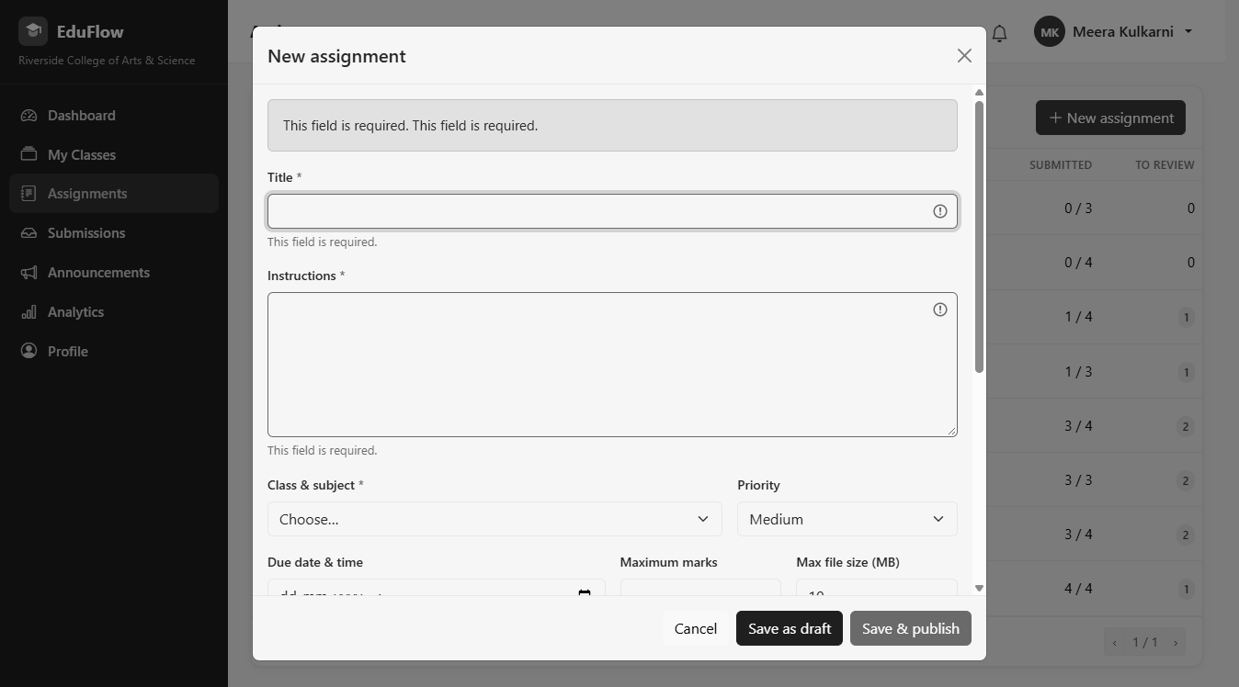
Figure 10: BUG-01 – no required-field message under Class & subject (TC23)
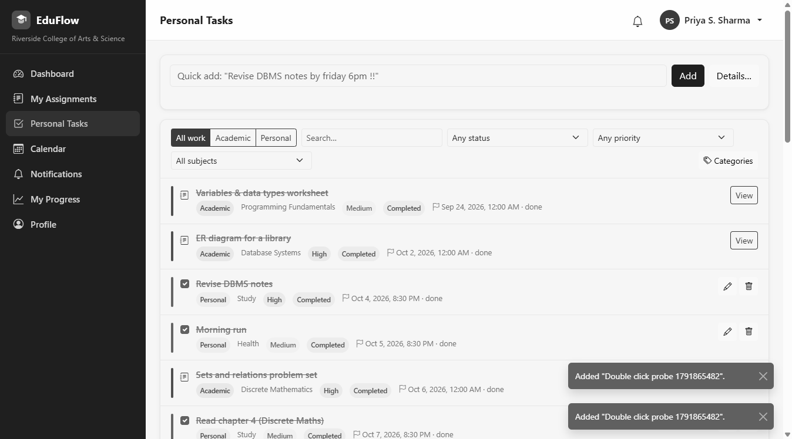
Figure 11: BUG-02 – duplicate tasks created by a double-click on Add

● Exploratory Testing
Date: 13 October 2026 · Build: EduFlow local, demo seed · Browser: Chrome 154 · Testers: Sakshi Jagadale, Priti Merurkar · Time box: about 60 minutes

Charter
Explore EduFlow beyond the scripted test cases to find defects in input handling, double submission, browser navigation (Back, Refresh, multiple tabs), access without logging in or with another user's ids, and layout on small screens.

Approach
Each idea was tried in the running application and the outcome recorded. To make the session repeatable, the probes were also written as a script (exploratory/explore.py) that saves screenshots (screenshots/EXP*.png) and the observations (exploratory/observations.json). Three probe scripts initially broke because of our own selectors (they did not wait for the redirect after saving, used a stale element, and clicked a hidden close button). These were fixed and re-run, and are not counted as application bugs.

Findings
# | Area | What we tried | What happened | Result
1 | Special characters | Task title <script>alert('x')</script> Café & "quotes" 😀 | Saved and displayed literally; no script ran | OK
2 | Very long input | 6,000 characters in task notes (limit 5,000) | Rejected: "Must be at most 5000 characters." | OK
3 | Long input (boundary) | 250 characters typed into the 200-character task title | Field keeps 200 characters (scripted TC31) | OK
4 | Whitespace only | Quick-add with only spaces | "Type what you need to do first." | OK
5 | Double submit | Double-click Add in quick-add | Two identical tasks created (2/2 attempts) | BUG-02
6 | Double submit | Double-click Save as draft on a new assignment | One assignment created (button disabled while saving) | OK
7 | Back button | Log out, then press browser Back | Returned to /login?next=%2Fstudent, not the dashboard | OK
8 | Refresh | Submit an assignment, then refresh the page | No resubmission prompt; one file listed | OK
9 | Multiple tabs | Log out in tab 2, then add a task in tab 1 | Tab 1 is sent to the login page | OK
10 | Direct URL, no login | /teacher/assignments/1, /student/tasks, /admin/settings, /profile | All redirect to /login?next=… | OK
11 | Direct API, no login | /api/admin/users, /api/files/submissions/1 | {"error":"Please log in to continue."} | OK
12 | Id tampering | Class B student opens a class A assignment and another student's file by id | "Assignment not found." / "Not found." | OK
13 | Injection-like input | ' OR 1=1 -- in admin user search | "No users match these filters." | OK
14 | Unicode | Devanagari profile name कबीर सिंह | Saved and shown in the header | OK
15 | Input normalisation | Login email with leading/trailing spaces | Logged in normally | OK
16 | Invalid number | Marks -5 when grading | "Must be at least 0." | OK
17 | File name case | Upload ANSWER_UPPER.PDF where pdf is allowed | Accepted | OK
18 | Logged-in user opens /login | Teacher visits /login | Redirected to the teacher dashboard | OK
19 | Responsive (390 px phone) | Dashboard, tasks, calendar, progress, assignments | No horizontal scrolling; sidebar collapses to a menu button that opens it | OK
20 | Responsive (768 px tablet) | Same pages | No horizontal scrolling; menu works | OK

Summary
20 ideas explored, 19 behaved correctly, 1 defect found (BUG-02, duplicate task on double-click). Access control held up well: every direct URL, API call and id change outside the user's scope was refused. Input handling escaped HTML, enforced length limits and accepted Unicode.
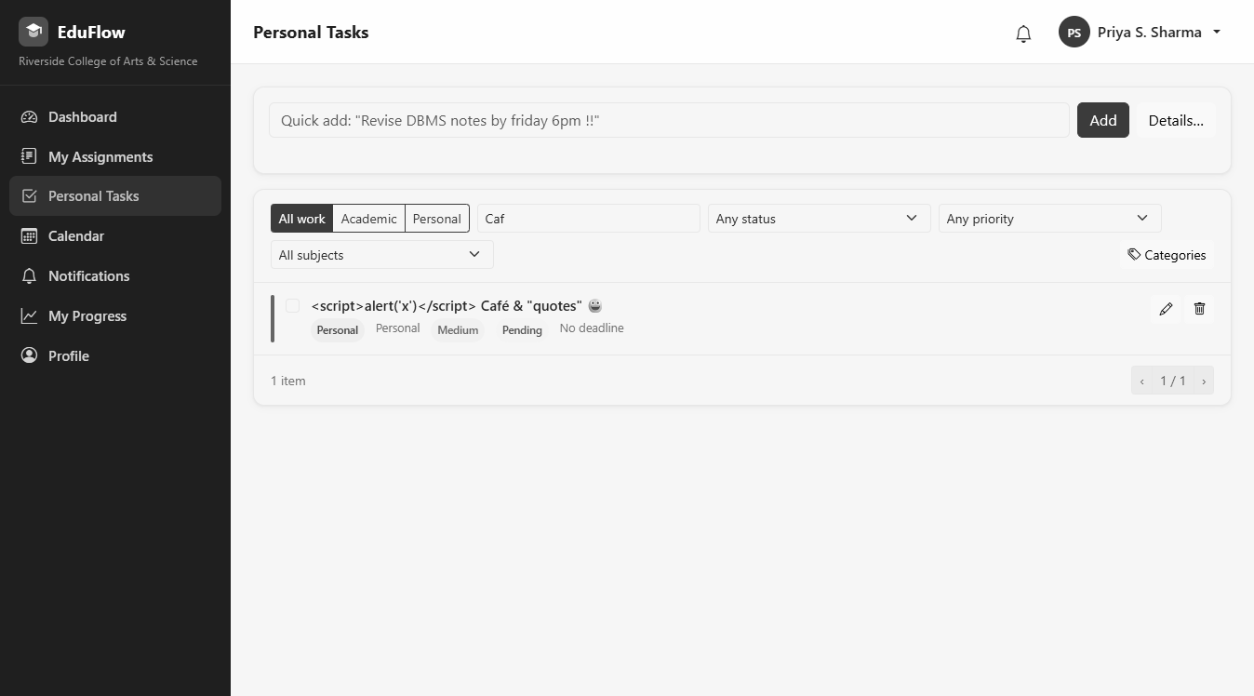
Figure 12: Exploratory: HTML typed into a task title is shown as text, not executed
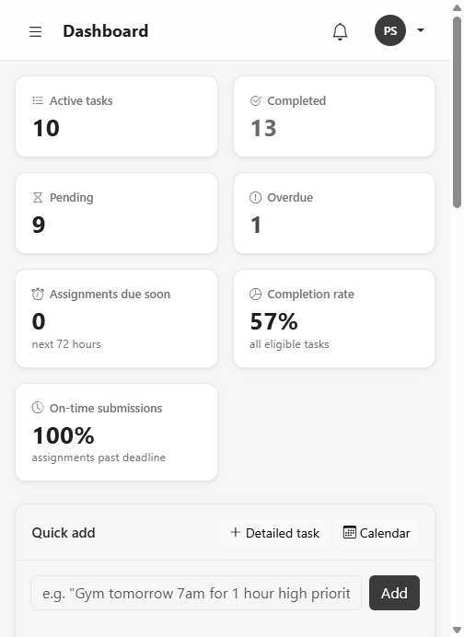
Figure 13: Exploratory: dashboard at 390 px phone width – no horizontal scrolling

● Test Summary Report
Application | EduFlow — Academic Management & Productivity Portal
Environment | Windows 11, PHP 8.4.5 built-in server, MySQL 8.0, Chrome 154 (headless)
Tools | Selenium WebDriver 4.27.1 (Python 3.13), pytest 8.3.4, pytest-html 4.1.1, Selenium IDE
Test run | 13 October 2026, full regression suite, database reset to demo seed before the run
Prepared by | Soniya Pawar, Sakshi Jagadale, Priti Merurkar

Execution summary
Metric | Value
Test cases designed | 36
Test cases executed | 36
Passed | 35
Failed | 1 (TC23)
Blocked / not run | 0
Run rate | 100 % (36 / 36)
Pass rate | 97.2 % (35 / 36)
Execution time | 8 min 18 s (497.6 s)
Selenium IDE flows | 3 / 3 passed (login, quick-add task, logout)

Results by module
Module | Test cases | Passed | Failed
Login, session, access control, password recovery | TC01–TC14 | 14 | 0
Admin: users and classes | TC15–TC21 | 7 | 0
Teacher: assignments and grading | TC22–TC26 | 4 | 1 (TC23)
Student: submissions, tasks, dashboard, notifications, calendar, progress, profile | TC27–TC36 | 10 | 0
Total | 36 | 35 | 1

Exit criteria
Criterion | Target | Achieved | Met?
Run rate | 100 % | 100 % | Yes
Pass rate | ≥ 80 % | 97.2 % | Yes
Open Critical defects | 0 | 0 | Yes
Suspension threshold | < 40 % failing | 2.8 % failing | Not triggered

All exit criteria are met.

Bug summary
Bug ID | Title | Category | Severity | Priority | Status
BUG-01 | "Class & subject" required error not shown under the field; vague duplicate banner instead | Validation / UI | Minor | P3 | Open
BUG-02 | Double-clicking "Add" in quick-add creates duplicate tasks | Functional | Minor | P3 | Open

Severity | Count
Critical | 0
Major | 0
Minor | 2
Trivial | 0

Script failures vs application defects
The first execution of the suite had three failures. Each was investigated:
Test case | First-run failure | Cause | Action
TC25, TC26 | "element click intercepted" on the roster's Open button | Script: the button was below the visible area | Script fixed to scroll the button into view; both now pass
TC23 | No error message under Class & subject | Application defect | Kept as a failing test; reported as BUG-01

● Conclusion
In this mini project we applied the software testing life cycle to EduFlow, a complete web application with three user roles. We prepared a test plan with scope, risks, entry/exit criteria and a schedule; defined a bug taxonomy with categories, severity and priority; designed 36 test cases covering valid and invalid logins, empty fields, boundary values, each module's main flow, navigation, logout and session handling; and automated all of them with Selenium WebDriver and pytest, using explicit waits, stable locators and automatic failure screenshots. We also recorded three flows in Selenium IDE and explored the application manually.
The final regression run executed all 36 test cases with 35 passing (97.2 %), which meets the exit criteria of a 100 % run rate and at least an 80 % pass rate. Two Minor defects were found and reported: a missing field-level validation message on the new-assignment form (BUG-01) and duplicate tasks created by a double-click in quick-add (BUG-02). Exploratory testing showed that access control, input escaping, length limits and responsive layouts work correctly.
The project showed us the value of automation for regression testing: the whole suite runs unattended in about eight minutes from a clean database, so it can be repeated after every change. It also showed that a failing test must be investigated before it is reported: two of our three first-run failures were caused by our own scripts, not by the application. Selenium WebDriver with pytest proved suitable for testing a modern JavaScript-driven web application, and the same suite can be extended with Selenium Grid for cross-browser testing in the future.

