**BUILD AN EMPLOYEE TRAVEL APPROVAL**

**APPLICATION FOR CORPORATES (ADMIN)**

**MAHADASU.SONIYA (TEAM LEADER)**

**CKIKKALA.YASWITHA (TEAM MEMBER) KOLLI.NIHARIKA (TEAM MEMBER)**

**GORSUPUDI.GOWTHAMI (TEAM MEMBER) GUNTUKU.SAIPRIYA (TEAM MEMBER)**

Step 1:

**Creating Developer Org by using Developer Edition Link**

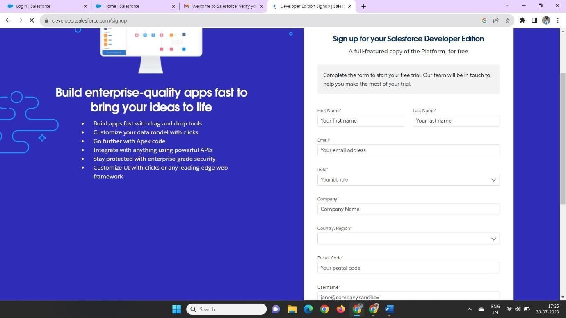

**Step 2:**

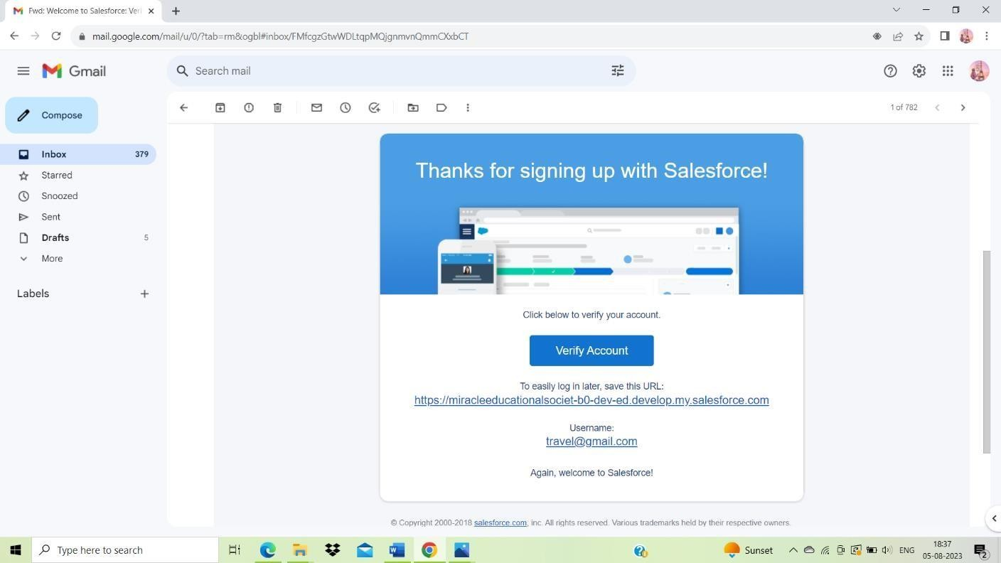**Account Activation**

**We can create password by clicking verify Account then we can directly login to salesforce Account**

**Step 3:**

**Creation Of Objects for Travel Approval App**

We Can Create Developer Object in Object Manager by clicking on create – Custom Object and follow the steps in the guide

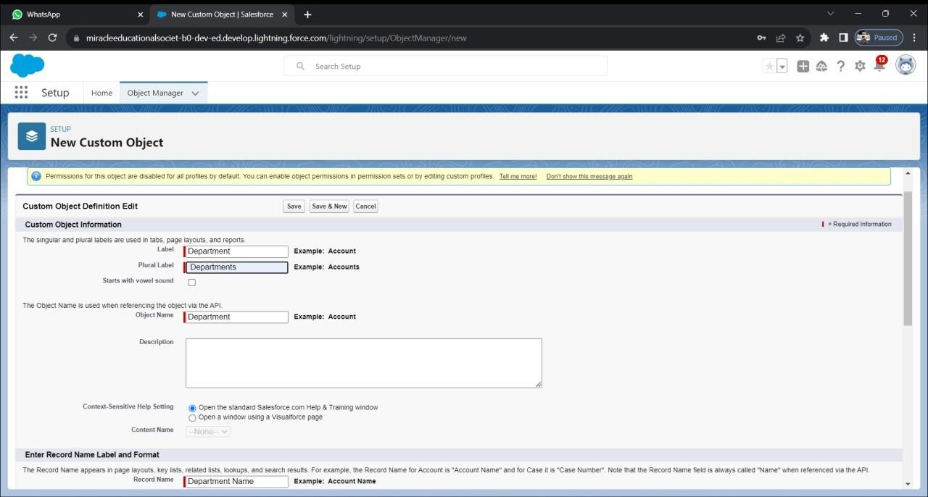

In The Same Manner We have to Create Employee details , Expense, Expense items and Travel Approval Objects.

**Step 4:**

**Creation of Custom Tab**

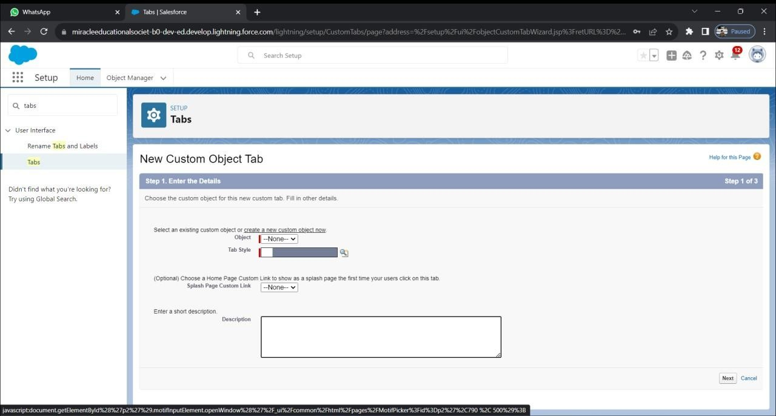

Here We can create Tabs for our objects which we created earlier

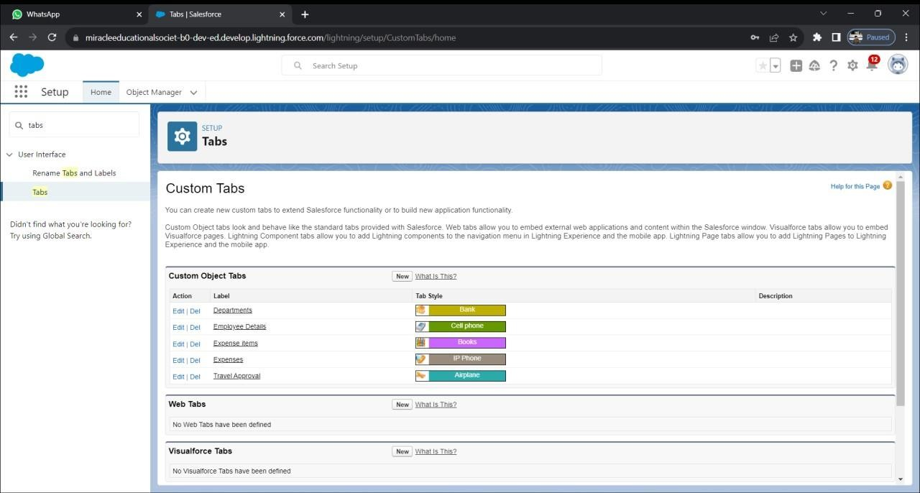

**Step 5:**

**Create Travel Approval App (Lightning App)**

Now We Can Create a New Lightning App by Using App Manager

Click New Lighting app

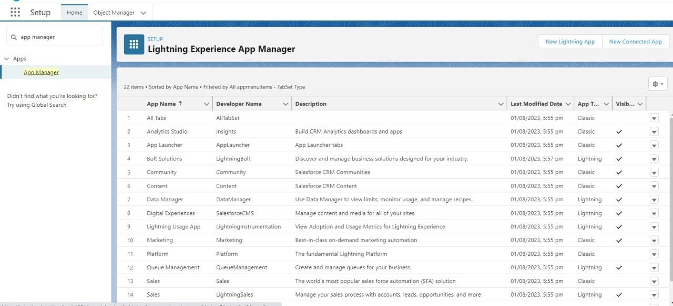

In those we Can Create a New lighting App

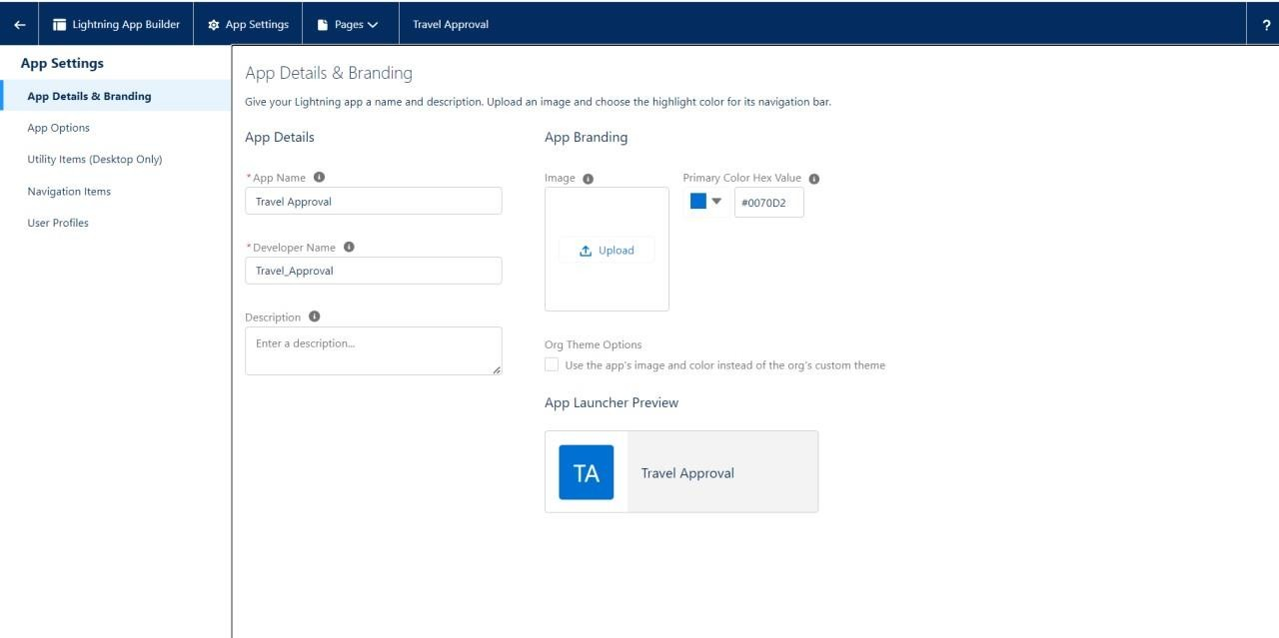

We have to give the app name as Travel Approval

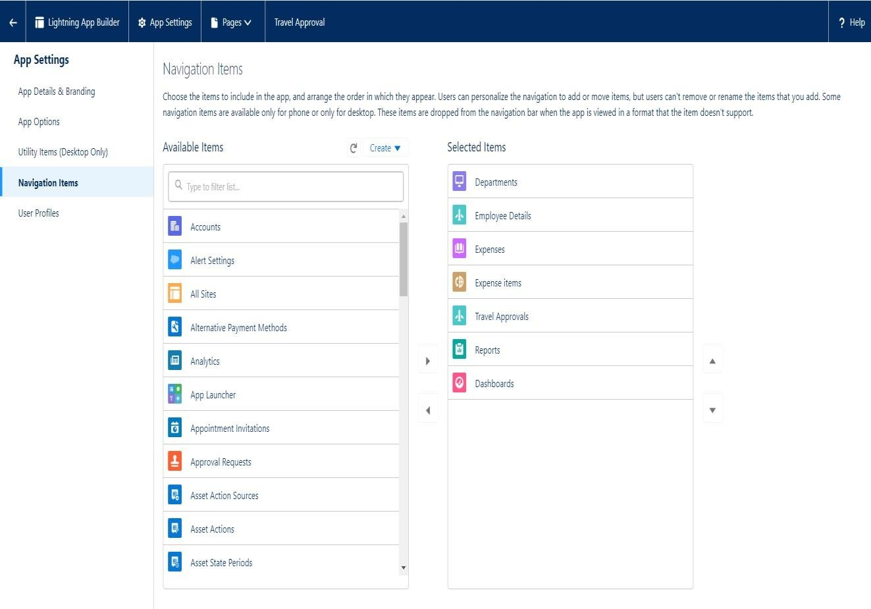Leave the default items and click next until we find Available items

After moving the items to Selected items from Available Profile Move the System Administrator into Selected Profiles and save

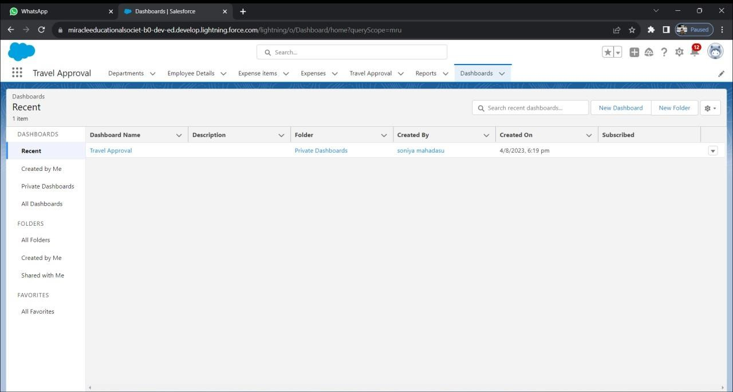

**Step 6: Creation of fields for the objects we created earlier**

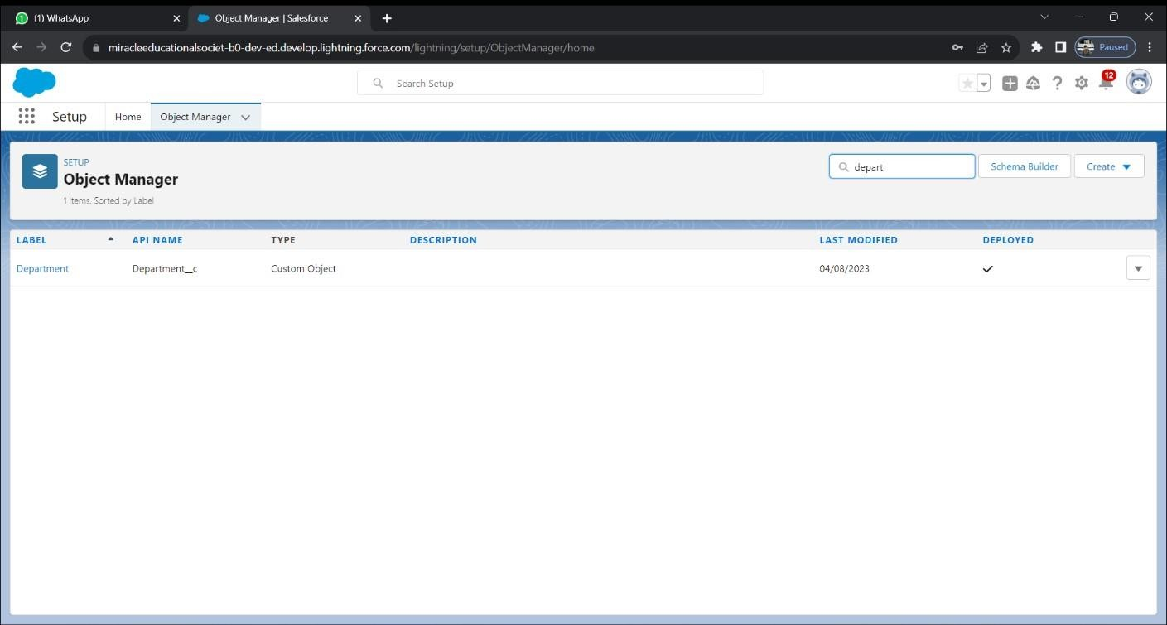In Those Manner We Can Create a Department Field Data

In department object fields and Relationships click on new Select Datatype this field is of text type and click next

Fill the field name as Department code and length as 5

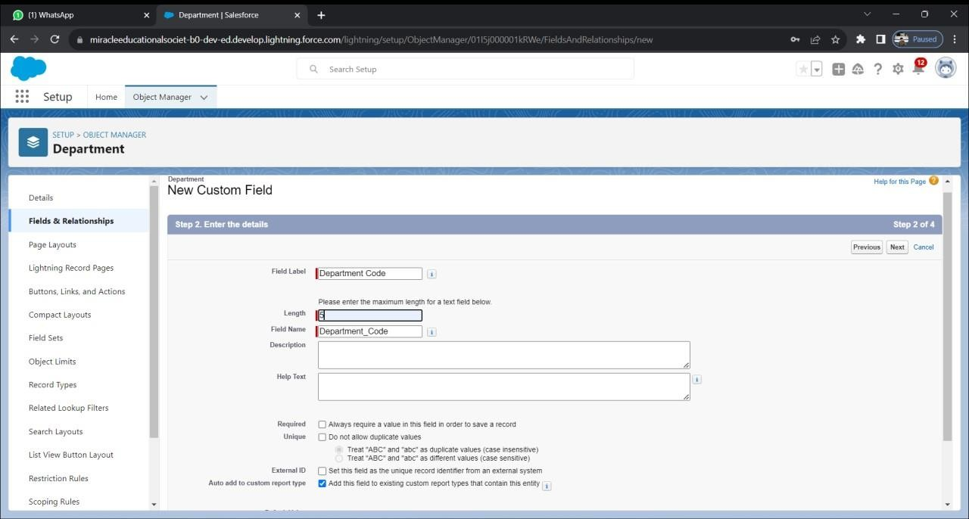Later we can click next, next & save

Follow the above steps and create two more text type fields District and State , provide length as 40 for both

Create URL type field and give School Website as the field label

In this We can create new look up data type on the fields & relationship Later we can click on the Department object to the related object

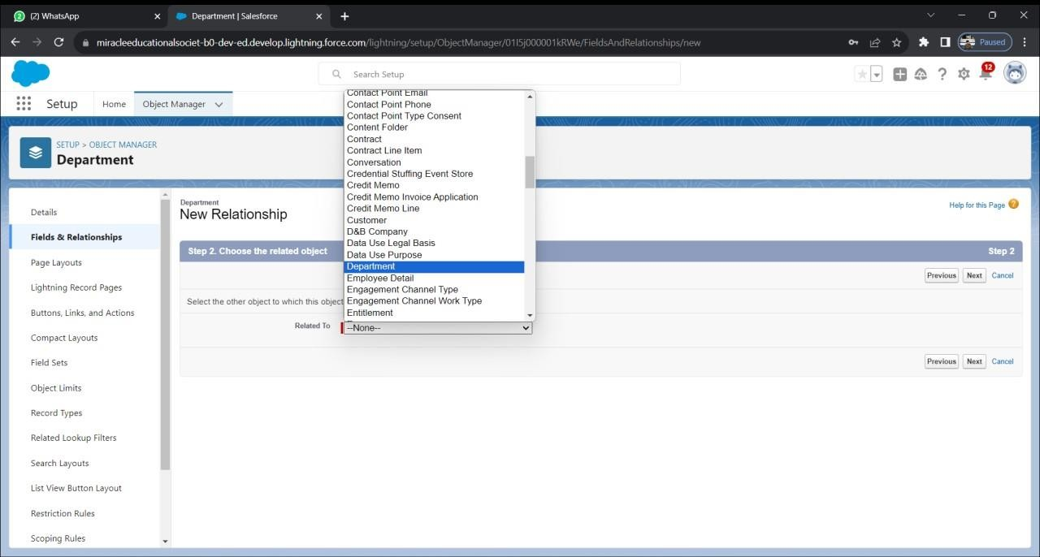

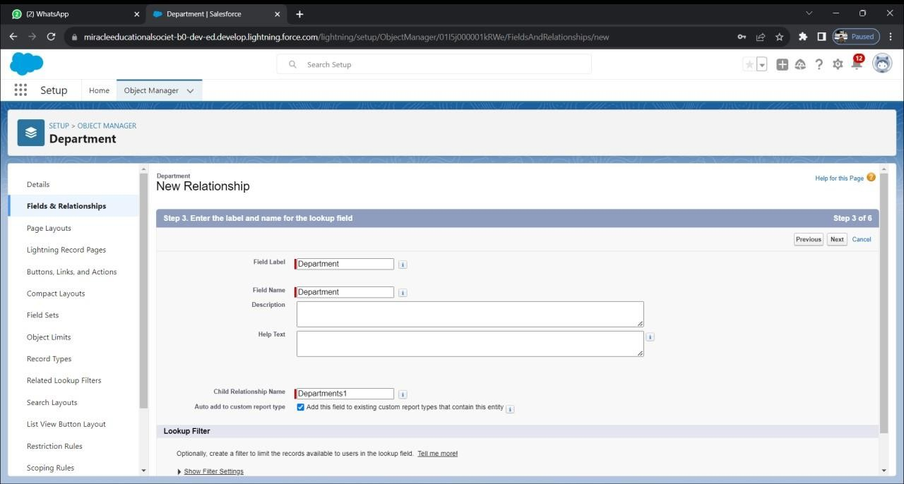Then we can enter the next step we can add a field label name as Department

Then click Next, Next, Save.

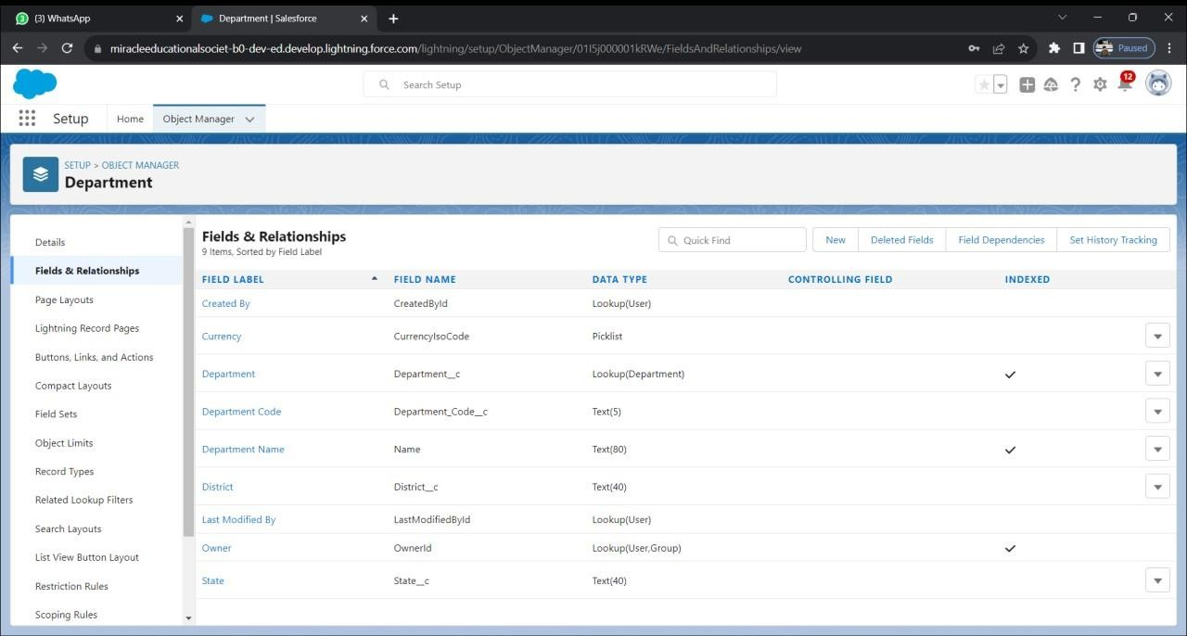

In those way we can create all the fields on Department, Employee details,

Expense, Expense items and Travel Approval objects by using the given datatypes in the data(Text,Lookup,Roolup summary,pick List,date)

## Step 7:

Import Departments Data

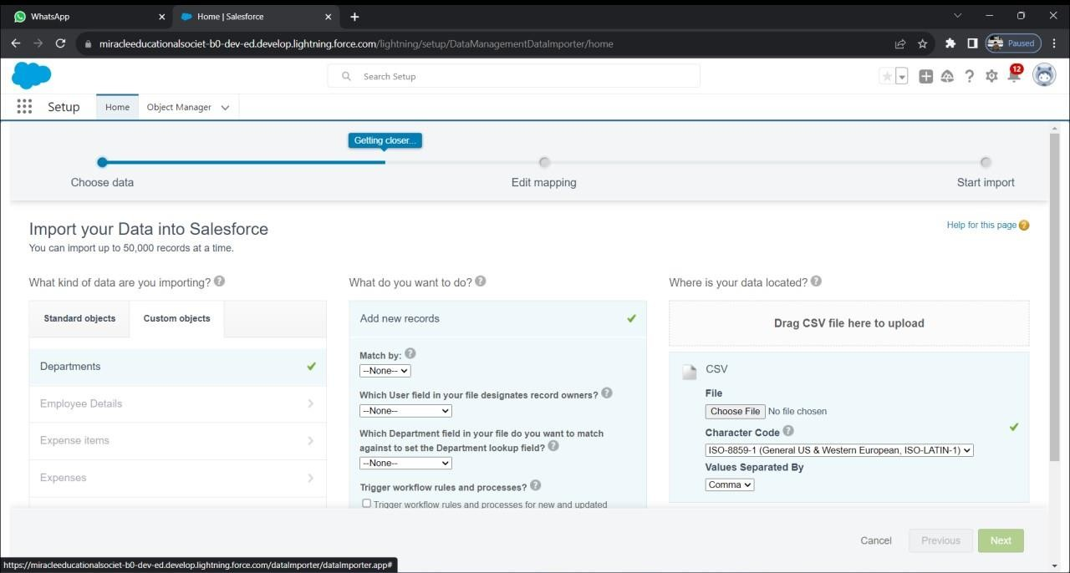To import data before we have to create a department csv file as shown in the data.In quick find click on data import wizard in that click on launch wizard and carefully follow the steps from the data

After choosing the csv file do mapping carefully and click next ,start import and click ok on the popup.

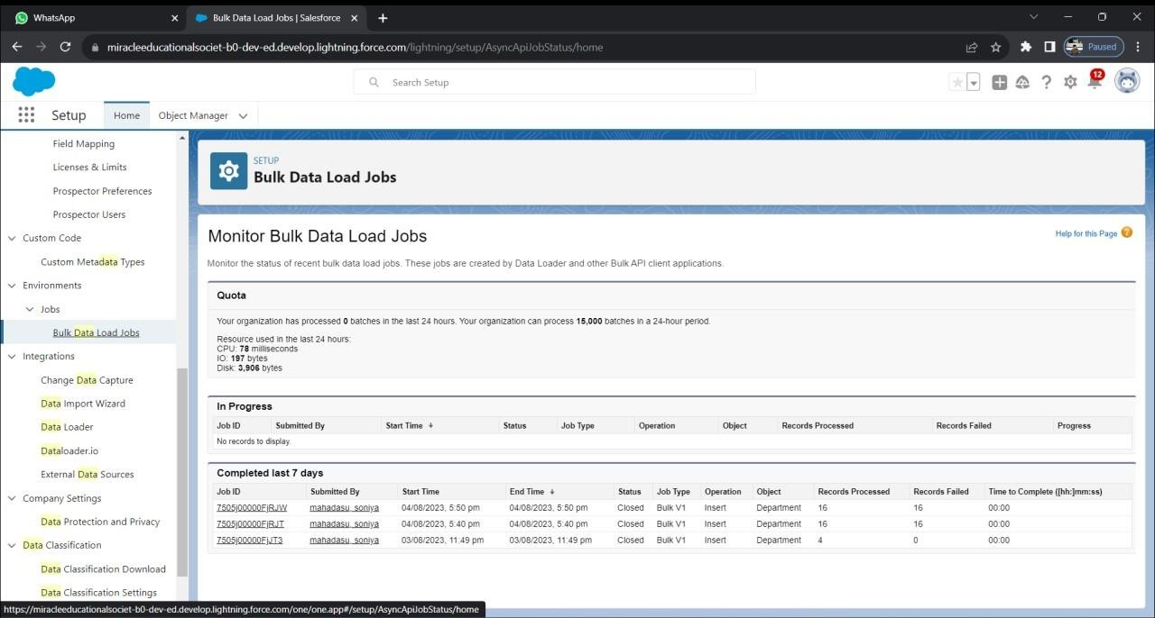

## Step 8: Creating a user in salesforce

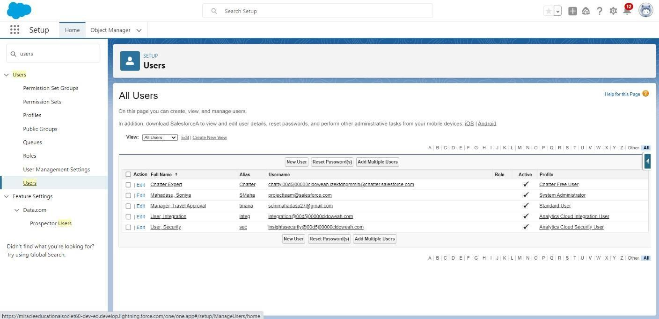In the users we can be create a user in those we can click on the home and click on the quick find box then enter user then click on the new user

We can enter the first name last name and username

Click on the user licence as salesforce and profile as standard user

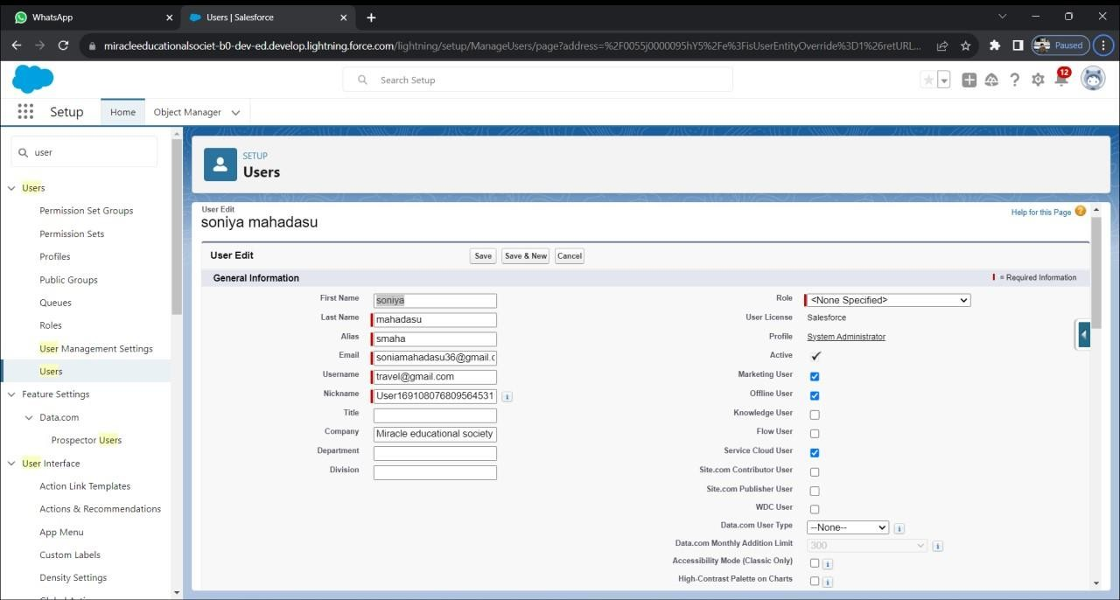

And click on the generate new password for login users of the data

## Step 9: Customize Travel Approval Object Page layout

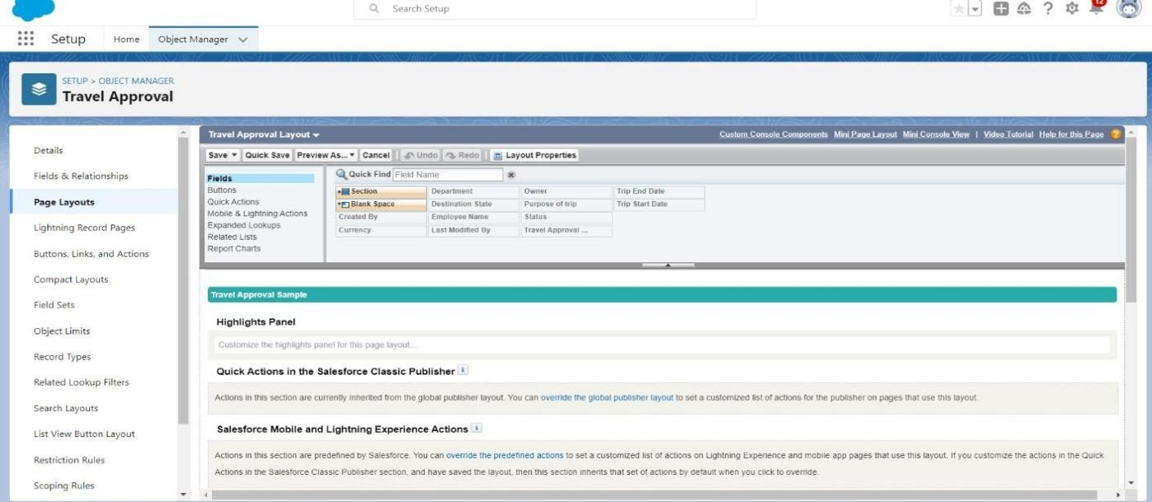To customize page layout go to object manager and select Travel Approval object in that click on page layouts and click travel approval layout

Drag the section from the top and place below the information section Name the section as Trip info and click ok

Then drag Trip start date ,Trip end date and status from top to Trip info Later drag Destination state and purpose of a trip to Trip info,save.

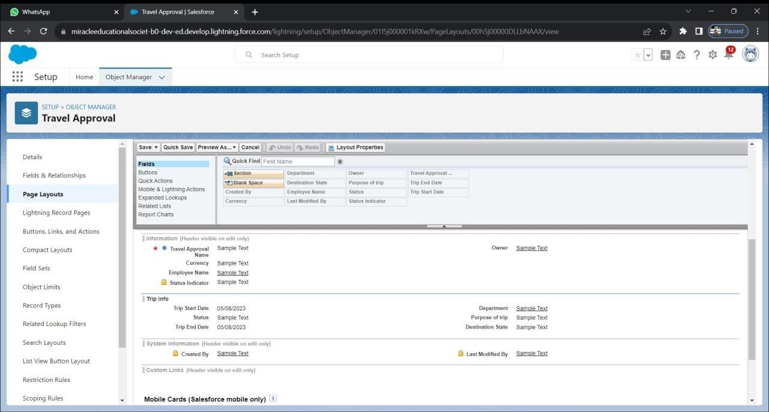

## Step :10: Create Validation Rule

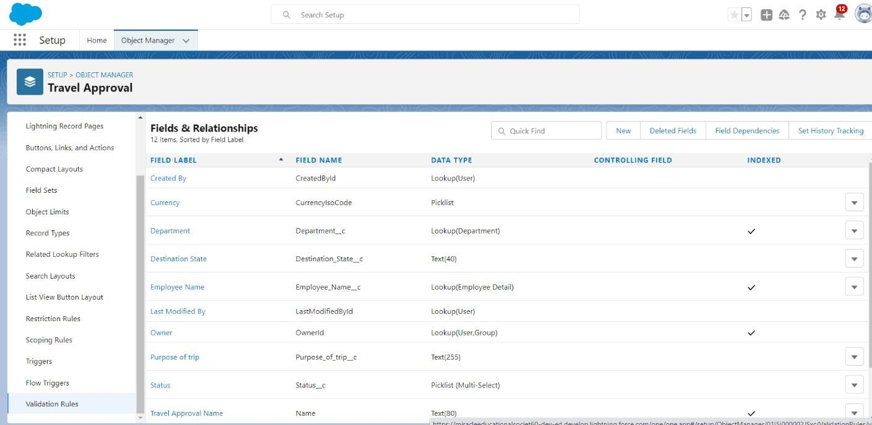From object manager search for Travel Approval object open validation rule and click on new

Give the rule name as Date_Validation and active should be checked Enter formula from data check no errors after input this condition

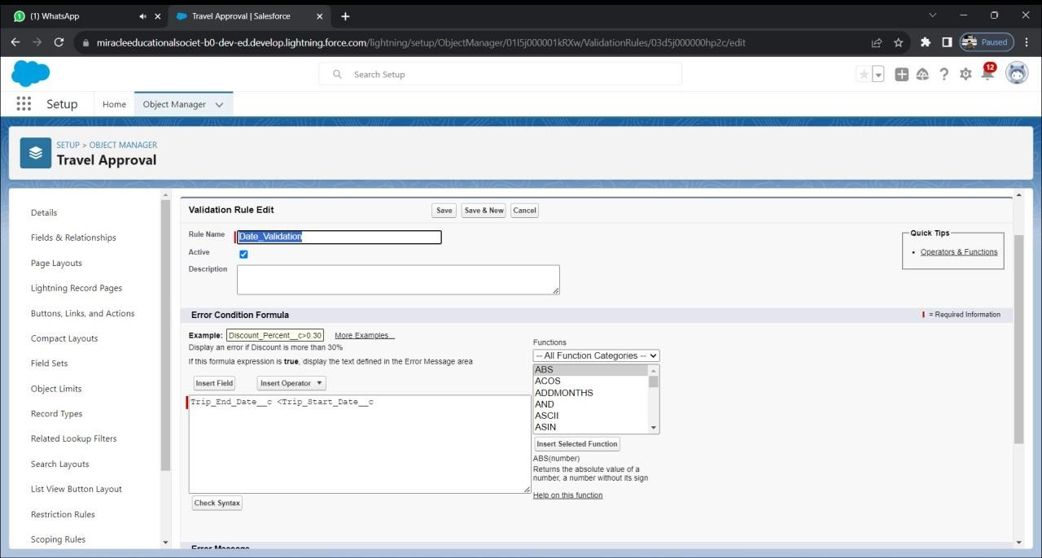

Give the error message and click on save

# Step 11: Create Formula Field

To create formulae field first we need a Zip file that contains

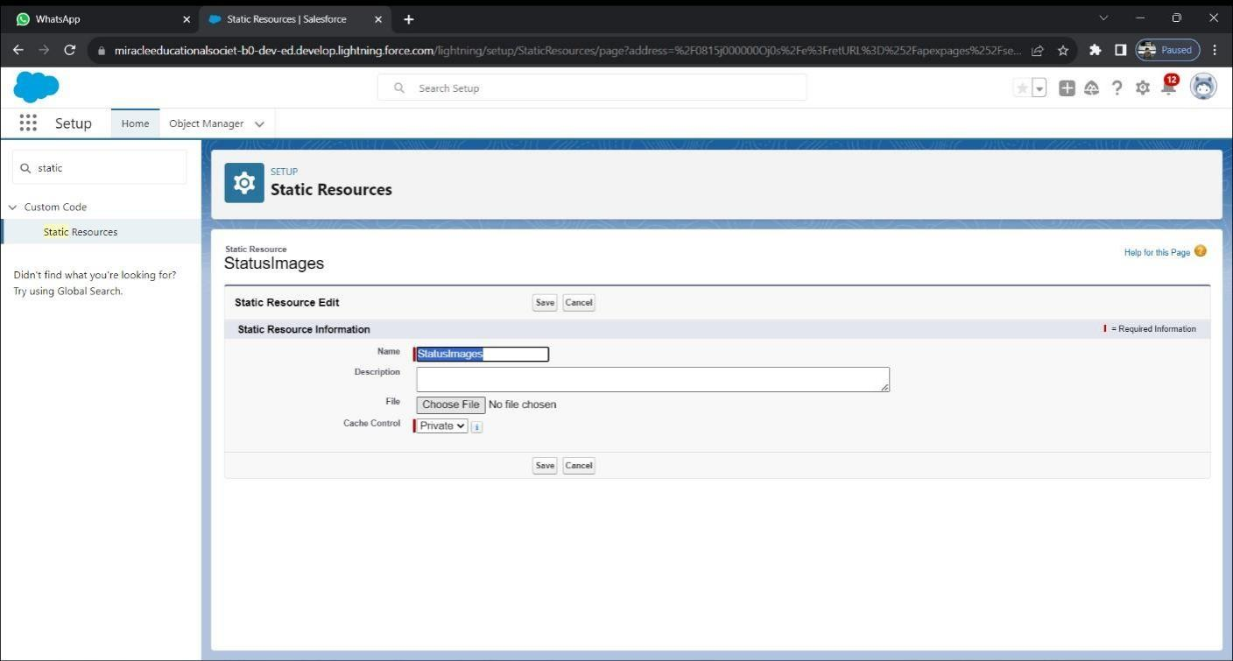statusimages.Zip .In setup click on static Resources and click new Enter name as StatusImages and choose the zip file ,save

Select Travel Approval object Fields and Relationships click new select formula datatype ,click next

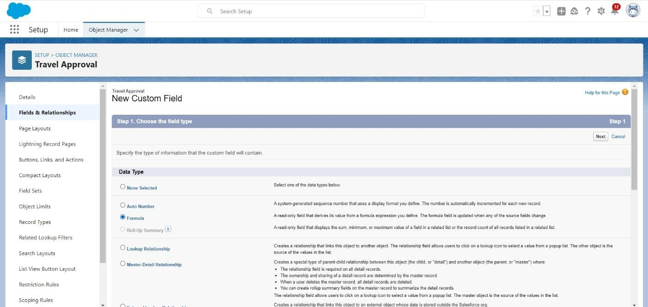

Enter the values from data and check there is no errors in formula

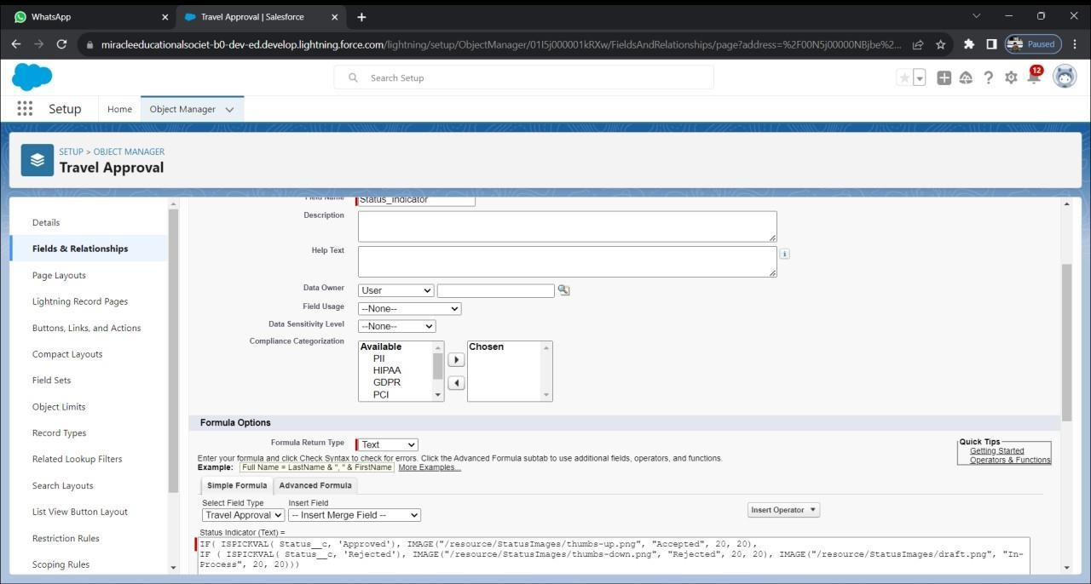

Click next ,next and save

# Step 12:

Create,View and Delete Records

Create Records:

Now click on the app launcher on the left side of the screen Click the Travel Approval on the app launcher

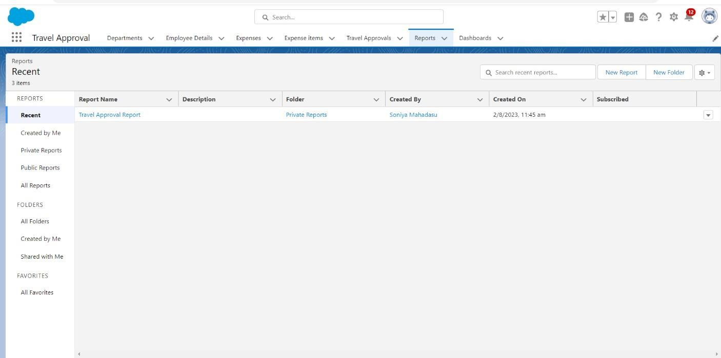Click reports tab new reports and select report type as Trave Approval With Departments click start Report ,then proceed as in the data

After clicking save and run give report name as Travel Approval Reports View Records :

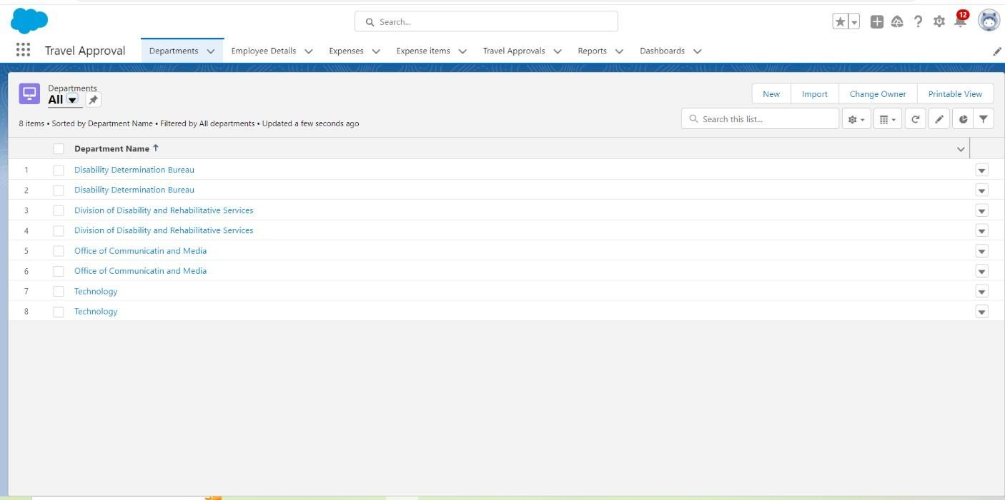Then we can view the created records on the Department Fielads

Delete Records :

We can click on the app launcher and search as Trave Approval We can delete the fields on the created data

In those we can delete the records on the object by clicking the arrow at Right-hand side on that record click delete and delete again .

# Step 13:

Create and view Reports

Create Report:

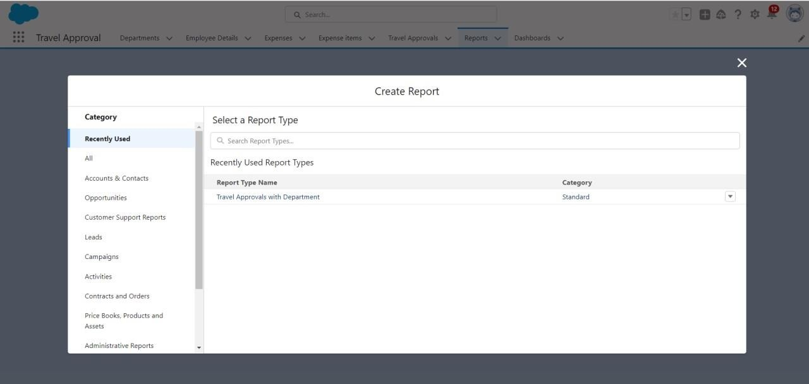We can click on the app launcher and search as Trave Approval Click on the reports tab and click on the new report

Click on report type as Travel Approval With Departments And click on

start report customize your report ,select Department Name click refresh Save and run



At last give the report name as Travel Approval Report,click save

View Report : click on the app launcher and search as Travel Approval App on the

reports tab

we can check the reports tab

# Step 14

Create Dashboard

click on the app launcher and search as Travel Approval we click on the dashboard and create a new dashboard with the name of Travel

Approval

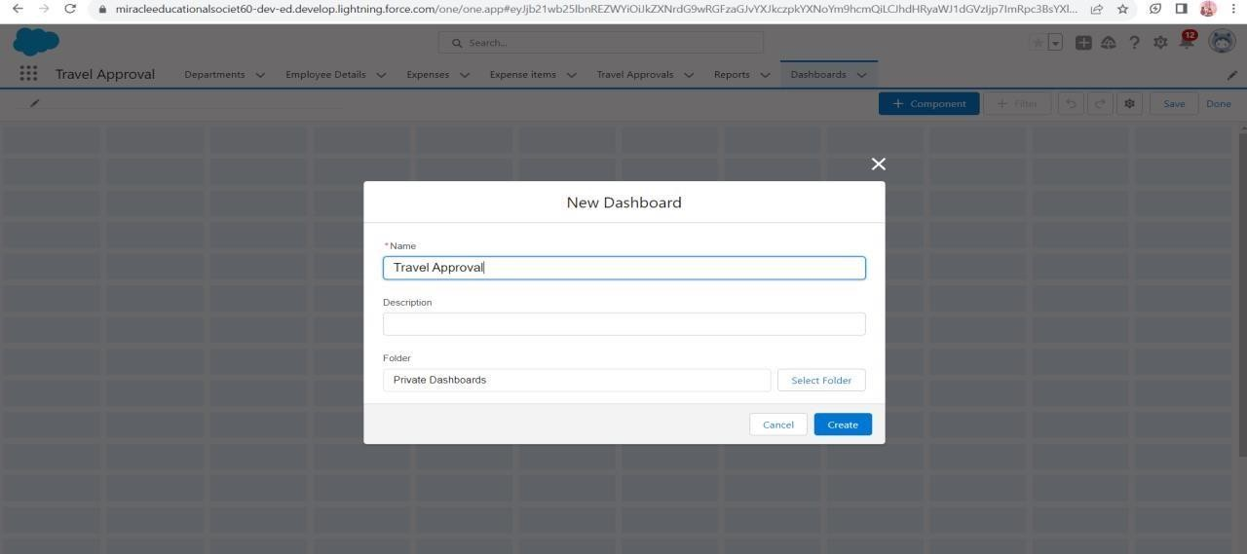

Then we can click on the + component and create a dashboard data

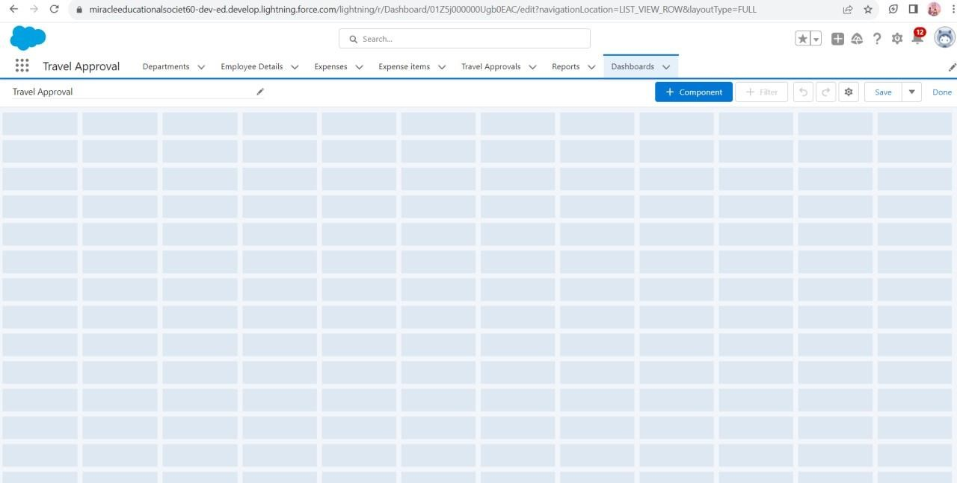

Select Travel Approval Report that you created

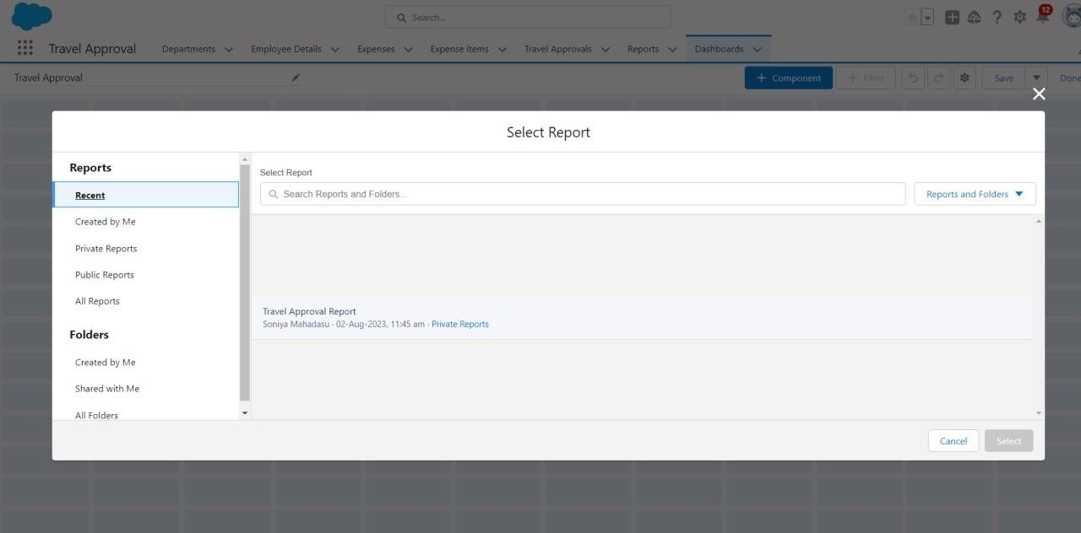

Later we click on the report we select the data on the field

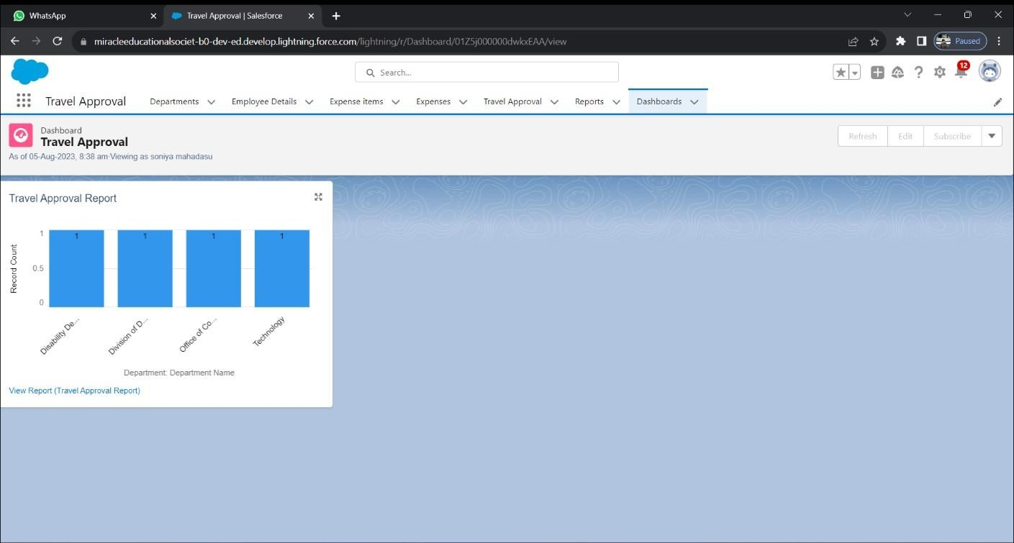

Then click on the finish it will be created

# Step 15:

View Dashboards

click on the app launcher and search as Travel Approval click on the dashboard tab and we can check the dashboards click on Travel Approval and See graph view of records

