Opening Browser and navigating to the URL

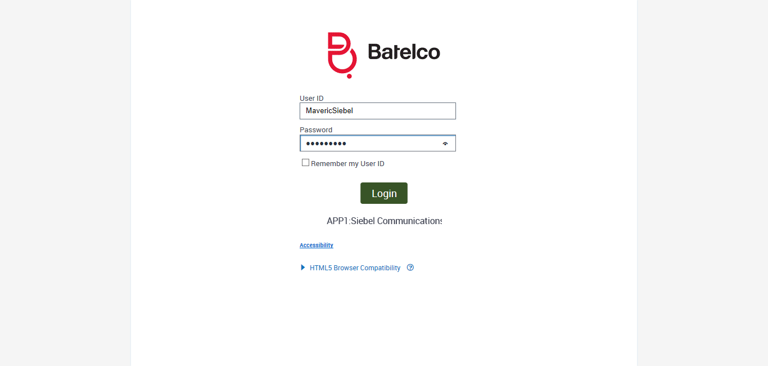

Clicked On Accounts Tab

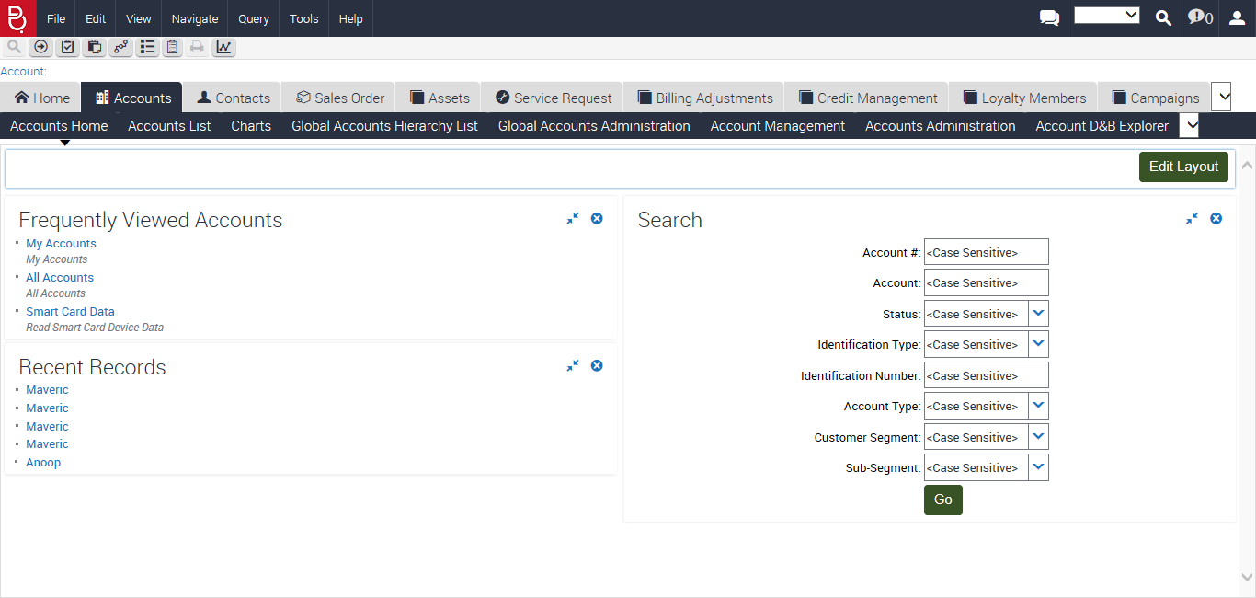

Entering Identification Number to Get the Account: 2102113126

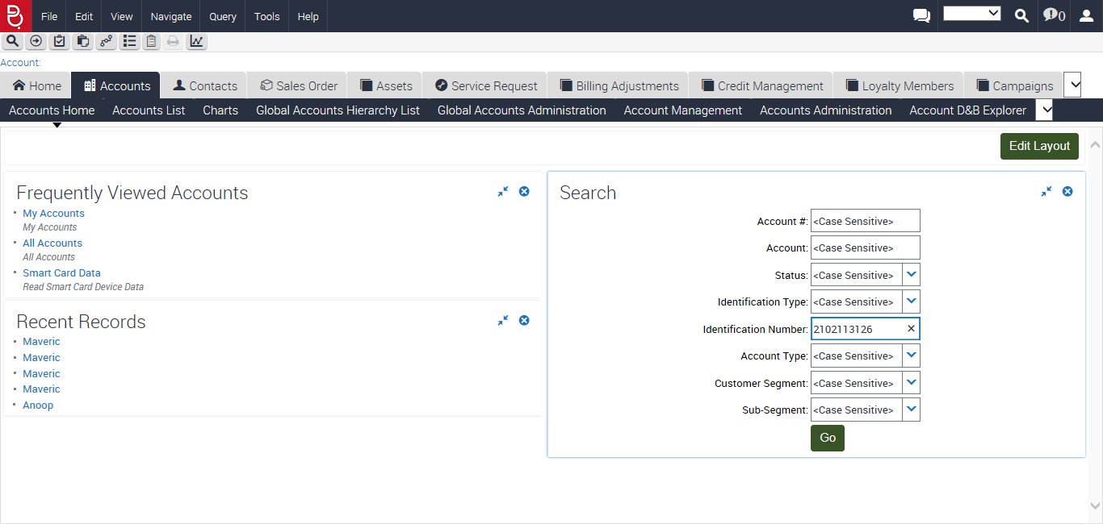

Clicked On Search Go

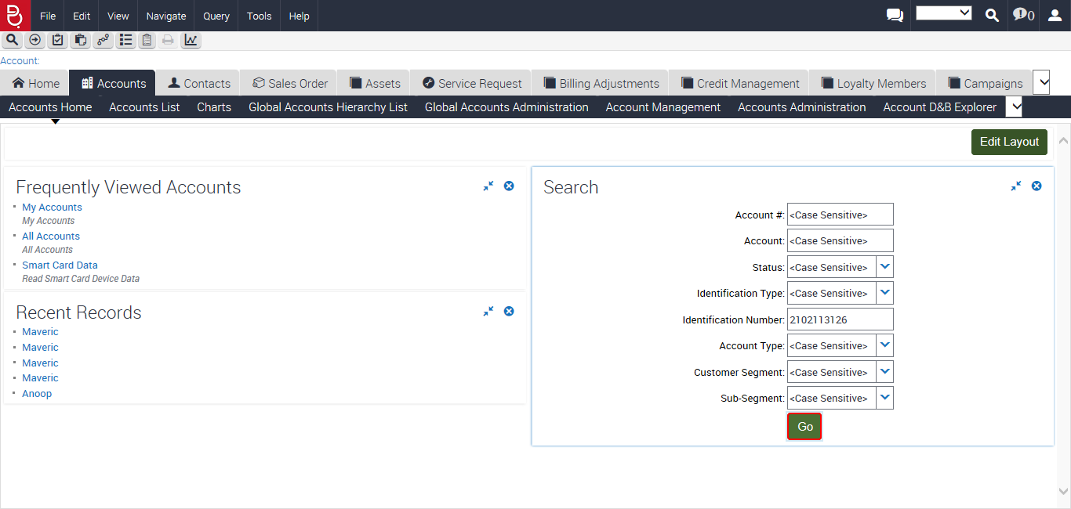

Entering into the Account

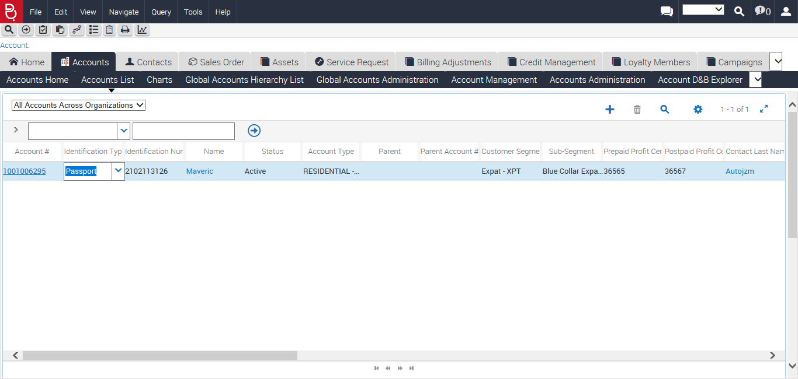

Account Number: 1001006295 and Name: Maveric

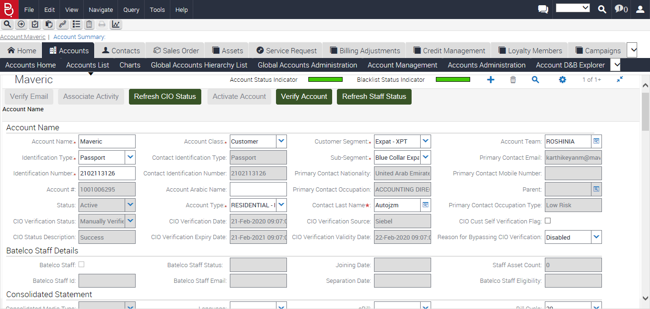

Installed Assets

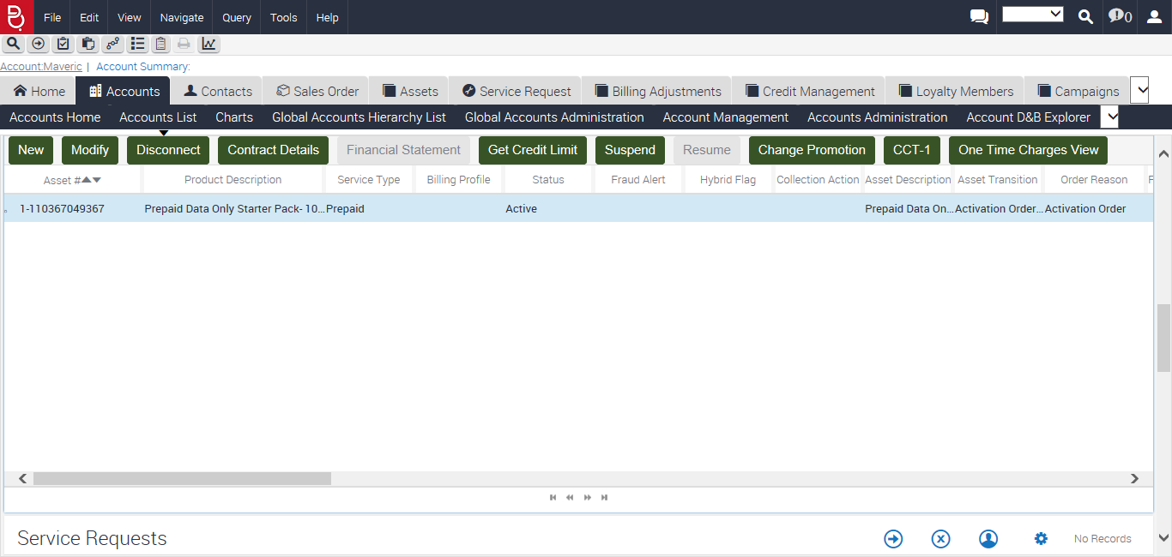

Selecting Order Reason: Modify Service

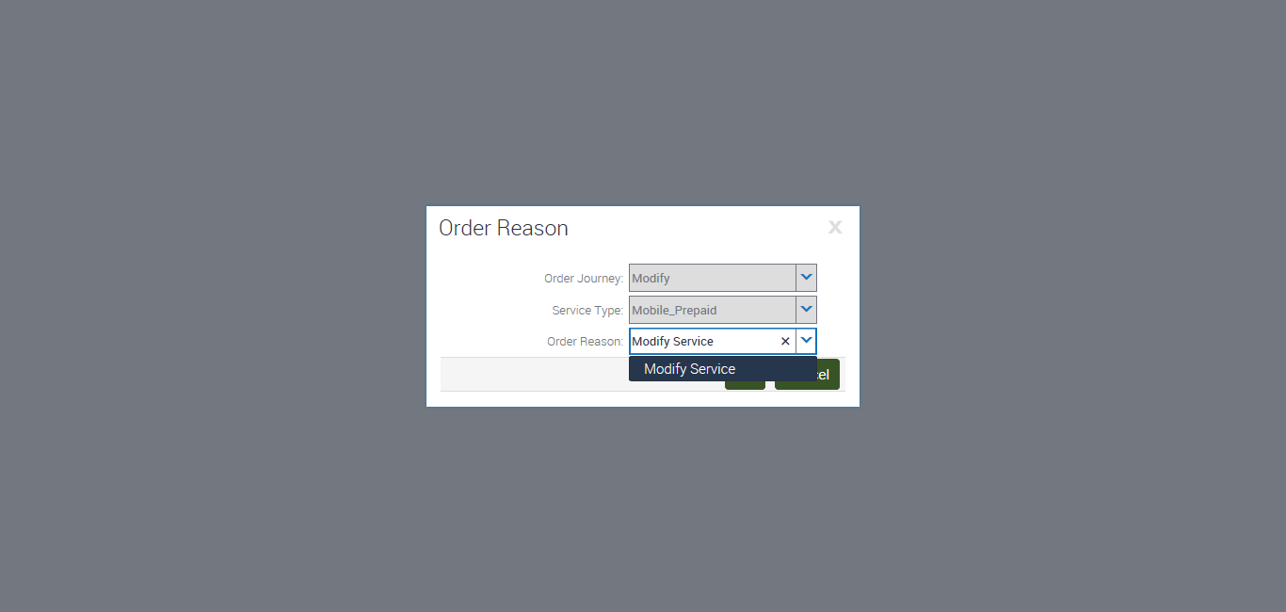

Clicking on Family Bolton Package

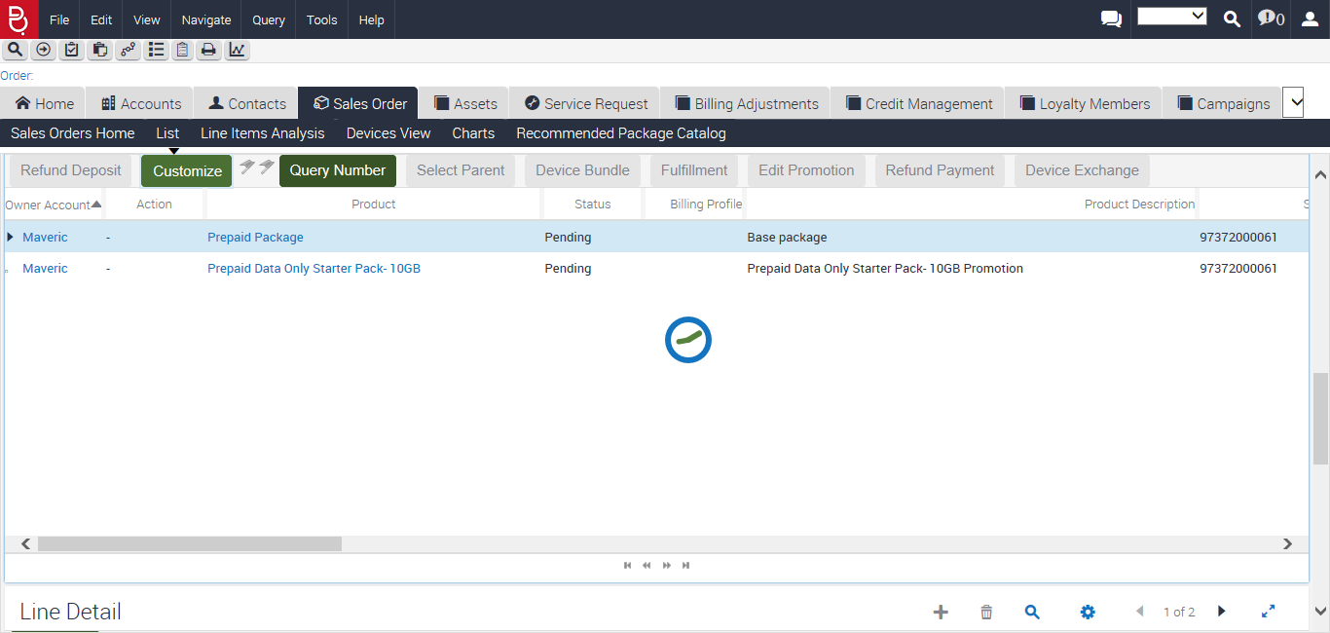

Wearable bolton Selected

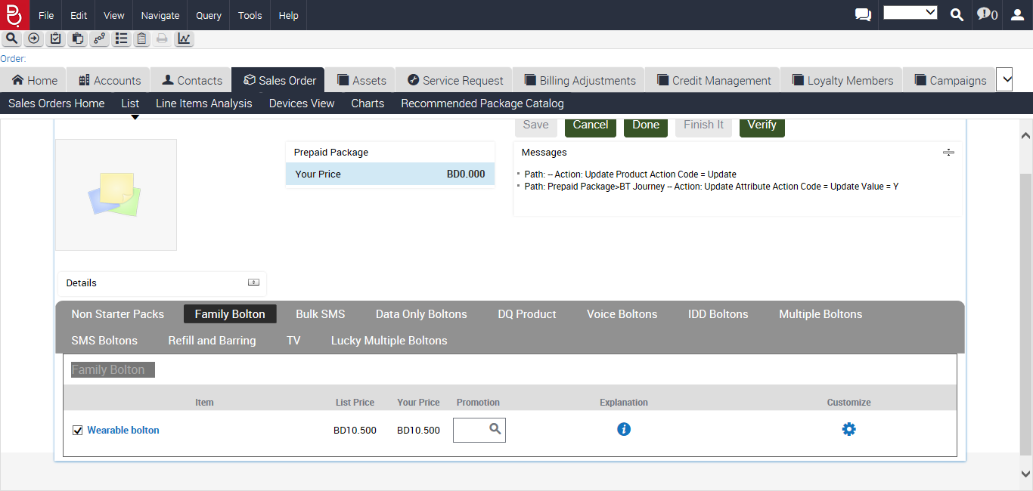

Clicking on MonthlyCharges_RoamingValue Package



1 Selected



Clicking on Done button.

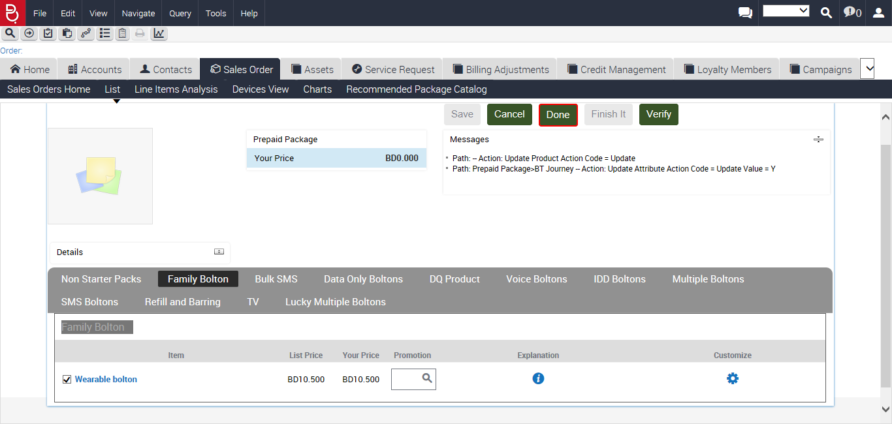

Exception occurred

