Setup Guide Formsflow.ai

formsflow.ai is a Free, Open-Source, Low Code Development Platform for rapidly building powerful business applications. formsflow.ai combines leading Open-Source applications includingform.ioforms, Camunda’s workflow engine, Keycloak’s security, and Redash’s data analytics into a seamless, integrated platform.

Prerequesties :

You must have a docker/docker desktop in your system.

For installation please follow the below documentations.

https://aot-technologies.github.io/forms-flow-installation-doc/

Before going to install the formsflow.ai , first setup the REDASH.

For Redash setup go to the below link -

https://redash.io/help/open-source/setup

Or directly clone from the git repository.

https://github.com/getredash/redash.git

After successfully clone replace the docker-compose.yaml and ceate the .env files on the same level of docker-compose file.

https://github.com/Soniyasharma6868/redash-docker-compose-file

After that, run the below command to create the db -

docker-compose run --rm server create_db

Then , run the docker command

docker-compose up -d.

Once build is succsseful , launch the Redash

http://localhost:7000/

Now,

1. Download the formsflow.ai tool for your system and choose installation type.

2. For next steps follow the officical documentation.

https://aot-technologies.github.io/forms-flow-installation-doc/Pages/PC/linux/onLinux.html

If your system is ubuntu then , go to

forms-flow-ai-deployment-main/scripts folder and open the terminal and run the bash file with or without sudo like -

sudo ./install.bash

and then follow the offical document again.

Formflow will ask the Redash API key – to get the Redash API key

I) Login to redash portal which you launch previously. Go to your profile icon and click on Edit profile pick the API key and paste ito your terminal.
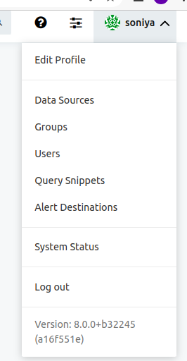

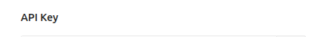

Aftre successful , you get the finish message.
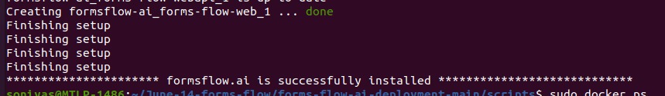

After that launch the formsflow windows,

To login the formsflow use the cred base on user role from below links -
https://github.com/AOT-Technologies/forms-flow-ai/blob/master/forms-flow-idm/keycloak/README.md

Thank you!

