CSC 351 Sprint 1 Submission
Linh Nguyen (LN) | SocialU
Selected Sprint 1 item: SRS-100.1 — Full name registration.

1 Team GitHub Project
https://github.com/users/SonjaSeferasi/projects/2

2 Board screenshot
Five SRS items and the five tasks linked to SRS-100.1. Open my board
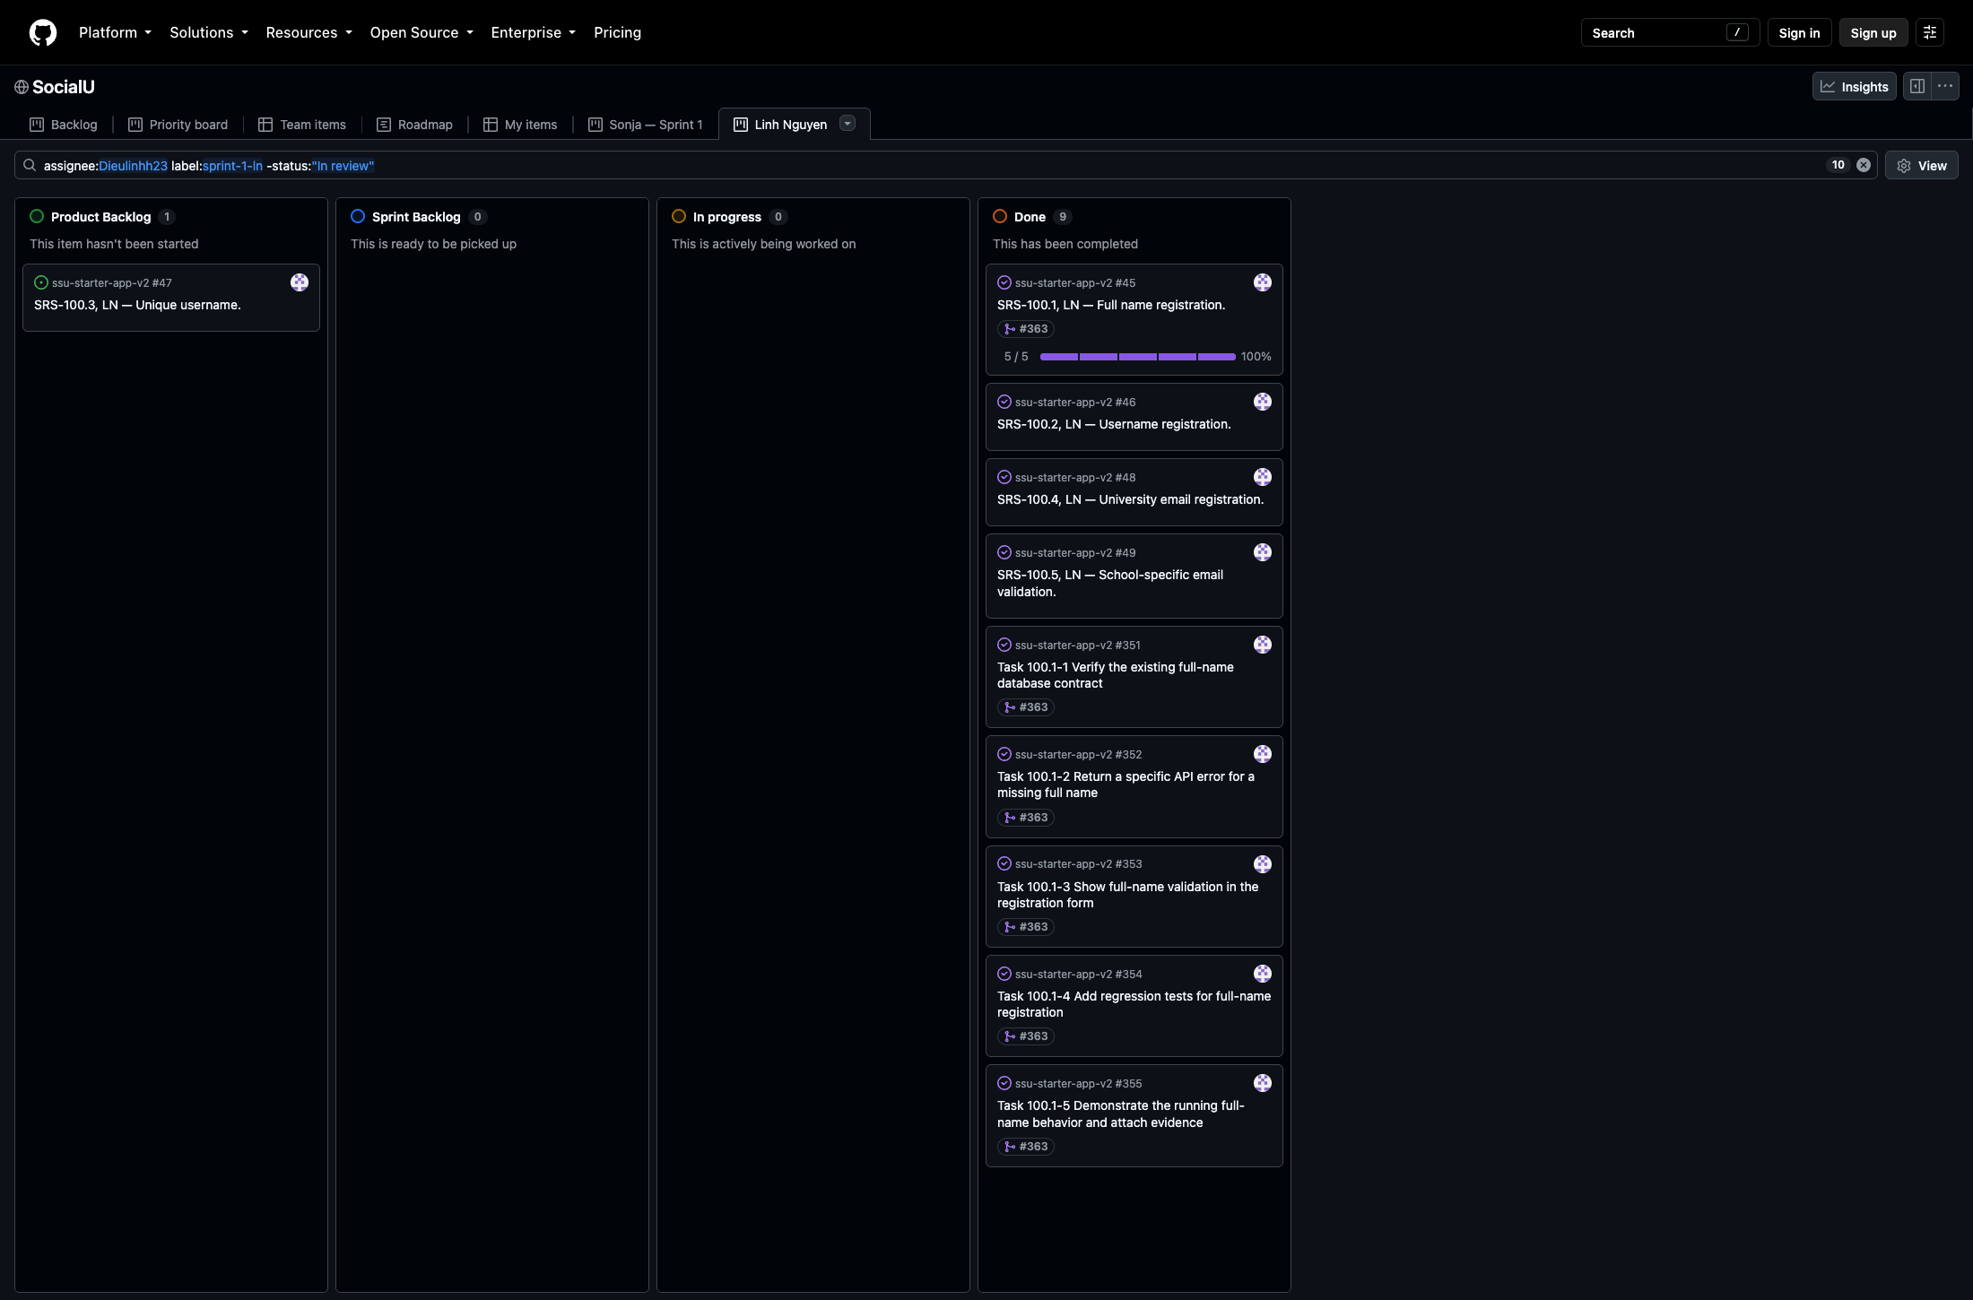
View the board screenshot at full resolution

3 Sprint 1 SRS issue
https://github.com/SonjaSeferasi/ssu-starter-app-v2/issues/45
Includes the requirement, assigned subtasks, branch and pull request links, and the running application evidence screenshot.

4 Merged Sprint 1 pull request
https://github.com/SonjaSeferasi/ssu-starter-app-v2/pull/363
PR 363 implements the focused SRS-100.1 validation and includes the code and evidence.

