SCHOOL OF COMPUTER SCIENCE AND ARTIFICIAL INTELLIGENCE |  |  |  | DEPARTMENT OF COMPUTER SCIENCE ENGINEERING
Program Name: B. Tech |  |  | Assignment Type : Lab |  |  | Academic Year : 2025-2026
CourseCode |  | 23CS002PC304 | Course Title |  | AI Assisted Coding
Year/Sem |  | III/II | Regulation |  | R23
Date and Day of Assignment |  | Week3 – Monday | Batch |  | 23CSBTB48
Name |  | S.TEJASWINI | Hall Ticket No |  | 2303A54027
Assignment Number: 5.1
Q.No. | Question
Lab 5: Ethical Foundations – Responsible AI Coding Practices Lab Objectives:
- To explore the ethical risks associated with AI-generated code.
- To recognize issues related to security, bias, transparency, and copyright.
- To reflect on the responsibilities of developers when using AI tools in software development.
- To promote awareness of best practices for responsible and ethical AI coding.
Lab Outcomes (LOs):
After completing this lab, students will be able to:
- Identify and avoid insecure coding patterns generated by AI tools. 
- Detect and analyze potential bias or discriminatory logic in AI-generated outputs. 
- Evaluate originality and licensing concerns in reused AI-generated code. 
- Understand the importance of explainability and transparency in AI-assisted programming. 
- Reflect on accountability and the human role in ethical AI coding practices. 
Task Description #1 (Privacy in API Usage)
Task: Use an AI tool to generate a Python program that connects to a weather API.
Prompt:
"Generate code to fetch weather data securely without exposing API keys in the code." Expected Output:
- Original AI code (check if keys are hardcoded). 
- Secure version using environment variables. 

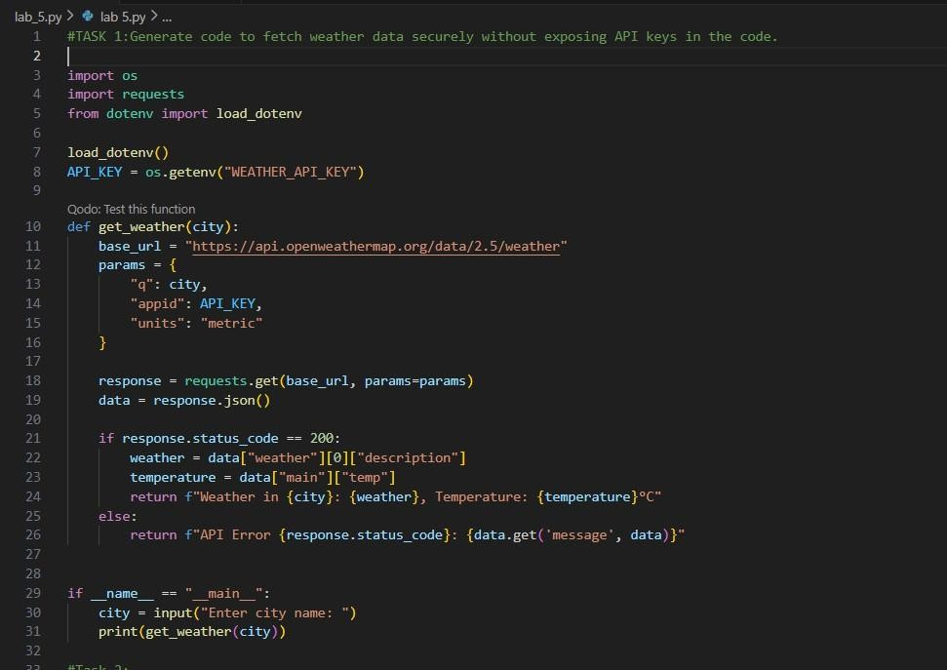
Output:
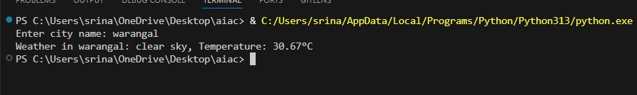
Task Description #2 (Privacy & Security in File Handling)
Task: Use an AI tool to generate a Python script that stores user data (name, email, password) in a file.
Analyze: Check if the AI stores sensitive data in plain text or without encryption.
Expected Output:
- Identified privacy risks.
- Revised version with encrypted password storage (e.g., hashing).
Prompt :
Generate a Python script that stores user details (name, email, password) in a file. Then analyze if storing the password is secure and modify the script to store the password safely using hashing instead of plain text.

Code :
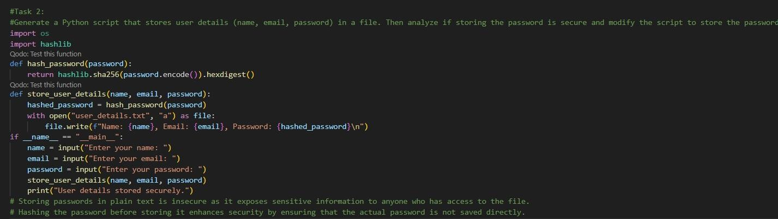
Output:
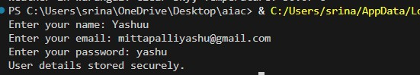
Explanation:
AI saves name, email, password straight to file readable by anyone, total hack risk.
Fix: Mash password into unreadable hash + random salt; store that instead can't steal real password.
Task Description #3 (Transparency in Algorithm Design)
Objective: Use AI to generate an Armstrong number checking function with comments and explanations.
Instructions:
- Ask AI to explain the code line-by-line.
- Compare the explanation with code functionality.
Expected Output:
- Transparent, commented code.
- Correct, easy-to-understand explanation.
Prompt : generate an Armstrong number checking function with comments and explanations and explain the code line by line ,compare the explanation with full code functionality.

Code :
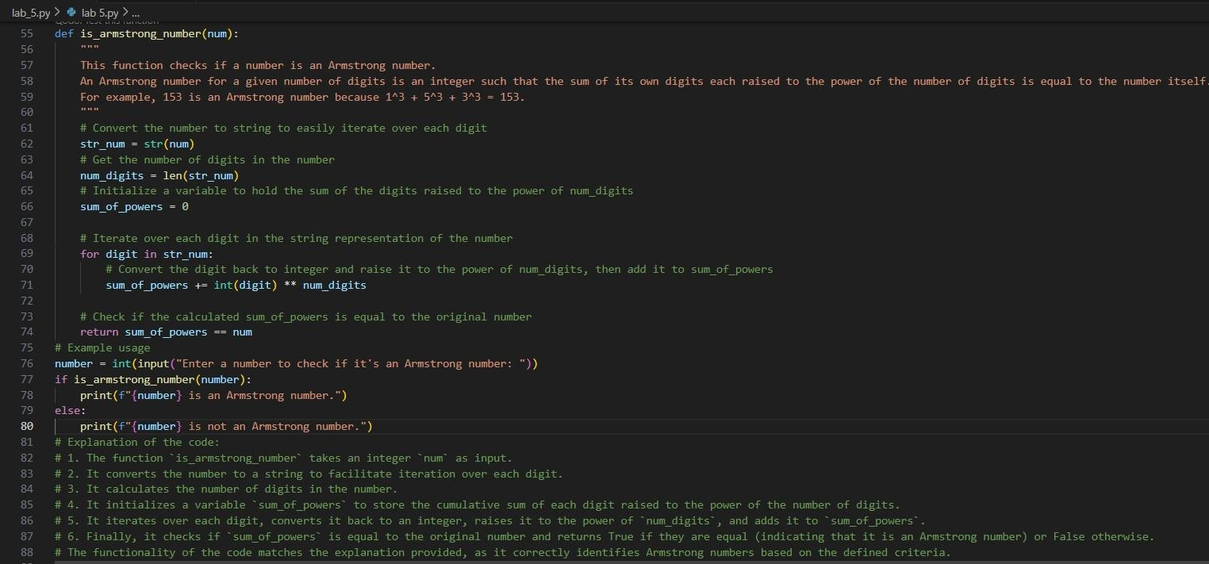
Output :
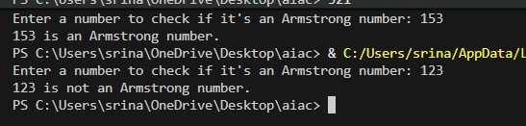
Explanation:
Armstrong number: A number equals the sum of its digits each raised to the power of total digit count. Here my Code grabs each digit, powers it correctly and also adds them up, then checks if that matches the original.
Task Description #4 (Transparency in Algorithm Comparison)
Task: Use AI to implement two sorting algorithms (e.g., QuickSort and BubbleSort).
Prompt:
"Generate Python code for QuickSort and BubbleSort, and include comments explaining step-by-step how each works and where they differ." Expected Output:
- Code for both algorithms.
- Transparent, comparative explanation of their logic and efficiency.
Codes :

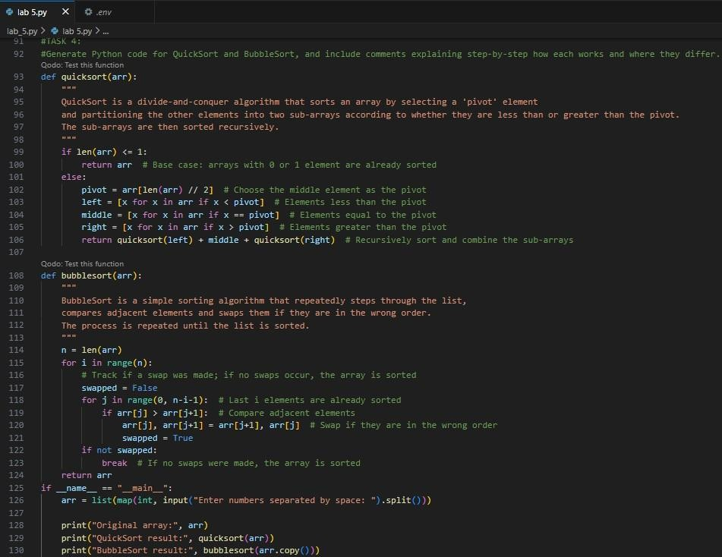
Output :
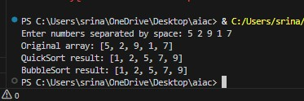
Explanation:
BubbleSort slowly swaps neighbor pairs until none needed simple but crawls on big lists.whereas,QuickSort picks middle value, splits smaller/larger sides, repeats divide fast splitter for real work.
Task Description #5 (Transparency in AI Recommendations) Task: Use AI to create a product recommendation system.
Prompt:

"Generate a recommendation system that also provides reasons for each suggestion." Expected Output:
- Code with explainable recommendations.
- Evaluation of whether explanations are understandable.
Code :
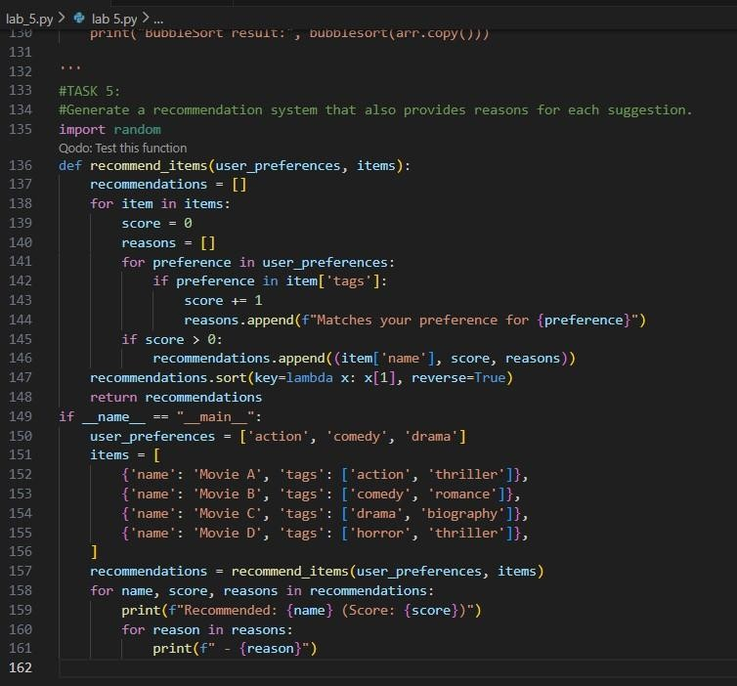

Output:
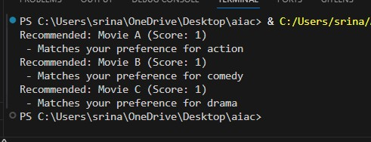
Explanation:

Recommendation system scans other users' tastes matching ours, then they suggest the matches according to our preferences and tastes so that every person can watch their own genre or taste preferences.
.

