AI-ASSISTANT CODING LAB 10.3
TASK1:
PROMPT:
def factorial(n):
result = 1
for i in range(1, n):
result = result * i
return result
identify the logical bug in the given code
CODE:
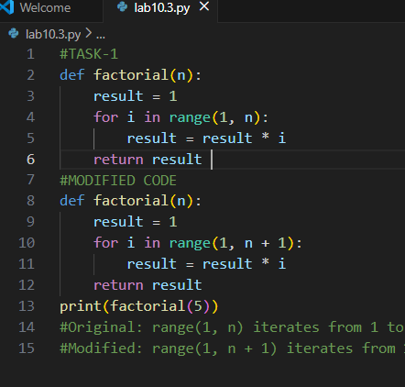
OUTPUT:
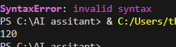
TASK2:
PROMPT:
def calc(a, b, c):
if c == "add":
return a + b
elif c == "sub":
return a - b
elif c == "mul":
return a * b
elif c == "div":
Critically analyze the given Python function for readability, parameter naming, and lack of documentation. Then rewrite it using descriptive names, add a complete docstring (description, parameters, return value, example), include exception handling for division by zero, and perform proper input validation following Python best practices.

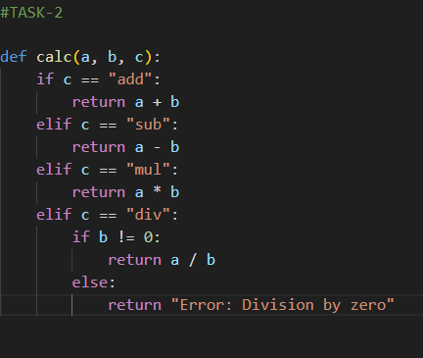
OUTPUT:
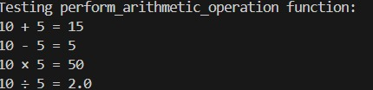

Task3:
Prompt:
Review the given Python function for correctness and PEP8 compliance. Test it with sample inputs, identify all PEP8 violations, and refactor it with proper naming, formatting, and spacing while preserving functionality. Finally, write a short note explaining how AI-powered automated code reviews can improve efficiency in large development teams.
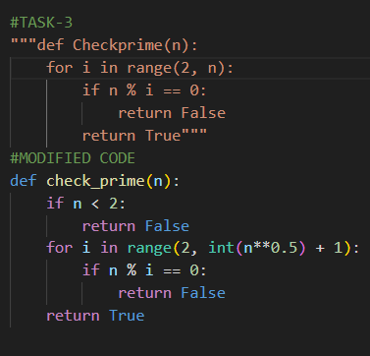
Output:
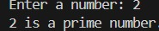

Task4:
Prompt:
Review the given Python function for readability, naming, modularity, and edge cases. Generate an AI-style code review suggesting better naming, input validation, type hints, and possible generalization (e.g., configurable multiplier). Refactor the function accordingly and write a short reflection on whether AI should be a standalone reviewer or an assistant.

Code:
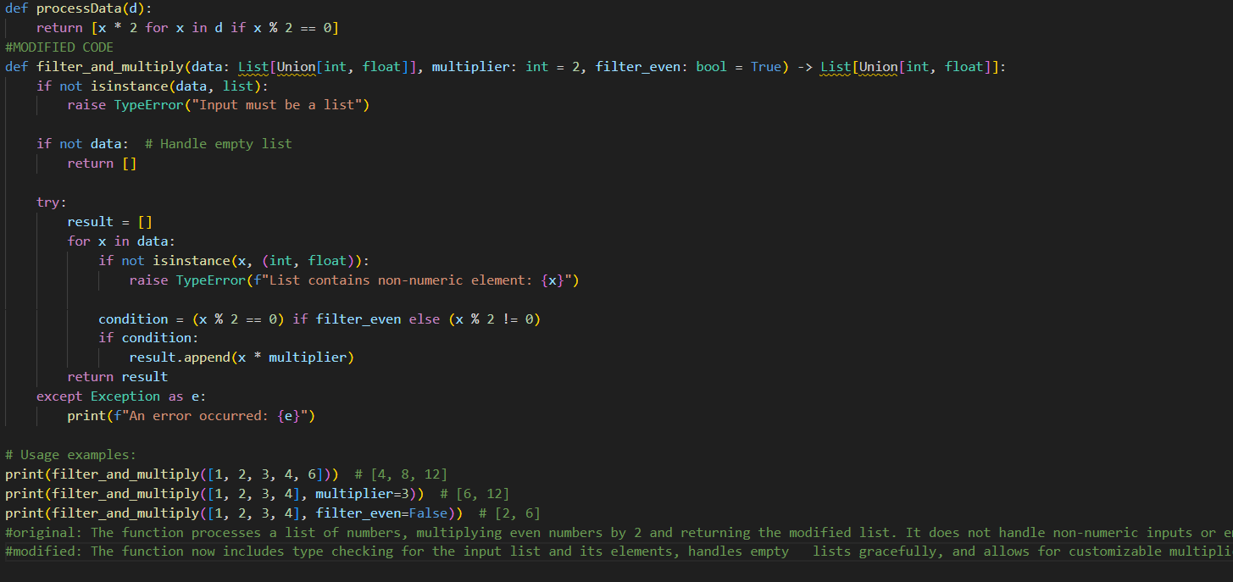
Output:
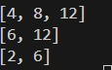
Task5:
Analyze the given Python function for performance on large datasets. Test it with a large input (e.g., range(1000000)), determine its time complexity, and suggest improvements using built-in functions or libraries like NumPy if appropriate. Provide an optimized version, compare execution times before and after optimization, and briefly discuss the trade-offs between readability and performance.
Code:
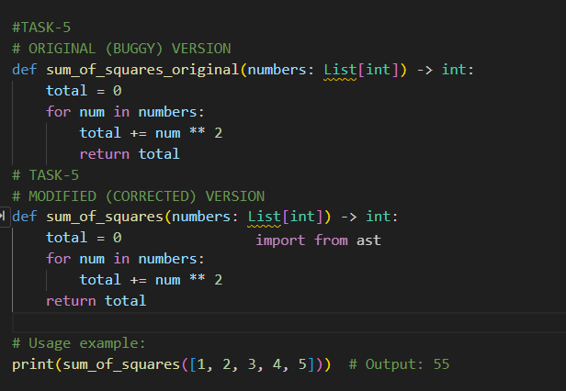
Output:

