Ai Assissted Coding
Name : s.tejaswini
Roll No : 2303A54027
Batch : 48

Lab 9: Documentation Generation – Automatic Documentation and Code Comments

Task 1: Basic Docstring Generation Scenario
You are developing a utility function that processes numerical lists and must be properly documented for future maintenance.
Requirements
- Write a Python function to return the sum of even numbers and sum of odd numbers in a given list
- Manually add a Google Style docstring to the function
- Use an AI-assisted tool (Copilot / Cursor AI) to generate a function-level docstring
- Compare the AI-generated docstring with the manually written docstring
- Analyze clarity, correctness, and completeness
Expected Output
- Python function with manual Google-style docstring
- AI-generated docstring for the same function
- Comparison explaining differences between manual and AI-generated documentation
- Improved understanding of AI-generated function-level documentation

Expected Output :
Prompt 1 – Generate Python Function :
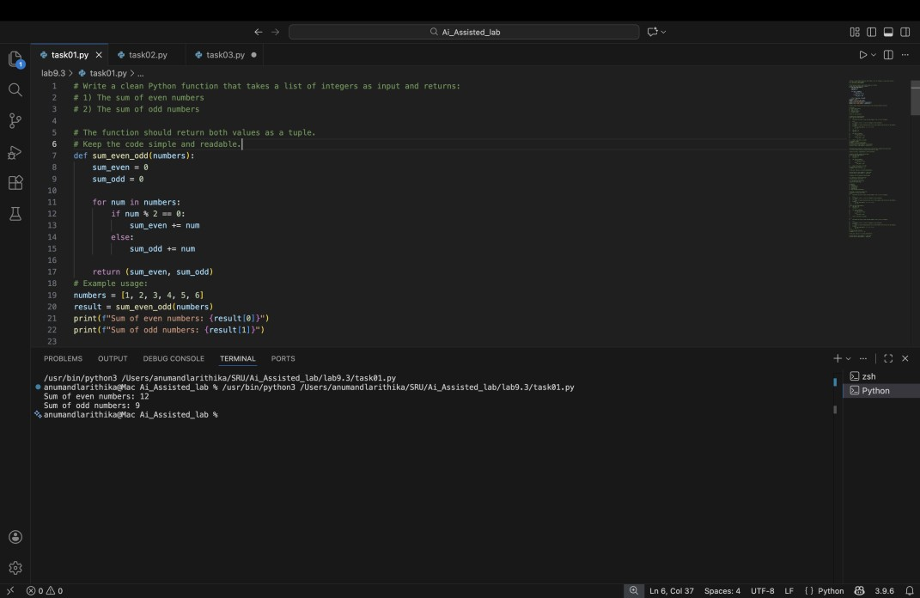
Prompt 2 – Generate Google Style Docstring :
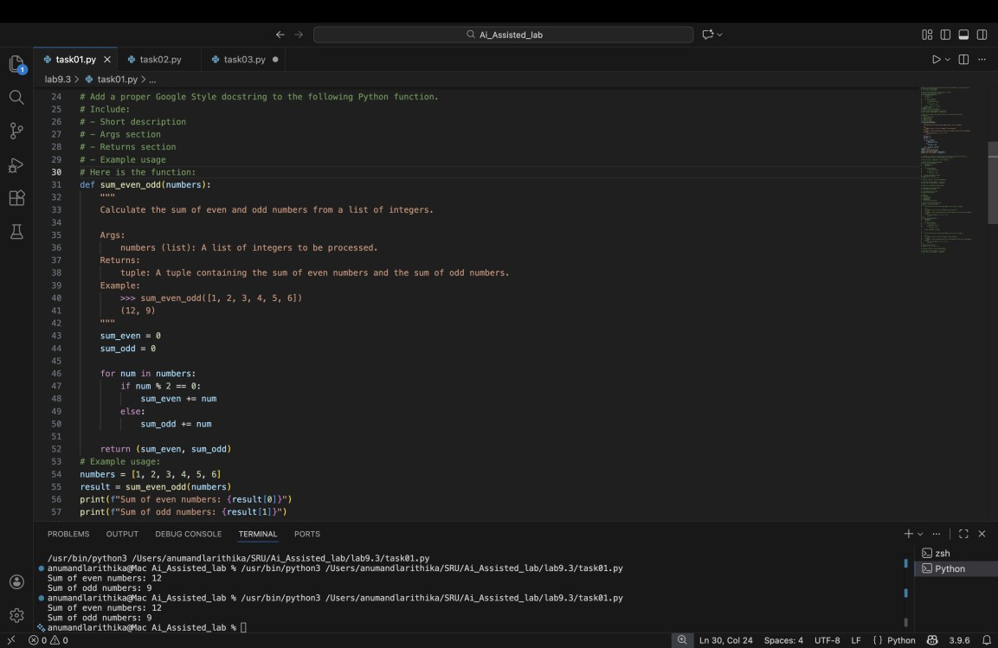

Prompt 3 – AI Docstring Generation (for comparison)

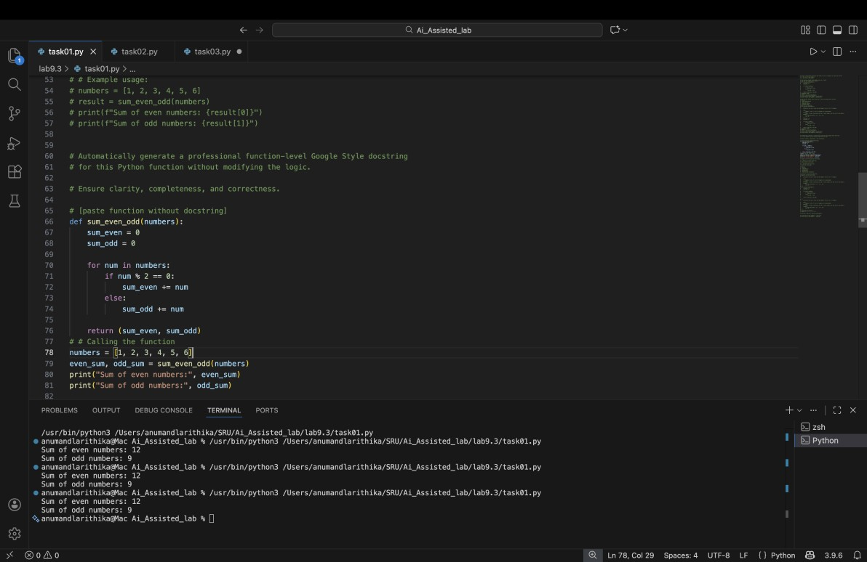

Prompt 4 – Comparison Prompt :
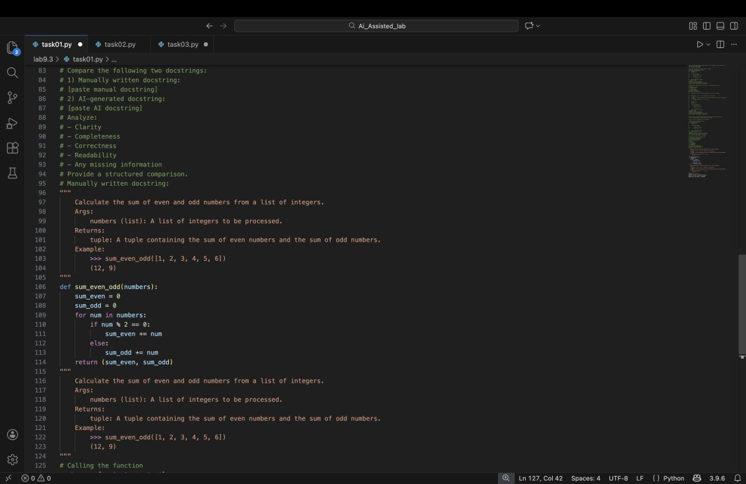

Criteria | Manual Docstring | AI Docstring
Clarity | Clear but short | More detailed
Completeness | Basic explanation | Includes examples
Accuracy | Correct | Correct
Readability | Simple | Professional tone

Explanation :
In this task, I wrote a Python function to calculate the sum of even numbers and odd numbers from a list.
First, I added a manual Google-style docstring to explain:
- What the function does
- What input it takes
- What it returns
Then, I used an AI tool to generate a docstring automatically.
After comparing both, I observed that:
- The AI-generated docstring was more detailed.
- My manual docstring was shorter and simple.
- AI documentation looked more professional.
- Both were correct, but AI saved time.
This task helped me understand how AI tools can generate function-level documentation quickly and clearly.

Task 2 – Automatic Inline Comments :
Prompt 1 – Generate Class :

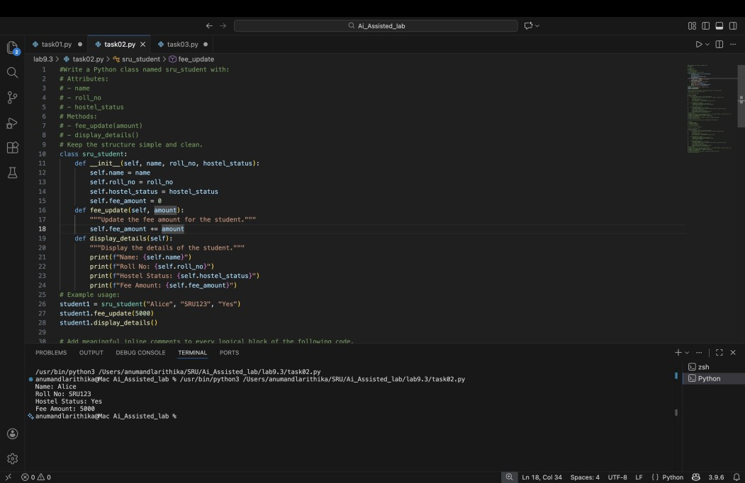

Prompt 2 – Add Manual Inline Comments :
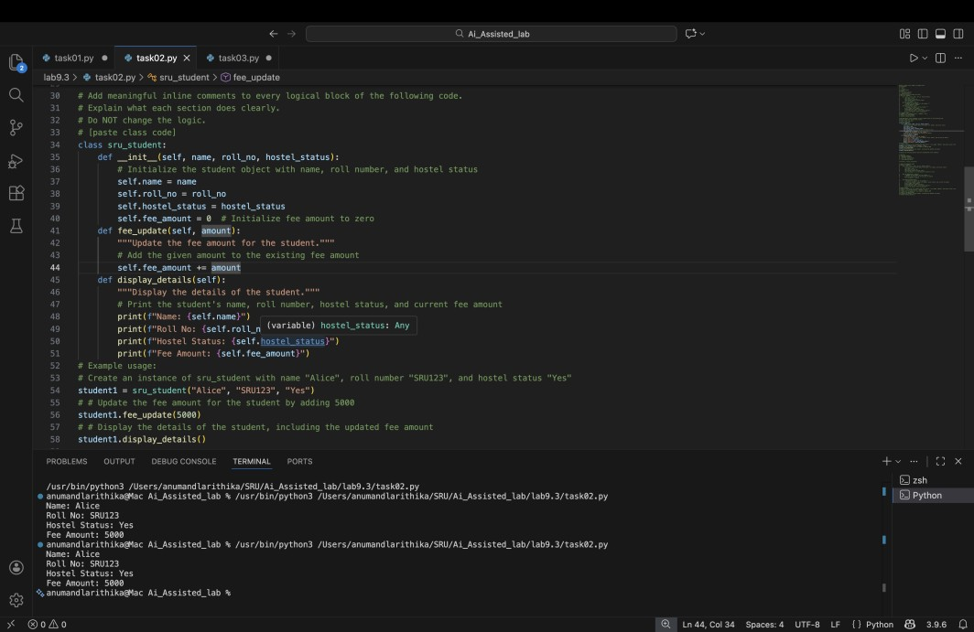
Prompt 3 – Evaluate AI Comments :
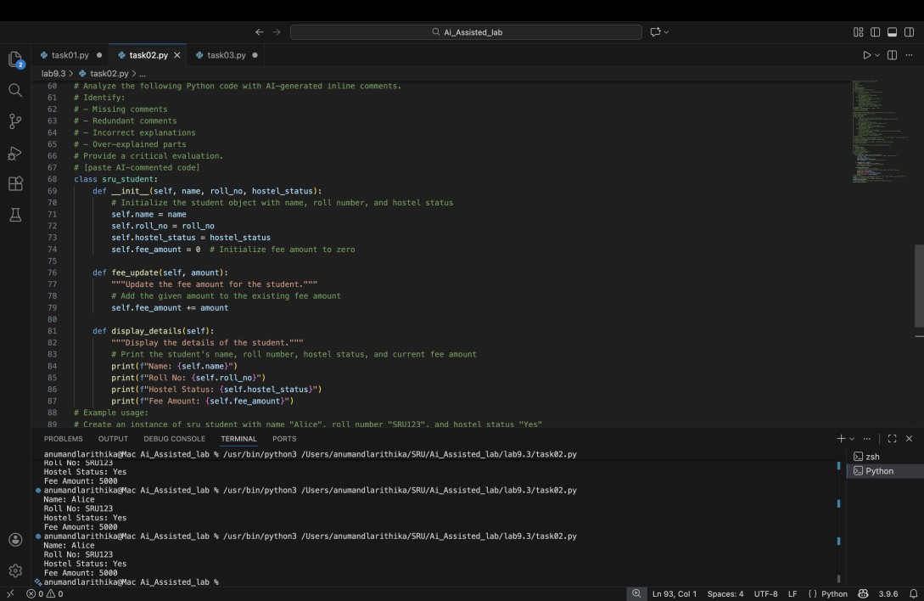

Explanation :
In this task, I created a Python class called sru_student with attributes like name, roll number, and hostel status.
First, I wrote inline comments manually to explain each part of the code.
Then, I used an AI tool to automatically generate inline comments.
After comparing them, I found:
- AI added comments for almost every line.
- Some AI comments were too detailed.
- Manual comments were shorter and focused.
- AI comments are helpful but need checking.
This task helped me understand how AI can automatically explain code logic.
TASK 3 – Module-Level & NumPy Style Documentation :
Prompt 1 – Generate Calculator Module :
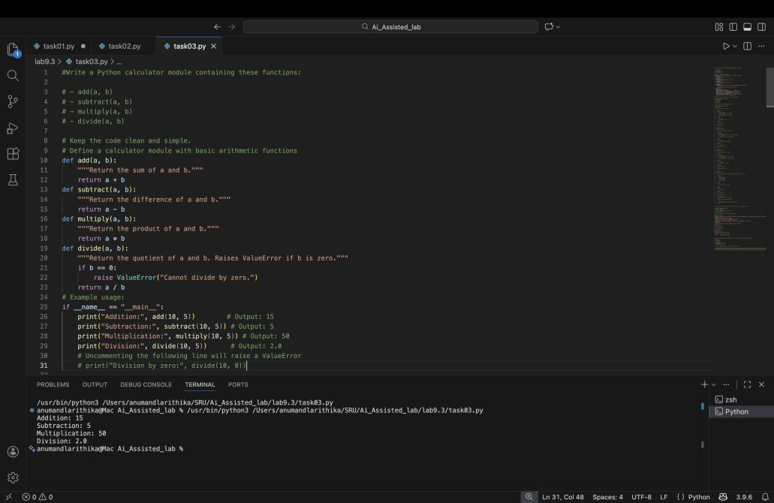
Prompt 2 – Add NumPy Style Docstrings :
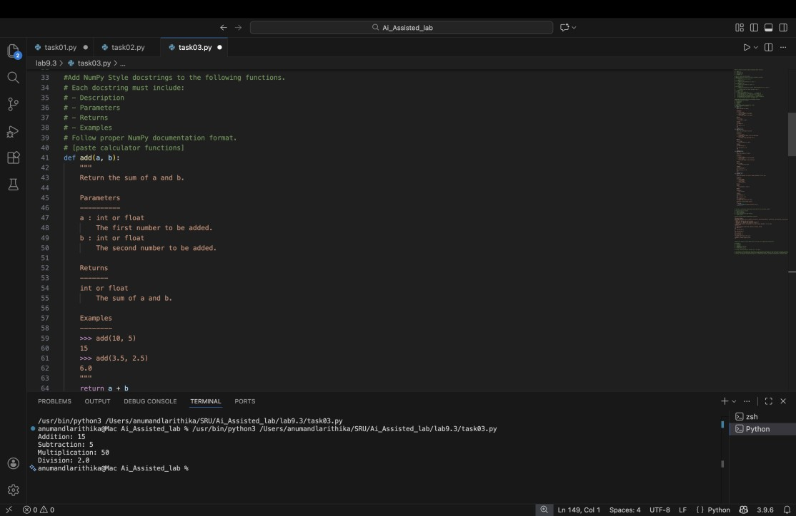
Prompt 3 – Generate Module-Level Docstring :
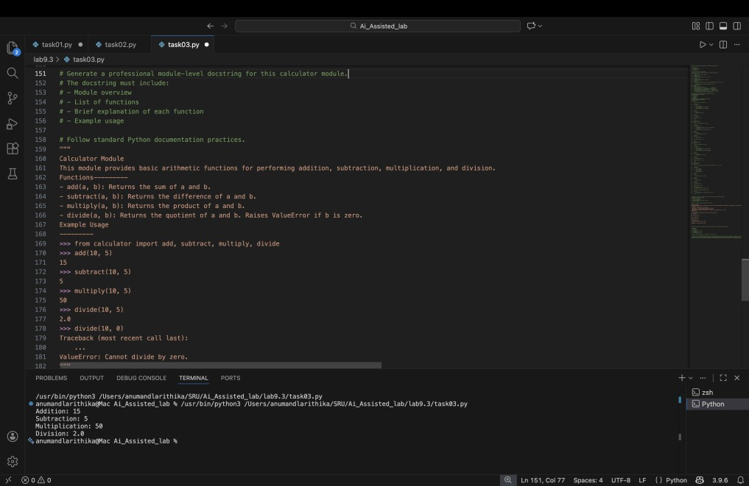
Explanation :
In this task, I created a small calculator module with functions like add, subtract, multiply, and divide.
First, I wrote NumPy-style docstrings manually for each function.
Then, I used AI to generate:
- A module-level docstring • Function-level docstrings
After comparing them, I observed:
- AI documentation was well structured.
- It followed proper formatting.
- Manual documentation was simple but correct.
- AI helps in maintaining consistency in large projects.
This task helped me understand structured documentation for multiple functions.

