AI Assisted Coding
H. No :- 2303A54002
Batch :- 48

Lab Experiment - Prompt Engineering – Improving Prompts and Context Management

Question 1: Zero-Shot Prompting (Palindrome Number Program)
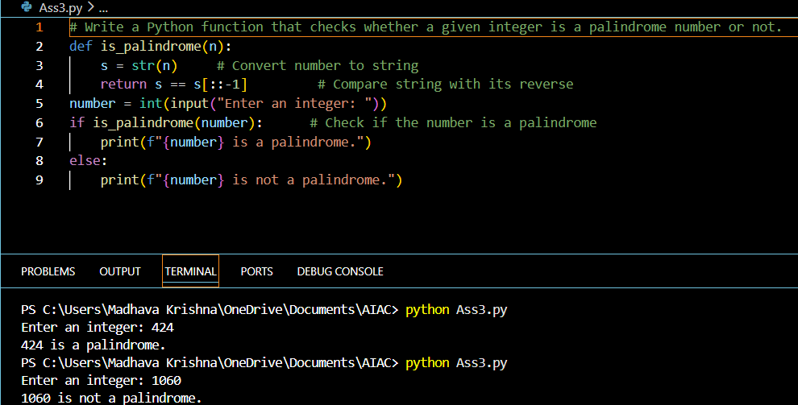
- Negative numbers not handled.
- Wrong inputs like letters or decimals give errors.
- No input checking.

Question 2: One-Shot Prompting (Factorial Calculation)
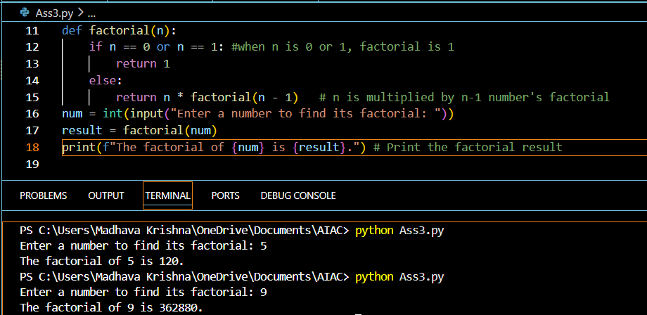
Question 3: Few-Shot Prompting (Armstrong Number Check)
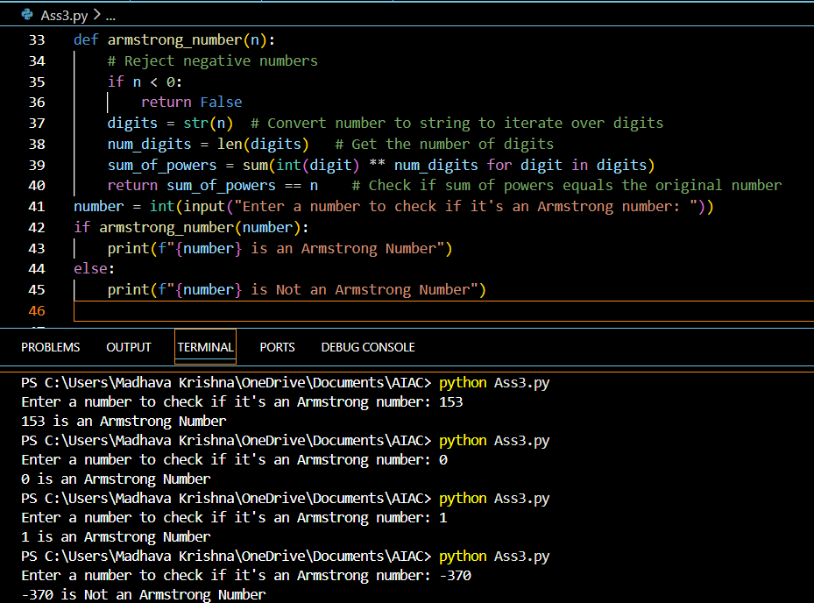
Because of the examples in the prompt, the AI gave correct logic and clear output. It also handled negative numbers and boundary values like 0 and 1.
The code is easy to understand and works correctly for all test cases.

Question 4: Context-Managed Prompting (Optimized Number Classification)
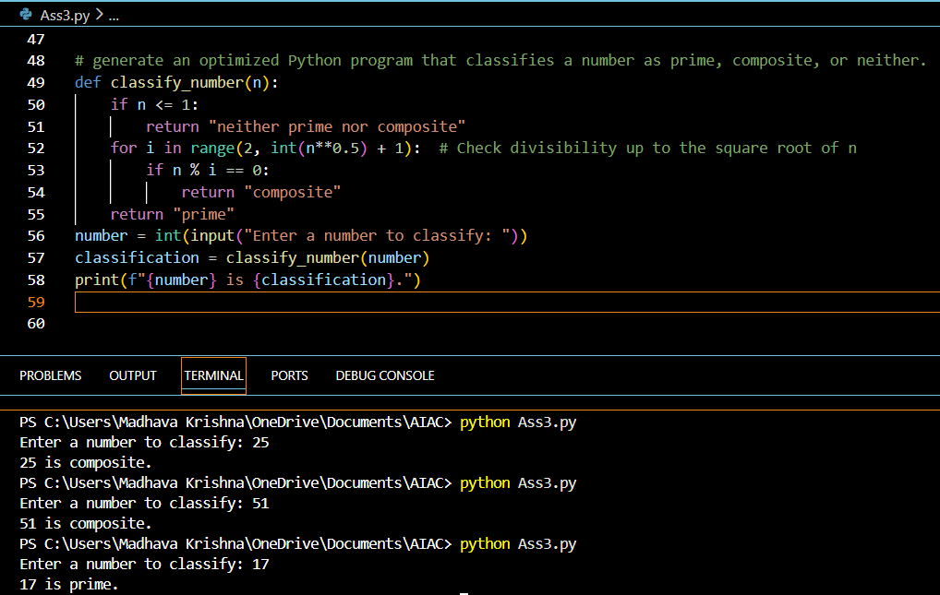
Before, the program checked all numbers up to n, which was slow. Now it only checks up to the square root, so it is faster. The outputs are clear and correct.

Question 5: Zero-Shot Prompting (Perfect Number Check)
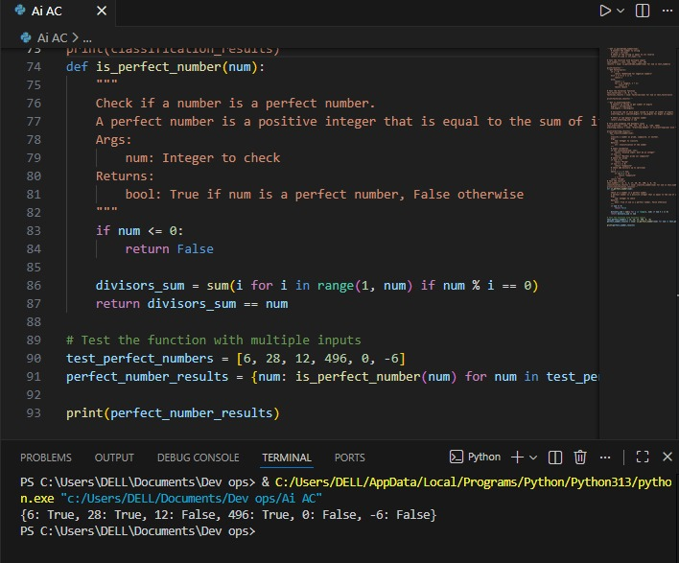
- The code works well for positive numbers.
- It correctly rejects 0 and negative numbers.
- There is no input validation for non-integer values.
- The logic is simple and correct, but not optimized using square root or divisor tricks.

Question 6: Few-Shot Prompting (Even or Odd Classification with Validation)
