STRAIN-RESOLVED METAGENOMICS ASSOCIATES TWO CLOSTRIDIACEAE SPECIES WITH A DIARRHEA OUTBREAK IN IMMUNODEFICIENT MICE

Abstract
Immunodeficient mice are important model organisms in diverse areas of research, including cancer, inflammation, autoimmunity, transplantation, and virology. Despite extreme immune deficits, these mice remain healthy while colonized by a gut microbiota that is “specific pathogen free” (SPF). Care must be taken to isolate these mice from infection prior to experimentation, as disease outbreaks are both costly and time-consuming. Here, we used a controlled infection experiment with strain-resolved shotgun metagenomics to identify the full genome sequences of two microbes consistent with a diarrhea outbreak in immunodeficient NSG mice at Stanford University. Follow-up infection and culturing experiments will confirm whether these microbes play a causative role.

Introduction
Over the past two decades, immunodeficient mice have served as important model organisms to understand the immune system and associated diseases. One of the most immunodeficient mouse models, NSG (NOD.Cg-Prkdc^{scid}IL2rg^{tm1Wjl}/SzJ) lack B and T cells due to a mutation in Prkdc, a DNA repair complex protein, and lack NK cells due to a mutation in IL2rg, the Interleukin 2 receptor common gamma chain (1, 2). These immunodeficiencies allow the mice to be engrafted with human cells, allowing NSG mice to serve as more accurate models for many types of cancer, viral infections, and autoimmune diseases. NSG mice have also been critical in precision medicine by allowing researchers to engraft tumor cells from human patients. These patient-derived xenografts share many similar features with the original tumor and can be used to determine the best course of action for a given patient (3).
However, given their broad immune deficiencies, special care must be taken to avoid introducing disease-causing organisms into breeder facilities for NSG mice prior to their use in experiments. Though NSG mice are rarely studied in a germ-free environment, efforts are made to ensure the mice remain “specific pathogen free”. Given the interconnectedness of the gut microbiome and the immune system, severe disruption of the gut microbiome of these mice through infection renders them unusable for experiments for which NSG mice were designed. Further, differentiating pathogens from commensal microbes in the mouse gut microbiome remains difficult as many mouse gut microbes are difficult to cultivate, are uncharacterized, or have not been associated with pathogenic activity in healthy mice but might be problematic in NSG mice.
A previous study described an outbreak of infectious diarrhea in the barrier suite containing NSG and NSGS (NOD.Cg-Prkdc^{scid}Il2rg^{tm1Wjl}Tg(CMV-IL3, CSF2, KITLG)1Eav/MloySzJ) mice (4). Despite the low mortality, the high morbidity, significant intestinal pathology, and rapid transmission rate required the core facility to euthanize more than 2,000 mice and completely shut down and decontaminate the barrier suite. In an effort to identify the infectious agent, Misic et al. performed 16S rRNA and shotgun metagenome sequencing on both infected and healthy mice, finding that infected mice were enriched in segmented filamentous bacteria (SFB, also referred to as Candidatus Arthromitus and Dwaynesavagella sp.), and unclassified Clostridiaceae spp. via 16S, and SFB and Clostridium celatum via shotgun sequencing (4).
Given their broad utility, NSG mice are critical to the studies of many investigators at Stanford University. An outbreak infectious intermittent diarrhea was first recognized at Stanford in October 2020, and has caused considerable loss of funds and research data since then. After many routine tests, no candidates for the cause of the intermittent diarrhea were identified, leaving a direct comparison of the microbiome of healthy and infected mice as one of the remaining options to be explored.
Investigating the microbiome through shotgun metagenomics is a powerful tool to generate testable hypotheses, but identifying causal links through microbiome data alone is difficult because of several key limitations. These include insufficient sequencing depth to detect very low abundance organisms, incomplete reference databases that lack the microbes of interest, and/or insufficient taxonomic resolution as is common with 16S rRNA amplicon sequencing leading to misidentification or over-grouping of causal and non-causal microbes.
Shotgun metagenomics has recently become more feasible, accurate, and informative as deceasing sequencing costs and improved reference databases allow researchers to characterize most of the sequencing data in human and mouse gut samples with up to species-level resolution (5, 6). Specifically, the recent publication of the Mouse Gastrointestinal Bacterial Catalogue (MGBC), a large genome database comprising thousands of species known to colonize the murine gut has shed light on most of the species present in lab-associated mice (6). These databases can also be augmented by genome sequences generated from a specific study through metagenome assembly and genome binning if they lack certain study-relevant organisms.
However, when studying real-time dynamics of microbial transmission, simply identifying species conserved between two samples is rarely sufficient given the vast genomic diversity within most microbial species. New software can confidently identify recent strain-sharing events between two metagenomes (7). The inStrain program requires a) reads mapping to a majority of the reference genome of interest, and b) sufficient coverage depth to identify single nucleotide variants with respect to the reference in both samples, but in return can detect when genomes differ by less than 0.001% average nucleotide identity (7). The number of strain-sharing events detected between two samples depends on the quality of the reference database and the sequencing depth of each sample.
In light of the large MGBC and strain-sharing software available, we designed two main experiments to identify microbes associated with the diarrhea outbreak in the Stanford mouse facility. We exposed healthy NSG mice with different microbiomes to material from mice with symptomatic diarrhea through gavage and co-housing. We hypothesized that using strain-resolved metagenomics on samples gathered during these experiments would a) allow identification of bacterial strains transmitted from sick to healthy mice, b) provide genomic insights regarding shared strains that might be candidate pathogens, and c) suggest methods to identify infected but pre-symptomatic mice, limiting pathogen spread.

Results
Healthy NSG mice purchased from Jackson Laboratories were administered intestinal homogenate gathered from mice with diarrhea, while healthy NSG mice bred and reared at Stanford were co-housed with diarrheic mice (see Materials and Methods, Figure 1A). Mice gavaged with unfiltered intestinal homogenate (n=3) showed symptoms of intermittent diarrhea at both timepoints when sampled for shotgun metagenome sequencing. Control mice (n=3) and mice receiving filtered intestinal homogenate (n=3) remained healthy at both time points. Additionally, mice exposed to diarrhea via co-housing developed intermittent diarrhea (n=4), while their littermates remaining in the original cages did not (n=4). Mice in the gavage experiment were purchased from Jackson Laboratories while the mice in the co-housing experiment were bred at Stanford.
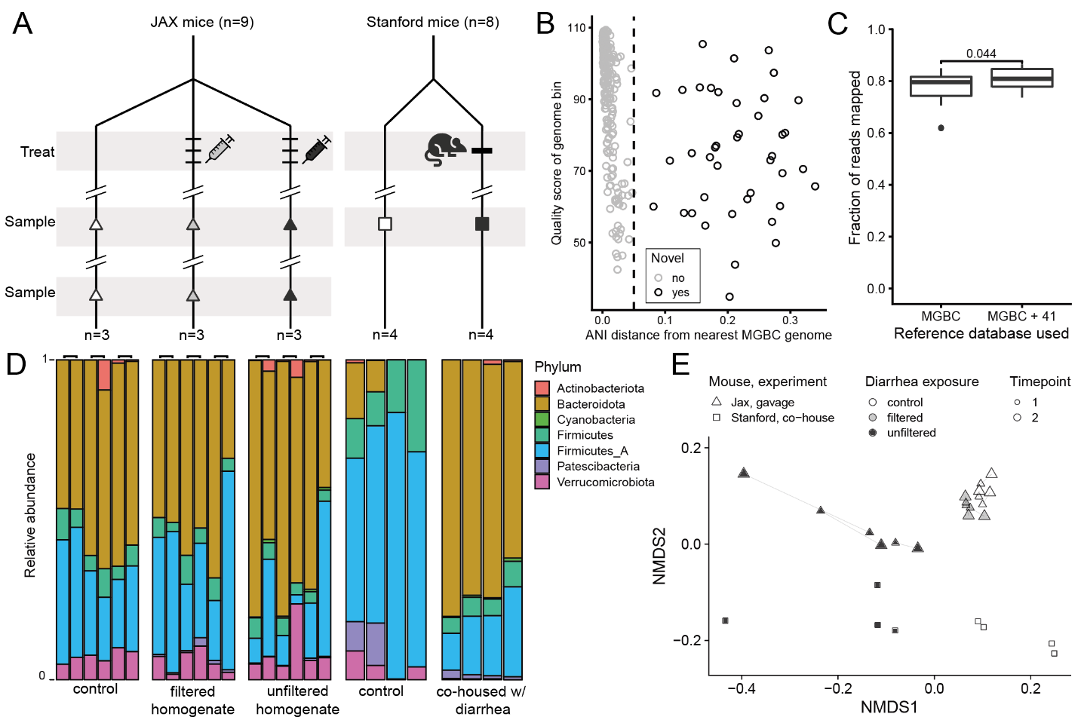
a. Diagram of experimental design. On the left, NSG mice from JAX were gavaged three times with 0.1 mL of filtered intestinal homogenate (n=3, gray triangle), unfiltered intestinal homogenate (n=3, black triangle), or were untreated (n=3, white triangle). Each of these nine mice were sampled twice, 25 days apart. Mice gavaged with unfiltered homogenate developed diarrhea. On the right, NSG mice from Stanford were co-housed with a mouse with symptomatic diarrhea (n=4, black square) or left in their home cages (n=4, white square). These mice were sampled once after co-housing resulted in symptomatic diarrhea in previously healthy mice. Mice co-housed with a symptomatic mouse developed diarrhea.
b. Scatterplot for 246 species-level representative genome bins recovered from mouse metagenomes in this study visualizing the MASH distance (1 – ANI) from the most similar genome in the MGBC and the quality score of the genome bin (see Methods). The dotted line represents 95% ANI (MASH distance = 0.5) and the 41 genome bins to the right represent novel species relative to the MGBC.
c. Boxplot illustrating fraction of reads mapped from each sample (n=26) onto full genome sequences for species representatives in the MGBC (MGBC, n=1,094) and fraction of reads mapped onto MGBC representatives plus the additional 41 species representatives recovered in this study (MGBC + 41); p < 0.05 (Wilcoxon test).
d. Stacked bar chart showing the relative abundance of seven phyla identified.
e. Non-metric multidimensional scaling plot of unweighted UniFrac distances between individual mouse microbiomes.
Figure 1. Experimental design and taxonomic profiling of mouse gut microbiome in response to diarrhea exposure
To identify species- and strain-level differences between each group of mice, we performed shotgun metagenome sequencing. The 26 shotgun metagenome samples were sequenced to a mean depth of 2.7 Gbp (+/- 0.8, 71 Gbp total) with 2.3 Gbp +/- 0.7 per sample remaining after duplicate removal, trimming, and host filtering (see Materials and Methods, Supplemental Tables S1). Surviving reads were then used for assembly, genome binning, and species- and strain-level profiling.
We took several steps to address sequencing depth, reference database bias, and taxonomic resolution. We generated 20 sample groups based on same-mouse (n=9), same-cage (n=7), or +/- diarrhea (n=4) and performed co-assembly, read-mapping, and genome binning on each sample group, resulting in 1,019 genome bins (see Materials and Methods, Supplemental Tables S2). These genome bins were dereplicated into 246 species-level groups at 95% average nucleotide identity (ANI) using dRep (8), with the highest-quality genome selected to represent each group. Next, we compared these genomes to those in Mouse Gastrointestinal Bacterial Catalogue (MGBC) (6) which consists of 26,640 genome bins and isolates from 1,094 species-level groups. Using MASH (9), we identified 41 of 246 species-level groups that were not represented in the MGBC (shared <95% ANI, MASH distance > 0.05, Figure 1B). The full genome sequences of the MGBC representatives (n=1,094) recruited, on average, 78+-6% of reads per sample (Figure 1C). Adding the 41 additional genomes provided a modest but significant (p<0.05) increase in read recruitment (81+-4%). The 1,135 genomes were assigned taxonomy using GTDB-TK v1.7.0 (r202) (10), and the compositional data representing these genomes across the 26 mouse metagenomes were used for the remainder of this study.
Aggregating the species-level data at the phylum level, we observed that the control mice in the co-housing experiment appear to have more Firmicutes and Firmicutes_A and less Bacteroidota than the other groups, including the gavage control group (Figure 1D), suggesting the underlying microbiota in Stanford vs JAX mice may have large compositional differences. However, we noted no significant differences when comparing the phylum-level composition between healthy mouse samples (n=16) and those with diarrhea (n=10, Wilcoxon test, p.adj > 0.05, Figure S1A).
We then investigated species-level changes in response to gavage or co-housing with respect to control mice. Non-metric multidimensional scaling (NMDS) performed on unweighted UniFrac distances at the species level revealed fundamental species-level differences between the two control groups. This analysis also revealed a negligible impact on species-level composition of the mouse microbiome from gavaging filtered homogenate when compared with control mice with the same microbiota from the same vendor. This lack of compositional change, and lack of diarrhea symptoms suggests the pathogen is a filterable agent. Further, samples from mice with diarrhea shared a similar trajectory along the x axis of the NMDS plot, away from their analogous controls (Figure 1E).
We then investigated whether individual species showed significant changes in abundance between healthy and diarrheic mice. At finer taxonomic resolution, more species varied significantly between healthy and diarrheic mice (Figure S1A). The phylum with the most species significantly enriched in diarrheic mice (Wilcoxon test, p.adj < 0.05) was Bacteroidota (n=13), followed by Firmicutes_A (n=4), Actinobacteria (n=4), Firmicutes (n=2), and Cyanobacteria (n=1) (Figure S1B).
Because the diarrhea disease is filterable and transmissible via gavage and co-housing, we next investigated bacterial strain-sharing events between mice in the study. We used inStrain (7) to identify the number of genomes in each sample that had sufficient depth (5x coverage over >=10% of the genome) and breadth (>=25% bases covered by >=1 read) for strain profiling. Of the 193 +-44 species detected on average in each sample, 26 +-7 genomes per sample met these cutoffs for strain profiling. Genomes of the same species that shared >=99.999% ANI over at least 10% of the genome between two samples were flagged as strain sharing events. The percent of strains profiled that were shared with a given sample was calculated and plotted as a heatmap in Figure 2A (see also Supplemental Table S5).
(a) A heatmap visualizing the percentage of strains profiled in a given sample that were also shared with another sample. Each of the 26 mouse samples are represented on the x and y axes, and the heatmap is divided into five experimental groups, colored by mouse source (JAX=green, Stanford=red) and experiment type (gavage=green, co-housing=red), as well as exposure to diarrhea (control=white, filtered homogenate=gray, unfiltered homogenate / co-housing exposure = black).
(b) A heatmap visualizing the relative abundance of 11 species (y axis) across each of the 26 mouse samples (x axis, same order as panel a). Strain-sharing events for these 11 species were detected between JAX mice with diarrhea and Stanford mice with diarrhea, exposed through gavage and co-housing, respectively (see panel a). Species are grouped and colored by bacterial family (Muribaculaceae=blue, n=3; Rikenellaceae=purple, n=6; Clostridiaceae=pink; n=2).
Figure 2. Strain sharing events between mice identifies candidate bacteria
As expected, the average number of strains shared between mice in the same experiment group was high, at 13+-5. The number of strains shared between JAX gavage controls and all Stanford mice (control or co-housed with diarrhea) was zero. Apart from a single strain shared between one JAX mouse receiving filtered homogenate and two Stanford control mice (MGBC113942, a Lachnospiraceae sp.), no other strain-sharing events between healthy mice from different sources were detected.
We also reasoned that strains shared between healthy Stanford mice and diarrheic Stanford mice (n=13) were not liable for causing the diarrhea (lower right red box, Figure 2A). Additionally, as the intestinal homogenate used for gavage was taken from a diarrheic Stanford mouse, any strains shared between healthy Stanford mice and diarrheic JAX mice (n=9) were also not liable (upper right red box, Figure 2A). The strains shared between JAX and Stanford mice with diarrhea (n=17, black box, Figure 2A) most likely were introduced through gavage or co-housing. Subtracting the strains we ruled out (red boxes, Figure 2A) from the 17 candidates (black box, Figure 2A) left 11 species for future analysis.
All 11 species were significantly enriched (Wilcoxon test, p.adj <0.05) and nearly universally present in diarrheic mice, while below the limit of detection in healthy mice (Figure 2). They belong to the families Rikenellaceae (n=6), Muribaculaceae (n=3), and Clostridiaceae (n=2). The two candidates in the Clostridiaceae family belong to the species Clostridium cuniculi, and Dwaynesavagella sp000270205. Members of the species Dwaynesavagella are segmented filamentous bacteria (SFB) and were formerly known as Candidatus Arthromitus. SFB have been studied extensively in mice and are known for their close association with the mouse gut epithelium and concomitant immunomodulatory effects. Further, SFB are spore-formers and though they can be mono-associated with mice, they have yet to be cultivated in vitro. Intriguingly, Dwaynesavagella was also associated with diarrhea in NSG mice in a previous study through both 16S, microscopy, and shotgun metagenome data (4).
Clostridium cuniculi was first identified as a pathogen in rabbits where it also causes diarrhea (11), yet little else is known about it. We performed several phylogenomic and functional analyses of C. cuniculi and its close relatives to better understand the lifestyle, potential modes of transmission, and pathogenic potential of this bacterium. To determine the relationship of the two candidate diarrhea-associated bins, we used GToTree v1.6.34 (12-18) to build a phylogenomic tree containing these genomes, 52 genomes from species closely related to C. cuniculi, and Dwaynesavagella, and 122 species representatives from the genus Clostridium (see Supplemental Table S7). The tree revealed that C. cuniculi is closely related to C. celatum, one of the other main species implicated previously in diarrhea among NSG mice (4), and near known pathogen C. perfringens which is known to contain several potent enterotoxins (19, 20) (Figure 3). Annotation of the C. cuniculi genome bin from this study for the presence of revealed the presence of Pfam (21) model PF03505, an enterotoxin found in C. perfringens, a common cause of food poisoning. No known toxin genes were identified in the Dwaynesavagella genome bin. We used DIAMOND (22) to detect whether the C. cuniculi enterotoxin protein was present in any other genomes in our tree, revealing 3 more: the C. cuniculi genome isolated from diseased rabbits (but not other C. cuniculi genomes analyzed), C. botulinum, and C. argentinense. Though the C. perfringens genome representing the species on NCBI lacks this gene, though many other members of the species have it at an average of ~26% amino acid identity when compared with the C. cuniculi enterotoxin.

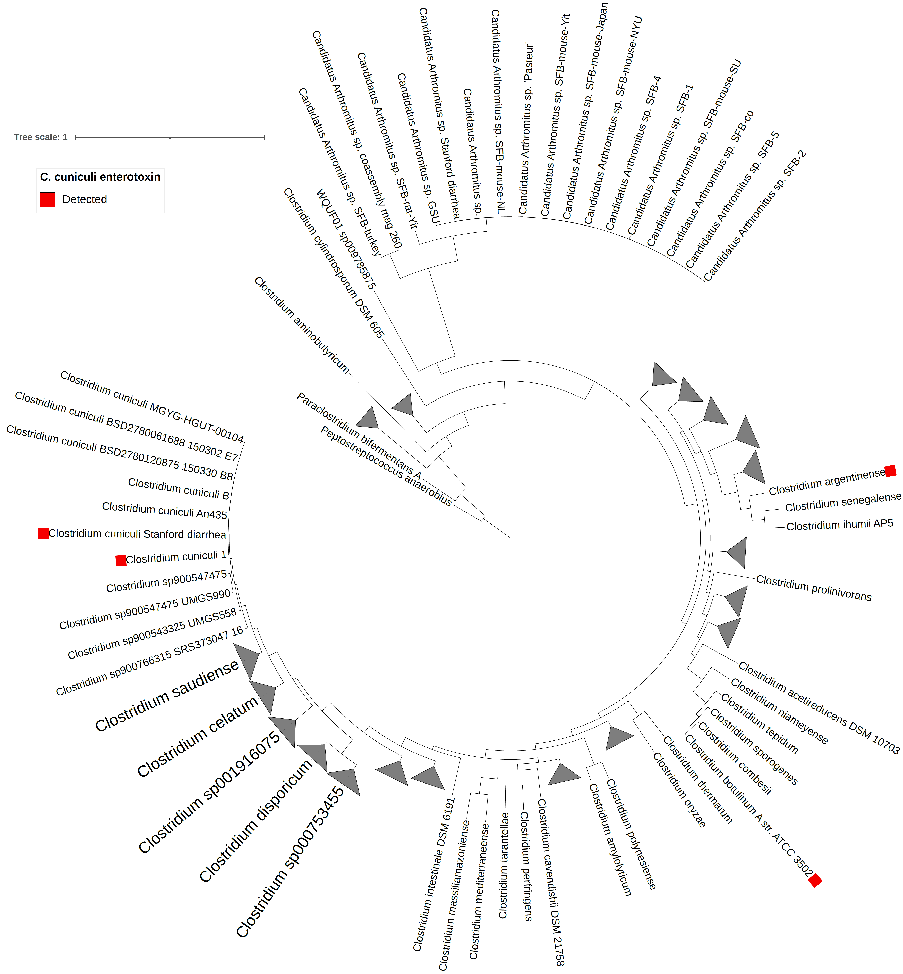
A total of 176 genomes belonging to the Clostridiaceae family were analyzed using GToTree to identify and align 119 genes common to bacteria in the Firmicutes phylum. A red box marks genomes containing the enterotoxin gene found in the C. cuniculi genome bin from this study (DIAMOND blastp e-value <1e-10, target coverage >=50%).
Figure 3. Phylogenomic tree of Clostridiaceae bacteria
To determine whether the genomes analyzed in the phylogenomic tree maintain the ability to perform spores, we screened each of them against a list of 55 genes described previously as being strongly predictive of spore-forming capability (23, 24). When accounting for genome completeness estimates provided by the Genome Taxonomy Database (GTDB, https://gtdb.ecogenomic.org) (25) for the genomes in this tree, only P. anaerobius, a known non-spore-former, contained fewer than half of the 55 spore-forming-associated genes. The diarrhea-associated C. cuniculi and Dwaynesavagella sp. genome bins from this study contained 49 and 40 sporulation-associated genes, respectively.
To determine the prevalence of the C. cuniculi enterotoxin gene in the healthy mouse gut, we ran DIAMOND blastp against all proteins in the 26,640 genomes from the MGBC, finding no hits which shared >50% coverage. Similarly, we ran DIAMOND blastp against the UHGP-95 (5), which is a gene catalog from nearly 300,000 gut genomes dereplicated at 95% average amino acid identity (AAI), and only found significant hits belonging to C. botulinum. Given the uncommon nature of this enterotoxin gene in the gut, we designed PCR primers against this toxin gene and screened for specificity using NCBI PrimerBlast (26) (Table 3-1). Together with primers previously reported to specifically target Dwaynesavagella spp. (27), and following validation in known healthy and know diseased mice, these primers could potentially be used to screen the mouse colony for latent infection.
Table 1. PCR primers to detect diarrhea-associated bacteria
Target | Forward primer | Reverse primer
C. cuniculi enterotoxin | 5'- CAGGCACAGAATATAAAATCGCA -3' | 5'- TCTTAGTGTTGGAGAGGAGAAGT -3'
Dwaynesavagella 16S rRNA | 5′-GACGCTGAGGCATGAGAGCAT-3’ | 5’-GACGGCACGGATTGTTATTCA-3′

Discussion
There are several reasons why immunodeficient mice might develop diarrhea. Aside from the primary hypothesis here of one or more specific transmittable causative agents, it also remains possible that a consortium of microbes act together to cause the intestinal pathology and intermittent diarrhea described in this study. Given limitations in sequencing depth, it also remains possible that microbes which were not identified here play a role.
However, we believe it likely that C. cuniculi, given its previous association with a rabbit disease, together with the enterotoxin both genomes harbor plays more of a causal role. The Clostridium perfringens enterotoxin causes food poisoning symptoms by cleaving gut endothelial cell tight junctions (19, 20), and it remains possible that the C. cuniculi enterotoxin does the same in mice and rabbits.
The fact that two distinct microbiomes with no overlapping strains develop the same disease following exposure to stool from diarrheic mice through gavage and co-housing suggests pathogenic, and not strictly dysbiotic behavior. Follow-up experiments to isolate C. cuniculi and challenge NSG mice with it alone would be helpful to determine whether it is sufficient to recapitulate the diarrhea alone. In the previous study involving rabbits, researchers were unable to recapitulate the diarrhea disease by exposing healthy rabbits to isolated C. cuniculi alone (11).
Metagenomics alone is unable to determine the contribution of the nine Muribaculaceae and Rikenellaceae associated with diarrhea towards disease pathology, and it remains possible that C. cuniculi alone is necessary, but not sufficient to induce disease symptoms. Of the 11 diarrhea-associated genomes identified, only the C. cuniculi and Dwaynesavagella are capable of forming spores. An additional follow-up experiment could remove all vegetative cells from stool of diarrheic mice by treating with chloroform or ethanol, and then delivering surviving spores to NSG mice via oral gavage Metagenome sequencing of treated vs healthy mouse stool compared with the gavaged sample would shed light on whether surviving spore-forming bacteria can colonize or induce diarrheal disease in NSG mice.
The role of Dwaynesavagella remains uncertain. In a previous study, immunodeficient Rag1-KO mice mono-colonized with Dwaynesavagella are healthy when unperturbed, and are even protected from viral diarrhea caused by rotavirus (27). However, given close proximity of Dwaynesavagella to gut epithelial cells and the previously reported association with Dwaynesavagella and diarrhea (4), it remains possible that C. cuniculi and Dwaynesavagella, potentially with other species, act together to cause diarrhea in NSG mice.

Conclusion
The results of this study share many similarities with the previous outbreak of infectious diarrhea in NGS mouse facilities. Improved metagenome databases for the murine gut microbiota augmented with study-specific genome bins, together with strain-resolved genomics showed a marked improvement over previous studies in identifying microbes associated with the diarrhea. Experiments building on this work will be better able to identify a causal role for C. cuniculi and Dwaynesavagella sp. in diarrhea of immunodeficient mice. The genome sequences made available will allow Stanford and other mouse facilities to screen for C. cuniculi infection. Finally, these methods represent another tool to improve animal husbandry.

Materials and Methods

Experimental infection (gavage)
A homogenate was prepared from the entire small and large intestines of NSG mice reared at Stanford with symptomatic diarrhea. Intestines were removed, homogenized by bead beating in sterile saline, and centrifuged at room temperature in a microcentrifuge at low rcf (5000 rcf, 2 min) to pellet large particles. Supernatant was removed to a 15 ml tube and the homogenization and centrifugation were repeated an additional 2 times. Half of the resulting supernatant was stored (“unfiltered homogenate”), while the rest was recentrifuged at high rcf (16,800 rcf, 5 min) to remove additional particulates then filtered through a 0.2 um syringe filter ("filtered homogenate").
NSG mice (n=9) were purchased as a cohort from Jackson Laboratories (Sacramento, CA). Mice were kept for a few days in the barrier, then moved to an experimental room in RAF. Mice were housed under identical conditions in 3 cages (cages 1, 2, 3) at 1M+2F / cage. Mice in cage 1 were not manipulated and served as controls. Mice in cages 2 and 3 were gavaged with 0.1 mL of filtered or unfiltered intestinal homogenate from a diarrheic mouse once a day for 3 days (0.3 mL total per mouse, see Figure 1). Fecal pellets were obtained for metagenomic sequencing x and (x+25) days after gavage.

Experimental infection (co-housing)
Two groups of four littermates each were co-housed after breeding and weaning at the Stanford mouse facility. For each group, two mice remained in the original cage, while two mice were co-housed with different diarrheic mice. After x days, fecal pellets were obtained for shotgun metagenome sequencing.

Metagenome sequencing, assembly, and genome binning
Fecal pellets for 26 samples were sent to Transnetyx for DNA extraction, library preparation, and 2x150bp sequencing (NovaSeq 6000) at an average depth of 2.7 Gbp per sample. Reads processed using bbmap v38.96 (28) by removing exact duplicates (clumpify), quality trimming (bbduk), and removing host reads (bbmap) as described previously.
Co-assembly of metagenomes from similar mice was used to maximize input data amount while minimizing added complexity and to provide many opportunities for genome bins to be identified that many only assemble in a given sample group. Specifically, surviving reads were grouped into 20 unique combinations by same-mouse (n=9), same-cage (n=7), or +/- diarrhea (n=4) (see Supplemental Tables S2) , and each group was co-assembled using metaSPAdes v3.15.4 (29).
Reads from each sample contributing to a given co-assembly were mapped onto assembled contigs >=1500bp using bowtie2 (v2.4.4) (30). Genome binning was performed on each group using MetaBAT v2.15 (31), and bin quality of the resulting 1,765 genomes was evaluated using CheckM (v1.1.3) (32) and scored using the following formula: Completeness-(5*Contamination)+(0.5*log10(N50))+log10(Length). All genome bins were grouped into species-level groups at 95% ANI (33) using dRep v2.6.2 (8) (cluster -ms 100000 -sa 0.95) and the highest-scoring bin in each species-level group was chosen as the representative. We identified 246 representative genome bins with >=50% completeness and <10% contamination.

Identification and classification of novel species
High-quality genomes (n=26,640) from the Mouse Gastrointestinal Bacterial Catalogue (MGBC) (6) were used as a reference database to identify which member had the highest average nucleotide identity (ANI) relative to each of the 246 genomes binned from this study using MASH v2.3 (9) (mash sketch -k 21 -s 10000). Of these, 41 of 246 genomes shared a MASH distance >0.05 (ANI < 0.95) with the most similar MGBC genome and were subsequently treated as novel species relative to the MGBC. Taxonomic classification for the 1,094 MGBC representatives and 41 additional genome bins was performed using GTDB-TK v1.7.0 (10) against the r202 database.

Reference database construction and read mapping
Complete genome sequences for all 1,135 mouse gut reference genomes were indexed using bowtie2-build (v2.4.4) (30). All 26 individual samples, as well as combined reads representing each of the 20 co-assemblies were mapped using bowtie2 (30) (v2.4.4, default parameters) onto this index. Additionally, individual samples were mapped onto MGBC genomes only (n=1,094) to establish a baseline read-mapping rate. All other analyses were performed using the larger index. CoverM (https://github.com/wwood/CoverM) (v0.6.1; genome -m mean trimmed_mean covered_bases length count --min-covered-fraction 0) was used to quantify genome breadth (percent of bases in a genome covered by >=1 read) and coverage in each single and combined sample. There were 446 genomes with at least 25% breadth in >=1 single or combined sample. These were kept for subsequent analysis, while the rest were assumed to be absent in these samples.
CoverM trimmed-coverage values for these genomes were multiplied by 1e4 to convert to counts-like data. A phylogenomic tree was built for these genomes (plus Cloacibacillus evryensis as an outgroup) using GToTree v1.6.34 (12-18) (-H Bacteria -T IQ-TREE -G 0.3 -B). Counts data, taxonomy data, sample data, and the tree were combined into a single phyloseq (v1.36.0) (34) object (provided as Supplemental Data File 1) for analysis in R (v4.1.2).

Compositional analysis
Taxa present in fewer than 4 samples were removed from future analysis, and counts were converted to relative abundance. Unweighted UniFrac sample-to-sample distance was computed prior to ordination using non-metric multidimensional scaling (NMDS).

Strain-level analysis
inStrain (v1.5.7; profile --min_read_ani 0.92 --skip_mm_profiling) was used to profile read-mapping data against the 1,135 reference genomes for each individual sample. Strain sharing events between individual samples, defined as two samples sharing >=10% of a given genome at >5x coverage and 99.999% ANI, were identified using the compare function of inStrain (--database_mode --breadth 0.25).
For each sample, we first identified the number of species that met the breadth and depth threshold to allow strain-level profiling. Next, we identified the percentage of those species exhibiting strain sharing with each other sample.

Statistical analysis
Two-sided Wilcoxon tests (with holm p-value adjustment) were performed to compare the change in abundance for all taxonomic levels (phylum through species) between mice with and without diarrhea.

Phylogenomic tree of Clostridiaceae genomes
We gathered all genomes available in NCBI GenBank (as of May 2022) belonging to the species Clostridium cuniculi or closely related species (including C. saudiense, C. celatum, and C. disporicum. We also gathered all available Candidatus Arthromitus / SFB / Dwaynesavagella sp. genomes, which lack any other closely related species. Finally, we identified 122 species-level representatives in the genus Clostridium. These 174 publicly available genomes, in addition to the Dwaynesavagella sp. and Clostridium cuniculi genome bins from this study were analyzed using GToTree v1.6.34 (-H Firmicutes -G 0.1) (12-18). Briefly, GToTree identified 119 Firmicutes-specific marker genes in each genome, aligned each each marker gene, and ran FastTree on a concatenated alignment of all marker genes. Peptostreptococcus anaerobius was selected as an outgroup. The resulting tree was visualized using iToL v4 (35).

Identifying sporulation-associated genes in Clostridiaceae genomes
We extracted 55 genes from Bacillus subtilis 168 and Clostridioides difficile that were previously described as being highly predictive of spore-forming capability (23, 24). We used DIAMOND (22) to determine the presence of each of these genes in the 176 Clostridiaceae genomes described above.

Identification of enterotoxin genes in Clostridiaceae genomes
We used hmmsearch (14) to screen the Dwaynesavagella sp. and Clostridium cuniculi genome bins from this study for proteins that matched PF03505, the entry in the Pfam database (21) representing Clostridium enterotoxin which is present in C. perfringens, C. botulinum, and other Clostridiaceae.

PCR primer design
NCBI Primer Blast was used to identify primers specific to the in the enterotoxin gene from C. cuniculi in the broader context of the NCBI nr database. To further ensure specificity in context of the mouse gut microbiome, we used DIAMOND (22) to search for genes related to the C. cuniculi enterotoxin in all 26,440 genomes in the MGBC (6), returning no hits.

Acknowledgements

Funding

Author contributions

Competing interests

Data and materials availability

Supplemental Information

Supplemental Figures
a. Volcano plot showing enrichment of bacteria in diarrhea (effect size >0) or healthy (effect size <0) mice, by taxonomic level (phylum through species). The horizontal line represents an adjusted p-value of 0.05. Each plotted point in the “phylum” sub-plot represents a phylum, each point in the “class” sub-plot represents a class, etc. Raw data can be found in Supplemental Table S6.
b. Volcano plot showing enrichment of bacterial species in diarrhea (effect size >0) or healthy (effect size <0) mice, colored and grouped into sub-plots by the phylum where each species resides. Each plotted point represents one species in each sub-plot. Raw data can be found in Supplemental Table S6.
Figure S1. Enrichment of bacteria by taxonomy in mice with diarrhea

Supplemental Tables
The supplemental tables for this manuscript are of a size that is not amenable for publishing in this format. Please see a description of these tables below, and refer to ___ to access them.
Table S1. Mouse stool sample metadata, including sequencing depth.
Table S2. Grouping of mouse metagenomes for co-assembly.
Table S3. Metadata for species-level representatives binned from co-assembled mouse metagenomes from this study.
Table S4: Taxonomic classification using GTDB r202 for 1,135 species-level representative genomes used to recruit mouse reads in this study.
Table S5: Strain-sharing events detected by inStrain.
Table S6: Summary from Wilcoxon test containing p-values and effect sizes for taxa abundance between healthy and diarrheic mice.
Table S7: List of genomes included in phylogenomic tree.

Supplemental Data
Data S1. A phyloseq object containing sample metadata, counts data, and taxonomic information for this study.

References
1. L. D. Shultz et al., Human lymphoid and myeloid cell development in NOD/LtSz-scid IL2R gamma null mice engrafted with mobilized human hemopoietic stem cells. Journal of immunology (Baltimore, Md. : 1950) 174, 6477-6489 (2005).
2. F. Ishikawa et al., Development of functional human blood and immune systems in NOD/SCID/IL2 receptor {gamma} chain(null) mice. Blood 106, 1565-1573 (2005).
3. Y. Choi et al., Studying cancer immunotherapy using patient-derived xenografts (PDXs) in humanized mice. Experimental & Molecular Medicine 50, 1-9 (2018).
4. A. M. Misic et al., Culture-independent Profiling of the Fecal Microbiome to Identify Microbial Species Associated with a Diarrheal Outbreak in Immunocompromised Mice. Comparative medicine 68, 261-268 (2018).
5. A. Almeida et al., A unified catalog of 204,938 reference genomes from the human gut microbiome. Nature Biotechnology, (2020).
6. B. S. Beresford-Jones et al., The Mouse Gastrointestinal Bacteria Catalogue enables translation between the mouse and human gut microbiotas via functional mapping. Cell Host & Microbe 30, 124-138.e128 (2022).
7. M. R. Olm et al., inStrain profiles population microdiversity from metagenomic data and sensitively detects shared microbial strains. Nat Biotechnol 39, 727-736 (2021).
8. M. R. Olm, C. T. Brown, B. Brooks, J. F. Banfield, dRep: a tool for fast and accurate genomic comparisons that enables improved genome recovery from metagenomes through de-replication. Isme j 11, 2864-2868 (2017).
9. B. D. Ondov et al., Mash: fast genome and metagenome distance estimation using MinHash. Genome Biol. 17, 132 (2016).
10. P.-A. Chaumeil, A. J. Mussig, P. Hugenholtz, D. H. Parks, GTDB-Tk: a toolkit to classify genomes with the Genome Taxonomy Database. Bioinformatics 36, 1925-1927 (2019).
11. A. Djukovic et al., Gut colonization by a novel Clostridium species is associated with the onset of epizootic rabbit enteropathy. Vet Res 49, 123-123 (2018).
12. D. Hyatt et al., Prodigal: prokaryotic gene recognition and translation initiation site identification. BMC Bioinformatics 11, 119 (2010).
13. M. D. Lee, GToTree: a user-friendly workflow for phylogenomics. Bioinformatics 35, 4162-4164 (2019).
14. S. R. Eddy, Accelerated Profile HMM Searches. PLoS Comput Biol 7, e1002195 (2011).
15. R. C. Edgar, MUSCLE v5 enables improved estimates of phylogenetic tree confidence by ensemble bootstrapping. bioRxiv, 2021.2006.2020.449169 (2021).
16. S. Capella-Gutiérrez, J. M. Silla-Martínez, T. Gabaldón, trimAl: a tool for automated alignment trimming in large-scale phylogenetic analyses. Bioinformatics 25, 1972-1973 (2009).
17. O. Tange, GNU Parallel: The Command-Line Power Tool. login Usenix Mag. 36, (2011).
18. B. Q. Minh et al., IQ-TREE 2: New Models and Efficient Methods for Phylogenetic Inference in the Genomic Era. Molecular Biology and Evolution 37, 1530-1534 (2020).
19. J. C. Freedman, A. Shrestha, B. A. McClane, Clostridium perfringens Enterotoxin: Action, Genetics, and Translational Applications. Toxins 8, (2016).
20. J. Katahira, N. Inoue, Y. Horiguchi, M. Matsuda, N. Sugimoto, Molecular cloning and functional characterization of the receptor for Clostridium perfringens enterotoxin. The Journal of cell biology 136, 1239-1247 (1997).
21. J. Mistry et al., Pfam: The protein families database in 2021. Nucleic acids research 49, D412-D419 (2021).
22. B. Buchfink, C. Xie, D. H. Huson, Fast and sensitive protein alignment using DIAMOND. Nat Meth 12, 59-60 (2015).
23. H. P. Browne et al., Host adaptation in gut Firmicutes is associated with sporulation loss and altered transmission cycle. Genome Biol. 22, 204 (2021).
24. H. P. Browne et al., Culturing of ‘unculturable’ human microbiota reveals novel taxa and extensive sporulation. Nature 533, 543-546 (2016).
25. D. H. Parks et al., Selection of representative genomes for 24,706 bacterial and archaeal species clusters provide a complete genome-based taxonomy. bioRxiv, 771964 (2019).
26. J. Ye et al., Primer-BLAST: a tool to design target-specific primers for polymerase chain reaction. BMC bioinformatics 13, 1-11 (2012).
27. Z. Shi et al., Segmented Filamentous Bacteria Prevent and Cure Rotavirus Infection. Cell 179, 644-658.e613 (2019).
28. B. Bushnell, in BBTools Software Package. (http://sourceforge.net/projects/bbmap/, 2014).
29. S. Nurk, D. Meleshko, A. Korobeynikov, P. A. Pevzner, metaSPAdes: a new versatile metagenomic assembler. Genome Research 27, 824-834 (2017).
30. B. Langmead, S. L. Salzberg, Fast gapped-read alignment with Bowtie 2. Nature methods 9, 357-359 (2012).
31. D. Kang et al., MetaBAT 2: an adaptive binning algorithm for robust and efficient genome reconstruction from metagenome assemblies. PeerJ Preprints 7, e27522v27521 (2019).
32. D. H. Parks, M. Imelfort, C. T. Skennerton, P. Hugenholtz, G. W. Tyson, CheckM: assessing the quality of microbial genomes recovered from isolates, single cells, and metagenomes. Genome Research 25, 1043-1055 (2015).
33. M. R. Olm et al., Consistent Metagenome-Derived Metrics Verify and Delineate Bacterial Species Boundaries. mSystems 5, e00731-00719 (2020).
34. P. J. McMurdie, S. Holmes, phyloseq: An R Package for Reproducible Interactive Analysis and Graphics of Microbiome Census Data. PLoS One 8, e61217 (2013).
35. I. Letunic, P. Bork, Interactive Tree Of Life (iTOL) v4: recent updates and new developments. Nucleic Acids Research 47, W256-W259 (2019).

