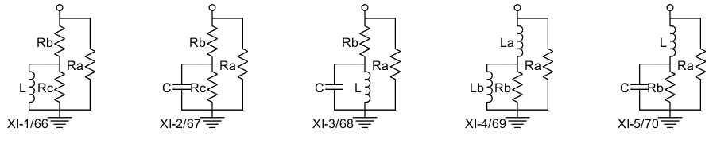

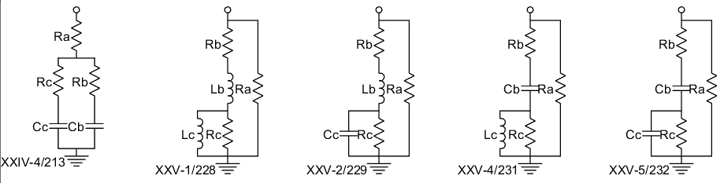

MATLAB code that generates this census:

function theCompIdList = Census(theCat)

% CompList = CRCat.Census Do a census of components meeting the

% criteria coded below. CompIdList is an array of all the component

% Id's (i.e., indices in Cat.list) that are found in the census.

% jcr21Apr2023

% Build and print out a list of all components that have one or

% two L or C elements. Display their schematics. List

% equivalent components. jcr21Apr2023

% Find the comps that meet the criteria.

for aIndex = length(theCat.list) : -1 : 1

aComp = theCat.list(aIndex); % Component to be checked.

aVstr = string( aComp.symVn ); % Symbolic variable names for the component, convert to string.

aNumLC = sum( strncmp(aVstr,"L",1) ) + sum( strncmp(aVstr,"C",1) );

aCompLogical(aIndex) = ( aNumLC == 1 || aNumLC == 2 ); % This is the criteria.

end % for aIndex

% Get the Id's, i.e., indices of the qualifying components.

theCompIdList = find( aCompLogical );

% List out the name of each component, its variable list, and

% equivalent components.

for aCompId = theCompIdList

fprintf( '%11s ',theCat.Id2Name(aCompId) );

% fprintf('%s',string( theCat.list(aCompId).symVn )); % This prints out each entire variable name.

aStr = string( theCat.list(aCompId).symVn );

for aIndex=1:length(aStr)

fprintf( '%c',aStr{aIndex}(1) ); % This prints out only the first letter of each variable name.

end % for aIndex

aConv = theCat.Same( aCompId );

if ~isempty( aConv.fewer )

for aId = aConv.fewer

if aId ~= aConv.fromId

fprintf( ' %s',theCat.Id2Name(aId) );

end % if aId

end % for aId

fprintf(' (Component is degenerate)');

elseif ~isempty( aConv.equal )

for aId = aConv.equal

if aId ~= aConv.fromId

fprintf( ' %s',theCat.Id2Name(aId) );

end % if aId

end % for aId

end % if length

fprintf('\n');

end % for aComp

% Draw component schematics, in groups of 10.

for aIndex = 1 : 10 : length(theCompIdList)

theCat.DrawArray( theCompIdList(aIndex:end) );

input('='); % Wait for user to input something before doing the next plot.

end % for aIndex

end % CRCat.Census