**Lab 3 – Requirements**

**A.** Given data in the **crudeoil_prod.csv**, please complete the following tasks.

1. Import data in .csv file to crudeoil_prod_input data frame in R



1. Create a time series object and then store in crudeoild_prod



1. Examine the time series



1. Examine the time series with **ylab** = "Crude Oil production (millions of barrels) and then show chart for Monthly crude oi lproduction



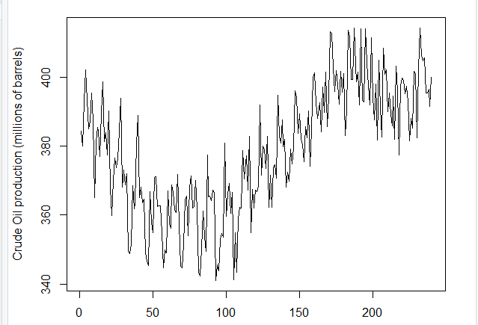

1. Using the diff() function to show *Differenced crude oild production time series*



1. Using R to plot
   1. *ACF of the differenced crude oild time series*



* 1. *PACF of the differenced crude oild time series*



1. Use arima() function in R to fit a (0,1,0) × (1,0,0)12 model applied to the original time series variable, *crudeoild_prod*. The differencing, d = 1, is specified by the order = c(0,1,0) term

1. Examine the residuals from fitting the (0,1,0) × (1,0,0)12 ARIMA model and then show the ACF and PACF plots of the residuals
   1. *ACF of residuals from seasonal AR(1) model*



* 1. *PACF of residuals from seasonal AR(1) model*



**B. The result report must be included in a document which has:**

- All necessary commands used to do task

- And output screen of command result