

SOFTWARE ARCHITECTURE AND DESIGN

REPORT 1

Project Overview and
Software Requirement Specification

– Hanoi, Sep 2026 –
Table of Contents
I. Project Overview 4
1.1. Project Information 4
1.2. Project Team 4
1.3. Product Background 4
1.4. Major Features 4
1.5. Tools & Infrastructures 6
II. Software Requirement Specification 6
1. Overall Requirement 6
1.1 Context Diagram 6
1.2 Main Workflows 7
1.3. User Requirements 8
1.4 System Functionalities 9
1.5 Entity Relationship Diagram 10
3. Use Case Specifications 10
3.1 <<Feature Name1>> 10
4. Non-Functional Requirements 11
4.1 External Interfaces 11
4.2 Quality Attributes 11
5. Requirement Appendix 11
5.1 Business Rules 12
5.2 Common Requirements 12
5.3 Application Messages List 12

Record of Changes
Date | A*  M, D | In charge | Change Description
*A - Added M - Modified D - Deleted

I. Project Overview

1.1. Project Information
- English name: Dermatology Hospital Booking and Medical Service Management System
- Vietnamese name: Hệ thống quản lý đặt lịch và dịch vụ y tế cho bệnh viện Da liễu
- Team name: SE1976-JS(AD) - Group 1
- Software type: Website

1.2. Project Team
StudentID | Full Name | Role | Email
HE190512 | Nguyễn Tuấn Nam | Leader | namnguyen170681@gmail.com
HE190862 | Nguyễn Hiếu Sơn | Member | nguyenhieuson6@gmail.com
HE181473 | Trương Khánh Đông | Member | dongtkhe181473@fpt.edu.vn
HE190123 | Hà Quốc Trung | Member | chishidotoji2k3@gmail.com

1.3. Product Background
Outpatient healthcare services involve multiple activities that must be coordinated throughout a patient’s visit, including appointment scheduling, patient reception, clinical examination, medical record management, medical service requests and results, and follow-up activities. These activities involve different hospital roles such as patients, receptionists, doctors, medical service staff, managers, and administrators. When these activities are managed through disconnected processes or systems, information may not be consistently available to the appropriate staff at the time it is needed, making it more difficult to coordinate patient care and monitor daily operations.
The need for a new system arises from the requirement to provide an integrated platform for managing outpatient appointments and medical services. Patients need a convenient way to register and manage appointments, access relevant medical information, and make payments for applicable services. Receptionists need to support appointment reception and patient check-in, while doctors need access to assigned patients and medical records, documentation of clinical encounters, and the ability to request medical services. Medical service staff need to manage service queues and record service results. Managers require information about staff schedules, appointments, operational performance, and patient feedback to support day-to-day management and reporting.
The proposed Hospital Appointment & Medical Service Management System is therefore intended to integrate these related activities into a single system. The system will support the coordination of outpatient appointments and reception, clinical records and encounters, medical service requests and results, staff scheduling and schedule-change requests, operational reporting, patient feedback, and service-related payments. The system is designed to provide each role with access to the functions and information relevant to its responsibilities while maintaining role-based access to protected information.
The project is proposed as a software solution for an outpatient hospital environment. The project idea is raised from the identified need to improve the coordination and management of outpatient appointment and medical service processes. The primary stakeholders involved in defining the requirements are patients, receptionists, doctors, medical service staff, managers, and system administrators, who represent the main user groups and operational stakeholders of the proposed system.

1.4. Major Features
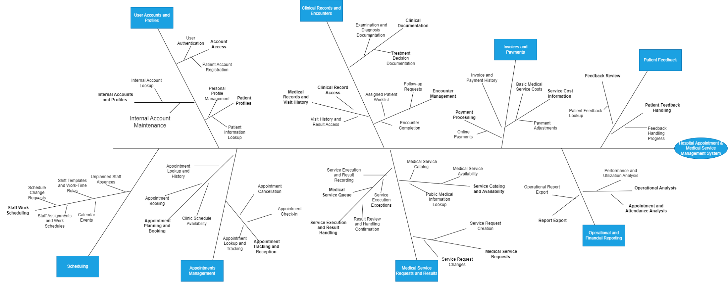

Fig1. Feature tree

Index | Major Feature | Description and Distinguishing Value
F01 | User Accounts and Profiles | Supports patient registration, sign-in, internal staff accounts, patient information, and doctor profiles. Access to information is controlled according to the user’s role.
F02 | Appointments and Patient Reception | Supports doctor schedule viewing, appointment booking, walk-in registration, appointment changes, cancellation, patient check-in, and clinic queue management. It combines appointment administration with front-desk reception activities.
F03 | Clinical Records and Encounters | Supports assigned patient worklists, medical record access, clinical examination documentation, diagnosis recording, treatment decisions, patient handoff acceptance, follow-up requests, and encounter completion.
F04 | Medical Service Requests and Results | Supports the complete service-request lifecycle: Ordered → Accepted → In Progress → Completed. It also supports service execution tracking, result recording, attachments, result correction, and doctor result review.
F05 | Invoices and Payments | Provides a reserved feature area for viewing basic medical service cost or payment-related information. The exact scope of invoices, payments, and adjustments requires further confirmation.
F06 | Patient Feedback | Supports manager access to patient feedback, priority flagging for low-rated feedback, and recording the progress of feedback handling without changing the original feedback content.
F07 | Operational and Financial Reporting | Supports operational dashboards, appointment reports, cancellation and no-show reports, doctor utilization, medical service performance reports, and PDF report export.

1.5. Tools & Infrastructures

Category | Tools / Infrastructure
Technology | React 18 (FrontEnd), Java Spring (BackEnd)
Database | My SQL, Redis
API | Restful API, WebSocket
IDEs/Editors | Visual Studio Code, Inteliji
Diagramming | Visual paradigm
Documentation | Google Docs/Sheets/Slides
Version Control | Git
Deployment server | AWS, Docker
Test tool | Postman, Swagger
Project management | GitLab (Tasks, Defects), Excel, Jira

II. Software Requirement Specification

1. Overall Requirement
The Hospital Appointment & Medical Service Management System is a software system designed to support outpatient appointment and medical service processes within a hospital. The system provides a common platform for managing patient appointments, patient reception, clinical records and encounters, medical service requests and results, staff schedules, operational reporting, patient feedback, and service-related payments.
The context diagram below illustrates the system boundary, the external actors interacting with the system, and the main information exchanged between the system and its external entities. The primary external actors are Patient, Receptionist, Doctor, Medical Service Staff, Manager, and Admin. The system also interacts with a VNPay Payment Service to process patient payments and SMTP Gmail Service to send notification to patient and hospital staff.
The system is intended to support the coordination of outpatient activities while providing role-based access to relevant information and functions. The context diagram represents the overall system context and does not describe the detailed internal processes or workflows of individual use cases.
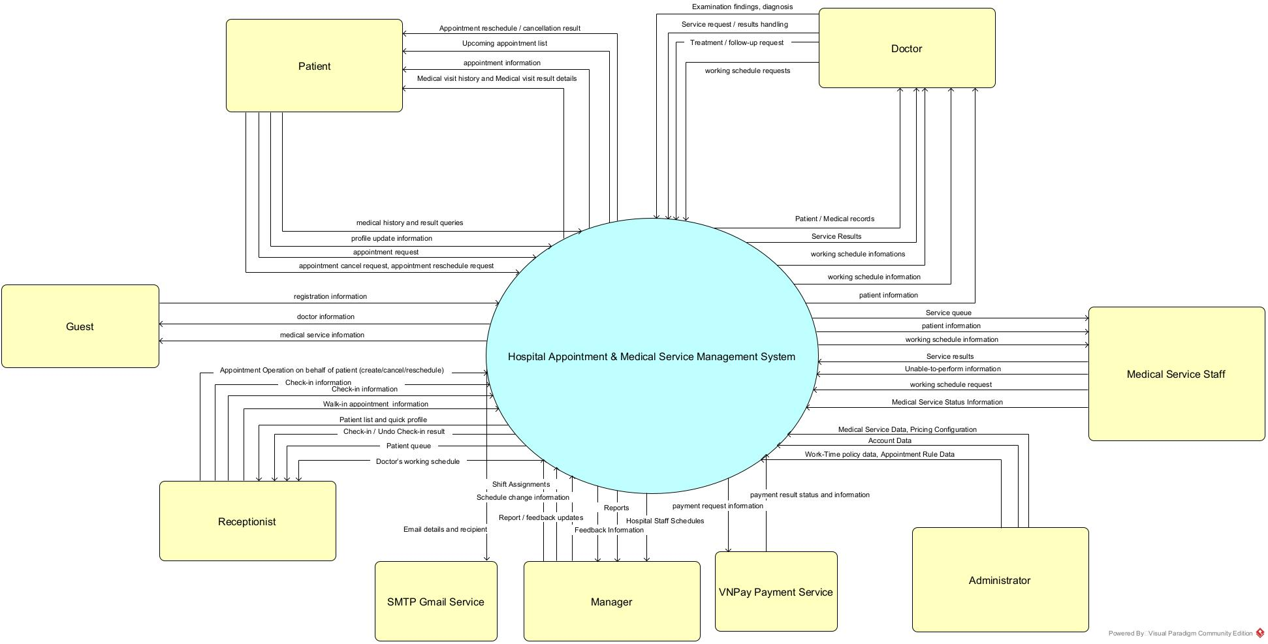

1.2 Main Workflows

1.2.1 Appointment Booking

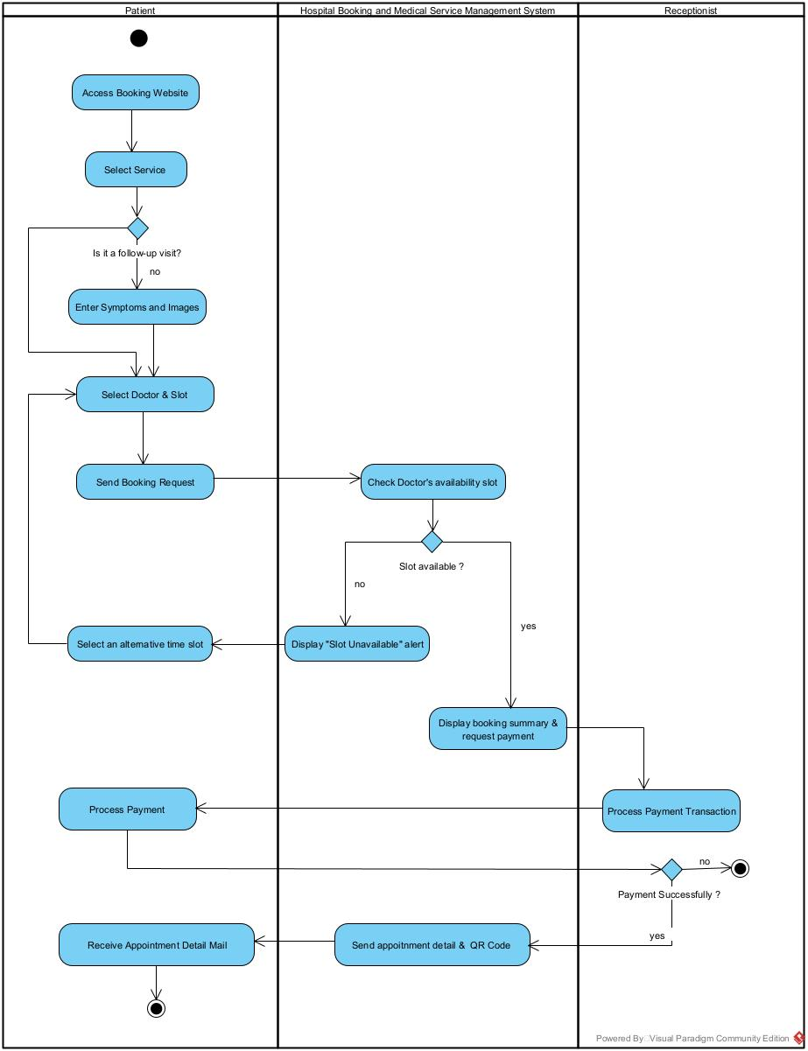

1.2.2 Appointment Processing
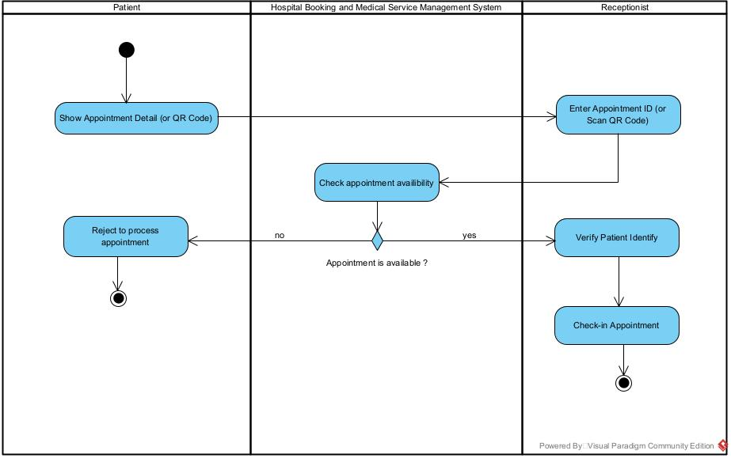

1.2.3 Clinical Examination and Medical Service Delivery
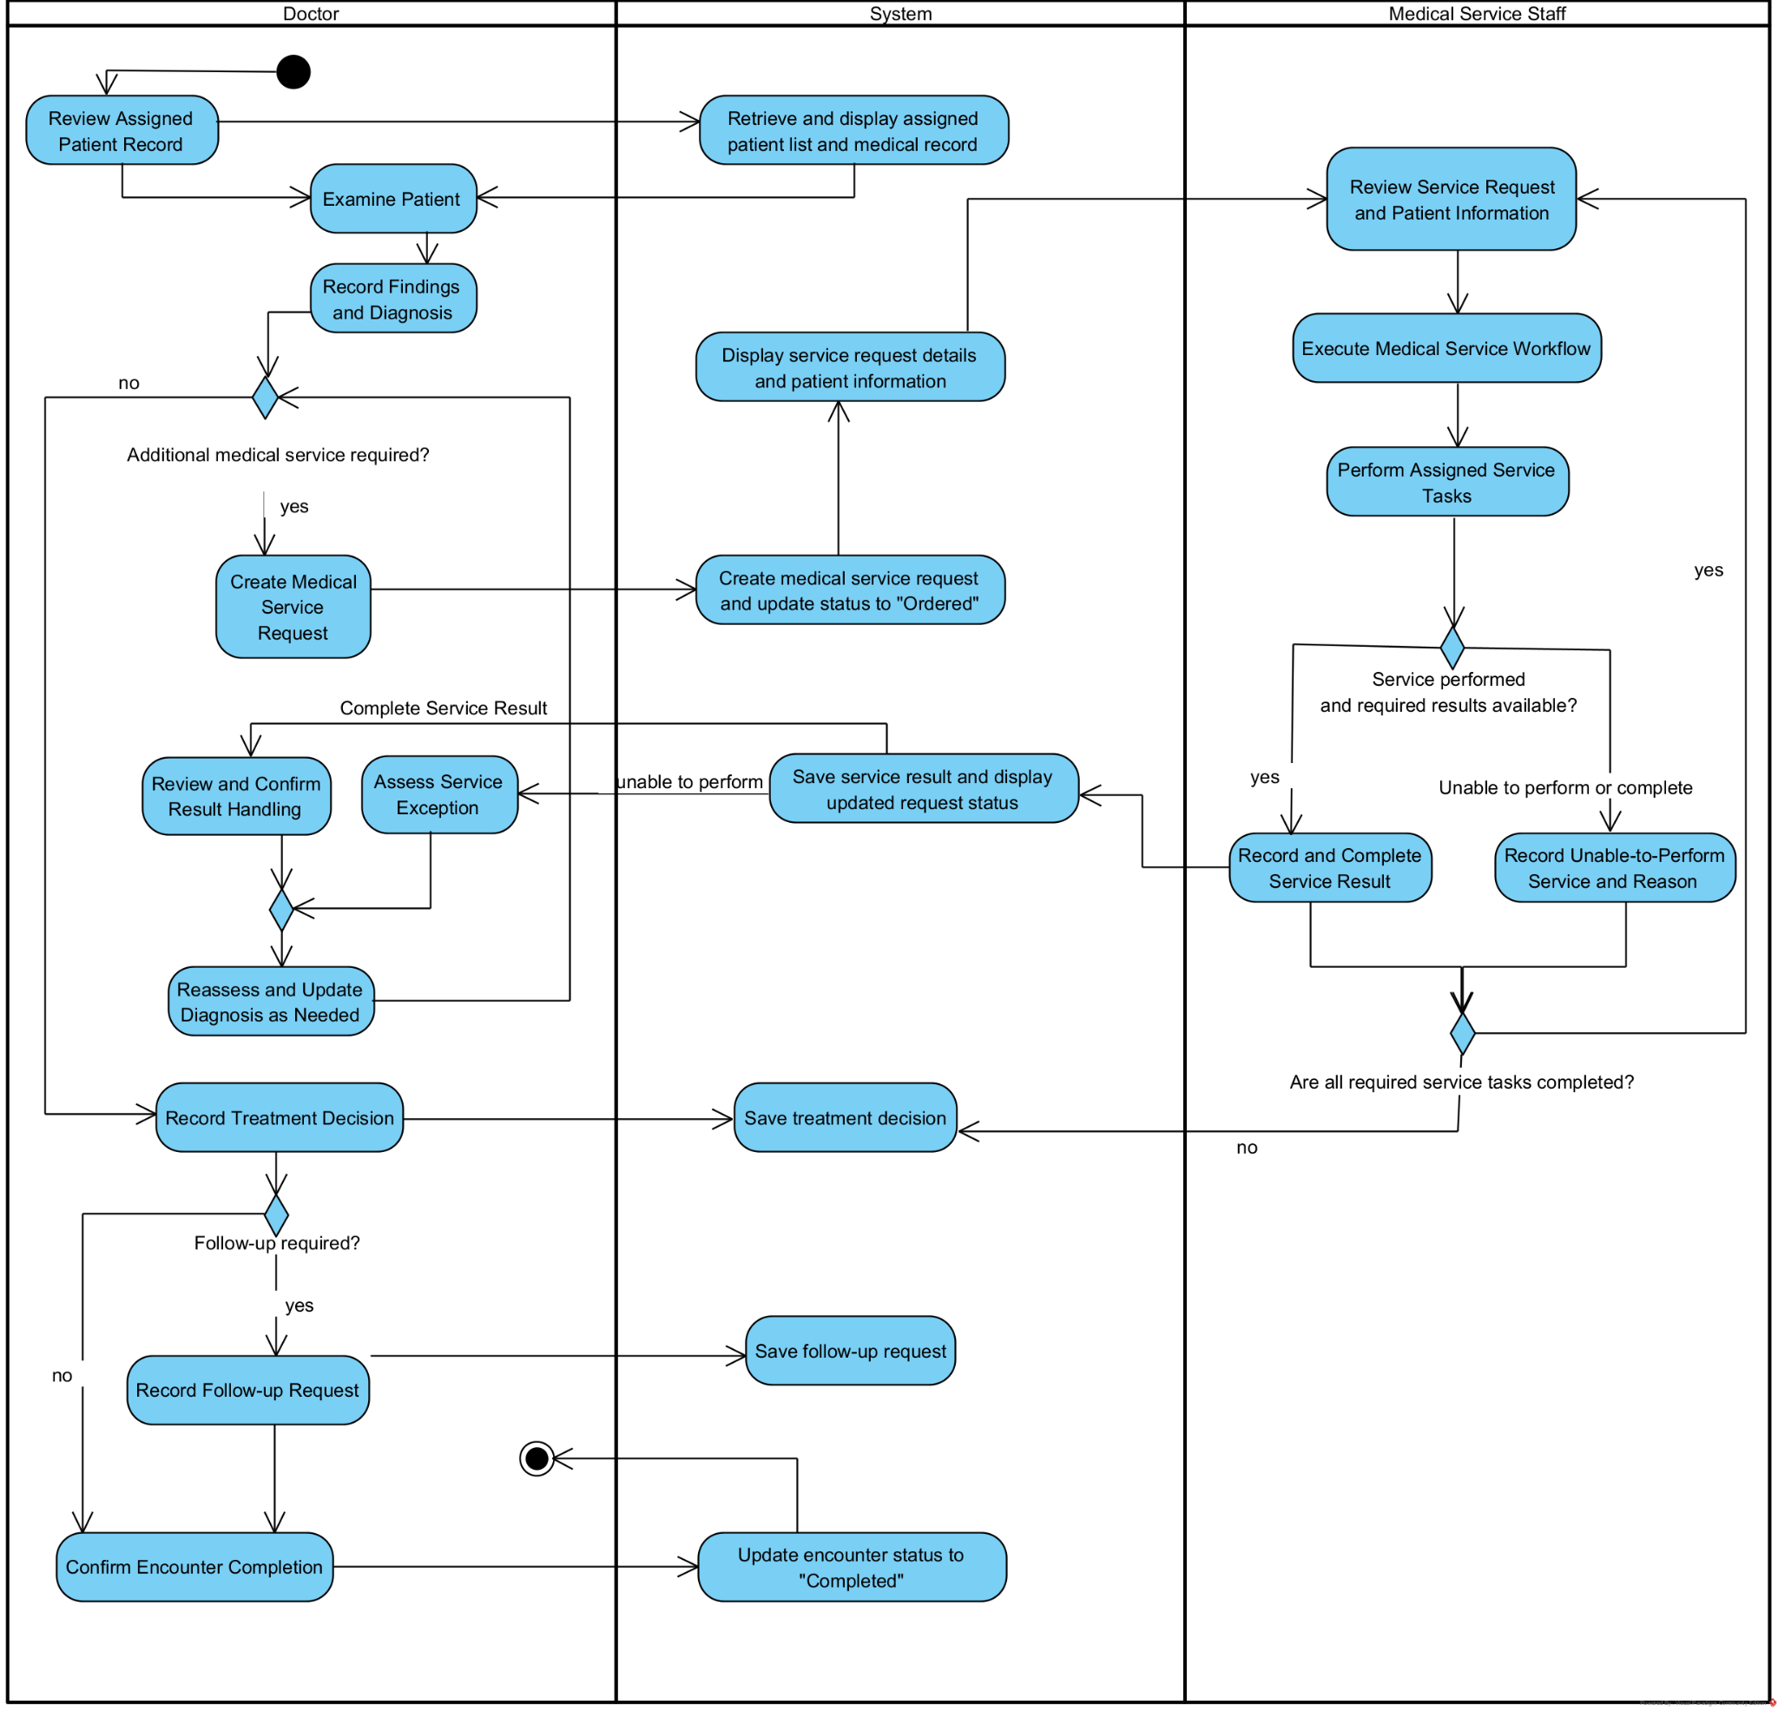

1.3. User Requirements

1.3.1 Actors
ID | Use Case | Feature
1 | Guest | A visitor who accesses public medical information, registers a patient account.
2 | Patient | A registered patient who manages personal information, appointments, visit history, and permitted medical results.
3 | Receptionist | A staff member who supports appointment handling, patient check-in, and clinic queue operations.
4 | Doctor | A physician who examines assigned patients, records clinical information, orders services, reviews results, and completes encounters.
5 | Medical Service Staff | A staff member who receives service requests, performs assigned services, records results, and updates service status.
6 | Admin | An administrator who manages internal accounts, doctor profiles, schedules, appointments, and permitted patient information.
7 | Manager | A manager who monitors operations, queues, doctor utilization, reports, and report exports.

1.3.2 Use Case List (UC)
ID | Use Case | Feature | Use Case Description
01 | Sign In | User Accounts and Profiles | User provides valid credentials to access the system according to the assigned role.
02 | Register Patient Account | User Accounts and Profiles | Guest provides required registration information and creates a patient account.
03 | View Personal Profile | User Accounts and Profiles | User views their personal profile and account information.
04 | Update Personal Information | User Accounts and Profiles | User updates permitted personal information.
05 | View Patient List | User Accounts and Profiles | The receptionist views the list of patients available for reception activities.
06 | View Patient Information | User Accounts and Profiles | Authorized staff member views permitted patient information required for their work.
07 | View Internal Account List | User Accounts and Profiles | Admin views the list of internal staff accounts.
08 | View Internal Account Detail | User Accounts and Profiles | Admin views the details of a selected internal account.
09 | Create Internal Account | User Accounts and Profiles | Admin creates an internal staff account, including the relevant staff profile information required by the system.
10 | Update Internal Account | User Accounts and Profiles | Admin updates permitted internal account information or account status.
11 | View Doctor List | User Accounts and Profiles | Guest views the list of available doctors in the system.
12 | View Doctor Profile | User Accounts and Profiles | Guest views the detailed profile information of a selected doctor.
13 | Create New Patient Profile | User Accounts and Profiles | Receptionist creates a new patient profile with the required personal information.
14 | Update Patient Profile | User Accounts and Profiles | Receptionist updates permitted information of an existing patient profile.
15 | Cancel Appointment | Scheduling, Appointments and Reception | User selects an eligible appointment and cancels it.
16 | View Doctor Work Schedule | Scheduling, Appointments and Reception | User views available doctor work schedules for appointment-related purposes.
17 | View Upcoming Appointments | Scheduling, Appointments and Reception | Patient views their upcoming appointments and current statuses.
18 | View Appointment Details | Scheduling, Appointments and Reception | Patient views the date, time, doctor, and related information of an appointment.
19 | Create Walk-in Appointment | Scheduling, Appointments and Reception | Receptionist creates an appointment for a patient who arrives without a prior appointment.
20 | Check In Appointment | Scheduling, Appointments and Reception | Receptionist verifies an appointment and records the patient's check-in.
21 | Undo Check-in | Scheduling, Appointments and Reception | Receptionist reverses an incorrect check-in and updates the appointment status.
22 | View Personal Work Schedule | Scheduling, Appointments and Reception | Authorized staff member views their assigned work schedule.
23 | Submit Schedule Change Request | Scheduling, Appointments and Reception | Doctor or Medical Service Staff submits a request to change an assigned work schedule. The request must be submitted at least one week before the requested change date.
24 | View Doctor Appointments | Scheduling, Appointments and Reception | Manager views appointments assigned to a doctor for a selected period.
25 | Assign Staff to Weekly Shifts | Scheduling, Appointments and Reception | Manager assigns staff to shifts for a selected work week.
26 | Update Shift Assignment | Scheduling, Appointments and Reception | Manager changes an existing staff shift assignment after checking applicable scheduling constraints.
27 | View Master Work Schedule | Scheduling, Appointments and Reception | Manager views the overall staff work schedule by period, staff member, or role.
28 | Process Schedule Change Request | Scheduling, Appointments and Reception | Manager reviews and approves or rejects a submitted schedule change request.
29 | Add Schedule Event | Scheduling, Appointments and Reception | Admin adds a schedule event with the required scheduling information.
30 | View Shift Template List | Scheduling, Appointments and Reception | Admin views available shift templates.
31 | View Shift Template Detail | Scheduling, Appointments and Reception | Admin views the details of a selected shift template.
32 | Create Shift Template | Scheduling, Appointments and Reception | Admin creates a shift template with the required working-time information.
33 | Update Shift Template | Scheduling, Appointments and Reception | Admin updates an existing shift template.
34 | View Work-Time Policy | Scheduling, Appointments and Reception | Admin views the configured staff work-time policy.
35 | Update Work-Time Policy | Scheduling, Appointments and Reception | Admin updates the applicable work-time rules used for staff scheduling.
36 | View Appointment Rule List | Scheduling, Appointments and Reception | Admin views the appointment rules configured in the system.
37 | View Appointment Rule Detail | Scheduling, Appointments and Reception | Admin views the details of a selected appointment rule.
38 | Create Appointment Rule | Scheduling, Appointments and Reception | Admin creates an appointment rule defining how appointments can be scheduled or managed.
39 | Update Appointment Rule | Scheduling, Appointments and Reception | Admin updates an existing appointment rule.
40 | Booking Appointment | Scheduling, Appointments and Reception | Patient selects an available time slot and submits required information to book a new appointment.
41 | Reschedule Appointment | Scheduling, Appointments and Reception | Patient or Receptionist selects an existing appointment and changes its date/time to a new available slot.
42 | View Appointment List | Scheduling, Appointments and Reception | Receptionist views the list of appointments for reception and management activities.
43 | Create New Appointment | Scheduling, Appointments and Reception | Receptionist creates a new appointment for a patient from the appointment list.
44 | View Medical Visit History | Clinical Records and Encounters | Patient views their previous medical visits.
45 | View Medical Visit Result Details | Clinical Records and Encounters | Patient views the details of an available medical visit result.
46 | View Assigned Patient List | Clinical Records and Encounters | Doctor views the patients assigned to the doctor for the relevant clinical work period.
47 | View Medical Record | Clinical Records and Encounters | Doctor views the permitted medical record information of an assigned patient.
48 | Record Clinical Examination Findings | Clinical Records and Encounters | Doctor records clinical examination findings for the current encounter.
49 | Record and Update Diagnosis | Clinical Records and Encounters | Doctor records or updates the patient's diagnosis.
50 | Record Treatment Decision | Clinical Records and Encounters | Doctor records the treatment decision resulting from the examination and available results.
51 | Record Follow-up Request | Clinical Records and Encounters | Doctor records the need for a future follow-up or revisit.
52 | Complete Encounter | Clinical Records and Encounters | Doctor completes the current clinical encounter after required documentation is recorded.
53 | Create Medical Service Request | Medical Service Requests and Results | Doctor creates a medical service request for a patient and the patient is placed in the appropriate service queue.
54 | Edit Ordered Service Request | Medical Service Requests and Results | Doctor updates permitted information of an eligible ordered service request.
55 | Cancel Ordered Service Request | Medical Service Requests and Results | Doctor cancels an eligible ordered medical service request.
56 | Review and Confirm Service Result Handling | Medical Service Requests and Results | Doctor reviews a completed service result and records the appropriate clinical handling.
57 | View Medical Service Queue | Medical Service Requests and Results | Medical Service Staff views patients waiting for a medical service and selects the next eligible patient according to the queue.
58 | Record and Complete Service Result | Medical Service Requests and Results | Medical Service Staff records the performed service and its result and completes the service result.
59 | Record Unable-to-Perform Service | Medical Service Requests and Results | Medical Service Staff records that a requested service cannot be performed and provides the applicable reason.
60 | View Medical Service List | Medical Service Requests and Results | Admin views the list of medical services available in the system.
61 | View Medical Service Detail | Medical Service Requests and Results | Admin views the details of a selected medical service.
62 | Create Medical Service | Medical Service Requests and Results | Admin creates a medical service with the required information.
63 | Update Medical Service | Medical Service Requests and Results | Admin updates permitted medical service information or status.
64 | View Basic Medical Service Costs | Service Costs and Payments | Authorized user views the basic cost information associated with available medical services.
65 | Make Payment | Service Costs and Payments | Patient initiates payment for an outstanding charge through the third-party payment provider, and the system records the payment result.
66 | View Performance and Utilization Reports | Operational Reporting | Manager views workload, schedule utilization, and defined operational performance indicators.
67 | View Appointment and No-Show Reports | Operational Reporting | Manager views appointment, cancellation, and no-show information for a selected period.
68 | Export Operational Reports | Operational Reporting | Manager exports a selected operational report using the supported format.
69 | Create Appointment Feedback | Patient Feedback | Patient submits feedback related to a completed appointment.
70 | View Patient Feedback List | Patient Feedback | The manager views the list of patient feedback records.
71 | View Patient Feedback Detail | Patient Feedback | The manager views the details of a selected patient feedback record.
72 | Update Patient Feedback Handling Status | Patient Feedback | Manager updates the handling status or progress of patient feedback without changing its original content.
73 | Log Out | User Accounts and Profiles | The authenticated user logs out of the hospital management system and The system terminates the current authenticated session
74 | Forgot password | User Accounts and Profiles | The account holder requests a password reset when they cannot remember their current password

1.3.3 Use Case Diagrams

1.3.3.1 UCs for Guest
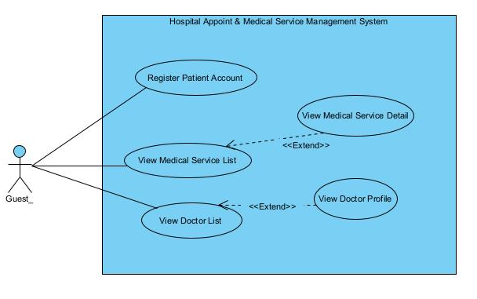

1.3.3.2 UCs for Patient
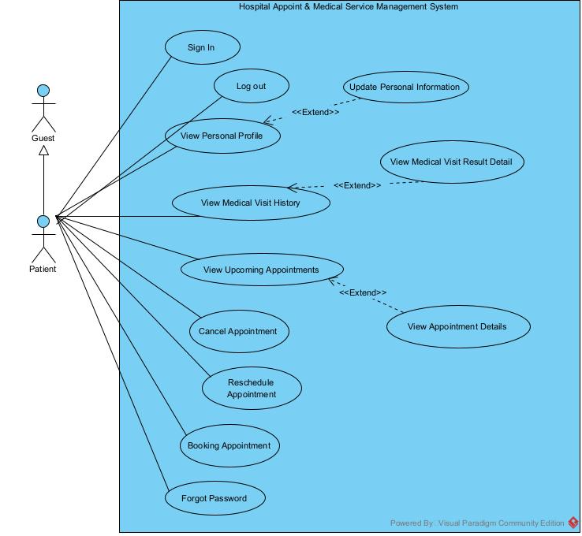

1.3.2.3 UCs for Receptionist
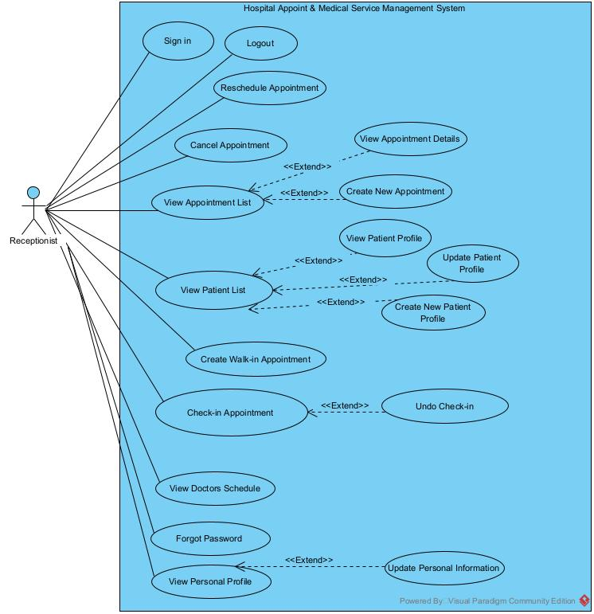

1.3.2.4 UCs for Doctor
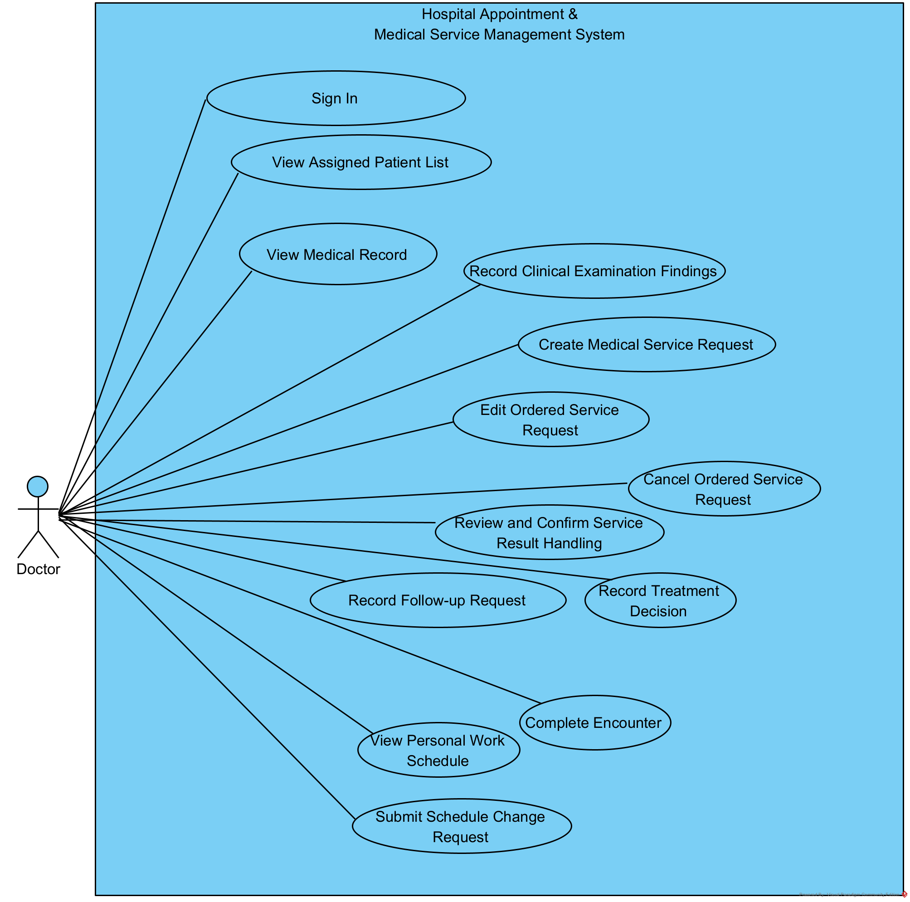

1.3.2.5 UCs for Medical Service Staff
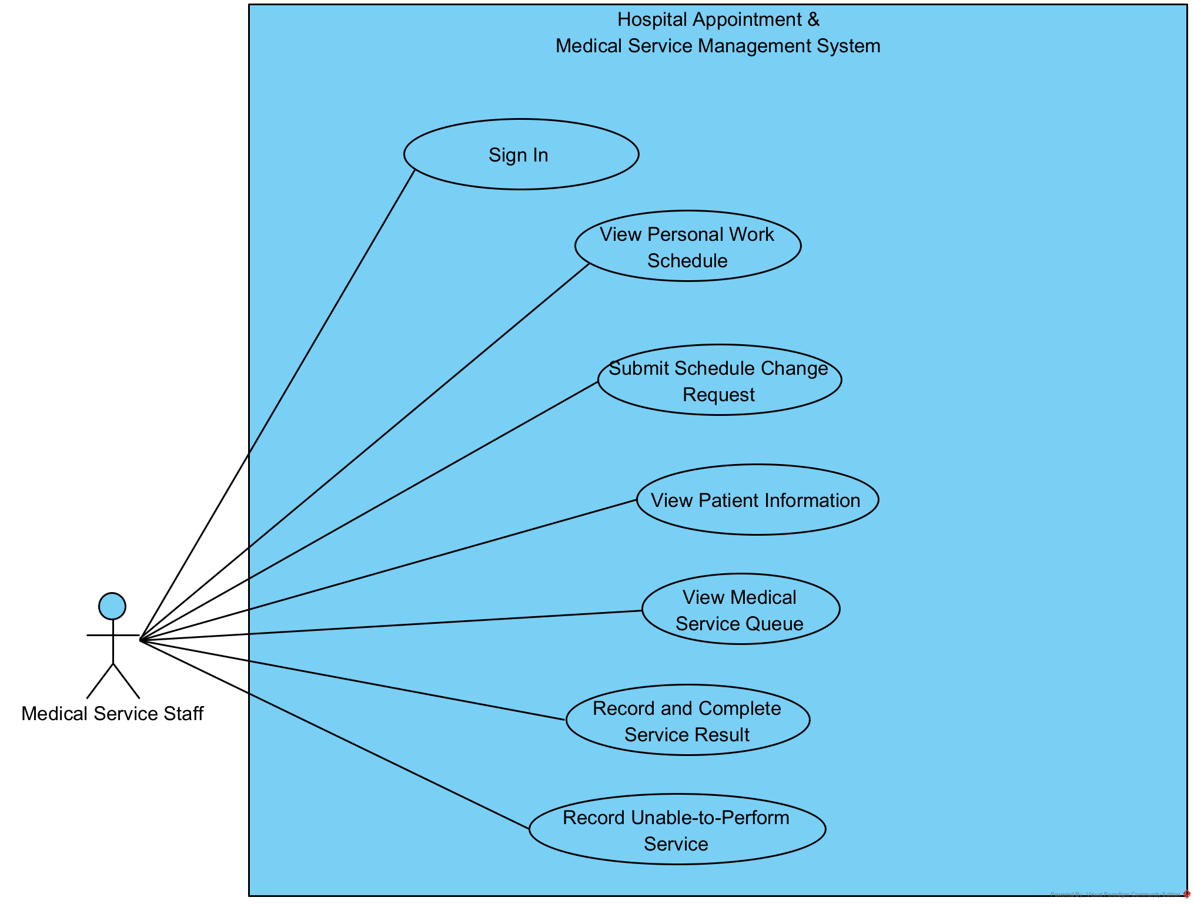

1.3.2.6 UCs for Admin
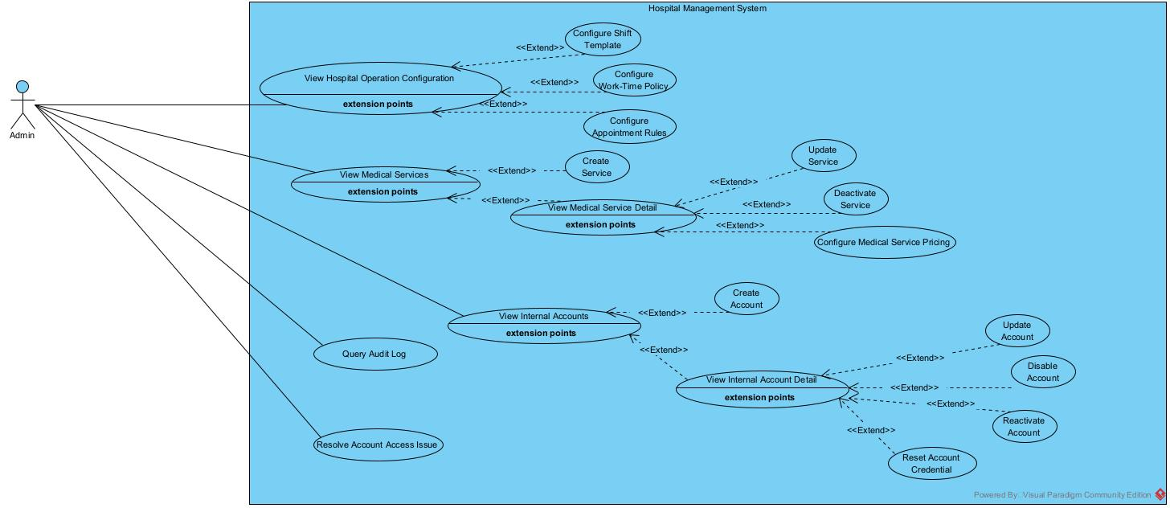

1.3.2.7 UCs for Manager

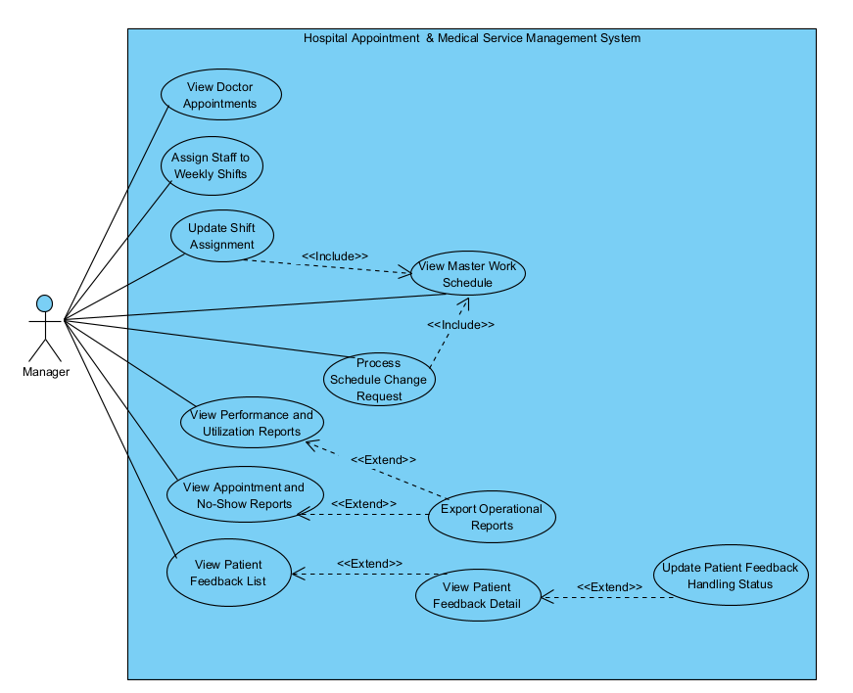

1.4 System Functionalities

1.4.1 Screens Flow
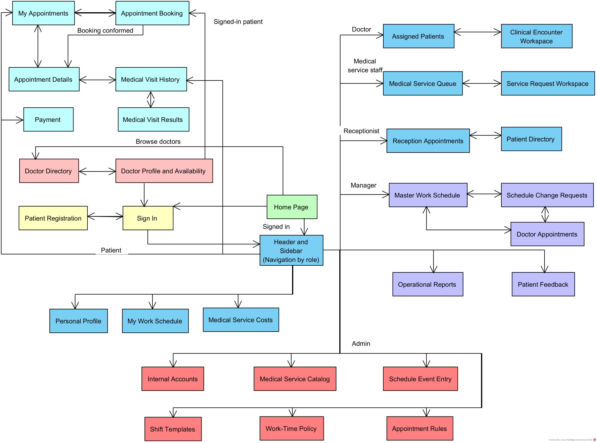

1.4.2 Screen Authorization
Screen | Guest | Patient | Receptionist | Doctor | Medical Service Staff | Manager | Admin
Home | X | X | X | X | X | X | X
Sign In | X | X | X | X | X | X | X
Patient Registration | X
Personal Profile |  | X | X | X | X | X | X
Doctor Directory | X | X | X | X | X | X | X
Doctor Profile and Availability | X | X | X | X | X | X | X
My Appointments |  | X
Appointment Details |  | X
Appointment Booking |  | X
Medical Visit History |  | X
Medical Visit Results |  | X
Payment |  | X
Patient Directory |  |  | X
Reception Appointments |  |  | X
My Work Schedule |  |  | X | X | X
Assigned Patients |  |  |  | X
Clinical Encounter Workspace |  |  |  | X
Medical Service Queue |  |  |  |  | X
Service Request Workspace |  |  |  |  | X
Internal Accounts |  |  |  |  |  |  | X
Shift Templates |  |  |  |  |  |  | X
Work-Time Policy |  |  |  |  |  |  | X
Appointment Rules |  |  |  |  |  |  | X
Medical Service Catalog |  |  |  |  |  |  | X
Schedule Event Entry |  |  |  |  |  |  | X
Medical Service Costs | X | X | X | X | X | X | X
Master Work Schedule |  |  |  |  |  | X
Schedule Change Requests |  |  |  |  |  | X
Doctor Appointments |  |  |  |  |  | X
Operational Reports |  |  |  |  |  | X
Patient Feedback |  |  |  |  |  | X

1.4.3 Non-UI Functions

# | Feature | System Function | Description
1 | Scheduling, Appointments and Reception | No-Show Detection Cron Job | Automatically scans appointments after each scheduled shift/session and identifies appointments whose patients did not check in or attend within the required time. The system updates the appointment status to No-Show according to the business rules.
2 | Notification | SMTP Email Notification Service | Sends automated email notifications to patients using an SMTP mail server. The service is used for appointment-related notifications, such as appointment confirmation, cancellation, rescheduling, and no-show notifications.
3 | Invoices and Payments | VNPay Payment API Integration | Integrates with the VNPay payment gateway to create payment requests, redirect patients to the VNPay payment page, and receive payment results/callbacks. The system verifies the transaction result and updates the corresponding appointment/payment status.

1.5 Entity Relationship Diagram
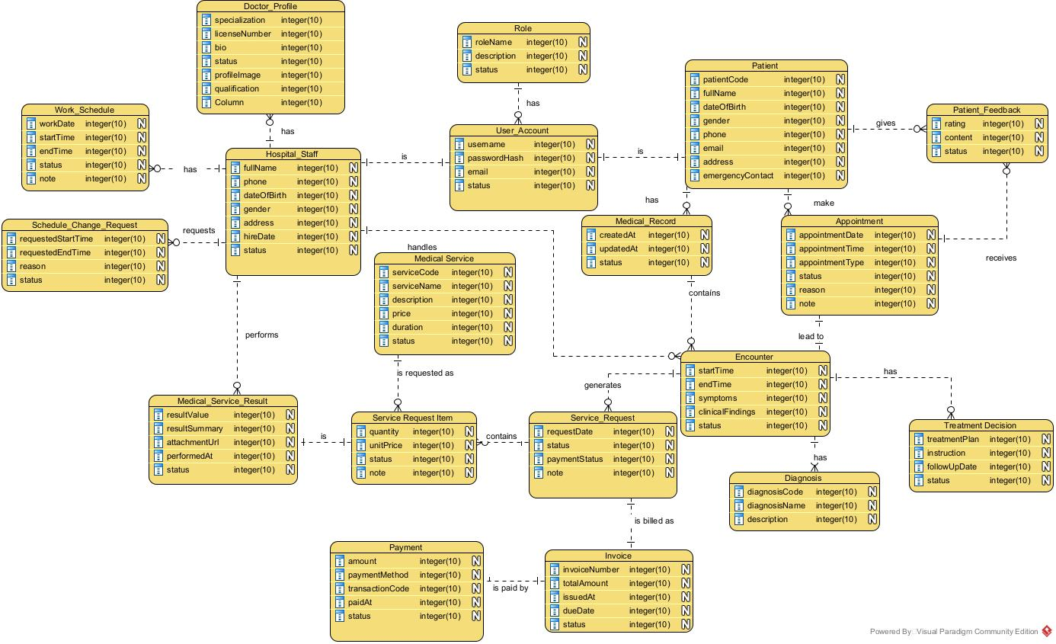
Entities Description

# | Entity | Description
1 | Doctor_Profile | Doctor's professional and public profile information
2 | Role | Defines the role and permissions assigned to a system user
3 | User_Account | Stores account and authentication information for system users
4 | Patient | Stores patient information and identifies a patient within the hospital system
5 | Patient_Feedback | Stores feedback provided by patients about their hospital experience or services
6 | Hospital_Staff | Stores information about hospital staff members who operate and manage the system
7 | Work_Schedule | Stores work schedule and assigned working periods of hospital staff
8 | Schedule_Change_Request | Stores requests submitted by staff to change their assigned work schedule
9 | Medical_Record | Stores and organizes a patient's medical information and clinical history
10 | Appointment | Stores information about a patient's scheduled or walk-in medical appointment
11 | Encounter | Represents a patient's actual medical visit or clinical interaction with the hospital
12 | Medical_Service | Stores information about medical services offered by the hospital
13 | Service_Request_Item | Represents a requested medical service item associated with a service request
14 | Medical_Service_Result | Stores the result and supporting information produced from performing a medical service
15 | Service_Request | Stores a request for a medical service for a patient during an encounter
16 | Diagnosis | Stores diagnoses recorded by a doctor during a patient's encounter
17 | Treatment_Decision | Stores treatment decisions made by a doctor during a patient's encounter
18 | Invoice | Stores billing information generated for medical services or service requests
19 | Payment | Stores payment information associated with an invoice

3. Use Case Specifications

3.1 User Accounts and Profiles

3.1.1. Sign In

ID and Name | UC01 - Sign In
Created by | Nguyễn Tuấn Nam
Primary Actor | System User | Secondary Actor | None
Description | Guest provides valid account credentials to sign in to the hospital system. The system authenticates the account and grants access according to the permissions assigned to the account.
Preconditions | The user has an existing account permitted to access the system.  The user is not currently signed in.
Main Sequence | 1. Guest selects the sign-in function.  2. The system displays the sign-in form.  3. Guest enters the account credentials.  4. The system validates the provided credentials.  5. The system authenticates the account and retrieves its assigned permissions.  6. The system grants access to the functions permitted for the account and displays the appropriate home page.
Alternative Sequences | Step 4: If the credentials are invalid, the system rejects the sign-in attempt and prompts the Guest to enter the credentials again.  Step 4: If the account is not permitted to access the system, the system rejects the sign-in attempt and informs the Guest that the account cannot be used to access the system.
Exceptions | None
Post conditions | The user is signed in successfully and has access only to functions permitted by the account's assigned permissions.
Business Rule | BR-42

3.1.2. Register Patient Account

ID and Name | UC02 - Register Patient Account
Created by | Nguyễn Tuấn Nam
Primary Actor | Guest | Secondary Actor | None
Description | Guests register a new patient account by providing the required personal and account information. The system validates the information and creates a patient profile and account that can subsequently be used to access patient functions.
Preconditions | The Guest is not currently signed in.  The Guest has the information required to create a patient account.
Main Sequence | 1. The guest selects the option to register a patient account.  2. The system displays the patient account registration form.  3. Guest provides the required personal information and account credentials.  4. The system validates the provided information.  5. System checks that the account credentials are not already associated with another account.  6. The system creates the patient account and associated patient profile.  7. The system confirms successful registration and displays the account registration result to the Guest.
Alternative Sequences | Step 4: If the provided information is invalid or required information is missing, the system displays the validation errors and prompts the Guest to correct the information.  Step 5: If the account credential is already associated with another account, the system informs the Guest and prompts the Guest to provide different account credentials.  Step 6: If account creation fails, the system informs the Guest that the registration could not be completed and does not create an incomplete patient account.
Post conditions | A patient account and its associated patient profile have been created successfully.
Business Rule | BR-46, BR-47

3.1.3. View Personal Profile

ID and Name | UC03 - View Personal Profile
Created by | Nguyễn Tuấn Nam
Primary Actor | System User | Secondary Actor | None
Description | Userview the personal information associated with their own patient profile after signing in to the hospital system.
Preconditions | The User has successfully signed in.  The User has an existing patient profile associated with the signed-in account.
Main Sequence | 1. The User selects the option to view their personal profile.  2. The system identifies the Patient profile associated with the signed-in account.  3. The system retrieves the Patient's personal profile information.  4. The system displays the Patient's personal profile to the Patient.  5. The User reviews the displayed information.
Alternative Sequences | Step 3: If the profile information cannot be retrieved, the system displays an error message “Can’t retrieve your information” and does not display incomplete or invalid information.
Post conditions | The User has viewed their own personal profile. No patient information is modified.
Business Rule | BR-49

3.1.4.Update Personal Information

ID and Name | UC04 - Update Personal Information
Created by | Nguyễn Tuấn Nam
Primary Actor | System User | Secondary Actor | None
Description | User updates the personal information associated with their own profile. The system validates the updated information and stores the changes while preserving the user’s identity.
Preconditions | The User has successfully signed in.  The User has an existing patient profile associated with the signed-in account.
Main Sequence | 1. User selects the option to update personal information.  2. System retrieves and displays the User’s current personal information.  3. User modifies the permitted personal information.  4. System validates the updated information.  5. System saves the updated personal information.  6. System confirms that the personal information has been updated successfully and displays the updated profile.
Alternative Sequences | Step 4: If the updated information is invalid or required information is missing, the system displays the validation errors and prompts the Patient to correct the information.  Step 5: If the system cannot save the updated information, the system informs the Patient that the update could not be completed and retains the previous valid information.
Post conditions | The User’s permitted personal information has been updated successfully. The Patient's identity and patient profile association remain unchanged.
Business Rule | BR-49, BR-50

3.1.5.View Patient List

ID and Name | UC05 - View Patient List
Created by | Nguyễn Tuấn Nam
Primary Actor | Receptionist | Secondary Actor | None
Description | Receptionist views the list of patients available within the Receptionist's authorized operational scope. The list provides patient information necessary for appointment and reception activities.
Preconditions | The Receptionist has successfully signed in and has permission to view patient information.
Main Sequence | 1. The receptionist selects the patient list function.  2. The system verifies the Receptionist's permission to access patient information.  3. The system retrieves patients within the Receptionist's permitted scope.  4. The system displays the patient list and the information necessary for Receptionist activities.  5. The receptionist reviews the patient list and may select a patient for an authorized operation.
Alternative Sequences | Step 2: If the Receptionist does not have permission to access patient information, the system denies access to the patient list.  Step 3: If no patients are available within the Receptionist's permitted scope, the system displays a message indicating that no patients are available.  Step 3: If the system cannot retrieve the patient list, the system displays an error message and does not display incomplete or invalid patient information.
Post conditions | The Receptionist has viewed the patient list within their permitted scope. No patient information is modified.
Business Rule | BR-65, BR-66, BR-67

3.1.6.View Patient Information

ID and Name | UC06 - View Patient Information
Created by | Nguyễn Tuấn Nam
Primary Actor | Receptionist | Secondary Actor | None
Description | Receptionist views the profile of a selected Patient to obtain personal and administrative information required for reception and appointment management.
Preconditions | The Receptionist has successfully signed in and has permission to access patient information.  The selected Patient exists in the system.
Main Sequence | 1. Receptionist selects a Patient from the patient list or another authorized patient-related function.  2. System retrieves the selected Patient profile.  3. System verifies that the Receptionist is authorized to access the Patient profile.  4. System displays the Patient profile information permitted for Receptionist access.  5. Receptionist reviews the Patient profile.
Alternative Sequences | Step 2: If the selected Patient does not exist, the system informs the Receptionist that the Patient profile cannot be found.  Step 3: If the Receptionist does not have permission to access the Patient profile, the system denies access.  Step 4: If the Patient profile cannot be retrieved, the system displays an error message and does not display incomplete or invalid information.
Post conditions | The Receptionist has viewed the permitted information of the selected Patient. No Patient information is modified.
Business Rule | BR-65, BR-66, BR-67

3.1.7. View Internal Account List

ID and Name | UC-ADM-01 - View Internal Account List
Created by | Hà Quốc Trung
Primary Actor | Admin | Secondary Actor | None
Description | The administrator retrieves and views the list of internal employee accounts within their authorized scope of management.
Preconditions | The admin has logged in and has permission to view the list of internal accounts.
Main Sequence | 1. The admin selects the option to view the internal account list.  2. The system retrieves the account list along with supported search and filter criteria.  3. The system displays the account list, including permitted information  4. The Admin reviews the returned account list.
Alternative Sequences | Step 2: The system is unable to complete the query for the Internal Account list due to a processing or data access error, the system displays an error message “Unable to load the list of internal accounts. Please try again later.” and return to View Internal Account Screen
Post conditions | The admin can view a list of Internal Accounts that match the criteria and permitted access scope.
Business Rule

3.1.8. View Internal Account Detail

ID and Name | UC-ADM-02 - View Internal Account Detail
Created by | Hà Quốc Trung
Primary Actor | Admin | Secondary Actor | None
Description | The administrator retrieves and views the detailed information of an internal employee account
Preconditions | The admin is logged in and has permission to view detailed information about internal accounts.
Main Sequence | 1. The system displays the list of Internal Accounts that the Admin is authorized to view.  2. The Admin selects the account for which they wish to view detailed information.  3. The system retrieves the detailed information for the account corresponding to the Account ID  4. The system displays the Internal Account Detail screen containing the information the Admin is authorized to view  5. The Admin reviews the account details.
Alternative Sequences | Step 2: If the administrator does not have permission to view the details of the selected account, or the account is outside the authorized administrative scope, displaying an error message “You do not have permission to view the details of this account.”
Post conditions | The administrator can view detailed information about the selected internal account within their authorized data scope.
Business Rule

3.1.9. Create Internal Account

ID and Name | UC-ADM-03 - Create Internal Account
Created by | Hà Quốc Trung
Primary Actor | Admin | Secondary Actor | None
Description | The administrator creates new accounts for internal hospital staff to provide system access based on predefined account types.
Preconditions | 1. The administrator receives a request to create an account for an internal employee.  2. The employee requiring an account must provide valid identification details for system verification.
Main Sequence | 1. The Admin selects the "Create Internal Account" function, provides the login identifier/email, and confirms the account creation details.  2. The system validates mandatory fields, the login information format, and the uniqueness of the Staff ID/login identifier/email.  3. The system creates the new account, assigns an Account ID, and sets the initial status according to the account activation policy.  4. The system returns the details of the newly created account and the account creation result to the Admin.
Alternative Sequences | Step 2: If the employee already has a corresponding internal account, and the system does not permit the creation, displaying an error message “The employee already has an internal account in the system.”  Step 2: If duplicate login identifier/email, missing mandatory information, or incorrect format., displaying an error message “The login information is invalid or has already been used.”
Post conditions | The administrator can view detailed information about the selected internal account within their authorized data scope.
Business Rule | BR-87; BR-88; BR-89; BR-90

3.1.10. Update Internal Account

ID and Name | UC-ADM-04 - Update Internal Account
Created by | Hà Quốc Trung
Primary Actor | Admin | Secondary Actor | None
Description | The administrator retrieves and views the detailed information of an internal employee account
Preconditions | The admin is logged in and has permission to view detailed information about internal accounts.
Main Sequence | 1. The system displays the list of Internal Accounts that the Admin is authorized to view.  2. The Admin selects the account for which they wish to view detailed information.  3. The system retrieves the detailed information for the account corresponding to the Account ID  4. The system displays the Internal Account Detail screen containing the information the Admin is authorized to view  5. The Admin reviews the account details.
Alternative Sequences | Step 2: If the administrator does not have permission to view the details of the selected account, or the account is outside the authorized administrative scope, displaying an error message “You do not have permission to view the details of this account.”
Post conditions | A new internal account is created, assigned an Account ID, and linked to the corresponding employee.
Business Rule | BR-91; BR-92

3.1.11. View Doctor List

ID and Name | UC11 - View Doctor List
Created by | Nguyễn Tuấn Nam
Primary Actor | Guest | Secondary Actor | None
Description | Guest views the list of doctors available through the hospital system and may review publicly accessible information to identify a doctor of interest.
Preconditions | The hospital system contains doctor information available for public access.
Main Sequence | 1. The guest selects the option to view the doctor list.  2. The system retrieves doctors whose information is available for public access.  3. The system displays the doctor list and the publicly available information for each doctor.  4. Guest reviews the displayed doctor list.
Alternative Sequences | Step 2: If no doctor information is currently available for public access, the system displays an appropriate message that “No doctors are available to display.”  Step 2: If the system cannot retrieve the doctor list, the system displays an error message “Error occurred during retrieving data” and does not display incomplete or invalid doctor information.
Post conditions | The Guest has viewed the currently available public doctor information.
Business Rule | BR-36, BR-48

3.1.12. View Doctor Profile

ID and Name | UC12 - View Doctor Profile
Created by | Nguyễn Tuấn Nam
Primary Actor | Guest | Secondary Actor | None
Description | Guest views the publicly accessible profile of a selected doctor, including information that the hospital has designated for public access.
Preconditions | The selected doctor exists in the system and has a profile available for public access.
Main Sequence | 1. Guest selects a doctor from the doctor list.  2. System retrieves the selected doctor's public profile information.  3. System displays the doctor's public profile to the Guest.  4. Guest reviews the displayed doctor profile.
Alternative Sequences | Step 2: If no doctor information is currently available for public access, the system displays an appropriate message that “No doctors are available to display.”  Step 2: If the system cannot retrieve the doctor list, the system displays an error message “Error occurred during retrieving data” and does not display incomplete or invalid doctor information.
Post conditions | The Guest has viewed the selected doctor's public profile.
Business Rule | BR-36, BR-48

3.1.13. Create New Patient Profile

ID and Name | UC13 - Create New Patient Profile
Created by | Nguyễn Tuấn Nam
Primary Actor | Receptionist | Secondary Actor | None
Description | Receptionist creates a new Patient profile for a person who does not yet have a Patient profile in the hospital system. The profile can subsequently be used for appointment creation, walk-in appointment processing, and other authorized hospital operations.
Preconditions | The Receptionist has successfully signed in and has permission to create Patient profiles.  The person does not already have an existing Patient profile in the system.
Main Sequence | 1. Receptionist selects the option to create a new Patient profile.  2. System displays the Patient profile creation form.  3. Receptionist provides the required Patient information.  4. System validates the provided information.  5. System checks whether an existing Patient profile matches the identifying information.  6. System creates the new Patient profile.  7. System records the Receptionist who created the profile and the creation timestamp.  8. System confirms successful Patient profile creation and displays the newly created profile information.
Alternative Sequences | Step 4: If the provided information is invalid or required information is missing, the system displays the validation errors and prompts the Receptionist to correct the information.  Step 5: If a matching Patient profile already exists, the system informs the Receptionist and displays or directs them to the existing Patient profile instead of creating a duplicate profile.  Step 6: If Patient profile creation fails, the system informs the Receptionist that the profile could not be created and does not create an incomplete Patient profile.
Post conditions | A new Patient profile has been successfully created. The Patient can subsequently be associated with appointments and other hospital processes.
Business Rule | BR-50, BR-69, BR-70

3.1.14. Update Patient Profile

ID and Name | UC14 - Update Patient Profile
Created by | Nguyễn Tuấn Nam
Primary Actor | Receptionist | Secondary Actor | None
Description | Receptionist updates the permitted administrative and personal information of an existing Patient profile when necessary for patient registration, appointment, or reception activities.
Preconditions | The Receptionist has successfully signed in and has permission to update patient profiles. The selected Patient profile exists in the system.
Main Sequence | 1. Receptionist selects a Patient profile to update.  2. System retrieves and displays the Patient's current information.  3. Receptionist modifies the permitted Patient information.  4. System validates the updated information.  5. System saves the updated Patient information.  6. System records the update information, including the Receptionist and update timestamp.  7. System confirms that the Patient profile has been updated successfully and displays the updated information.
Alternative Sequences | Step 4: If the updated information is invalid or required information is missing, the system displays the validation errors and prompts the Receptionist to correct the information.  Step 5: If the system cannot save the updated information, the system informs the Receptionist that the update could not be completed and retains the previous valid information.  Step 6: If the Receptionist attempts to modify information outside their permitted scope, the system rejects the modification and does not change the restricted information.
Post conditions | The permitted Patient information has been updated successfully. The Patient identity and Patient profile identifier remain unchanged.
Business Rule | BR50,BR-65, BR-66

3.2 Scheduling, Appointments and Reception

3.2.1.Cancel Appointment

ID and Name | UC12 - Cancel Appointments
Created by | Nguyễn Tuấn Nam
Primary Actor | Patient | Secondary Actor | None
Description | Patient cancels one of their eligible upcoming appointments. The system verifies that the appointment belongs to the Patient and is still eligible for cancellation before recording the cancellation.
Preconditions | The Patient has successfully signed in.  The Patient has an existing appointment associated with their Patient profile. The appointment is eligible for cancellation.
Main Sequence | 1. Patient selects an upcoming appointment to cancel.  2. The system retrieves the selected appointment and verifies that it belongs to the Patient.  3. The system verifies that the appointment is eligible for cancellation.  4. The system displays the appointment information and asks the Patient to confirm cancellation.  5. The patient confirms the cancellation.  6. The system changes the appointment status to Cancelled and records the cancellation information.  7. The system confirms that the appointment has been cancelled successfully and displays the updated appointment status.  8. The system send email to notifying that appointment was cancelled
Alternative Sequences | Step 2: If the selected appointment does not belong to the Patient, the system denies the cancellation request and does not modify the appointment.  Step 3: If the appointment is no longer eligible for cancellation, the system informs the Patient and does not modify the appointment.  Step 5: If the Patient does not confirm the cancellation, the system returns to the appointment information without changing its status.  Step 6: If the cancellation cannot be recorded, the system informs the Patient that the cancellation could not be completed and retains the existing appointment status.
Post conditions | The selected eligible appointment has been marked as Cancelled and the cancellation information has been recorded. A cancelled appointment is no longer treated as an active upcoming appointment.
Business Rule | BR-53, BR-55, BR-56

3.2.3.View Doctor Work Schedule

ID and Name | UC16 - View Doctor Schedule
Created by | Nguyễn Tuấn Nam
Primary Actor | Receptionist | Secondary Actor | None
Description | Receptionist views a Doctor's work schedule and available appointment time slots to support appointment booking, walk-in appointment processing, and reception operations.
Preconditions | The Receptionist has successfully signed in and has permission to view Doctor schedules.  Doctor schedule information exists in the system.
Main Sequence | 1. Receptionist selects the option to view a Doctor schedule.  2. System displays the Doctor search or selection interface.  3. Receptionist selects a Doctor and the required date or date range.  4. System retrieves the selected Doctor's applicable work schedule.  5. System identifies the appointment time slots and their availability based on existing appointments and schedule information.  6. System displays the Doctor's schedule and applicable appointment availability.  7. Receptionist reviews the schedule and may use the information to continue an appointment-related operation.
Alternative Sequences | Step 3: If the selected Doctor does not exist or is not available for viewing, the system informs the Receptionist and prompts them to select another Doctor.  Step 4: If no schedule is available for the selected date or date range, the system displays an appropriate message that “no schedule is available.”  Step 5: If the system cannot determine appointment availability, the system displays the available schedule information and indicates that appointment availability cannot currently be determined.  Step 6: If the schedule cannot be retrieved, the system displays an error message and does not display incomplete or invalid schedule information.
Post conditions | The Receptionist has viewed the selected Doctor's schedule and applicable appointment availability. No Doctor schedule or appointment information is modified.
Business Rule | BR-58, BR-61, BR-66

3.2.4.View Upcoming Appointments

ID and Name | UC17 - View Upcoming Appointments
Created by | Nguyễn Tuấn Nam
Primary Actor | Patient | Secondary Actor | None
Description | Patient views their upcoming appointments, including the scheduled date, time, doctor, medical service, and appointment status that are available to the Patient.
Preconditions | The Patient has successfully signed in.  The Patient has an existing patient profile.
Main Sequence | 1. The patient selects the option to view upcoming appointments.  2. The system identifies the Patient associated with the signed-in account.  3. The system retrieves the Patient's appointments scheduled for a future date and time and permitted for patient access.  4. The system displays the upcoming appointments and their relevant information.  5. The patient reviews the displayed appointments.
Alternative Sequences | Step 3: If the Patient has no upcoming appointments, the system displays a message indicating that “no upcoming appointments to display”.  Step 3: If the system cannot retrieve the appointments, the system displays an error message and does not display incomplete or invalid appointment information.
Post conditions | The Patient has viewed the permitted details of the selected medical service result. The result and its processing state are not modified.
Business Rule | BR-53, BR-54

3.2.5.View Appointment Details

ID and Name | UC18 - View Appointment Detail
Created by | Nguyễn Tuấn Nam
Primary Actor | Patient | Secondary Actor | None
Description | Patient views the details of an appointment associated with their Patient profile, including the scheduled date and time, doctor, medical service, and appointment status.
Preconditions | The Patient has successfully signed in.  The selected appointment exists and is associated with the Patient.
Main Sequence | 1. Patient selects an appointment from their appointment list.  2. System retrieves the selected appointment.  3. System verifies that the appointment belongs to the Patient.  4. System retrieves the appointment details.  5. System displays the appointment details to the Patient.  6. Patient reviews the appointment information.
Alternative Sequences | Step 2: If the selected appointment does not exist, the system informs the Patient that “the appointment cannot be found.”  Step 3: If the selected appointment does not belong to the Patient, the system denies access to the appointment details.  Step 4: If the appointment details cannot be retrieved, the system displays an error message and does not display incomplete or invalid information.
Post conditions | The Patient has viewed the selected appointment details. No appointment information is modified.
Business Rule | BR-53, BR-60

3.2.6.Create Walk-in Appointment

ID and Name | UC19 - Create Walk-in Appointment
Created by | Nguyễn Tuấn Nam
Primary Actor | Receptionist | Secondary Actor | None
Description | Receptionist creates an Appointment for a Patient who arrives at the hospital without a previously scheduled appointment. The Receptionist identifies the Patient, selects the required Medical Service and Doctor, assigns an available appointment time, and records the appointment as a walk-in appointment.
Preconditions | The Receptionist has successfully signed in and has permission to create appointments.  The Patient has an existing Patient profile, or a Patient profile can be created through the applicable workflow.  The required Medical Service and Doctor are available for walk-in processing.
Main Sequence | 1. Receptionist selects the option to create a walk-in appointment.  2. System displays the walk-in appointment form.  3. Receptionist identifies and selects the Patient.  4. Receptionist selects the required Medical Service.  5. System displays Doctors and applicable appointment availability for the selected Medical Service.  6. Receptionist selects an available Doctor and appointment time.  7. System verifies the Patient, Medical Service, Doctor, and selected time slot.  8. System creates the Appointment and marks it as a walk-in appointment.  9. System records the Receptionist who created the appointment.  10. System confirms successful walk-in appointment creation and displays the appointment information.
Alternative Sequences | Step 3: If the Patient cannot be identified, the system informs the Receptionist and allows the Receptionist to create a new Patient profile through the applicable workflow.  Step 5: If no Doctor or applicable availability exists for the selected Medical Service, the system informs the Receptionist and prompts them to select another Medical Service or available Doctor.  Step 6: If the selected time slot is no longer available, the system informs the Receptionist and requires another available slot to be selected.  Step 8: If appointment creation fails, the system informs the Receptionist that the walk-in appointment could not be created and does not create an incomplete appointment.
Post conditions | A new Appointment has been created for the Patient and is identified as a walk-in appointment. The Appointment contains the required Patient, Doctor, Medical Service, and scheduling information.
Business Rule | BR-60, BR-61, BR-63, BR-64, BR-71

3.2.7.Check In Appointment

ID and Name | UC20 -Check-in Appointment
Created by | Nguyễn Tuấn Nam
Primary Actor | Receptionist | Secondary Actor | None
Description | Receptionist checks in a Patient for a scheduled or walk-in Appointment when the Patient arrives at the hospital. The system verifies the appointment and records the Patient's arrival for the appointment.
Preconditions | The Receptionist has successfully signed in and has permission to manage check-in.  The Patient has an existing Appointment.  The Appointment is eligible for check-in and has not already been checked in or cancelled.
Main Sequence | 1. Receptionist selects the option to check in an Appointment.  2. Receptionist identifies the Patient or Appointment.  3. System retrieves the Appointment information.  4. System verifies that the Appointment is valid and eligible for check-in.  5. System displays the Patient and Appointment information for confirmation.  6. Receptionist confirms the Patient's arrival.  7. System records the check-in status and check-in timestamp.  8. System records the Receptionist who performed the check-in.  9. System confirms that the Patient has been checked in successfully.
Alternative Sequences | Step 2: If the Patient or Appointment cannot be identified, the system informs the Receptionist and prompts them to provide valid appointment information.  Step 3: If the Appointment does not exist, the system informs the Receptionist that “no matching Appointment can be found.”  Step 4: If the Appointment is cancelled, already checked in, or otherwise not eligible for check-in, the system informs the Receptionist and does not change the Appointment status.  Step 7: If the system cannot record the check-in, the system informs the Receptionist that check-in could not be completed and does not mark the Appointment as checked in.
Post conditions | The Appointment is marked as checked in. The check-in timestamp and Receptionist who performed the check-in are recorded.
Business Rule | BR-64, BR-72, BR-73, BR-74

3.2.8.Undo Check-in

ID and Name | UC21 - Undo Check-in
Created by | Nguyễn Tuấn Nam
Primary Actor | Receptionist | Secondary Actor | None
Description | Receptionist reverses an incorrect or accidental check-in for an Appointment. The system removes the active check-in status while retaining the check-in history and recording the reversal.
Preconditions | The Receptionist has successfully signed in and has permission to manage check-in.  The selected Appointment has previously been checked in.  The check-in is eligible to be reversed.
Main Sequence | 1. Receptionist selects an Appointment that has been checked in.  2. System retrieves the Appointment and check-in information.  3. System verifies that the Appointment has an active check-in and that the Receptionist is authorized to reverse it.  4. System displays the Appointment and check-in information.  5. Receptionist selects the option to undo the check-in.  6. System requests confirmation of the reversal.  7. Receptionist confirms the undo check-in operation.  8. System removes the active check-in status from the Appointment.  9. System records the undo check-in action, including the Receptionist, timestamp, and reason where required.  10. System confirms that the check-in has been successfully reversed.
Alternative Sequences | Step 1: If the Appointment cannot be found, the system informs the Receptionist that “the Appointment does not exist.”  Step 3: If the Appointment has not been checked in or the check-in has already been reversed, the system informs the Receptionist that there is no active check-in to undo.  Step 3: If the Receptionist is not authorized to reverse the check-in, the system denies the operation.  Step 7: If the Receptionist cancels the confirmation, the system keeps the existing check-in status unchanged.  Step 8: If the system cannot reverse the check-in, the system informs the Receptionist that the operation failed and retains the existing check-in status.
Post conditions | The Receptionist has viewed the patient list within their permitted scope. No patient information is modified.
Business Rule | BR-73, BR-75, BR-76

3.2.9.View Personal Work Schedule

3.2.10.Submit Schedule Change Request

3.2.11.View Doctor Appointments

ID and Name | UC24 - View Doctor Appointments
Created by | Truong Khanh Dong
Primary Actor | Manager | Secondary Actor | None
Description | Manager views appointments assigned to a doctor for a selected period.
Preconditions | Manager is logged into the system
Main Sequence | 1. Manager selects the "Doctor Appointments" menu.  2. System displays a list of appointment schedules with filter options (date range, doctor, department, status).  3. Manager applies desired filters to refine the list.  4. System retrieves and displays matching appointment details (patient name, time slot, doctor, status)
Alternative Sequences | Step 4a: If no records match the filter criteria, system displays a "No appointments found" message.
Post conditions | Appointment schedule details are displayed on the screen.
Business Rule | none

3.2.12.Assign Staff to Weekly Shifts

ID and Name | UC25 - Assign Staff to Weekly Shifts
Created by | Truong Khanh Dong
Primary Actor | Manager | Secondary Actor | None
Description | Manager assigns staff to shifts for a selected work week.
Preconditions | The Manager is logged into the system. The work schedule for the upcoming week has not been published yet
Main Sequence | 1. Manager selects the target week and department to assign shifts.  2. System displays the list of department staff and empty shift slots for the week.  3. Manager selects staff members and assigns them to specific shifts (Morning / Afternoon / Night).  4. System validates assignment details against Business Rules.  5. System saves the shift assignments and notifies staff members of their new schedule.
Alternative Sequences | Step 4: If the assignment violates Business Rules (e.g., overlapping shifts, exceeding maximum hours), the system displays error alerts and prompts the Manager to adjust
Post conditions | The new weekly schedule is created successfully and status is set to "Assigned"
Business Rule | BR11: A staff member cannot be assigned to two overlapping shifts on the same day.  BR12: Staff working a Night shift must have a minimum rest period of 12 consecutive hours before starting the next shift.  BR14: Total working hours for a staff member must not exceed 48 hours per week

3.2.13.Update Shift Assignment

ID and Name | UC26 - Update Shift Assignment
Created by | Truong Khanh Dong
Primary Actor | Manager | Secondary Actor | None
Description | Manager changes an existing staff shift assignment after checking applicable scheduling constraints.
Preconditions | Manager is logged into the system. An existing shift assignment schedule is available
Main Sequence | 1. Manager opens the published shift assignment schedule.  2. Manager selects a specific staff member/shift slot to update.  3. Manager modifies the shift details (change shift time, reassign staff, or remove assignment).  4. System validates the updated entry against Business Rules.  5. System saves changes and sends schedule update notifications to affected staff.
Alternative Sequences | Step 4a: If modification violates rest period or overlap constraints, system displays an error and prompts revision.
Post conditions | Shift assignment is updated in the database and notifications are logged.
Business Rule | BR30: Modifications to a shift occurring within 12 hours require mandatory confirmation prompt before saving.

3.2.14.View Master Work Schedule

ID and Name | UC27 - View Master Work Schedule
Created by | Truong Khanh Dong
Primary Actor | Manager | Secondary Actor | None
Description | Manager views the overall staff work schedule by period, staff member, or role.
Preconditions | Manager is logged into the system
Main Sequence | 1. Manager accesses the Master Work Schedule view.  2. System displays the overall schedule matrix filtered by current week/month.  3. Manager filters view by department, shift type, or staff role.  4. System updates the master schedule table view accordingly.
Alternative Sequences | Step 2a: If schedule is not published yet for the selected period, system displays "Schedule Pending Approval".
Post conditions | Consolidated master work schedule is displayed.
Business Rule | none

3.2.15.Process Schedule Change Request

ID and Name | UC28 - Process Schedule Change Request
Created by | Truong Khanh Dong
Primary Actor | Manager | Secondary Actor | None
Description | Manager reviews and approves or rejects a submitted schedule change request.
Preconditions | Manager is logged into the system. There is at least one pending schedule change or leave request submitted by a staff member.
Main Sequence | 1. Manager navigates to the list of schedule change/leave requests.  2. Manager selects a specific request to view details (applicant, replacement staff, reason, requested leave/shift dates).  3. Manager selects "Approve" for the request.  4. System verifies the availability and qualification of the replacement staff according to Business Rules.  5. System updates the Master Work Schedule, adjusts shift assignments, and sends notification to the applicant and replacement staff.
Alternative Sequences | Step 3a: Manager selects "Reject" and enters a rejection reason. System updates request status to "Rejected" and notifies the staff member  Step 4a: If the replacement staff violates Business Rules (e.g., skill mismatch, overtime threshold), system alerts the Manager and blocks approval
Post conditions | Request status is updated (Approved/Rejected) and the Master Work Schedule is updated accordingly
Business Rule | BR19: Schedule change or leave requests must be submitted and processed at least 24 hours prior to the shift start time.  BR20: Replacement staff must hold the same role/specialization (e.g., Specialist Doctor A can only be replaced by Specialist Doctor A).  BR23: Swap requests must be pre-confirmed by the designated replacement staff before Manager review.

3.2.16.Add Schedule Event

3.2.17.View Shift Template List

ID and Name | UC-ADM-05 -View Shift Template List
Created by | Hà Quốc Trung
Primary Actor | Admin | Secondary Actor | None
Description | The administrator retrieves and views detailed information for all existing shifts in the system.
Preconditions | The administrator is logged in and has permission to view shift details.
Main Sequence | 1. The administrator selects the option to view all shifts.  2. The system retrieves the Shift Templates within the Admin's authorized management scope.  3. The system displays the Shift Template list , including Shift Code, Shift Name, Start Time, End Time, applicable employee category and effective period.  4. The Admin reviews the returned Shift Template list.
Alternative Sequences | Step 2: If the system fails to retrieve the list of Shift Templates due to a processing or data access error, the system displays an error message “Unable to load the Shift Template list. Please try again later. ”
Post conditions | The Admin can view the Shift Template list matching authorized management scope
Business Rule

3.2.18.View Shift Template Detail

ID and Name | UC-ADM-06 - View Shift Template Detail
Created by | Hà Quốc Trung
Primary Actor | Admin | Secondary Actor | None
Description | The administrator retrieves and views the detailed configuration information of a selected Shift Template within their authorized management scope.
Preconditions | The Admin has permission to view Shift Template details and has accessed the Shift Template list.
Main Sequence | 1. The system displays the Shift Template list that the Admin is authorized to view.  2. The Admin selects a Shift Template to view its detailed configuration  3. The system retrieves the detailed configuration information corresponding to the selected Shift Template  4. The system displays the Shift Template Detail screen, including Shift Code, Shift Name, Start Time, End Time, Break Configuration, applicable employee category and effective period.  5. The Admin reviews the Shift Template details.
Alternative Sequences | Step 3: If the system determines that the selected Shift Template no longer exists, , the system displays an error message “Shift Template not found.” and return to returns to the Shift Template List screen.
Post conditions
Business Rule

3.2.19.Create Shift Template

ID and Name | UC-ADM-07 - Create Shift Template
Created by | Hà Quốc Trung
Primary Actor | Admin | Secondary Actor | None
Description | The administrator sets up shared shift templates for hospital operations.
Preconditions | 1. The administrator is logged in and has permission to configure work shifts.  2. The employee groups to which the work shifts apply have been defined in the system.
Main Sequence | 1. The Admin selects the option to create a new shift template.  2. The Admin provides configuration details for the new shift template.  3. The system validates mandatory data, the time interval, and consistency with shift rules  4. The system returns the shift template creation and the operation result.
Alternative Sequences | Step 3: If the new configuration conflicts with the current shift rules, the system displays an error message “The shift configuration conflicts with the current configuration or work schedule. Please check the relevant information.”  Step 3: If start times, end times, break times, or mandatory fields are invalid, or required data is missing. The system displays an error message “Invalid shift information. Please check the highlighted fields..”
Post conditions | A new Shift Template version is saved with a defined validity period.
Business Rule | BR-75; BR-76; BR-77

3.2.20.Update Shift Template
ID and Name | UC-ADM-08 - Update Shift Template
Created by | Hà Quốc Trung
Primary Actor | Admin | Secondary Actor | None
Description | The administrator sets up shared shift templates for hospital operations.
Preconditions | 1. The administrator is logged in and has permission to configure work shifts.  2. The employee groups to which the work shifts apply have been defined in the system.
Main Sequence | 1. The admin selects an existing shift template, modifies the permitted parameters, and specifies the effective date.  2. The Admin provides updating details for the updated shift template.  3. The system validates mandatory data, the time interval, and consistency with shift rules  4. The system returns the shift template creation and the operation result.
Alternative Sequences | Step 3: If the new configuration conflicts with the current shift rules, the system displays an error message “The shift configuration conflicts with the current configuration or work schedule. Please check the relevant information.”  Step 3: If start times, end times, break times, or mandatory fields are invalid, or required data is missing. The system displays an error message “Invalid shift information. Please check the highlighted fields..”
Post conditions | A new Shift Template version is updated with a defined validity period.
Business Rule | BR-75; BR-76; BR-77

3.2.21.View Work-Time Policy

ID and Name | UC-ADM-09 - View Work-Time Policy
Created by | Hà Quốc Trung
Primary Actor | Admin | Secondary Actor | None
Description | The administrator retrieves and views the Work-Time Policy configuration
Preconditions | The Admin has permission to view Work-Time Policies.
Main Sequence | 1. The Admin accesses the Work-Time Policy Management function.  2. The system displays the available Work-Time Policies within the Admin's authorized management scope.  3. The Admin selects a Work-Time Policy to view.  4. The system retrieves the configuration information corresponding to the selected Work-Time Policy.  5. The system displays the Work-Time Policy details, including applicable employee category, standard daily/weekly hours, work-day rules, holiday/rest rules and effective period.  6. The Admin reviews the Work-Time Policy configuration.
Alternative Sequences | Step 2: If the system determines that no Work-Time Policies are available, the system displays an error message “No Work-Time Policies found. ”  Step 4: If the system determines that the selected Work-Time Policy no longer exists, the system displays an error message “The selected Work-Time Policy does not exist.” and returns to the Work-Time Policy Management screen.
Post conditions | The Admin can view the configuration information of the selected Work-Time Policy
Business Rule

3.2.22.Update Work-Time Policy

ID and Name | UC-ADM-10 - Update Work-Time Policy
Created by | Hà Quốc Trung
Primary Actor | Admin | Secondary Actor | None
Description | The administrator updates an existing Work-Time Policy applicable to an employee category, including standard working hours, work-day rules, holiday/rest rules and effective period.
Preconditions | 1. The Work-Time Policy to be updated exists in the system.  2. The applicable employee category exists and is valid.
Main Sequence | 1. The Admin selects the Work-Time Policy and selects the Update Work-Time Policy function.  2. The system displays the update form with the current policy configuration.  3. The Admin modifies the permitted configuration fields, including standard daily/weekly hours, work-day rules, holiday/rest rules and effective period.  4. The Admin submits the updated Work-Time Policy configuration.  5. The system validates the employee category, required information, working hours, work-day rules, holiday/rest rules and effective period.  6. The system saves the updated Work-Time Policy configuration, records the configuration change history and displays the updated Work-Time Policy configuration and confirms that the update was successful.
Alternative Sequences | Step 1: If the system determines that the selected Work-Time Policy no longer exists, the system displays an error message “The selected Work-Time Policy does not exist.” and returns to the Work-Time Policy Management screen.  Step 4: If the system detects invalid working hours, inconsistent work-day/holiday/rest rules, an invalid effective period or conflicting policy configuration, the system displays an error message “The Work-Time Policy configuration is invalid or conflicts with existing policies. Please review the entered information.” and returns to the Work-Time Policy Management screen.
Post conditions | The selected Work-Time Policy is updated with valid configuration information and a defined effective period. The configuration change history is recorded.
Business Rule | BR-78; BR-79; BR-80

3.2.23.View Appointment Rule List

ID and Name | UC-ADM-11 - View Appointment Rule List
Created by | Hà Quốc Trung
Primary Actor | Admin | Secondary Actor | None
Description | The administrator retrieves and views the list of Appointment Rules including the basic configuration information of each rule.
Preconditions | The Admin has permission to view Appointment Rules.
Main Sequence | 1. The Admin selects the option to view the Appointment Rule list.  2. The system retrieves the Appointment Rules within the Admin's authorized management scope.  3. The system displays the Appointment Rule list, including applicable Medical Service/Doctor category, maximum appointments per shift/day, appointment duration and effective period.  4. The Admin reviews the returned Appointment Rule list
Alternative Sequences | Step 2: If the system is unable to retrieve the Appointment Rule list, the system displays an error message “Unable to load the Appointment Rule list. Please try again later.”
Post conditions | The Admin can view the Appointment Rule list
Business Rule

3.2.24.View Appointment Rule Detail

ID and Name | UC-ADM-12 - View Appointment Rule Detail
Created by | Hà Quốc Trung
Primary Actor | Admin
Description | The administrator retrieves and views the detailed configuration information of a selected Appointment Rule
Preconditions | 1.The Admin has permission to view Appointment Rule details.  2. The Admin has accessed the Appointment Rule list.
Main Sequence | 1. The Admin selects an Appointment Rule to view its detailed configuration.  2. The system retrieves the detailed configuration information corresponding to the selected Appointment Rule.  3. The system displays the Appointment Rule Detail screen, including applicable Medical Service/Doctor category, maximum appointments per shift/day, appointment duration, effective period and other supported configuration information.  4. The Admin reviews the Appointment Rule details
Alternative Sequences | Step 2: If the system determines that the selected Appointment Rule no longer exists, the system displays an error message “Appointment Rule not found.” and returns to the Appointment Rule List screen .
Post conditions | The Admin can view the detailed configuration information of the selected Appointment Rule
Business Rule

3.2.25.Create Appointment Rule

ID and Name | UC-ADM-13 - Create Appointment Rule
Created by | Hà Quốc Trung
Primary Actor | Admin
Description | The administrator creates a new Appointment Rule to define appointment capacity, appointment duration and the effective period applicable to a specified Medical Service or Doctor category.
Preconditions | 1.The referenced Medical Service or Doctor category exists and is valid.  2. The Admin has a valid request to create a new Appointment Rule.
Main Sequence | 1. The Admin selects the Create Appointment Rule function.  2. The system displays the Appointment Rule creation form.  3. The Admin selects the applicable Medical Service or Doctor category, enters the maximum appointments per shift/day, appointment duration and effective period.  4. The Admin submits the new Appointment Rule configuration.  5. The system validates the applicable Medical Service or Doctor category, required information, appointment capacity, appointment duration and effective period.  6. The system saves the updated Appointment Rule configuration and records the configuration change history, including the previous and updated information, the Admin performing the update and the update timestamp.  7. The system displays the updated Appointment Rule configuration and confirms that the update was successful.
Alternative Sequences | Step 3: If the system determines that the selected Appointment Rule does not exist or is no longer accessible to the Admin. , the system displays an error message “The selected Appointment Rule could not be found ” and returns to the Appointment Rule List screen.  Step 5: If the system detects invalid appointment capacity, invalid appointment duration, an invalid reference or effective period, or a conflict with existing Appointment Rules, the system displays an error message “The updated Appointment Rule is invalid or conflicts with existing rules. Please review the entered information. .” and returns to the Appointment Rule List screen.
Post conditions | A new Appointment Rule is created and saved with valid configuration information, a defined scope of application and an effective period. The creation history is recorded.
Business Rule | BR-81; BR-82; BR-83

3.2.26.Update Appointment Rule

ID and Name | UC-ADM-14 - Update Appointment Rule
Created by | Hà Quốc Trung
Primary Actor | Admin
Description | The administrator updates the configuration of an existing Appointment Rule, including appointment capacity, appointment duration and effective period, according to the applicable appointment management policy.
Preconditions | 1. The Appointment Rule to be updated exists in the system.  2. The Admin has a valid request to modify the existing Appointment Rule configuration.
Main Sequence | 1. The Admin selects the Appointment Rule to update and selects the Update Appointment Rule function.  2. The system displays the update form with the current Appointment Rule configuration.  3. The Admin modifies the permitted configuration fields, including maximum appointments per shift/day, appointment duration, applicable criteria and effective period.  4. The Admin submits the updated Appointment Rule configuration.  5. The system validates the applicable Medical Service or Doctor category, required information, appointment capacity, appointment duration and effective period.  6. The system checks whether the updated rule affects existing confirmed appointments and validates the applicable policy for handling those appointments.  7. The system saves the updated Appointment Rule configuration.  8. The system displays the updated Appointment Rule configuration and confirms that the update was successful.
Alternative Sequences | Step 3: If the system determines that the selected Medical Service or Doctor category does not exist or is invalid, the system displays an error message “The selected Medical Service or Doctor category is invalid or unavailable ” and returns to the Appointment Rule List screen.  Step 5: If the system detects missing required information, invalid appointment capacity, invalid appointment duration, an invalid effective period or a conflict with existing Appointment Rules, the system displays an error message “The Appointment Rule configuration is invalid or conflicts with existing rules. Please review the entered information.” and returns to the Appointment Rule List screen.
Post conditions | The selected Appointment Rule is updated with valid configuration information and a defined effective period. The configuration change history is recorded. Previously confirmed appointments are handled according to the applicable appointment
Business Rule | BR-81; BR-82; BR-83

3.2.27.Booking Appointment

ID and Name | UC40 - Booking Appointment
Created by | Nguyễn Tuấn Nam
Primary Actor | Patient | Secondary Actor | None
Description | The patient books an appointment by selecting an available doctor, medical service, date, and time. The system verifies availability and creates an appointment for the patient.
Preconditions | The Patient has successfully signed in.  The Patient has an existing Patient profile.  At least one doctor, medical service, and appointment time slot are available for booking.
Main Sequence | 1. The patient selects the appointment booking function.  2. The system displays available medical services and doctors.  3. The patient selects a medical service and doctor.  4. System retrieves the doctor's applicable schedule and available appointment time slots.  5. The system displays the available dates and time slots.  6. The patient selects an available appointment date and time.  7. The system verifies that the selected slot is still available and that the Patient can book the appointment.  8. The system creates the appointment with the Patient, Doctor, Medical Service, date, time, and applicable appointment information.  9. The system confirms the appointment booking and displays the appointment details to the Patient.  8. The system send email to notifying that appointment was created
Alternative Sequences | Step 4: If the selected doctor does not have an available schedule for the selected medical service, the system informs the Patient and prompts them to select another doctor or service.  Step 6: If the selected time slot is no longer available, the system informs the Patient and prompts them to select another available time slot.  Step 7: If the Patient is not eligible to book the selected appointment, the system informs the Patient and does not create the appointment.  Step 8: If appointment creation fails, the system informs the Patient that the booking could not be completed and does not create an incomplete appointment.
Post conditions | A new appointment has been created and associated with the Patient, Doctor, Medical Service, and selected date and time.
Business Rule | BR-58, BR-60, BR-61, BR-62

3.2.28.Reschedule Appointment

ID and Name | UC40 - Booking Appointment
Created by | Nguyễn Tuấn Nam
Primary Actor | Patient | Secondary Actor | None
Description | The patient books an appointment by selecting an available doctor, medical service, date, and time. The system verifies availability and creates an appointment for the patient.
Preconditions | The Patient has successfully signed in.  The Patient has an existing Patient profile.  At least one doctor, medical service, and appointment time slot are available for booking.
Main Sequence | 1. The patient selects the appointment booking function.  2. The system displays available medical services and doctors.  3. The patient selects a medical service and doctor.  4. System retrieves the doctor's applicable schedule and available appointment time slots.  5. The system displays the available dates and time slots.  6. The patient selects an available appointment date and time.  7. The system verifies that the selected slot is still available and that the Patient can book the appointment.  8. The system creates the appointment with the Patient, Doctor, Medical Service, date, time, and applicable appointment information.  9. The system confirms the appointment booking and displays the appointment details to the Patient.  8. The system send email to notifying that appointment was created
Alternative Sequences | Step 4: If the selected doctor does not have an available schedule for the selected medical service, the system informs the Patient and prompts them to select another doctor or service.  Step 6: If the selected time slot is no longer available, the system informs the Patient and prompts them to select another available time slot.  Step 7: If the Patient is not eligible to book the selected appointment, the system informs the Patient and does not create the appointment.  Step 8: If appointment creation fails, the system informs the Patient that the booking could not be completed and does not create an incomplete appointment.
Post conditions | A new appointment has been created and associated with the Patient, Doctor, Medical Service, and selected date and time.
Business Rule | BR-53, BR-57, BR-58, BR-59

3.2.29.View Appointment List

ID and Name | UC12 - View Appointment List
Created by | Nguyễn Tuấn Nam
Primary Actor | Receptionist | Secondary Actor | None
Description | Receptionist views the list of appointments that are relevant to the Receptionist's appointment management responsibilities. The list provides appointment information needed to manage and process scheduled patient visits.
Preconditions | The Receptionist has successfully signed in and has permission to view appointment information.
Main Sequence | 1. The receptionist selects the appointment list function.  2. System retrieves appointments within the Receptionist's permitted scope.  3. The system displays the appointment list with relevant information such as Patient, Doctor, Medical Service, date, time, and appointment status.  4. The receptionist reviews the appointment list and may select an appointment to view its details.
Alternative Sequences | Step 2: If no appointments are available within the Receptionist's permitted scope, the system displays a message that “no appointments are available”.  Step 2: If the system cannot retrieve the appointment list, the system displays an error message and does not display incomplete or invalid appointment information.
Post conditions | The appointment has been rescheduled to the selected available date and time. The original appointment record remains identifiable as the same appointment.
Business Rule

3.2.30.Create New Appointment

ID and Name | UC43 - Create New Appointment
Created by | Nguyễn Tuấn Nam
Primary Actor | Receptionist | Secondary Actor | None
Description | Receptionist creates a new appointment on behalf of a Patient by selecting the Patient, Doctor, Medical Service, and an available appointment date and time. This function supports appointment creation for patients who require staff assistance, including walk-in appointment processing where applicable.
Preconditions | The Receptionist has successfully signed in and has permission to create appointments.  The selected Patient exists in the system.  A Doctor, Medical Service, and appointment time slot are available.
Main Sequence | 1. The receptionist selects the option to create a new appointment.  2. The system displays the appointment creation form.  3. The receptionist identifies and selects the patient.  4. The receptionist selects the Medical Service and Doctor.  5. System retrieves the applicable doctor schedule and available appointment time slots.  6. The receptionist selects an available appointment date and time.  7. The system verifies the Patient, Doctor, Medical Service, and selected time slot.  8. The system creates the appointment and records the Receptionist who created it.  9. The system confirms successful appointment creation and displays the appointment information to the Receptionist.
Alternative Sequences | Step 3: If the Patient cannot be identified, the system informs the Receptionist and prompts them to select another Patient or create/register the Patient through the applicable workflow.  Step 5: If no applicable appointment time is available, the system informs the Receptionist and prompts them to select another Doctor, Medical Service, date, or time.  Step 7: If the selected time slot is no longer available, the system informs the Receptionist and requires another available time slot to be selected.  Step 8: If appointment creation fails, the system informs the Receptionist that the appointment could not be created and does not create an incomplete appointment. d not be completed and retains the original appointment information.
Post conditions | A new appointment has been created and associated with the selected Patient, Doctor, Medical Service, and scheduled date and time. The creating Receptionist is recorded.
Business Rule | BR-60, BR-61, BR-63, BR-64

3.3 Clinical Records and Encounters

3.3.1. View Medical Visit History
ID and Name | UC12 - View Medical Visit History
Created by | Nguyễn Tuấn Nam
Primary Actor | Patient | Secondary Actor | None
Description | Patient views their historical medical visits, including completed visits and associated medical information that is permitted for patient access.
Preconditions | The Patient has successfully signed in.  The Patient has an existing patient profile.
Main Sequence | 1. Patient selects the option to view medical visit history.  2. System identifies the Patient associated with the signed-in account.  3. System retrieves the Patient's medical visit history that is permitted for patient access.  4. System displays the medical visits in the Patient's history.  5. Patient reviews the medical visit history and may select a visit to view its details.
Alternative Sequences | Step 3: If the Patient has no medical visit history, the system displays a message “no medical visits to display”.  Step 3: If the system cannot retrieve the medical visit history, the system displays an error message and does not display incomplete or invalid information.
Post conditions | The Patient has viewed their permitted medical visit history. No medical record is modified.
Business Rule | BR-31

3.3.2.View Medical Visit Result Details

ID and Name | UC12 - View Medical Visit Result Detail
Created by | Nguyễn Tuấn Nam
Primary Actor | Patient | Secondary Actor | None
Description | Patient views the detailed result information of a medical service performed during one of the Patient's medical visits.
Preconditions | The Patient has successfully signed in.  The selected medical visit belongs to the Patient.  A medical service result exists and is permitted for patient access.
Main Sequence | 1. The patient selects a medical visit from the medical visit history.  2. The system retrieves the medical service results associated with the selected visit.  3. The system verifies that the selected result belongs to the Patient and is permitted for patient access.  4. The system displays the result details, including the applicable result information and attachments.  5. The patient reviews the medical service result.
Alternative Sequences | Step 2: If no result is available for the selected medical visit, the system displays a message indicating that no result is available.  Step 3: If the selected result does not belong to the Patient or is not permitted for patient access, the system denies access and displays an appropriate message.  Step 4: If the result contains an attachment that cannot be retrieved, the system displays the available result information and indicates that the attachment cannot currently be accessed.
Post conditions | The Patient has viewed the permitted details of the selected medical service result. The result and its processing state are not modified.
Business Rule | BR-18, BR-31, BR-39, BR-52

3.3.3.View Assigned Patient List
ID and Name | 40 — View Assigned Patient List
Created by | Nguyễn Hiếu Sơn
Primary Actor | Doctor | Secondary Actor | None
Description | The Doctor views patients assigned to them for the relevant clinical work period.
Preconditions | 1. The Doctor is signed in.  2. The account is associated with an authorized doctor profile.
Main Sequence | 1. The Doctor opens the assigned patient worklist.  2. The System identifies the Doctor and the current clinical work period.  3. The System retrieves patients associated with the Doctor through valid appointments, explicit assignments, or valid check-ins.  4. The System displays the assigned patients with identifying information and available appointment, check-in, or encounter status.  5. The Doctor reviews the worklist.
Alternative Sequences | 3a. No assigned patients: The System displays a message that no patients are assigned for the selected period. The use case ends.  3b. Retrieval fails: The System displays an error and allows the Doctor to retry Step 3.  5a. Select another period: The Doctor selects another permitted work period. The System retrieves and displays the corresponding worklist.  5b. Open a medical record: The Doctor selects a patient and requests their medical record. The interaction continues in 41 — View Medical Record.
Post conditions | Success: The Doctor has viewed the assigned patient worklist or received confirmation that no patients are assigned.  In all cases: Viewing or selecting a patient does not create an assignment or transfer clinical responsibility.
Business Rule | BR-01: The worklist contains only patients associated with the Doctor through a valid Appointment, assignment, or Check-in.  BR-23: Clinical responsibility changes only after the receiving Doctor confirms handoff acceptance. Selecting a patient from the worklist does not constitute acceptance.

3.3.4.View Medical Record

ID and Name | 41 — View Medical Record
Created by | Nguyễn Hiếu Sơn
Primary Actor | Doctor | Secondary Actor | None
Description | The Doctor views the permitted medical record information of an assigned patient to support examination and clinical decisions.
Preconditions | 1. The Doctor is signed in.  2. A patient has been selected.  3. The Doctor has an authorized care assignment or accepted responsibility for the patient.
Main Sequence | 1. The Doctor requests the selected patient’s medical record.  2. The System verifies the Doctor’s current access authorization.  3. The System retrieves the patient identification and medical record information within the permitted scope.  4. The System displays the record overview and available clinical sections.  5. The Doctor selects a section or encounter.  6. The System displays the corresponding clinical information and its recording details where available.  7. The Doctor reviews the displayed information.
Alternative Sequences | 2a. Access is no longer authorized: The System denies access without displaying the medical record. The use case ends.  3a. No previous clinical history: The System displays the available patient and current encounter information and indicates that no previous clinical history is recorded.  3b or 6a. Retrieval fails: The System identifies the information that could not be loaded and allows the Doctor to retry the failed retrieval.  6b. Selected section has no information: The System displays an empty-section message. The Doctor may return to Step 5.  7a. View another section: The Doctor selects another section or encounter. The flow returns to Step 6.
Post conditions | Success: The Doctor has viewed the permitted medical record information.  In all cases: Medical record content remains unchanged. Opening a result does not confirm clinical handling.
Business Rule | BR-21: Opening a Medical Service Result does not remove it from the Action needed state.  BR-35: The Doctor may access a patient’s medical record only through an authorized care assignment or accepted clinical responsibility and within their permitted access scope.

3.3.5.Record Clinical Examination Findings

ID and Name | 42 — Record Clinical Examination Findings
Created by | Nguyễn Hiếu Sơn
Primary Actor | Doctor | Secondary Actor | None
Description | The Doctor records clinical examination findings for the patient’s current encounter.
Preconditions | 1. The Doctor is signed in.  2. The patient and encounter have been selected.  3. The encounter is active.  4. The Doctor is authorized to document the encounter.
Main Sequence | 1. The Doctor opens the examination documentation function for the selected encounter.  2. The System displays the patient identification, encounter identification, and applicable examination fields.  3. The Doctor enters the examination findings.  4. The Doctor reviews and submits the information.  5. The System validates required information and data formats and rechecks authorization and encounter status.  6. The System saves the findings with the Patient, Encounter, recording Doctor, and recording time.  7. The System confirms the save and displays the recorded findings.
Alternative Sequences | 4a. Cancel entry: The Doctor cancels before saving. The System asks for confirmation before discarding unsaved information. If confirmed, the use case ends without saving; otherwise, the flow returns to Step 3.  5a. Invalid or missing information: The System identifies the affected fields and retains the input. The Doctor corrects the information and returns to Step 4.  5b. Encounter is no longer active or authorization is lost: The System rejects the save and explains the restriction. Existing records remain unchanged.  6a. Save fails: The System reports that the findings were not saved and retains the input for retry while the session remains valid.
Post conditions | Success: Examination findings are saved for the selected encounter with the recording Doctor and recording time.  Failure or cancellation: No new findings are saved by the attempt; existing information remains unchanged.  Saving findings does not complete the encounter.
Business Rule | BR-26: Encounter completion requires confirmation by the Responsible Doctor after the completion conditions are satisfied.  BR-32: Clinical documentation identifies its Patient, Encounter, recording Doctor, and recording time.  BR-33: Examination findings may be recorded only by an authorized Doctor while the encounter is active.

3.3.6.Record and Update Diagnosis

ID and Name | 43 — Record and Update Diagnosis
Created by | Nguyễn Hiếu Sơn
Primary Actor | Doctor | Secondary Actor | None
Description | The Doctor records a diagnosis or updates an existing diagnosis for the patient’s current encounter.
Preconditions | 1. The Doctor is signed in.  2. The patient and encounter have been selected.  3. The encounter is active.  4. The Doctor is authorized to document diagnoses for the encounter.
Main Sequence | 1. The Doctor opens the diagnosis section of the selected encounter.  2. The System displays the patient and encounter identification and any existing diagnoses.  3. The Doctor chooses to add a diagnosis.  4. The System displays the applicable diagnosis fields.  5. The Doctor enters the diagnosis information and submits it.  6. The System validates the required information and rechecks authorization and encounter status.  7. The System saves the diagnosis with the Patient, Encounter, recording Doctor, and recording time.  8. The System confirms the save and displays the diagnosis.
Alternative Sequences | 3a. Update a diagnosis: The Doctor selects an existing diagnosis. The System displays its current information. The Doctor changes the permitted information and submits it. The flow continues at Step 6. At Step 7, the System saves the updated diagnosis and its change history.  5a. Cancel entry or update: The Doctor cancels and confirms discarding unsaved input. The use case ends without changing stored diagnoses.  6a. Invalid or missing information: The System identifies the problem and retains the input. The Doctor corrects and resubmits the information.  6b. Encounter is no longer active or authorization is lost: The System rejects the operation without changing the diagnosis.  7a. Save fails: The System reports the failure and retains the input for retry while the session remains valid.  Step 3: If the customer’s credit card request is denied, the system prompts  the customer to enter a different credit card number. The customer can  either enter a different credit card number or cancel the order.
Post conditions | Success: A diagnosis is recorded or the selected diagnosis is updated for the encounter. A diagnosis update retains the previous information in its change history.  Failure or cancellation: Existing diagnosis information remains unchanged.
Business Rule | BR-26: Required clinical information must be recorded before Encounter completion.  BR-32: Diagnosis documentation identifies its Patient, Encounter, recording Doctor, and recording time.  BR-33: Diagnosis entry or update requires an authorized Doctor and an active encounter.  BR-34: Diagnosis updates preserve the previous information, updated information, editor, and update time.

3.3.7.Record Treatment Decision

ID and Name | 44 — Record Treatment Decision
Created by | Nguyễn Hiếu Sơn
Primary Actor | Doctor | Secondary Actor | None
Description | The Doctor records the treatment decision based on the examination and available clinical information.
Preconditions | 1. The Doctor is signed in.  2. The patient and encounter have been selected.  3. The encounter is active.  4. The Doctor is authorized to record treatment decisions for the encounter.
Main Sequence | 1. The Doctor opens the treatment decision section.  2. The System displays the patient and encounter identification and the applicable documentation fields.  3. The Doctor enters the treatment decision and applicable care instructions.  4. The Doctor reviews and submits the information.  5. The System validates required information and rechecks authorization and encounter status.  6. The System saves the treatment decision with the Patient, Encounter, recording Doctor, and recording time.  7. The System confirms the save and displays the recorded decision.
Alternative Sequences | 3a. No additional treatment is required: The Doctor records that decision and any applicable instructions. The flow continues at Step 4.  4a. Cancel entry: The Doctor cancels and confirms discarding unsaved input. The use case ends without saving.  5a. Invalid or missing information: The System identifies the affected fields and retains the input. The Doctor corrects the information and returns to Step 4.  5b. Encounter is no longer active or authorization is lost: The System rejects the save.  6a. Save fails: The System reports the failure and retains the input for retry while the session remains valid.  Step 3: If the customer’s credit card request is denied, the system prompts  the customer to enter a different credit card number. The customer can  either enter a different credit card number or cancel the order.
Post conditions | Success: The treatment decision is recorded for the selected encounter.  Failure or cancellation: No treatment decision is saved by the attempt.  Recording the decision does not automatically create a service request, book an appointment, or complete the encounter.
Business Rule | BR-16: Medical Service Staff shall not record or determine the patient’s clinical treatment decision.  BR-25: Completion of a treatment service does not automatically require a return visit or Follow-up Request.  BR-26: Required clinical information must be recorded before Encounter completion.  BR-32 and BR-33: Treatment documentation identifies its Patient, Encounter, author, and recording time and requires an authorized Doctor and an active encounter.

3.3.8.Record Follow-up Request

ID and Name | 45 — Record Follow-up Request
Created by | Nguyễn Hiếu Sơn
Primary Actor | Doctor | Secondary Actor | None
Description | The Doctor records a request for future follow-up, including the reason, requested timing, and Follow-up Priority.
Preconditions | 1. The Doctor is signed in.  2. The patient and relevant encounter have been identified.  3. The Doctor is authorized to arrange clinical follow-up for the patient.
Main Sequence | 1. The Doctor opens the follow-up request function for the selected patient and encounter.  2. The System displays the patient and encounter identification and the follow-up request fields.  3. The Doctor enters the follow-up reason and requested timing.  4. The Doctor specifies the Follow-up Priority and a preferred Doctor or clinic, if needed.  5. The Doctor reviews and submits the request.  6. The System validates the required information and the Doctor’s authorization.  7. The System saves the Follow-up Request with the Patient, originating Encounter, requesting Doctor, and recording time.  8. The System confirms that the request is recorded and available for appointment handling.
Alternative Sequences | 5a. Cancel request: The Doctor cancels and confirms discarding unsaved input. No Follow-up Request is created.  6a. Invalid or missing information: The System identifies the affected fields and retains the input. The Doctor corrects the information and returns to Step 5.  6b. Authorization is no longer valid: The System rejects the request.  7a. Save fails: The System reports the failure and retains the input for retry while the session remains valid.
Post conditions | Success: A Follow-up Request is recorded and available to the Appointment workflow. No specific appointment slot is reserved by this use case.  Failure or cancellation: No Follow-up Request is created by the attempt.  A completed originating encounter is not automatically reopened.
Business Rule | BR-03: Follow-up Priority and Service Priority are stored and evaluated independently.  BR-24: A Follow-up Request is separate from an Appointment and contains the reason, requested timing, and Follow-up Priority.  BR-25: Completing a treatment service does not automatically create a Follow-up Request.  BR-27: Result correction does not automatically reopen a completed encounter.  BR-30: If follow-up cannot be provided by an eligible Doctor during the current clinic session, a new Appointment is required through the Appointment process.

3.3.9.Complete Encounter

ID and Name | 46 — Complete Encounter
Created by | Nguyễn Hiếu Sơn
Primary Actor | Doctor
Description | The Responsible Doctor confirms completion of the encounter after the System verifies that required clinical documentation, service processing, and result handling are complete.
Preconditions | 1. The Doctor is signed in.  2. An active encounter has been selected.  3. The Doctor is the current Responsible Doctor for the encounter.
Main Sequence | 1. The Doctor requests to complete the selected encounter.  2. The System verifies that the Doctor is the current Responsible Doctor.  3. The System checks that required clinical information, including examination findings, diagnosis, treatment decisions, and any required follow-up information, has been recorded.  4. The System checks that no required Medical Service remains unfinished within the current encounter and that required results have a recorded handling decision and processing confirmation.  5. The System displays the encounter completion summary and requests confirmation.  6. The Doctor confirms completion.  7. The System rechecks responsibility and completion conditions, then records the encounter as Completed with the confirming Doctor and completion time.  8. The System confirms that the encounter is completed.
Alternative Sequences | 2a. Doctor is not the Responsible Doctor: The System rejects the completion request. The encounter remains unchanged.  3a. Required clinical information is missing: The System lists the missing information and blocks completion. After recording the information through the relevant functions, the Doctor may restart this use case.  4a. Service processing or result handling is outstanding: The System identifies the outstanding items and leaves the encounter active.  6a. Doctor cancels confirmation: The System leaves the encounter active.  7a. Completion conditions or responsibility have changed: The System rejects completion and displays the current restriction.  7b. Encounter is already completed: The System displays its completion information without recording a second completion.  7c. Save fails: The System reports the failure and does not confirm a successful completion.
Post conditions | Success: The encounter is Completed, and the confirming Doctor and completion time are recorded.  Blocked or cancelled: This attempt does not change the encounter status.  Future follow-up requests remain available for appointment handling.
Business Rule | BR-21: Viewing a result is insufficient; the Responsible Doctor must record and confirm its clinical handling.  BR-23: A receiving Doctor becomes responsible only after accepting the handoff.  BR-24: A Follow-up Request is separate from the future Appointment.  BR-26: Only the Responsible Doctor may complete an encounter, and required services, result review, and clinical documentation must be complete.  BR-27: A later result correction does not automatically reopen the encounter.

3.4 Medical Service Requests and Results

3.4.1. Create Medical Service Request
ID and Name | 48 — Create Medical Service Request
Created by | Nguyễn Hiếu Sơn
Primary Actor | Doctor | Secondary Actor | None
Description | The Doctor creates a Medical Service Request for a patient when an additional medical service is required for diagnosis, treatment, or supplementary information. The Doctor specifies the requested Medical Service, request details, and Service Priority.
Preconditions | 1. The Doctor is authenticated.  2. The Patient has an active Encounter.  3. The Doctor is authorized to create a Medical Service Request for the Encounter.
Main Sequence | 1. The Doctor selects the Patient and the relevant Encounter.  2. The doctor selects the required Medical Service.  3. The doctor enters the request details.  4. The doctor specifies the Service Priority.  5. The system validates the Patient, Encounter, Medical Service, and Service Priority information.  6. The system creates a new Medical Service Request with status Ordered.  7. The system associates the request with the Patient, Encounter, requesting Doctor, Medical Service, and Service Priority.  8. The system confirms that the Medical Service Request has been created.
Alternative Sequences | Step 5: If any required request information is missing or invalid, the System identifies the invalid information and asks the Doctor to correct it.  Step 6: If an existing request for the same service is already In Progress, the Doctor creates a new or additional request. The existing request remains unchanged.
Post conditions | A new Medical Service Request exists with status Ordered and is associated with the relevant Patient, Encounter, requesting Doctor, Medical Service, and Service Priority.
Business Rule | BR-02: A Medical Service Request shall identify the Patient, Encounter, requesting Doctor, requested Medical Service, and Service Priority.  BR-03: A newly created Medical Service Request shall have status Ordered and shall not be considered accepted or in progress until it is accepted by Medical Service Staff.  BR-07: If an existing request is already In Progress, the Doctor shall create a new or additional request instead of modifying or stopping the existing request.

3.4.2.View Medical Treatment Information

ID and Name
Created by
Primary Actor
Description
Preconditions
Main Sequence
Alternative Sequences
Post conditions
Business Rule

3.4.3.Edit Ordered Service Request

ID and Name | 49 — Edit Ordered Service Request
Created by | Nguyễn Hiếu Sơn
Primary Actor | Doctor | Secondary Actor | None
Description | The Doctor changes permitted information in a Medical Service Request before Medical Service Staff accepts it.
Preconditions | 1. The Doctor is signed in.  2. A Medical Service Request has been selected.  3. The request has status Ordered.  4. The Doctor is authorized to modify the request.
Main Sequence | 1. The Doctor requests to edit the selected Medical Service Request.  2. The System verifies the Doctor’s authorization and the request’s current status.  3. The System displays the current request information and the permitted editable fields.  4. The Doctor changes the request information.  5. The Doctor reviews and submits the changes.  6. The System validates the changed information and rechecks that the request is still Ordered and has not changed since it was opened.  7. The System saves the changes and records the change history.  8. The System confirms the update and displays the updated request.
Alternative Sequences | 2a or 6a. Request is no longer Ordered: The System prevents direct editing and displays the current status. No changes are saved.  5a. Cancel editing: The Doctor cancels and confirms discarding unsaved changes. The original request remains unchanged.  6b. Invalid or missing information: The System identifies the affected fields and retains the input. The Doctor corrects the information and returns to Step 5.  6c. Request was changed by another operation: The System prevents overwriting the newer information and asks the Doctor to reload the request before editing again.  2b or 6d. Authorization is denied: The System rejects the operation.  7a. Save fails: The System reports the failure without confirming an update.
Post conditions | Success: The permitted request information is updated, the changes are traceable, and the request remains Ordered.  Failure or cancellation: This attempt does not change the request.
Business Rule | BR-02: The updated request retains the required Patient, Encounter, requesting Doctor, Medical Service, and Service Priority information.  BR-03: Changing Service Priority does not change Follow-up Priority.  BR-10: Direct editing is permitted only while the request is Ordered.  BR-37: Request changes preserve the request identity, patient and encounter association, and an attributable change history.

3.4.4. Cancel Ordered Service Request

ID and Name | 50 — Cancel Ordered Service Request
Created by | Nguyễn Hiếu Sơn
Primary Actor | Doctor | Secondary Actor | None
Description | The Doctor cancels a Medical Service Request that has not yet been accepted by Medical Service Staff.
Preconditions | 1. The Doctor is signed in.  2. A Medical Service Request has been selected.  3. The request has status Ordered.  4. The Doctor is authorized to cancel the request.
Main Sequence | 1. The Doctor requests to cancel the selected Medical Service Request.  2. The System verifies the Doctor’s authorization and the request’s current status.  3. The System displays the request details and asks for the cancellation reason and confirmation.  4. The Doctor enters the cancellation reason and confirms cancellation.  5. The System validates the reason and rechecks that the request is still Ordered.  6. The System records the request as Cancelled and stores the reason, cancelling Doctor, and cancellation time.  7. The System makes the request unavailable for acceptance or execution.  8. The System confirms the cancellation.
Alternative Sequences | 2a or 5a. Request has already been accepted or started: The System rejects direct cancellation and displays the current status.  4a. Doctor withdraws cancellation: The Doctor closes or declines the confirmation. The request remains unchanged.  5b. Cancellation reason is missing: The System asks the Doctor to provide a reason. The flow returns to Step 4.  5c. Request has already been cancelled: The System displays the existing cancellation information without recording another cancellation.  2b or 5d. Authorization is denied: The System rejects the operation.  6a. Save fails: The System reports the failure and does not confirm cancellation.
Post conditions | Success: The permitted request information is updated, the changes are traceable, and the request remains Ordered.  Failure or cancellation: This attempt does not change the request.
Business Rule | BR-02: The updated request retains the required Patient, Encounter, requesting Doctor, Medical Service, and Service Priority information.  BR-03: Changing Service Priority does not change Follow-up Priority.  BR-10: Direct editing is permitted only while the request is Ordered.  BR-37: Request changes preserve the request identity, patient and encounter association, and an attributable change history.

3.4.5. Review and Confirm Service Result Handling

ID and Name | 51 — Review and Confirm Service Result Handling
Created by | Nguyễn Hiếu Sơn
Primary Actor | Doctor | Secondary Actor | None
Description | The Responsible Doctor reviews a Medical Service Result, records the clinical handling decision, and confirms that the result has been processed.
Preconditions | 1. The Doctor is signed in.  2. A result is available for review.  3. The Doctor is the current Responsible Doctor for the result.
Main Sequence | 1. The Doctor opens the list of results requiring action.  2. The System displays the results assigned to the Doctor for review.  3. The Doctor selects a result.  4. The System verifies responsibility and displays the result, its version, the originating request, and the relevant patient and encounter information.  5. The Doctor reviews the result and records the clinical handling decision.  6. The Doctor confirms that the result has been processed.  7. The System checks that a handling decision is recorded, that responsibility remains valid, and that the reviewed result version is still current.  8. The System saves the handling decision, reviewing Doctor, confirmation time, and reviewed result version, and marks that result as processed.  9. The System removes the result from the action-needed list and confirms completion.
Alternative Sequences | 2a. No results require action: The System displays an empty-list message. The use case ends.  5a. Follow-up is required: The Doctor records a Follow-up Request through 45 — Record Follow-up Request, then returns to complete the handling decision.  6a. Doctor leaves without confirming: The result remains in the action-needed list. Opening or reviewing it does not mark it as processed.  7a. Handling decision is missing: The System asks the Doctor to record the decision. The flow returns to Step 5.  7b. A newer result version is available: The System prevents confirmation of the outdated version and displays the current version for review. The flow returns to Step 5.  4a or 7c. Responsibility has changed: The System prevents handling confirmation by the previous Responsible Doctor.  8a. Save fails: The System reports the failure. The result remains in the action-needed list.
Post conditions | Success: The current result version has a recorded handling decision and processing confirmation and no longer appears as requiring action.  Failure or no confirmation: The result remains pending handling.  The result content and encounter completion status are not changed by this use case.
Business Rule | BR-20: A corrected finalized result returns to the Action needed state.  BR-21: A result remains Action needed until the Responsible Doctor records a handling decision and confirms processing.  BR-22 and BR-23: Result responsibility remains with the requesting Doctor until an accepted handoff transfers it.  BR-39: Handling confirmation identifies the reviewed result version and cannot mark a newer, unreviewed version as processed.

3.4.6. View Medical Service Queue

ID and Name | 52 — View Medical Service Queue
Created by | Nguyễn Hiếu Sơn
Primary Actor | Medical Service Staff | Secondary Actor | None
Description | Medical Service Staff views the service requests waiting for execution within their assigned service scope and selects an eligible request to inspect.
Preconditions | 1. The Staff member is signed in.  2. The Staff member is authorized to access the relevant Medical Service queue.
Main Sequence | 1. The Staff member opens the Medical Service queue.  2. The System identifies the service scope available to the Staff member.  3. The System retrieves Accepted requests for which execution has not started.  4. The System displays the requests according to the applicable queue ordering, including Service Priority and acceptance time.  5. The Staff member selects the next eligible request.  6. The System rechecks its current queue eligibility and displays the request details and necessary patient information.
Alternative Sequences | 3a. Queue is empty: The System displays a message that no requests are waiting for execution.  4a. Refresh queue: The Staff member requests an updated queue. The flow returns to Step 3.  6a. Selected request is no longer eligible: The System informs the Staff member that the request has changed and refreshes the queue. The Staff member may select another request.  3b or 6b. Retrieval fails: The System displays an error and allows the Staff member to retry.  6c. Access is no longer permitted: The System does not display protected request or patient information.
Post conditions | Success: The Staff member has viewed the current service queue and, if selected, an eligible request’s details.  In all cases: Viewing or selecting a request does not record patient arrival, accept responsibility, or start service execution.
Business Rule | BR-03: Service Priority determines the processing priority of a request.  BR-06: Accepted does not indicate patient arrival or service start.  BR-09: Staff access is limited to patient information necessary for the service.  BR-28: The queue contains Accepted requests whose execution has not started.

3.4.7. Record and Complete Service Result

ID and Name | 53 — Record and Complete Service Result
Created by | Nguyễn Hiếu Sơn
Primary Actor | Medical Service Staff | Secondary Actor | None
Description | Medical Service Staff records the execution information and required result content of a performed service and confirms its completion.
Preconditions | 1. The Staff member is signed in and authorized to document the selected request.  2. The request has status In Progress.  3. The service has been performed and its result information is available for entry.
Main Sequence | 1. The Staff member opens the result-entry function for the selected request.  2. The System verifies authorization and displays the Patient, Encounter, request information, and result fields for the service type.  3. The Staff member records the service execution information and required result content.  4. The Staff member attaches supporting documents or images where required.  5. The Staff member reviews the information and submits it for completion.  6. The System validates mandatory result fields, required attachments, authorization, and the request’s current state.  7. The System saves the completed result with the Patient, Encounter, originating request, recording Staff member, and completion time and changes the request status to Completed.  8. The System makes the result available for handling by the Responsible Doctor.  9. The System confirms completion and displays the saved result.
Alternative Sequences | 4a. Attachments are not required: The Staff member proceeds to Step 5 without attaching files.  5a. Cancel entry: The Staff member cancels and confirms discarding unsaved input. No result is completed, and the request remains unchanged by this attempt.  6a. Required information is missing or invalid: The System identifies the affected fields or attachments and retains the input. The Staff member corrects it and returns to Step 5.  6b. Service was not performed: The Staff member cannot complete the result. The inability to perform is recorded through 54 — Record Unable-to-Perform Service.  6c. Request is already Completed: The System displays the existing result and prevents replacement through this use case.  6d. Authorization or request state no longer permits completion: The System rejects the operation.  7a. Save fails: The System does not mark the request Completed without successfully saving the required result information and reports the failure.
Post conditions | Success: The completed result is saved, the request is Completed, and the result is available to the Responsible Doctor for handling.  Failure or cancellation: This attempt does not complete the request or replace a previously completed result.
Business Rule | BR-08: Completion requires the performed service and all mandatory result information.  BR-15: Result content follows the associated Medical Service type.  BR-16: Staff records execution and result information, not the clinical treatment decision.  BR-17: An unperformed service cannot be marked Completed.  BR-18: Each result references its Patient, Encounter, and originating request.  BR-14 and BR-19: Corrections to completed or finalized results use a correction/version process rather than replacement.

3.4.8. Record Unable-to-Perform Service

ID and Name | 54 — Record Unable-to-Perform Service
Created by | Nguyễn Hiếu Sơn
Primary Actor | Medical Service Staff | Secondary Actor | None
Description | Medical Service Staff records that a requested service cannot be performed or completed and documents the reason and any execution information already recorded.
Preconditions | 1. The Staff member is signed in.  2. The Staff member is authorized to document the selected request.  3. The request has been accepted and is not Completed or Cancelled.
Main Sequence | 1. The Staff member selects the request and chooses to record an inability to perform the service.  2. The System displays the request, patient identification, and current execution information.  3. The Staff member enters the reason the service cannot be performed or completed.  4. The Staff member records relevant circumstances and any part of the service already performed.  5. The Staff member reviews and submits the information.  6. The System validates the required reason, authorization, and current request state.  7. The System records the inability-to-perform outcome, reason, reporting Staff member, and reporting time without marking the request Completed.  8. The System makes the recorded exception available to the Responsible Doctor and confirms that it has been saved.
Alternative Sequences | 4a. Execution has not started: The Staff member records the circumstances without indicating that any part of the service was performed.  5a. Cancel entry: The Staff member cancels and confirms discarding unsaved input. No inability-to-perform information is saved.  6a. Reason is missing: The System asks the Staff member to provide the reason. The flow returns to Step 3.  6b. Request is now Completed or Cancelled: The System rejects the operation and displays the current request state.  6c. Authorization is lost: The System rejects the operation.  7a. Save fails: The System reports the failure without confirming that the exception was recorded.
Post conditions | Success: The inability-to-perform outcome and reason are recorded and available for further clinical handling. Previously recorded execution information is retained.  In all cases: This use case does not mark the service Completed or automatically determine a replacement service, cancellation, or follow-up appointment.
Business Rule | BR-16: Staff may record inability-to-perform information but shall not determine the clinical treatment decision.  BR-17: An unperformed service shall not be marked Completed, and the reason must be recorded.  BR-13: Original request information shall not be overwritten after execution has started.

3.4.9.View Medical Service List

ID and Name | UC-ADM-15 - View Medical Service List
Created by | Hà Quốc Trung
Primary Actor | Admin | Secondary Actor | None
Description | The administrator retrieves and views the list of Medical Services
Preconditions | The Admin has permission to view the Medical Service catalogue.
Main Sequence | 1. The Admin selects the option to view the Medical Service list.  2. The system retrieves the Medical Services within the Admin's authorized management scope.  3. The system displays the Medical Service list, including Service ID, Service Code, Service Name, Service Category and current service status.  4. The Admin reviews the returned Medical Service list.
Alternative Sequences | Step 2: If the system is unable to retrieve the Medical Service list, the system displays an error message “Unable to load the Medical Service list. Please try again later.”
Post conditions | The Admin can view the Medical Service list
Business Rule

3.4.10.View Medical Service Detail

ID and Name | UC-ADM-16 - View Medical Service Detail
Created by | Hà Quốc Trung
Primary Actor | Admin | Secondary Actor | None
Description | The administrator retrieves and views the detailed information and configuration of a selected Medical Service
Preconditions | 1. The Admin has permission to view Medical Service details.  2. The Admin has accessed the Medical Service list.
Main Sequence | 1. The Admin selects a Medical Service to view its detailed information.  2. The system retrieves the detailed information corresponding to the selected Service ID.  3. The system displays the Medical Service Detail screen, including Service ID, Service Code, Service Name, Description, Service Category, Service Parameters, applicable Room/Location information and current service status.  4. The Admin reviews the Medical Service details.
Alternative Sequences | Step 2: If the system determines that the selected Medical Service no longer exists, the system displays an error message “Medical Service does not exist” and returns to the Medical Service List screen.
Post conditions | The Admin can view the detailed information and configuration of the selected Medical Service
Business Rule

3.4.11.Create Medical Service

ID and Name | UC-ADM-17 - Create Medical Service
Created by | Hà Quốc Trung
Primary Actor | Admin | Secondary Actor | None
Description | The administrator creates a new Medical Service in the hospital's Medical Service catalogue based on an approved service creation request.
Preconditions | A request to add the new Medical Service has been approved.
Main Sequence | 1. The Admin selects the Create Medical Service function.  2. The Admin enters the required service information, including Service Code, Service Name, Description, Service Category and Service Parameters.  3. The Admin submits the new Medical Service information.  4. The system validates the required fields, data formats, Service Code uniqueness and applicable service information.  5. The system creates the new Medical Service, assigns a unique Service ID and saves the applicable organizational and location relationships.  6. The system records the Medical Service creation history, including the new Service ID and the creation timestamp.  7. The system displays the newly created Medical Service information, including Service ID, Service Code, Service Name and the creation result.
Alternative Sequences | Step 4: If the system detects missing required information, invalid data formats, a duplicate Service Code or invalid service information, the system displays an error message “The Medical Service information is invalid or the Service Code already exists. Please review the entered information.” and returns to the Medical Service List screen.
Post conditions | A new Medical Service is created and saved with a unique Service ID and the applicable organizational and location relationships. The creation history is recorded.
Business Rule | BR-84; BR-85; BR-86

3.4.12.Update Medical Service

ID and Name | UC-ADM-18 - Update Medical Service
Created by | Hà Quốc Trung
Primary Actor | Admin | Secondary Actor | None
Description | The administrator updates the permitted information or configuration parameters of an existing Medical Service according to a valid service modification request.
Preconditions | 1. The Medical Service to be updated exists in the system.  2. The Admin has a valid request to modify the existing Medical Service information.
Main Sequence | 1. The Admin selects the Medical Service to update and selects the Update Medical Service function.  2. The Admin submits the updated Medical Service information.  3. The system validates the required fields, data formats, Service Code uniqueness where applicable and related service relationships.  4. The system saves the updated Medical Service information and records the Medical Service update history, including the previous and updated information, the change reason and the update timestamp.  5. The system displays the updated Medical Service information and confirms that the update was successful.
Alternative Sequences | Step 3: If the system determines that the selected Medical Service does not exist or is no longer accessible to the Admin, the system displays an error message “The selected Medical Service could not be found.” and returns to the Medical Service List screen.  Step 3: If the system detects missing required information, invalid data formats, a duplicate Service Code or a violation of the applicable Medical Service management rules, the system displays an error “The updated Medical Service information is invalid or violates the applicable service management rules. Please review the entered information.” and returns to the Update Medical Service form with the entered information retained.
Post conditions | The selected Medical Service is updated with valid information. The Service ID remains unchanged, and the update history is recorded.
Business Rule | BR-84; BR-85; BR-86

3.5 Invoices and Payments

3.5.1.View Basic Medical Service Costs

ID and Name | UC-PAT-01 — View Basic Medical Service Costs
Created by | Hà Quốc Trung
Primary Actor | Patient | Secondary Actor | None
Description | The Patient retrieves and views the publicly listed basic costs and standard fee information of active Medical Services offered by the hospital, with support for filtering by service category or keyword.
Preconditions | The Medical Service catalogue is configured in the system with basic unit prices
Main Sequence | 1. The Patient opens the Basic Medical Service Costs lookup function.  2. The Patient optionally selects a Service Category or enters a search keyword (Service Code or Service Name).  3. The System retrieves active Medical Services matching the criteria along with their configured basic unit prices.  4. The System displays the basic cost list, including Service Code, Service Name, Service Category, Basic Unit Price, currency unit, and a notice that displayed costs are standard base rates excluding clinical surcharges or insurance adjustments.  5. The Patient selects a specific Medical Service from the list to inspect its cost breakdown details.  6. The System verifies that the service remains active and displays the detailed basic cost information, including Description, standard parameters, and applicable fee notes.
Alternative Sequences | Step 3a: No matching active services found: The System displays a message stating that no active Medical Services match the selected criteria.  Step 3b or Step 6b. Retrieval fails: The System displays an error message "Unable to load basic medical service costs. Please try again later." and allows retry.  Step 6a. Selected service is no longer active: The System informs the Patient that the selected service is currently unavailable and refreshes the cost list.
Post conditions | Success: The Patient has viewed the basic cost list and, if selected, the detailed standard fee information of an active Medical Service.  Viewing basic service costs is read-only and does not create an Encounter, Medical Service Request, or billing obligation.
Business Rule

3.5.2.Make Payment

ID and Name | UC-PAY-01 — Make Payment
Created by | Hà Quốc Trung
Primary Actor | Patient | Secondary Actor | None
Description | The Patient reviews the payable Medical Service charges for an Encounter, selects a payment method, and completes the payment transaction to authorize the execution of the associated Medical Service Requests.
Preconditions | The Patient is signed in and authorized to access the billing information of the selected Encounter.  The Encounter has at least one unpaid MedicalServiceRequest (or an open Invoice) awaiting payment.
Main Sequence | 1. The Patient opens the payment function for the selected Encounter.  2. The System verifies authorization, retrieves the unpaid Medical Service Requests for the Encounter, calculates the total payable amount based on the locked service prices, and displays the payment summary.  3. The Patient selects a payment method and confirms payment submission.  4. The System locks the target Encounter/Request records, validates that the items have not already been paid or cancelled, and initiates a payment request with the Payment Gateway.  5. The Payment Gateway processes the payment and returns a verified payment confirmation with a transaction reference.  6. The System records the Payment Transaction (including transaction reference, paid amount, payment method, payer, and timestamp).  7. The System updates the associated MedicalServiceRequest statuses to Accepted (ready for the Medical Service Queue in UC-52) and marks the billing state as Paid.  8. The System displays the payment receipt and confirms successful payment completion.
Alternative Sequences | Step 2a. No payable items exist: The System informs the Patient that there are no pending charges requiring payment. The use case ends.  Step 4a. Items already paid or cancelled concurrently: The System prevents duplicate payment, displays the current payment status, and refreshes the billing summary.  Step 4b. Invalid payment method or missing billing input: The System highlights the invalid selection and asks the Patient to correct it.  Step 5a. Payment declined or cancelled at Payment Gateway: The System records the failed/cancelled attempt, leaves the MedicalServiceRequest statuses unchanged (unpaid), displays the failure reason, and allows the Patient to retry.  Step 5b. Payment Gateway timeout / uncertain state: The System marks the transaction as PendingVerification, prevents duplicate charging, and informs the Patient that payment status is being verified.  Step 6a or 7a. Database save fails after gateway confirmation: The System logs a critical reconciliation alert, retains the gateway transaction reference, and reports a processing error without losing the payment trace.
Post conditions | Success: A PaymentTransaction record is persisted, the payable charges are marked Paid, and the corresponding MedicalServiceRequest items transition to Accepted for clinical execution.  Failure or cancellation: The payable items remain unpaid, no duplicate charge is confirmed, and unperformed requests are not released to the execution queue.
Business Rule

3.6 Operational and Financial Reporting

3.6.1.View Performance and Utilization Reports

ID and Name | UC66 - View Performance and Utilization Reports
Created by | Truong Khanh Dong
Primary Actor | Manager
Description | Manager views workload, schedule utilization, and defined operational performance indicators.
Preconditions | Manager is logged into the system
Main Sequence | 1. Manager navigates to Reports & Analytics and selects "Performance & Utilization".  2. Manager selects time range (Weekly, Monthly, Quarterly) and department filter.  3. System aggregates data and renders visual charts/tables (workload distribution, doctor fulfillment rate).  4. Manager reviews performance indicators.
Alternative Sequences | Step 3a: If data processing takes time, system shows a loading indicator and caches results.
Post conditions | Performance metrics and charts are successfully displayed
Business Rule | none

3.6.2.View Appointment and No-Show Reports

ID and Name | UC67 - View Appointment and No-Show Reports
Created by | Truong Khanh Dong
Primary Actor | Manager
Description | Manager views appointment, cancellation, and no-show information for a selected period.
Preconditions | Manager is logged into the system
Main Sequence | 1. Manager selects "Appointment & No-Show Reports" from the report menu.  2. Manager specifies date range and target departments/doctors.  3. System calculates statistics (Total Bookings, Completed, Cancelled, No-Show Rates).  4. System displays summary tables and percentage breakdown graphs.
Alternative Sequences | Step 3a: If no appointment data exists for the selected period, system displays "No data available".
Post conditions | Appointment and no-show statistics are displayed
Business Rule | none

3.6.3.Export Operational Reports

ID and Name | UC68 - Export Operational Reports
Created by | Truong Khanh Dong
Primary Actor | Manager
Description | Manager exports a selected operational report using the supported format.
Preconditions | Manager is currently viewing a report screen with active data filters
Main Sequence | 1. Manager clicks the "Export Report" button on any active report page.  2. System prompts Manager to choose export format (PDF / Excel / CSV).  3. Manager confirms export selection.  4. System generates the document file according to selected layout.  5. System triggers file download to Manager's local device.
Alternative Sequences | Step 4a: If report dataset exceeds export limit size, system displays error prompting Manager to narrow filter criteria.
Post conditions | The report file is exported and saved locally
Business Rule | none

3.7 Patient Feedback

3.7.1.Create Appointment Feedback

3.7.2.View Patient Feedback List

ID and Name | UC70 - View Patient Feedback List
Created by | Truong Khanh Dong
Primary Actor | Manager
Description | Manager views the list of patient feedback records.
Preconditions | Manager is logged into the system
Main Sequence | 1. Manager accesses the "Patient Feedback" module.  2. System displays feedback list sorted by submission date (newest first).  3. Manager filters feedback by status (Pending, In Progress, Resolved) or category (Service, Doctor, Facility).  4. System updates and renders filtered list items.
Alternative Sequences | Step 2a: If list is empty, system displays "No feedback entries recorded"
Post conditions | Patient feedback list is rendered on screen.
Business Rule | none

3.7.3.View Patient Feedback Detail

ID and Name | UC71 - View Patient Feedback Detail
Created by | Truong Khanh Dong
Primary Actor | Manager
Description | Manager views the details of a selected patient feedback record.
Preconditions | Manager is viewing the Patient Feedback List
Main Sequence | 1. Manager selects a specific feedback item from the list.  2. System retrieves detailed record (patient info, date, department, ratings, full comment, handling history).  3. System presents feedback detail view to Manager.
Alternative Sequences | Step 2a: If feedback contains restricted private notes, system displays only authorized viewable sections based on role.
Post conditions | Detailed information of selected feedback item is displayed
Business Rule | none

3.7.4.Update Patient Feedback Handling Status

ID and Name | UC72 - Update Patient Feedback Handling Status
Created by | Truong Khanh Dong
Primary Actor | Manager
Description | Manager updates the handling status or progress of patient feedback without changing its original content.
Preconditions | Manager is logged into the system and selects a specific feedback item from the list
Main Sequence | 1. Manager selects a patient feedback item requiring action.  2. Manager updates the status (e.g., "In Progress" or "Resolved") and inputs resolution notes.  3. Manager submits the update.  4. System validates the input data and logs the update history.  5. System sends a notification/email update to the patient regarding the feedback resolution.
Alternative Sequences | Step 2a: If the feedback is marked as high severity, Manager escalates it to the Board of Directors or Head of Department.  Step 4a: If handling notes are empty when changing status to "Resolved", the system displays an error prompt.
Post conditions | Feedback status is successfully updated and logged in the system audit trail
Business Rule | BR27: Handling Notes are mandatory when transitioning feedback status to "Resolved".  BR29: Feedback categorized as "Urgent Complaint" must be processed and updated within 48 hours of submission

3.8 Others

3.8.1 Log out
ID and Name | UC-COM-01 – Log Out
Created by | Hà Quốc Trung
Primary Actor | Authenticated User | Secondary Actor | None
Description | The authenticated user logs out of the hospital management system. The system terminates the current authenticated session and prevents further access to protected functions through that session.
Preconditions | 1. The User has successfully logged in to the system.  2. The User has an active authenticated session.
Main Sequence | 1. The User accesses the account menu and selects the Log Out option.  2. The system receives the logout request and identifies the current authenticated session.  3. The system invalidates the current authenticated session and revokes the associated authentication credentials or tokens as applicable.  4. The system clears the authentication information associated with the current session from the client.  5. The system redirects the User to the Login page.  6. The system displays a message confirming that the User has successfully logged out.
Alternative Sequences | Step 3: If the system is unable to confirm that the current authenticated session has been invalidated , the system displays an error message “Unable to complete the logout process. Please check your session status before trying again. ”
Post conditions | 1. The current authenticated session is invalidated.  2. The authentication information associated with the current session is cleared from the client.  3. The User is redirected to the Login page.
Business Rule

3.8.2 Forgot password
ID and Name | UC-COM-02 – Forgot Password
Created by | Hà Quốc Trung
Primary Actor | Account Holder | Secondary Actor | None
Description | The account holder requests a password reset when they cannot remember their current password. The system verifies the account holder's identity and allows them to establish a new password using a valid password reset link.
Preconditions | 1. The User has an existing registered account in the system.  2. The account is eligible for password recovery under the applicable account management policy.  3. The account has a registered and verified recovery method.  4. The user can prove the account holder's identity.
Main Sequence | 1. The User accesses the Login page and selects the Forgot Password function.  2. The User enters the account holder's identity associated with their account.  3. The system authenticates the user's identity and checks whether a valid account is associated with the provided identifier.  4. The system generates a secure, time-limited password reset token and associates it with the identified account.  5. The system sends a password reset link containing the reset token to the account's registered device  6. The system displays a confirmation message informing the User that password reset instructions will be sent  7. The User opens the password reset link.  8. The system validates the password reset token, including its validity, expiration time and usage status.  9. The system displays the Reset Password form.  10. The User enters a new password, confirms the new password and submits the new password.  11. The system securely updates the account's authentication credential and invalidates the used password reset token.  12. The system displays a message confirming that the password has been successfully reset.  13. The User can log in using the new password.
Alternative Sequences | Step 8: If the system determines that the password reset token is invalid, expired or has already been used, the system displays an error message “This password reset link is invalid or has expired. Please request a new link.”  Step 10: If the system determines that the new password does not satisfy the password policy or that the password confirmation does not match, the system displays an error message “The new password does not meet the password requirements or the confirmation password does not match. Please check and try again ”  Step 3: If the system determines that the password reset request exceeds the permitted request frequency, the system displays an error message “Too many password reset requests. Please wait before trying again.”
Post conditions | 1. The User's account password is securely updated.  2. The password reset token used to complete the operation is invalidated and cannot be reused.  3. The User can authenticate using the new password, provided the account is otherwise permitted to sign in.
Business Rule

4. Non-Functional Requirements

4.1 External Interfaces

ID | Interface | Description
UI-01 | Responsive Web Interface | The web application shall be fully responsive across desktop resolutions (1920 × 1080 to 1366 × 768) for internal staff (Doctors, Receptionists, Managers) and mobile viewports (minimum width 375px) for Patients.
UI-02 | Initial Page Rendering | Initial page render (First Contentful Paint - FCP) for public interfaces shall complete within 1.5 seconds over standard 4G connections.
UI-03 | Client-side Validation | All client-side form validation errors shall be displayed within 100 ms of user input.
HW-01 | Deployment Environment | The system shall run within Docker containers deployed on AWS EC2 instances.
HW-02 | Barcode/QR Scanner | The system shall support standard USB/HID barcode and QR code scanners at reception counters for patient check-in (UC20) with a response time of less than 500 ms.
SW-01 | Database Interface | The system shall interface with MySQL 8.0 through HikariCP connection pooling, maintaining 20 to 100 active connections.
SW-02 | Redis Integration | Redis shall be integrated for session management and caching clinic schedules.
SW-03 | Payment Gateway | The system shall integrate with VNPay Payment Service via RESTful APIs over HTTPS/TLS 1.3, handling payment verification within a 30-second timeout limit.
CI-01 | REST API Communication | The system shall strictly enforce HTTPS (Port 443) for all RESTful API communication.
CI-02 | Real-time Communication | The system shall use WSS (WebSocket Secure) for real-time medical service queue updates.
CI-03 | Data Format | Data payload exchange between the React 18 frontend and Spring backend shall adhere 100% to JSON formatting.

4.2 Quality Attributes

4.2.1 Usability

ID | Quality Attribute | Description
USA-01 | Learnability | Hospital staff (Doctors, Receptionists) shall be able to perform primary tasks, including patient check-in, clinical documentation, and service requests, after no more than 2 hours of system training.
USA-02 | Workflow Efficiency | The patient appointment booking workflow shall require no more than 4 steps from doctor selection to confirmation.
USA-03 | Accessibility | The patient-facing web portal shall comply with WCAG 2.1 Level AA standards to ensure readability for elderly users.

4.2.2 Reliability

ID | Quality Attribute | Description
REL-01 | System Availability | The system shall maintain an operational availability of 99.5% (24/7), allowing a maximum unplanned downtime of no more than 3.65 hours per month.
REL-02 | Fault Tolerance | In the event of Third-Party Payment provider failure, the system shall safely log transaction attempts and allow patient retries without duplicating invoices.

4.2.3 Performance

ID | Quality Attribute | Description
PER-01 | Read API Response Time | For read operations, including queries for schedules, doctor lists, and patient records, 95% of requests shall respond within 200 ms.
PER-02 | Write API Response Time | For write operations, including booking submission, clinical notes, and diagnosis recording, 99% of requests shall complete within 500 ms.
PER-03 | Report Generation | PDF and Excel report exports (UC68) containing up to 10,000 records shall finish generation within 3.0 seconds.
PER-04 | Concurrent Users | The system shall support at least 200 concurrent active users during peak hospital operating hours without performance degradation.
PER-05 | API Throughput | The backend API shall handle a peak throughput of at least 1,000 Requests Per Second (RPS) during high-demand booking slots.

4.2.4 Security

ID | Quality Attribute | Description
SEC-01 | Authentication & Access Control | User authentication shall be enforced using JSON Web Tokens (JWT) combined with Role-Based Access Control (RBAC).
SEC-02 | Session Timeout | Staff user sessions shall automatically expire after 30 minutes of inactivity to prevent unauthorized access to medical data.
SEC-03 | Password Protection | User passwords shall be hashed using BCrypt with a minimum work factor of 12.
SEC-04 | Data Encryption | All data in transit shall be encrypted via TLS 1.3.
SEC-05 | Application Protection | The application shall mitigate 100% of OWASP Top 10 vulnerabilities, including SQL Injection, XSS, CSRF, and IDOR.
SEC-06 | Auditability | All access and modifications to Patient Medical Records (UC47, UC48, UC49) shall generate immutable Audit Logs recording User_ID, Action, Timestamp, and IP_Address.

5. Requirement Appendix

5.1 Business Rules

ID | Rule Definition
BR-01 | A Doctor’s patient worklist shall contain only patients associated with the Doctor through a valid Appointment, explicit patient assignment, or valid Check-in. A Doctor shall not add a patient without such an association.
BR-02 | Each Medical Service Request shall reference exactly one Patient, one Encounter, one requesting Doctor, and one Medical Service, and shall contain one Service Priority.
BR-03 | Service Priority shall determine the processing priority of a Medical Service Request. Follow-up Priority shall determine the priority of a Follow-up Request. The two values shall be stored and evaluated independently.
BR-04 | The successful execution lifecycle of a Medical Service Request shall be Ordered → Accepted → In Progress → Completed. These execution states shall not be skipped. Cancellation shall follow the applicable cancellation rules.
BR-05 | A newly created Medical Service Request shall have status Ordered and shall remain pending acceptance until an authorized Medical Service Staff member accepts responsibility for processing it.
BR-06 | A Medical Service Request shall have status Accepted only when an authorized Medical Service Staff member has accepted responsibility for processing it. Accepted shall not indicate patient arrival or service execution.
BR-07 | A Medical Service Request shall have status In Progress only after the responsible Medical Service Staff member records that execution has started.
BR-08 | A Medical Service Request shall have status Completed only after the service has been performed and all result information defined as mandatory for that service has been recorded.
BR-09 | Medical Service Staff shall view only patient information necessary for performing the Medical Service associated with the selected request.
BR-10 | An authorized Doctor shall directly edit or cancel a Medical Service Request only while its status is Ordered.
BR-11 | A staff member cannot be assigned to two overlapping shifts on the same day.
BR-12 | Staff working a Night shift must have a minimum rest period of 12 consecutive hours before starting the next shift.
BR-13 | Original request information shall not be overwritten when a Medical Service Request is In Progress or Completed. Additional service requirements shall be recorded as separate requests.
BR-14 | Total working hours for a staff member must not exceed 48 hours per week
BR-15 | Each Medical Service Result shall contain common result metadata and content appropriate to its Medical Service type. Different service types may require different result-content structures.
BR-16 | Medical Service Staff may record execution information, results, attachments, and inability-to-perform information. They shall not record or determine the patient’s clinical treatment decision.
BR-17 | A Medical Service Request shall not be marked Completed when the requested service has not been performed. An inability to perform or complete the service shall have a recorded reason.
BR-18 | Each Medical Service Result shall reference exactly one Patient, one Encounter, and one originating Medical Service Request.
BR-19 | Schedule change or leave requests must be submitted and processed at least 24 hours prior to the shift start time.
BR-20 | Replacement staff must hold the same role/specialization (e.g., Specialist Doctor A can only be replaced by Specialist Doctor A).
BR-21 | A result in the Action needed state shall remain in that state until the Responsible Doctor records a clinical handling decision and confirms processing. Opening or viewing the result shall not change this state.
BR-22 | The Doctor who creates a Medical Service Request shall be recorded as the Responsible Doctor for its result.
BR-23 | Swap requests must be pre-confirmed by the designated replacement staff before Manager review.
BR-24 | A Follow-up Request shall be stored separately from an Appointment and shall contain the follow-up reason, requested timing, and Follow-up Priority. The actual appointment date and time shall be determined through the Appointment workflow.
BR-25 | Completing a treatment Medical Service shall not automatically create a Follow-up Request or require the patient to return to the Doctor.
BR-26 | Only the Responsible Doctor shall confirm Encounter completion. Completion shall be blocked while a required service remains unfinished within the current Encounter, a required result remains unprocessed, or required clinical documentation is missing. Required documentation includes treatment decisions and follow-up information where applicable.
BR-27 | Handling Notes are mandatory when transitioning feedback status to "Resolved".
BR-28 | The Medical Service Queue shall contain Accepted requests whose execution has not started. Queue membership shall not indicate that the patient is physically present.
BR-29 | Feedback categorized as "Urgent Complaint" must be processed and updated within 48 hours of submission
BR-30 | Modifications to a shift occurring within 12 hours require mandatory confirmation prompt before saving.
BR-31 | A Patient shall view only medical visit history and results associated with their own patient profile and permitted for patient access.
BR-32 | Each clinical examination entry, diagnosis entry, and treatment decision shall reference exactly one Patient and one Encounter and identify the documenting Doctor and recording timestamp.
BR-33 | Clinical examination findings, diagnoses, and treatment decisions shall be recorded or updated only by a Doctor authorized for the Encounter and only while the Encounter is active.
BR-34 | Updating a diagnosis shall preserve the previous information, updated information, updating Doctor, and update timestamp.
BR-35 | A Doctor shall view a patient’s medical record only when authorized through a valid care assignment or recorded clinical responsibility. Access shall remain within the Doctor’s permitted scope.
BR-36 | Public medical information shall contain only information designated for public access and shall not disclose patient-specific information or internal clinical records.
BR-37 | Editing a Medical Service Request shall preserve its identity, Patient, Encounter, and requesting Doctor. The previous and updated values, editor, and update timestamp shall be retained.
BR-38 | Cancelling a Medical Service Request shall retain the request record and record the cancellation reason, cancelling Doctor, and cancellation timestamp. A Cancelled request shall not be accepted, started, or completed.
BR-39 | Each result-handling confirmation shall identify the reviewed result version, handling decision, confirming Doctor, and confirmation timestamp. Confirmation of an earlier version shall not mark a newer, unreviewed version as processed.
BR-40 | Each Medical Service catalogue entry shall have a unique, stable identifier that shall not be reused for a different service.
BR-41 | Updating a Medical Service catalogue entry shall not rewrite historical request or result information. Making a service unavailable for new ordering shall prevent new requests for it without automatically cancelling existing requests or removing historical results.
BR-42 | Sign-in shall require valid credentials and an account permitted to access the system. Successful sign-in shall grant only the permissions assigned to that account.
BR-43 | The personal work schedule function shall display only assignments associated with the signed-in staff profile. Viewing the schedule shall not permit the Staff member to modify those assignments.
BR-44 | A schedule change request shall be submitted at least one week before the requested change takes effect.
BR-45 | A Staff member shall submit schedule change requests only for their own assignments. Each request shall identify the affected assignment, requested change, reason, requester, and submission time. Submission shall leave the request pending Manager review and shall not itself modify the assignment.
BR-46 | Each patient account shall have a unique account identifier and unique sign-in credential within the system. The system shall not create multiple patient accounts using the same unique credential.
BR-47 | A patient account shall be associated with exactly one Patient profile. A Patient profile shall not be created without an associated patient account when the profile is created through patient account registration.
BR-48 | The Doctor List shall display only doctors whose profiles are designated as available for public viewing. Patient-specific information and internal staff information shall not be included in the list.
BR-49 | A User shall view only the personal profile associated with the currently signed-in account. A Patient shall not access another User's personal profile.
BR-50 | Updating personal information shall preserve the User's identity and patient profile identifier. Personal information updates shall not create a new User profile.
BR-51 | Medical visit history displayed to a Patient shall contain only visits associated with that Patient's profile. The system shall not disclose another Patient's visit history.
BR-52 | Viewing a Medical Service Result shall not change its processing, handling, or confirmation state.
BR-53 | A Patient shall access only appointments associated with their own Patient profile.
BR-54 | An upcoming appointment shall have a scheduled future date and time and a status that permits the Patient to view it as an upcoming appointment.
BR-55 | A Patient may cancel an appointment only while the appointment status permits cancellation and before the applicable cancellation deadline.
BR-56 | Appointment cancellation shall retain the appointment record and record the cancellation status, cancelling actor, cancellation timestamp, and cancellation reason where required. A cancelled appointment shall no longer be active for execution.
BR-57 | A Patient may reschedule an appointment only while the appointment status permits rescheduling and before the applicable rescheduling deadline.
BR-58 | An Appointment shall be assigned to one valid time slot, and conflicting appointments for the same Doctor and time shall not be allowed when the Doctor's schedule does not permit concurrent appointments.
BR-59 | Rescheduling an Appointment shall preserve the Appointment identity and Patient association and shall record the updated appointment date and time.
BR-60 | A new Appointment shall reference exactly one Patient, one Doctor, one Medical Service, and one scheduled date and time.
BR-61 | The system shall create an Appointment only for a time slot that is available at the time the booking is confirmed.
BR-62 | A Patient shall not create multiple active appointments for the same Patient, Doctor, Medical Service, date, and time.
BR-63 | An authorized Receptionist may create an Appointment on behalf of a Patient and shall be recorded as the staff member who created the Appointment.
BR-64 | A walk-in Appointment shall still be represented as an Appointment and shall contain the required Patient, Doctor, Medical Service, and scheduling information.
BR-65 | A Receptionist shall access information only within the scope of functions and data they are authorized to manage.
BR-66 | Staff shall view only information necessary for appointment management and processing.
BR-67 | Patient information displayed to a Receptionist shall not include clinical information unless it is specifically required and authorized for the Receptionist's operational responsibility.
BR-68 | Updating a Patient profile shall preserve the Patient identity and existing Patient profile. The system shall retain the previous and updated values, updating staff member, and update timestamp for auditable profile changes.
BR-69 | Each Patient shall have one unique Patient profile within the hospital system. The system shall not create a duplicate Patient profile for an existing Patient.
BR-70 | Creation of a Patient profile shall record the staff member who created it and the creation timestamp for audit purposes.
BR-71 | A walk-in Appointment shall be identified as a walk-in appointment and shall be created through the walk-in appointment workflow.
BR-72 | An Appointment shall be checked in only when it is valid and eligible for check-in. Cancelled or already checked-in appointments shall not be checked in again.
BR-73 | Each successful check-in shall record the check-in timestamp and the staff member who performed the check-in.
BR-74 | A successful check-in shall record the Patient's arrival for the Appointment but shall not by itself indicate that a medical examination or treatment has started.
BR-75 | A shift template must have a valid working period. The shift start and end times must be reasonably defined.
BR-76 | Break times must not alter the total working time of the shift.
BR-77 | Adjusting the work shift configuration must not affect existing work shifts.
BR-78 | The new Work-Time Policy configuration must not arbitrarily alter recorded timekeeping data or work history.
BR-79 | The rules regarding working hours, days off, and public holidays must remain consistent from year to year.
BR-80 | Each Work-Time Policy must clearly distinguish between specific groups of internal employees and the applicable timeframes.
BR-81 | The maximum number of appointments per shift/day must be a positive integer and fall within the limits permitted by the system.
BR-82 | The appointment duration must be greater than 0 and have a specified time unit.
BR-83 | The new appointment rules must be implemented after the latest appointment has been finally conducted.
BR-84 | The service code must be unique within the system
BR-85 | The price of the Medical Service must not be a negative number.
BR-86 | The service code must remain unique if the system allows the service code to be edited.
BR-87 | Accounts may only be created for internal employees who fully meet the requirements for account creation.
BR-88 | The login identifier must be unique within the system's identification scope.
BR-89 | The system must verify the existence of the corresponding internal account immediately after identifying the employee and before requesting the Admin to complete the account creation details.
BR-90 | Admins must not use the "Create Internal Account" function to create Patient or Guest accounts.
BR-91 | The Account ID must not be changed when updating the Internal Account.
BR-92 | Administrators must not use the "Update Internal Account" function to change an account's password or active status.

5.2 Common Requirements

ID | Use Case | Feature | Use Case Description
01 | Sign In | User Accounts and Profiles | The user provides valid credentials to access the system according to the assigned role.
02 | Register Patient Account | User Accounts and Profiles | Guest provides required registration information and creates a patient account.
03 | View Personal Profile | User Accounts and Profiles | Users view their personal profile and account information.
04 | Update Personal Information | User Accounts and Profiles | User updates permitted personal information.
73 | Log Out | User Accounts and Profiles | The authenticated user logs out of the hospital management system and The system terminates the current authenticated session
74 | Forgot password | User Accounts and Profiles | The account holder requests a password reset when they cannot remember their current password

5.3 Application Messages List

# | Message code | Message Type | Context | Content
1 | MSG03 | In line | No doctor information is currently available for public access | No doctors are available to display.
2 | MSG04 | In red, in the profile information area | Patient profile information cannot be retrieved | Can’t retrieve your information.
3 | MSG05 | In line | Patient has no medical visit history | No medical visits to display.
4 | MSG06 | In line | Patient has no upcoming appointments | No upcoming appointments to display.
5 | MSG07 | In line | The selected appointment does not exist | The appointment cannot be found.
6 | MSG08 | In line | No appointments are available within the Receptionist's permitted scope | No appointments are available.
7 | MSG09 | In line | The Appointment does not exist when searched by the Receptionist | No matching appointment can be found.

