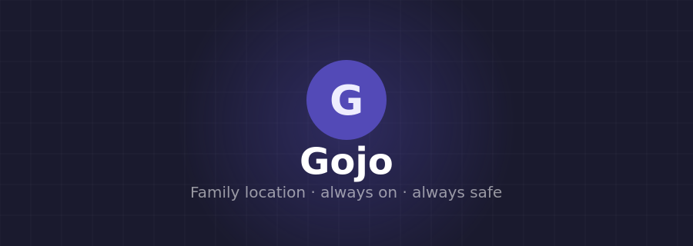

Gojo
Family Location & Safety App
Product Description Document · v1.0

1. Overview
Gojo is a family-first, always-on location sharing and quick-messaging app built for real-life family safety. Unlike commercial tracking apps that are ad-heavy, overly complex, or drain batteries, Gojo does exactly three things — and does them well:
- Shows every family member's live location on a shared map, 24 / 7
- Keeps the last known location visible even when someone is offline or in a dead zone
- Provides a lightweight group chat for quick family check-ins

Design philosophy
Gojo is built on one rule: a family member opens the app and immediately knows everyone is safe. No configuration, no dashboards, no noise. Set it once and forget it — Gojo runs quietly in the background until someone needs it.

2. App screens
Gojo has three screens. Nothing more — every feature lives within this structure.

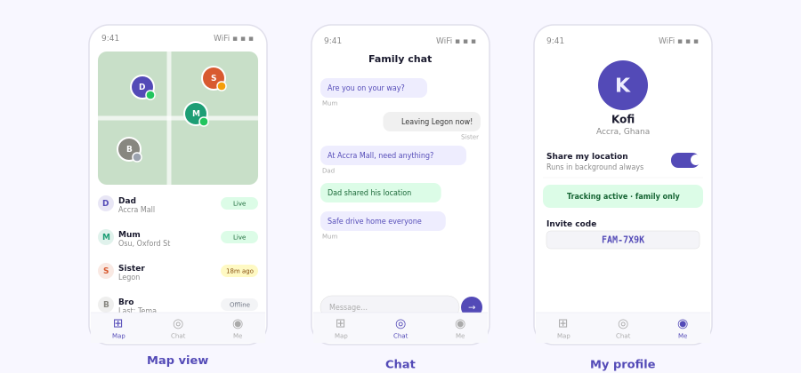
Figure 1 — Left: Live map with family pins and status indicators. Centre: Family group chat. Right: Personal profile with the master tracking toggle.

2.1 Map screen
The map screen is the home screen. Every family member appears as a coloured pin labelled with their name. Each pin carries a small status dot:
- Green dot — location updated within the last 2 minutes (live)
- Amber dot — last seen 2 – 30 minutes ago, timestamp shown on the pin label
- Grey dot — offline or app closed; pin remains at last known position with time elapsed
Tapping any pin opens a small card showing the member's name, approximate address, and how long ago the position was captured. The map auto-centres to show the entire family group on load.

2.2 Chat screen
A single flat group chat shared by the whole family. No threads, no reactions, no channels. Members send short text messages and can share their current location as a tappable map card directly inside the chat. Messages are delivered via Supabase Realtime — no polling, no delays.

2.3 Profile screen (Me)
The profile screen contains the single most important control in the app: the master tracking toggle. When on, Gojo runs in the background continuously — surviving app close, screen lock, and phone restart. When off, the member's pin disappears from all family maps instantly. The screen also shows the family invite code for onboarding new members.

3. Always-on background tracking
Gojo's most important technical feature is persistent background location. Here is exactly how it works:
Feature | Detail
Background task | Expo Task Manager registers a persistent OS-level location task. The phone operating system keeps it alive independently of the app process.
App close | Closing or swiping away the Gojo app does not stop tracking. The background task continues uninterrupted.
Phone restart | The background task auto-registers on device boot. No action needed from the user — tracking resumes automatically within seconds of the phone coming back on.
Battery saver / low power | Location updates are set to every 60 seconds with medium accuracy. This reduces GPS radio usage significantly while still providing useful family-level awareness.
No internet | The last captured location is stored locally on the device. The moment connectivity returns, the location is pushed to Supabase and becomes visible to the family again.
Offline viewer | If the person viewing the map is offline, the app serves cached locations from the last sync so the map is never blank.
Manual off | The only way tracking stops is if the user taps the toggle off themselves. No timeout, no automatic expiry.

4. Safety and anti-stalking design
Gojo is built with five independent safety layers. Even if one layer fails, the others continue to protect every member.

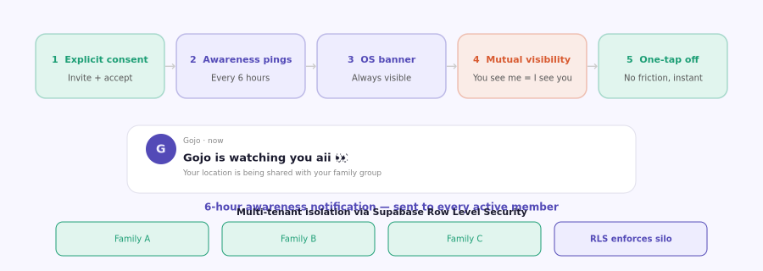
Figure 2 — The five safety layers and the 6-hour "Gojo is watching you aii" awareness notification.

Layer 1 — Explicit consent
Nobody is added to a family group silently. Joining requires entering an invite code and explicitly accepting a screen that states: "Joining this group means your family can see your location. They can also see yours." Acceptance is logged in the database with a timestamp. No acceptance, no location shared — ever.

Layer 2 — Awareness notifications
Every 6 hours, Gojo sends a push notification to every member whose tracking is active. The notification reads:

Gojo · now
Gojo is watching you aii 👀
Your location is being shared with your family group.

This notification cannot be suppressed by anyone except the phone owner. It ensures that no member can be tracked without being continually reminded that the app is active. A would-be stalker cannot use Gojo silently.

Layer 3 — Persistent OS notification banner
Both Android and iOS require a permanent notification in the status bar whenever an app is running in the background. Gojo shows "Location sharing active" at all times while tracking is on. This is enforced by the operating system — not something the app can hide.

Layer 4 — Mutual visibility
If you can see someone's location, they can see yours. This rule is absolute and enforced at the database level using Row Level Security policies — not just in the app interface. Even if someone used the API directly or found a bug in the app layer, the database would reject any query that violates mutual visibility.

Layer 5 — One-tap off, always
Any member can stop sharing their location instantly by toggling off on their profile screen. There is no confirmation dialog, no delay, and no notification sent to other family members. The pin disappears from all family maps within seconds. This freedom is essential — people who feel trapped or surveilled abandon safety tools entirely.

5. Multi-tenant architecture
Gojo is designed to serve many separate family groups — not just one. Each family group is a completely isolated tenant:
- Every family group has its own rows in the database, scoped by a unique family_id
- Supabase Row Level Security (RLS) policies ensure that a query from Family A can never return data belonging to Family B, even if the app itself has a bug
- Invite codes are unique per family and expire after use or can be regenerated
- Push notification tokens, location history, and chat messages are all siloed per family
This architecture means Gojo can be deployed as a shared service. Each family that signs up gets a completely private, invisible-to-others space with no additional infrastructure needed.

6. Technology stack
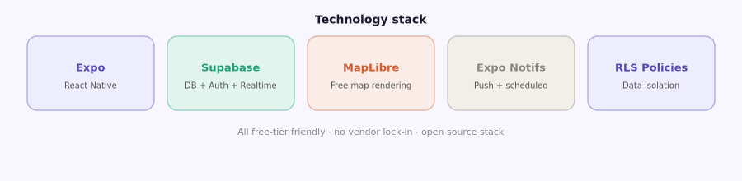
Figure 3 — Technology stack. All components are free-tier friendly.

Feature | Detail
Expo + React Native | Single codebase for iOS and Android. Expo's managed workflow removes the need for Xcode or Android Studio for most development. Expo Task Manager handles the persistent background location task.
Supabase (Auth) | Email / phone sign-up and sign-in. Session management and JWT tokens are handled automatically. No custom auth code needed.
Supabase (Database) | PostgreSQL database with Row Level Security for multi-tenant data isolation. The schema contains four core tables: users, families, locations, messages.
Supabase (Realtime) | WebSocket-based realtime subscriptions push location and chat updates to all connected family members instantly — no polling required.
Expo Location | On-device GPS access with background permission. Updates configured at 60-second intervals with medium accuracy to preserve battery life.
MapLibre GL | Free, open-source map rendering library. No API key fees, no usage limits. Renders family member pins with live status indicators.
Expo Notifications | Handles both scheduled notifications (6-hour awareness pings) and push notifications for incoming chat messages. Works on iOS and Android.

7. Database schema
The core schema is deliberately minimal. Four tables handle everything Gojo needs:
Feature | Detail
families | id (uuid PK), name, invite_code (unique), created_at
users | id (uuid PK), family_id (FK → families), name, avatar_url, email, created_at
locations | id (uuid PK), user_id (FK → users), latitude, longitude, accuracy, speed, updated_at — one row per user, updated in place on each GPS fix
messages | id (uuid PK), family_id (FK → families), sender_id (FK → users), text, sent_at

RLS policy pattern
Every table carries a Supabase RLS policy of the form: "Allow SELECT only where family_id = (SELECT family_id FROM users WHERE id = auth.uid())". This means a user can only ever read rows belonging to their own family group — enforced by the database engine, not the application.

8. Build phases
Feature | Detail
Phase 1 — Foundation | Supabase project setup · database schema + RLS policies · Expo project scaffold · auth flow (sign up, sign in, join family with invite code)
Phase 2 — Live map | Expo Location background task · location writes to Supabase · MapLibre map screen · family member pins with live / stale / offline status
Phase 3 — Chat | Messages table + Supabase Realtime subscription · chat screen UI · location-share message card
Phase 4 — Safety layer | 6-hour scheduled awareness notifications · persistent OS background notification · mutual visibility enforcement · one-tap off
Phase 5 — Polish | Offline caching of last known locations · phone restart auto-resume · invite code management · family member profile avatars

9. What Gojo deliberately is not
These features were considered and excluded to keep Gojo focused and trustworthy:
- No location history or playback — Gojo shows where people are, not where they have been
- No arrival / departure alerts — these create anxiety and encourage obsessive checking
- No admin roles or one-way watching — all members have identical permissions
- No ads, no data selling, no analytics passed to third parties
- No speed or route tracking — Gojo is family safety, not surveillance

Core promise
Every person in a Gojo family group knows exactly what is shared, who can see it, and how to stop it at any moment. Trust is the product.

Gojo · Family Location & Safety App · Product Description v1.0

