Gojo
Family Location & Safety App
Product Description Document · v2.0 · New features addendum
About this document
This is the v2.0 addendum to the Gojo Product Description (v1.0). It covers five new features added to the app: battery level display, signal/connectivity indicator, SOS emergency button, named places, and Twi language support. The v1.0 document covers the core app — read both together for the full picture.

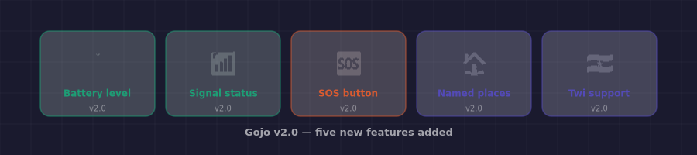
Figure 1 — The five features added in Gojo v2.0.

10. New features — v2.0
These five features were added after the core app was defined. Each one was chosen because it either makes Gojo meaningfully safer or meaningfully easier to use for the real people it is built for — families in Ghana where battery anxiety, signal drops, and language are real daily factors.

10.1 Battery level display
Every family member pin on the map now shows their phone's current battery percentage. The colour of the battery indicator changes based on level:
- Green — 30% and above, no concern
- Amber — 15–29%, worth noting
- Red — below 15%, location updates may stop soon
This is genuinely useful information that no amount of messaging replaces. If Dad's pin shows 4% battery, the family knows he may go offline shortly — they can call now rather than wonder later why his pin disappeared.

How it works technically
Expo's Battery API provides the current level as a number between 0 and 1. This is included in every location update sent to Supabase and stored as battery_level (float) in the locations table. No extra permissions needed — battery access is included in the standard Expo location permission bundle.

10.2 Signal / connectivity indicator
Alongside battery, each family member's pin card shows their current connectivity type: WiFi, 4G, 3G, 2G, or No signal. This solves a specific problem: when someone's location goes stale, the family can see whether it is because they are offline (no signal) or simply not moving (stale but connected).
- WiFi — strong connectivity, location updates are reliable
- 4G / 3G — mobile data, updates may be slightly delayed
- 2G — weak signal, updates may be infrequent
- No signal — device is offline, showing last known location
This small piece of information dramatically reduces anxiety. "Sister's pin hasn't moved in 20 minutes" means something very different if she's on WiFi versus No signal.

How it works technically
Expo's NetInfo API returns the connection type synchronously on every location update. The value is stored as signal_type (text) in the locations table alongside the coordinates. No additional permissions required.

10.3 SOS / I need help button
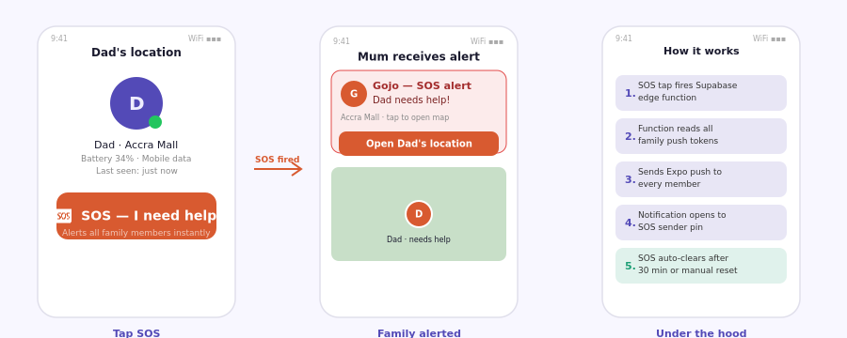
Figure 2 — Left: the SOS button on a member's pin card. Centre: the alert received by family. Right: the technical flow.
The SOS button is the single most important addition to Gojo v2. It transforms the app from a passive tracker into an active safety tool.
Every family member's pin card (the screen that opens when you tap a pin) has a large red SOS button at the bottom. Tapping it fires an urgent push notification to every other member of the family group simultaneously, regardless of whether the Gojo app is open on their phones.
The notification reads:

Gojo — SOS alert
[Name] needs help!
[Last known location]
Tap to open their location on the map.

Tapping the notification opens Gojo directly to that person's pin with their exact coordinates. The SOS state is visible to all family members on the map — the pin pulses red until the person manually clears it or 30 minutes pass.

Item | Detail
Who can trigger it | Any family member from any other member's pin card — including their own
Who receives it | Every other member in the family group, via push notification
What it shows | Name, last known location, and a direct link to their pin on the map
How it clears | The SOS sender taps "I'm OK" in the app, or it auto-clears after 30 minutes
False alarm protection | Requires a 2-second hold, not a single tap — prevents accidental triggers
Offline behaviour | The SOS is queued in Supabase and delivered the moment the sender regains connectivity

How it works technically
Tapping SOS calls a Supabase Edge Function. The function writes a row to the sos_alerts table (with sender_id, family_id, lat, lng, and created_at), then queries all push tokens for the family group and fires Expo push notifications in a single batch call. The entire flow takes under 2 seconds end to end.

10.4 Named places — Home, School, Work
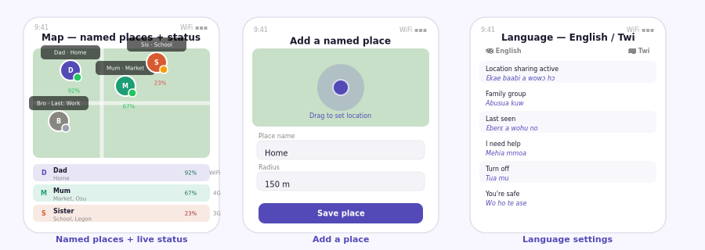
Figure 3 — Left: map with named place labels and battery/signal. Centre: add a place screen. Right: language settings with English and Twi side by side.
Named places let each family member save a small number of significant locations — Home, School, Work, Church, Market — with a custom name and a radius (default 150 metres). When a family member's GPS coordinates fall within that radius, their pin label shows the place name instead of a raw street address.
This makes the map readable for everyone, especially older family members who navigate by landmark rather than by address. "Mum is at Market" is instantly understood. "Mum is at 14A Oxford St, Osu" requires interpretation.
- Each family member can save up to 10 named places
- Place names are personal — only visible to the person who created them
- Radius is adjustable from 50m to 500m to suit the location (home vs. a large market)
- If outside all saved places, the app falls back to a reverse-geocoded address

How it works technically
A saved_places table stores each place as a lat/lng point + radius in metres. On every location update, the app checks whether the new coordinates fall within any of the user's saved place radii (simple Haversine distance check, done client-side). If yes, the place name is included in the location update sent to Supabase and displayed on all family members' maps.

10.5 Twi / local language support
Gojo v2 ships with English and Twi as the two supported languages. The phone's system language setting determines which is shown by default, with a manual override available in the profile screen.
The translated strings cover the six most important phrases in the app — the ones that matter most for the people least comfortable with English:
Item | Detail
English | Twi
Location sharing active | Ɛkae baabi a wowɔ hɔ
Family group | Abusua kuw
Last seen | Ɛberɛ a wohu no
I need help | Mehia mmoa
Turn off | Tua mu
You're safe | Wo ho te ase

Additional languages can be added as simple JSON translation files — no code changes needed. French (for Francophone West Africa) and Hausa are the suggested next additions.

Why this matters
If a family member does not fully understand what a button does, they will not use it — or worse, they will distrust the app. An SOS button labelled in Twi is one that a grandmother in Accra will press without hesitation in an emergency. That is the whole point.

11. Updated database schema — v2.0
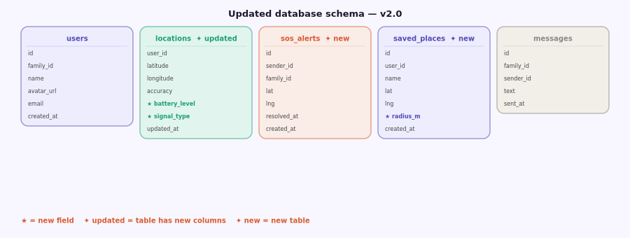
Figure 4 — Updated schema showing new fields (★) and new tables. Existing tables not shown are unchanged from v1.0.
The v2.0 schema adds two new tables and two new columns to the existing locations table:
Item | Detail
locations.battery_level | Float (0.0–1.0). Added to every location update. Stored alongside coordinates.
locations.signal_type | Text (WiFi / 4G / 3G / 2G / none). Added to every location update.
sos_alerts (new table) | id, sender_id (FK→users), family_id (FK→families), lat, lng, resolved_at (nullable), created_at. One row per SOS event. resolved_at is set when sender taps "I'm OK" or 30 minutes elapse.
saved_places (new table) | id, user_id (FK→users), name (text), lat, lng, radius_m (integer, default 150), created_at. Max 10 rows per user, enforced by RLS policy.

RLS on new tables
sos_alerts: members can INSERT where their family_id matches, and SELECT all alerts for their family_id. saved_places: members can INSERT, UPDATE, DELETE only their own rows (user_id = auth.uid()), and SELECT only their own saved places — place names are private.

12. Updated build phases — v2.0
The five new features slot into the existing build plan as an extended Phase 5:
Item | Detail
Phase 5a — Battery + signal | Add battery_level and signal_type columns · update location task to read Expo Battery + NetInfo APIs · update map pin UI to show coloured battery indicator and signal badge
Phase 5b — Named places | Create saved_places table + RLS · build add-place screen with map pin drag and radius slider · update location update logic to check proximity · update pin label rendering
Phase 5c — SOS button | Create sos_alerts table + RLS · write Supabase Edge Function for batch push · add SOS button to pin card UI · add 2-second hold gesture · add "I'm OK" clear button · add pulsing red state to map pin
Phase 5d — Language | Set up i18n with expo-localization · create en.json and tw.json translation files · add language picker to profile screen · wrap all user-facing strings in translation calls

Gojo · Family Location & Safety App · Product Description v2.0

