Beginner Basics of C#

Module 5 – C# IF, Switch, For, While loop Statement
Both For and While loops allow you to repeat a block of code multiple times, but they are used in different scenarios based on whether you know exactly how many times the code needs to run.
The While Loop
A while loop is used when the number of iterations is unknown beforehand. It keeps running as long as a specific condition remains true. You use it when you say, "Keep running until the user types 'exit'" or "Keep running until the player's health reaches zero."
Structure: It only contains the condition. You must manage the changes to that condition inside the loop body.
Example: The while Loop (User Interaction)
Now imagine a login screen. You want to keep asking the user for a password until they get it right. You have no idea if they will get it on the 1st try or the 100th try, so you use a while loop.
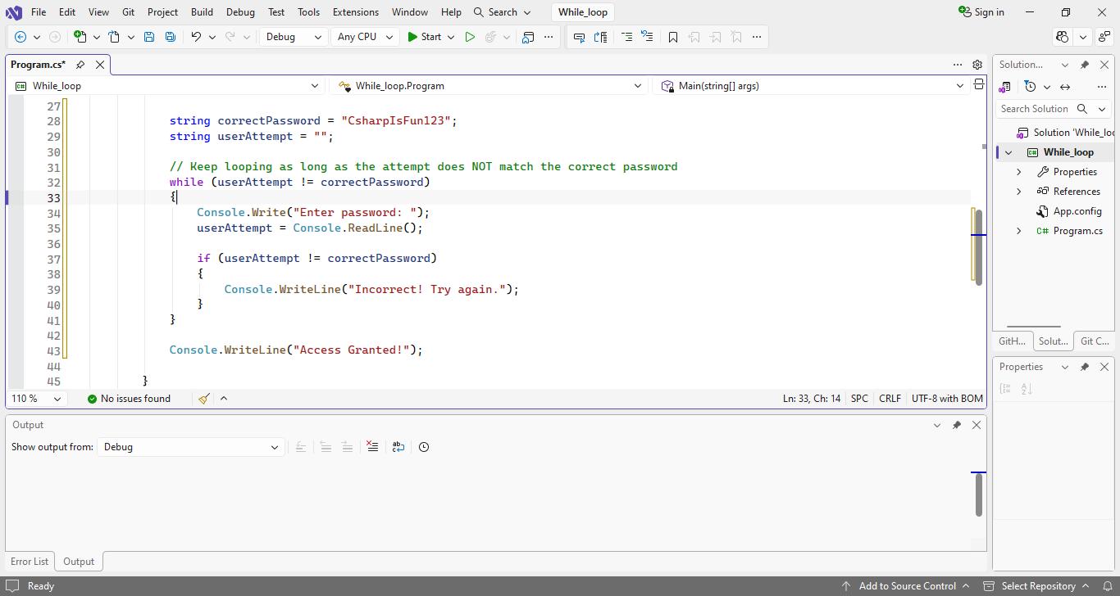
OutPut:
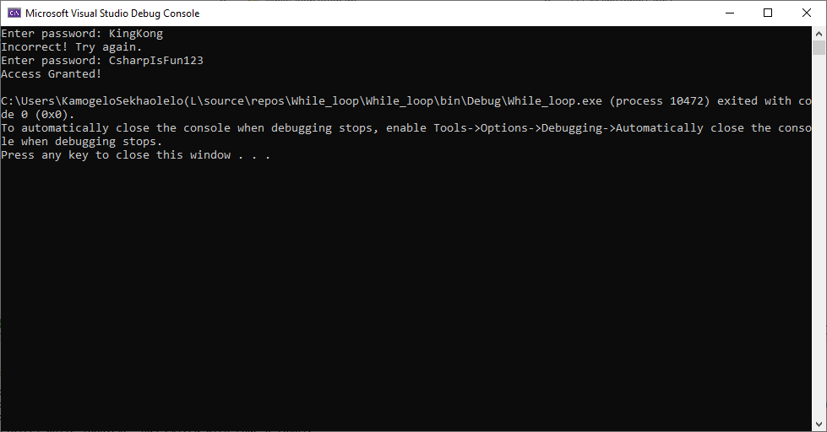
As you can see from the example above, I displayed 2 inputs which is both correct and incorrect password. Every time I enter an incorrect password the “Try again.” Prompt will continue to loop indefinitely until I enter a correct password then the loop stops

The For Loop:
A for loop is generally used when you have a fixed number of iterations. You use it when you can say, "Run this code exactly 10 times" or "Run this for every item in this list."
Example: The for Loop (Processing Data)
Imagine you are building a simple shopping cart. You have an array (a list) of item prices, and you need to calculate the total. Since you know exactly how many items are in the list, a for loop is perfect.
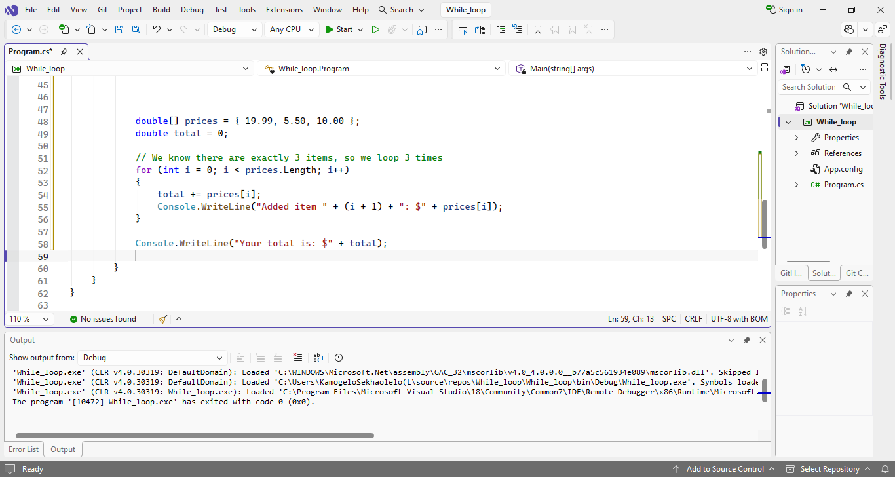

OutPut:
