Food Trends & Understanding Customer Preferences in FB
Power BI Analytics Project Report

Prepared by
Sonta Ramesh
Tool Used
Microsoft Power BI

- Introduction
This project analyzes food trends and customer preferences using the Food.com dataset. The primary objective is to understand customer engagement patterns, product performance, sentiment behavior, and potential strategic opportunities derived from review-based interactions. Food platforms generate a large amount of user-generated data, including ratings, reviews, and engagement metrics. Analyzing this data helps organizations identify popular product segments, understand user satisfaction, and improve product recommendations. By leveraging Microsoft Power BI, this project transforms raw recipe and review data into interactive dashboards and analytical visualizations. These dashboards provide insights into recipe popularity, sentiment distribution, health-related preferences, and behavioral engagement patterns. The insights generated from this analysis can support product strategy, marketing decisions, and future innovation by identifying high-performing categories and uncovering potential growth opportunities.

- Problem Statement
Food platforms generate large volumes of user interaction data through ratings, reviews, and engagement with various recipes. While this data provides valuable information about user preferences, extracting meaningful insights from it can be challenging without proper analytical tools and visualization techniques.
Understanding how customers interact with recipes is essential for identifying popular categories, improving product recommendations, and enhancing user experience. By analyzing engagement patterns and sentiment behavior, organizations can better understand customer preferences and identify opportunities for product improvement and marketing strategies.
The goals of this analysis are:
- Understand customer engagement behavior
- Identify high-performing recipe categories
- Analyze satisfaction patterns
- Evaluate health impact on customer preferences
- Detect emerging opportunities for product promotion
- Translate analytical insights into business strategies

- Dataset Description
This project uses two datasets obtained from the Food.com platform. These datasets contain information about recipes and user reviews, which together enable analysis of engagement patterns, sentiment behavior, and product performance.
Recipes Dataset
The Recipes dataset contains recipe-level attributes that describe the characteristics of each recipe available on the platform. The main fields included in this dataset are:
RecipeId – Unique identifier for each recipe
RecipeCategory – Category or type of recipe
Preparation Time – Time required to prepare the recipe
Nutrition Details – Nutritional information such as protein, fat, and sugar values
AuthorId – Identifier of the recipe creator
DatePublished – Date when the recipe was published
Reviews Dataset
The Reviews dataset contains user-generated interactions with recipes in the form of ratings and reviews. These fields help analyze customer satisfaction and engagement patterns.
ReviewId – Unique identifier for each review
RecipeId – Identifier linking the review to a specific recipe
Rating – User rating provided for the recipe
Review Text – Written feedback from the user
DateSubmitted – Date when the review was submitted
Relationship Between Datasets
The Recipes and Reviews datasets are connected using the RecipeId field. A one-to-many relationship exists between the tables, where one recipe can have multiple user reviews. This relationship allows review data to be analyzed based on recipe categories and other recipe attributes.
- Data Extraction
The dataset used in this project was obtained from Kaggle and downloaded in CSV (Comma Separated Values) format. The dataset contains two main tables: recipes and reviews, which provide information about recipe attributes and user interactions.
To begin the analysis, the CSV files were imported into Microsoft Power BI. During the import process, the column headers were promoted to ensure that each column was correctly labeled. After importing the data, the dataset structure was validated by checking the column names, data types, and row counts.
Additional verification steps were performed to confirm that the data had been imported correctly. This included reviewing column consistency and ensuring that the dataset matched the expected schema. These validation steps helped ensure that the data was accurate and ready for the next stages of data cleaning and transformation.

- Data Cleaning
Several data cleaning steps were performed to ensure that the dataset was accurate, consistent, and suitable for analysis. Data cleaning is an important step in the data preparation process because raw datasets often contain unnecessary attributes, missing values, or formatting issues that can affect analytical results.
Column Removal
During the initial review of the dataset, several columns were identified as irrelevant for analytical purposes and were therefore removed. These included:
Images
RecipeInstructions
Keywords
AuthorName
Description
These fields primarily contained descriptive or multimedia information that was not required for the analytical objectives of this project.
Handling Missing Values
The dataset contained missing values represented as NA. Instead of deleting rows containing missing data, these values were replaced with NULL. This approach helped prevent unnecessary data loss while still allowing the dataset to be used for analysis.
Error Handling
Some columns generated errors during data type conversion. These errors were handled by replacing them with NULL values instead of removing the entire rows. This ensured that valid data within those rows could still be retained for analysis.
Through these cleaning steps, the dataset was prepared for further transformation and analytical modeling.

- Data Transformation
After completing the data cleaning process, several data transformation steps were performed using Power Query in Microsoft Power BI. Data transformation helps convert raw data into a structured format that is suitable for analysis and visualization. These steps ensured that the dataset was consistent, properly formatted, and ready for analytical modeling.
Date Processing
The original dataset contained datetime values that combined both date and time information in a single field. These values were split into separate Date and Time components to improve readability and enable time-based analysis. Additionally, a new column called Review Year was created to support trend analysis and yearly comparisons.
Duration Conversion
Preparation time values were initially stored in duration format. These values were converted into numeric minutes to simplify calculations and enable aggregation in Power BI visuals such as averages and comparisons across recipe categories.
Outlier Handling
During data transformation, extreme values were identified and filtered. For example, preparation times exceeding 1440 minutes (24 hours) were considered unrealistic and were removed from the dataset to maintain analytical accuracy.
These transformation steps ensured that the dataset was well-structured and suitable for further data modeling and dashboard development.

Data Modeling

After completing the data cleaning and transformation stages, a data model was created in Microsoft Power BI to establish relationships between the datasets. Data modeling is an essential step in the analytical process because it allows different tables to interact with each other and enables meaningful analysis across multiple data sources.
The model connects the Recipes table and the Reviews table using the RecipeId field. A one-to-many relationship was established where one recipe can have multiple user reviews. In this relationship, the Recipes table acts as the primary table, while the Reviews table contains multiple records linked to each recipe.
This relationship allows review data to be analyzed by recipe attributes such as category, preparation time, and nutritional values. By connecting these tables, it becomes possible to evaluate customer engagement, sentiment patterns, and product performance across different recipe categories.
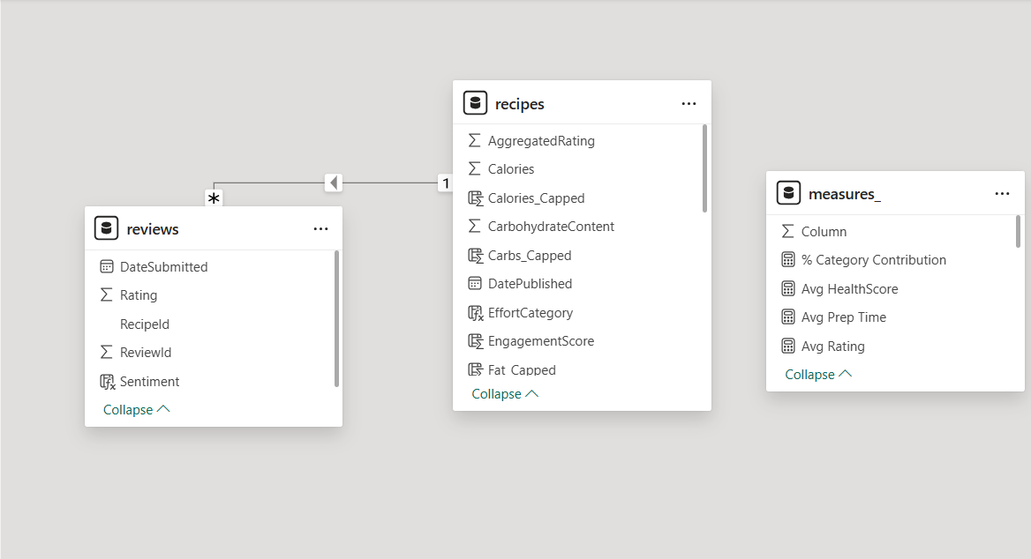
Figure 1: Power BI Data Model Showing Relationship Between Recipes and Reviews Tables
The data model ensures that review information can be accurately aggregated and filtered based on recipe characteristics, enabling deeper analytical insights within the Power BI dashboards.

DAX Measures and Calculations

To support the analytical dashboards, several measures were created using Data Analysis Expressions (DAX) in Power BI. DAX measures allow dynamic calculations to be performed on the dataset and enable the creation of key performance indicators (KPIs) used throughout the dashboards.
These measures help summarize engagement metrics, calculate sentiment distributions, evaluate product performance, and identify strategic insights from the dataset.
Some of the key measures developed in this project include:
- Total Recipes – Calculates the total number of recipes available in the dataset.
- Total Reviews – Counts the number of reviews submitted by users.
- Average Rating – Determines the average rating given by users across all recipes.
- Engagement Score – A composite metric calculated by multiplying the average rating with the total number of reviews to estimate overall engagement performance.
- HealthScore – A derived metric based on nutritional components such as protein, fat, and sugar to evaluate recipe health impact.
- Positive Sentiment Percentage – Calculates the proportion of reviews with ratings greater than or equal to four.
- Category Contribution Percentage – Measures the contribution of each recipe category to the overall engagement.
- Hidden Gem Category – Identifies categories with high ratings but relatively lower engagement, indicating potential opportunities for promotion.
These DAX measures enabled the creation of meaningful KPIs and supported the advanced analytical visualizations used throughout the Power BI dashboards.

Overview Dashboard

This section provides a high-level summary of the overall platform engagement and key performance indicators derived from the dataset.
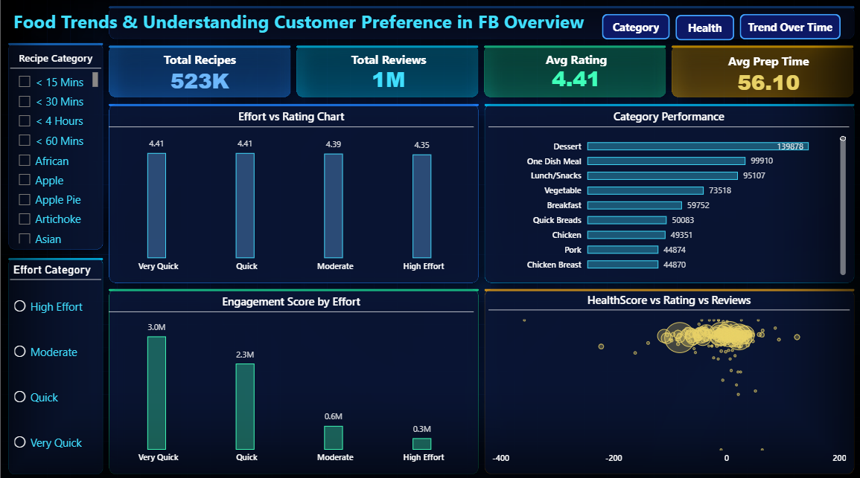Figure 1: Overview Dashboard – Engagement Summary
The overview dashboard highlights important metrics such as total recipes, total reviews, average rating, and average preparation time. These indicators help provide a quick understanding of user engagement and overall platform activity. The analysis shows strong interaction with recipes and consistently high ratings, indicating positive user satisfaction across the platform.

Category & Popularity Analysis

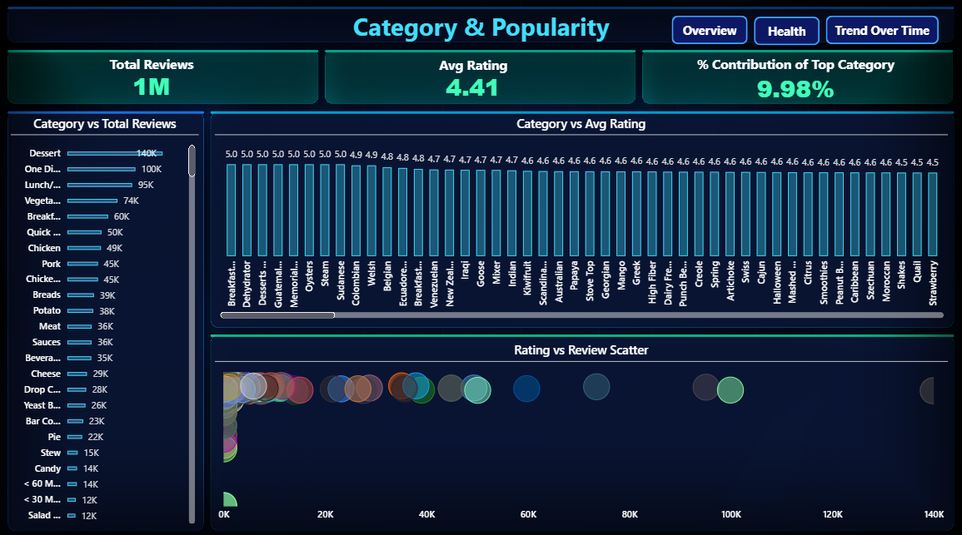
This section evaluates the performance of different recipe categories based on engagement and user interaction.

Figure 2: Category Performance and Popularity Analysis
The dashboard analyzes recipe categories using review counts and average ratings. The results show that dessert recipes generate the highest engagement among users, followed by one dish meals and lunch/snack categories. These categories not only attract large numbers of reviews but also maintain strong rating scores, indicating high customer satisfaction and popularity.

Health & Preference Analysis

This section explores the relationship between nutritional characteristics of recipes and customer engagement.
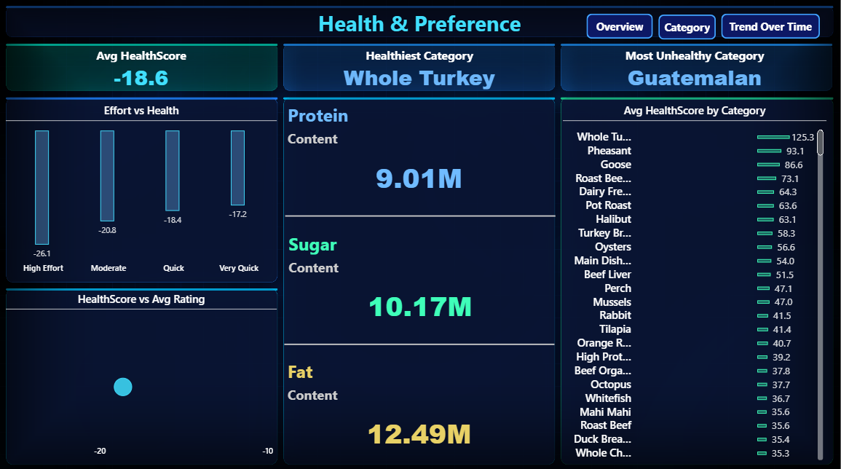Figure 3: Health Score and Preference Analysis
A HealthScore was developed using nutritional components such as protein, fat, and sugar to evaluate the health impact of recipes. The analysis reveals that recipes with higher health scores do not necessarily receive higher engagement or ratings. This suggests that users tend to prioritize taste, convenience, and familiarity over nutritional factors when selecting recipes.

Sentiment Analysis Dashboard

This section analyzes user sentiment based on review ratings and evaluates overall customer satisfaction.
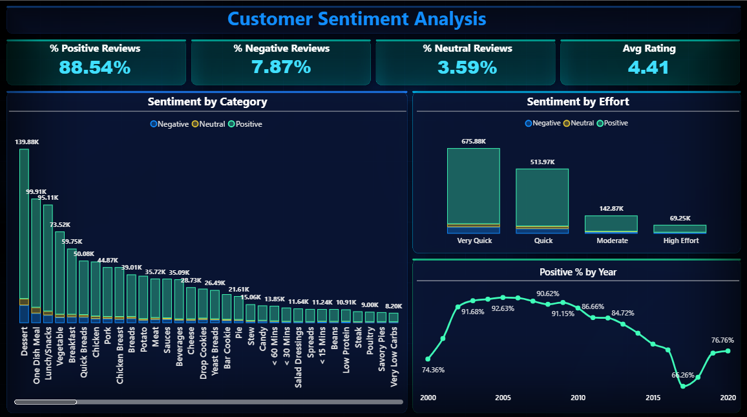Figure 4: Customer Sentiment Analysis Dashboard
Reviews were categorized into positive, neutral, and negative sentiment groups based on rating values. The results indicate that more than 88% of reviews are positive, demonstrating strong satisfaction with the recipes available on the platform. Quick and very quick recipes tend to receive higher positive sentiment, highlighting the importance of convenience in customer engagement.

Enhanced Performance Analysis
This section provides deeper analytical insights by examining performance relationships between engagement, satisfaction, and recipe characteristics.
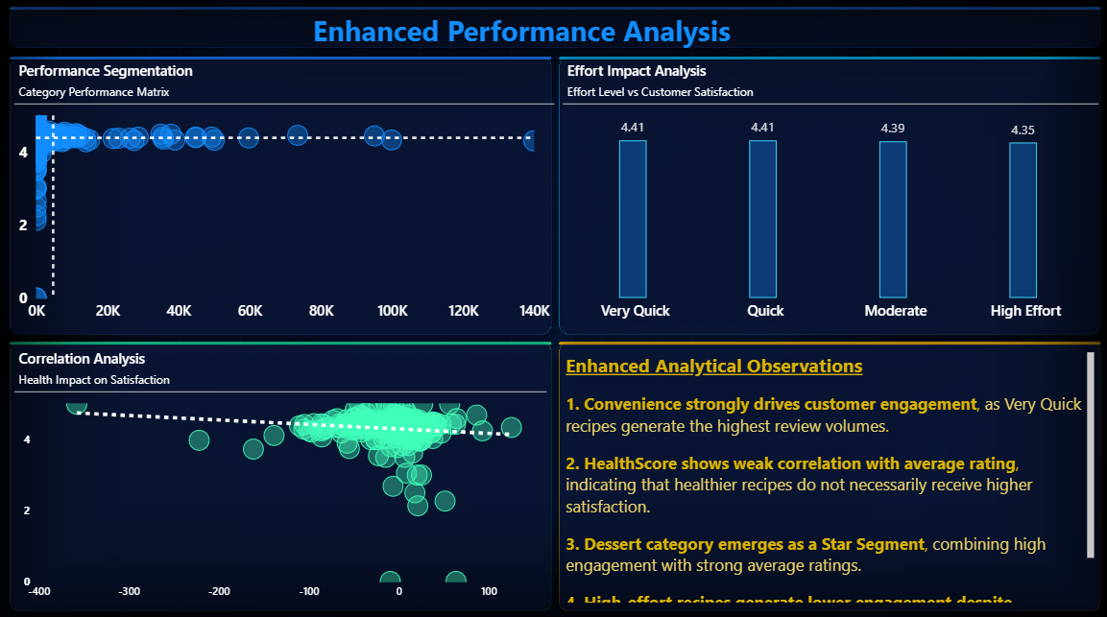Figure 8: Enhanced Performance Analysis Dashboard
The enhanced analysis evaluates category performance using metrics such as total reviews, average ratings, and health score relationships. Scatter plots and comparative visualizations help identify high-performing categories and potential opportunity segments. The analysis shows that popular categories maintain high engagement levels while convenience-oriented recipes tend to receive higher satisfaction scores.

Trend Over Time Dashboard

This section investigates how user engagement and satisfaction have evolved over time.
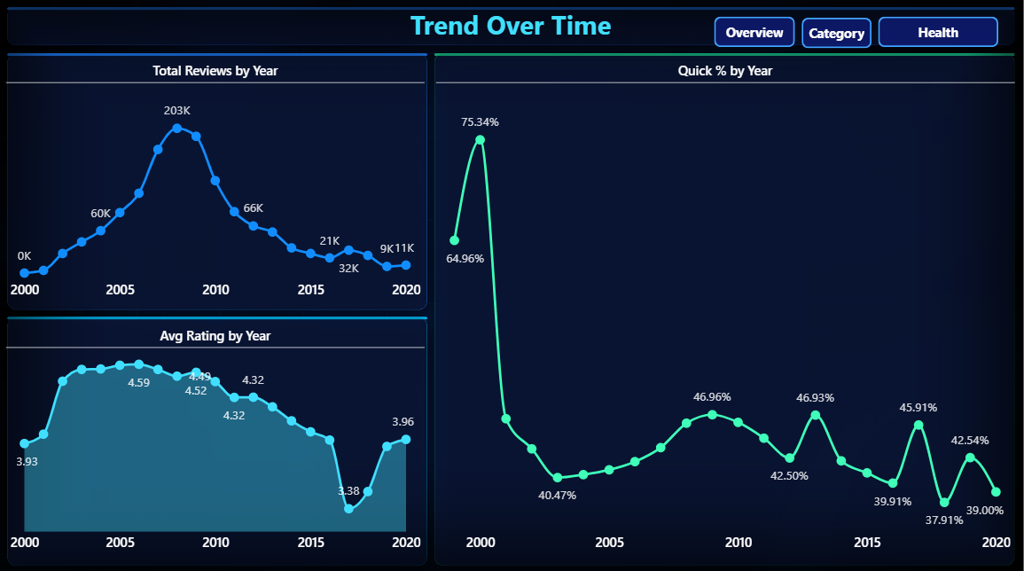Figure 5: Engagement Trend Over Time
The dashboard visualizes review activity and rating trends across different years. The analysis indicates that engagement reached its peak around the mid-2000s and gradually declined afterward. Despite this decrease in activity, the average rating remains relatively stable, suggesting that user satisfaction with recipes has remained consistent.

Product Insight Module

This section focuses on translating analytical findings into product-level insights that support strategic decision-making.
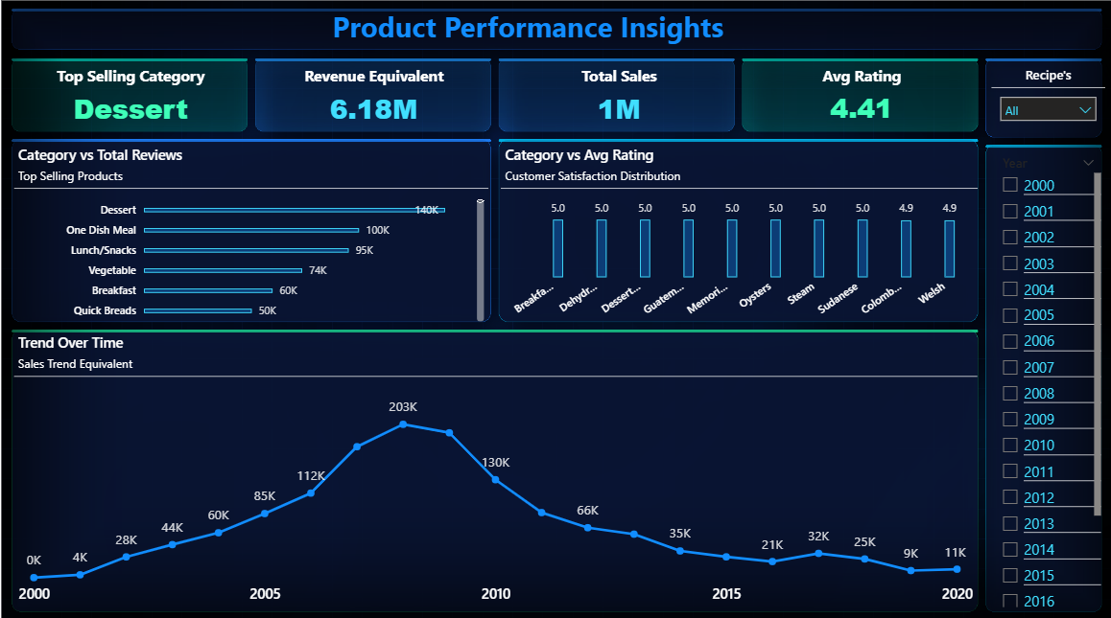Figure 9: Product Insight and Performance Dashboard
The product insight dashboard highlights the top-performing recipe categories based on engagement and satisfaction metrics. It identifies categories with strong customer demand as well as emerging opportunity areas. By analyzing product-level engagement patterns, this dashboard helps understand which recipe segments drive the most interaction and where potential improvements or promotions could be implemented.

Customer Behavior Segmentation

This section segments users based on their rating behavior to better understand engagement patterns.
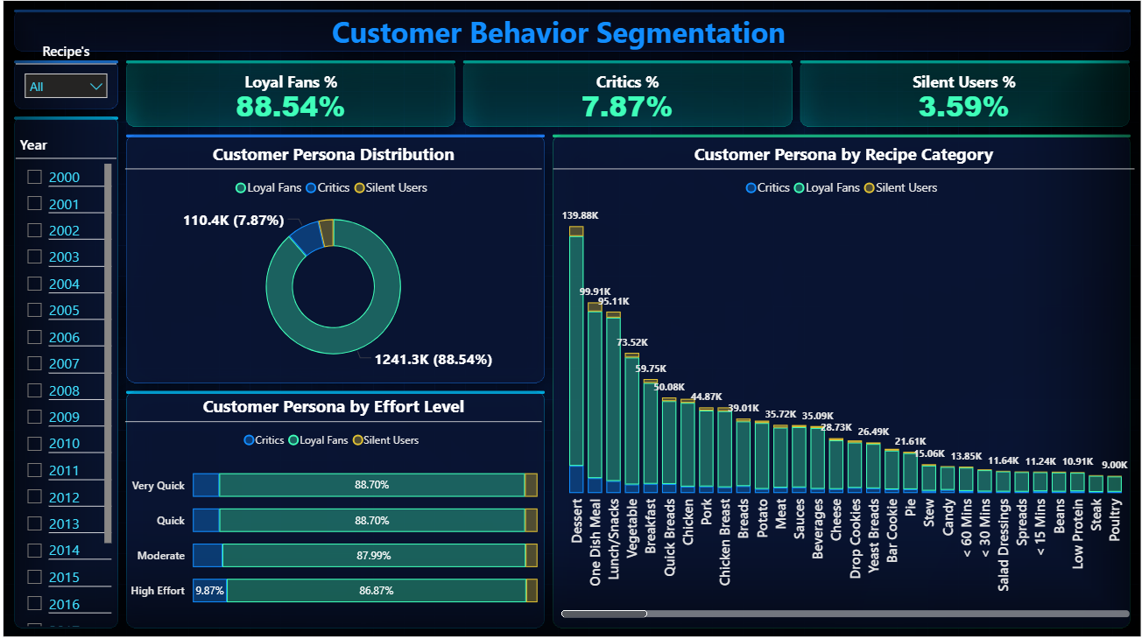Figure 6: Engagement-Based Customer Behavior Segmentation
Customers were categorized into Loyal Fans, Silent Users, and Critics based on their rating behavior. The results show that the majority of users belong to the Loyal Fans segment, contributing to the majority of positive reviews. Critics represent a small portion of users, while Silent Users provide neutral feedback. This segmentation helps understand how different customer groups interact with recipe categories.

Strategy & Innovation Dashboard

This section translates analytical findings into actionable business insights for product and marketing strategies.
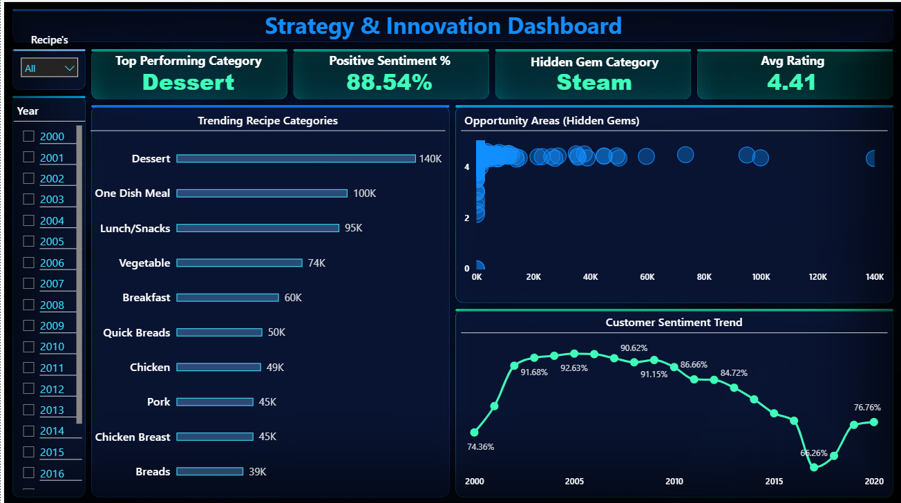Figure 7: Strategy and Innovation Insights Dashboard
The dashboard highlights top-performing recipe categories, overall customer sentiment, and potential growth opportunities. Dessert appears as the most engaging category, while certain high-rated but less visible categories represent hidden opportunities for promotion. These insights can help guide marketing strategies, improve product recommendations, and support future innovation.

Limitations

Although the analysis provides valuable insights into food trends and customer engagement patterns, the dataset used in this project has certain limitations that restrict the scope of the analysis. These limitations primarily relate to the absence of detailed customer and financial information.
The main limitations of the dataset include:
- No customer identifiers – The dataset does not contain unique user identifiers such as UserId or ReviewerId. Because of this, detailed customer-level segmentation and behavioral tracking cannot be performed.
- No geographic data – The dataset does not include location-based information such as country or region. As a result, geographic preference analysis or regional trend comparisons cannot be conducted.
- No transactional revenue data – The dataset does not include financial information such as sales revenue, purchase transactions, or pricing data. This limits the ability to perform revenue-based performance analysis or profitability evaluation.
Due to these limitations, the analysis focuses primarily on engagement metrics and review-based insights rather than financial or demographic analysis.

Future Scope

Although this analysis provides valuable insights into food trends and customer engagement patterns, there are several opportunities to expand and enhance the analysis in future work. Incorporating additional data sources and advanced analytical techniques could provide deeper insights and improve decision-making capabilities.
Potential improvements for future analysis include:
- Adding demographic attributes – Including user demographic information such as age, gender, or location would allow more detailed customer segmentation and behavioral analysis.
- Including transactional revenue data – Access to financial information such as sales revenue, purchase history, and pricing data would enable profitability analysis and more accurate performance evaluation.
- Implementing advanced customer segmentation methods – Techniques such as RFM (Recency, Frequency, Monetary) analysis or clustering algorithms could help identify distinct customer segments and engagement patterns.
- Applying machine learning models for trend prediction – Predictive models could be developed to forecast future engagement trends, identify emerging recipe categories, and support data-driven product strategy.
By incorporating these improvements, future studies could generate more comprehensive insights and support more advanced analytics.

Conclusion

This project analyzed food trends and customer preferences using the Food.com dataset. By applying data cleaning, transformation, modeling, and visualization techniques in Microsoft Power BI, meaningful insights were extracted from recipe and review data. The analysis helped identify customer engagement patterns, category performance, sentiment trends, and strategic opportunities for product promotion.
The project demonstrates the following key analytical outcomes:
- End-to-end data preparation including cleaning, transformation, and validation
- Advanced analytical modeling using Power BI and DAX measures
- Multi-layer dashboard development for engagement, sentiment, and category performance analysis
- Business-oriented KPI simulation to represent engagement and product performance
- Strategic insight generation to support product and marketing decision-making
Final Insight
The analysis shows that customer engagement on food platforms is primarily driven by convenience-oriented and indulgent recipe categories. At the same time, several high-rated but less visible categories represent potential opportunities for growth, promotion, and product innovation.

