NFC MCU-reader product

Specification and Information

Ha Noi, Apr 2022

Author: T.T.Son

Document for product version 0.0.1, 0.0.2

# Section 1: Introduction

...

# Section 2: MCU hardware specs and graph

* Required OS: standard linux, ubuntu
* CPU specs: Quad-core 64-bit SoC @ 1.5GHz ([https://gadgetversus.com/processor/broadcom-bcm2711b0-specs](https://gadgetversus.com/processor/broadcom-bcm2711b0-specs/) [/](https://gadgetversus.com/processor/broadcom-bcm2711b0-specs/))

|  |  |
| --- | --- |
| Cache memory | 1 MB |

* GPU specs: Broadcom VideoCore VI. Reach 41.4 fps at (1280×720) resolution

|  |  |
| --- | --- |
| Max. Memory: | 2 GB |

|  |  |  |  |
| --- | --- | --- | --- |
| GPU frequency | FP16 (Half Precision) | FP32 (Single Precision) | FP64 (Double Precision) |
| 0.50 GHz | 64 GFLOPS | 32 GFLOPS | 8 GFLOPS |

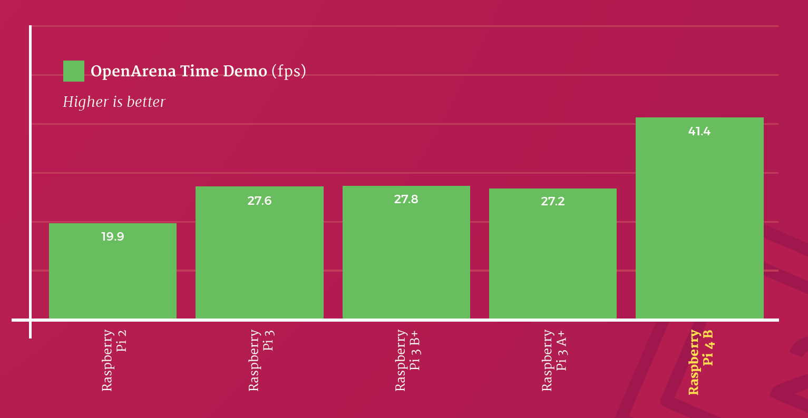

* System RAM: 2 GB
* Memory bandwidth: read, write BW is approximately 4129, 4427 MBps respectively

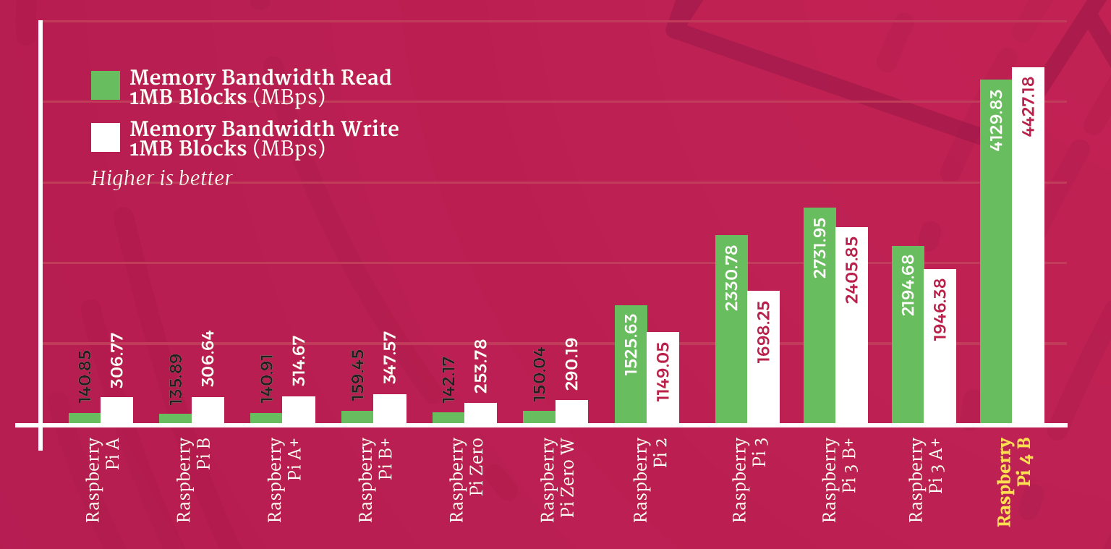

* Connectivity: Bluetooth 5.0 (optional), 1 × USB 3.0 ports, 1 × USB 2.0 ports, Gigabit Ethernet
* GPIO: Standard GPIO header (optional), should support python GPIO library

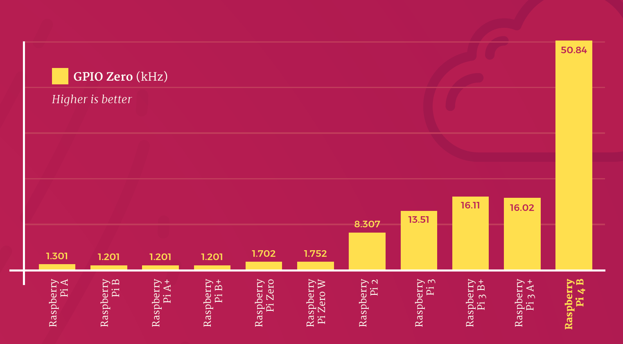

* Video & sound: 1 × HDMI ports (up to 4Kp60 supported), 2-lane MIPI DSI display port
* Multimedia: H.265 (4Kp60 decode); H.264 (1080p60 decode, 1080p30 encode); OpenGL ES, 3.0 graphics
* SD card support: Micro SD card slot for loading operating system and data storage (16,32,64,128,256 GB, etc)
* Dimensions: 88 mm × 58 mm × 19.5 mm, 46 g
* Input power: N/A
* Environment: N/A

# Section 3: Reader hardware specs

…

# Section 4: Firmware (OS) and software specs and info

* Required OS: standard linux, ubuntu

Reference:

1. <https://magpi.raspberrypi.com/articles/raspberry-pi-4-specs-benchmarks>
2. [https://gadgetversus.com/processor/broadcom-bcm2711b0-specs](https://gadgetversus.com/processor/broadcom-bcm2711b0-specs/)
3. <https://www.cpu-monkey.com/en/igpu-broadcom_videocore_vi-221>