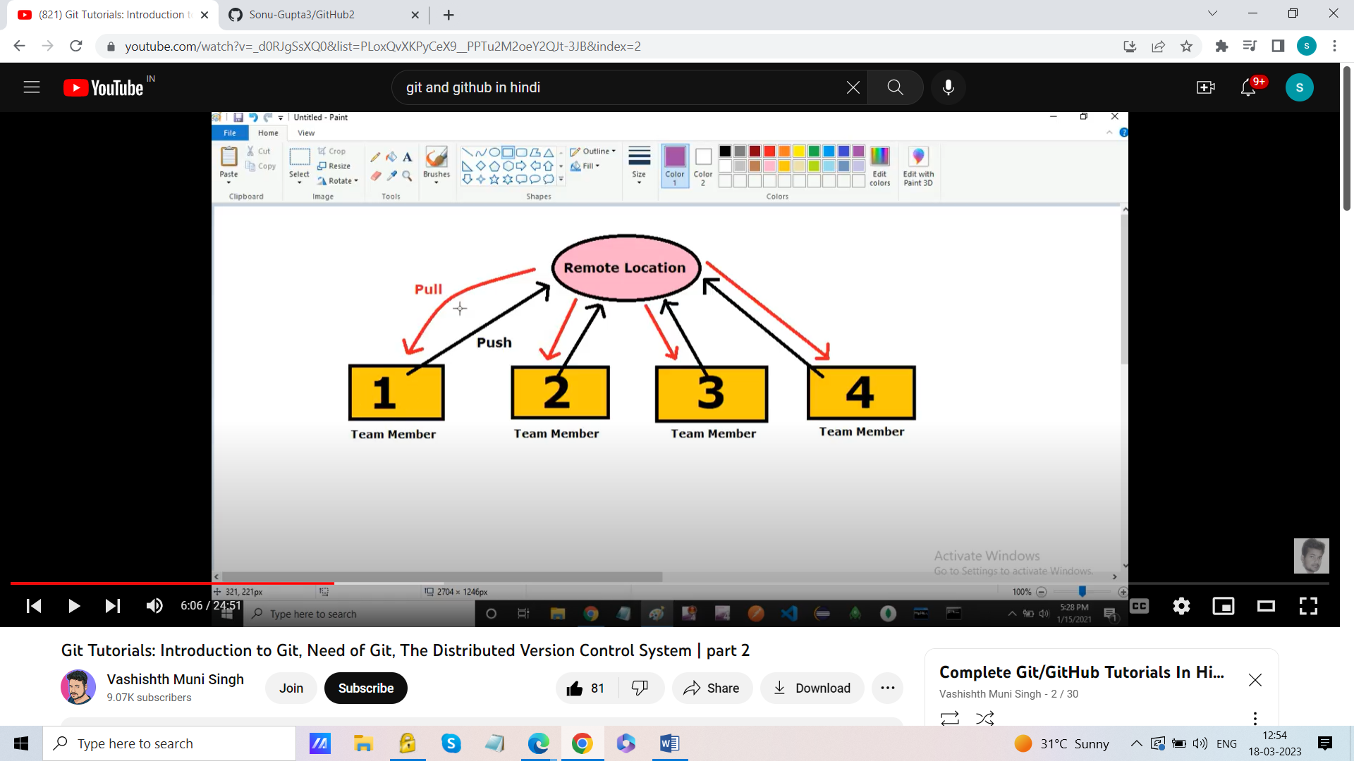

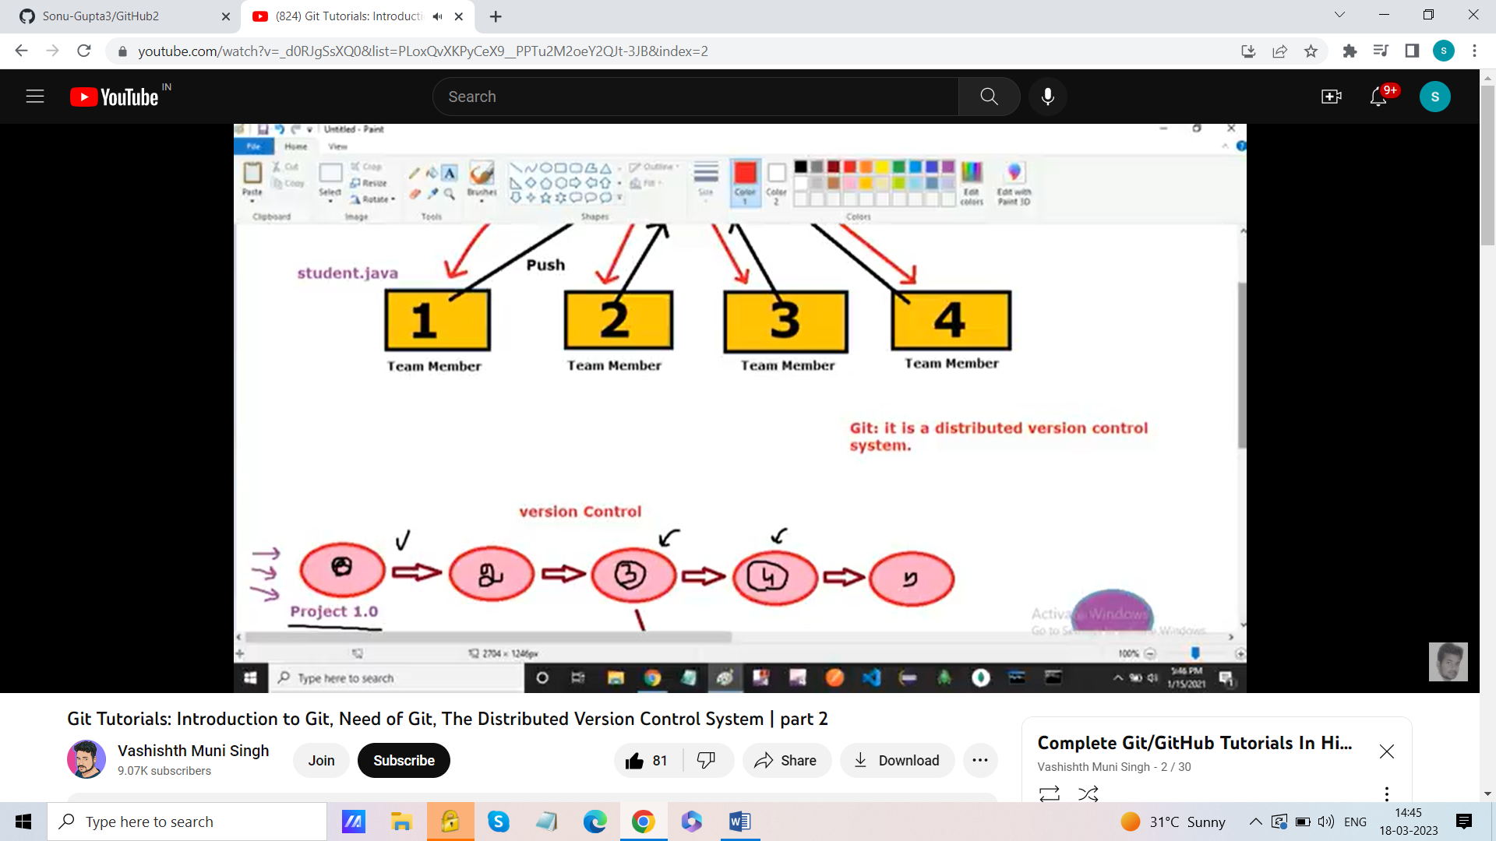

git config –list

git config --global user.name "SonuGupta" ------ Set the name

git config --global user.email “[sonu.gupta03@outlook.com](mailto:sonu.gupta03@outlook.com)” -----to set the email

touch file.txt----- text file will create at the location

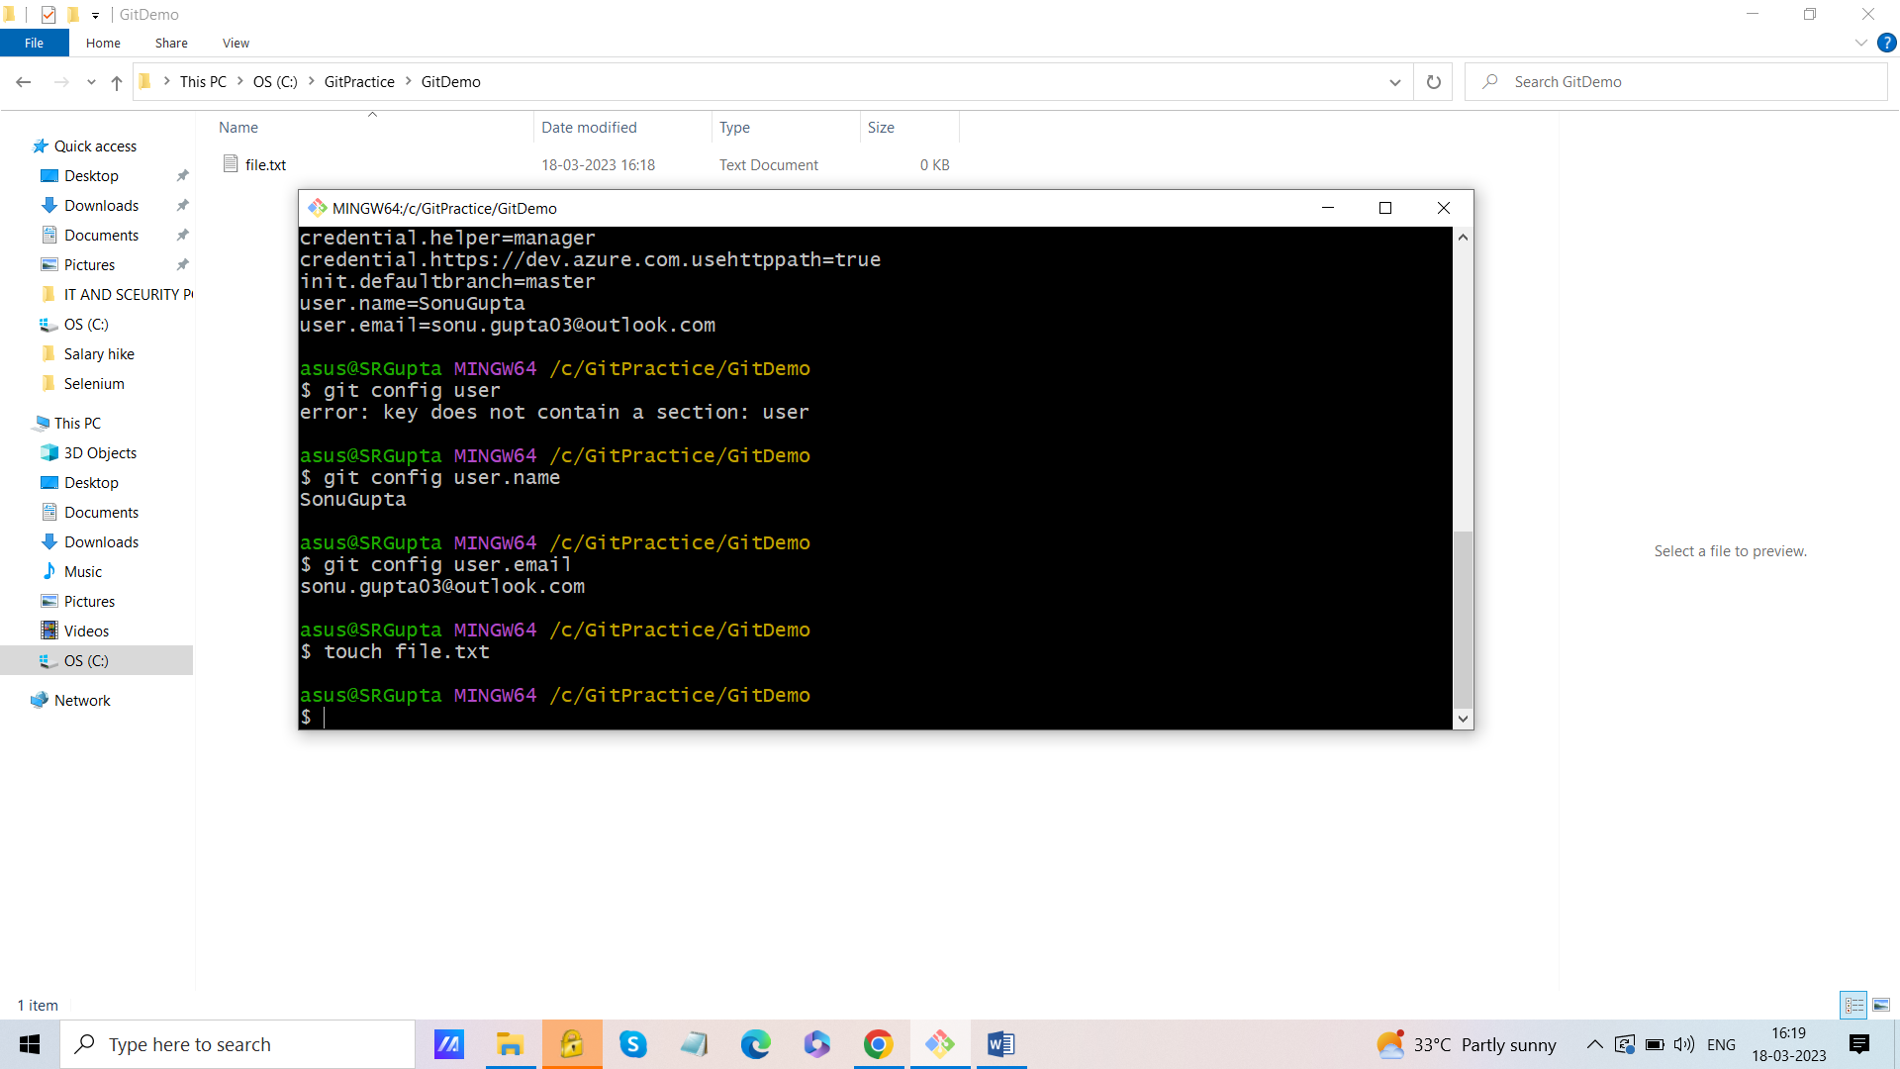

Make the complete folder into Git Repository

git status-----provide the information of complete folder

to make any folder as git Repository

git init ---make any folder into git repository (initialization)

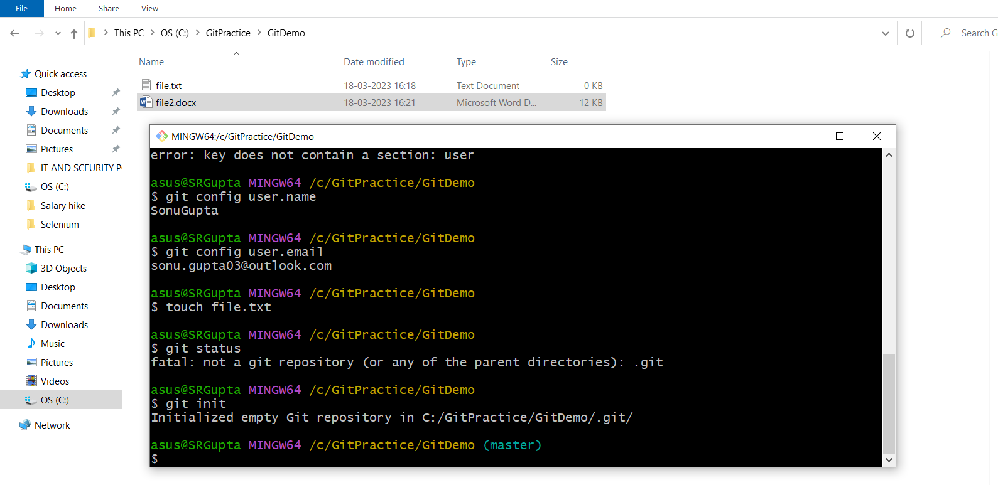

After init it will make a .git folder(Hidden), it will manage all the operations

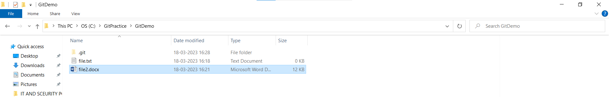

Untracked file shown in Red colour

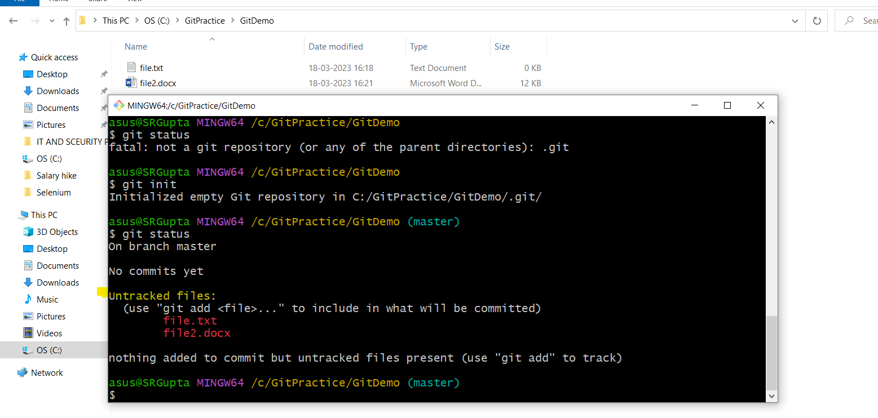

We need to track those untracked file

git add file.txt----git will start tracking file.txt

git add -A (Use to add file get tracked i.e in statging area)

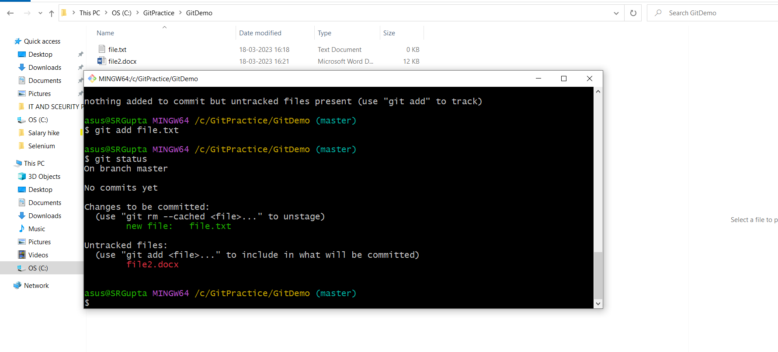

git add. ------will track all the files

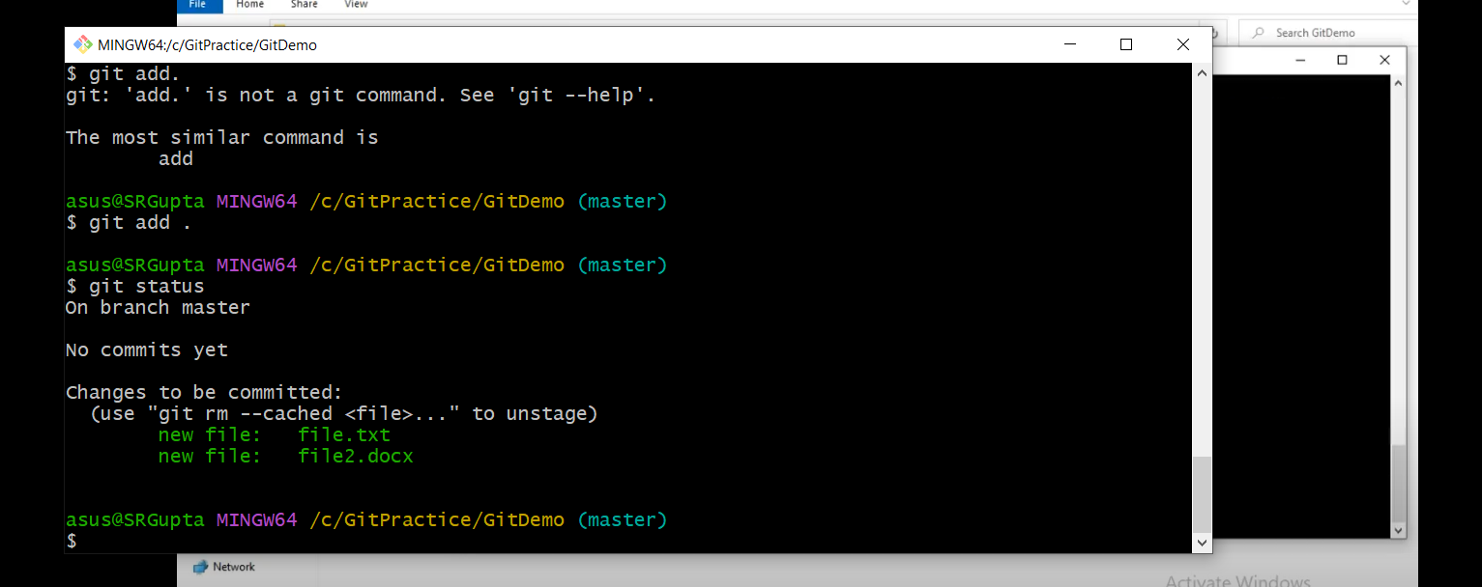

We need to commit to move file from folder to repository

git commit -m “Commit message provided”

you are in master branch

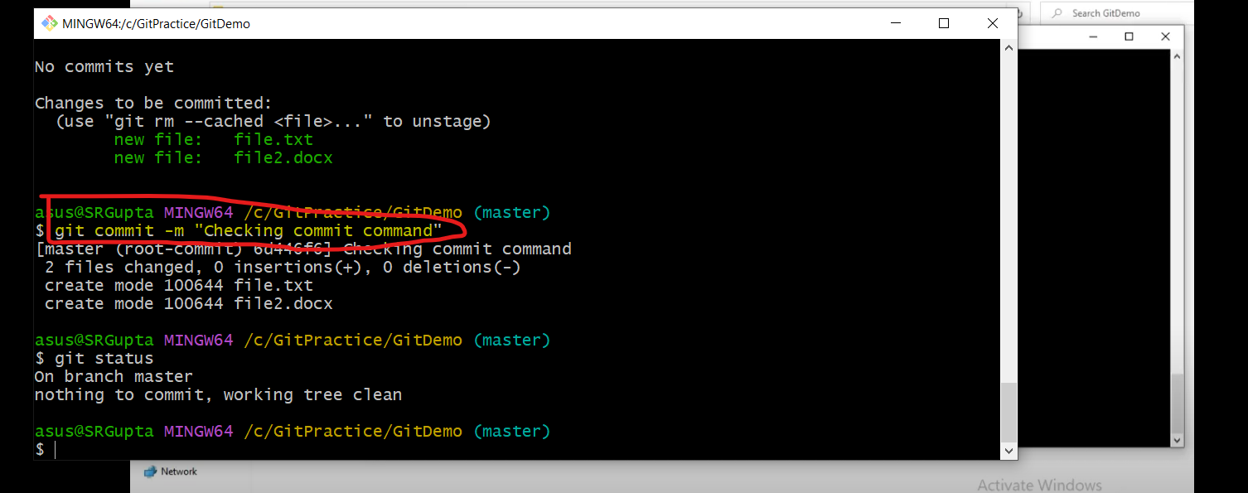

If we modify anything in the file

Step1: git add .

Step2: git status ----to check the status if Modified file is in Green or not

Step3: git commit -m “Adding the comment”

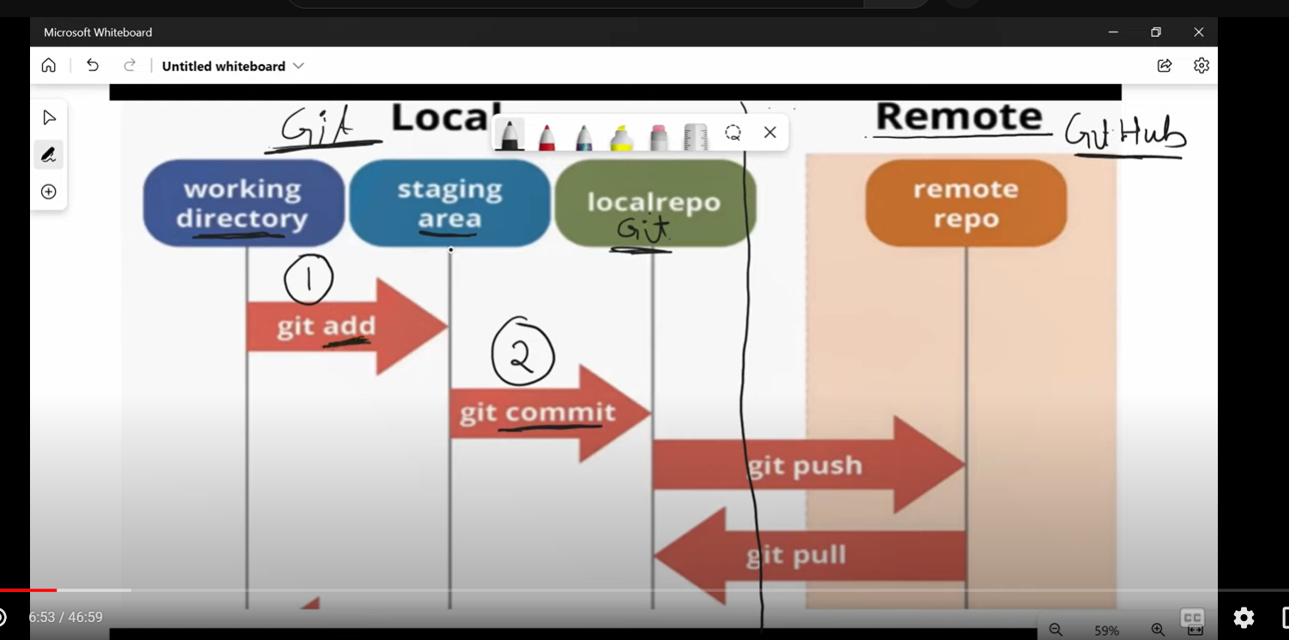

How to Push the code in remote repository:

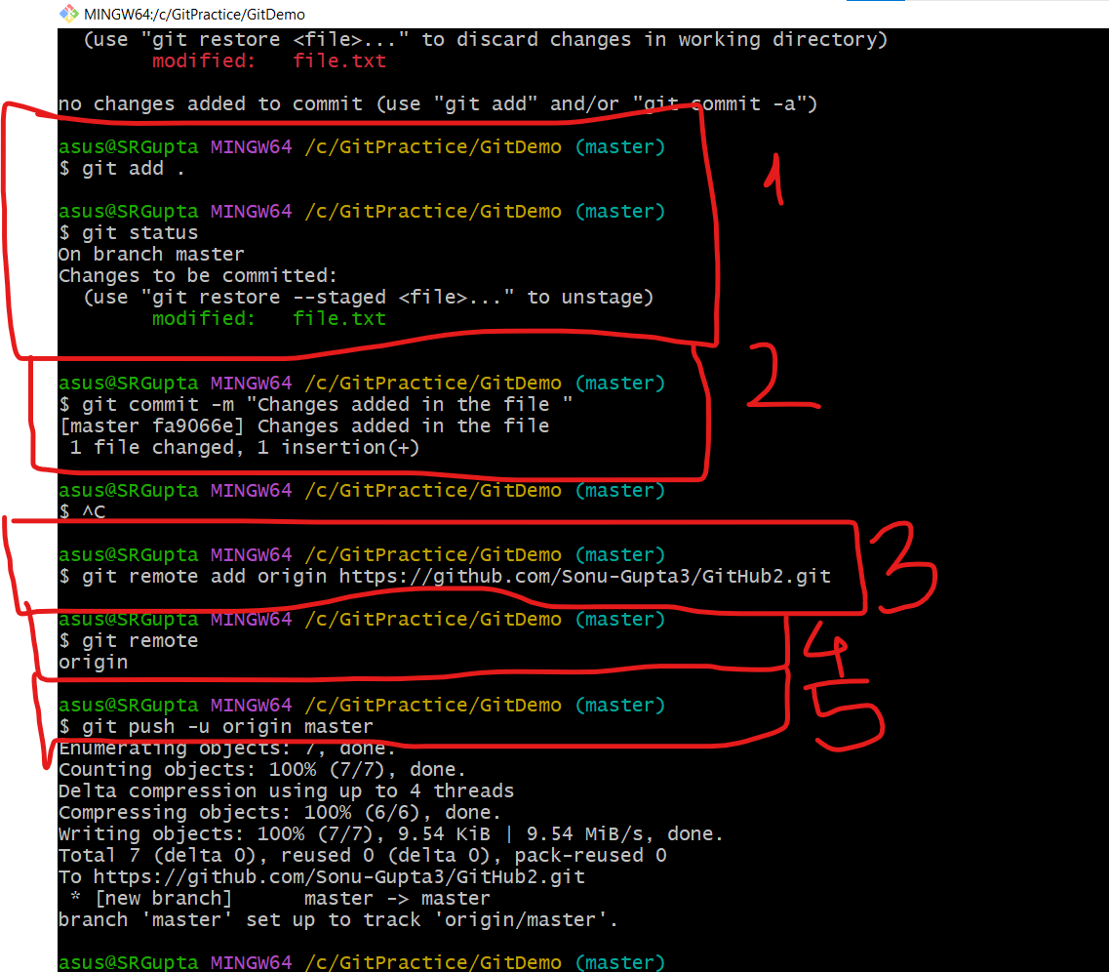

Modified the changes -1

Commit that changes -2

Provide the repository location-3

Check the exact repository location -4

And Push your file in the repository-5

Added the new file and move to first repository

Pull the file from github

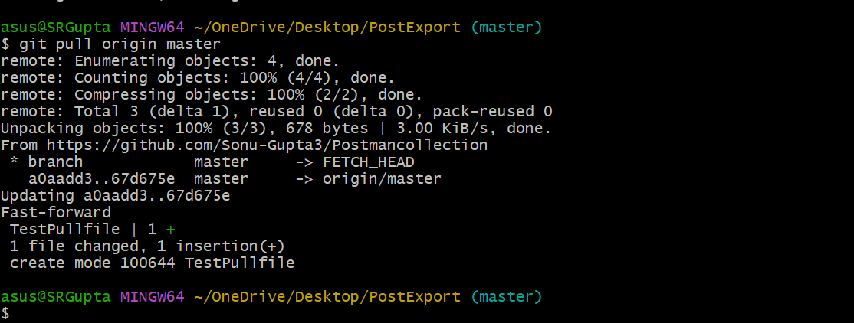

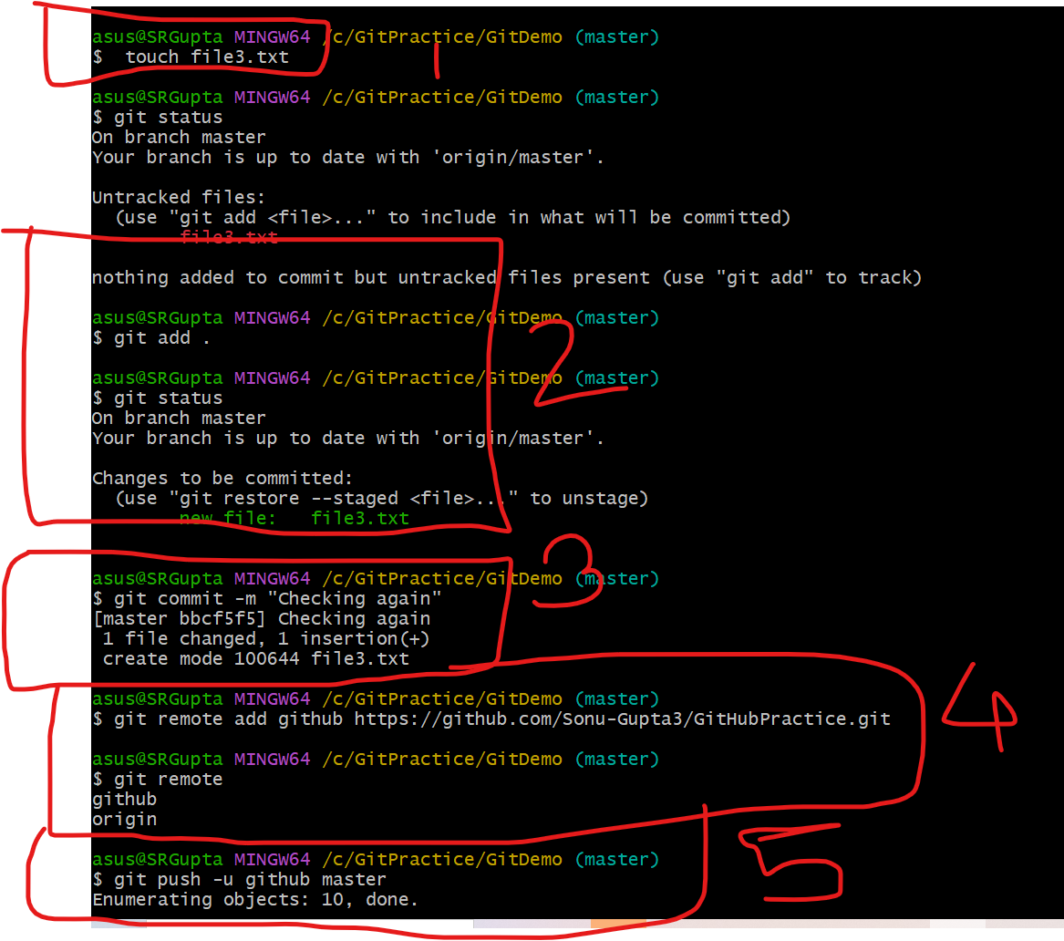

Commit mesaages

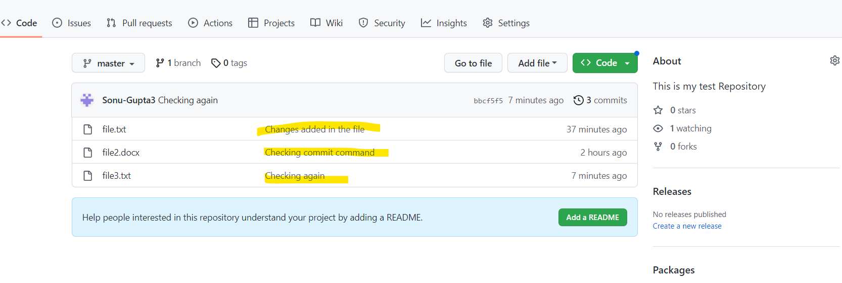

git log --- is used to check the complete log

