SOFTWARE ENGINEERING LAB
Project Documentation: HOTEL MANAGEMENT SYSTEM
Group Member | Enrollment / Roll No.
Sahil Kumar | 20252651044
Sonu Jha | 20252651056
Aakash | 20252651001
Manish Saxsena | 20252651033
Vedansh Raghwanshi | 20252651062

Course / Batch: | MCA (2nd Year) — Software Engineering Lab
Date of Submission: | 29/10/2026

Experiment 1: Software Requirements Specification (SRS) Framework
Aim: To analyze the project domain for a modern Hotel Management System (HMS) and compile a comprehensive Software Requirements Specification outline detailing stakeholders, functionalities, performance parameters, and architectural system boundaries.

1.1 Project Stakeholder Matrix
Stakeholder Entity | Operational Responsibility within HMS | Core System Interactivity
Guest / Customer | Initiates remote queries, updates personal metadata, processes payments. | External consumer layer interface access.
Receptionist / Front Desk | Manages operational live status check-ins, check-outs, room re-allocations. | Internal operations terminal dashboard client.
System Administrator | Performs continuous master infrastructure configuration, backup auditing, user provisioning. | Root console full control panel access.

1.2 Draw.io Architecture Diagram: System Context Boundary View
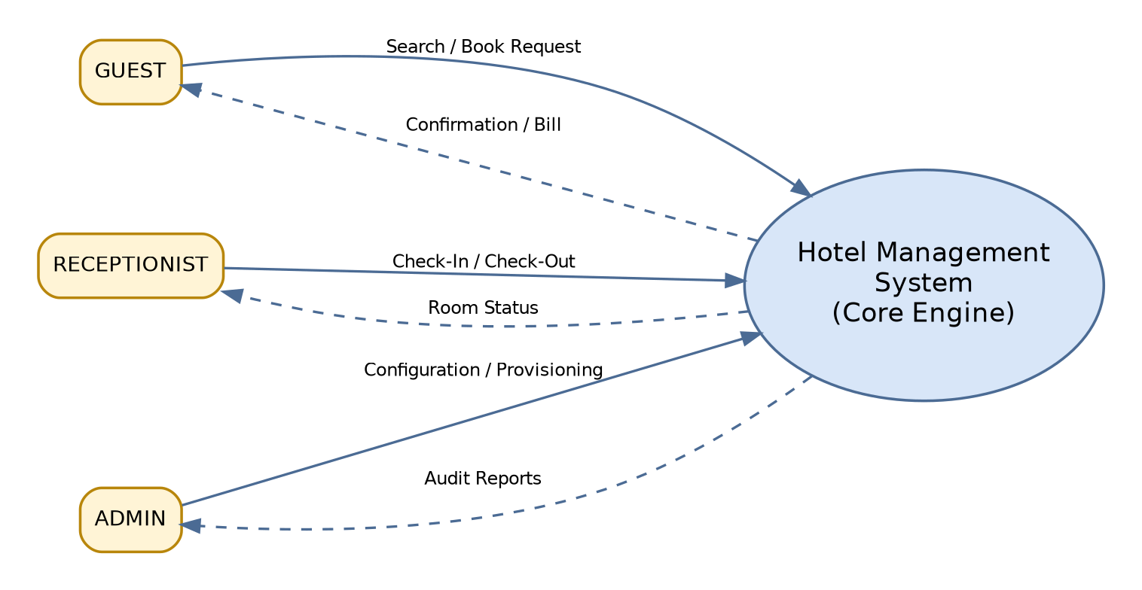
Figure 1.2: System Context Diagram - Hotel Management System

Experiment 2: Software Development Life Cycle (SDLC) Model Optimization
Aim: To contrast structural software process engineering models (Waterfall, Spiral, Agile/Scrum, Prototyping) and evaluate their fitness criteria for application deployment within a Hotel Management System framework.

2.1 Comparative Analysis Matrix
SDLC Process Model | Requirement Volatility | Feedback Loop Rate | Risk Containment Tier | HMS Applicability Verdict
Waterfall Model | Static / Highly Rigid | Extremely Low | Low Capability | Sub-optimal: Fails with market feature iterations.
Prototype Model | Evolutionary / Evolving | High (Pre-launch) | Medium Tier | Good for front-end interface adjustments.
Spiral Framework | Highly Adaptable | Periodic / Cycle-based | Very High / Strong | Over-engineered: Exceeds standard system risk bounds.
Agile (Scrum Framework) | Fluid / Rapidly Changing | Continuous / Iterative | High Efficiency | Optimized: Excellent for sprint feature updates.

2.2 Draw.io Agile Cycle Flow Diagram
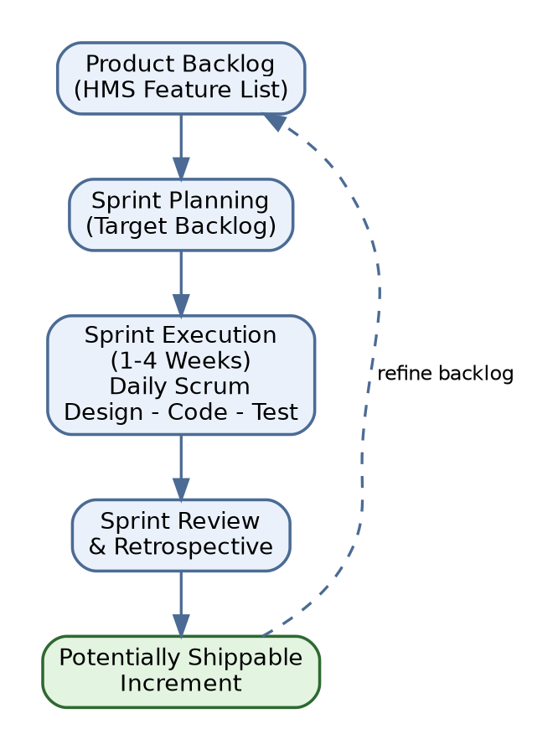
Figure 2.2: Agile (Scrum) Cycle Flow Diagram

Experiment 3: Functional Use Case Engineering Topology
Aim: To identify and establish concrete behavioral boundaries for the Hotel Management System through formalized Use Case scenarios, explicitly mapping actor roles and inclusion/extension rules.

3.1 Core System Use Case Map
Primary Actor | Target Functional Use Case | Stereotype Dependency | Pre-Condition Boundary
Guest | Book Room | Includes: <<Authenticate User>> | User session initialized active.
Guest | Cancel Booking | Extends: <<Apply Cancellation Fee>> | Existing active booking entry matching account.
Receptionist | Check-In Guest | Includes: <<Check Room Availability>> | Assigned reservation record present in queue.
Receptionist | Generate Bill/Invoice | Includes: <<Process Payment>> | Checkout processing sequence triggered.
Admin | Manage Room Assets | None Base Vector | Root administrative authentication verified.

3.2 Draw.io Use Case Diagram Architecture
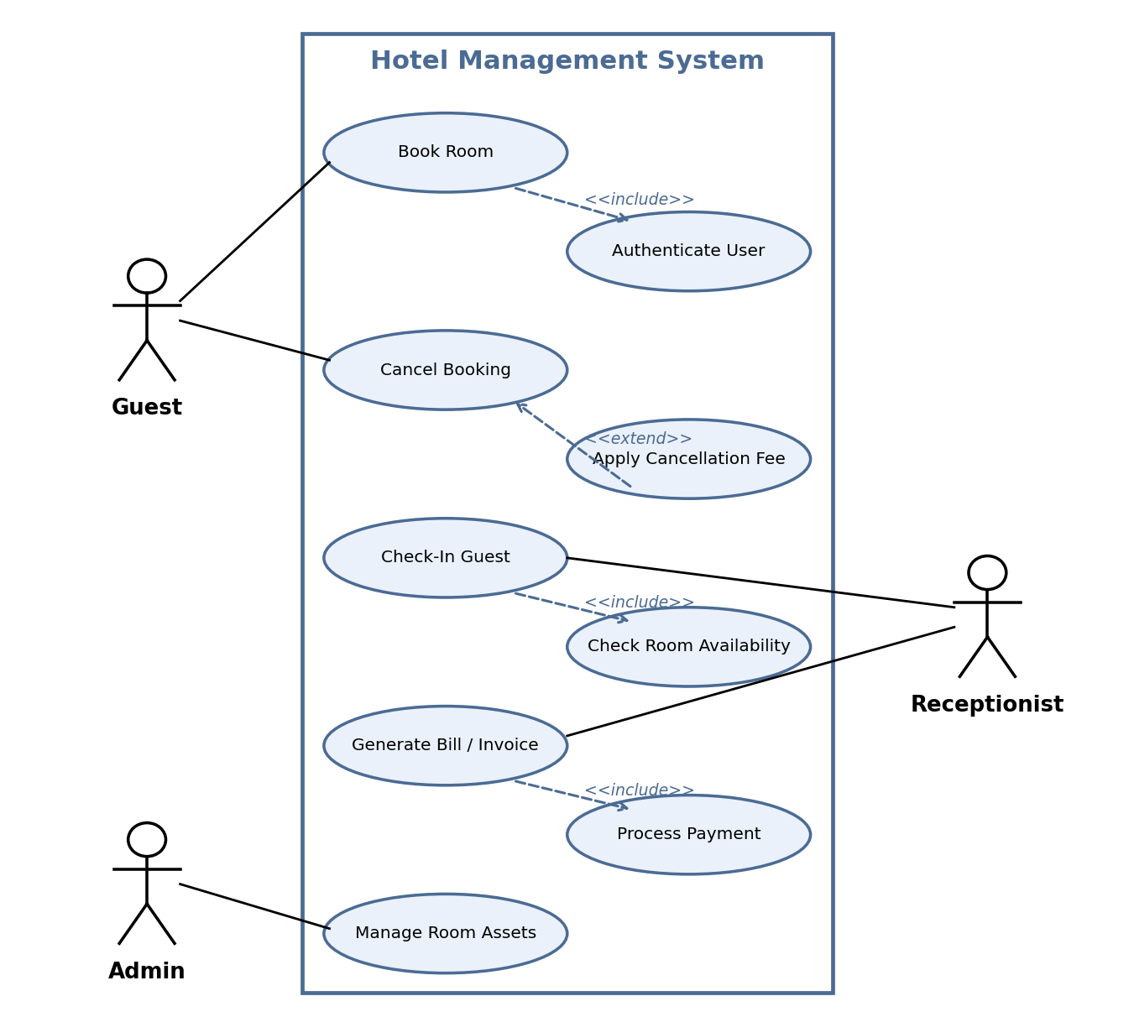
Figure 3.2: Use Case Diagram - Hotel Management System

Experiment 4: Structural Data Flow Architecture (DFD Mapping)
Aim: To establish functional transformations and data flow routing within the Hotel Management System, creating Context, Level 0, and Level 1 Data Flow Diagrams.

4.1 Data Repository and Entity Identifiers
Identifier | Structural Data Store / Entity Name | Payload Description Stored
D1 | Guests Master Ledger | Personal attributes: profile information, contact identifiers, security salts.
D2 | Rooms Status Catalog | Structural data: classifications, rates, real-time availability states.
D3 | Bookings Central Matrix | Transactional information: schedules, allocations, assignment keys.
D4 | Finance Transactions Log | Invoices, settlement records, tokenized logs.

4.2 Draw.io Level 0 Data Flow Diagram Routing Diagram
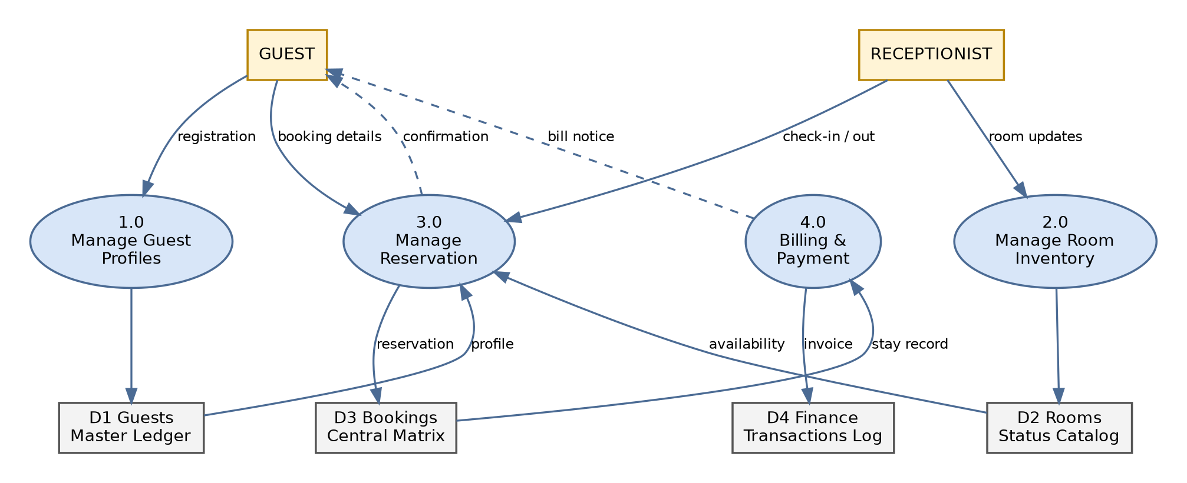
Figure 4.2: Level 0 Data Flow Diagram
Experiment 5: Static UML Class Architecture Blueprint
Aim: To define the persistent object data structure of the Hotel Management System through a structural UML Class Diagram, mapping class interfaces, inner fields, data types, and multiplicities.

5.1 Class Diagram Relational Mapping Matrix
Class Origin A | Structural Link Vector | Class Destination B | Multiplicity A | Multiplicity B
Guest | Association: makes | Booking | 1 | * (Zero to Many)
Booking | Association: maps to | Room | * | 1..* (One to Many)
Booking | Composition: generates | Invoice | 1 | 1 (Exactly One)
Employee | Generalization (Inherited Base) | Receptionist / Manager | 1 | Sub-class (Is-A)

5.2 Draw.io Static UML Class Layout Architecture
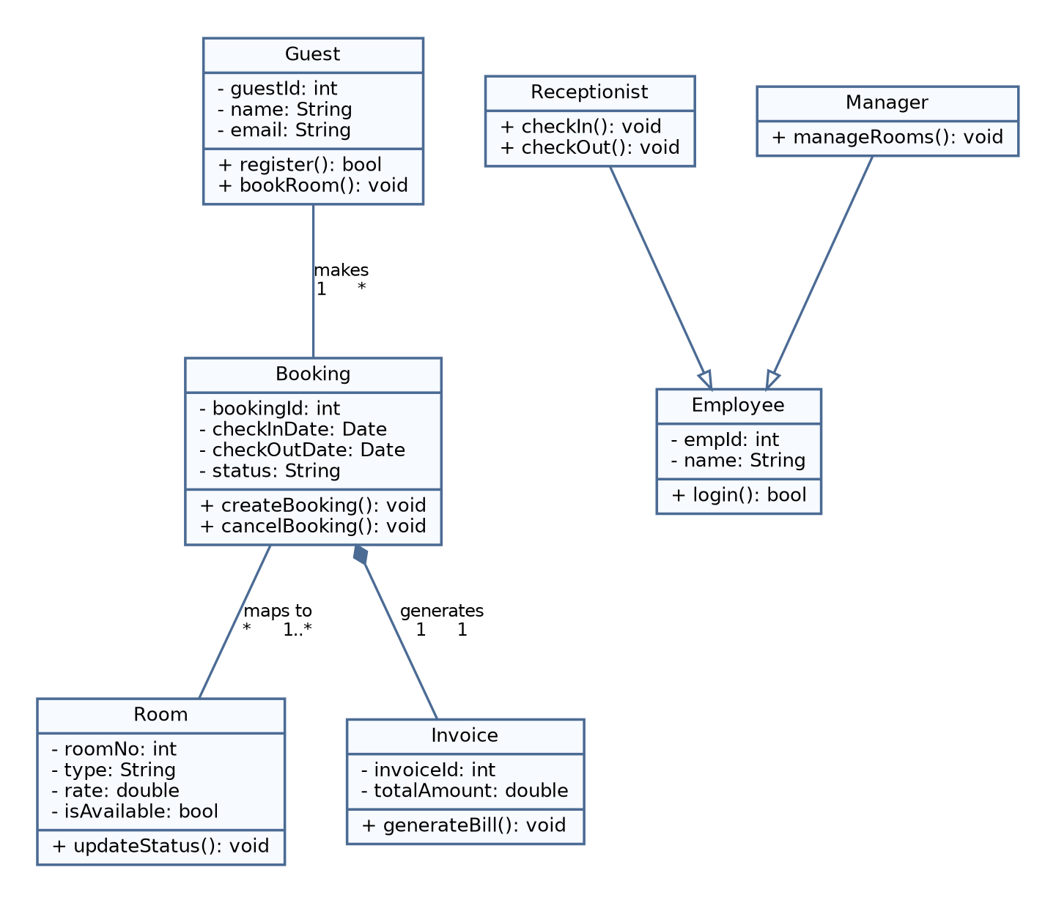
Figure 5.2: UML Class Diagram

Experiment 6: Dynamic Behavior Modeling (UML Sequence Diagram)
Aim: To establish runtime communications and message synchronization within the Hotel Management System through an interactive UML Sequence Diagram illustrating the room booking transaction workflow.

6.1 Sequential Step Registry
Step Index | Source Sub-Component | Target System Link | Synchronous Payload / Operation
1.0 | Guest Actor Client | BookingUI Interface | submitReservationRequest(date, roomType)
2.0 | BookingUI Interface | ReservationManager Engine | verifyAllocationAvailability(date, roomType)
3.0 | ReservationManager | RoomDB Repository | queryRoomStateFlags(date)
4.0 | RoomDB Repository | ReservationManager Engine | Return availability token (Status: Valid)
5.0 | ReservationManager | BookingUI Interface | renderReservationSuccessConfirmation()

6.2 Draw.io Dynamic Sequence Diagram Tracing Execution Timeline
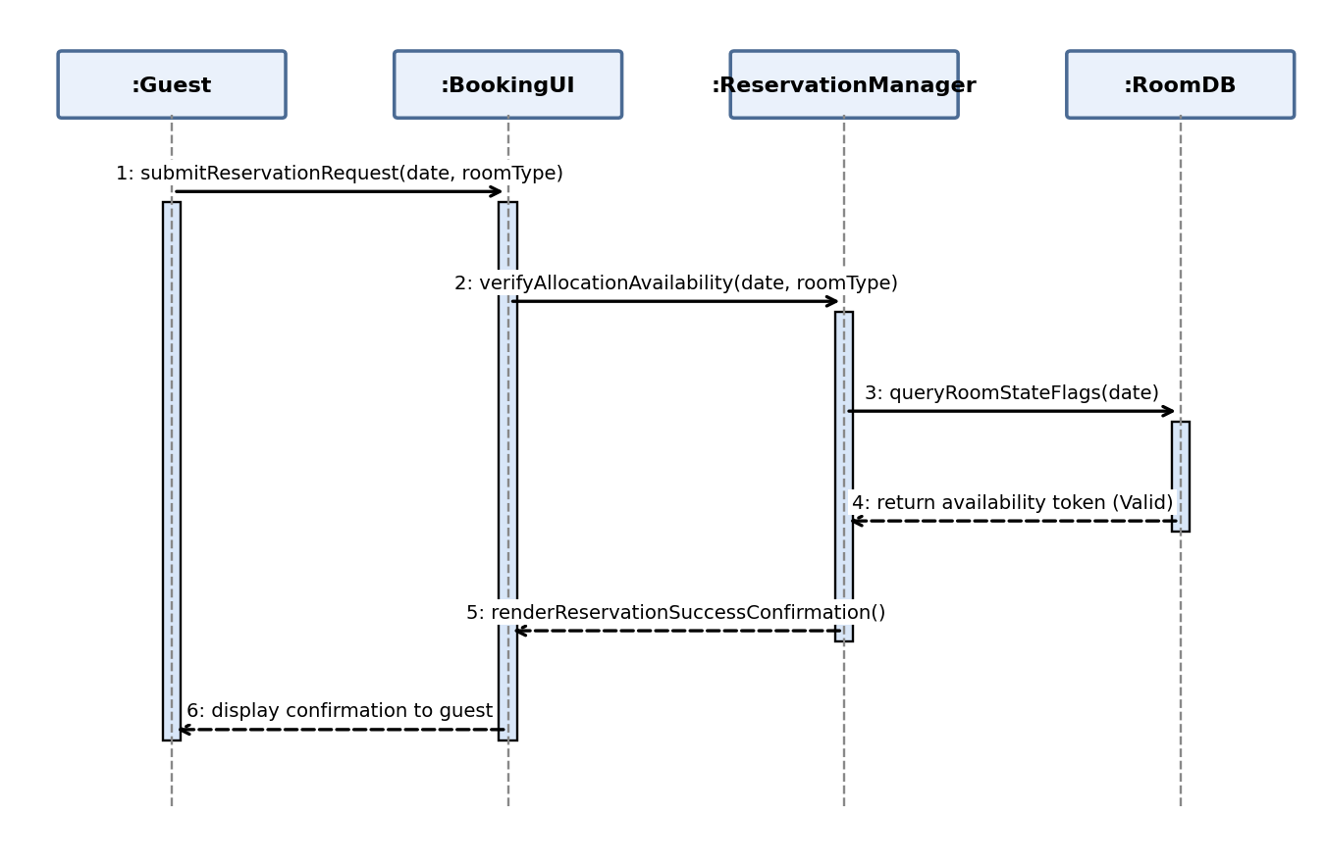
Figure 6.2: UML Sequence Diagram - Room Booking

Experiment 7: Software Project Management Plan (SPMP Metrics)
Aim: To formulate standard operational metrics and resource estimates for the Hotel Management System using empirical algorithmic sizing tools (Basic COCOMO) and construct a project milestone schedule.

7.1 Sizing Calculations via Basic COCOMO Formula
Given Size Allocation = 32 KLOC (Organic System Project Parameters: a_b=2.4, b_b=1.05, c_b=2.5, d_b=0.38)
1. Computational Formula for Project Effort Calculation:
Effort = a_b * (KLOC)^(b_b) = 2.4 * (32)^(1.05)
Resulting Effort = 2.4 * 38.34 = 92.01 Person-Months
2. Computational Formula for Project Development Duration Calculation:
Duration = c_b * (Effort)^(d_b) = 2.5 * (92.01)^(0.38)
Resulting Duration = 2.5 * 5.54 = 13.85 Calendar Months
3. Average Optimal Team Staffing Requirements Matrix:
Staff Required = Effort / Duration = 92.01 / 13.85 = 6.64 Developers (~7 Full-Time Engineers)

7.2 Draw.io Project Gantt Timeline Milestone Schedule
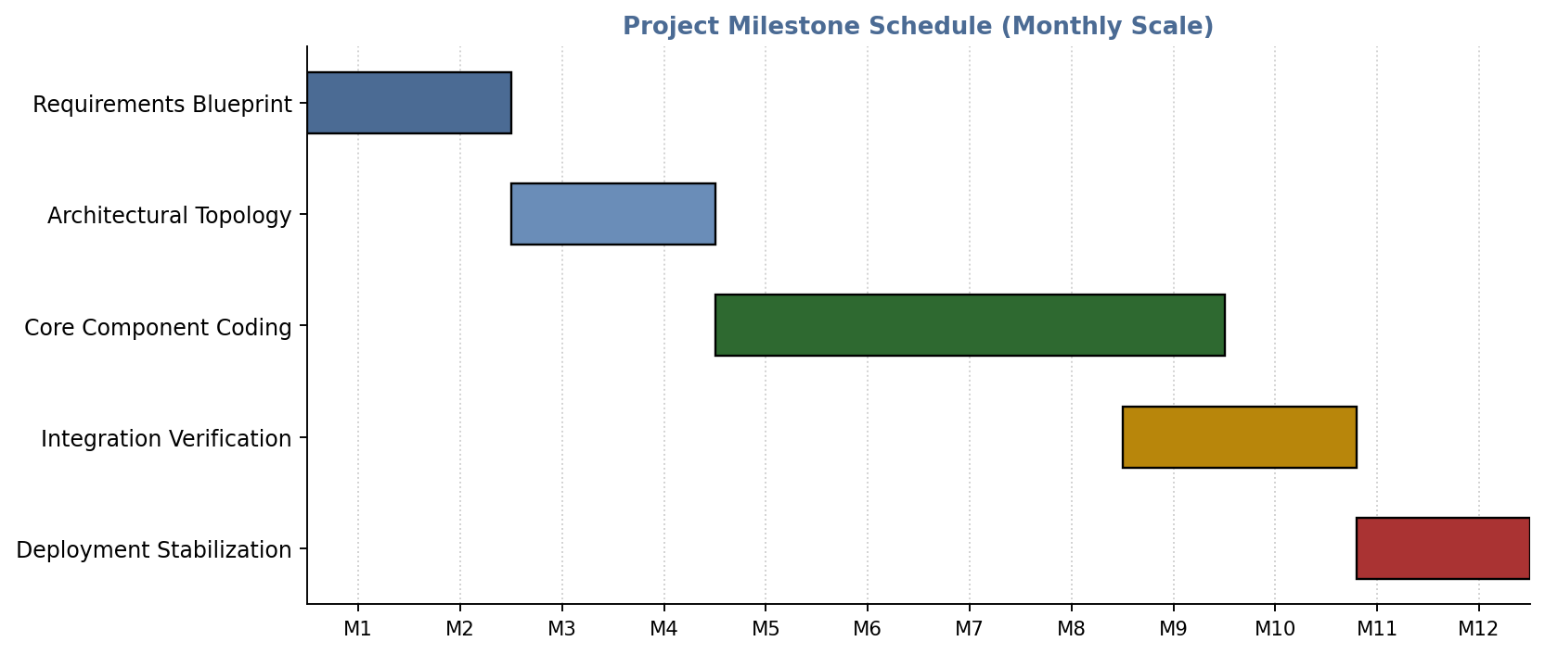
Figure 7.2: Project Gantt Chart - Milestone Schedule

Project Planning Documentation
Aim: To document the planning of the Hotel Management System project: scope, team organisation, work breakdown, schedule, risk management and planning parameters, building on the Basic COCOMO estimates of Experiment 7.

7A.1 Project Overview and Scope
Parameter | Description
Project Title | Hotel Management System (HMS)
Objective | Automate room search, booking, cancellation, check-in/check-out, billing and room management for a hotel.
In Scope | Guest registration and login, room availability search, reservation and cancellation, front-desk check-in/out, invoice generation and payment recording, admin room and user management.
Out of Scope | Third-party channel manager integration, mobile application, loyalty programme.
Process Model | Agile (Scrum), as justified in Experiment 2.
Effort Estimate | 92.01 person-months, 13.85 months duration, about 7 developers (Basic COCOMO, 32 KLOC, Experiment 7).

7A.2 Team Organisation and Responsibilities
Role | Responsibility | Team Member
Project Manager / Documentation | Planning, schedule tracking, SRS and journal compilation, submission. | Sahil Kumar (20252651044)
Requirements Analyst | Stakeholder analysis, SRS, use case identification. | Sonu Jha (20252651056)
System Designer | DFD, UML class and sequence diagrams, module decomposition. | Manish Saxena (20252651033)
Developer | Implementation of UserAuth, Reservation and Finance modules. | Aakash (20252651001)
Tester / QA | Test planning, test case design and execution, defect reporting. | Vedansh Raghwanshi (20252651062)

7A.3 Work Breakdown Structure (WBS)
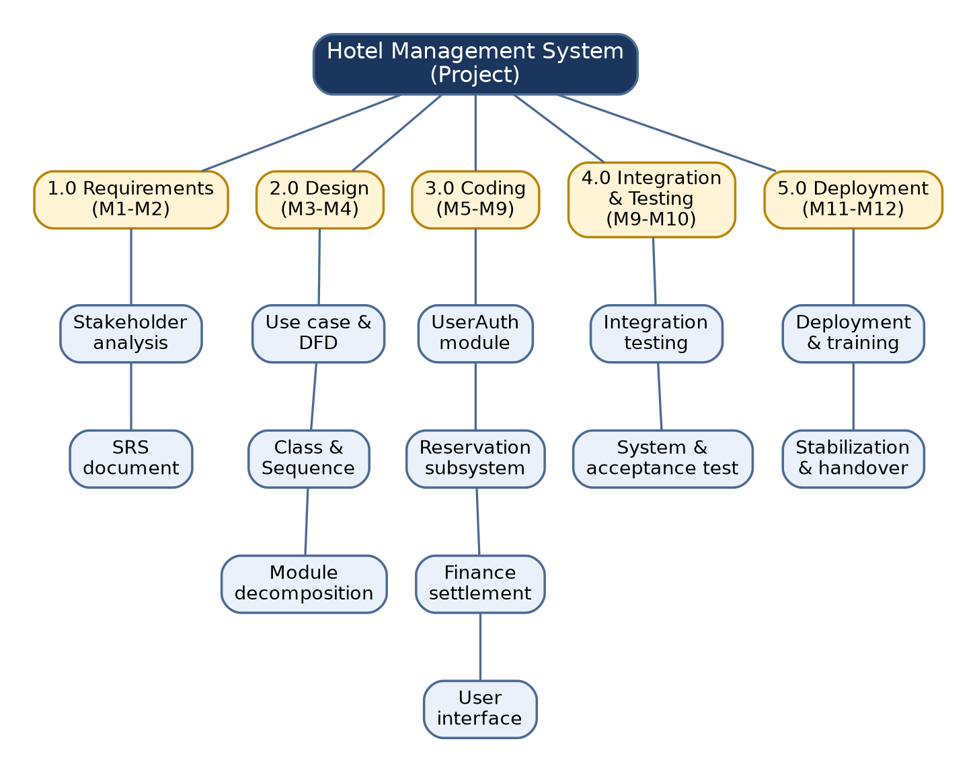
Figure 7A.3: Work Breakdown Structure of the Hotel Management System
Phase | Major Activities | Duration | Deliverable
1.0 Requirements | Stakeholder analysis, requirement elicitation, SRS preparation. | M1 - M2 | SRS document
2.0 Design | Use case, DFD, class and sequence diagrams, subsystem decomposition. | M3 - M4 | Design documents
3.0 Coding | Implementation of UserAuth, Reservation, Finance modules and user interface. | M5 - M9 | Source code
4.0 Integration and Testing | Module integration, system testing, defect fixing. | M9 - M10 | Test report
5.0 Deployment | Deployment, user training, stabilization and handover. | M11 - M12 | Deployed system and user manual

7A.4 Milestone Schedule
No. | Milestone | Target Month | Completion Criterion
M-1 | SRS baseline approved | End of M2 | Requirements reviewed and frozen for first release.
M-2 | Design baseline approved | End of M4 | All UML and DFD diagrams reviewed.
M-3 | Core modules coded | End of M9 | Unit tests passed for all modules.
M-4 | Integration and system testing complete | End of M10 | All critical and major defects closed.
M-5 | Release and handover | End of M12 | Acceptance sign-off obtained.

7A.5 Risk Management Plan
Risk | Probability | Impact | Mitigation Strategy
Requirement changes during development | High | High | Agile sprints with backlog refinement; change control through sprint review.
Double booking due to concurrency | Medium | High | Transactional database locking; test case TC-HMS-004.
Schedule slippage | Medium | Medium | Weekly progress review and buffer in the coding phase.
Team member unavailability | Medium | Medium | Cross-training and shared documentation.
Data loss or security breach | Low | High | Regular backups, hashed credentials, role-based access.
Integration defects between modules | Medium | Medium | Low coupling interfaces (Experiment 8) and early integration testing.

7A.6 Planning Parameters
Planning Item | Decision
Sprint Length | 2 weeks, within the 1 to 4 week Scrum range of Experiment 2.
Progress Review | Weekly team meeting with sprint review and retrospective at sprint end.
Configuration Management | Version control of source code and documents; baselines at each milestone.
Quality Assurance | Peer review of SRS and design; test-driven verification as in Experiment 9.
Note on Scale | COCOMO gives an industrial-scale estimate; the five-member academic team delivers a reduced-scope first release.

Experiment 8: Advanced Modular Architecture Decomposition
Aim: To partition the Hotel Management System into discrete structural subsystems, maximizing internal module cohesion while minimizing cross-component coupling dependencies.

8.1 Cohesion and Coupling Structural Specification
Subsystem Component | Internal Functional Mandate | Cohesion Matrix Classification | Coupling Interface Control
UserAuth Module | Handles security validation tokens, session lifecycle controls, and identity mapping. | High Functional Cohesion | Low Data Coupling (Exposes isolate identity checks)
ReservationSubsystem | Manages scheduling pipelines, allocations, inventory availability lookups. | High Sequential Cohesion | Medium Data Coupling (Interacts with room state storage)
FinanceSettlement | Processes invoices, line item tracking, and transaction settlement. | High Informational Cohesion | Low Message Coupling (Driven by tokenized triggers)

8.2 Draw.io Subsystem Architecture Component View
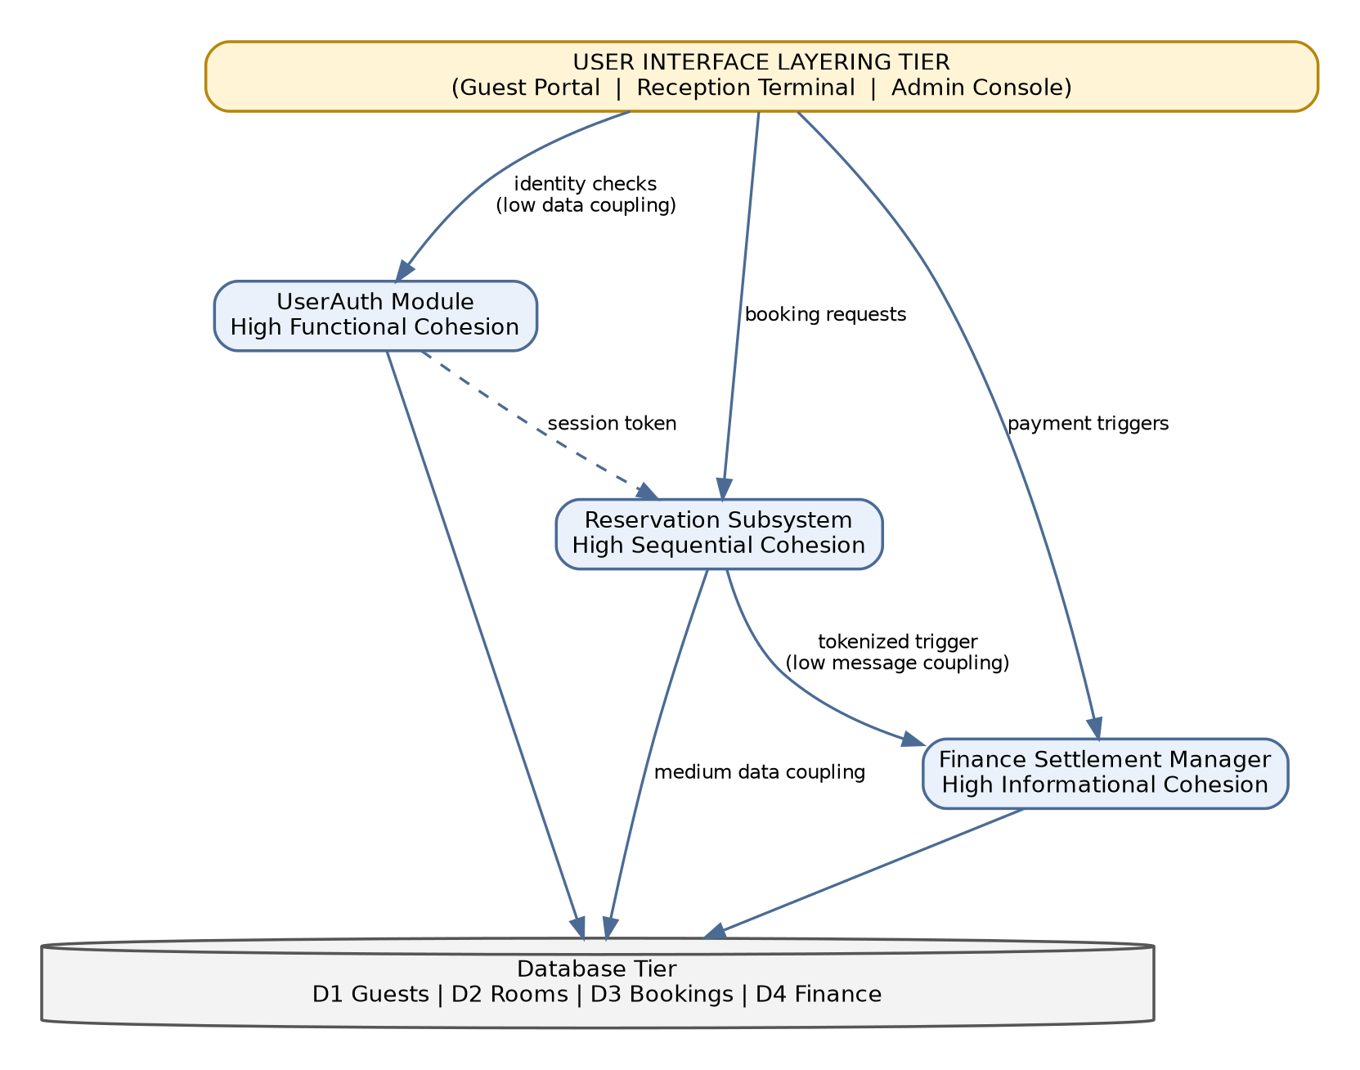
Figure 8.2: Subsystem Architecture Component View

Experiment 9: Comprehensive Black-Box Verification & Validation
Aim: To design structured, functional verification conditions for the Hotel Management System using black-box testing methodologies, validating both positive and negative operational parameters.

9.1 Comprehensive System Test Case Register
Test Identifier | Functional Sizing Vector | Input Evaluation Payload | Observable Expected System Output | Validation Strategy
TC-HMS-001 | User Login Profile Verification | Valid Username + Valid Cryptographic Password | System profile dashboard initializes successfully. | Positive Test Baseline
TC-HMS-002 | User Login Profile Verification | Valid Username + Incorrect Cryptographic Password | Security alert triggered, authentication rejected. | Negative Test Boundary
TC-HMS-003 | Room Allocation Request Engine | Target Room Available (Status Flags Open) | Allocation locked, confirmation token generated. | Positive Test Baseline
TC-HMS-004 | Double Reservation Conflict Prevention | Request Room on dates already fully booked | Transaction rolls back, error message displayed. | Negative Test Boundary

9.2 Draw.io Test Pipeline Pipeline Flowchart
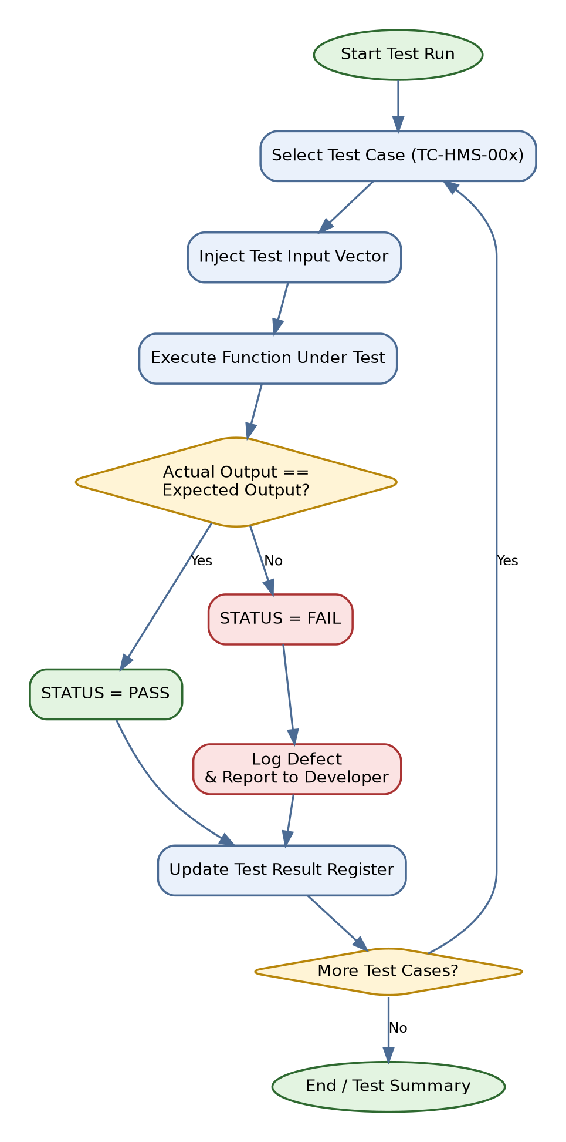
Figure 9.2: Black-Box Test Execution Flowchart

Testing Documentation
Aim: To document the complete test plan, test cases, traceability, test design techniques and defect handling for the Hotel Management System, extending the black-box verification of Experiment 9.

T.1 Test Plan
Item | Description
Test Objective | Verify that every functional requirement of HMS behaves as specified, for valid and invalid inputs.
Features to be Tested | Login, guest registration, room search, booking, cancellation, check-in/out, billing and payment, admin room management, access control.
Features not Tested | Performance and load testing, third-party payment gateway internals.
Test Approach | Black-box testing using equivalence partitioning and boundary value analysis, at unit, integration, system and acceptance levels.
Test Environment | Web browser client, application server and relational database holding stores D1 to D4.
Entry Criteria | Module coded, unit tests prepared, test data available.
Exit Criteria | All test cases executed, no open critical or major defects.
Pass / Fail Rule | A test passes when actual output equals the expected output; otherwise it is logged as a defect.

T.2 Levels of Testing (V-Model)
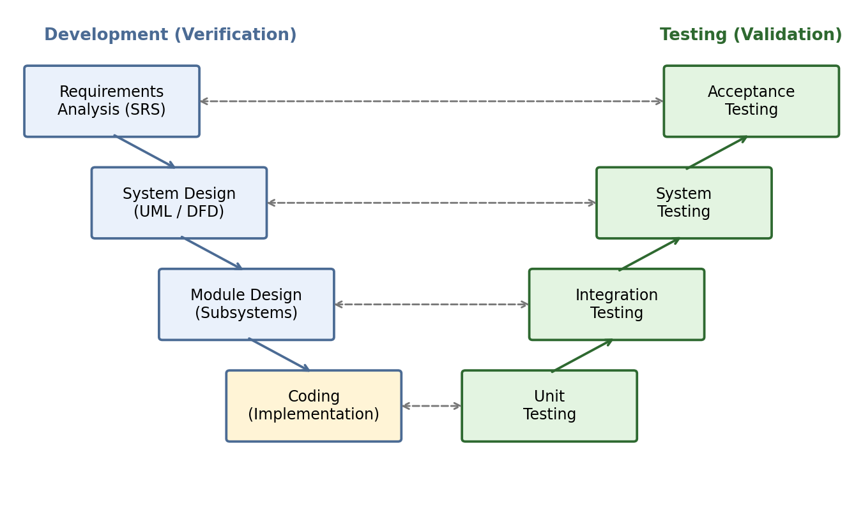
Figure T.2: V-Model mapping development phases to testing levels

T.3 Extended Test Case Register
Test cases TC-HMS-001 to TC-HMS-004 are listed in Experiment 9. The register below extends them to cover all modules.
Test ID | Module | Input | Expected Output | Type
TC-HMS-005 | Guest Registration | Valid name, email and password | Profile created in D1 and confirmation shown. | Positive
TC-HMS-006 | Guest Registration | Email that is already registered | Error message: account already exists. | Negative
TC-HMS-007 | Room Search | Valid date range and room type | List of available rooms is displayed. | Positive
TC-HMS-008 | Booking | Check-out date earlier than check-in date | Validation error; booking not created. | Negative / Boundary
TC-HMS-009 | Cancel Booking | Existing active booking | Status set to Cancelled, fee applied as per policy, room released. | Positive
TC-HMS-010 | Check-In | Valid reservation ID entered by receptionist | Room status changes to Occupied. | Positive
TC-HMS-011 | Check-In | Reservation ID not present in system | Error message: reservation not found. | Negative
TC-HMS-012 | Billing | Check-out of a completed stay | Invoice total equals room rate multiplied by nights plus extra charges. | Positive
TC-HMS-013 | Payment | Payment attempt that fails | Invoice remains Unpaid and retry is allowed. | Negative
TC-HMS-014 | Room Management | Admin adds a room with an existing room number | Request rejected with duplicate error. | Negative
TC-HMS-015 | Room Management | Admin adds a room with valid details | Room stored in D2 and shown as available. | Positive
TC-HMS-016 | Access Control | Guest opens an admin-only page | Access denied and event logged. | Negative / Security

T.4 Requirements Traceability Matrix
Req. ID | Functional Requirement | Covered by Test Cases
FR-01 | User authentication and access control | TC-HMS-001, 002, 016
FR-02 | Guest registration | TC-HMS-005, 006
FR-03 | Room search and availability | TC-HMS-003, 007
FR-04 | Room booking | TC-HMS-003, 004, 008
FR-05 | Booking cancellation | TC-HMS-009
FR-06 | Check-in and check-out | TC-HMS-010, 011
FR-07 | Billing and payment | TC-HMS-012, 013
FR-08 | Room management by admin | TC-HMS-014, 015

T.5 Equivalence Partitioning and Boundary Value Analysis
The input limits below are assumed business rules chosen for test design.
Input Field | Valid Partition | Invalid Partitions | Boundary Values to Test
Number of nights | 1 to 30 | Less than 1; more than 30 | 0, 1, 2, 29, 30, 31
Guests per room | 1 to 4 | Less than 1; more than 4 | 0, 1, 2, 3, 4, 5
Password length | 8 to 16 characters | Fewer than 8; more than 16 | 7, 8, 9, 15, 16, 17
Stay dates | Check-out after check-in | Check-out on or before check-in | Same day, next day, previous day

T.6 Defect Severity Classification
Severity | Definition | Example in HMS
Critical | System crash or data corruption; no workaround. | Double reservation of the same room.
Major | Key function fails but a workaround exists. | Invoice shows wrong total.
Minor | Function works with small deviation. | Wrong error message text.
Trivial | Cosmetic issue only. | Label alignment on dashboard.

