YuvaIntern

Week 3 – Unsupervised Learning and Clustering Analysis
Customer Segmentation Using K-Means Clustering
Prepared by:
Sonu Dada Funde
Internship Role:
Virtual Data Science with Python Trainee
Tools:
Python, Pandas, Jupyter Notebook
Year: 2026

1. Introduction
This project applies unsupervised learning to customer transaction data to discover behavioural segments without a predefined target label. The transaction-level Superstore dataset is transformed into customer-level profiles using sales, profit, quantity, order frequency, and average order value. K-Means clustering is then applied after standardization, followed by quantitative profiling and visual analysis.

2. Objective
The objective is to identify meaningful groups of customers with similar purchasing behaviour, explain how the groups differ using numerical evidence, and discuss how such segmentation can support marketing, retention, sales analysis, and future customer analytics.

3. Dataset Description
The dataset contains 51,290 transaction rows and 27 original columns. A constant record-count field was removed because it carries no discriminatory information. The final clustering table contains 4,873 unique customers. Transaction attributes include sales, profit, quantity, discount, customer, order, product, region, market, and shipping information.

4. Tools and Technologies
Python, Jupyter Notebook, Pandas, NumPy, Matplotlib, Seaborn, and Scikit-learn.

5. Why Unsupervised Learning?
No customer segment label is provided in the dataset. Therefore, a supervised target is unavailable for segmentation. K-Means is appropriate as an exploratory technique because it groups observations by similarity in the selected standardized behavioural features. The resulting cluster labels are created by the algorithm and do not have an inherent business meaning until they are profiled.

6. Data Preprocessing
The constant record-count column was removed. Order and ship dates were converted to datetime values and shipping duration was derived for data-quality analysis. Infinite values were excluded and missing values in the final modelling features were replaced with feature medians. The customer aggregation was then checked before scaling.

7. Customer-Level Feature Engineering
Each customer was represented by five primary clustering variables: Total Sales, Total Profit, Total Quantity, Number of Orders, and Average Order Value. This aggregation converts thousands of transaction records into behavioural customer profiles. For example, two customers with similar sales can still be separated if one purchases frequently while the other makes fewer high-value orders.

8. Feature Scaling
K-Means uses distance calculations. Sales and profit can be numerically much larger than order counts and quantities, which could cause large-scale variables to dominate the distance measure. StandardScaler was therefore applied so that the selected variables contribute on a comparable standardized scale.

9. Selecting the Number of Clusters
The Elbow Method and Silhouette Score were evaluated for k = 2 through 8. The highest silhouette score in this run was 0.407 at k=2. The final model uses k=4 because it produces a more detailed and interpretable customer segmentation while remaining manageable for cluster profiling. This is a documented modelling choice rather than a claim that k=4 maximizes the silhouette score.
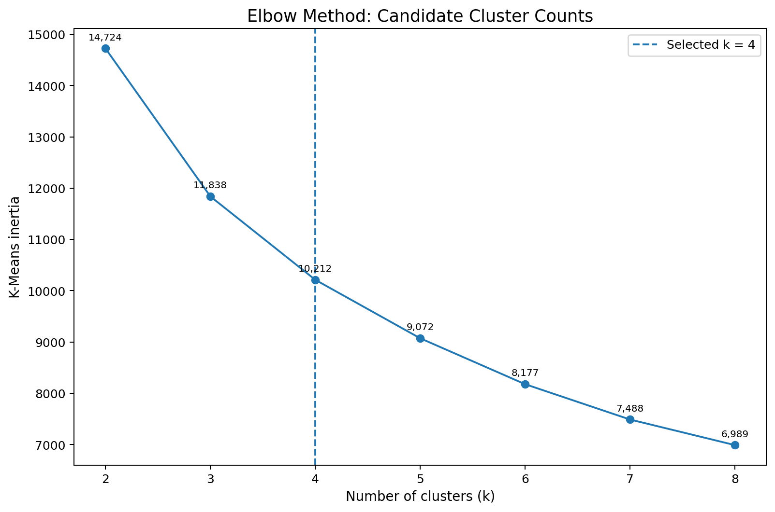
Figure 1. Elbow curve with annotated inertia values and the selected k=4.
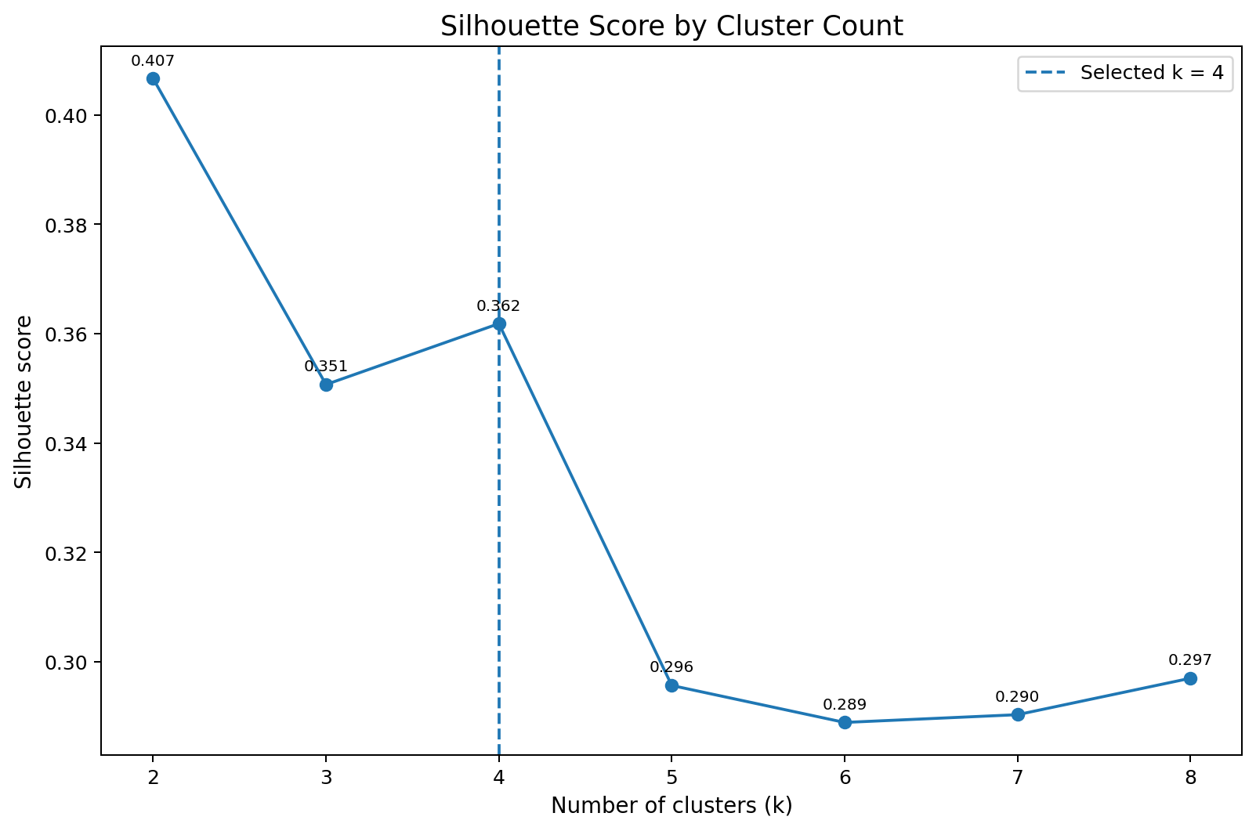
Figure 2. Silhouette scores for k=2 to k=8, with values annotated.

10. K-Means Model Design
The final K-Means configuration uses n_clusters=4, random_state=42, and n_init=20. The random seed makes the experiment reproducible, while multiple initializations reduce dependence on a single random centroid starting point.
Code example:
kmeans = KMeans(n_clusters=4, random_state=42, n_init=20)
customer_df['Cluster'] = kmeans.fit_predict(X_scaled)

11. Cluster Distribution
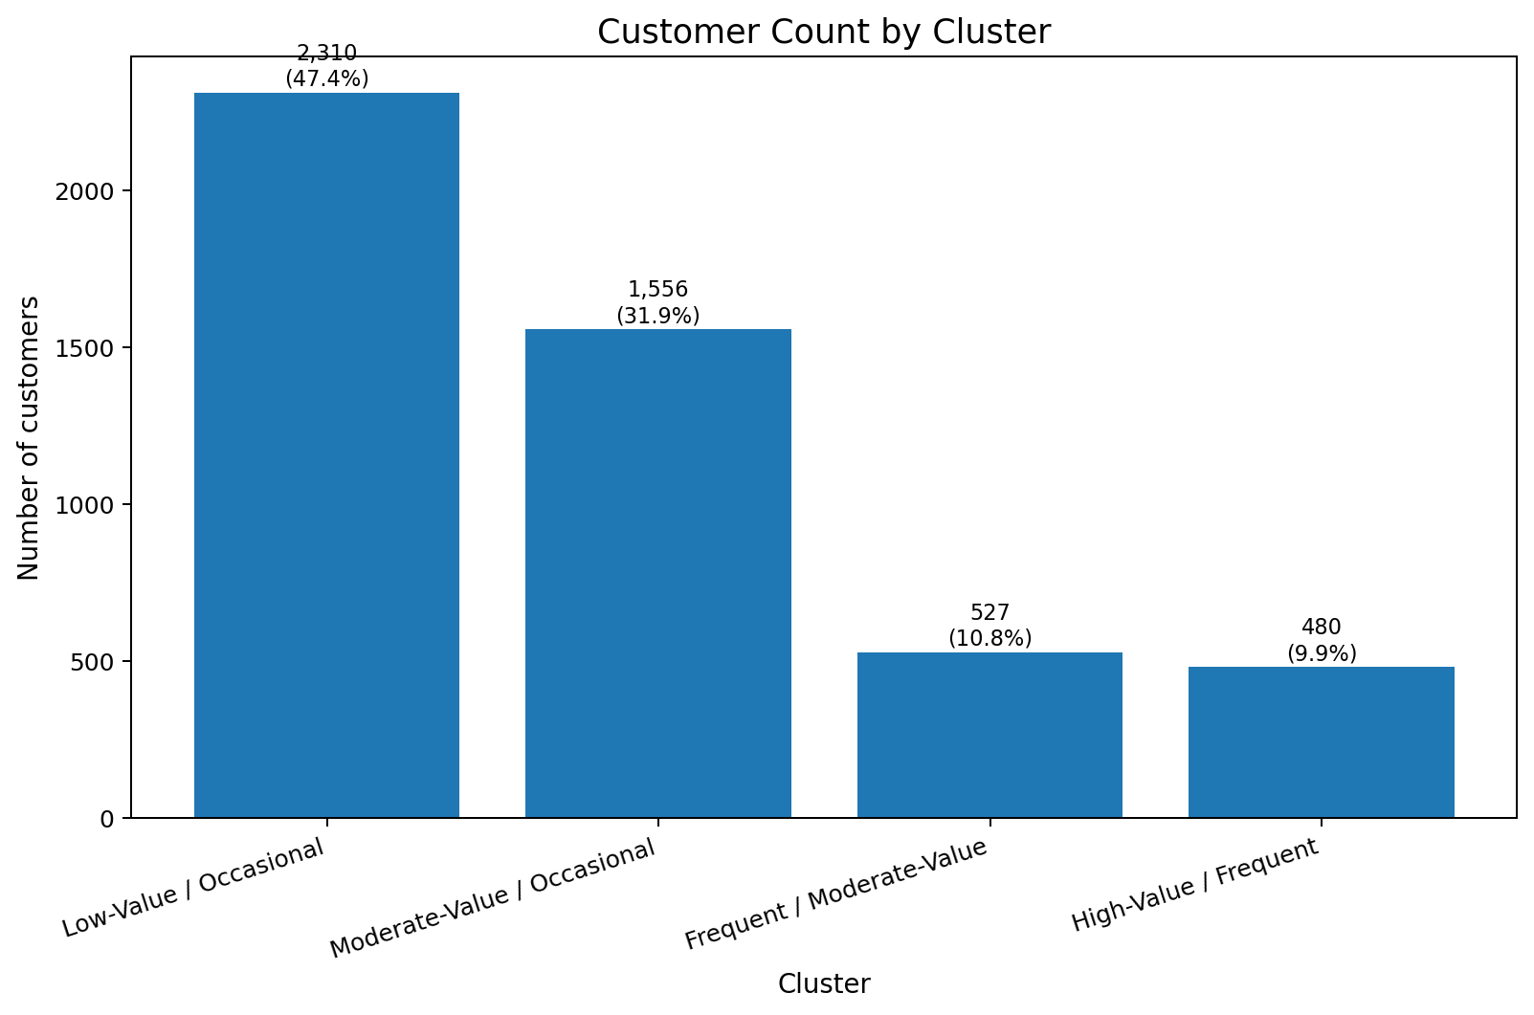
Figure 3. Customer count and percentage by cluster. The annotations make the size of each segment explicit.

12. Cluster Profile Summary
Cluster | Customers | Avg Sales | Avg Profit | Avg Qty | Avg Orders | Avg AOV | Sales Share
0 | 2,310 | 819.77 | 37.67 | 15.91 | 3.18 | 137.75 | 14.98%
1 | 1,556 | 3,147.35 | 208.30 | 54.78 | 7.41 | 217.68 | 38.74%
2 | 527 | 4,049.48 | 789.95 | 31.87 | 4.48 | 526.98 | 16.88%
3 | 480 | 7,745.62 | 1,333.41 | 82.37 | 9.41 | 393.57 | 29.41%

13.1 Low-Value / Occasional
This cluster contains 2,310 customers (47.4% of customers). Average sales per customer are 819.77, average profit is 37.67, average quantity is 15.91, average order frequency is 3.18, and average order value is 137.75. The group contributes 14.98% of total customer sales and 5.93% of total customer profit. The segment name is an interpretation of these measurements; the numeric cluster ID itself has no inherent meaning.
Analytical interpretation: this is the lowest average-sales segment and has relatively low order frequency. A practical example is a customer who places only a few orders with modest transaction totals. The segment is large in customer count, so small changes in engagement could affect aggregate activity even though the average value per customer is lower.

13.2 Moderate-Value / Occasional
This cluster contains 1,556 customers (31.9% of customers). Average sales per customer are 3,147.35, average profit is 208.30, average quantity is 54.78, average order frequency is 7.41, and average order value is 217.68. The group contributes 38.74% of total customer sales and 22.09% of total customer profit. The segment name is an interpretation of these measurements; the numeric cluster ID itself has no inherent meaning.
Analytical interpretation: this group has higher average sales and profit than Cluster 0 but lower purchase frequency than the frequent segments. This pattern is consistent with customers who place fewer but comparatively valuable orders.

13.3 Frequent / Moderate-Value
This cluster contains 527 customers (10.8% of customers). Average sales per customer are 4,049.48, average profit is 789.95, average quantity is 31.87, average order frequency is 4.48, and average order value is 526.98. The group contributes 16.88% of total customer sales and 28.37% of total customer profit. The segment name is an interpretation of these measurements; the numeric cluster ID itself has no inherent meaning.
Analytical interpretation: the defining characteristic is purchase frequency. Average order count is substantially higher than Cluster 0, while average order value is moderate. This indicates repeat purchasing rather than only occasional high-value transactions.

13.4 High-Value / Frequent
This cluster contains 480 customers (9.9% of customers). Average sales per customer are 7,745.62, average profit is 1,333.41, average quantity is 82.37, average order frequency is 9.41, and average order value is 393.57. The group contributes 29.41% of total customer sales and 43.62% of total customer profit. The segment name is an interpretation of these measurements; the numeric cluster ID itself has no inherent meaning.
Analytical interpretation: this segment combines the highest average sales, profit, quantity, and order frequency in the four-cluster solution. It also contributes a large share of total profit. These measurements make it distinct in the selected feature space and useful for further retention and customer-value analysis.

14. Visual Cluster Analysis
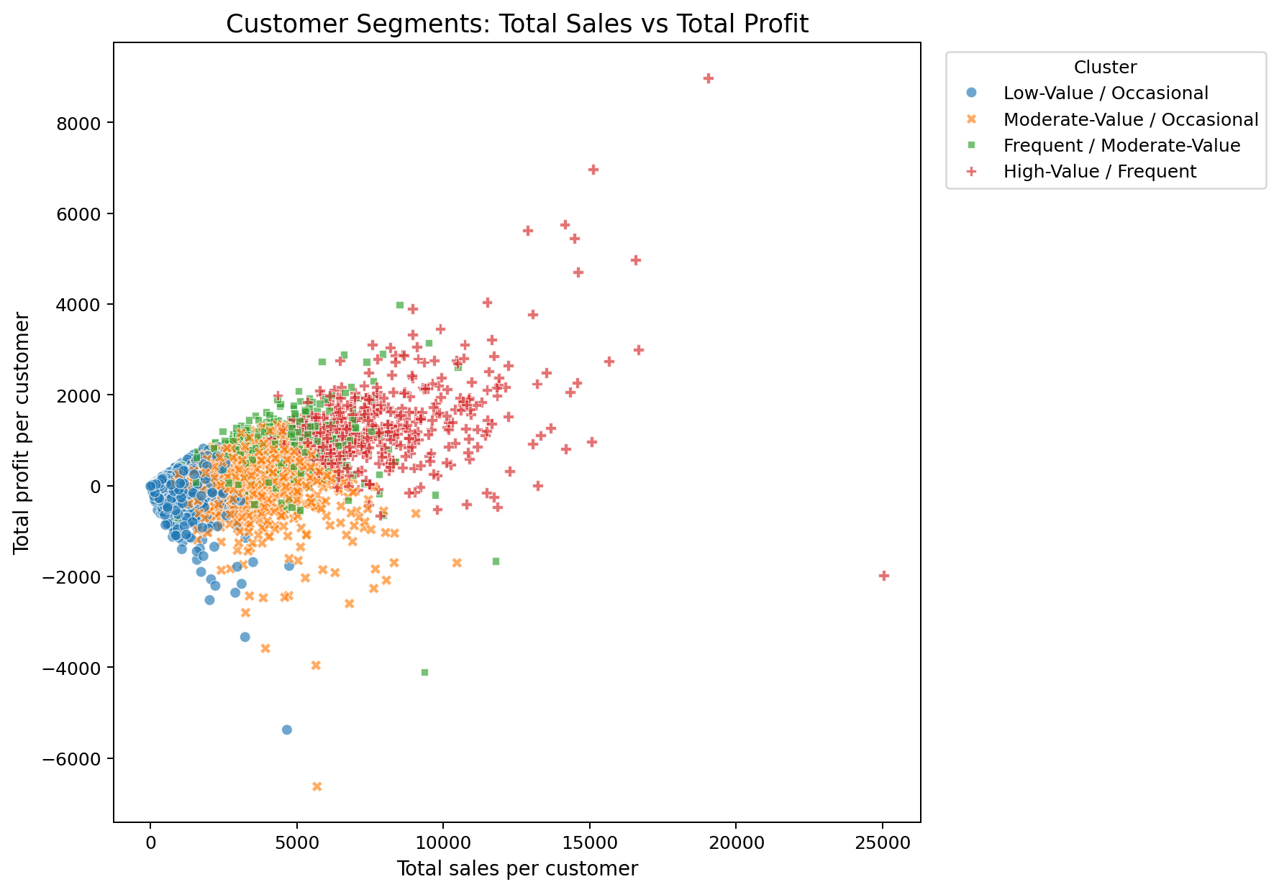
Figure 4. Total sales versus total profit with cluster labels.
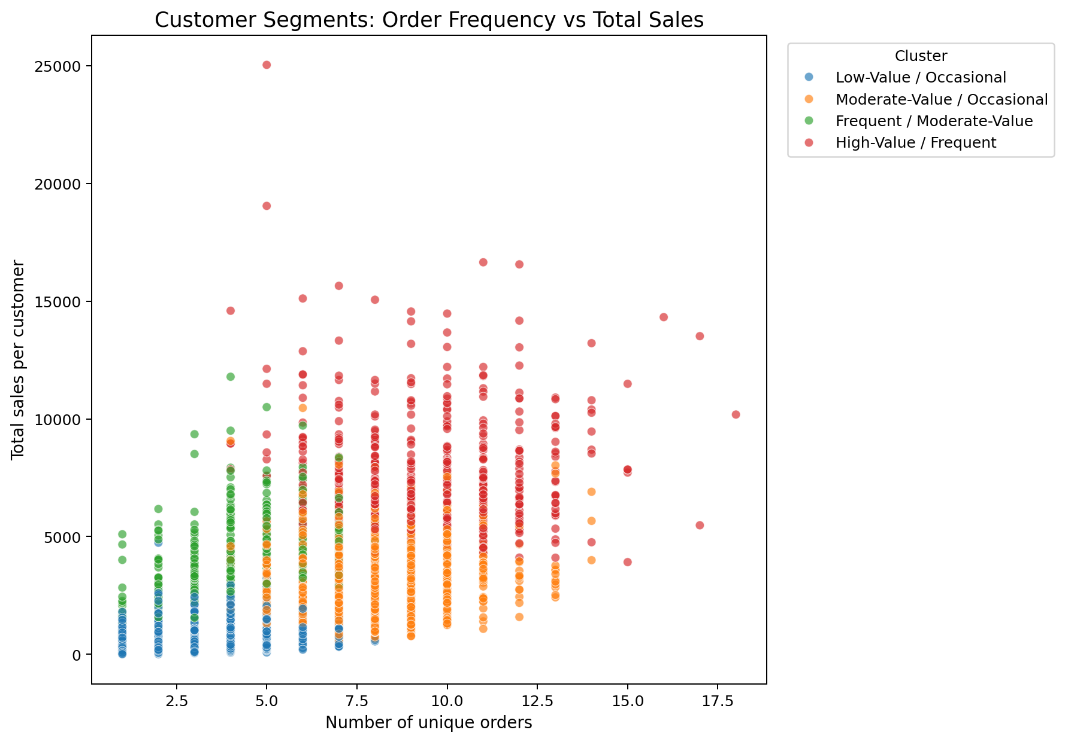
Figure 5. Order frequency versus total sales, showing behavioural differences.
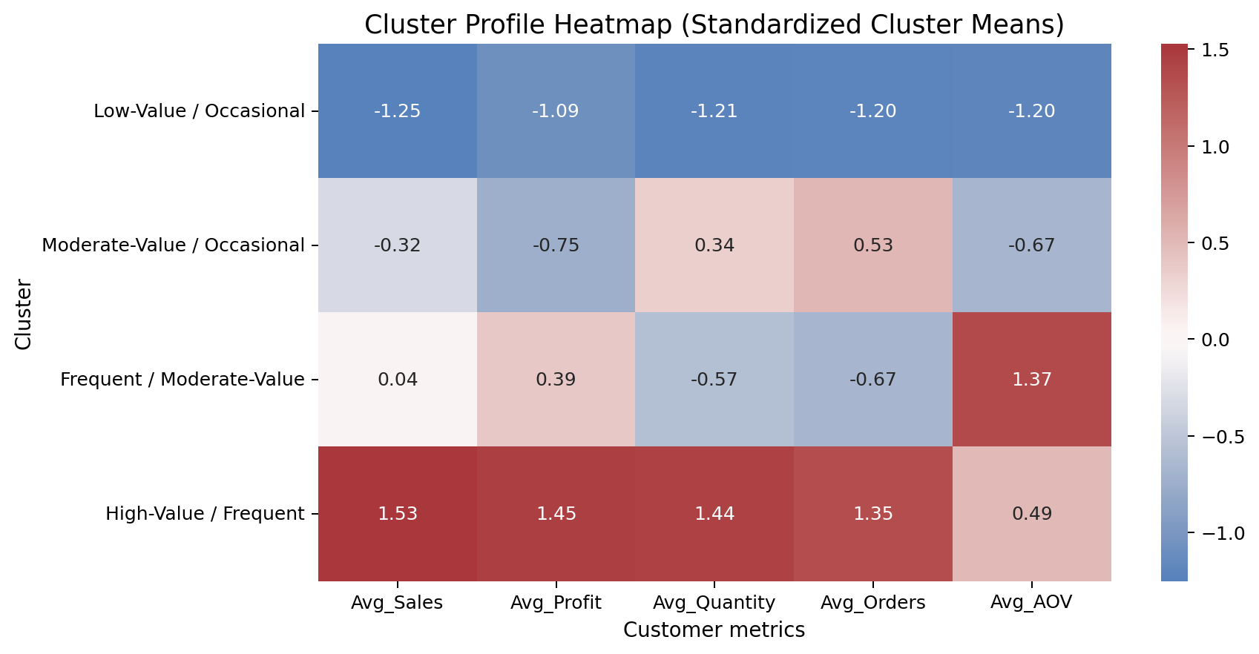
Figure 6. Standardized cluster-profile heatmap; positive values indicate above-average cluster means across the feature set.
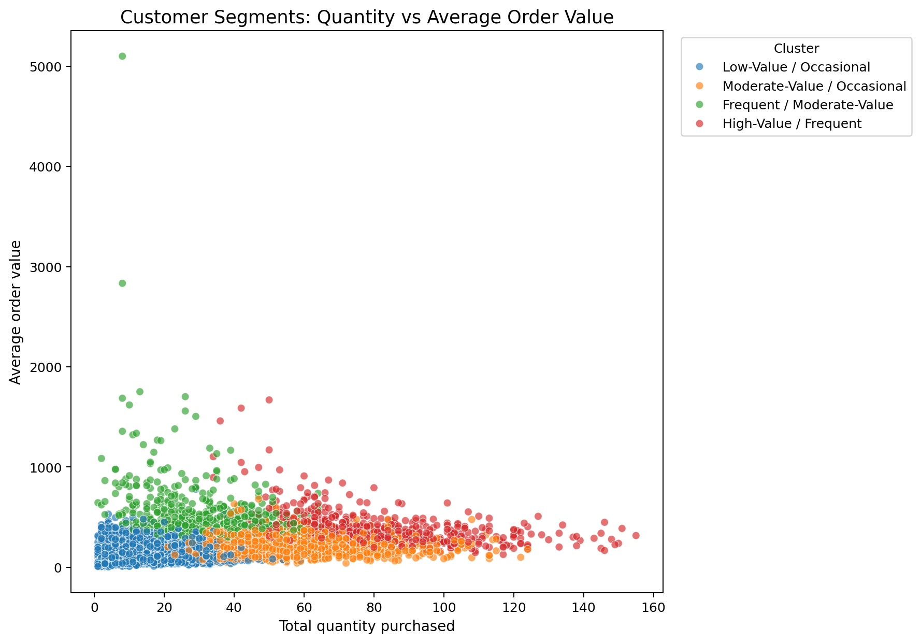
Figure 7. Total quantity versus average order value.
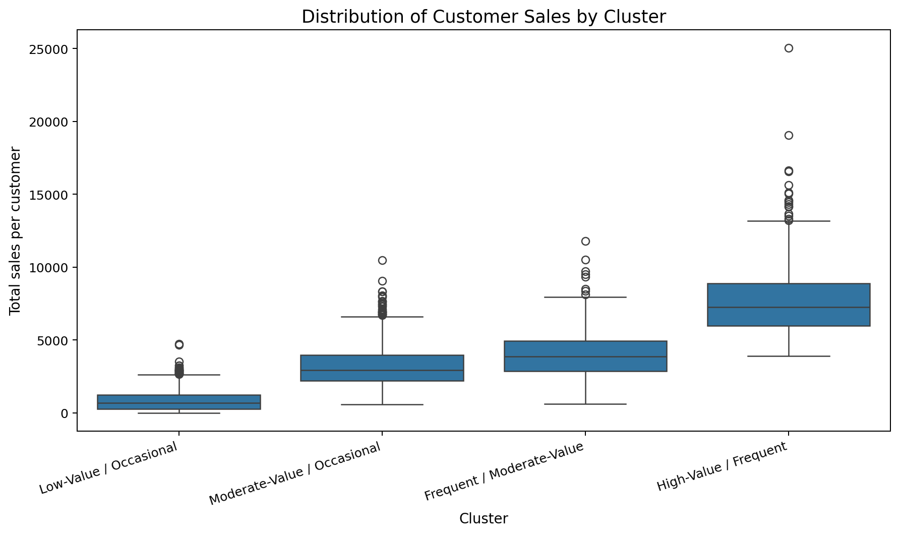
Figure 8. Customer-level sales distribution by cluster.
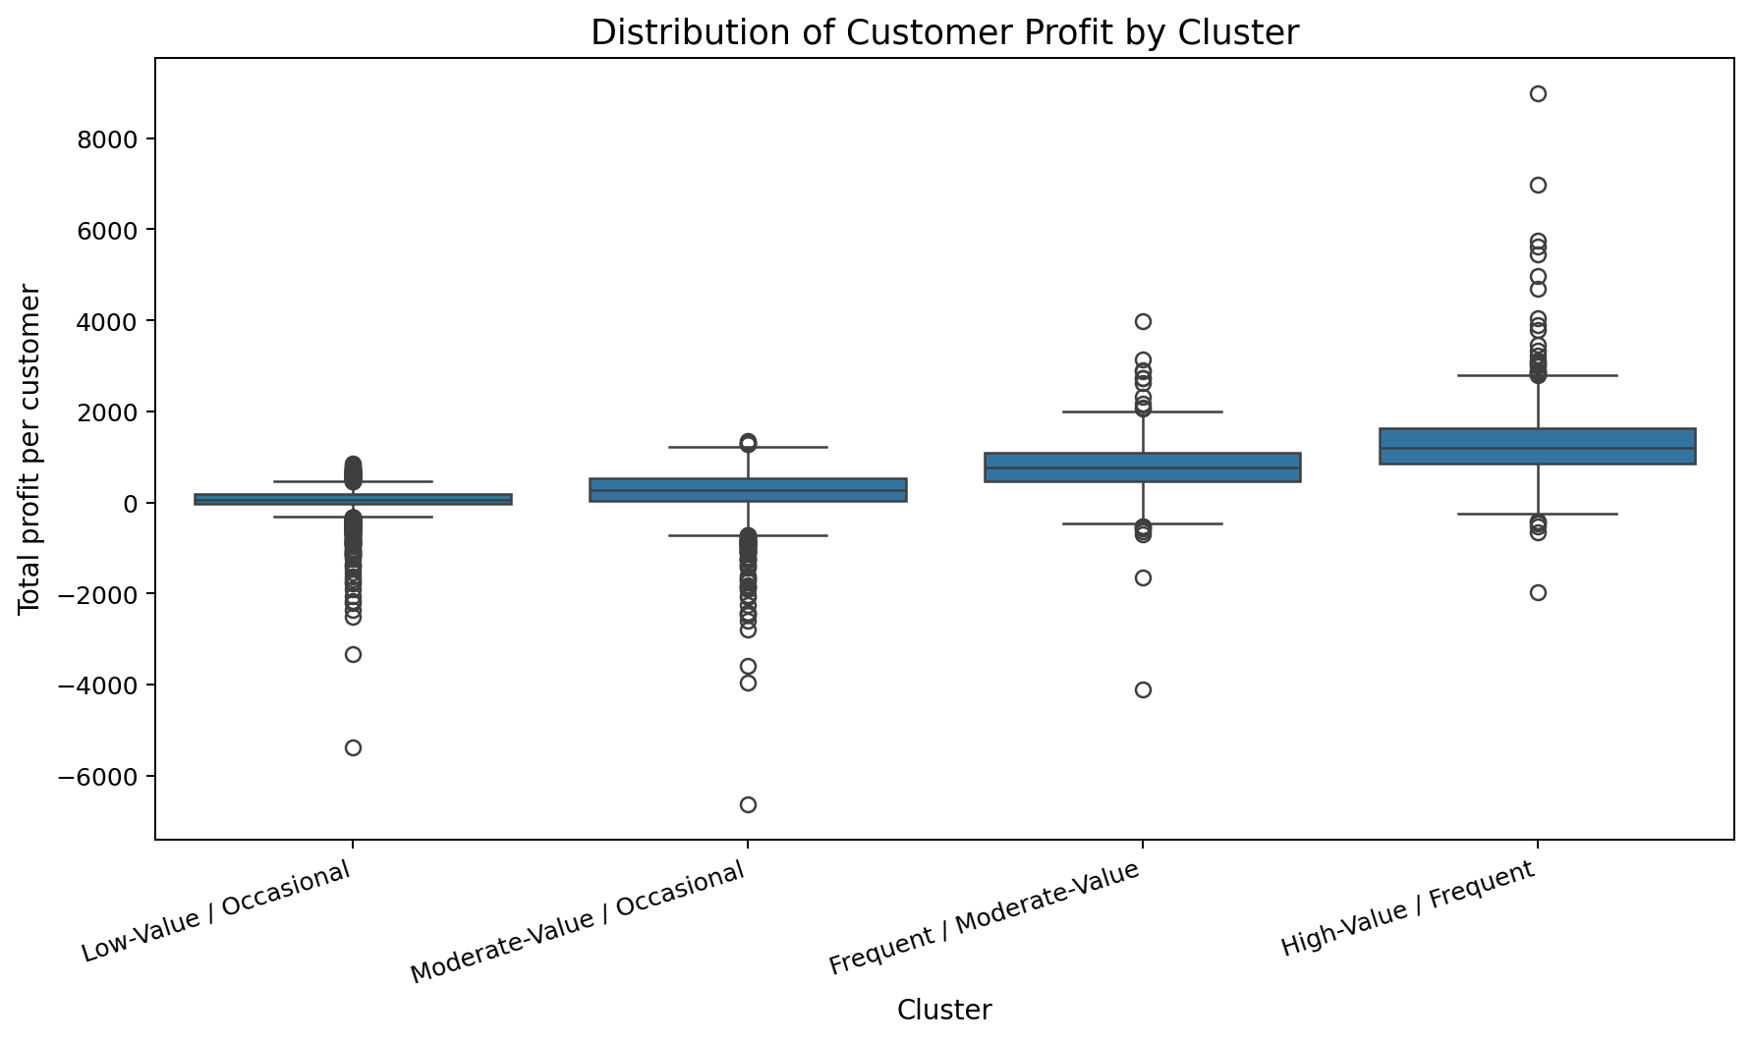
Figure 9. Customer-level profit distribution by cluster.
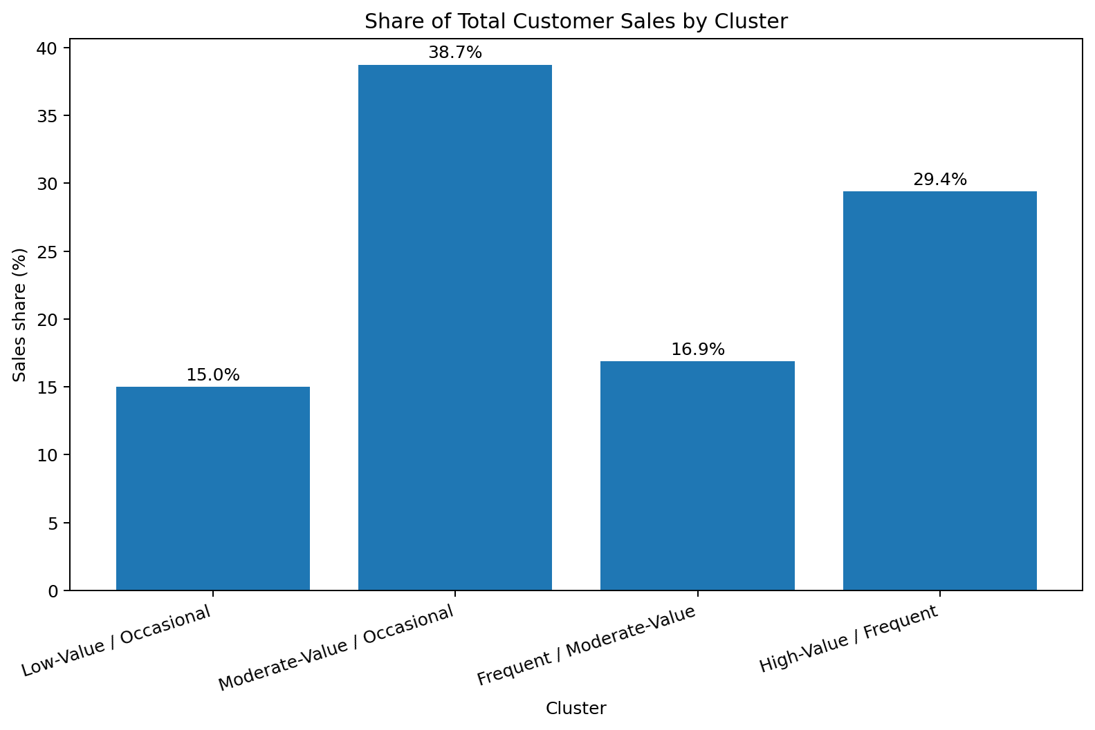
Figure 10. Contribution of each cluster to total customer sales.
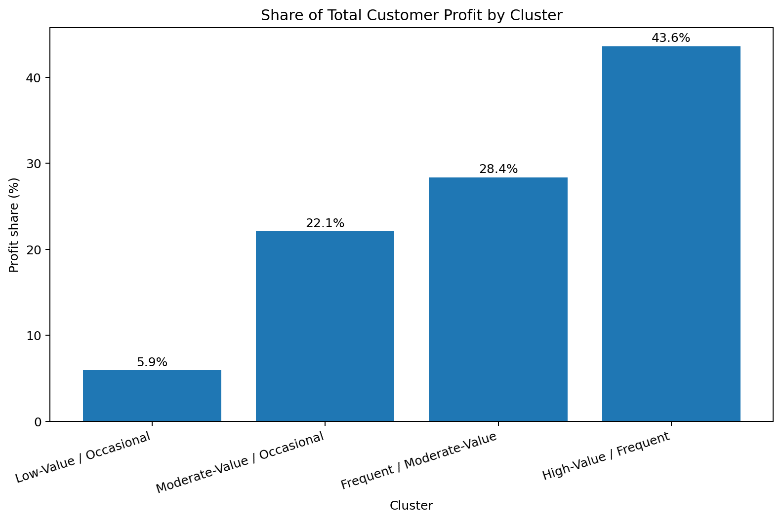
Figure 11. Contribution of each cluster to total customer profit.
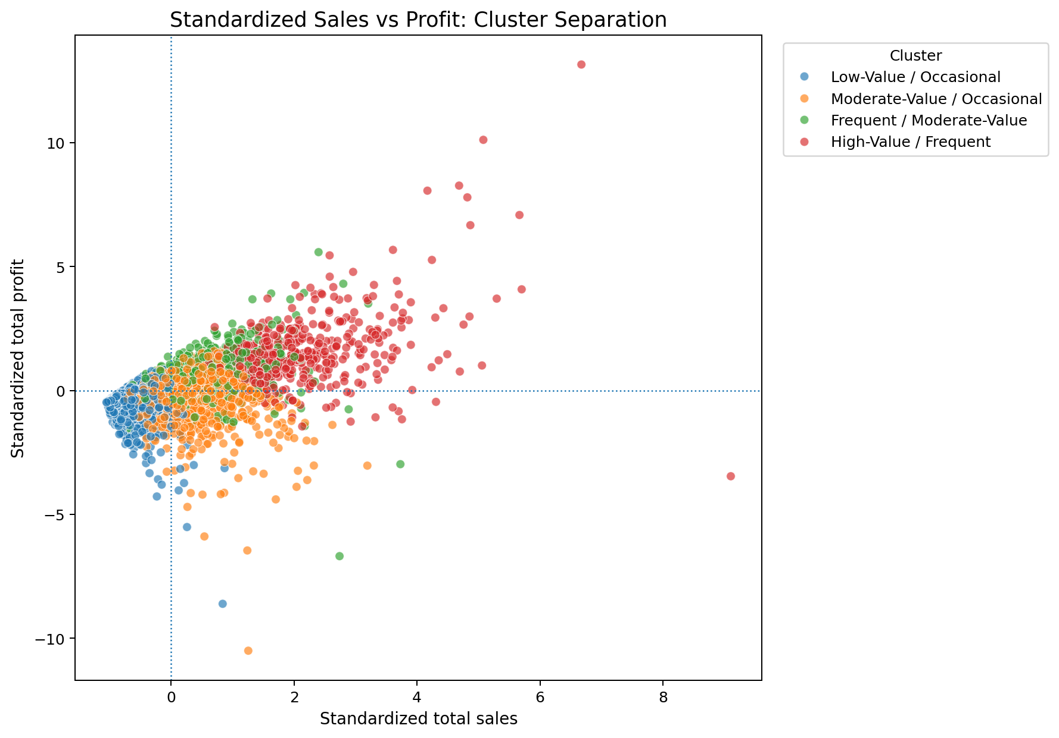
Figure 12. Standardized two-dimensional sales-profit view.

15. Deeper Analytical Findings
The cluster analysis should not be interpreted from a single chart. The sales-profit scatter shows the value dimension, while order frequency adds a behavioural dimension. The heatmap provides a relative comparison across all five modelling variables. Together, these views show why customer segmentation is more informative than simply ranking customers by sales.
Comparison example: Cluster 3 (High-Value / Frequent) has average sales of 7,745.62 versus 819.77 for Cluster 0 (Low-Value / Occasional). Its average order frequency is 9.41 versus 3.18. This demonstrates that the segmentation captures differences in both monetary value and purchasing behaviour.
Comparison example: Cluster 2 (Frequent / Moderate-Value) has average sales of 4,049.48 versus 819.77 for Cluster 0 (Low-Value / Occasional). Its average order frequency is 4.48 versus 3.18. This demonstrates that the segmentation captures differences in both monetary value and purchasing behaviour.
Comparison example: Cluster 3 (High-Value / Frequent) has average sales of 7,745.62 versus 3,147.35 for Cluster 1 (Moderate-Value / Occasional). Its average order frequency is 9.41 versus 7.41. This demonstrates that the segmentation captures differences in both monetary value and purchasing behaviour.

16. Business / Research Implications
- Retention analysis can monitor the high-value/frequent segment separately from occasional customers.
- Marketing analysis can compare segment-level purchase frequency, order value, and profitability before designing differentiated campaigns.
- Sales teams can investigate customers with strong sales but different order-frequency patterns because similar revenue totals can arise from very different purchasing behaviours.
- Product and service planning can use quantity and average-order patterns to understand purchasing intensity.
- The clusters can serve as exploratory features for later customer lifetime value, recommendation, churn, or supervised modelling studies after independent validation.

17. Challenges and Limitations
- K-Means requires the number of clusters to be selected before final training.
- The result depends on the selected features and scaling method.
- K-Means favours compact, distance-based groups and may not represent every possible customer structure.
- Outliers can affect centroid positions; robust scaling or alternative algorithms could be tested in future work.
- The clusters are descriptive, not causal. They do not prove that a customer characteristic causes higher sales or profit.

18. Future Improvements
Future experiments could compare K-Means with Hierarchical Clustering or DBSCAN, test alternative feature sets such as Recency-Frequency-Monetary features, use PCA for dimensional visualization, and evaluate cluster stability across random seeds or time periods. A production-oriented study should also validate whether the segments improve measurable business outcomes.

19. Conclusion
The project demonstrates a complete unsupervised-learning workflow: dataset preparation, customer-level feature engineering, scaling, K-Means clustering, model-selection diagnostics, annotated visualizations, numerical profiling, and business interpretation. The four-cluster solution provides a practical exploratory segmentation of Superstore customers while transparently acknowledging that k=4 was selected for interpretability rather than because it produced the highest silhouette score.

