YuvaIntern

Week 4 – Supervised Learning Model Implementation
Superstore Profit Prediction using Regression
Prepared by:
Sonu Dada Funde
Internship Role:
Virtual Data Science with Python Trainee
Tools:
Python, Pandas, Jupyter Notebook
Year: 2026

1. Objective
The objective is to design and implement a supervised learning model in Python on a public dataset, covering data preparation, feature engineering, model training, validation, evaluation and interpretation.

2. Problem Definition
A regression problem was selected: estimate transaction-level Profit from discount, quantity, shipping, categorical and operational information. Profit is continuous, so regression is appropriate.

3. Dataset
The Superstore dataset contains 51,290 transaction records. The Week 2 cleaned dataset was reused. Earlier analysis reported total sales of $12,642,905.00, total profit of $1,467,457.29, average sales of $246.50 and average profit of $28.61.

4. Data Preparation and Feature Engineering
Order.Date and Ship.Date were converted to datetime values and Shipping.Days was derived from them. Numerical missing values are median-imputed and categorical values are most-frequent imputed inside the modelling pipeline.

5. Feature Selection
Predictors: Discount, Quantity, Shipping.Cost, Shipping.Days, Category, Region, Segment, Ship.Mode and Order.Priority. Sales is excluded because it is directly related to transaction revenue and would make the exercise less useful as a pre-decision predictive demonstration.

6. Models and Rationale
Ridge Regression provides a regularized linear baseline. HistGradientBoostingRegressor provides a flexible nonlinear model that can capture interactions and nonlinear relationships.

7. Validation
An 80/20 train-test split with random_state=42 was used. Three-fold cross-validation was performed on the training data to assess consistency.

8. Results
HistGradientBoosting test MAE=42.558, RMSE=124.253, R²=0.4745. Three-fold CV R² values were [0.4825, 0.5614, 0.5179] with mean 0.5206.

9. Interpretation
The model comparison shows the difference between a linear baseline and a nonlinear boosting approach. The actual-vs-predicted plot and error distribution help inspect prediction quality and large residuals. Cross-validation adds evidence about consistency across training subsets.

10. Strengths
The project uses a complete reproducible pipeline, combines numerical and categorical predictors, compares two models, uses hold-out testing and cross-validation, and includes visual diagnostics.

11. Limitations
The data is historical; important drivers of profit may be absent; extreme profit values can create large errors; and the model is an educational demonstration rather than a production system. Correlation or predictive association does not establish causation.

12. Possible Improvements
Use time-based validation, tune hyperparameters, add carefully defined customer/product history features without leakage, compare additional algorithms, and apply explainability techniques such as permutation importance or SHAP.

13. Conclusion
The Week 4 task demonstrates a complete supervised regression workflow from data preparation through evaluation. The project provides a practical foundation for more advanced supervised learning experiments.

14. Evaluation Metrics
Model | MAE | RMSE | R²
Ridge Regression | 62.772 | 153.653 | 0.1965
HistGradientBoosting | 42.558 | 124.253 | 0.4745

15. Visualizations
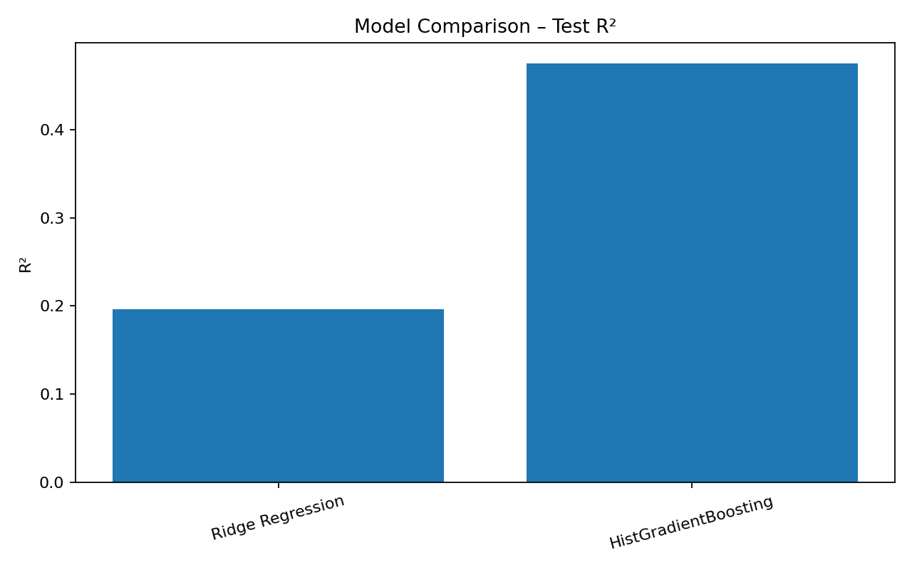
Figure 1. Model comparison using test-set R².
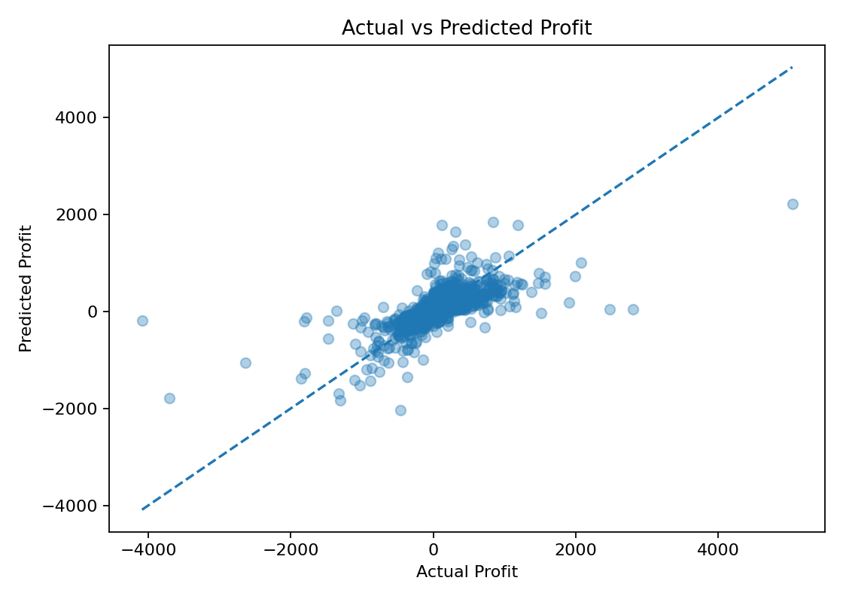
Figure 2. Actual versus predicted profit.
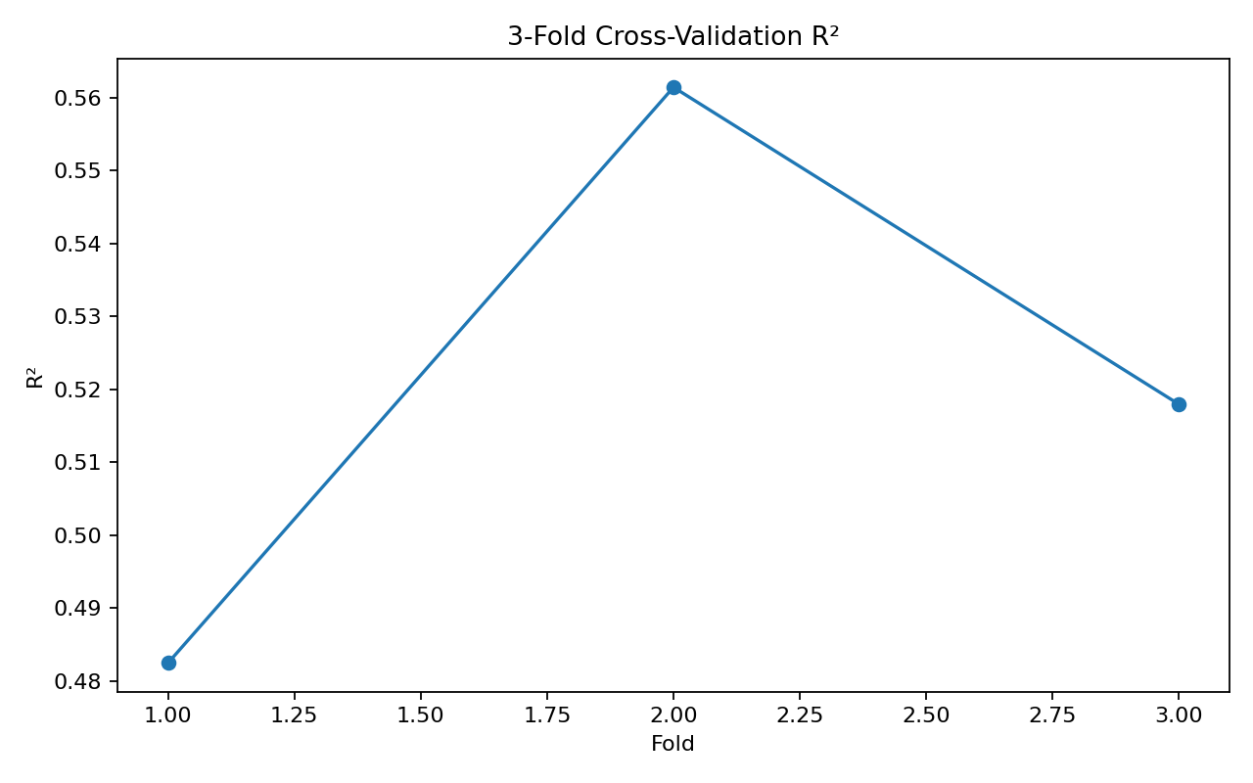
Figure 3. Three-fold cross-validation R².
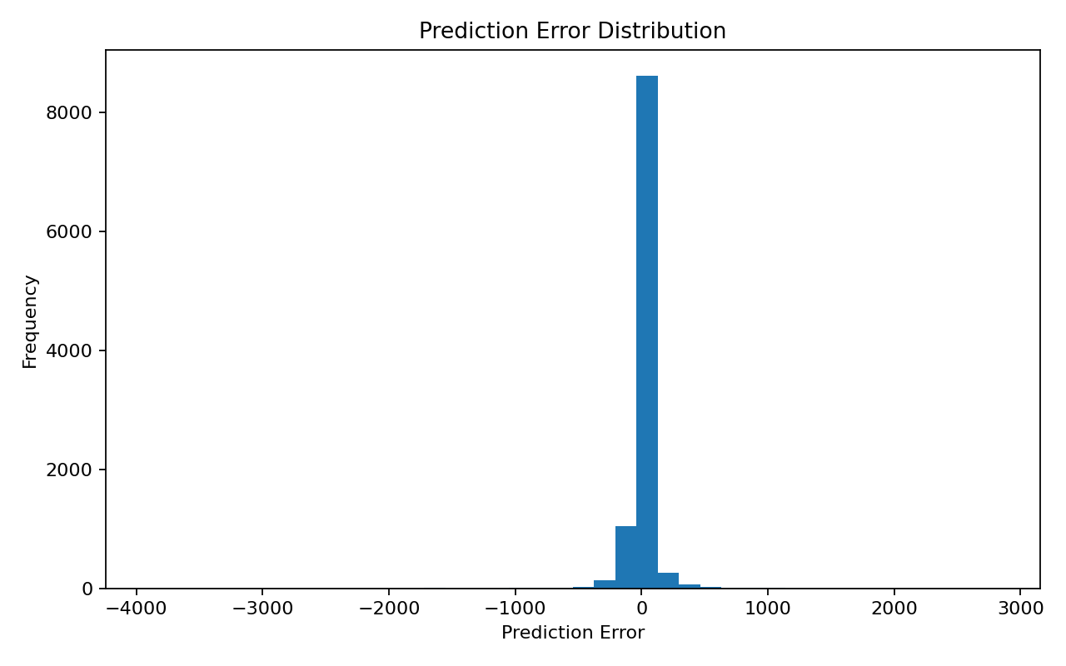
Figure 4. Prediction error distribution.

16. Technologies Used
Python, Pandas, NumPy, Matplotlib, Scikit-learn, Jupyter Notebook and Microsoft Word.

17. Project Structure
YuvaIntern_Week4_Supervised_Learning/
├── data/superstore_cleaned.csv
├── output/modeling_dataset.csv
├── output/model_metrics.csv
├── output/cross_validation_results.csv
├── output/predictions.csv
├── output/charts/
├── Week4_Supervised_Learning.ipynb
├── YuvaIntern_Week4_Supervised_Learning_Report.docx
├── README.md
└── requirements.txt

