Title of Work
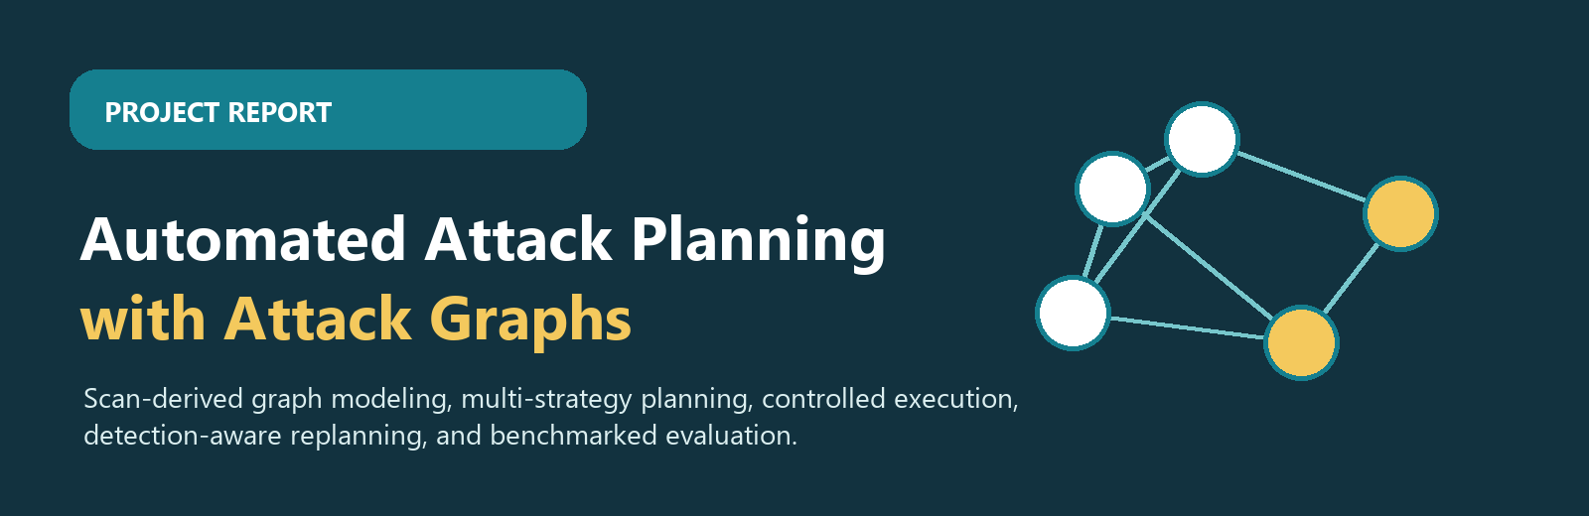

Automated Attack Planning with Attack Graphs
A detailed project report on building an automated, graph-backed security planning framework that converts scan evidence into ranked attack paths, validates planner behavior, and presents results through metrics and visuals.
Codebase  42 Python files  Graph, planners, execution, detection, RL, evaluation, visualization. | Tests  44 passed  Pytest completed successfully; four warnings are UTC deprecation notices. | Complex graph  7 hosts / 12 edges  Used for planner path-quality comparison and visual graph outputs. | Huge benchmark  600 devices  1,597 edges, 12 zones, 25 repeat runs for timing and trade-off analysis.

Ethical use boundary
The implementation and report are framed for authorized lab environments, defensive validation, education, and security research. Operational use outside explicit authorization is out of scope.

Abstract
Abstract element | Answer
What | The project implements an automated attack-planning framework that builds an attack graph from network scan evidence, CVE intelligence, and exploit relationships.
Why | Manual red-team planning is expensive, inconsistent, and difficult to repeat across large networks; defenders need explainable paths, measurable risk, and repeatable comparisons.
How | The framework parses Nmap XML, enriches services with vulnerability data, stores graph entities, compares A*, LLM-guided, RL, and detection-aware planners, then evaluates the outputs with path and detection metrics.

What: This work presents Automated Attack Planning with Attack Graphs, a software system that transforms discovered hosts, services, and vulnerabilities into a structured attack graph. The graph represents reachable assets, exploit transitions, privileges, and attacker progress so that a planner can reason over possible routes instead of relying on isolated vulnerability lists.
Why: Traditional red-team path planning depends heavily on expert judgement, manual tool chaining, and repeated interpretation of scan outputs. As networks grow, it becomes harder to compare direct, fast paths against stealthier alternatives or to explain why a given path is chosen. Recent work on automated red team testing and LLM-assisted multi-host red teaming shows the value of automation, but also highlights gaps around dynamic feedback, defender visibility, and reliable execution boundaries.
How: The project combines graph construction, CVE enrichment, multiple planners, a controlled execution layer, IDS-aware cost modeling, and evaluation dashboards. Its implementation is organized across graph parsing and storage modules, planner modules, executor adapters, detection monitors, reinforcement-learning components, metrics/reporting, and visualization utilities. Benchmarks demonstrate that the same graph can support short aggressive paths, longer low-detection paths, and repeatable planner comparisons.

Problem Statement
Organizations often receive security scan outputs as lists of vulnerabilities, ports, and services. Those lists are useful, but they do not directly answer the higher-level question that defenders and red teams care about: which sequence of actions could move an attacker from an initial foothold to a critical asset, and what trade-offs exist between speed, reliability, exploitability, and detection exposure?
The problem addressed by this project is the absence of a unified, implementation-backed workflow that converts raw discovery evidence into a measurable and visually explainable attack plan. A useful workflow must represent multi-host dependencies, compare planning strategies, remain adaptable when telemetry changes, and produce outputs that a human security analyst can inspect.
Core challenge
The project must bridge three layers that are often separated: vulnerability modeling, automated planning, and operational feedback. Without that bridge, a plan may be theoretically shortest but operationally noisy, or visually impressive but disconnected from executable steps.

Objective 1:

Construct a high-fidelity attack graph
The first objective is to convert network discovery evidence into a graph that is rich enough for planning. The graph must represent hosts, services, vulnerabilities, exploitability, privileges, and directed movement between assets. In this implementation, the graph layer parses scan data, enriches services with CVE context, and persists entities so that planners can query and score candidate routes.
Focus | Implementation detail | Expected output
Discovery ingestion | Nmap XML parsing and service normalization in the graph layer. | Consistent host/service inventory.
Vulnerability context | CVE enrichment, severity fields, exploit hints, and local cache support. | Risk-aware graph nodes and edges.
Graph persistence | Host, service, vulnerability, and transition models with Neo4j-facing persistence utilities. | Reusable attack graph for planning and visualization.

Objective 2:

Implement and compare multiple planning strategies
The second objective is to avoid a single-planner blind spot. The project implements and evaluates several planning families: heuristic A* search for efficient shortest-path reasoning, LLM-assisted planning for high-level strategic guidance, reinforcement learning for policy-style path selection, and detection-aware Pareto planning for balancing reachability against exposure.
Planner | Role in project | Value of comparison
A* | Fast heuristic baseline that favors short, direct paths. | Shows the best-case path length and runtime baseline.
LLM-guided | Uses language-model reasoning in an offline or assisted planning role. | Explores strategic planning quality while preserving graph grounding.
Reinforcement learning | Learns or follows a policy over graph states and rewards. | Tests whether repeated experience can approximate stealth-aware choices.
Detection-aware | Scores routes using IDS/detection cost and Pareto trade-offs. | Surfaces safer alternatives even when they require extra hops.

Objective 3:

Execute, monitor, and evaluate attack plans
The third objective is to connect planning to a controlled execution and evaluation workflow. The executor layer maps selected graph actions into playbook-oriented operations and adapter calls, while the detection layer models IDS exposure and triggers replanning when a path becomes too noisy. The evaluation layer reports path length, detection cost, runtime, success indicators, and graph visuals.
Capability | Project component | Evaluation signal
Controlled execution | PlaybookRunner with Metasploit, SSH, and CALDERA-style adapters. | Plan steps can be represented as executable actions in a lab setting.
Runtime feedback | IDS monitor, detection cost model, and replanning trigger. | Plans can react to visibility rather than remaining static.
Reporting | Metrics reporter, log collector, Graphviz/dashboard outputs. | Results are repeatable, visual, and easier to audit.

Scope of Work
The scope is intentionally practical: it covers the design, implementation, and evaluation of an automated attack-planning workflow for authorized lab networks. It does not attempt to build a general-purpose offensive tool for uncontrolled environments, nor does it claim that graph planning alone can replace human security judgement.
In scope | Out of scope | Assumptions
Parsing scan evidence, enriching CVE context, constructing graph objects, and visualizing graph routes. | Unauthorized exploitation, real-world deployment against third-party systems, or weaponization outside a lab. | Input scans and benchmark data represent authorized environments with known goals.
Comparing A*, LLM-guided, RL, and detection-aware planners using path and runtime metrics. | Proving universal optimality for every possible enterprise topology. | Planner quality is evaluated on repeatable benchmark graphs and explicit cost functions.
Modeling execution as playbooks and adapter calls, plus monitoring with IDS-style detection cost. | Replacing professional red-team operators or incident responders. | Human review remains responsible for authorization, interpretation, and remediation decisions.

Existing approaches and gaps/improvement areas(min 3)
The minimum of three existing approaches is covered below; four are included to make the comparison more useful. The project borrows useful ideas from each approach while addressing gaps through graph grounding, multiple planner baselines, execution adapters, and detection-aware evaluation.
Existing approach | Strength | Gap / improvement area | Project response
Classical attack graphs and vulnerability graphs | Excellent for representing reachability, dependencies, and attack paths. | Often stop at static visualization or require heavy manual modeling before planning. | Builds graph objects from scan evidence and CVE enrichment, then feeds them directly into planners and visuals.
STRIPS / partial-order planning for red-team automation, such as Wang et al. [1] | Formalizes attack actions, preconditions, ordering, and dynamic adjustment after feedback. | Focused on post-penetration planning; less emphasis on comparing graph planners, LLM/RL baselines, and detection trade-offs together. | Keeps planning explicit while adding multi-planner comparison and IDS-cost-aware route selection.
LLM-assisted multi-host red teaming, such as Incalmo [2] | Raises abstraction by separating high-level planning from expert task-agent execution and auxiliary services. | LLM-centric systems still need strong state grounding, controlled execution boundaries, and defender visibility modeling. | Uses graph state as the planning substrate and includes detection-aware replanning/evaluation rather than relying only on language context.
MDP / RL-style autonomous penetration testing | Can learn policies from repeated interaction and reward signals. | Policies can be opaque, slow to train, and difficult to compare with deterministic baselines. | Includes RL as one planner family while reporting it beside A*, LLM, and detection-aware paths using the same benchmark metrics.

Novelty/Innovativeness in Project
The novelty is not a claim that attack graphs, automated red teaming, or LLM planning are individually new. The innovation is the project-level integration: a working educational framework that unifies scan-derived graph construction, multiple planners, controlled execution abstractions, detection-aware costs, and polished reporting in one reproducible codebase.
Innovative element | Why it matters
Planner diversity on one graph | A*, LLM-guided, RL, and detection-aware planners can be compared without changing the underlying graph representation.
Detection as a first-class cost | Plans are judged not only by length or reachability but also by expected defender visibility.
Execution-aware modeling | The system connects paths to playbook runner/adapters, making the plan closer to an operational workflow.
Benchmark-backed visuals | Complex and huge benchmark outputs provide interpretable evidence instead of only narrative claims.
Ethical defensive framing | The report and scope keep the work in authorized lab and defensive assessment contexts.

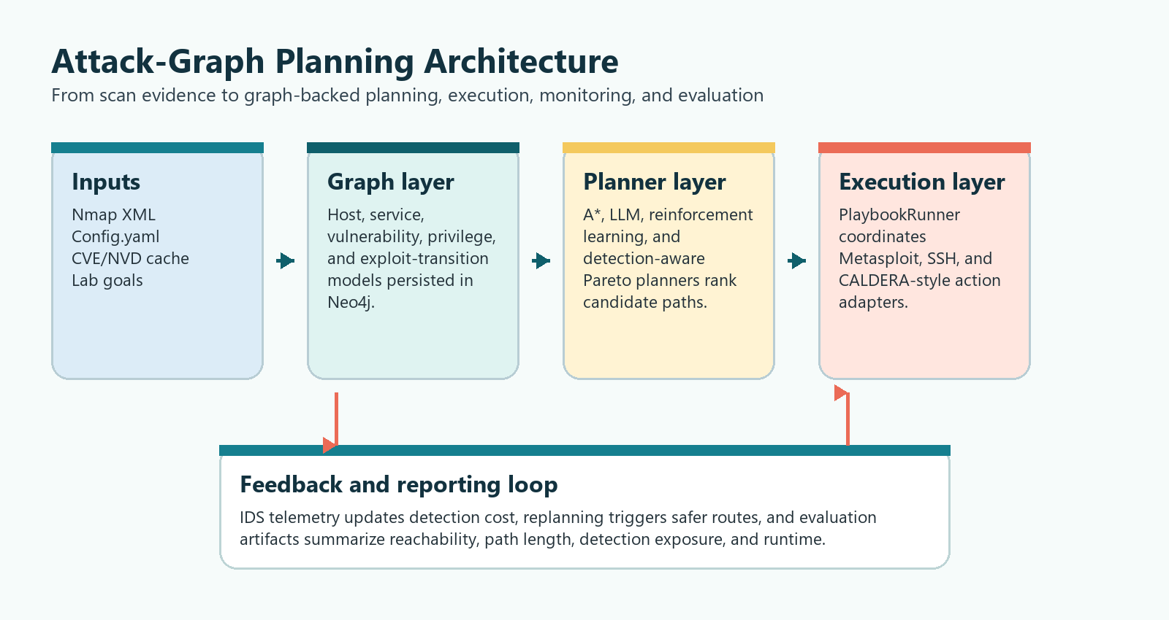
Figure 1. Integrated architecture for graph construction, planning, execution, monitoring, and evaluation.

Proposed Method
The proposed method treats attack planning as a measurable graph-search and decision problem. Instead of presenting vulnerabilities as a flat list, the workflow creates a typed graph, assigns costs to transitions, and allows multiple planners to produce comparable routes. The chosen path can then be translated into controlled playbook steps and re-evaluated if monitoring signals change.
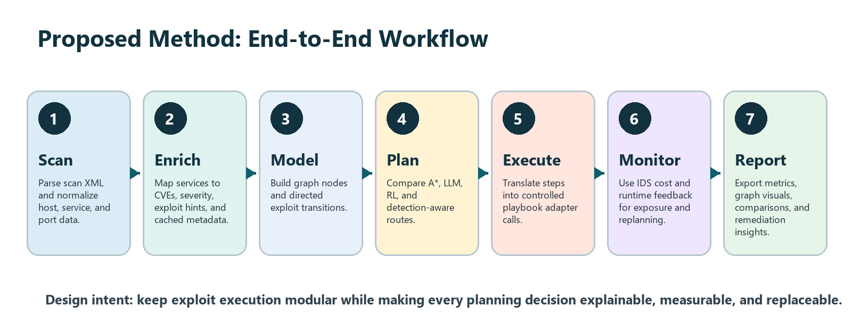
Figure 2. Proposed end-to-end method from scanning to reporting.
1. Collect authorized scan data and configuration inputs for the lab network.
2. Normalize host, service, port, and version data into a common inventory.
3. Enrich inventory items with CVE metadata, severity, exploitability hints, and cached vulnerability context.
4. Construct attack-graph nodes and directed transitions that encode prerequisites, reachable privileges, and target assets.
5. Run multiple planners over the same graph so that route differences are attributable to planning strategy, not inconsistent input data.
6. Apply detection cost and monitoring feedback to compare direct paths against quieter alternatives.
7. Export metrics, visuals, and analyst-readable explanations to support validation and remediation planning.
Input | Processing | Output
Nmap XML, config.yaml, benchmark fixtures | Parser and normalization layer | Host/service inventory
Service versions and CVE cache | Enrichment and severity mapping | Vulnerability-aware graph facts
Graph facts and target goal | Planner scoring and route generation | Candidate attack paths
Candidate path and telemetry | Execution abstraction and IDS-cost feedback | Selected route, replanning signal, metrics

Implementation and Result
The implementation is organized as a modular Python codebase. Excluding the virtual environment, Git metadata, and caches, the current repository contains 42 Python files and 7 Python test files. The latest test run completed successfully with 44 passing tests and four deprecation warnings related to timezone-naive UTC usage in the CVE enrichment layer.
Layer | Representative modules | Role
Graph modeling | graph/ | Nmap parsing, CVE enrichment, graph entities, and persistence-oriented data structures.
Planning | planners/ | A*, LLM, RL, detection-aware, and Pareto-style path planning logic.
Execution | executor/ | Playbook execution and adapters for Metasploit, SSH, and CALDERA-style actions.
Detection | detection/ | IDS monitor, cost model, and replanning trigger.
Reinforcement learning | rl/ | Gymnasium-style attack environment, Q-agent, and training utilities.
Evaluation and visuals | evaluation/, visualization/ | Metrics, reporting, log collection, Graphviz outputs, and dashboard support.

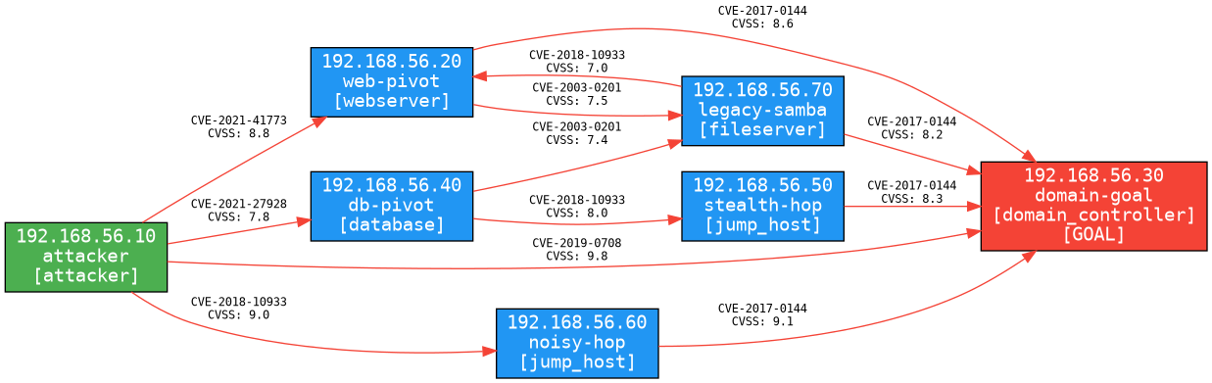
Figure 3. Complex benchmark full graph generated from the project visualization outputs.
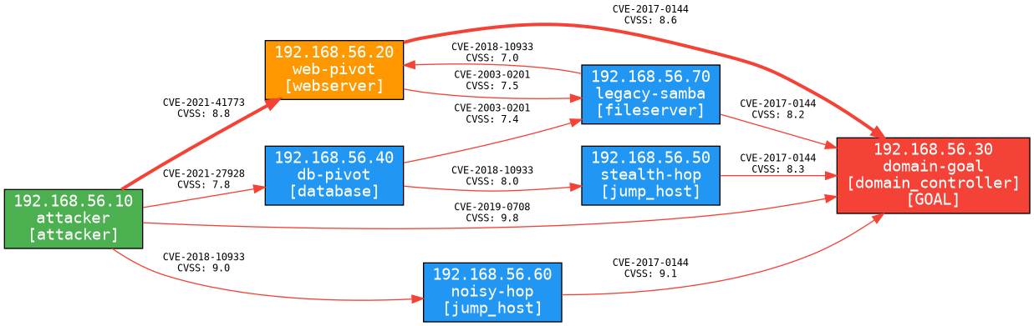
Figure 4. Detection-aware combined route on the complex benchmark.
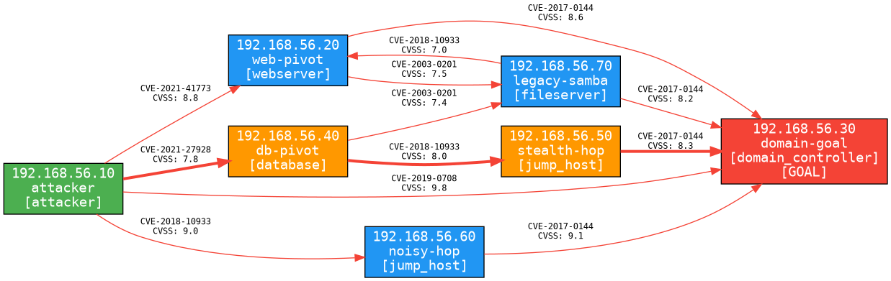
Figure 5. Detection-aware stealthiest route on the complex benchmark.
Benchmark | Planner / route | Steps | Detection cost | Runtime / note
Complex: 7 hosts, 12 edges | A*, LLM, RL direct route | 1 | 0.95 | Shortest route via CVE-2019-0708.
Complex: 7 hosts, 12 edges | Detection-aware combined | 2 | 0.40 | Balances route length and visibility.
Complex: 7 hosts, 12 edges | Detection-aware stealthiest | 3 | 0.18 | Lowest exposure route in this benchmark.
Huge: 600 devices, 1,597 edges | A* | 6 | 5.70 | 0.0662 ms average.
Huge: 600 devices, 1,597 edges | LLM offline | 6 | 5.70 | 3.253 ms average.
Huge: 600 devices, 1,597 edges | Detection combined | 11 | 1.54 | 0.4248 ms average.
Huge: 600 devices, 1,597 edges | RL seeded | 11 | 1.54 | 0.1671 ms average.
Huge: 600 devices, 1,597 edges | Detection stealthiest | 13 | 0.26 | 86.2081 ms mean Pareto-set computation.

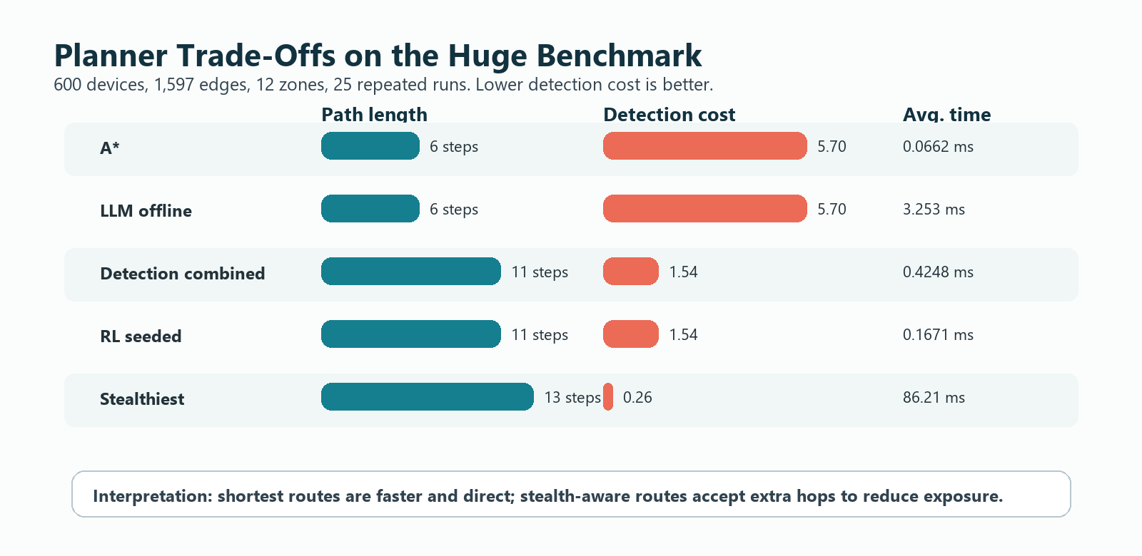
Figure 6. Planner trade-off visualization for the huge benchmark.
Result interpretation
The results show a clear and useful trade-off. Direct planners find short paths quickly, but detection-aware planning exposes quieter alternatives. This is the main practical value of the graph-backed approach: the defender can see not only whether a path exists, but what kind of operational risk the path carries.

Conclusion
The project successfully demonstrates a complete attack-graph planning workflow: scan evidence is normalized, enriched, converted into graph structures, planned over by multiple strategy families, and evaluated with both path and detection metrics. The final system is not merely a visualization tool; it provides an analysis pipeline that can compare planning assumptions and present the consequences of choosing speed over stealth or vice versa.
The implementation aligns with current research directions in automated red-team planning and LLM-assisted multi-host red teaming, but keeps the work grounded in structured graph state, repeatable benchmarks, and a defensive evaluation scope. The benchmark results confirm that the same attack graph can support direct, combined, and stealth-oriented routes, making it easier for analysts to reason about exposure and remediation priorities.

Future Work
- Add timezone-aware UTC handling in the CVE enrichment layer to remove the current deprecation warnings.
- Expand benchmark scenarios with more heterogeneous services, credential relationships, privilege escalation chains, and segmented enterprise-style topologies.
- Add richer defender models, including alert fatigue, sensor coverage, response time, and adaptive blocking policies.
- Improve LLM planner guardrails by constraining suggestions to graph-valid actions and explaining rejected actions.
- Integrate remediation recommendations so each high-risk path maps to patching, segmentation, credential hardening, or detection-control improvements.
- Automate report generation from benchmark outputs so future experiments can update tables and figures without manual editing.

References
1. Wang, Z., Li, S., Zhang, L., Hu, C., and Yan, L. (2024). A Red Team automated testing modeling and online planning method for post-penetration. Computers & Security, 144, 103945. https://doi.org/10.1016/j.cose.2024.103945
2. Singer, B., Lucas, K., Adiga, L., Jain, M., Bauer, L., and Sekar, V. (2025). Incalmo: An Autonomous LLM-assisted System for Red Teaming Multi-Host Networks. arXiv:2501.16466v4. https://arxiv.org/html/2501.16466v4
3. Ammann, P., Wijesekera, D., and Kaushik, S. (2002). Scalable, graph-based network vulnerability analysis.
4. Ou, X., Govindavajhala, S., and Appel, A. W. (2005). MulVAL: A logic-based network security analyzer.
5. Applebaum, A., et al. (2016). Intelligent, automated red team emulation.
6. Alford, R., et al. (2022). Caldera: A red-blue cyber operations automation platform.
7. Project repository implementation artifacts: graph, planners, executor, detection, rl, evaluation, visualization, tests, and benchmark outputs inspected in the local workspace.

