**ADVANCED COLLEGE OF ENGINEERING AND MANAGEMENT**

**(Affiliated to Tribhuvan University)**

**Kalanki, Kathmandu**



Computer Graphics

Project On:

**2D-Moving Car**

**Submitted by: Submitted to:**

Name: Sonu Sah Department of

ACE077BCT087 Computer & Electronics

SOURCE CODE:

 #include <stdio.h>  
  #include <conio.h>  
  #include <graphics.h>  
  #include <dos.h>  
  
  int main() {  
/* request auto detection */  
int gdriver = DETECT, gmode, err;  
int i, maxx, midy;  
  
/* initialize graphic mode */  
initgraph(&gdriver, &gmode, "C:/TURBOC3/BGI");  
err = graphresult();  
  
if (err != grOk) {  
/* error occurred */  
printf("Graphics Error: %s\n",  
grapherrormsg(err));  
return 0;  
}  
  
/* max position in x-axis */  
maxx = getmaxx();  
/* mid position in y-axis */  
midy = getmaxy() / 2;  
  
for (i = 0; i < maxx - 125; i = i + 3) {  
/* clears the graphic screen */  
cleardevice();  
  
/* draw a white road */  
setcolor(WHITE);  
line(0, midy + 37, maxx, midy + 37);  
  
/* body of the car */  
setcolor(YELLOW);  
setfillstyle(SOLID_FILL, YELLOW);  
  
line(0 + i, midy + 23, 0 + i, midy);  
line(0 + i, midy, 20 + i, midy);  
line(20 + i, midy, 40 + i, midy - 20);  
line(40 + i, midy - 20, 80 + i, midy - 20);  
line(80 + i, midy - 20, 100 + i, midy);  
line(100 + i, midy, 120 + i, midy);  
line(120 + i, midy, 120 + i, midy + 23);  
line(0 + i, midy + 23, 18 + i, midy + 23);  
arc(30 + i, midy + 23, 0, 180, 12);  
line(42 + i, midy + 23, 78 + i, midy + 23);  
arc(90 + i, midy + 23, 0, 180, 12);  
line(102 + i, midy + 23, 120 + i, midy + 23);  
  
line(28 + i, midy, 43 + i, midy - 15);  
line(43 + i, midy - 15, 57 + i, midy - 15);  
line(57 + i, midy - 15, 57 + i, midy);  
line(57 + i, midy, 28 + i, midy);  
  
line(62 + i, midy - 15, 77 + i, midy - 15);  
line(77 + i, midy - 15, 92 + i, midy);  
line(92 + i, midy, 62 + i, midy);  
line(62 + i, midy, 62 + i, midy - 15);  
floodfill(5 + i, midy + 22, YELLOW);  
setcolor(DARKGRAY);  
  
/* draw wheels of the car */  
if (i % 2 == 0) {  
setfillstyle(SLASH_FILL, DARKGRAY);  
} else {  
setfillstyle(BKSLASH_FILL, DARKGRAY);  
}  
  
circle(30 + i, midy + 25, 9);  
circle(90 + i, midy + 25, 9);  
floodfill(30 + i, midy + 25, DARKGRAY);  
floodfill(90 + i, midy + 25, DARKGRAY);  
delay(250);  
}  
  
  
getch();  
  
/* deallocate memory allocated for graphic screen */  
closegraph();  
return 0;  
  }

**SCREENSHOT**

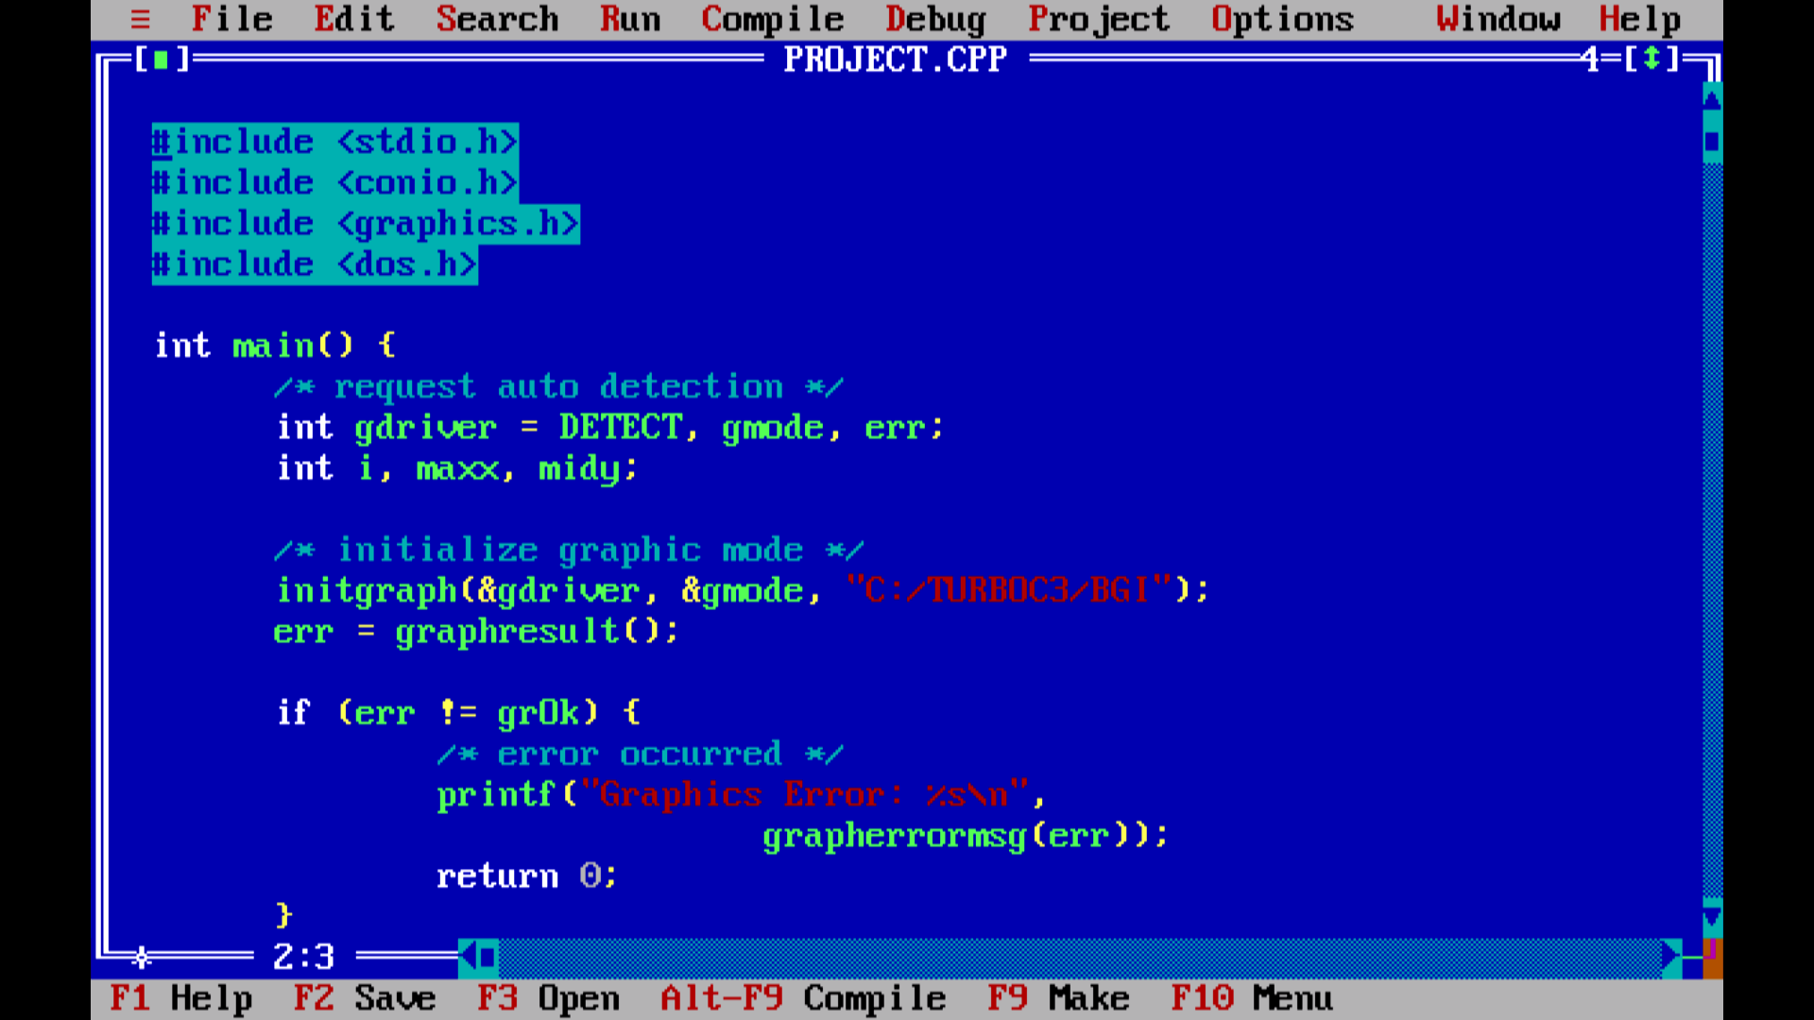

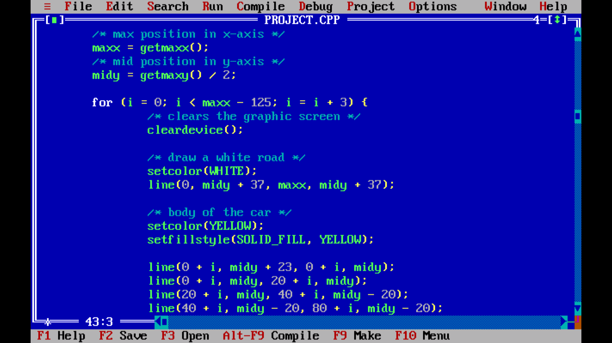

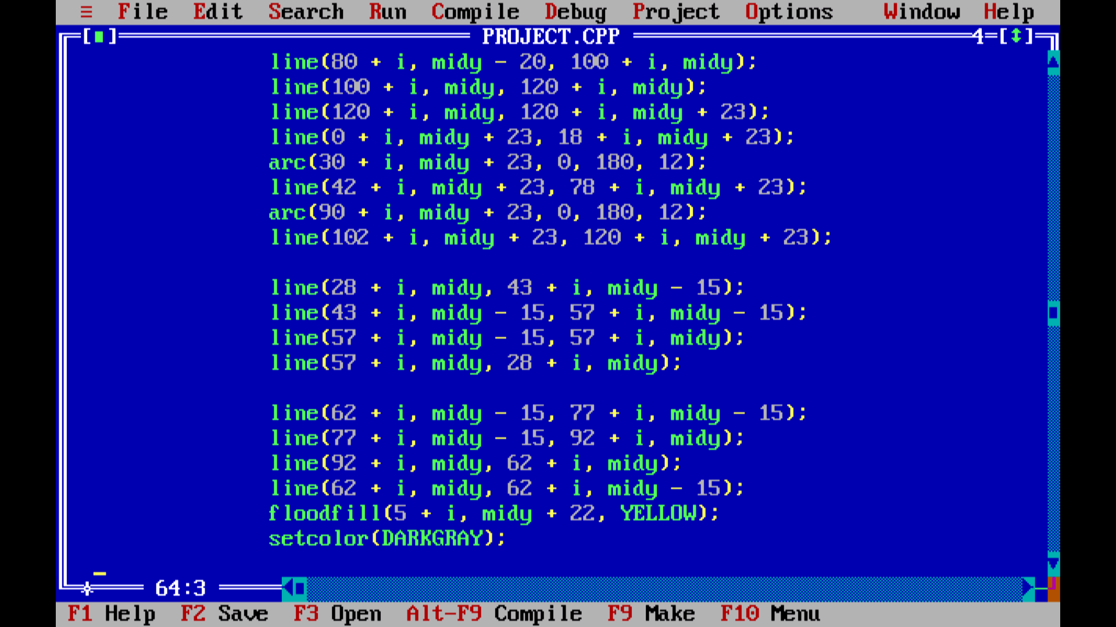

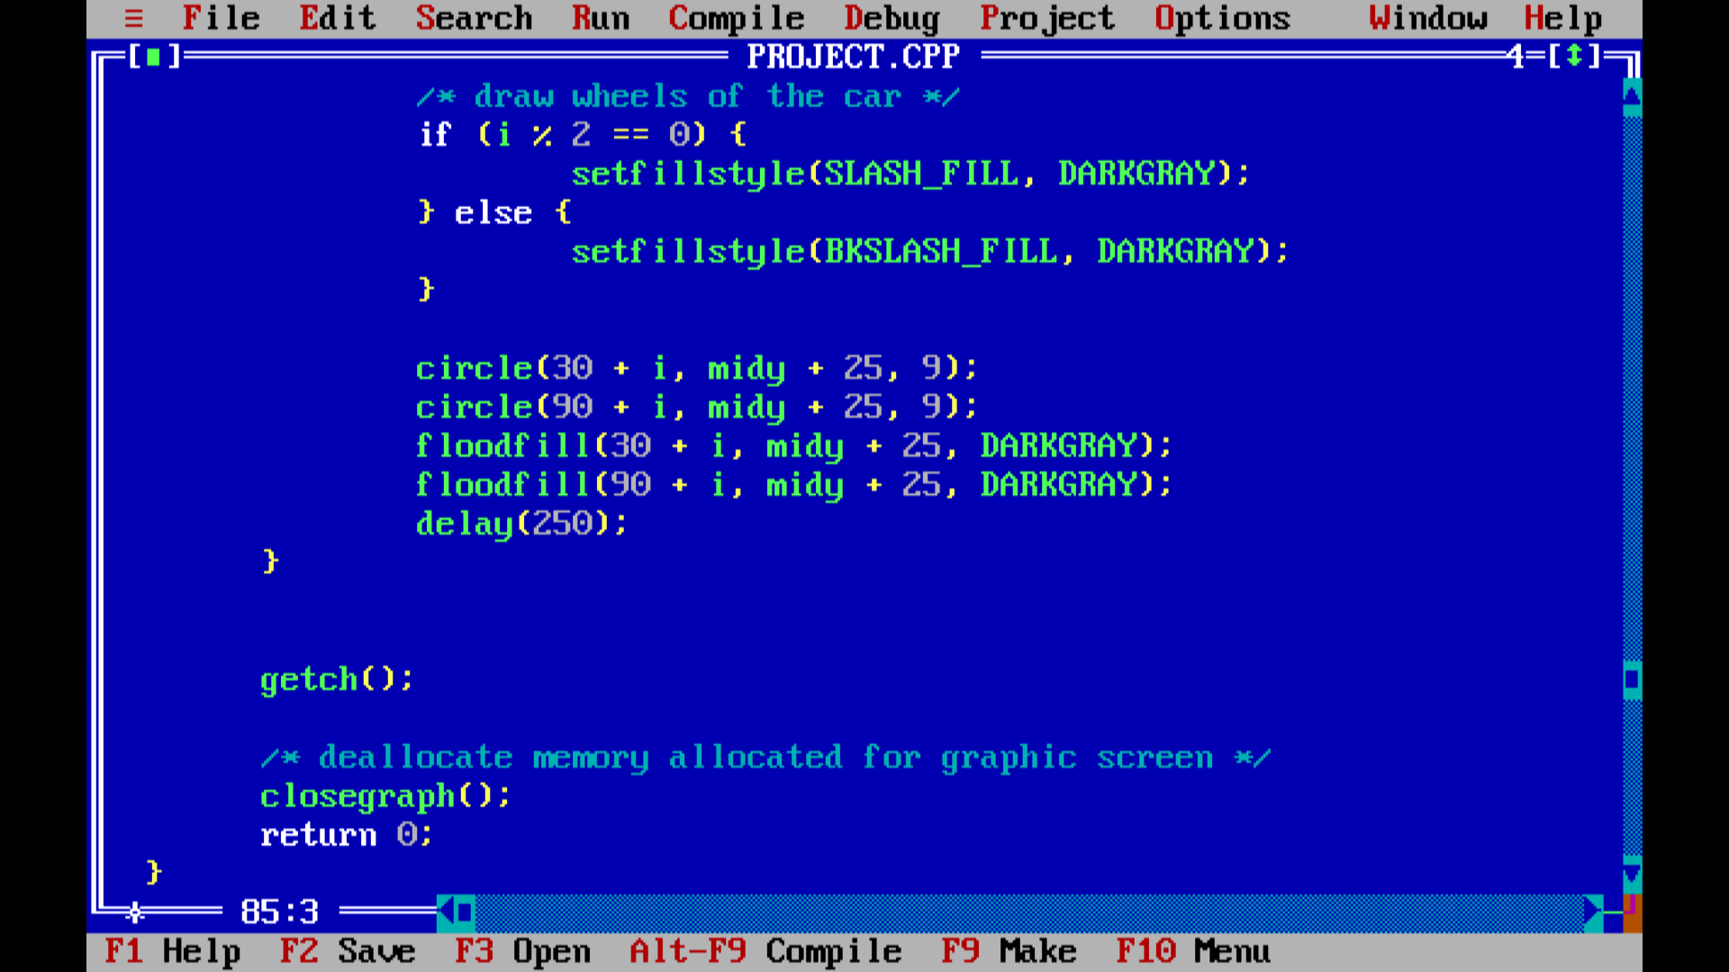

OUTPUT

