SMART CARD PAYMENT SYSTEM USING QR CODE

ABSTRACT

Smart Card Payment System Using QR code is a web based application developed inthe windows platform aims at improving the efficiency and security of the payment system. A smart card with QR code can be used instead of cash when making purchases. The system is an automated payment system used by students to make their money transaction inside the campus

MODULES

1.PAYMENT

2. STOCK

3.PURCHASE

1.PAYMENT

This module describes about the payment facility. The payment is done using the smart card provided to the students.Admin of the respective terminal read the QR embedded in smart card using the webcam.Each time a transaction happens the student account is updated. Since the system is centralized the transaction made by the students can be monitored by their parents, principal and other higher authorities.

2. STOCK

This module describes the complete management of the resources. Here we provide the details of the stock items, no of items that has been sold out , the complete details of the product along with their price . PURCHASE

3.PURCHASE

This module offers the status of items that are placed on the cart. Students can place orders.Store admin process the order received and also , deals with the payment register handling.

About the Topic

* The proposed system is a smart payment system
* using QR Code, which is a unique code of identity for each student. Using this system,
* A student can purchase items from the store a pays bill, pays
* all kinds of fees in the office and track all transactions

He made.

* OFFICE ADMIN
* STORE ADMIN
* STUDENT
* PRICIPAL

OFFICE ADMIN

* The Admin shall keep, or cause to be kept, the
* following records:-
* They are responsible for managing Students details
* Update Students account
* Manage Fee payments.

STORE ADMIN

* Manage stock details
* Manage product details.
* Manage Product orders.
* Make Payments.
* View sales & stocks reports.
* View sold out products & products in stock

STUDENT

* Students can order any product from the college store.
* Students can check/update their account balance
* View transactions made by them.
* Student can do payment through smartcard

Introduction to ASP.NET

We are doing our project in ASP.NET Building tools are :

* Visual Studio 2010
* GITHub
* ASP.NET is a web application framework developed and marketed by Microsoft to allow programmers to build dynamic web sites. It allows you to use a full featured programming language such as C# or VB.NET to build web applications easily.

EXISTING SYSTEM

The existing payment system uses traditional methods for making payment.The students need to go to the respective terminal for purchase and payment.The main terminal includes Store, Office, Canteen, Hostel, Library etc. When there is heavy rush in the terminal, the students need to wait for his turn. This can affect his class sessions.

Limitation of Existing System

No centralized report generation.Student need to carry money.In case of rush at a counter, student need to wait for a long, which can affect their classes.Manual calculations can have mistakes, which affect the entire system.There is no provision for parents to check whether a student paid the fee or not. There is no tracking of expenditure for a student.

Proposed System

The proposed system is a smart payment system using QR Code, which is a unique code of identity for each student. Using this system, a student can purchase items from the store a pays bill, pays all kinds of fees in the office and track all

DIAGRAMES

CONTEXT DIAGRAM

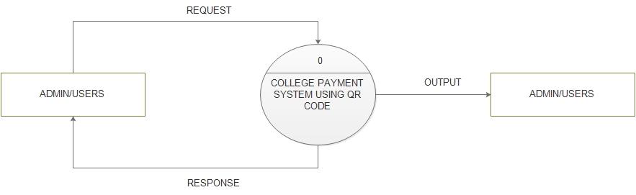

LEVEL 1

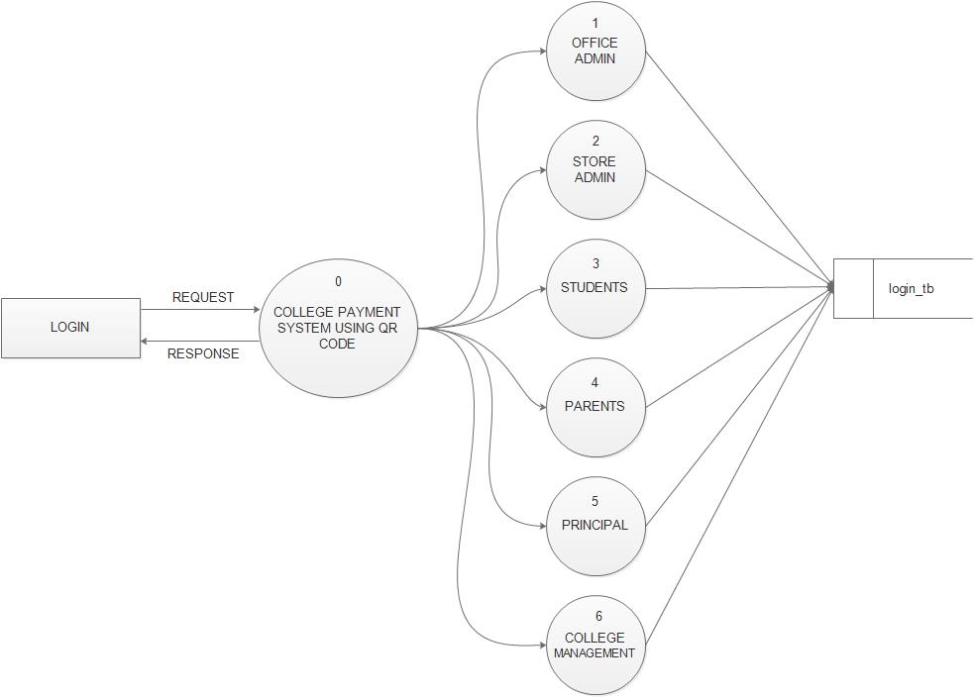

Level 2.1 (Office Admin)

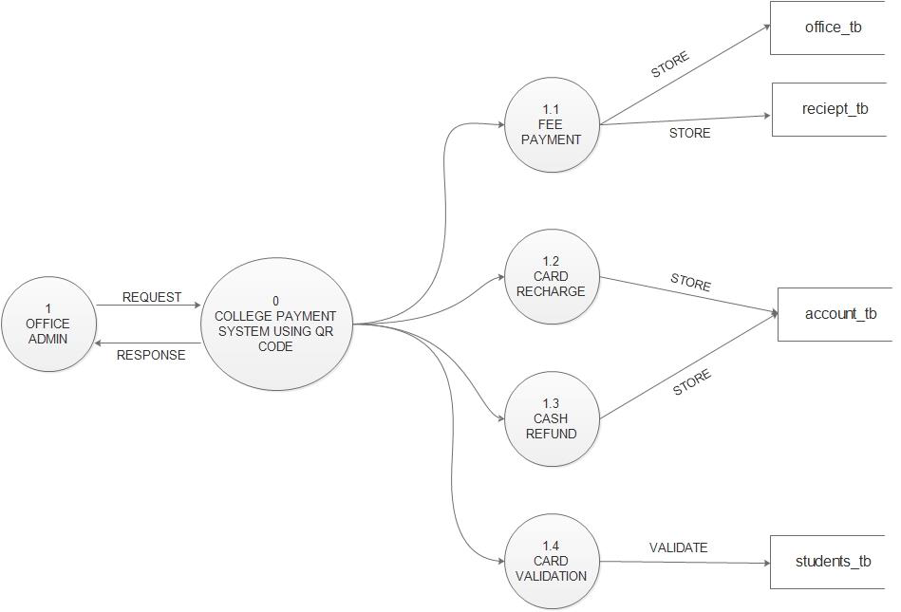

LEVEL 2.2(Store Admin)

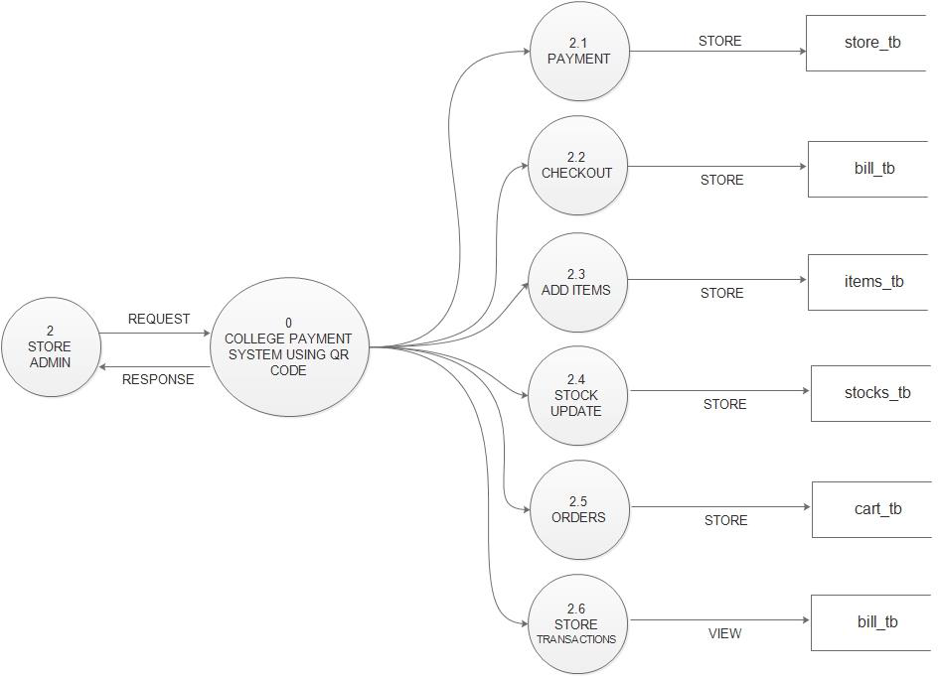

Conclusions

Smart Card Payment System Using QR code is a web based application developed in the windows platform aims at improving the efficiency and security of the payment system. A smart card with QR code can be used instead of cash when making purchases