search_enquiries:

* getting results only with enquiry id but not with reference id.

1)With enquiry id:

{

"req_process" : "search_enquiries",

"rapi_version" : "v1.0",

"api_token" :"RoYe2v0N7TUYGMDGaBXudzz6xchr16rKOCANAUXvJfCb0SWaQIF04wkeftPU",

"case_number_basic":"866136"

}

Response:

{

"code": "200",

"content": {

"cases_array": {

"count": 1,

"cases_array": [

{

"id": "ad67e3cf-ed8b-afc4-8356-5b3061667569",

"name": "<span style=background-color:red;color:black>star River</span>",

"case_number": "866136",

"modus_operandii_c": "",

"date_entered": "2018-06-25 03:27:08",

"reference_no_c": "",

"bureau_c": "IMB",

"priority": "New",

"account_id": "1b7d9e27-7f7e-2ae6-897c-5a30afa35a37",

"date_completed_c": false,

"branch_name": "Test Client"

}

]

}

}

}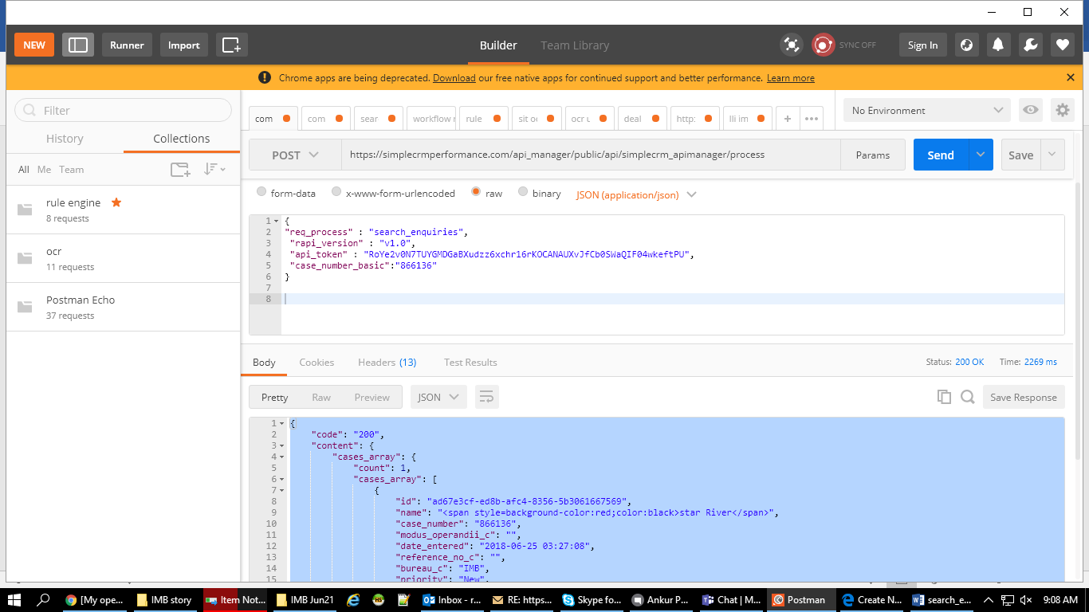

with reference id:

{

"req_process" : "search_enquiries",

"rapi_version" : "v1.0",

"api_token" : "RoYe2v0N7TUYGMDGaBXudzz6xchr16rKOCANAUXvJfCb0SWaQIF04wkeftPU",

"reference_no_c_basic": "ad67e3cf-ed8b-afc4-8356-5b306166756945" // Wrong input // This is not the reference no.

}

Response:

{

"code": "200",

"content": {

"cases_array": {

"count": 0,

"cases_array": ""

}

}

}

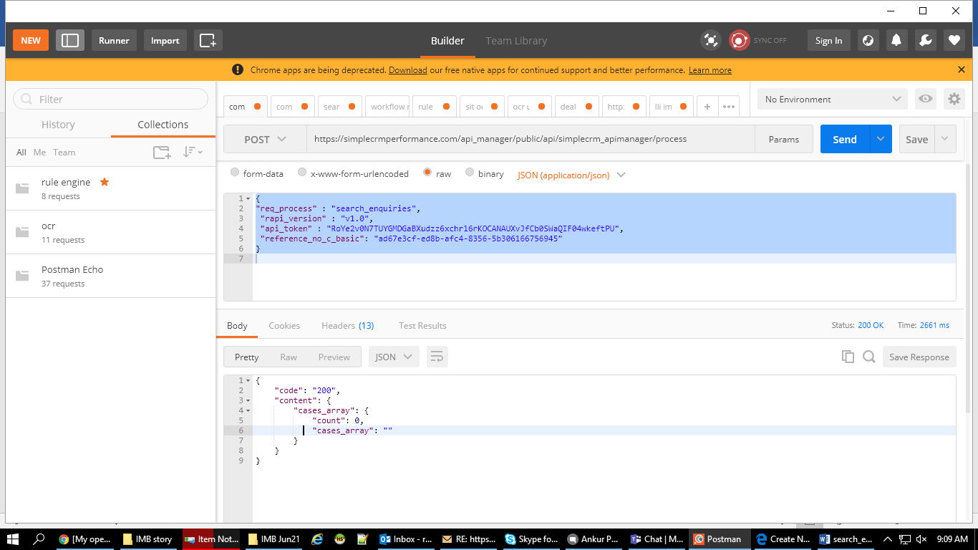

// This is the output when i checked it with proper input.

// Here the input is.

{

"req_process" : "search_enquiries",

"rapi_version" : "v1.0",

"api_token" :"HA1kCeAO8t9iXyTBWYM0ytaK0tRVzD1yBIrZBkNhOdt0l0J6Dl0CjtHOuxBo",

"reference_no_c_basic": "225522"

}

{

"code": "200",

"content": {

"cases_array": {

"count": 1,

"cases_array": [

{

"id": "35b0938b-d6db-6eae-1dbb-5b44637f700a",

"name": "test",

"case_number": "866147",

"modus_operandii_c": "",

"date_entered": "2018-07-10 07:41:58",

"reference_no_c": "225522",

"bureau_c": "IMB",

"priority": "New",

"account_id": "aea759ca-8b15-7a9a-e41c-5113df026191",

"date_completed_c": false,

"branch_name": "Portal test member (Head office)"

}

]

}

}

}