[ACPL logo]

UI Automation Framework
Diagram guide for revision
All eight framework diagrams in one place, each with a step-by-step description of its flow, the points to remember and revision questions
Document detail
Audience | QA, development and DevOps team members (revision)
Prepared by | [Name, Designation] - QA Automation
Date | 3 November 2026
Version | 1.0
Diagram files | docs/diagrams/01 ... 08 *.png
Classification | Confidential - Internal use only
Contents
How to use this guide 3
Legend - used in all diagrams 3
The eight diagrams 3
1. System overview 4
1.1 Step-by-step flow 4
1.2 Why it is built this way 5
2. Code layers 6
2.1 Step-by-step flow 6
2.2 Why it is built this way 7
3. Test lifecycle 8
3.1 Step-by-step flow 8
3.2 Why it is built this way 9
4. Configuration 10
4.1 Step-by-step flow 10
4.2 Why it is built this way 10
5. Jenkins pipeline 11
5.1 Step-by-step flow 11
5.2 Build results 12
6. Parallel execution 13
6.1 Step-by-step flow 13
6.2 Why it is built this way 13
7. Reporting 15
7.1 Step-by-step flow 15
8. CCS end-to-end flow 16
8.1 Step-by-step flow 16
8.2 Why it is built this way 17
Revision questions 18

How to use this guide
Each section shows one diagram followed by four parts:
- How to read it - the direction of the flow and what the colours and line styles mean.
- Step-by-step flow - every box and arrow in the order things happen.
- Why it is built this way - the reason behind the design, so it is easy to explain.
- Remember - three to five points to recall during revision.
Revision questions for all diagrams, with answers, are at the end.

Legend - used in all diagrams
Element | Meaning
Solid arrow | Main flow - the next step, or data passed on
Dashed arrow | Secondary relation - "uses", "extends", "reads back" or an optional path
Dashed outline | A group or environment (e.g. the Jenkins agent, SmartPing staging)
Diamond | A decision - the flow takes one branch
Purple box | People, entry points or framework foundations
Blue box | Framework or pipeline steps
Green box | Application, a successful path or a test running
Amber box | Configuration, conditions or shared data
Pink box | Error handling or recovery

The eight diagrams
# | Diagram | Answers the question
1 | System overview | Who and what is involved in a run?
2 | Code layers | Where is each kind of code written?
3 | Test lifecycle | What happens before and after every test?
4 | Configuration | Where does a setting or password come from?
5 | Jenkins pipeline | What does Jenkins do when I click Build?
6 | Parallel execution | What runs at the same time, and why?
7 | Reporting | Where do results go, and who reads them?
8 | CCS flow | How do the CCS parts work together and clean up?

1. System overview
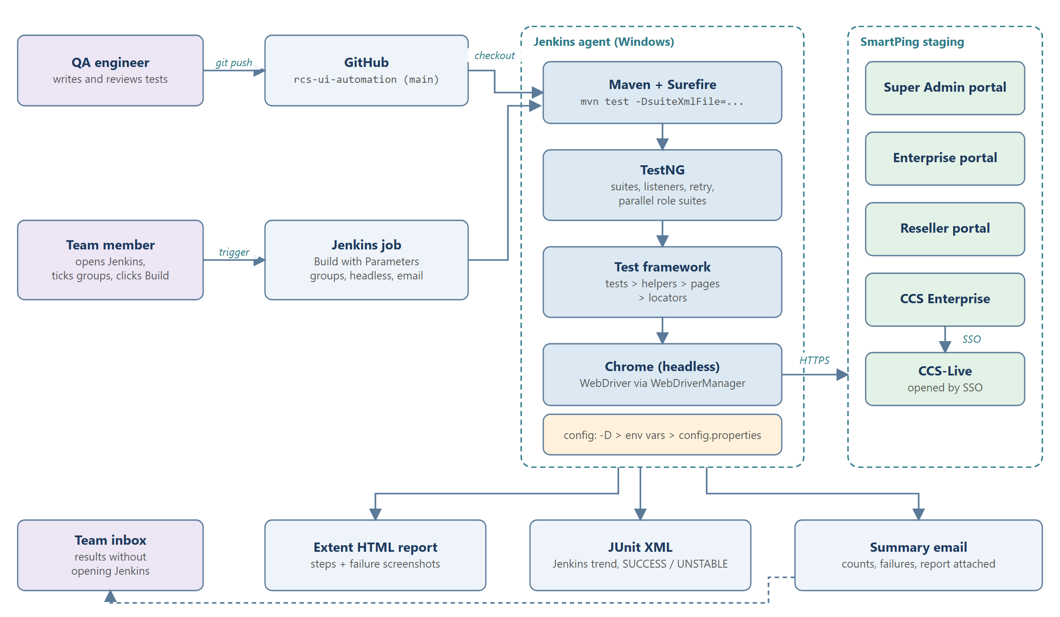
Figure 1. System overview
How to read this diagram
Read from left to right: people on the left start the work, the Jenkins agent in the middle runs it, the SmartPing staging portals on the right are tested, and the outputs along the bottom go back to the team.

1.1 Step-by-step flow
- QA engineer > GitHub (git push). Engineers write and review tests and push them to the rcs-ui-automation repository, branch main. Only pushed code is run by Jenkins.
- Team member > Jenkins job (trigger). Anyone opens the Jenkins job, chooses Build with Parameters, ticks the test groups, sets headless and email options and starts the build.
- GitHub > Jenkins agent (checkout). The build downloads the latest main branch onto the Windows Jenkins agent.
- Maven + Surefire. Jenkins runs mvn test with the chosen suite file (-DsuiteXmlFile=...). Maven compiles the code and hands control to the Surefire plugin.
- TestNG. Surefire starts TestNG, which reads the suite files, registers the listeners (retry, email reporter, parallel role suites) and runs the test classes.
- Test framework. Each test calls helpers and page objects, which use locators to find elements (Figure 2).
- Chrome (headless) > staging (HTTPS). WebDriverManager provides the matching chromedriver; Chrome opens the Super Admin, Enterprise, Reseller or CCS Enterprise portal. CCS tests continue into CCS-Live through SSO.
- Config box. URL, accounts and settings are read in the order -D property, environment variable, config.properties (Figure 4).
- Outputs. When the run ends, three outputs are produced: the Extent HTML report (steps and failure screenshots), JUnit XML (Jenkins trend and SUCCESS / UNSTABLE) and the summary email.
- Summary email > Team inbox (dashed). The email reaches the team, so results are visible without opening Jenkins.

1.2 Why it is built this way
- A real browser against the real staging portals tests exactly what users see.
- Jenkins makes runs repeatable and available to non-developers; headless Chrome needs no screen on the agent.
Remember
1. Jenkins always runs the code on GitHub main - push before you run.
2. The chain is Jenkins > Maven > TestNG > framework > Chrome > staging.
3. CCS-Live is reached by SSO from CCS Enterprise, not by a separate login.
4. Every run ends with three outputs: report, JUnit XML, email.

2. Code layers
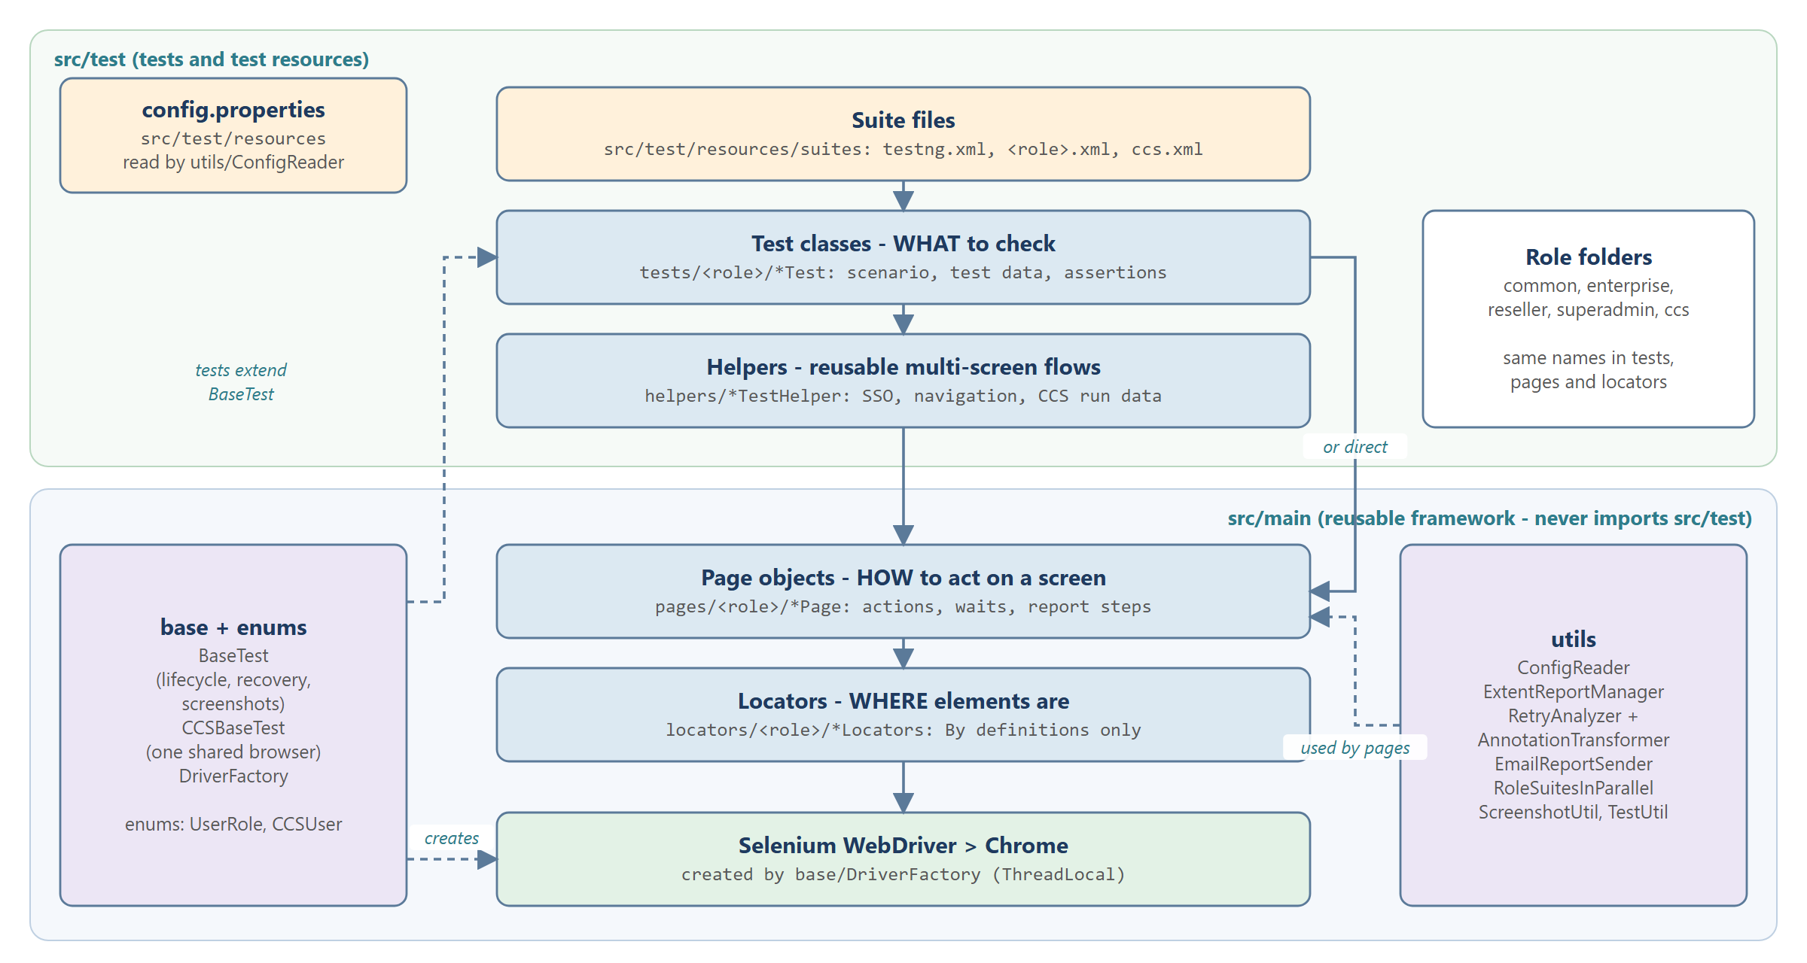
Figure 2. Code layers and where each part lives
How to read this diagram
Read the centre column from top to bottom - it is the call chain from a suite file down to the browser. The upper green band is src/test, the lower blue band is src/main. Side boxes are supporting parts; dashed arrows show "extends", "creates" and "uses".

2.1 Step-by-step flow
- Suite files (src/test/resources/suites: testng.xml, <role>.xml, ccs.xml) decide which test classes run and in what order.
- Test classes - WHAT to check (tests/<role>/*Test). They hold the scenario, the test data and the assertions. They never use raw locators.
- Helpers - reusable multi-screen flows (helpers/*TestHelper), e.g. SSO into a service, dashboard navigation, CCS run data. A test uses a helper when a flow is shared by several classes.
- "or direct" arrow. When no shared flow is needed, a test calls page objects directly, skipping helpers.
- Page objects - HOW to act on a screen (pages/<role>/*Page): clicks, typing, selecting, waiting, reading values and writing report steps. They do not assert.
- Locators - WHERE elements are (locators/<role>/*Locators): only By definitions, e.g. ADD_USER_BUTTON.
- Selenium WebDriver > Chrome performs the actions in the browser; the driver is created by base/DriverFactory and kept per thread (ThreadLocal).
- base + enums (left). Every test class extends BaseTest (dashed arrow "tests extend BaseTest"); CCS classes extend CCSBaseTest. DriverFactory "creates" the WebDriver. Enums UserRole and CCSUser name the test users.
- utils (right). ConfigReader, ExtentReportManager, RetryAnalyzer + AnnotationTransformer, EmailReportSender, RoleSuitesInParallel, ScreenshotUtil and TestUtil - "used by pages" and by the base classes.
- config.properties (src/test/resources) holds default settings, read by utils/ConfigReader.
- Role folders. The same role names - common, enterprise, reseller, superadmin, ccs - are used in tests, pages and locators.

2.2 Why it is built this way
- One job per layer: a UI change is fixed in one locator or page method, and every test that uses it keeps working.
- src/main never imports src/test, so the framework stays reusable and compiles first.
- Role folders match the test accounts, the suite files, the Jenkins checkboxes and the report categories.
Remember
1. Tests = WHAT to check, pages = HOW to act, locators = WHERE elements are.
2. Assertions only in tests; locators only in locator classes.
3. Every test class extends BaseTest (CCS: CCSBaseTest).
4. Framework code in src/main, tests and helpers in src/test, suites and config in src/test/resources.

3. Test lifecycle
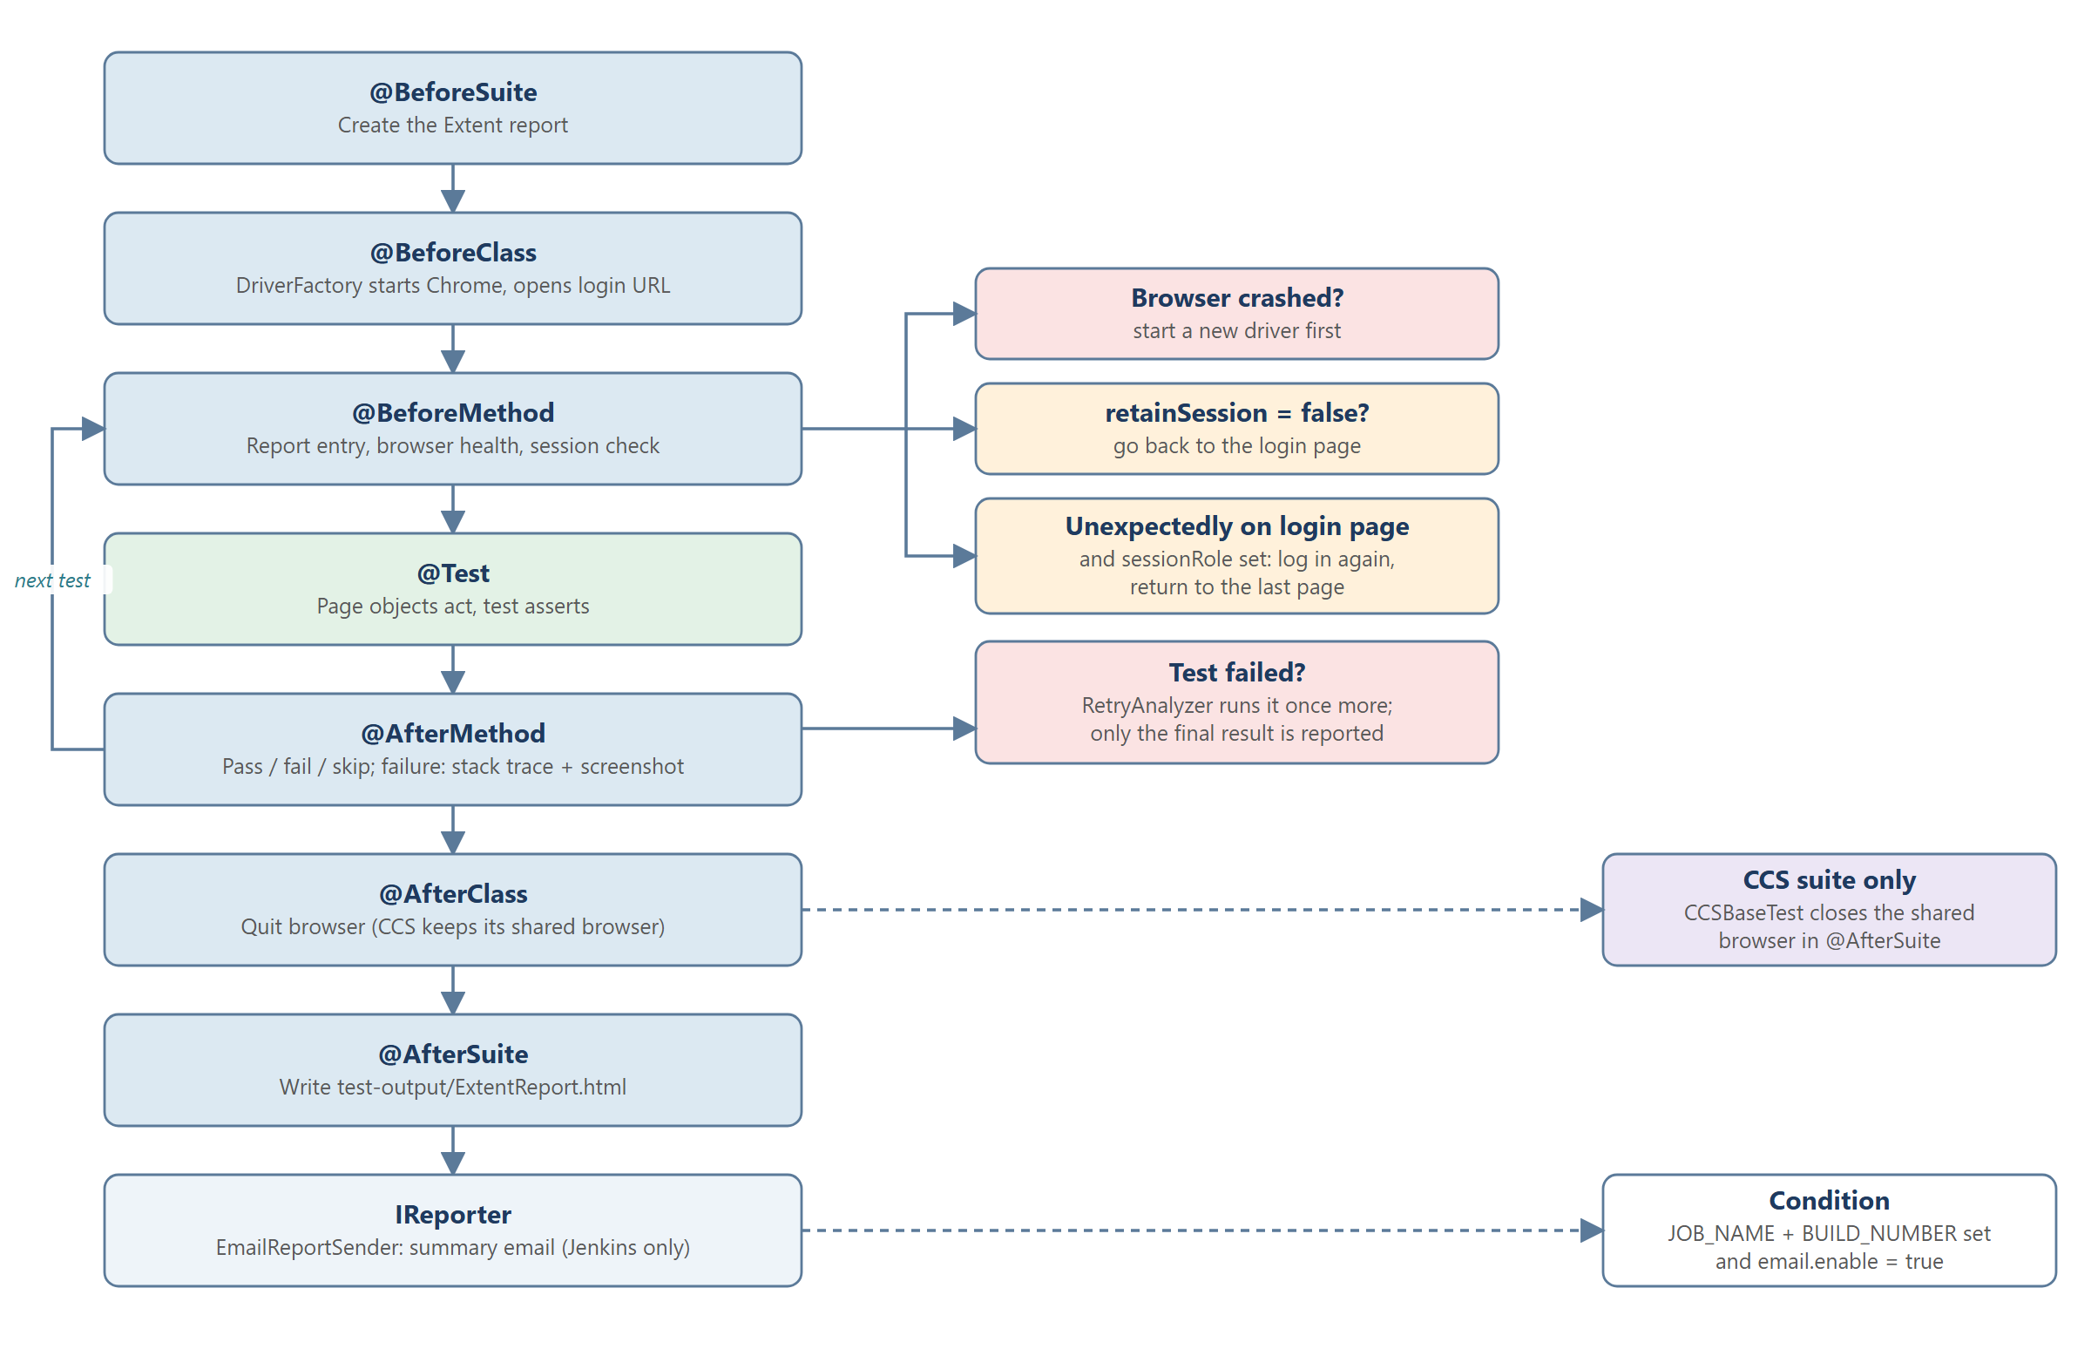
Figure 3. What happens around every test (BaseTest hooks)
How to read this diagram
The left column runs top to bottom once per suite and class; the loop arrow "next test" repeats the middle part for every test method. Boxes on the right are the checks and special cases at that step.

3.1 Step-by-step flow
- @BeforeSuite - create the Extent report. Runs once at the start of the suite.
- @BeforeClass - start Chrome, open the login URL. DriverFactory creates the browser (headless if configured), with a 2-second implicit wait and a 60-second page-load limit.
- @BeforeMethod - report entry, browser health, session check. Before every test three checks run (right-hand boxes):
  - Browser crashed? A new driver is started, so one crash does not fail all remaining tests.
  - retainSession = false? The browser goes back to the login page for a clean start. Classes that keep one login set retainSession = true.
  - Unexpectedly on the login page with sessionRole set? The framework logs in again as that role and returns to the last page (session ended elsewhere).
- @Test - page objects act, the test asserts. The scenario runs.
- Test failed? RetryAnalyzer runs the test once more; only the final result is reported.
- @AfterMethod - pass / fail / skip. The result is written to the report; on failure the stack trace and a Base64 screenshot are embedded.
- Loop "next test". Steps 3-6 repeat for each test method in the class.
- @AfterClass - quit the browser. Each class closes its own browser. CCS suite only (dashed): CCSBaseTest keeps the shared browser open and closes it in @AfterSuite.
- @AfterSuite - write test-output/ExtentReport.html.
- IReporter - EmailReportSender. After TestNG finishes, the summary email is sent - only when running inside Jenkins (JOB_NAME and BUILD_NUMBER set) and email.enable = true.

3.2 Why it is built this way
- Putting setup, recovery and reporting in one base class gives every test the same behaviour without extra code.
- Recovery steps stop one problem (crash, lost session) from failing a whole class.
Remember
1. Order: BeforeSuite > BeforeClass > (BeforeMethod > Test > AfterMethod) per test > AfterClass > AfterSuite > email.
2. Three checks before each test: crashed browser, retainSession, unexpected login page.
3. A failed test is retried once; the report shows only the final result.
4. The email is sent only from Jenkins, never from a local run.

4. Configuration
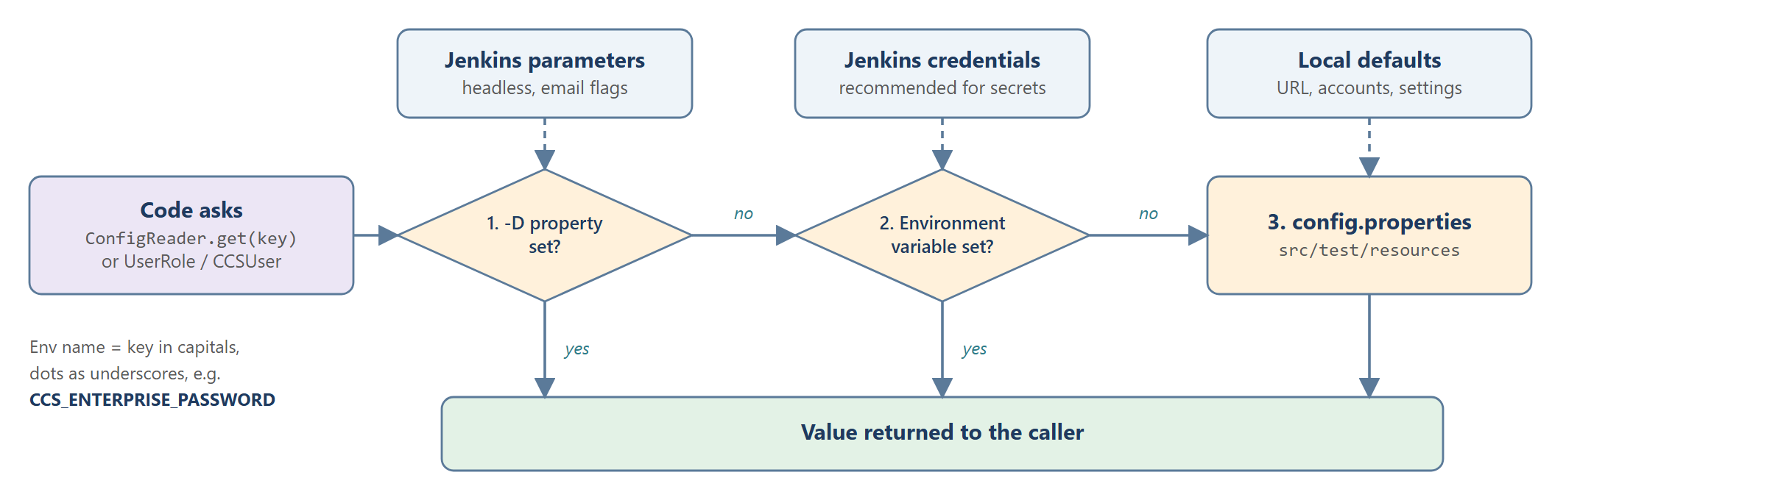
Figure 4. How a setting is resolved
How to read this diagram
Read left to right along the middle row: the code asks for a value, two decisions are checked in order, and the first source that has a value wins. The top row shows where each source normally comes from.

4.1 Step-by-step flow
- Code asks: a test or page calls ConfigReader.get(key), or uses UserRole / CCSUser, which call ConfigReader.
- 1. -D property set? A JVM property such as -Dbrowser.headless=true. Jenkins parameters (headless, email flags) arrive this way. If set, it is returned.
- 2. Environment variable set? The key in capitals with dots replaced by underscores, e.g. CCS_ENTERPRISE_PASSWORD. This is the recommended route for secrets from Jenkins credentials. If set, it is returned.
- 3. config.properties (src/test/resources) supplies the local default: URL, accounts and settings.
- Value returned to the caller.

4.2 Why it is built this way
- No URL, username or password is written in test code, so the same code runs locally and in Jenkins.
- Secrets can move to Jenkins credentials without code changes, because environment variables are checked before the file.
Remember
1. Priority: -D property > environment variable > config.properties.
2. Env name = key in capitals, dots as underscores.
3. Never hardcode credentials; never print a password.

5. Jenkins pipeline
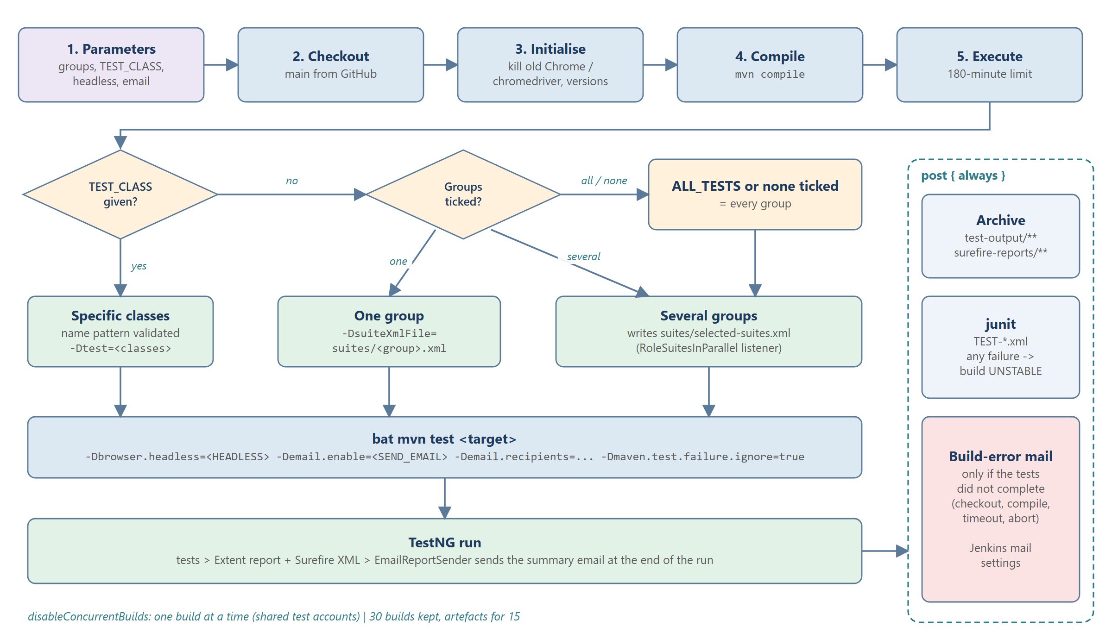
Figure 5. Jenkins pipeline - stages, suite selection and post-build steps
How to read this diagram
The top row is the five pipeline stages. Under stage 5 the two diamonds decide what to run; the green boxes are the three possible targets, which all lead to one mvn command and the TestNG run. The dashed box on the right is the post section, which always runs at the end.

5.1 Step-by-step flow
- 1. Parameters. The user picks ALL_TESTS or groups (COMMON, ENTERPRISE, RESELLER, SUPER_ADMIN, CCS), optional TEST_CLASS, HEADLESS, SEND_EMAIL and EMAIL_RECIPIENTS.
- 2. Checkout. main is checked out from GitHub.
- 3. Initialise. Leftover Chrome and chromedriver processes are killed; Java and Maven versions are printed.
- 4. Compile. mvn compile - a compile error stops the build here.
- 5. Execute (maximum 180 minutes) - the decisions:
  - TEST_CLASS given? Yes > Specific classes. The value is checked against a safe name pattern, then run with -Dtest=<classes>.
  - No > Groups ticked? One group > -DsuiteXmlFile=suites/<group>.xml. Several groups > Jenkins writes suites/selected-suites.xml (a parent suite with the RoleSuitesInParallel listener). ALL_TESTS or nothing ticked > every group, handled like "several".
- bat mvn test <target>. The same command for every target, with -Dbrowser.headless, -Demail.enable, -Demail.recipients and -Dmaven.test.failure.ignore=true (so the run finishes and the report is always produced, even when tests fail).
- TestNG run. Tests run, the Extent report and Surefire XML are written, and EmailReportSender sends the summary email at the end of the run.
- post { always }: Archive test-output/** and surefire-reports/**; junit reads TEST-*.xml and marks the build UNSTABLE if any test failed; Build-error mail is sent only if the tests did not complete (checkout, compile, timeout or abort).
- Footer. disableConcurrentBuilds - one build at a time because the test accounts are shared; 30 builds and artefacts of 15 are kept.

5.2 Build results
Result | Meaning | Email
SUCCESS | All tests passed | Summary email
UNSTABLE | Run completed, some tests failed | Summary email with failures
FAILURE / ABORTED | Stopped before the tests completed | Short build-error email
Remember
1. Five stages: Parameters > Checkout > Initialise > Compile > Execute; then post.
2. TEST_CLASS overrides the checkboxes; several groups become one generated selected-suites.xml.
3. Test failures give UNSTABLE, not FAILURE - the report and email are still produced.
4. Only one build at a time.

6. Parallel execution
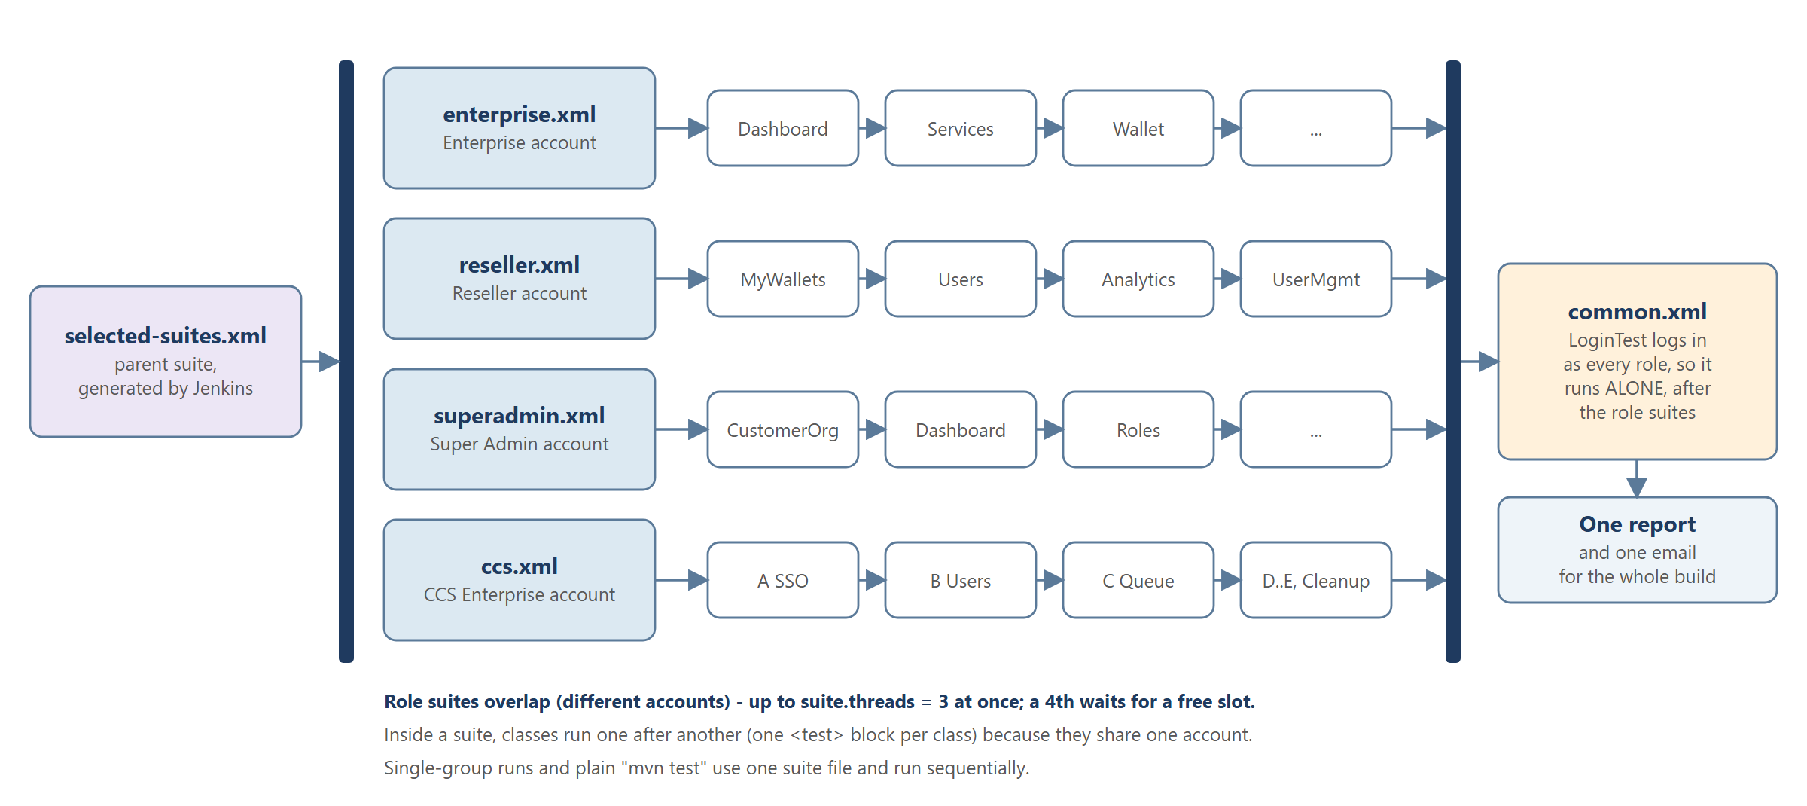
Figure 6. Multi-group run - role suites in parallel, Common last
How to read this diagram
Read left to right. The first dark bar splits the run into lanes that run at the same time; each lane runs its classes one after another. The second dark bar waits for all lanes, then Common runs alone.

6.1 Step-by-step flow
- selected-suites.xml is the parent suite Jenkins generates when several groups are ticked.
- Split (first bar). RoleSuitesInParallel lets the role suites start together: enterprise.xml (Enterprise account), reseller.xml (Reseller), superadmin.xml (Super Admin) and ccs.xml (CCS Enterprise). Up to three run at once (suite.threads = 3 in pom.xml); a fourth waits for a free slot.
- Inside each lane the classes run one after another (e.g. Dashboard > Services > Wallet...; for CCS: A SSO > B Users > C Queue > D, E, Cleanup), because they share one account.
- Join (second bar). Common waits until all role suites have finished.
- common.xml (LoginTest) logs in as every role, so it runs alone at the end.
- One report and one email for the whole build.

6.2 Why it is built this way
- Logging out ends every session of that account in every browser. Different accounts can overlap; the same account must not.
- Running portals side by side shortens the total run time.
Remember
1. Parallel across accounts, sequential within an account.
2. Up to 3 role suites at once; Common always last and alone.
3. Single-group runs and local mvn test are fully sequential.

7. Reporting
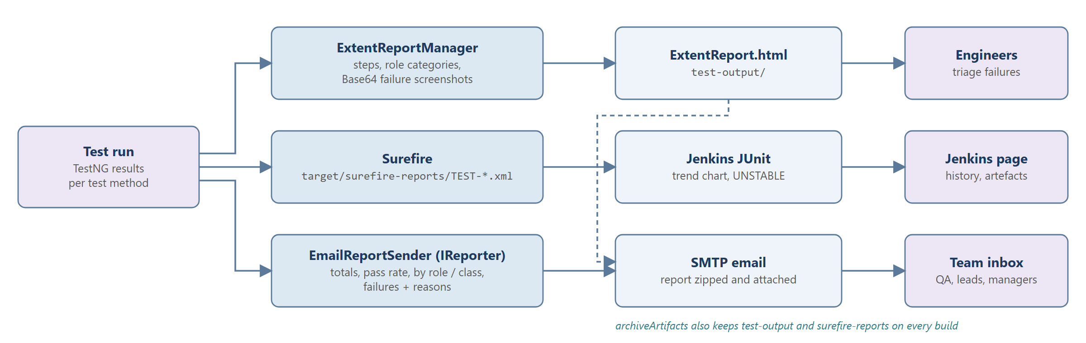
Figure 7. From test results to the people who use them
How to read this diagram
Read each row left to right: the test run feeds three producers, each producer writes one output, and each output has its main audience on the right. The dashed line shows the Extent report being attached to the email.

7.1 Step-by-step flow
- Test run > ExtentReportManager > ExtentReport.html > Engineers. Every step logged by page objects, grouped by role and class, with Base64 screenshots for failures, in test-output/. Engineers use it to triage failures.
- Test run > Surefire > Jenkins JUnit > Jenkins page. target/surefire-reports/TEST-*.xml feeds the Jenkins trend chart and sets UNSTABLE when tests fail; the Jenkins page keeps history and artefacts.
- Test run > EmailReportSender > SMTP email > Team inbox. The IReporter builds the summary - totals, pass rate, results by role and class, failed and skipped tests with reasons - and sends it with the Extent report zipped and attached (dashed line).
- archiveArtifacts keeps test-output and surefire-reports on every build.
Remember
1. Three outputs: Extent HTML (details), JUnit XML (trend and status), email (summary).
2. Screenshots are embedded in the HTML, so the single file can be shared.
3. Open the zipped report from the email; opened directly in Jenkins it may lose styling.

8. CCS end-to-end flow
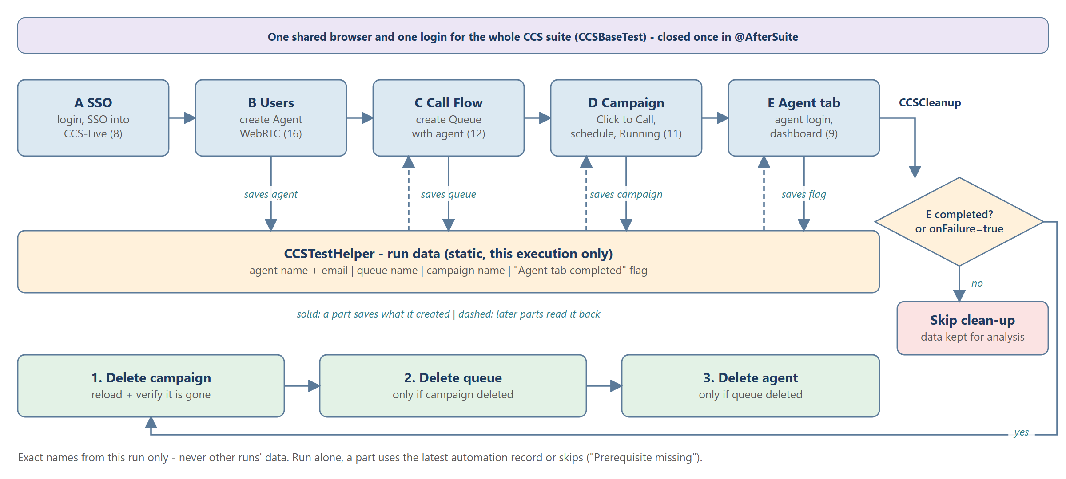
Figure 8. CCS suite - chained parts, shared run data and gated clean-up
How to read this diagram
The top band applies to the whole suite. The blue row is the five parts in order. Solid arrows down mean a part saves what it created into CCSTestHelper; dashed arrows up mean a later part reads it back. On the right, the diamond decides whether clean-up runs; the green row is the clean-up order.

8.1 Step-by-step flow
- Shared browser band. CCSBaseTest keeps one browser and one login for all CCS classes and closes it once in @AfterSuite.
- A - SSO (8 tests). Log in to CCS Enterprise and open CCS-Live by SSO; the tab is remembered for the next parts.
- B - Users (16 tests). Add User validations, then create one Agent with WebRTC; saves the agent name and email. If the account limit (2 agents) is reached, the oldest automation agent is deleted once and Save is retried.
- C - Call Flow (12 tests). Reads the agent, creates a Queue with that agent and Call Waiting Type "Queue"; saves the queue name.
- D - Campaign (11 tests). Reads the queue, creates a Click to Call - Manual campaign on it, schedules it for today and checks it is Running; saves the campaign name.
- E - Agent tab (9 tests). Reads the agent and campaign, logs the agent in (WebRTC + campaign) and verifies the Agent Live Dashboard; saves the "Agent tab completed" flag.
- CCSTestHelper (amber). Holds the run data in static fields - for this execution only.
- CCSCleanup decision: E completed? or onFailure=true. No > Skip clean-up, data kept for analysis. Yes > clean-up runs.
- Clean-up order: 1. Delete campaign (reload and verify it is gone) > 2. Delete queue (only if the campaign was deleted) > 3. Delete agent (only if the queue was deleted).
- Footer rule. Only exact names from this run are deleted. When a part runs on its own, it uses the latest automation record or skips with "Prerequisite missing" - it never creates extra data.

8.2 Why it is built this way
- It mirrors the real business journey with one login.
- Deleting in dependency order avoids "in use" errors; skipping clean-up after a failure keeps evidence.
Remember
1. A > B > C > D > E, then CCSCleanup - one browser, one login.
2. Agent > Queue > Campaign are created in order and handed on via CCSTestHelper.
3. Clean-up only if E completed (or -Dccs.cleanup.onFailure=true), in the order campaign > queue > agent.
4. Never delete data that this run did not create.

Revision questions
# | Question | Answer | Figure
1 | Which branch does Jenkins run? | main from GitHub - local changes must be pushed first | 1
2 | Name the chain from Jenkins to the application. | Jenkins > Maven/Surefire > TestNG > framework > Chrome > staging | 1
3 | Where do assertions go? Where do locators go? | Assertions in test classes; locators in locators/<role> classes | 2
4 | When does a test call a page object directly? | When no shared multi-screen flow (helper) is needed | 2
5 | What three checks run before every test? | Crashed browser, retainSession, unexpected login page with sessionRole | 3
6 | How many times is a failed test retried? | Once; only the final result is reported | 3
7 | When is the summary email sent? | At the end of a Jenkins run with email.enable = true; never locally | 3, 7
8 | In what order is a setting looked up? | -D property, environment variable, config.properties | 4
9 | What is the environment name of ccs.enterprise.password? | CCS_ENTERPRISE_PASSWORD | 4
10 | What happens when several groups are ticked? | Jenkins writes selected-suites.xml and runs it: one build, one report, one email | 5
11 | A build shows UNSTABLE - what does it mean? | The run completed but at least one test failed | 5
12 | Why can only one build run at a time? | All runs share the same staging accounts | 5
13 | Why does Common run last and alone? | LoginTest logs in and out as every role, which would end the other suites' sessions | 6
14 | How many role suites run at the same time? | Up to 3 (suite.threads) | 6
15 | Where are failure screenshots? | Embedded in test-output/ExtentReport.html | 7
16 | How does Part C know which agent to use? | Part B saved it in CCSTestHelper | 8
17 | When does CCSCleanup run, and in what order? | Only if Part E completed (or onFailure=true); campaign, queue, agent | 8

