UI Automation Framework - End-to-End Architecture
From a code push or a Jenkins click to the result email. Numbers 1-14 are explained in the step key on the next page.
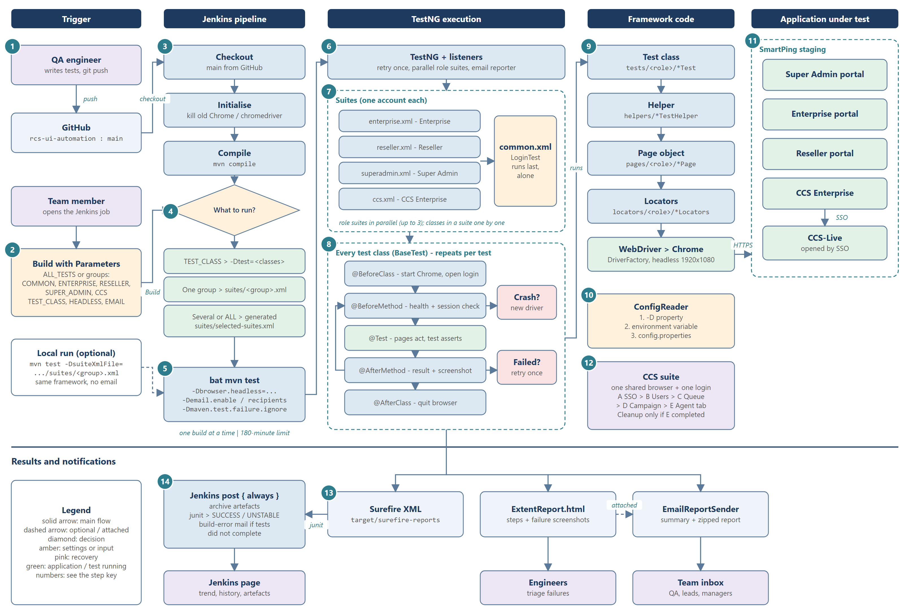
Step key
# | Stage | What happens | Where it lives
1 | Code to GitHub | Engineers write and review tests and push them to rcs-ui-automation, branch main. Jenkins only ever runs pushed code. | GitHub repository
2 | Build with Parameters | A team member opens the Jenkins job and chooses ALL_TESTS or groups (COMMON, ENTERPRISE, RESELLER, SUPER_ADMIN, CCS), or a TEST_CLASS, plus HEADLESS and email options. | Jenkinsfile - parameters
3 | Checkout, Initialise, Compile | main is checked out; leftover Chrome / chromedriver processes are killed; the project is compiled. A compile error stops the build here. | Jenkinsfile - stages
4 | What to run? | TEST_CLASS (validated name) > -Dtest=<classes>. One group > suites/<group>.xml. Several groups or ALL > Jenkins writes suites/selected-suites.xml. | Jenkinsfile - Execute; src/test/resources/suites
5 | bat mvn test | One Maven command with -Dbrowser.headless, -Demail.enable / recipients and -Dmaven.test.failure.ignore, so the run always finishes and produces the report. One build at a time; 180-minute limit. | Jenkinsfile; pom.xml (Surefire)
6 | TestNG + listeners | Surefire starts TestNG. Listeners add: retry once (AnnotationTransformer + RetryAnalyzer), parallel role suites (RoleSuitesInParallel) and the summary email (EmailReportSender). | src/main/java/utils; META-INF/services
7 | Suites | Each role suite uses its own account. Role suites run in parallel (up to 3, suite.threads); classes inside a suite run one by one; common.xml (LoginTest) runs last and alone. | suites/*.xml; pom.xml suite.threads
8 | Every test class | BaseTest hooks: @BeforeClass starts Chrome; @BeforeMethod checks browser health and session (crash > new driver; lost session > log in again); @Test runs; @AfterMethod records the result and a failure screenshot (failed > retry once); @AfterClass quits the browser. | src/main/java/base/BaseTest, DriverFactory
9 | Framework code | Test class (what to check) > helper (shared multi-screen flow) > page object (how to act) > locators (where elements are) > WebDriver and Chrome (headless 1920x1080). | tests/, helpers/, pages/, locators/
10 | ConfigReader | Every setting is read in the order -D property, environment variable, config.properties. No URL or password is written in test code. | utils/ConfigReader; src/test/resources/config.properties
11 | Application under test | Chrome drives the SmartPing staging portals over HTTPS: Super Admin, Enterprise, Reseller and CCS Enterprise; CCS-Live is opened by SSO from CCS Enterprise. | Staging environment
12 | CCS suite | One shared browser and one login (CCSBaseTest). Parts A-E run in order and pass the created agent, queue and campaign through CCSTestHelper; CCSCleanup deletes them only if Part E completed. | base/CCSBaseTest; tests/ccs; helpers/CCSTestHelper
13 | Results | Surefire XML (target/surefire-reports), the Extent HTML report with steps and failure screenshots (test-output/ExtentReport.html), and the summary email with the report attached - sent only from Jenkins. | Surefire; ExtentReportManager; EmailReportSender
14 | Jenkins post { always } | Archives the reports, reads the JUnit XML (any failure > build UNSTABLE) and, if the tests did not complete, sends a short build-error email. Results reach the Jenkins page, engineers and the team inbox. | Jenkinsfile - post

The whole flow in one paragraph
An engineer pushes tests to GitHub (1). Someone starts the Jenkins job with parameters (2). Jenkins checks out, cleans up and compiles (3), decides what to run (4) and runs one mvn test command (5). TestNG, with its listeners (6), runs the role suites in parallel and Common last (7). Every test class gets the same lifecycle from BaseTest (8) and calls test > helper > page > locator > Chrome (9), with settings from ConfigReader (10), against the staging portals (11); CCS runs as one chained journey with its own clean-up (12). The run produces Surefire XML, the Extent report and the summary email (13), and Jenkins archives the results and sets SUCCESS or UNSTABLE (14).

Remember
Jenkins runs | GitHub main only - push first; one build at a time
Parallelism | Different accounts in parallel (up to 3 suites); same account never; Common last
Reliability | New browser after a crash; re-login after a lost session; failed test retried once
Settings | -D property > environment variable > config.properties; no credentials in code
Build status | SUCCESS = all passed; UNSTABLE = run finished with failures; FAILURE = run did not complete

