Aim: To implement Bresenham’s algorithms for drawing a line segment between two given end points.

Objective:
Draw a line using Bresenham's line algorithm that determines the points of an n-dimensional raster that should be selected to form a close approximation to a straight line between two points

Theory:
In Bresenham’s line algorithm pixel positions along the line path are obtained by determining the pixels i.e. nearer the line path at each step.

Algorithm - {
x=x1;
y=y1;
dx=x2-x1;
dy=y2-y1;
p=2dy-2dx;

while(x<=x2)
{
putpixel(x,y);
x++;
if(p<0)
{
p=p+2dy;
}
else
{
y=y+1;
p=p+2dy-2dx;
}

}
}

Program -
#include<stdio.h>
#include<conio.h>
#include<graphics.h>
#include<math.h>
#include<dos.h>
void main()
{
int gd=DETECT, gm;
int x1,y1,x2,y2,dx,dy,p;
clrscr();
initgraph(&gd,&gm,"c:\\turboc3\\bgi");
printf("Enter the first co-ordinates:\n");
scanf("%d %d",&x1,&y1);
printf("Enter the second co-oedinates:\n");
scanf("%d %d",&x2,&y2);
dx=x2-x1;
dy=y2-y1;
p=2*dy-dx;
while(x1<=x2){
putpixel(x1,y1,50);
x1++;
if(p<0){
p=p+2*dy;
}
else
{
p=p+2*dy-2*dx;
y1++;
}
}
getch();
closegraph();
}

Output – 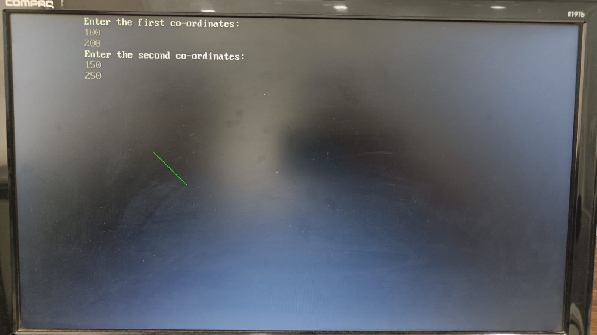

Conclusion: Comment on -
- Pixel :- : A pixel, short for "picture element," is the smallest unit of a digital image. It represents a single point in a raster graphics system, such as a computer screen, and is usually displayed as a square of a specific color.
- Equation for line :-the equation for a straight line in 2D can be represented as y = mx + b, where 'm' is the slope of the line, 'x' is the x-coordinate of a point on the line, 'y' is the corresponding y-coordinate, and 'b' is the y-intercept (the point where the line crosses the y-axis).
- Need of line drawing algorithm :- The need for a line drawing algorithm arises from the fact that most display devices, such as computer screens, work on a pixel-based raster grid. To display a line on such a grid, the graphics system must determine which pixels to turn on or off to form the desired line segment between the given endpoints.
- Slow or fast :- Fast

