The Cosmoliner

Review-1: The Motor Test Stand

Structure:

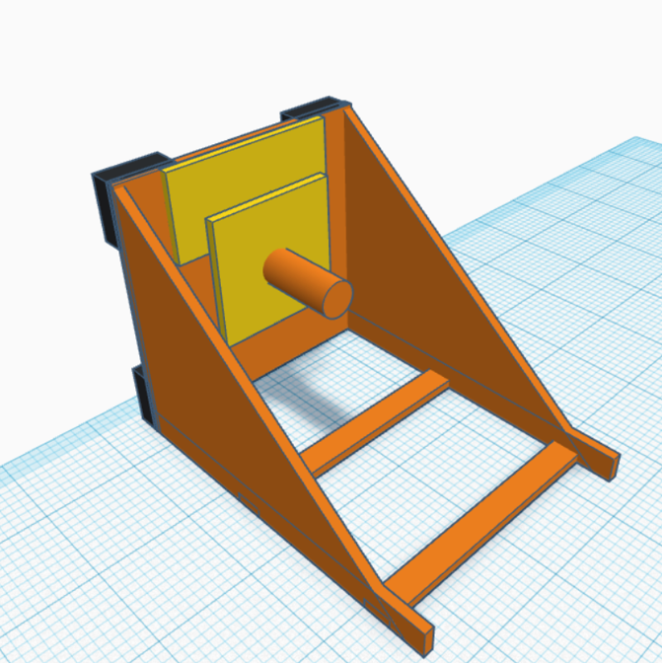

The test stand prepared for the initial testing of the motors is a dual deployment test stand which will theoretically be able to take measurements with motor mount alignment both vertically and horizontally.

The test stand will be wedge shaped and must follow a 1:1 replication from the tinkerCAD model shown above.

The whole structure will be made out of wooden planks and ply wood with wood fevicol resin and/or nails for proper alignment.

Parts:

Frame- the frame is the basic and important component of our test stand as it provides required strength and rigidity to the whole structure.

Motor base- the motor base is made out of thinner ply wood which is connected to the measuring end of the loadcell, the static end is then connected to the static plank connected to the big base.

Big Base- the big base is the platform on which both the motor base and the respective circuitry are attached.

Motor mount- the long cylindrical structure at the middle of the motor base is actually the motor base, where motor of different shapes and sizes will be placed for performance measurement.

Support base: there are 4 support bases attached to the rear end of the big base, their purpose is to support the stand and provide ground clearance to the circuit during vertical motor testing and act as a padding to the delicate circuitry.

Note: The current structure of the motor testing stand is strictly based upon type of equipment for circuitry that will be used according to best of my knowledge.

TinkerCAD design link: <https://www.tinkercad.com/things/lfDJyPIH9RK-fantastic-hillar/edit?sharecode=NfnwU5a03LlmU-8v4n7dEzNWwuEhHHgE2BRw16KOHi>

Submitted by;

Ayushman Dash