**COSMOLINERS 1**

**MOTOR TESTING - ELECTRICAL CONNECTIONS**

Cosmoliner is going to be a rocket developed by our team. The first part for this project is to build the sugar motor for the rocket.

**Materials required:**

1. KNO3 & Sugar – Propeller
2. Motor test stand – required for testing the necessary parameters of the built motor.

2 .1. Test Frame ( Wooden built)

2.2. Arduino Uno

2.3 Load cell 50 kgs

2.4 Hx11 amplifier

1. Safety protocol things – masks, glasses

**Mechanisms:**

2.1. **Test Frame:**

By the idea of this test frame, we expect it to test motors both horizontally and vertically which is a great 2-in-1 frame as compared to the others.

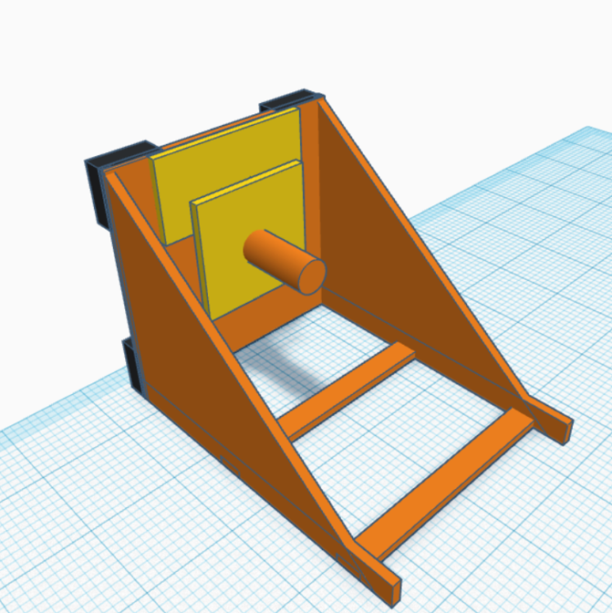

2.2. **Connections:**

All the electrical connections are supposed to be used on the backplate of our stand. The connection has to be done between the Load cell, Hx11 Amplifier and the Arduino Uno.

Simulation link : https://www.circuito.io/static/reply/index.html?solutionId=619326056bdeb4003061fb40&solutionPath=storage.circuito.io

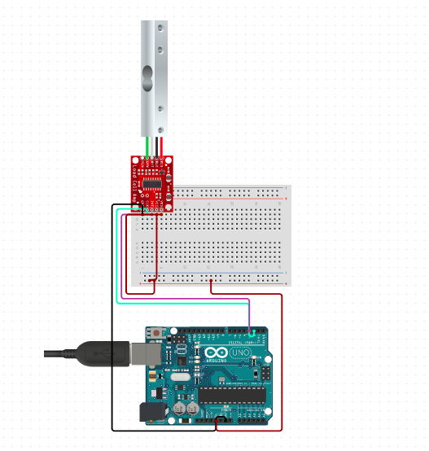

The circuit connections are clear above. The customized code to be used is linked below.

https://github.com/nmrocketryreviews/motorteststand

Once the connections are successful, the motor thrust results can be easily extrapolated into a graph through the arduino serial monitor.

End of Review 1.

Beleswar