Global Analysis of Internet Penetration

Introduction

The project examines the dynamics of internet usage across different countries and its impact on societal and economic development. Internet connectivity is not merely a tool for communication; it is a critical driver of global economic transformation. Access to the internet influences factors such as education, healthcare access, job opportunities, and technological adoption, which collectively shape a country’s development trajectory.

For developed countries, widespread internet access often correlates with robust digital infrastructure, higher education levels, and a thriving economy. In contrast, for developing countries, establishing basic internet infrastructure can act as a catalyst for growth. For instance, enhanced internet penetration enables citizens to acquire new skills, opens pathways to remote work opportunities, and supports entrepreneurship.

A compelling case is India, where affordable internet access has played a pivotal role in attracting global companies to invest in its tech ecosystem. As more companies establish operations, it leads to increased job creation, skill enhancement, and ultimately, a boost in GDP. Similar patterns are observed in other developing nations that have embraced internet connectivity as a fundamental component of their growth strategy.

By analyzing the percentage of internet users, GDP, and infrastructure development, this project aims to highlight the interplay between internet access and economic development. It seeks to answer key questions about how digital infrastructure can accelerate growth and attract international investment, contributing to a nation's overall prosperity.

Research Questions

1. How has internet usage evolved across different countries from 2020 to 2023?
2. What role does internet penetration play in determining whether a country is developed or developing?
3. What is the relationship between internet speed and GDP, and how does infrastructure development impact this?
This project leverages multiple datasets, including internet usage statistics, GDP data, and population data, to draw insights through advanced data visualization techniques. The findings will provide a deeper understanding of the role of internet access in shaping modern economies and societies.

Methodology

Data Sources:
Countries Internet Data :
https://worldpopulationreview.com/country-rankings/internet-users-by-country
https://en.wikipedia.org/wiki/List_of_countries_by_number_of_Internet_users
The dataset from World Population Review provides comprehensive statistics on internet usage across various countries for the years 2020 and 2023. It includes the following key metrics:

- Country: The name of the country.
- Internet Users: The total count of individuals using the internet in each country.
- Internet Users(12/31/2020) : The total count of individuals using the internet in each country at that date
- For example, in 2023, China had approximately 1.1 billion internet users.In contrast, India had about 881.3 million internet users.

This dataset enables analysis of internet penetration rates and user growth over time, offering insights into digital connectivity trends worldwide.

World Population Data :
https://population.un.org/wpp/
https://www.census.gov/data/tables/time-series/demo/international-programs/historical-est-worldpop.html

The dataset from World Population Review provides detailed demographic information for each country, including:
- Country Name: The official name of the country.
- Population 2023: The estimated population of the country in the year 2023.
- Area: The total land area of the country, typically measured in square kilometers.
- Density: The population density, calculated as the number of people per square kilometer.
- World Percentage: The percentage of the world's total population that resides in the country.

For example, according to the dataset, India has a population of approximately 1,450,940,000 in 2023, covering an area of about 3.3 million square kilometers, resulting in a population density of 488 people per square kilometer. This constitutes approximately 18.13% of the world's population. This comprehensive dataset allows for analysis of population distribution, density, and each country's share of the global population.

World GDP Data
Source: CIA World Factbook
Description:
This dataset provides Real GDP per capita (in terms of Purchasing Power Parity, or PPP) for countries worldwide.
- Country Name: The name of the country.
- Real GDP per Capita (PPP): A measure of the economic productivity and standard of living, adjusted for purchasing power differences. It reflects the average economic output per person in a country.
- This dataset is ideal for comparing the relative wealth and development of nations.

World Internet Data
Source: International Telecommunication Union (ITU)
Description:
This dataset includes key ICT (Information and Communication Technology) statistics:
- Country Name: The name of the country.
- Number of Internet Users: The total count of individuals who use the internet in each country.
- Fixed Broadband Subscriptions: The number of fixed-line broadband internet connections.
- Mobile Broadband Subscriptions: The number of active mobile broadband connections.
- Percentage of Households with Internet Access: The proportion of homes with internet connectivity.
This dataset provides a comprehensive view of digital connectivity, making it possible to analyze global internet trends and disparities.

Internet Speed Data
Source: Fastmetrics
Description:
This dataset focuses on average internet speeds by country:
- Country Name: The name of the country.
- Average Download Speed (Mbps): The average speed at which data is downloaded in the country.
- Average Upload Speed (Mbps): The average speed at which data is uploaded in the country.
- These metrics reflect the quality of a country's digital infrastructure and are critical for understanding how well-equipped nations are to handle modern digital demands.

Analysis

1.How has internet usage evolved across different countries from 2004 to 2023?

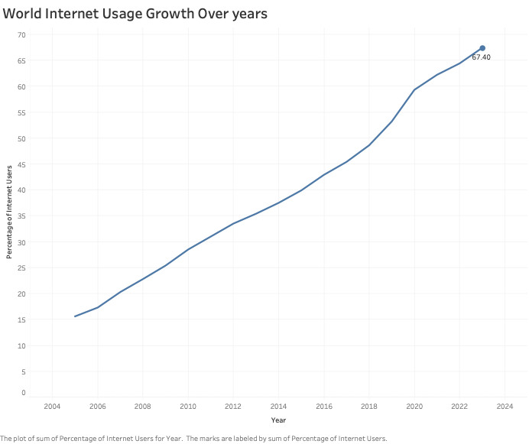

The visualization illustrates the growth in the percentage of internet users globally from 2005 to 2023. It highlights a steady upward trend, showing how internet access has expanded significantly over nearly two decades. Starting from just 15.6% in 2005, the percentage of internet users rose to 67.4% in 2023. This growth reflects advancements in technology, infrastructure development, and affordability of internet services worldwide. The steady rise highlights how nations are becoming more digitally connected and how crucial the internet is becoming for enabling access to information and services, promoting creation, and people together.

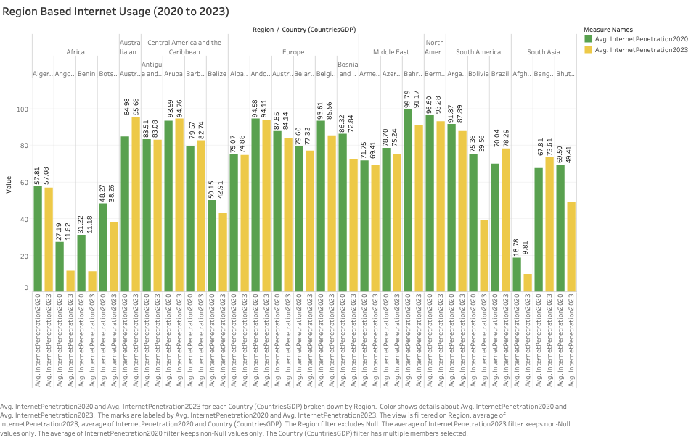
The analysis of internet usage evolution from 2020 to 2023 reveals significant global progress in digital connectivity, though with notable regional disparities. While Europe and North America maintain consistently high internet penetration rates (above 80-90%), developing regions show varied patterns of growth. Africa and parts of South Asia demonstrate the most room for improvement, with many countries still below 50% penetration, though countries like Bangladesh show remarkable progress (from 18% to around 50%). Middle Eastern and South American nations generally maintain moderate to high penetration rates (60-90%), with steady improvements over the period. The data illustrates a global trend toward increased internet adoption, though the digital divide between developed and developing regions persists, albeit gradually narrowing. Most notably, regions that already had high penetration rates in 2020 show minimal changes, while developing nations exhibit more dramatic improvements, suggesting successful digital inclusion initiatives in these areas.

Visualization Appropriateness Analysis:
Bar Chart (Region-based comparison):
- Appropriateness: Effectively shows side-by-side comparison of 2020 vs 2023 data
- Grouping by region helps identify geographical patterns
- Color coding (green/yellow) makes year-over-year changes easily distinguishable

2. What role does internet penetration play in determining whether a country is developed or developing?

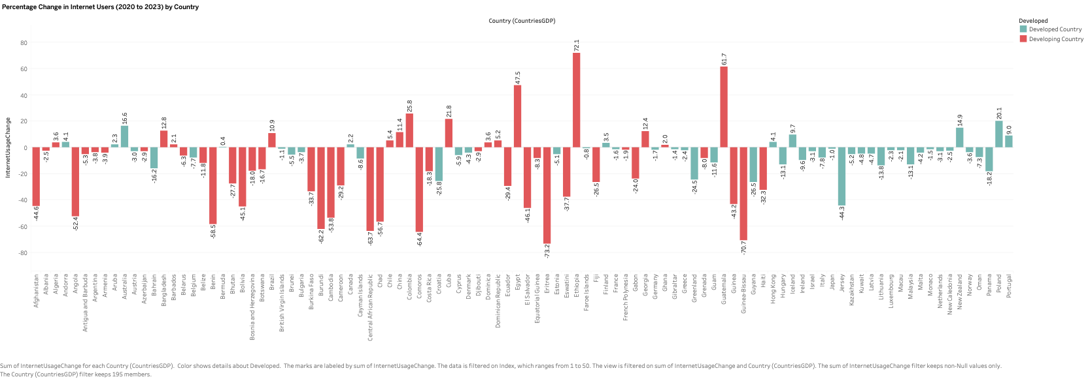

The visualization presents changes in internet usage percentages for a random selection of 50 countries between 2020 and 2023. It highlights a steady increase in internet usage among several developing countries, reflecting progress in digital infrastructure and accessibility. Interestingly, the data also reveals a slight decline in internet usage in some developed countries during the same period, which could be attributed to population shifts, changes in demographics, or market saturation. This contrasting trend emphasizes the diverse factors influencing internet adoption across different regions and development levels.

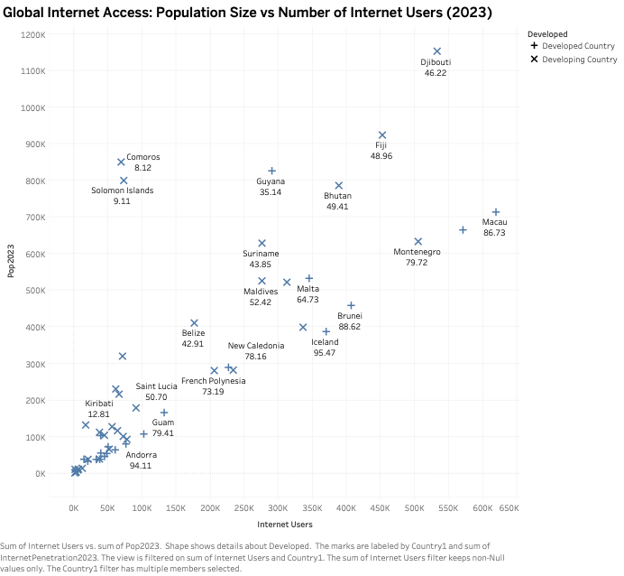

This scatterplot shows the relationship between population size and internet usage for smaller-population countries, distinguishing between developed and developing nations. Developed countries such as Iceland (95.47%), Aruba (94.76%), and Malta (64.73%) exhibit high internet penetration rates despite their small populations. In contrast, developing countries like Comoros (8.12%) and Kiribati (12.81%) show much lower internet usage rates, highlighting the persistent digital divide. Countries like Bhutan (49.41%) and Fiji (48.96%) occupy middle ground, reflecting varying levels of infrastructure and development in internet access. This visualization emphasizes the disparity in internet adoption among small nations.

Visualization Appropriateness Analysis:

Scatter Plot (Population vs Internet Users):
- Appropriateness: Best suited for showing relationship between two continuous variables
- Log scale used to handle wide range of population sizes
- Color coding distinguishes developed vs developing nations
- Avoids overlapping by focusing on smaller population countries
- Interactive tooltips provide detailed information for each data point

Conclusion
The analysis reveals several key findings about global internet usage patterns and their relationship with development:

1. Digital Divide Persistence: Despite overall growth in internet penetration from 2020 to 2023, significant regional disparities remain. Developed regions (Europe, North America) maintain high connectivity rates (80-90%), while developing regions, particularly in Africa and South Asia, still lag behind.

2. Development Correlation: The analysis clearly demonstrates that internet penetration serves as a strong indicator of a country's development status. Developed nations consistently show higher internet adoption rates, regardless of population size, while developing nations exhibit varying levels of digital infrastructure maturity.

3. Regional Progress: Many developing nations are showing promising growth in internet adoption, suggesting successful digital inclusion initiatives and infrastructure development programs.

Further Research Questions:
1. "How does mobile internet penetration compare to fixed broadband adoption across developed and developing nations, and what implications does this have for future development strategies?"

2. "What is the correlation between internet affordability (cost as a percentage of average income) and adoption rates in developing countries?"

3. "How does the quality of digital infrastructure (measured by factors like reliability and speed) impact foreign direct investment in developing nations?"

4. "What role do government policies and regulations play in accelerating or hindering internet adoption rates across different regions?"

