**DATA FLOW DIAGRAM**

The Data Flow Diagram is graphical representation of flow of data in a system. The DFD we made includes all the functionality and flow of data through these functionalities connecting the entire system. This DFD includes the incoming data, outgoing data as well as stored data.

Here, we will see mainly 3 levels in the data flow diagram: -

1. **0-level DFD:** It is also known as a context diagram. It’s designed to be an abstraction view, showing the system as a single process with its relationship to external entities. It represents the entire system as a single bubble with input and output data indicated by incoming/outgoing arrows.

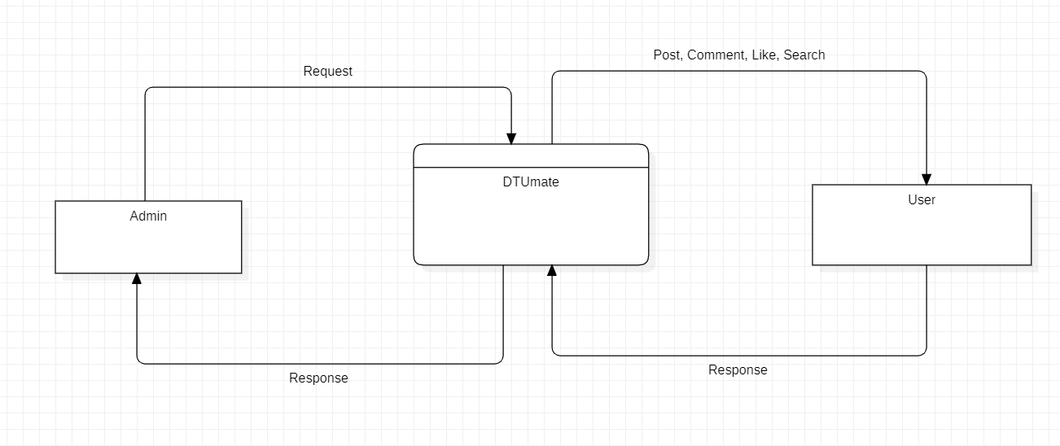

1. **1-level DFD:** In 1-level DFD, the context diagram is decomposed into multiple bubbles/processes. In this level, we highlight the main functions of the system and breakdown the high-level process of 0-level DFD into subprocesses.

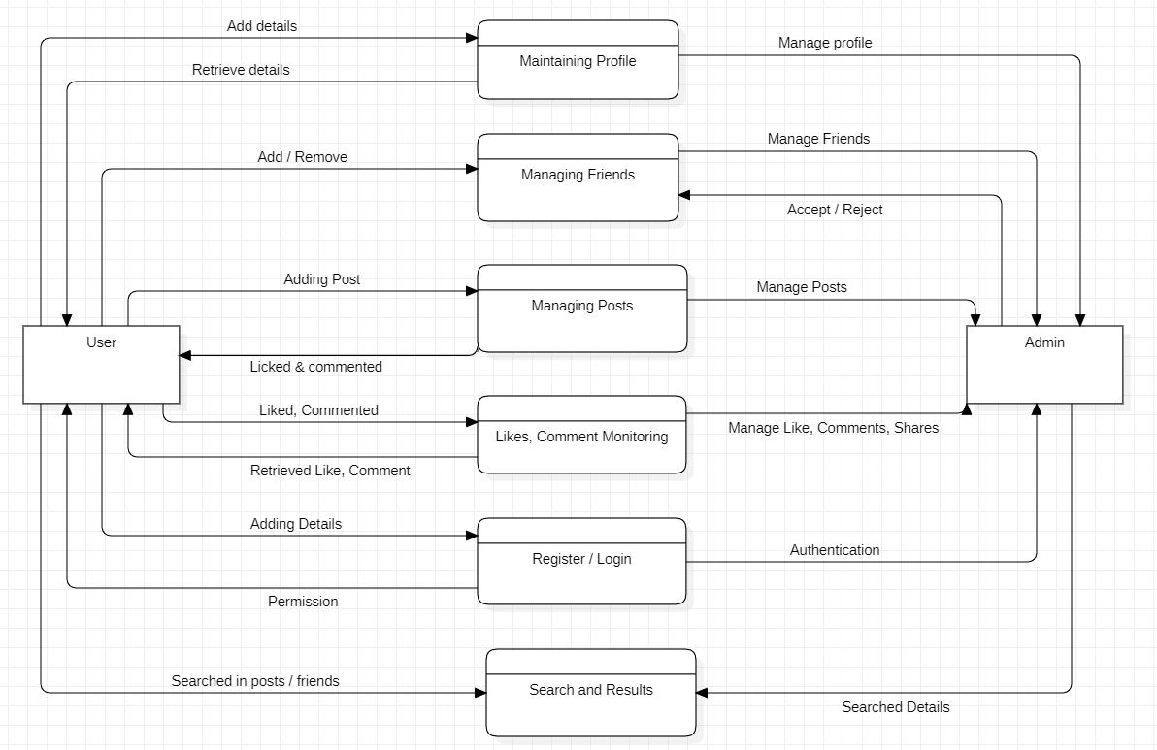

1. **2-level DFD:** 2-level DFD goes one step deeper into parts of 1-level DFD. It can be used to plan or record the specific/necessary detail about the system’s functioning.
2. **Managing Profile:**

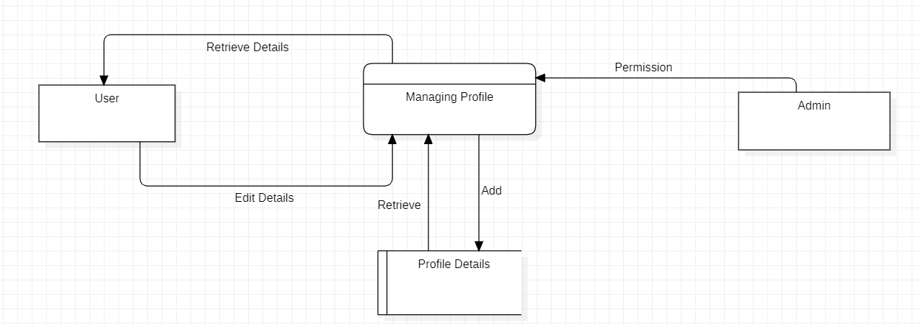

1. **Managing Friends:**

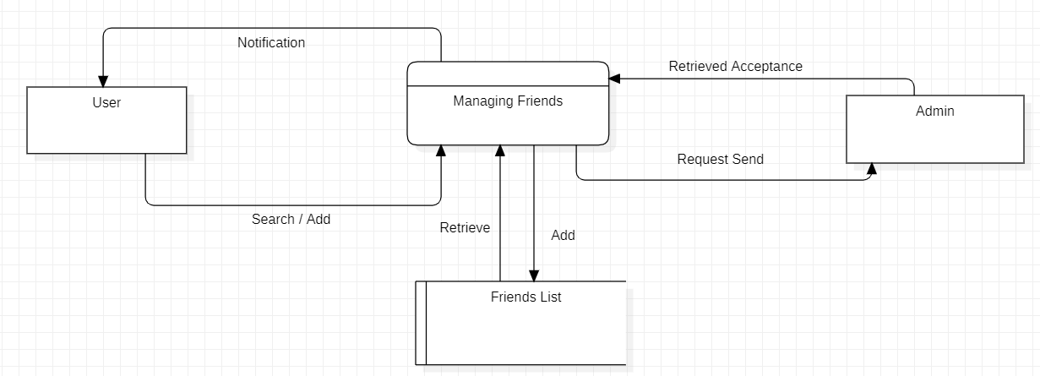

1. **Likes, Comments Monitoring:**

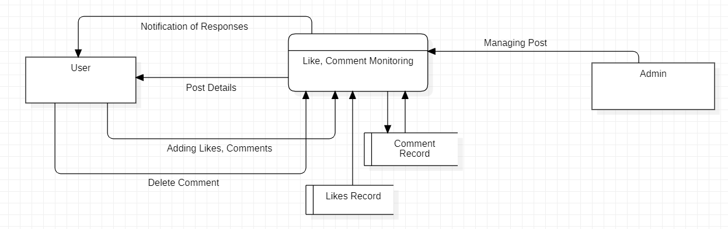

1. **Managing Posts:**

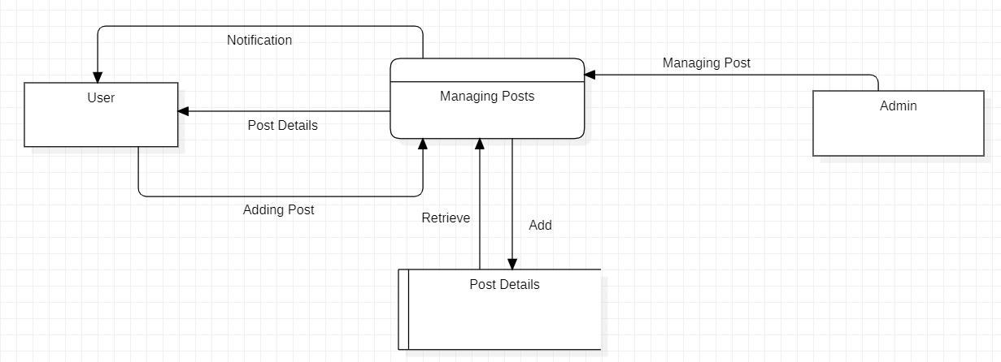

1. **Register/Login Manager:**

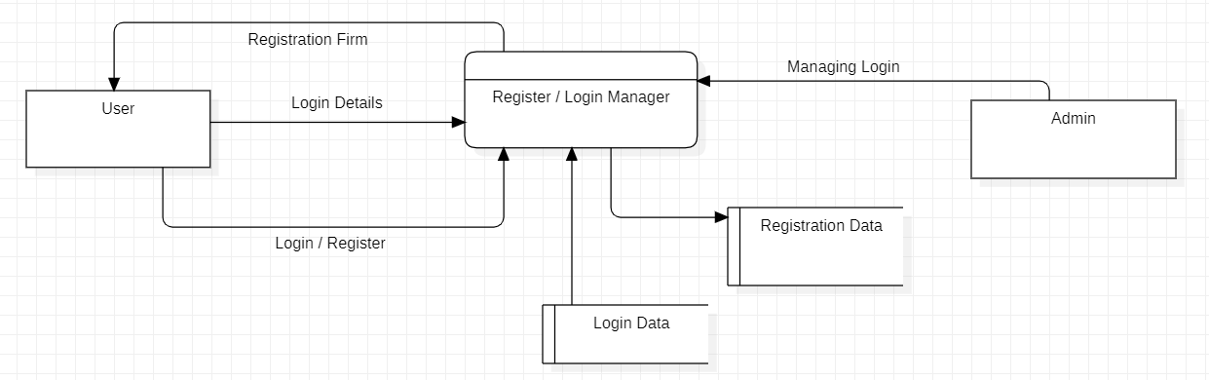

1. **Search & Result Manager:**

