**SOFTWARE REQUIREMENTS SPECIFICATION DOCUMENT**

**Team Members:**

*Ayush Karn – 2k19/CO/454*

*Sonu Kumar Kushwaha - 2K19/CO/383*

**Project Name: Social Media Site, “*DTUmate*”**

1. **Introduction:**

**1.1) Category:** The proposed project is a Web Application.

**1.2) Purpose:** The purpose of the project is to develop a social media for a targeted group of people, especially to an Engineering college. The media will bring its own particular feature of idea sharing, problem rising and communication data being anonymous to others.

**1.3) Document convention:** To make the document more effective and readable we used bet font style and font size and headings are bold and highlighted with attractive colors.

**1.4) Intended Audience:** This document is written for the researchers, project managers, programmers, designers, developers, testers, documentation writers, users involved in the website modification of the online social media website of the specific institute. This document consists of the various steps and procedures for the website update initiated with an open discussion with the company by the system analyst. The following section describes the rest of the product function, scope, and other overall descriptions; finally, with the references.

**1.5) Product Scope:** It will integrate the benefits of sharing knowledges and data. This website is especially beneficial for those who are shy to ask questions in front of others, and for the questions that are considered silly to be asked openly. Adding more features can enable DTU to share notices at high pace and can be a solution to resolve face notices circulation.

**1.6) Reference:** References that I used to create questions for the initial discussion between the client is noted below,

* Singh H S., Singh U. “Study on Google Firebase for Website Development (The real time database)” International Journal of Engineering Technology Science and Research, Volume 4, Issue 3 March 2017
* Khawas C., Shah P. “Application of Firebase in Android App Development-A Study” International Journal of Computer Applications Volume 179(46): June 2018
* Yeshwin A., Sahoo A., Shoby P. “A Research Paper on a Pet-Friendly Application using Flutter and Firebase” International Journal for Research in Applied Science & Engineering Technology (IJRASET)Volume 8 Issue XII Dec 2020

1. **Overall Description:**

**2.1) Product Perspective:** This product is to make changes in the traditional way of questioning. This product will develop a close environment to consult the doubts related subject matters, placement, interviews, coding or behavioral activities. This website will act as a better and more interactive way of studies and preparation for placements. Our approach towards programming was a highly methodical one since a Web application is created using various fields and principles.

**2.2) Product Function:** This product enables the official to get a detailed idea about the questioning and also to be well informed about the notice share by authority. The system includes maintaining profile, managing friends, posting doubts in form of text and images, adding like and comments to a post and to search a problem with tags.

**2.3) User- classes and Characteristics:** Users of the system should be able to register, login, search friend or posts, upload post, add comments and likes to a post and also manage his/her profile information. The system will support two types of user privileges, Customer, and Admin. Customers will have access to customer functions, and the Admin will have access to both customer and admin management functions. The customer should be able to do the following functions,

* Create account.
* Upload post.
* Influence posts.
* Search by tags.

The Admin should have the following functionalities:

* Customer Functions:
* Maintenance of the website in order to view track records.
* Transfer the information of the dead posts to the archived section.
* Maintain the confidentiality of sensitive cases.
* Administrative Functions:
* Add/Delete profiles
* Add/Delete posts
* Influence the spreading of post.
* Able to gather data
* Can make changes in website.

**2.4) Operating Environment:** Operating environment for the Social Media system is as listed below,

* Non-sql database
* Client/Server system
* Operating system: Window/Linux
* Database: Firebase
* Platform: HTML, CSS, JavaScript, React.js, Node.js, Firebase

**2.5) Design and Implementation Constraints:** The interaction between the actors and system is well shown in Use Case diagram of the product,

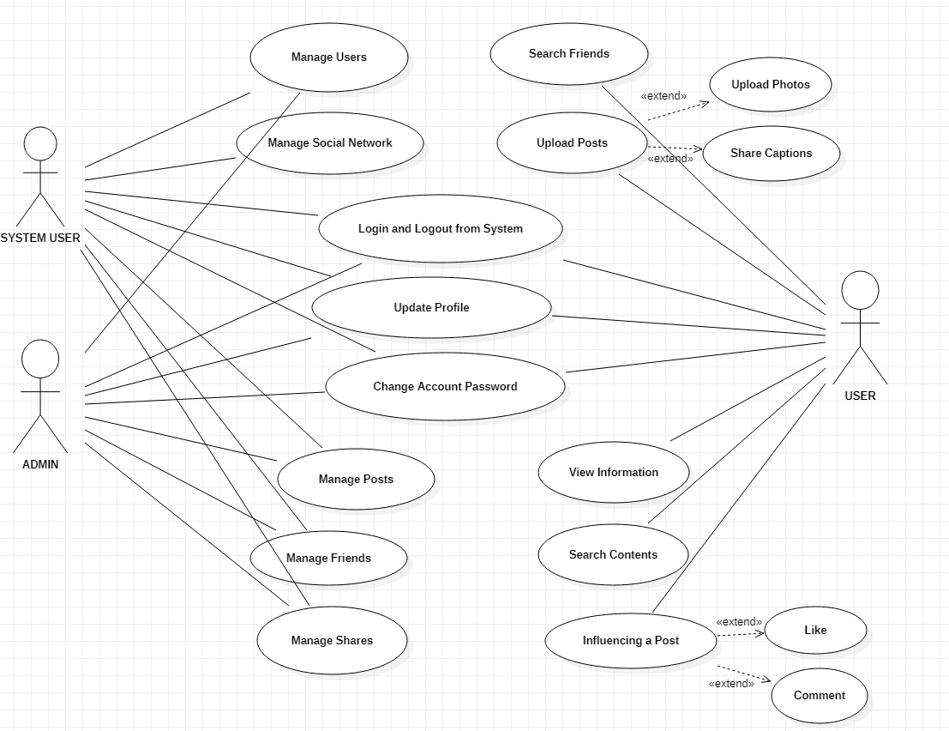

The Use Case Diagram has three actors, User, Admin and System User. System User can basically manage or control overall functioning of the website. User will have the functionality to register/login, create a post, influence posts, search friends or posts by names or tags. System Admin have all the functionality of User along with functionality to manipulate protected data.

**2.6) User Documentation:** The general characteristics of the user of our website will be anyone from the targeted audience (like here DTU students) along with professors, passouts and authorities.

**2.7) Assumptions and Dependencies:** Our approach towards programming was a highly methodical one since a Web application is created using various fields and principles. We also focused on backend and using different feature of Firebase by hosting.

1. **External Interface Requirements:**

**3.1) User Interface:** Front-end software: React.js version; Back-end software: Firebase

**3.2) Hardware Interface:** Windows and any browser which supports CGI, HTML, and JavaScript library.

**3.3) Software Interfaces:** Following are the software used for the social media web application,

|  |  |
| --- | --- |
| Software Used | Description |
| Operating System | We have chosen Windows operating system for its best support and user-friendliness. |
| Database | To save the all the website data, we have chosen the FireStore (Firebase) database. |
| Node.js | Node Package Manager |

**3.4) Communication Interface:** This project supports all types of web browsers. We are using simple electronic forms for interacting, browsing, sharing, etc.

1. **System Features:**

**4.1) Description:** Social media play a crucial role in connecting people and developing relationships, not only with key influencers and journalists covering your company's sector, but also provides a great opportunity to establish customer service by gathering input, answering questions and listening to their feedback.

**4.2) Priority:** The priority is given to,

* Enclosed environment of sharing and communication
* Interactive and anonymous sharing feature
* Easier tag searching and authority data and notice sharing.

**4.3) Functional Requirements:**

* NO-SQL Database: The database which don’t store data in form of tables are called no-SQL database. The database of our system is stored in Firestore of Firebase in No-SQL form. The Firebase Realtime Database is a cloud-hosted database. Data is stored as JSON and synchronized in realtime to every connected client. When you build cross-platform apps with our Apple platforms, Android, and JavaScript SDKs, all of your clients share one Realtime Database instance and automatically receive updates with the newest data.
* Client/Server System: The term client/server refers primarily to architecture or logical division of responsibilities, the client is the application (also known as the front-end), and the server is the Firebase (also known as the back-end).

1. **Non-Functional Requirements:**

**5.1) Performance Requirements:** The steps involved to perform the implementation of the social media website system are listed below.

* Class diagram: Class diagram is a static diagram that represents the static view of an application. Class diagram is not only used for visualizing, describing, and documenting different aspects of a system but also for constructing executable code of the software application. Class diagram describes the attributes and operations of a class and also the constraints imposed on the system.

The standard class diagram is composed of three sections:

* **Upper section:** Contains the name of the class. This section is always required, whether you are talking about the classifier or an object.
* **Middle section:** Contains the attributes of the class. Use this section to describe the qualities of the class. This is only required when describing a specific instance of a class.
* **Bottom section:** Includes class operations (methods). Displayed in list format, each operation takes up its own line. The operations describe how a class interacts with data.

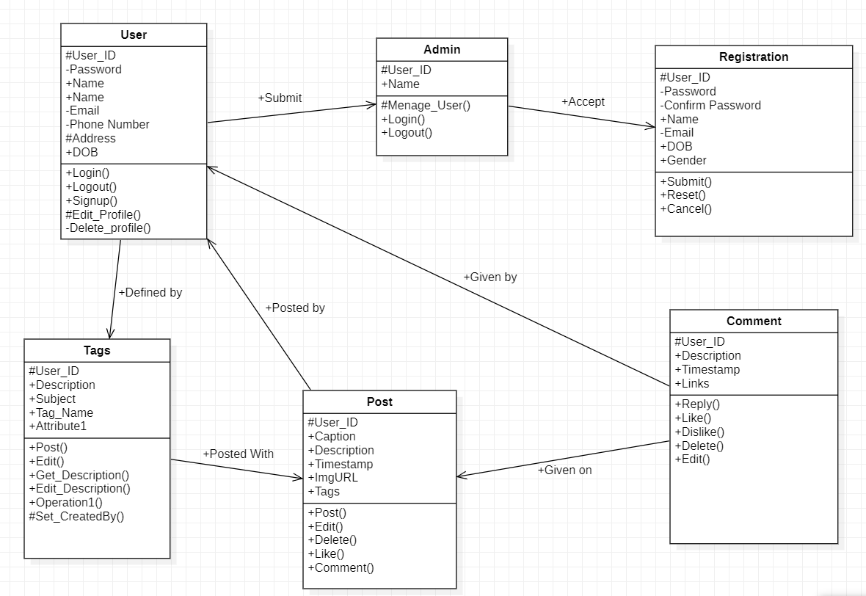

Class diagram contains 6 classes, User, Admin, Registration, Tags, Post and Comment. The User class holds the data of user also defining functionality provided to user. Registration class holds the registration firm and registered data and functionality defined for registration. Tags class holds the name and description of tags that can be used in posts for describing problem in as sort form as possible and can also be used for searching required post using the tags used in the respective post. Post and Comment classes holds data and functionality any user is provided for posting and commenting respectively.

**5.2) Safety Requirements:** In case there is sharing of inconvenient content action can be taken. The user can be mater of punishment for spreading fake news and notices. Research and analysis can be done to track user behaviors and feature for reporting inconvenient content can be added. User have security to share post being anonymous in any case of personal data leak.

**5.3) Security Requirements:** Security frameworks can be controlled by administration (DTU authority). Authority can manage users profile, posts, network connections and content searched.

**5.4) Software Quality Attributes:**

* **Availability:** The project is aimed at to be used by targeted audiences only, specially by Engineering college students. Availability of the website will begin from DTU, named as *DTAmate.* Including students of DTU, professors, Authorities and DTU passouts will be able t use the website. The availability will be extended to other colleges or schools by making some changes, making website specifically suitable and interactive to user according to the respective schools or college.
* **Correctness:** The main component of our project i.e. Database Management was carried out in Firebase. The database was created and maintained using Firebase is a real-time database leading to less errors in database and quite fast error detection. But querying and modifying the database through the web app required another JS library by the same name to mediate the database on the system and the web app populating the database using data from its form fields.
* **Maintainability:** The implementation of the website is carried on Firebase which secures maintainability by offering inbuilt features. The feature of real-time database improves data maintenance, feature of Google analysis helps in maintaining user interface and interactivity. Regular update will keep the system Bug-free. Here multiple checks can be implemented to ensure the integrity and correctness authentications so that the file can be maintained and not corrupted.
* **Usability:** We have presented a simple technique for sharing doubts, ideas, information, notices and data, also allowing the user to be anonymous for the purpose of security or anything else. We have additional features for administration for analysis of post circulation, attractive interactions, and fast notice circulation. These feature will add up the usability of our web application.

**5.5) Business Rules:** DTUmate initiatives significantly improve social media for DTU targeted audiences bringing the advance features of sharing and communication in more of interactive way while maintaining user’s privacy.

As India enhancing in use of social media, this system is next step of personalized social media according to specific institute for specific targeted audience to create more usability, interactive and security.